基于Item-Based算法实现推荐系统的概率模型

李明、本杰明、迪亚斯 | 瓦埃勒·埃尔 | 保罗 J. G. 里斯本
共同研究 | 曼彻斯特科技大学 | 利物浦约翰·摩尔斯大学
沙恩布洛克, 贝德福德郡, 英国 |  | 计算机学院
Ming.x.Li@Unilever.com  Ben-jamin.Dias@Unilever.com | Wael.El-deredy@manchester.ac.uk | 数学与科学专业
Ming.x.Li@Unilever.com  Ben-jamin.Dias@Unilever.com | Wael.El-deredy@manchester.ac.uk | P.J.Lisboa@livjm.ac.uk

摘要

推荐系统预测被购买的商品Xj的条件概率P(Xj|Xi)，假设客户已经购买了商品Xi。虽然存在近似该条件概率的不同方法，但是该表达通常被用于指代在同一类目或者其他用户特定商品列表中的商品同现的频率，而不是被看作是共同出现的Xi和Xj一起购买的所有其他商品的比例。本论文提出了一种基于项目而不是商品类目计数条件计算的概率演算。所提出的方法具有以下结果：作为一个类目的一部分的商品作为一个组成部分，相对于彼此共同出现在大类目中，彼此更具有预测性。实证结果表明，这可以提高个性化建议的准确性。

类别和主题描述： H.3.3 [信息
系统]: 信息搜索和检索

通用术语： 算法，实验，性能。

关键词： 购物车推荐，朴素贝叶斯分类器，性能评价，人气排序。

- 引言

类条件概率的估计位于个性化推荐系统的核心。 通常情况下，项目对的同时出现通过其中两个项目一起出现的篮子的平均比例来经验地估计。 我们将这称为基于篮子的估计。 然而，这失去了对所购买的剩余项目的上下文的跟踪，特别是所观察到的配对是否是用户项目数据矩阵中的相关篮中的几个或非常多的项对中的一个。 这个方案提出了一种替代的建模框架，其中每个项目配对被计数为总篮子尺寸的一部分，也就是说，项目xj与项目xi的配对出现的频率被与xi一起购买的项目的总数标准化 。 这是我们基于项目的估计。

允许为个人或课堂使用制作数字或部分此类作品的数字或硬拷贝，无需付费，但前提是副本不是为了利润或商业利益而制作或分发的，且副本带有第一页上的通知和完整的引用 。 否则，要重新发布，在服务器上发布或重新分发到列表，需要事先获得特定许可和/收费。
系统文件’12年10月 19–20, 2013, 明尼阿波里斯市, 明尼苏达州（美国中北部洲）, 美国. 版权 20 ACM 978-1-59593-730-8/07/0010 ...$5.00.

它需要重新计算概率演算以计算P（xj | xi），这将在下一节中讨论。第3节通过参考条件的最简单的估计器，即朴素贝叶斯（NB）推荐系统来说明所提出的方法，然后简要评估从真实世界应用中的历史数据估计的建议的预期吸收。为了方便起见，在本文的其余部分，使用基于篮子和基于项目的时间的NB分类器将分别被称为NB（篮子）和NB（项目）。

2. ITEM-BASED算法概论

- Basket-based算法和Item-based算法概率预测

概率估计表示在限定的可能性空间上采取的感兴趣事件的预期频率。 在协同过滤中，对基础人群有两种不同的解释，从中可以得出关于项目购买的推论，其可以是购买事件的数量（即篮子）或购买的单个项目的总数[5,7,3,6 ]。

- 基于Basket-based算法的概率计算。在 Basket-based算法算法预测中，这是实践中最常用的[5,7,6]，计算单位是一个篮子。因此，先验证概率P（Ci = Xi），根据经验预测为包含Xi（即ND（Xi））和篮子总数的篮子数量之间的比率；条件概率P（Fj = xj | Ci = xi）类似地由其中（Xi，Xj）共同出现在同一篮子中的数量除以包含Xi的篮子的总数量而得出。以下是计算公式。

P_{D} (C_{i} = x_{i}) | = | N_{D} (x_{i}) |  |  | (1)
P_{D} (C_{i} = x_{i}) | = | |baskets| |  |  | (1)
P_{D} (F_{j} = x_{j} |C_{i} = x_{i}) | = | n(x_{i}, x_{j} ) |  |  | (2)
P_{D} (F_{j} = x_{j} |C_{i} = x_{i}) | = | N_{D} (x_{i}) |  |  | (2)

- 基于Item-based算法的概率计算。 建议是将每个篮子项目计为一个事件。 在这个模型中，独立随机变量成为购买每个单独项目的决定，而不是作为一个整体的篮子。 因此，P（Ci = xi）是与xi一起购买的物品的数量与所有放在一起的篮子中的可能物品对的总数之间的比率，其被称为一对物品。

129

条件概率P（Fj = xj | Ci = xi）现在被计算为项目xi与项目xj配对的次数除以在相同篮子中购买的总数项目对xi。

P_{F} (C_{i} = x_{i}) | = | N_{F} (x_{i}) |  |  | (3)
P_{F} (C_{i} = x_{i}) | = | |item pairs| |  |  | (3)
P_{F} (F_{j} = x_{j} |C_{i} = x_{i}) | = | n(x_{i}, x_{j} ) |  |  | (4)
P_{F} (F_{j} = x_{j} |C_{i} = x_{i}) | = | N_{F} (x_{i}) |  |  | (4)

当NF (xi) = _{j:j=i} n(xi, xj ) 和 |item pairs| =
_{i} NF (xi) .

注意，基于篮子的估计不区分已经发生的项目与不同数量的其他项目。 相比之下，基于项目的方法捕获特征或项目空间中的项目同现信息。

此外, 为了使概率演算完整和一致，必须满足以下三个条件：

- _{i} P_{F} (x_{i}) = 1: 个体概率归一化

- _{j:j=i} P_{F} (x_{j} |x_{i}) = 1: 条件概率归一化

_{j:j=i} P_{F} (x_{i}, x_{j} ) = P (X_{i} ): 计算概率边界值

前两个条件遵循所述定义。第三个条件遵循如下原则

_{j:j=i} PF (xi, xj ) = |  | n(x_{i}, x_{j} ) |  | = | _{j:j=i} n(xi, xj )
_{j:j=i} PF (xi, xj ) = | _{j:j=i} |item pairs| |  |  | = | |item pairs|
N_{F} (x_{i})
= _{|item pairs|} = PF (Ci = xi) = P (Xi)

2.2 一个简单案例说明

为了说明两个概率估计之间的差异，考虑表1中给出的例子，其中在所有篮子中有8个篮子（即|篮子| = 8）和23个篮子项目（即|item pairs| = i NF（xi）= 48）。 使用基于Basket-based算法 的概率预测：

P_{D} (a) = |  | n(a) |  |  |  | = |  | 4 |  | , P_{D} (d) = | 6
P_{D} (a) = | |baskets| |  |  |  |  |  |  | 8 |  | , P_{D} (d) = | 8
P_{D} (d|a) = |  | n(d, a) |  | = |  | 2 |  | , P_{D} (a|d) = |  |  | 2
P_{D} (d|a) = |  | n(a) |  |  |  | 4 |  |  |  |  | 6

相同的, item-based 算法的预测概率：

P_{F} (a) | = | x=(b,c,d) ^{n(x, a)} |  | = | 8 |  | , P_{F} (d) = | 13
P_{F} (a) | = | |item pairs| |  | = | 48 |  | , P_{F} (d) = | 48
P_{F} (d|a) | = | n(d, a) |  | = | 2 | , P_{F} (a|d) = |  | 2
P_{F} (d|a) | = | x=(b,c,d) ^{n(x, a)} |  | = | 8 |  |  | 13

在该案例中很容易表明这两种概率预测算法都满足贝叶斯定理，即 P (d|a) = P (a|d)P (d)/P (a).

- 贝叶斯算法推荐系统的简单应用

推荐列表一般是通过以相应的概率预测 P (C_{i} = x_{i}|F )对所有非购买商品进行排序而生成，然后利用topN算法推荐可能性最高的物品

表 1: 购物车案例.

Basket I D | F₁ | F₂ | F₃ | F₄ | F₅ | F₆
1 |  |  |  | d | e | f
2 |  |  |  | d | e | f
3 |  |  | c | d
4 |  | b | c | d
5 | a | b | c | d
6 | a | b | c | d
7 | a | b
8 | a | b

首先，再一个NB推荐系统中， 概率P (C_{i} = x_{i}|F ) 计算可以简化为：
P (C_{i} = x_{i}|F ) ≈ P (C_{i}) |  | m
 |  | P (F_{j} |C_{i})
 | m | j:j=i
= | _{j:j=i} n(xi, xj )
= | N (x_{i})^{m−1}
上述等式意味着如果NB（篮子）和NB（项目）对于NB（项目）的N（xi），即ND（xi）和对于NB（项目）的NF（xi），则将生成相同的推荐列表， 相同的顺序。 否则，两个列表将不同。

In a preliminary experiment, we evaluate the impact of N (x_{i}) on the ranking position of item x_{i} in the recommendation list. The result is shown in Figure1. As can be seen, among 210 active cat-egories, there are only around 23 categories with the same ranking position in both cases.

 | 25
Frequency | 20
Frequency | 15
 | 10
 | 5
 | 0
 | 0 |  |  | −10 |  |  |  |  | 0 |  |  |  |  |  |  |  |  | 10 |  |  |  |  |  |  |  |  |  | 20 |  |  |  |  |  | 30 |  |  | 40 | 50
 | −20
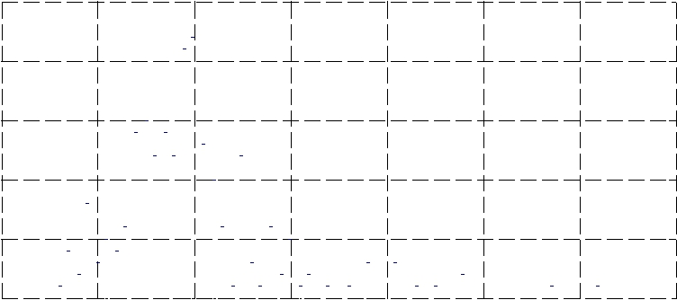
Ranking Difference

Figure 1: Histogram of the diﬀerence between the ranks of the prior probability generated by NB(baskets) and NB(items) i.e. Rank(P_{D} (x_{i})) − Rank(P_{F} (x_{i})). Among 210 active categories in total, there are only around 23 categories with t same ranking position in both cases.

4. 性能预测

In order to compare NB(baskets) and NB(items), LeShop pro-vided us with access to link-anonymized shopping basket data from actual historical records comprising individual transactions, as pre-viously described in [6]. We use data covering six consecutive months for training, and ran tests on the following seventh month.

¹We notice that the authors in [7] calculate the purchase

likelihood in a way similar to |  | P (C_{i}|F |  | ) |  | . In our pre-
 | P (C_{i}|F )+P (C_{i}|F )
liminary experiment, however, we did not observe any ad-vantage of such an approach in terms of recommendation performance.

130

 | 1 |  |  |  |  |  |  |  |  | 22
 | 0.9 |  |  |  |  |  |  |  |  | 22
 | 0.9 |  |  |  |  |  | NB(baskets) |  |  | 20
 | 0.8 |  |  |  |  |  |  |  |  | 20
 | 0.8 |  |  |  |  |  | NB(items) |  | Averaged Basket Length | 18
 | 0.7 |  |  |  |  |  | item CF |  | Averaged Basket Length | 16
HR(Binary) | 0.6 |  |  |  |  |  |  |  | Averaged Basket Length | 14
HR(Binary) | 0.5 |  |  |  |  |  |  |  | Averaged Basket Length | 12
HR(Binary) | 0.5 |  |  |  |  |  |  |  | Averaged Basket Length | 10
HR(Binary) | 0.4 |  |  |  |  |  |  |  | Averaged Basket Length | 10
HR(Binary) | 0.4 |  |  |  |  |  |  |  | Averaged Basket Length | 8
HR(Binary) | 0.3 |  |  |  |  |  |  |  | Averaged Basket Length | 8
HR(Binary) | 0.3 |  |  |  |  |  |  |  | Averaged Basket Length | 6
HR(Binary) | 0.2 |  |  |  |  |  |  |  | Averaged Basket Length | 6
HR(Binary) | 0.2 |  |  |  |  |  |  |  | Averaged Basket Length | 4
 | 0.1 |  |  |  |  |  |  |  |  | 2
 | 0 |  |  |  |  |  |  |  |  | 0
 | 0.2 | 0.3 | 0.4 | 0.5 | 0.6 | 0.7 | 0.8 | 0.9 | 1
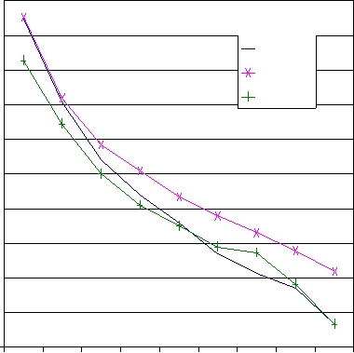

0.2 | 0.3 | 0.4 | 0.5 | 0.6 | 0.7 | 0.8 | 0.9 | 1
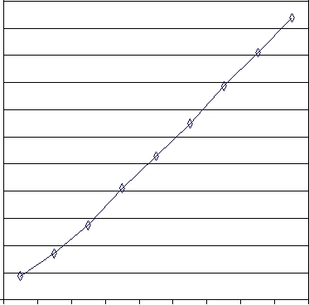
real-life recommender systems to model the correlations among a subset of all the product categories, also called active categories. In this section, we compare the performance difference among sev-eral algorithms. A performance curve is plotted, for each methods, with increasing coverage = (0.2, 0.3, 0.4, 0.5, 0.6, 0.7, 0.8, 0.9,

1.0) of all the n% categories (i.e. the categories that account for most of the total spend over the training data). Note that, a low (or high) coverage of the active categories is indicative of a small (or large) value of the average basket size, which is shown in Figure 2(b).

Here, we also implement the item-based collaborative filtering

Coverage of Active Category(%) Coverage of Active Category(%)

(a) Hit Rate (Binary) (b) Avg. Basket Length

Figure 2: Performance comparison with increasing coverage of the active categories. testset = LeShop.

After aggregating the training baskets², there are around 210 active categories and 40,000 baskets. The test data are not aggregated. We also used data from an anonymous Belgium retailer [2] in order to verify our results. However, as the results of the Belgium basket dataset show similar patterns to that of the LeShop, we report its results only in Section 4.2.

In keeping with our previous live intervention study of recom-mender systems [6], binary hit rate (HR Binary) is used for mea-suring the system performance and it is calculated as the proportion of the baskets having at least one correctly predicted item. Fur-thermore, we evaluate the performance following the same strategy proposed in [6], which removes duplicated items from the test bas-

kets, re-orders those items in descending global-popularity order and then defines the last three (i.e. the least popular items) as the target to be predicted, given the remainder as evidence. This evaluation setting reflects a real scenario of marketing promotion: increasing visibility of less popular (or new) products. As shown in our previous study, among other alternatives (e.g. temporal and leave-one-out ordering), the popularity-based approach is the only evaluation strategy that generates a consistent ranking of several recommendation algorithms in terms of their live performance in a check-out recommender system using the marginal distribution of item purchase for the prior of a NB recommender algorithm. The consistency sought is to correctly rank the expected take-up of recommendations between four groups of consumers in a 2 × 2 contingency table comprising active vs. non-active and case vs. control baskets. The former characterizes consumers according to their frequency of shopping episodes during the preceding 6 month block period, and the latter separates the consumers receiv-ing personalised recommendations from those receiving a generic recommendation using the global prior only. More details about the data and the popularity-based evaluation strategy can be found on [6].

- Performance Comparison Using Popularity Based Protocol

  - Performance with Increasing Number of Active Categories

Due to the feasibility concern, it is common practise for many

²A well-known characteristic of shopping habits is seasonal behavior. Its eﬀect is partly avoided in this study by aggre-gating shopping baskets for each customer over the training period
algorithm (item CF) [3], for comparison. In item CF, the pairwise item similarity is calculated as:

sim(x_{i}, x_{j} ) = | ^{∀q:R}q,j>0 | Rx_{q} ,x_{j} | (5)
sim(x_{i}, x_{j} ) = | N_{D} (x_{i}) × N_{D} (x_{j} )^{α} |  | (5)

where α ∈ [0, 1], N_{D} (x_{i}) is the number of shoppers that have purchased the items in the training data and R(x_{i}, x_{j} ) is an element in the normalized n × m user-item matrix. With item CF, we report only its best performance.

Figure 2 shows results of each method evaluated on the LeShop data. As can be seen, all the methods do best at the minimum value of the average basket size, while the performance drops with increasing category coverage (i.e. the data become sparser). It is interesting to note that, both NB-based methods perform similar when the average basket size is small. This is because the value of P_{F} (F_{j} |C_{i} ) is closer to P_{D} (F_{j} |C_{i} ) (cf. Eq(2) and Eq(4)) when the basket size is small. In an extreme example where all the baskets contain no more than two items, P_{F} (F_{j} |C_{i} ) are identical.

With increasing basket sizes (Figure 2(b)), NB(items) consis-tently outperforms NB(baskets). We attribute this to the benefit of item-based probability estimate (Eq(4)) as it assigns lower weight to the co-occurring items in larger baskets. This is similar to the con-cept adopted in Eq(5) that gives lower weight to the shoppers that have purchased more items [3]. Consequently, we see that, with increasing basket sizes, both NB(items) and item CF outperform NB(baskets), which does not discriminate between items take have co-occurred with different number of other items. Our future work will explore the reasons why the item CF approach shows inferior performance in comparison with NB(items) for larger baskets.

4.1.2 Performance with Increasing last N Items

In ongoing work we find that the performance of NB(baskets) is adversely affected by the increasing number of evidence items. It is well known that feature selection using information gain can benefit the NB classifier in text classification [4]. In practice, however, we choose to use the lastN items to deal with the “noisy” features (or items) due to the concern of the difference between the recom-mender system and the text classifier [7]. Given a list of basket items ordered by their global prior (i.e. popularity), we use only the last few to predict the purchase probability of the new items. Intuitively, these less popular (or frequent) items are more useful in capturing item similarity than those universally liked ones [1].

Figure 3 shows the performance curves of all the methods with increasing number of the last n items, n = (1, 2, 3, 4, 5, 6, 7, 8, 9, 10, all). Here, NB(baskets) shows its best performance at a value of five (lastN =5). Both the NB(items) and item CF models are relatively noise-resistant and do best when all the items are used for prediction. This is a practical advantage over NB(baskets) as it saves the time required to regulate the model for the optimal value of lastN over different time periods.

131

 | 0.4
 | 0.38 | NB(baskets)
 | 0.36
 | 0.36 | NB(items)
 | 0.34
HR(Binary) | 0.34 | item CF
HR(Binary) | 0.32
HR(Binary) | 0.3
HR(Binary) | 0.28
HR(Binary) | 0.26
 | 0.24
 | 0.22
 | 0.2
 | 1 | 2 | 3 | 4 | 5 | 6 | 7 | 8 | 9 | 10 | ALL
 |  |  |  |  |  | lastN
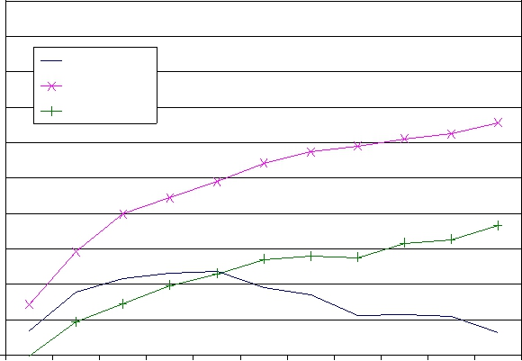
Figure 3: Performance comparison with increasing lastN items. coverage = 80% and testset = LeShop.

- Performance Comparison Using Leave-One-Out Protocol

In keeping with our previous work regarding the performance evaluation of a recommender system, we also report the results obtained by using all-but-one (or leave-one-out) protocol [1] and compare them with another baseline method that simply recom-mends the most popular items not present in the basket (referred as popular in Figure4). Note that, with the Belgium data, we only test it with the NB-based methods as the user information required by the item CF is not available.

As shown in Figure4(b), the popular recommendation has the best performance with the leave-one-out evaluation (p < 0.05, McNemar’s test). This is because the leave-one-out approach favors the performance on common classes as it weights all the items equally.

The popularity-based evaluation, on the contrary, favors the per-formance over rare classes (i.e. less popular items) as it assigns zero weight to the “hits” over the popular items in the test bas-kets. It is worth noting that, our previous live intervention study in LeShop has revealed that the performance comparison over the rare classes are more indicative of the models’ live performance as the customers are unlikely to accept the recommendations of those common classes (popular product items). As shown in Figure4(a), NB(items) with the popularity ordering has the best performance in all the basket datasets (p < 0.05, McNemar’s test).

0.8 |  |  |  |  | 0.8
0.7 |  |  | NB(baskets) |  | 0.7
 |  |  | NB(items) |  | 0.7 |  |  |  |  |  |  |  |  |  | NB(baskets)
 |  |  | item CF |  |  |  |  |  |  |  |  |  |  |  | NB(items)
0.6 |  |  | Popular |  | 0.6 |  |  |  |  |  |  |  |  |  | item CF
 |  |  |  |  |  |  |  |  |  |  |  |  |  |  | Popular
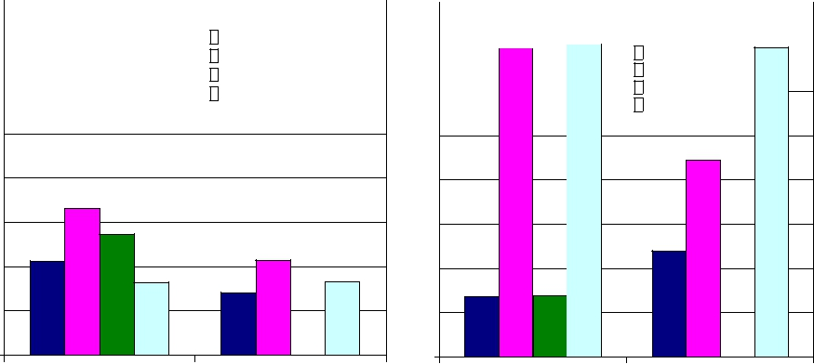
0.5 |  | 0.5
0.4 |  | 0.4
0.3 |  | 0.3
0.2 |  | 0.2
0.1 |  | 0.1
0 |  | 0
LeShop | Belgium | LeShop | Belgium

(a) Popularity Ordering (b) Leave One Out Order-
ing

Figure 4: Performance on the Belgium data and three months of the LeShop data. coverage = 80%.
5. 总结

A probabilistic framework using individual item purchases was proposed and its performance for personalised recommender sys-tems was benchmarked against the standard basket-based estimates of conditional probabilities. The two alternative models of con-ditional probabilities were evaluated over two real-world basket datasets. The NB(items) model is found to be uniformly better than the NB(baskets) in terms of both binary hit rates and noise resis-tance. We attribute this to the item-based approach discriminating between items co-occurring with different numbers of other items. As the novelty (or focus) of this paper is not in the use of condi-tional probability but how it is estimated, one follow-up study is to evaluate the impact of the two estimates for other personalized recommender systems such as the association rule based system. Another future work is to generalize the current idea to estimate the high-order conditional probability, e.g. the conditional probability based on the co-occurrence of three or four items at the same time. It is intended also to deploy the NB(items) model in a live recom-mender system and so track its actual performance against other candidate methods.

Acknowledgements

The authors wish to thank Dominique Locher and his team at LeShop (www.LeShop.ch - The No.1 e-grocer of Switzerland since 1998) for providing us with the data for this work, without which the work presented in this paper would not have been possible.

6. 参考文献

- J. Breese, D. Heckerman, and C. Kadie. Empirical analysis of predictive algorithms for collaborative filtering. In

Proceedings of the Fourteenth Conference on Uncertainty in Artificial Intelligence, 1998.

- T. Brijs, G. Swinnen, K. Vanhoof, and G. Wets. Using association rules for product assortment decisions: A case study. In Knowledge Discovery and Data Mining, pages 254–260, 1999.

- M. Deshpande and G. Karypis. Item-based top-n recommendation algorithms. ACM Transactions of Information System, 22(1):143–177, 2004.

- A. McCallum and K. Nigam. A comparison of event models for naive bayes text classification. In In AAAI-98 Workshop on Learning for Text Categorization,, 1998.

- V. Robles, n. P. Larra E. Menasalvas, M. S. Perez,´ and

  - Herves. Improvement of naive bayes collaborative filtering using interval estimation. In WI ’03: Proceedings of the

2003 IEEE/WIC International Conference on Web Intelligence, 2003.

- C. M. Sordo-Garcia, M. B. Dias, M. Li, W. El-Deredy, and

  - J. G. Lisboa. Evaluating retail recommender systems via retrospective data: Lessons learnt from a live-intervention study. In The 2007 International Conference on Data Mining, DMIN’07, 2007.

- T. Zhang and V. S. Iyengar. Recommender systems using linear classifiers. Journal of Machine Learning Research, 2:313–334, 2002.

132

