PIZZA SALES SQL QUERIES
A. KPI’S
1. Total Revenue:
SELECT sum(total_price) as Total_Revenue from pizza_sales;
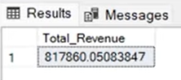

2. Average Order Value:
SELECT sum(total_price) / COUNT(DISTINCT order_id)) AS Avg_Order_Value FROM pizza_sales;
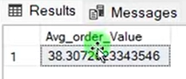

3. Total Pizzas Sold
SELECT SUM(quantity) AS Total_pizza_sold FROM pizza_sales;
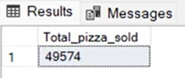

4. Total Orders
SELECT COUNT(DISTINCT order_id) AS Total_Orders from pizza_sales;
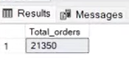

5. Average Pizza per order
SELECT CAST(CAST(SUM(quantity) AS DECIMAL(10,2)) / CAST(COUNT(DISTINCT Order_id) AS DECIMAL(10,2)) AS Avg_Pizzas_Per_Order from pizza_sales;
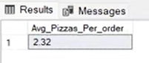

Charts
1. Daily Trend for Total Orders
SELECT DATENAME(DW, order_date) as order_day, COUNT(DISTINCT order_id) AS Total_orders from pizza_sales
GROUP BY DATENAME(DW, order_date);
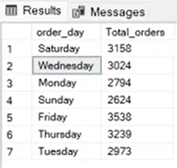

2. Monthly Trend for Total Orders
SELECT DATENAME (MONTH, order_date) as Month_Name, COUNT(DISTINCT order_id) as Total_Orders from pizza_sales
GROUP BY DATENAME (MONTH, order_date)
ORDER BY Total_Orders DESC;
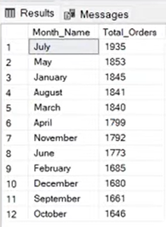

3. Percentage of Sales by Pizza Category
SELECT pizza_category, sum(total_price) * 100 / (SELECT sum(total_price) from pizza_sales) AS PCT from pizza_sales
GROUP BY pizza_category
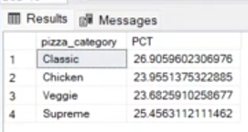

4. Percentage of Sales by Pizza Size
SELECT pizza_size, sum(total_price) as Total_Sales, sum(total_price) * 100 / (SELECT sum(total_price) from pizza_sales) AS PCT from pizza_sales
GROUP BY pizza_size
ORDER BY PCT DESC
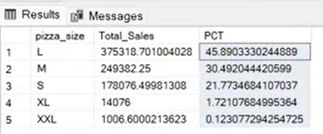

5. Top 5 Best Sellers by Revenue
SELECT TOP 5 pizza_name, SUM(total_price) AS Total_Revenue FROM pizza_sales
GROUP BY pizza_name
ORDER BY Total_Revenue DESC
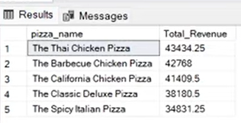

6. Bottom 5 Best Sellers by Revenue
SELECT TOP 5 pizza_name, SUM(total_price) AS Total_Revenue FROM pizza_sales
GROUP BY pizza_name
ORDER BY Total_Revenue
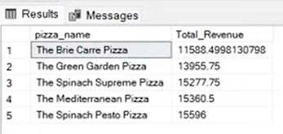

7. Top 5 Best Sellers by Quantiy
SELECT TOP 5 pizza_name, SUM(quanity) AS Total_Quantity FROM pizza_sales
GROUP BY pizza_name
ORDER BY Total_Quantity DESC
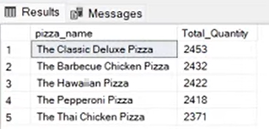

8. Bottom 5 Best Sellers by Quantiy
SELECT TOP 5 pizza_name, SUM(quanity) AS Total_Quantity FROM pizza_sales
GROUP BY pizza_name
ORDER BY Total_Quantity
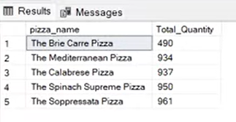
7. Top 5 Best Sellers by Orders
SELECT TOP 5 pizza_name, COUNT(DISTINCT order_id) AS Total_Orders FROM pizza_sales
GROUP BY pizza_name
ORDER BY Total_Orders DESC
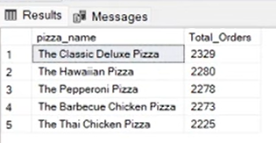

7. Bottom 5 Best Sellers by Orders
SELECT TOP 5 pizza_name, COUNT(DISTINCT order_id) AS Total_Orders FROM pizza_sales
GROUP BY pizza_name
ORDER BY Total_Orders
