**A Novel Approach for Multispectral Data Stream Project (Landsat 7).**

**Introduction**

With multispectral images, we can capture more data per pixel, and understand objects based on their chemical composition or the variation of composition that encompasses an object. For example, is the image you see an apple or an orange? Further, is the apple or the orange real? If it is plastic, was it made in Mexico or India? Real life impacts of using spectral data as part of object detection in images could one day save a life, if a self-driving car could not only detect faces, but also the difference between skin and plastic, a lone pedestrian could avoid being if it was a choice between them or a group of three manikins.

**Description**

The number of channels/bands could be considered as features in multispectral imagery. Suppose, a model is trained on certain type of channels (in multispectral Images) and after few months some new channels introduced into the multispectral Images then model must capable to handle these new feature adaptations. I want to develop an Online Machine Learning model, which could classify the remote sensing data-streams and can dynamically adjust the new channel (Spectral Bands) in the Online Machine learning. Because in traditional ML, a classifier can classify the certain number of channels (in which it is already trained), my intention is that, if it come across any new channel, so the model must robust enough to incorporate those changes, it is somethings training during testing, and this phenomenon is called Virtua CD in multispectral Images.

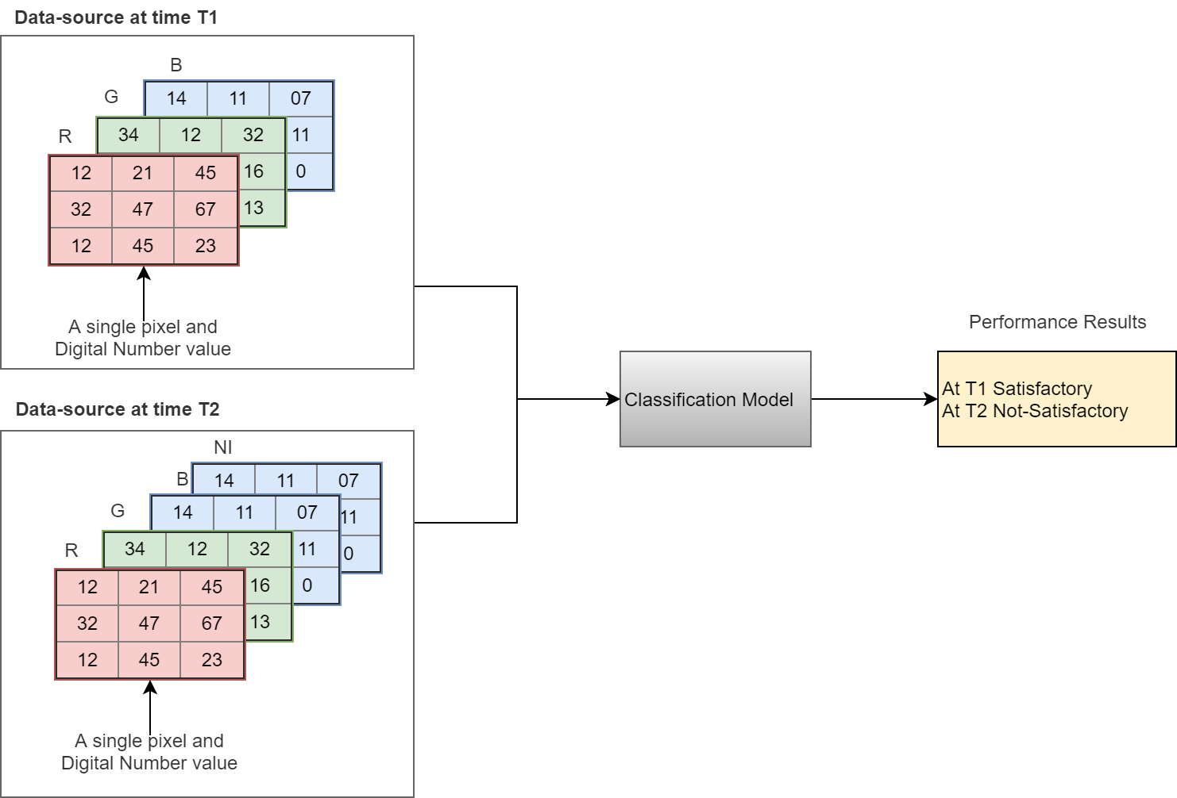

**Scope**

The scope of this project is related to Multispectral Imagery Datastream using MNIST Multispectral for milestone 1 and Landsat-7 data for milestone2.

**Milestone 01: Design, implement the adaptive online model for new spectral band adaptation using Multispectral MNIST dataset**

**Model Design and Implementation Objectives**

1. Proposed the adaptive multispectral band model (MBM), this model must be able to learn new spectral band during classification (training window along with classification).
   1. Detect the change in input stream (if any new spectral bands come)
   2. Start training process along with classification
   3. The model will have capability to retain its previous knowledge (this could be done that model will manage its previous records of arrival bands) after training with new data samples, so that if any previous changes come across, the model should recognize it.
2. Now create the algorithm to detect the arrival of new spectral band and start the training process during the online classification

**Validation Objective**

1. Take any of the available CNN model and classify the prepared dataset and record its performance (Accuracy, Kohen Kappa etc.).
2. Train the offline model (our proposed MBM) using all 7 bands (R, G, B, NI and SI etc.) and record its performance (Accuracy, Kohen Kappa etc.).
3. Then train the model (MBM) using online approach, for that reason first train model with 3 bands and gradually input 4 bands after some time span (in the end the online model is supposed to adapt the all 7 bands of multispectral images) and record its performance after arrival of each band (Accuracy, Kohen Kappa etc.).
4. Now compare the Traditional CNN results with our Offline model and compare the Online model with our Offline model (Benchmarking).
5. Draw the visualization for results, to depict more significance in results. Also mention the optimized selection of training parameters for each result.

**Milestone 02: Validate the proposed model on Landsat-7 or similar kind of Realtime multispectral dataset in online new spectral band adaptation scenario.**

Data Preparation Objectives

1. Prepare the Landsate data for classification of vegetation, water, soil. Each class must contain the 5000 training sample, with 7 spectral bands (as it suppose to be 7 in lansat 7 dataset). Perform data annotation and transformation for given input to the proposed model. NOTE :If developer unable to find the landsat dataset, you may refer any similar kind of multispectral dataset containing more than 6 bands and consisting at least 4 to 5 classes with more than 5000 sample size per class (more classes and sample size is encouraging).

Model Design and Implementation Objectives

1. Proposed the adaptive multispectral band model (MBM), this model must be able to learn new spectral band during classification (training window along with classification).
   1. Detect the change in input stream (if any new spectral bands come)
   2. Start training process along with classification
   3. The model will have capability to retain its previous knowledge (this could be done that model will manage its previous records of arrival bands) after training with new data samples, so that if any previous changes come across, the model should recognize it.
2. Now create the algorithm to detect the arrival of new spectral band and start the training process during the online classification

Validation Objectives

1. Take any of the available CNN model and classify the prepared dataset and record its performance (Accuracy, Kohen Kappa etc.).
2. Train the offline model (our proposed MBM) using all 7 bands (R, G, B, NI and SI etc.) and record its performance (Accuracy, Kohen Kappa etc.).
3. Then train the model (MBM) using online approach, for that reason first train model with 3 bands and gradually input 4 bands after some time span (in the end the online model is supposed to adapt the all 7 bands of multispectral images) and record its performance after arrival of each band (Accuracy, Kohen Kappa etc.).
4. Now compare the Traditional CNN results with our Offline model and compare the Online model with our Offline model (Benchmarking).
5. Draw the visualization for results, to depict more significance in results. Also mention the optimized selection of training parameters for each result.

**Outcomes**

1. Algorithm design and its diagrams.
2. Coding of proposed model in python with modular approach, so that change in model should be easy.
3. A complete report on the model validation and working, record of all the experiments (which has been performed during this project) must be in report.

**Dataset**

USGS, Landsat dataset can be used for this project

Link. <https://www.usgs.gov/land-resources/nli/landsat>.

**Classification Problem**

You can show the classification problem of vegetation, water and soil using the Landsat dataset, compare the offline with online model. In offline the model must train through the all bands and in Online model the initially model should be trained on certain bands, later it must be provided few more bands (now the model has equal bands as it was in its offline model). The performance of Online Model must the more than or equal to its offline model.

**Benchmark**

Your benchmark is your classifier model using static full data with all spectral bands (offline). The validation process is to compare your result score against the classifier in offline with full training data. Our Online results must not lower than offline model. Let’s you have concept replacement from initial concept1 (starting with less spectral bands) to be replaced with concept2 (addition of new spectral bands in the data source), then you must compare your result with offline classifier trained with concept2 (all spectral bands). Check with other papers discussed online classifier, they compared with their offline version.

**Tentative Module**

In Fig 03., I used Ensemble approach here using CNN for feature extraction and we can see either SVM, or CNN for classification too, this is tentative solution to give you a look only. This is my approach. **Developer is highly encourage to developed own algorithm and come up with his own framework/model towards adaptation, the novelty of work is mandatory.**

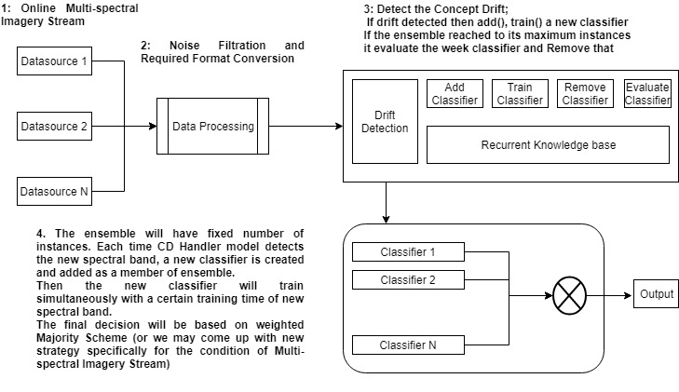Fig. 3. The Tentative Solution 1 (Please discuss your own proposed solution)