**Microprocessor Lab**

Laboratory Activity No. 2

**Arduino and Tinkercad Interface**

|  |
| --- |
|  |

Score

*Submitted by:*

**LastName, FirstName MI.**

**<Schedule> / <Section>**

*Date Submitted*

**DD-MM-YYYY**

*Submitted to:*

**Engr. Maria Rizette H. Sayo**

I. Objectives

This laboratory activity aims to implement the principles and techniques of hardware programming using Arduino through:

- creating an Arduino programming and circuit diagram.

II. Method/s

- Perform a task problem given in the presentation.

- Write a code and perform an Arduino circuit diagram of a ring counter that display eight (8)LEDs starting from left.

III. Results

**TinkerCad**

**Exercise 1: Write a code that does a ring counter display for eight (8) LEDs starting from left.**

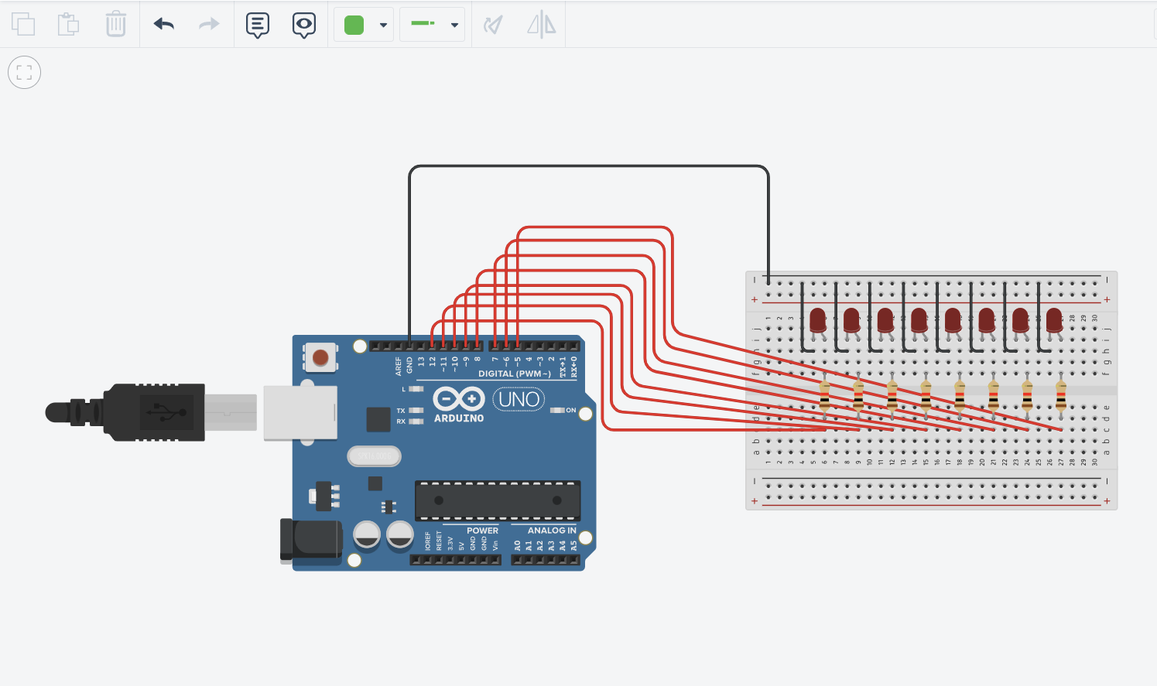

Figure No.1 Ring Counter Display Circuit Diagram

**Components Used**

1. 8 LEDs
2. Resistor
3. Breadboard

**CODE:**

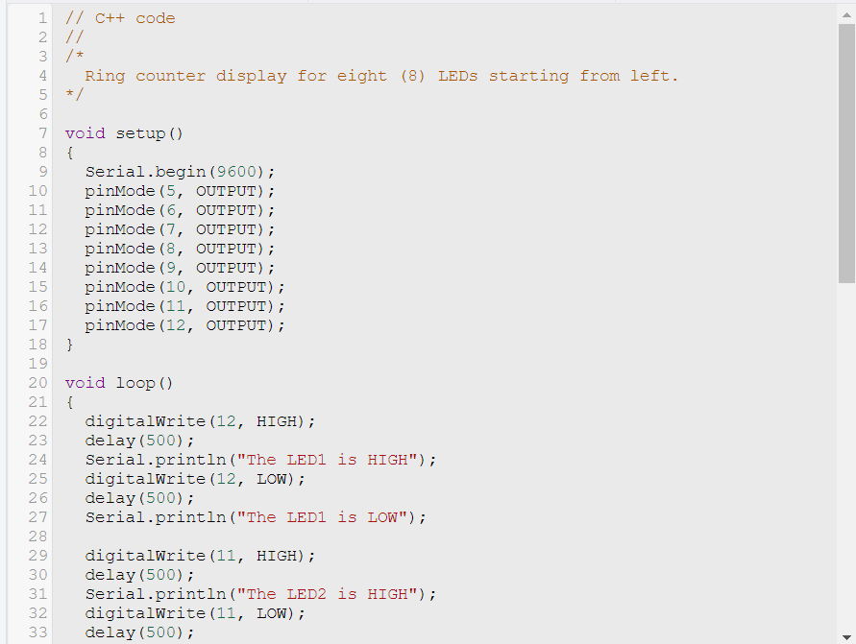

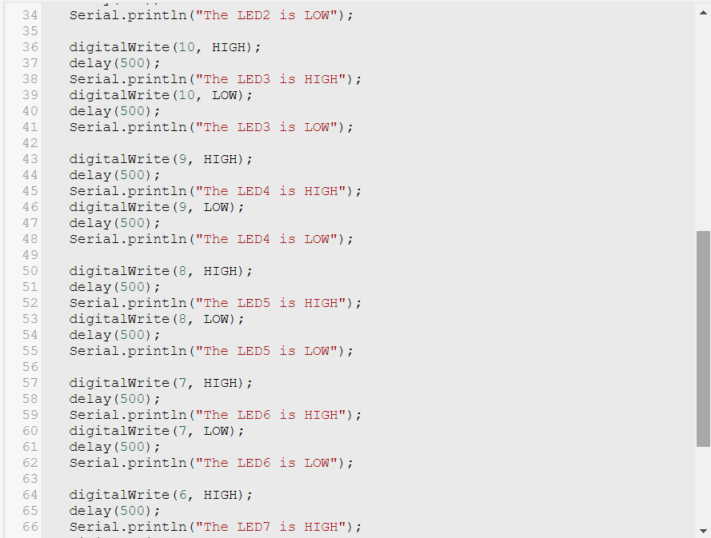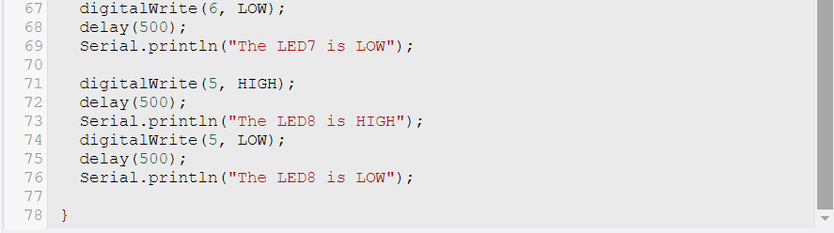

IV. Conclusion

This project implements a ring counter display for eight LEDs. It is a circuit that allows the circuit to light up eight LEDs in a sequence, one at a time. The circuit works by setting all the LED pins to output mode, which means that the Arduino can control whether each LED is turned on. In the loop() function of the Arduino circuit, the first LED is turned on for 500 milliseconds. After 500 milliseconds, the first LED is turned off and the second LED is turned on. This process continues until all eight LEDs have been turned on and off.

The circuit also prints a message to the serial monitor each time an LED is turned on or off. This can be useful for debugging the circuit or for monitoring its operation. This circuit can be used to create a variety of different displays, such as a simple running light display or a more complex display that changes patterns over time. For example, you could modify the circuit to create a display that chases a single LED around the ring, or a display that fades the LEDs in and out. This circuit was tested with eight standard LEDs. The LEDs lit up in a sequence, starting with the leftmost LED and ending with the rightmost LED. The LEDs remained lit for 500 milliseconds each. The circuit also printed a message on the serial monitor each time an LED was turned on or off.

Overall, this project is a simple but effective way to create a variety of different LED displays. The circuit is easy to modify and can be used with different types of LEDs.

**References**

[1] D.J.D. Sayo. “University of the City of Manila Computer Engineering Department Honor Code,” PLM-CpE Departmental Policies, 2020.

*<This is in a separate page>*