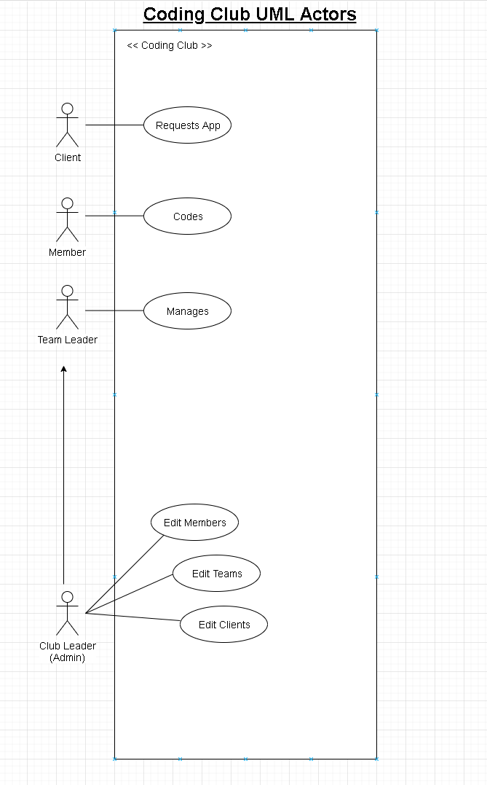Assignment #1

Figure - Use Case Actors

**Actors**

In order to properly create a system for members of a coding club to create applications for clients and customers, we must identify the actors which will use the system. The actors of the system will be.

* Members (Students)
* Teams
* Projects
* Clients
* Leaders (Managers)

*Members* consisting of students will create code, collaborate with other students within a *team* in order to satisfy a piece or whole *project* which has been requested by a *client.* The leader will be responsible for *managing* all members, teams, projects, and clients.

**Business Rules**

* A *member* **joins** one and only one *team*.
* A *team* **can have** one or many *members*.
* A *team* **takes** on one or many *projects*.
* A *project* **can have** one and only one *team*.
* A *project* **belongs** to one or many *clients*.
* 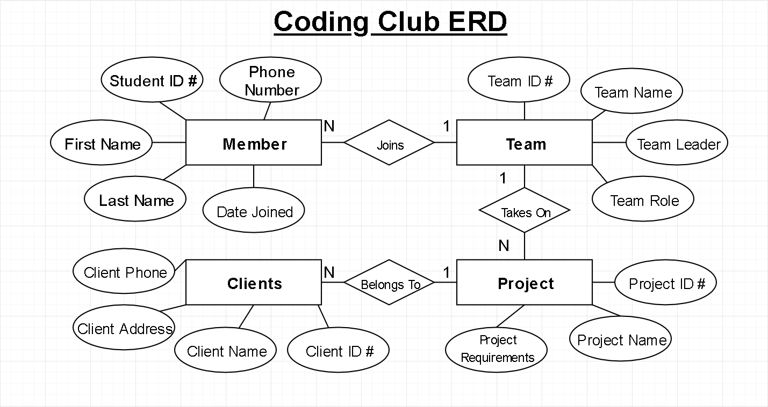A *client* **can have** one and only one *project*.

Figure - ERD