23CSE111 OBJECT ORIENTED PROGRAMMING
S2 B.Tech CSE
Department of Computer Science and Engineering
Amrita School of Computing, Amritapuri Campus
CASE STUDY
PHASE – 2 (Design)
Architectural Modelling (CO2)

Group No : D10
Team Members :
Roll No | Student Name
AM.SC.U4CSE25302 | Anandanarayan P
AM.SC.U4CSE25312 | Devanandana C
AM.SC.U4CSE25313 | Devang S R
AM.SC.U4CSE25327 | Kasinath K S

- Problem Title : Hotel Management System

STRUCTURAL DESIGN
- Class diagram (draw class diagram that shows different classes and their relationships. Use UML notations)
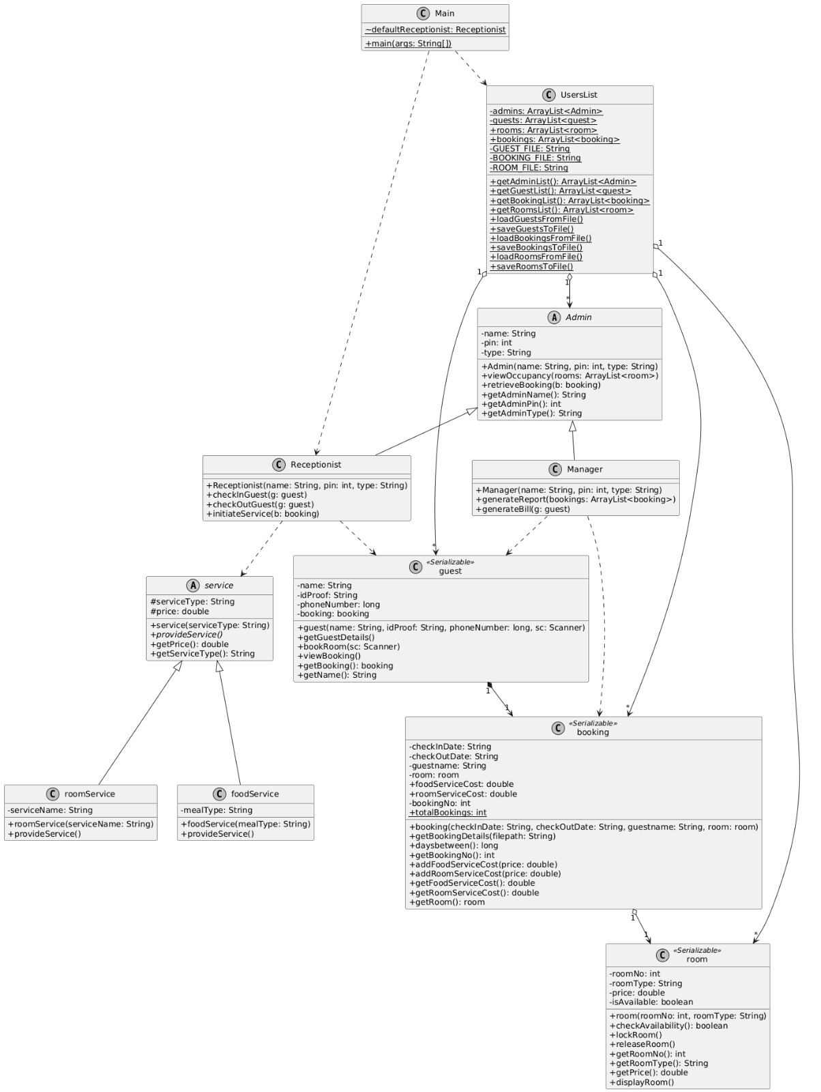

BEHAVIUORAL DESIGN
- Use-case diagram

- List of actors
- Guest
- Manager
- Receptionist
- List of use-cases
1. The Guest selects a room and stay dates, triggering the creation of a booking object that is then stored in the system’s database files. This process links a specific room to the guest and initializes the stay duration for future billing.
2. The Guest asks for additional amenities, which prompts the system to identify the specific category of help needed. This acts as the starting point for the Receptionist to log either food or room-related tasks.
3. An Admin generates a real-time report showing which rooms are currently available or occupied. This is essential for the hotel staff to manage room assignments and housekeeping schedules effectively.
- Use case diagram (use UML notation)
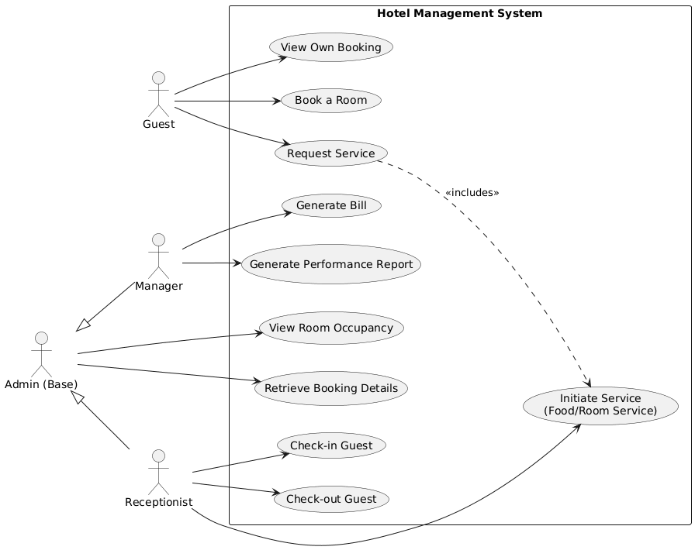

4.Sequence diagram (use UML notations)
- Choose key use cases and draw their sequence diagram. First describe the scenario in few sentences. Then draw the sequence diagram.

  - Book A Room
The Guest provides stay dates, room type, and a specific room number via the console. The system instantiates a new room and booking object, calculates the initial details, and updates the global UsersList. Finally, it triggers a serialization process to save the updated room and booking data to .dat files for persistence.
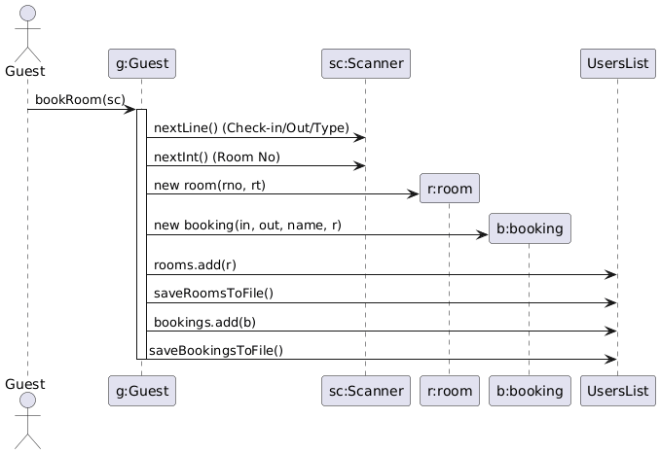

  - Retrieve Booking Details
An Admin (either a Receptionist or a Manager) searches for a specific booking using its unique Booking Number. The system locates the booking object and invokes its getBookingDetails method, which formats the guest name, room number, and stay
dates into a text string and appends it to an external file named current.txt.

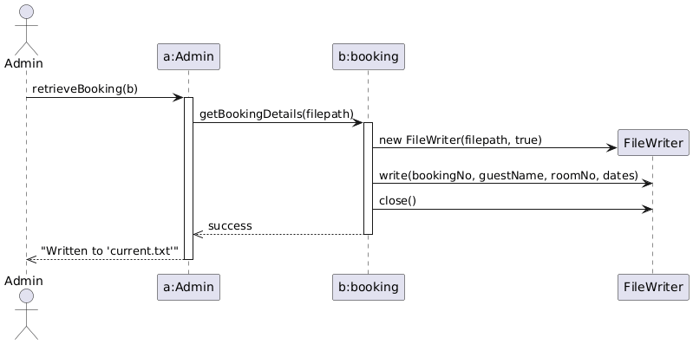

  - Initiate Service
The Receptionist facilitates a service request for a guest's booking. The system prompts for a service category (Food or Room Service) and a specific type (e.g., "Laundry" or "Breakfast"). Based on this input, it creates the corresponding service object, displays the cost to the console, and automatically updates the foodServiceCost or roomServiceCost variables within the booking object for later billing.
