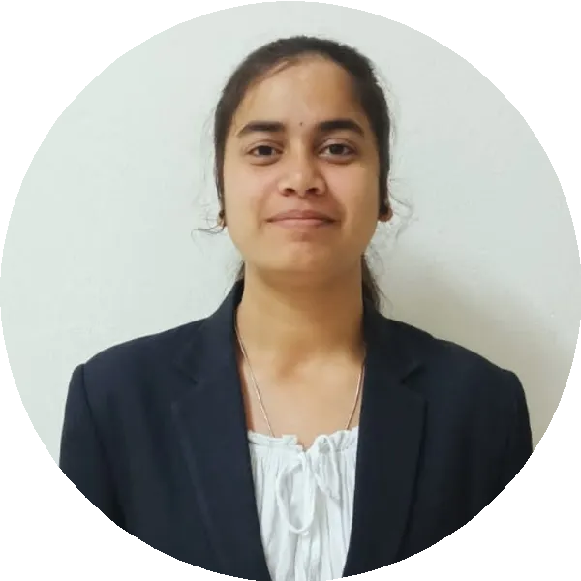MAHIMA M

[mahima2062013@gmail.com](mailto:mahima2062013@gmail.com) 9150436521

 HOSUR, KRISHNAGIRI-635114

https://[www.hackerrank.com/mahima2062013](http://www.hackerrank.com/mahima2062013) https://[www.linkedin.com/in/mahima-m-7a4559213/](http://www.linkedin.com/in/mahima-m-7a4559213/)

# OBJECTIVE

I am a Organized and dependable candidate, Successful at managing multiple priorities with the positive attitude.I would like to be a part of an organization which enables me to enhance my skills and knowledge in the Technology world.

# EDUCATION

Coimbatore, India **BE-Computer Science And Engineering,**

*KIT-Kalaignarkarunanidhi Institute Of Technology*

2020 - Present up to 5th Sem - 9.0 CGPA

Peddabelagondapalli, India

Peddabelagondapalli, India

**Senior secondary,** *Govt.Higher.Secondary School*

2020 - 69%

**Higher Secondary,** *Govt.Girls.High School*

2018 - 79%



**SKILLS**

JAVA

React.js Decision Making Hardworking

PYTHON SQL

Teamwork

Good communication

C

Problem Solving Leadership HTML,CSS and

JavaScript



**PROJECTS**

1. **PORTFOLIO WEBSITE,** *USING HTML,CSS and JAVASCRIPT*

Description :It is my personal portfolio website were i have added my all information. Duration : 1 Month.

1. **Dark Mode Toggle,** *HTML,CSS and JAVASCRIPT*

Description : It is a dark mode toggle project using Html,css and javascript. Duration :2 weeks.

1. **TIC TAC TOE,** *HTML,CSS and JAVASCRIPT*

Description : It is a tic tac toe game. Duration : 2 weeks.



**CERTIFICATIONS**

Infosys Springboard Certification : HTML,CSS and Javascript

Certification in web development internship

Python Programming by Infosys

Participation certificate: Robo Race in World Robortics Championship- Technoxian

Programming using Java

The Complete C Programming Course for Beginners by Udemy



**INTERNSHIP**

**Internship training on Web Development**

By e-soft IT Solutions ,learned Html,css, JavaScript and PHP. Duration: 2 weeks.



**AREA OF INTERESTS**

Programming Languages in C,Java and Python Web Development



**LANGUAGES KNOWN**

English Telugu

Tamil Kannada

Hindi Bhojpuri



**HOBBIES**

Playing Outdoor games Read Story Book Competitive coding Listening Music Travelling and Exploring



**ACHIEVEMENTS**

**THROW BALL (WINNER)** - NCC CAMP.

**KABADDI GOLD MEDAL** -ZONAL KABADDI COMPETITION AT SCHOOL.



**MEMBERSHIP**

Member of the NCDRC project team at KIT. Member in Product Development Center of KIT. NCC cadet.



**DECLARATION**

I hereby declare that the information and details given above are complete and true to the best of my knowledge.

