**Scripts for create exploratory and results visualizations:**

These scripts would contain code to generate visual representations (such as graphs, charts, and plots) of the data during the exploratory data analysis phase and to visualize the results of the analysis.

**Visualization of Results**:

Used visualizations such as histograms, scatter plots, and heatmaps to effectively communicate analysis findings. Visual representations of data can make complex patterns and relationships more accessible and understandable.

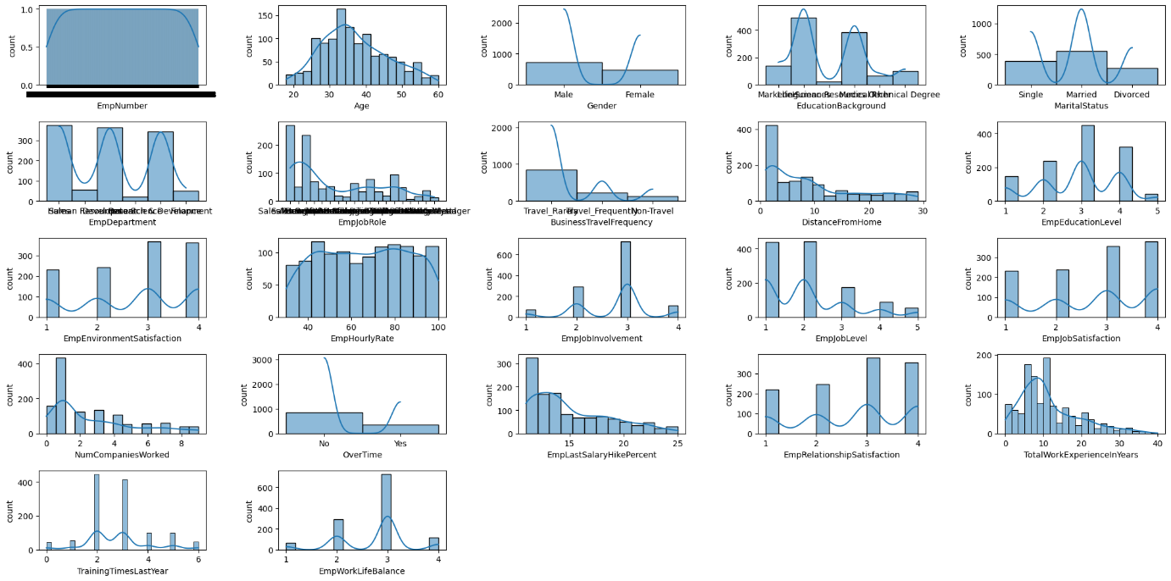

In this histograms plot comparing the data which is available in specific columns.