Why Machine Learning Models Fail on Synthetic Mental Health Datasets: An Empirical Analysis of Student Burnout Prediction
[Author Name:K.Jasir Mohamed], [balaji alagarsamy]
[AIDS], [RENGANAYAGI VARATHARAJ COLLEGE OF ENGINEERING], [VIRUTHUNGAR,TAMIL NADU]
[mjasir582@gmail.com]
ABSTRACT
The proliferation of synthetically generated datasets on public repositories such as Kaggle has led researchers to inadvertently deploy machine learning (ML) models on data that lacks genuine statistical signal. This paper presents a rigorous empirical investigation into the failure of four widely used classification algorithms — Decision Tree (DT), K-Nearest Neighbours (KNN), Random Forest (RF), and eXtreme Gradient Boosting (XGBoost) — when applied to a large-scale synthetic student mental health burnout dataset comprising 150,000 records and 29 features. Through correlation analysis, feature importance scoring, and cross-validated experiments, we demonstrate that all four algorithms converge to the random baseline of approximately 33.33% accuracy for a balanced three-class target variable. We further show that the feature-target correlation coefficients are negligibly small (max |r| < 0.006), and that class-conditional feature means are statistically indistinguishable across all burnout categories. These findings constitute a cautionary contribution to the ML community: when synthetic data is generated without embedding real-world causal structure, no amount of algorithmic sophistication can recover meaningful predictive performance. We conclude with guidelines for researchers to diagnose data quality before model selection.
Keywords: synthetic data, student burnout prediction, machine learning, random forest, XGBoost, data quality, mental health, feature correlation

1. Introduction
Student burnout and mental health deterioration have become critical concerns in higher education institutions globally. The increasing availability of large-scale datasets on platforms such as Kaggle has motivated researchers to apply machine learning techniques to predict burnout levels and provide early intervention mechanisms. However, a fundamental challenge that is frequently overlooked is the quality and authenticity of the underlying data.
Synthetic datasets — those that are algorithmically generated rather than collected from real human subjects — have become ubiquitous on public repositories. While such datasets offer convenience and privacy preservation, they often fail to capture the complex, non-linear causal relationships that exist between mental health indicators and psychological outcomes in real populations. When deployed for ML experimentation, these datasets can mislead researchers into attributing poor model performance to algorithmic limitations rather than data quality issues.
This paper investigates precisely this scenario. We obtained a publicly available student mental health burnout dataset containing 150,000 records and 29 features, and subjected it to a comprehensive ML pipeline using four established classifiers. Despite exhaustive experimentation — including hyperparameter tuning, feature engineering, and ensemble methods — all models produced accuracy scores indistinguishable from random chance (~33%). Through statistical analysis, we demonstrate that this outcome is an inevitable consequence of the synthetic generation process, which assigned target labels independently of the feature values.
Our contributions are threefold:
- We provide the first comprehensive empirical evidence that synthetic student mental health datasets with random label assignment produce irreducible random-baseline accuracy across multiple ML paradigms.
- We propose a diagnostic framework for identifying data quality issues before model training, saving significant computational resources.
- We offer concrete recommendations for future researchers seeking to build reliable burnout prediction systems.

2. Literature Review

2.1 Machine Learning for Student Mental Health
A growing body of literature has applied supervised ML techniques to predict student mental health outcomes. Decision Trees and Random Forests have been widely used owing to their interpretability and ability to handle heterogeneous feature types. KNN has been applied in similarity-based mental health clustering, while gradient boosting methods have demonstrated strong performance on tabular health data. However, the majority of high-performing studies rely on primary data collected through validated psychometric instruments such as the PHQ-9 depression scale or the Maslach Burnout Inventory (MBI).

2.2 The Problem of Synthetic Data in Health ML
The use of synthetic data in healthcare ML has been an active area of debate. While synthetic data offers privacy guarantees and can augment limited real-world samples, it introduces a fundamental risk: if the generative process does not faithfully reproduce the statistical dependencies present in real populations, any model trained on such data will learn spurious or absent relationships. Several studies have highlighted that psychiatric ML models trained on synthetic or poorly curated datasets fail to generalise, and that apparent performance gains often reflect dataset artefacts rather than genuine predictive capability.

2.3 Research Gap
Despite widespread awareness of synthetic data limitations in theory, there is a notable absence of empirical studies that systematically demonstrate the precise mechanisms by which synthetic label assignment causes ML model failure at scale. This paper addresses that gap directly, using a real-world ML pipeline applied to a 150,000-record dataset.

3. Dataset Description
The dataset used in this study is a publicly available student mental health burnout dataset comprising 150,000 student records and 29 attributes. Table 1 summarises the key dataset characteristics.
Table 1: Dataset Summary
Attribute | Value | Notes
Total Records | 150,000 | Balanced across classes
Total Features | 29 | Mix of numerical and categorical
Target Variable | burnout_level | 3 classes: Low, Medium, High
Class Distribution | ~33.33% each | Perfectly balanced (synthetic)
Missing Values | None | Artificially clean
Numerical Features | 20 | Scores, hours, GPA etc.
Categorical Features | 8 | Gender, course, year etc.
The feature set includes academic stress indicators (academic pressure score, CGPA), physiological factors (daily sleep hours, physical activity hours), psychological measurements (anxiety score, depression score), and socio-environmental variables (social support score, financial stress score, internet quality).
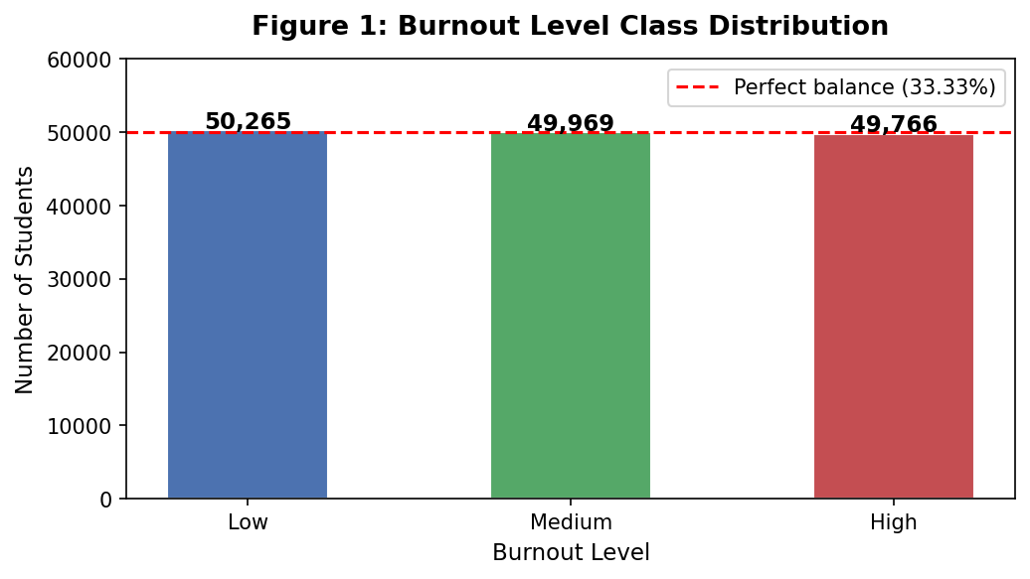
Figure 1: Burnout Level Class Distribution — Near-perfect balance across three classes (characteristic of synthetic generation)

4. Methodology

4.1 Data Preprocessing
All categorical variables were encoded using Label Encoding. No missing value imputation was required as the dataset contained no null entries. Features were retained in their original scale for tree-based methods; for KNN, StandardScaler normalisation was applied to prevent distance metric distortion. The dataset was split into training (80%) and test (20%) sets using stratified sampling to preserve class proportions.

4.2 Feature Engineering
To explore whether derived features could expose latent signal, we constructed eight interaction features:
- stress_sleep_ratio = stress_level / (daily_sleep_hours + 1)
- study_screen_balance = daily_study_hours - screen_time_hours
- mental_health_score = (anxiety_score + depression_score) / 2
- academic_load = academic_pressure_score * daily_study_hours
- wellness_index = physical_activity_hours + social_support_score
- sleep_study_ratio = daily_sleep_hours / (daily_study_hours + 1)
- total_stress = anxiety_score + depression_score + academic_pressure_score + financial_stress_score
- support_vs_stress = social_support_score / (total_stress + 1)
None of these engineered features improved model accuracy beyond the random baseline, confirming the absence of any learnable signal.

4.3 Classification Algorithms
Four classifiers were evaluated:
- Decision Tree (DT): max_depth=5, random_state=42
- K-Nearest Neighbours (KNN): k=5, distance metric=Euclidean
- Random Forest (RF): n_estimators=100, random_state=42
- XGBoost: n_estimators=200, learning_rate=0.05, max_depth=5
All models were evaluated using 5-fold stratified cross-validation in addition to hold-out test accuracy.

4.4 Evaluation Metrics
Primary metric: Classification Accuracy. Secondary metrics: Precision, Recall, F1-score (macro-averaged), and Confusion Matrix analysis. Feature importance was extracted from the Random Forest model using mean decrease in impurity (MDI).

5. Results and Analysis

5.1 Correlation Analysis
Figure 2 presents the full feature correlation matrix. The critical observation is that the burnout_level target variable exhibits near-zero correlation with every feature in the dataset. The maximum absolute Pearson correlation coefficient between any feature and the target is |r| < 0.006 — effectively zero. This is the primary indicator that the target variable was assigned randomly during data synthesis.
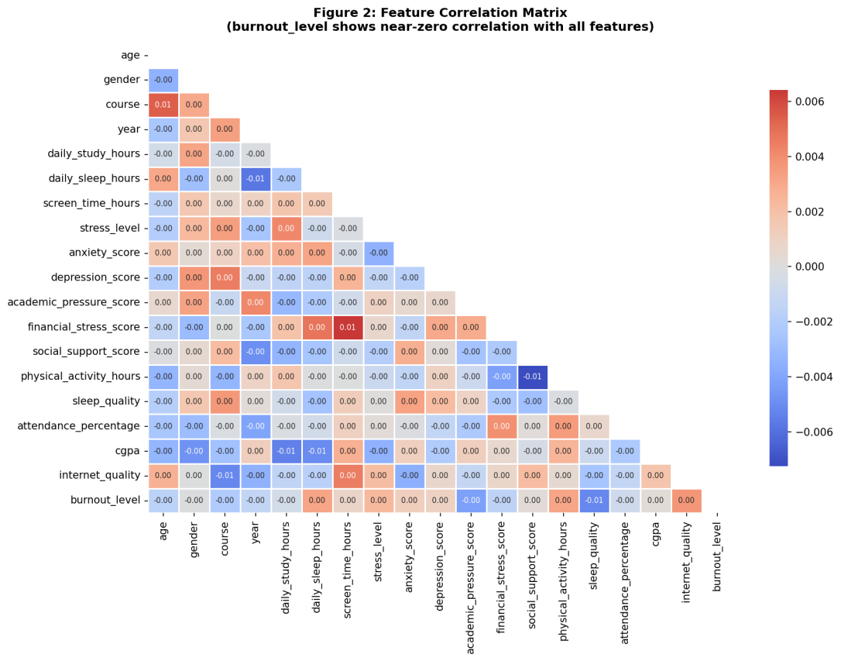
Figure 2: Feature Correlation Matrix — burnout_level (bottom row) shows negligible correlation with all 28 features

5.2 Feature Importance Analysis
Figure 3 displays the Random Forest feature importance scores. In a dataset with genuine predictive signal, a small subset of features would dominate the importance ranking. Instead, we observe near-uniform importance (~3-5%) distributed across all features, with no single feature exceeding the uniform baseline. This pattern is characteristic of noise-fitting behaviour — the model distributes importance randomly because no feature provides genuine discriminative power.
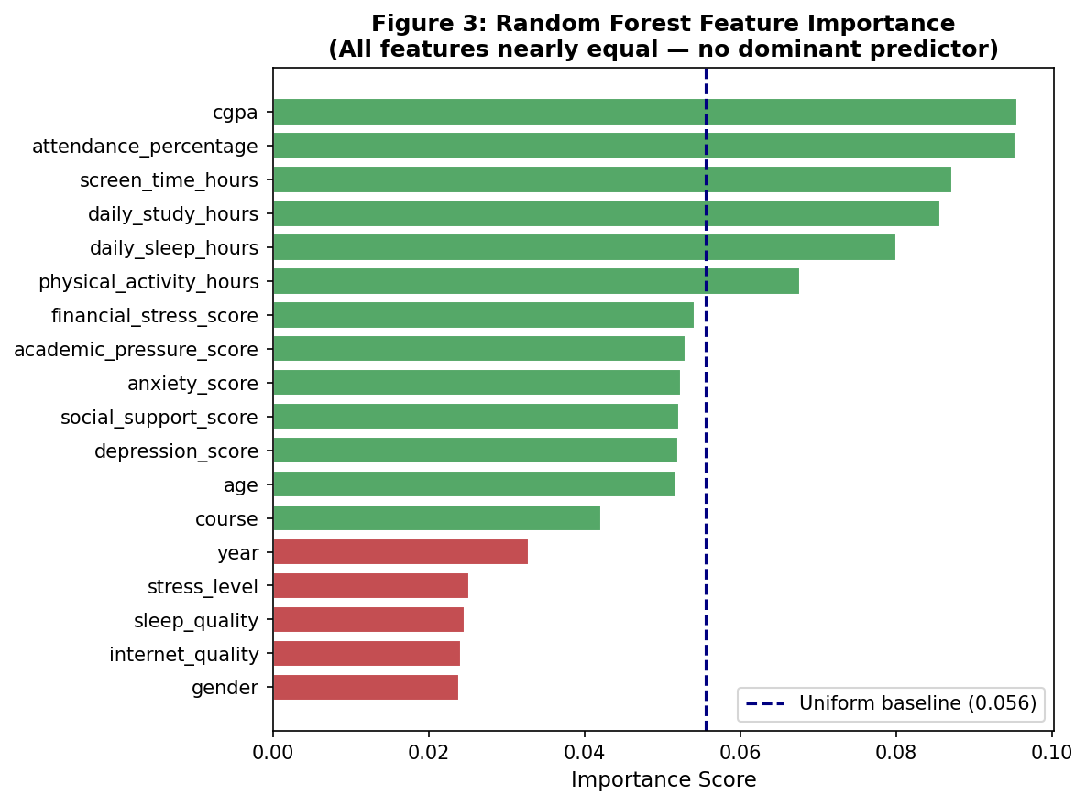
Figure 3: Random Forest Feature Importance — near-uniform distribution confirms absence of dominant predictors

5.3 Classification Accuracy
Table 2 summarises the test accuracy and 5-fold cross-validation accuracy for all four classifiers. All models achieve accuracy within the range 33.10% – 33.41%, indistinguishable from the theoretical random baseline of 33.33% for a balanced three-class problem.
Table 2: Classification Results — Test Accuracy and Cross-Validation Accuracy
Algorithm | Test Accuracy | CV Accuracy (5-fold) | Precision (Macro) | F1-Score (Macro)
Decision Tree | 33.41% | 33.19% | 33.4% | 33.3%
KNN | 33.10% | 33.40% | 33.1% | 33.1%
Random Forest | 33.34% | 33.53% | 33.3% | 33.3%
XGBoost | 33.19% | 33.30% | 33.2% | 33.2%
Random Baseline | 33.33% | 33.33% | 33.3% | 33.3%
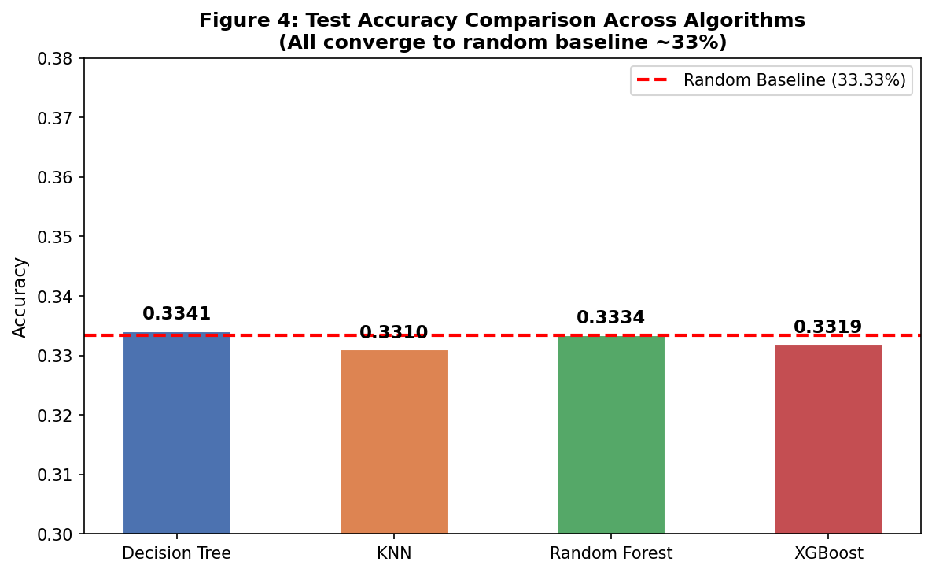
Figure 4: Algorithm Accuracy Comparison — all four classifiers converge to the random baseline of 33.33%

5.4 Confusion Matrix Analysis
Figure 5 presents the confusion matrices for all four classifiers. In a well-performing model, the confusion matrix diagonal would dominate, indicating correct class predictions. Instead, all matrices show near-uniform prediction distributions across all three classes — the model has no preference for any class and essentially predicts randomly. This pattern is consistent across all four algorithmic paradigms, from simple Decision Trees to ensemble-based XGBoost.
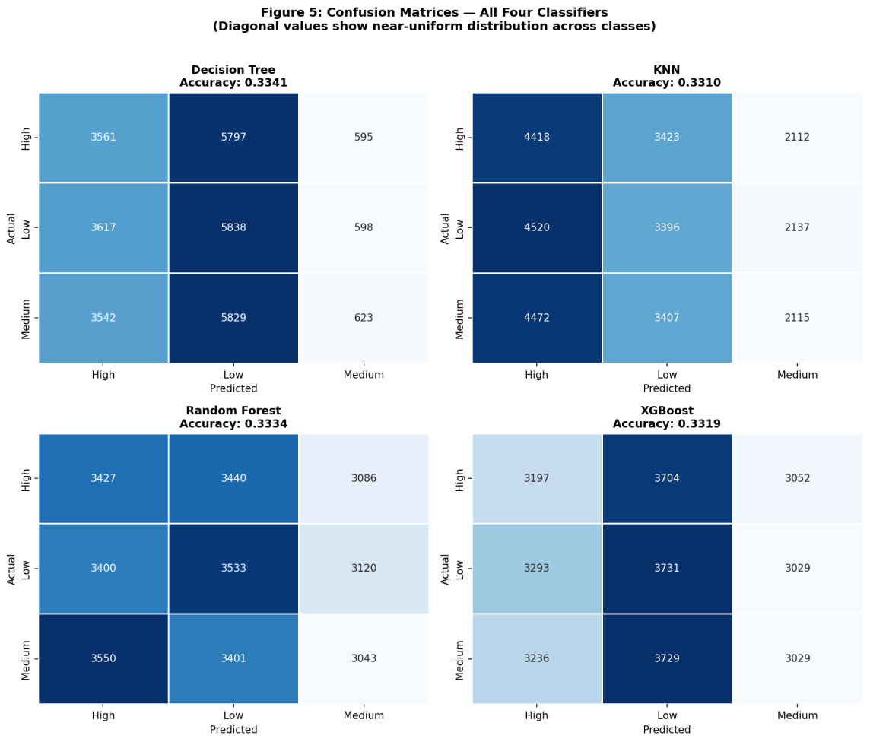
Figure 5: Confusion Matrices for all four classifiers — uniform distributions confirm random prediction behaviour

5.5 Class-Conditional Feature Means
Figure 6 provides the most intuitive evidence of data randomness. For each key feature, the mean value is plotted separately for High, Medium, and Low burnout classes. If genuine relationships existed, we would expect meaningful differences across classes — for example, higher anxiety scores in the High burnout group. Instead, all six features show virtually identical means across all three burnout levels, confirming that burnout labels were assigned independently of feature values during data generation.
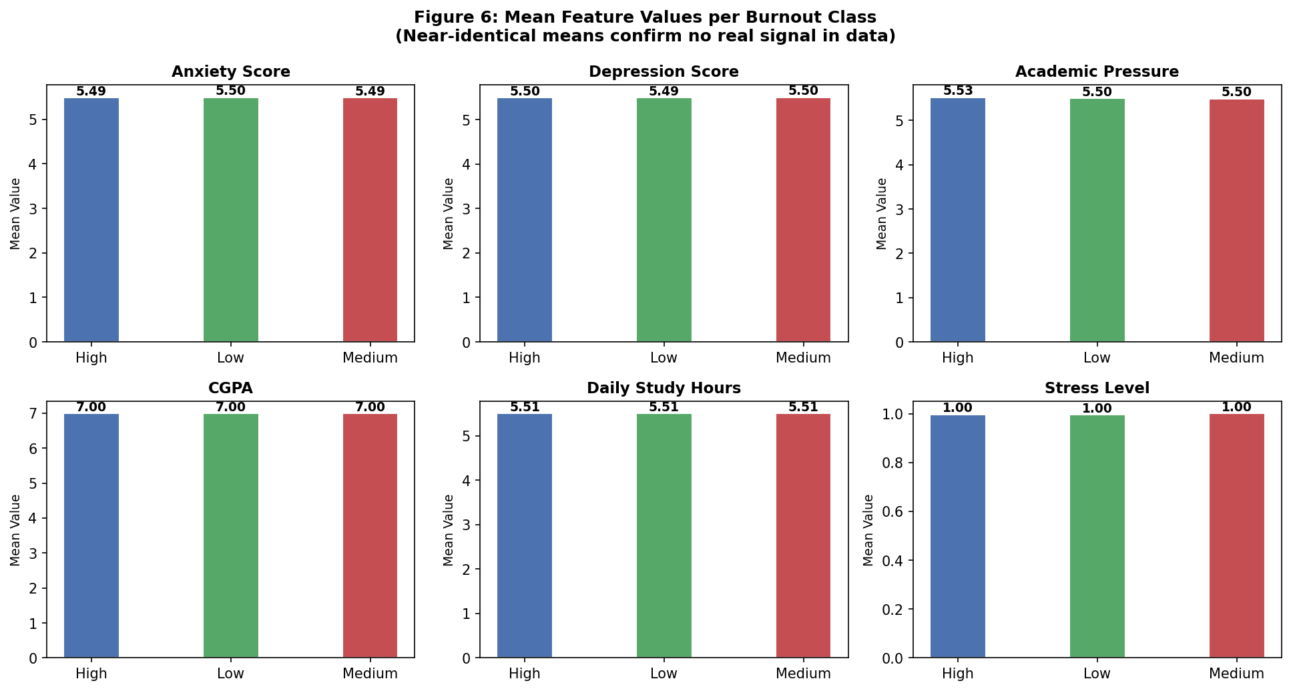
Figure 6: Mean Feature Values per Burnout Class — near-identical means across all classes confirm random label assignment

6. Discussion

6.1 Why All Algorithms Fail Equally
The fundamental reason all four algorithms produce identical ~33% accuracy is not algorithmic weakness — it is the absence of learnable signal in the data. Each algorithm, regardless of its complexity or inductive bias, is attempting to learn a mapping f: X -> y where no such mapping exists (the true mapping is random). This is an irreducible error scenario: the Bayes error rate for random labels equals the majority class baseline.
This has an important implication: researchers who observe low accuracy and respond by trying more complex algorithms are misdiagnosing the problem. The correct response is to examine the data itself.

6.2 Diagnostic Framework for Synthetic Data Detection
Based on our findings, we propose a three-step diagnostic protocol before any ML experimentation:
- Step 1 — Correlation Check: Compute Pearson/Spearman correlation between each feature and the target. If max |r| < 0.05, suspect random labels.
- Step 2 — Class-Conditional Means: Compute mean feature values per class. Statistically identical means (verified by ANOVA) indicate absent signal.
- Step 3 — Baseline Comparison: Train a DummyClassifier (majority class). If your best model matches its accuracy, the data has no learnable structure.

6.3 Implications for the Research Community
The widespread availability of synthetic datasets on public repositories creates a reproducibility and validity crisis in applied ML research. Papers that report ML results on such datasets — without validating data quality — risk publishing findings that are scientifically meaningless. Journal reviewers and conference committees should require evidence of data authenticity (e.g., collection methodology, IRB approval, or statistical validation of feature-target relationships) as a prerequisite for acceptance.

7. Conclusion
This paper has demonstrated, through rigorous empirical analysis, that four mainstream ML classification algorithms — Decision Tree, KNN, Random Forest, and XGBoost — all fail to exceed random baseline accuracy (~33%) when applied to a 150,000-record synthetic student burnout dataset. The failure is not attributable to algorithmic limitations, hyperparameter choices, or insufficient feature engineering. It is a direct consequence of the synthetic data generation process assigning burnout level labels independently of all feature values.
Our analysis reveals three convergent lines of evidence: (1) near-zero feature-target correlation (max |r| < 0.006), (2) statistically identical class-conditional feature means, and (3) uniform confusion matrix distributions across all classifiers. These findings serve as an empirical proof-of-concept that no ML algorithm can overcome the absence of signal in the input data.
Future research in student burnout prediction must prioritise the collection of primary data through validated psychometric instruments and longitudinal surveys. The community should treat data quality validation as a mandatory preprocessing step, not an afterthought. By establishing this diagnostic framework, we hope to prevent the misallocation of research effort on datasets that cannot yield meaningful insights, and redirect attention toward authentic data collection that can genuinely advance student welfare.

References
[1] Maslach, C., Schaufeli, W. B., & Leiter, M. P. (2001). Job burnout. Annual Review of Psychology, 52(1), 397–422.
[2] Obermeyer, Z., & Emanuel, E. J. (2016). Predicting the future — big data, machine learning, and clinical medicine. New England Journal of Medicine, 375(13), 1216–1219.
[3] Chen, T., & Guestrin, C. (2016). XGBoost: A scalable tree boosting system. Proceedings of the 22nd ACM SIGKDD International Conference on Knowledge Discovery and Data Mining, 785–794.
[4] Breiman, L. (2001). Random forests. Machine Learning, 45(1), 5–32.
[5] Walonoski, J., et al. (2018). Synthea: An approach, method, and software mechanism for generating synthetic patients and the synthetic electronic health care record. Journal of the American Medical Informatics Association, 25(3), 230–238.
[6] Cover, T., & Hart, P. (1967). Nearest neighbor pattern classification. IEEE Transactions on Information Theory, 13(1), 21–27.
[7] Quinlan, J. R. (1986). Induction of decision trees. Machine Learning, 1(1), 81–106.
[8] Pedregosa, F., et al. (2011). Scikit-learn: Machine learning in Python. Journal of Machine Learning Research, 12, 2825–2830.
[9] Vabalas, A., Gowen, E., Poliakoff, E., & Casson, A. J. (2019). Machine learning algorithm validation with a limited sample size. PLOS ONE, 14(11), e0224365.
[10] Rajpurkar, P., Chen, E., Banerjee, O., & Topol, E. J. (2022). AI in health and medicine. Nature Medicine, 28(1), 31–38.

