Mobile Services and Networks

Grupo de Arquitectura y Redes de Computadores

Introduction to simulation in NS3

3 de febrero de 2020

ooxWord://word/media/image5.jpegooxWord://word/media/image6.jpegooxWord://word/media/image7.jpeg1. Simulating mobile communications

1.1. Objectives

The main objective of this documents is to guide student in its ﬁrst simulation process through NS3simulator.

1.2. Prerequisites

Meanwhile redacting this document, the most recent stable release of NS3 simulator is the version

3.30.1. The student is free to use any other version of the simulator. We work with basic examples andcommands so probably the following procedure is also valid for next releases of ns3.

In a similar way, the steps that we will describe later are tested in a PC with Debian GNU/Linuxinstalled.

1.3. Introduction

The student should follow this procedure

Download the all-in-one package from www.nsnam.org ([Direct link](https://www.nsnam.org/releases/ns-allinone-3.30.1.tar.bz2))

Unzip the ﬁle ns-allinone-3.30.1.tar.bz2

$tar -xjvf ns-allinone-3.30.1.tar.bz2

Install the ns3 following [this full list of dependencies](https://www.nsnam.org/wiki/Installation#Ubuntu.2FDebian.2FMint) , as a summary, in debian:

• pre-requisites (as root):

apt-get install gcc g++ python python3 python3-dev apt-get install mercurial python-setuptools git

apt-get install qt5-default sqlite sqlite3 libsqlite3-devapt-get install gir1.2-goocanvas-2.0 python-gi python-gi-cairo python-pygraphviz papt-get install libgtk2.0-0 libgtk2.0-dev

apt-get install libxml2 libxml2-dev

apt-get install doxygen graphviz imagemagickapt-get install texlive texlive-extra-utils texlive-latex-extraapt-get install python-sphinx dia

apt-get install gdb valgrind

apt-get install gsl-bin libgsl-dev libgsl23 libgslcblas0

1

ooxWord://word/media/image9.jpegooxWord://word/media/image10.jpeg1. SIMULATING MOBILE COMMUNICATIONS 2

• go to the directory (ns-allinone-3.30.1) and execute build.py with the following options:

./build.py --enable-test --enable-examples

• you should get something like ’build’ ﬁnished successfully (8m45.341s) with a list of modules

built and a list of modules not built. At this point you could start to work with ns3, however, the most interesting source of information for starting are examples and test. We need toenable examples and test for use them.

• Execute the veriﬁcation script to check that everything is ok. Inside of ns-3.30.1 directory

execute test.py. You should see something like:

. .

281 of 284 tests passed (281 passed, 3 skipped, 0 failed, 0 crashed, 0 valgrind er

At this point, you are ready for start to execute simulations from examples.

1.4. Simulation ﬂow

In ns-3.30.1/examples/stats you can ﬁnd a good example of a full simulation process including:

a wireless topology deﬁned mainly in wiﬁ-example-sim.cc. The topology deﬁnes two nodes with a

802.11 interface each one. Both nodes communicate each other by mean a wireless channel sendingpackets from attached applications (implemented in wiﬁ-example-apps.cc/h). The simulation takesseveral arguments from line command. The most important argument for us is the distance apart toplace nodes in meters. This simulation put all results in a sqlite3 database for be analysed.

the shell script wiﬁ-example-db.sh executes the simulated topology changing distance betweenwireless nodes. After the execution, the script open the database with the results, summarises the results in wiﬁ-default.data ﬁle and executes a gnuplot script which build a graph.

The graph shows the amount of packet lost according to the distance between the nodes (ﬁgure 1.1).

We will use this example extensively (removing, changing and adding source lines of code) so youshould do a backup copy in order to recover the original source code whenever you want.

1.5. Lab 1 deliverable

The student should write a report with the results of the steps redacted in each subsection of this section.So, for each subsection, a graph with the result obtained should be embedded in the report. The studentalso should answer each one of the subsection’s questions.

1.5.1. Changing the script

Starting with the original example stats:

to increment the distances used in each iteration of the simulation to: 25 50 75 100 125 145 147150 152 155 157 160 162 165 167 170 172 175 177 180 185 190 195 200 210 220 230 240 250 300 350 400 450 500 600 750 1000

to reduce the number of iterations for each distance from ﬁve to one.

to adjust the x-axis of the gnuplot script to show results of the new distance.

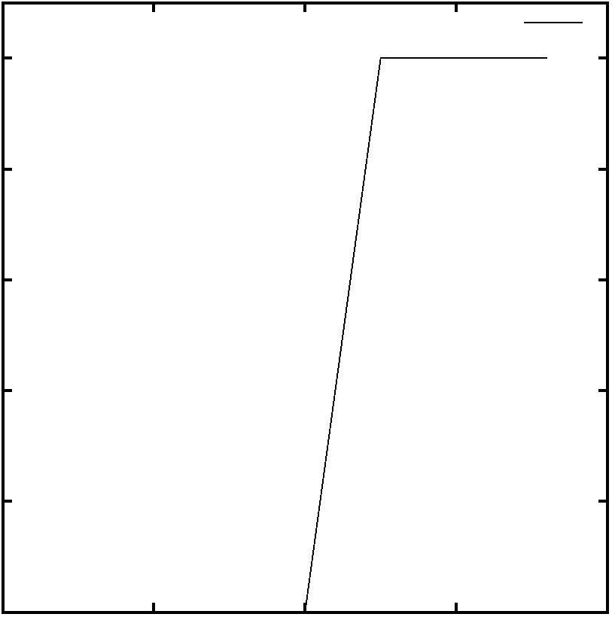ooxWord://word/media/image13.jpeg1. SIMULATING MOBILE COMMUNICATIONS 3

WiFi Defaults

100

80

60

40

20

0

0 50 100 150 200

Distance (m)

FIGURA 1.1: Figure 1: Graphic generated by example stats of NS3

1.5.2. Changing the antenna parameters of simulation

Let’s start changing the topology in the physical layer. The next source code correspond graphicallywith ﬁgure 1.2. In the lines 1 and 2 a node container with two nodes is created ( 1.2.a). A WiﬁHelper is a class for connect all elements in a wiﬁ environment. Lines 5-6, 7 and 8 are devoted to create, conceptually, a wiﬁ mac card, a wiﬁ physical equipment (equivalent to an antenna) and a wireless channel respectively ( 1.2.b)). Finally, ﬁrst we have to attach the channel to the physical layer 1.2.c in the line 9 and next, install in each node, the combination of wiﬁPhy and wiﬁMac (conceptually the wiﬁ interface and the antenna) using for that the wiﬁHelper (line 10).

1 NodeContainer nodes;2 nodes.Create (2);

3 NS_LOG_INFO ("Installing WiFi and Internet stack.");4 WifiHelper wifi = WifiHelper::Default ();

5 NqosWifiMacHelper wifiMac = NqosWifiMacHelper::Default ();6 wifiMac.SetType ("ns3::AdhocWifiMac");

7 YansWifiPhyHelper wifiPhy = YansWifiPhyHelper::Default (); 8 YansWifiChannelHelper wifiChannel = YansWifiChannelHelper::Default (); 9 wifiPhy.SetChannel (wifiChannel.Create ());

10 NetDeviceContainer nodeDevices = wifi.Install (wifiPhy, wifiMac, nodes);

Our main target in this subsection is to change antenna parameters, so:

which object represents the antenna? Which properties do you should change for increase the rangeof a successful communication?

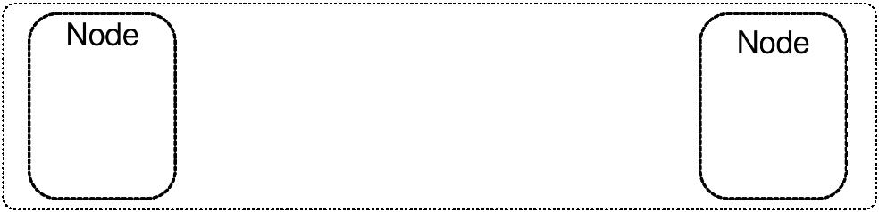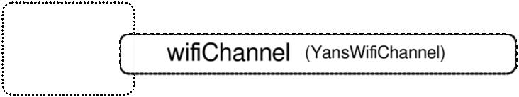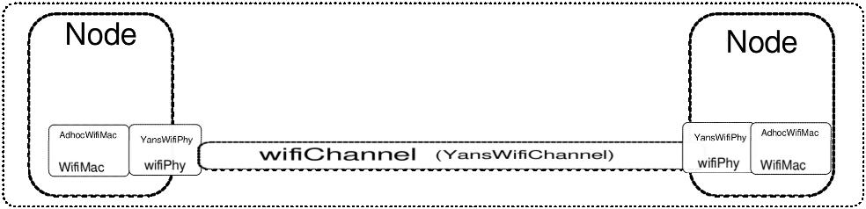ooxWord://word/media/image20.jpeg1. SIMULATING MOBILE COMMUNICATIONS 4

NodeContainer

a)

AdhocWiଏMac YansWiଏPhy

WiଏMac

wiଏPhy

wiଏChannel (YansWiଏChannel)

b)

YansWiଏPhy

wiଏPhy

c)

NodeContainer

d)

FIGURA 1.2: NS3 objects

ooxWord://word/media/image22.jpegooxWord://word/media/image23.jpegooxWord://word/media/image24.jpeg1. SIMULATING MOBILE COMMUNICATIONS 5

To study the values of the properties to change in order to establish a successfully communicationof 200, 400 and 800 meters. The student should include a table with parameters changed toget a successful communication and the proof of the working conﬁguration (include also thecorresponding graphics)

1.5.3. The propagation model

As the reader can observe, the lost of connectivity (100 % of packet loss) is achieved in abrupt way.For simulating high level protocols is ok since they need keep simple low-level communications issues.However, This lost of connectivity is not very realistic according to the real wiﬁ communication wherethe lost of connectivity is done in a soft way. So, it would be more accurate increasing the rate of packetlost according to the distance between both nodes.

In NS3 one of the main issues is modelling the radio wave propagation. Researchers has been developingaccurate models for simulate radio propagation models. In [PS12] you can ﬁnd a brief description of themost used in wireless simulation.

The key problem in a radio propagation model is calculate how distance, fading, etc. affects to thepower of the radio wave. In NS3 this is the main issue of the channel class where you have to add apropagation loss according to the model you want to use. Coming back to our ﬁrst example, you cansee how in line 8 a default wiﬁ channel is created (variable wiﬁChannel) and is attached to the physicalinterface (line 9) with defaults parameters.

1 NodeContainer nodes;2 nodes.Create (2);

3 NS_LOG_INFO ("Installing WiFi and Internet stack.");4 WifiHelper wifi = WifiHelper::Default ();

5 NqosWifiMacHelper wifiMac = NqosWifiMacHelper::Default ();6 wifiMac.SetType ("ns3::AdhocWifiMac");

7 YansWifiPhyHelper wifiPhy = YansWifiPhyHelper::Default (); 8 YansWifiChannelHelper wifiChannel = YansWifiChannelHelper::Default (); 9 wifiPhy.SetChannel (wifiChannel.Create ());

10 NetDeviceContainer nodeDevices = wifi.Install (wifiPhy, wifiMac, nodes);

In this section:

Surf in the NS3 documentation and list the different types of loss propagation models implemented.

Test one of the radio propagation models using our example (check AddPropagationLoss method of class YansWiﬁChannelHelper) and provide a graphic comparing the results of the YansWiﬁChannelwith default loss propagation model and the radio propagation model chosen by you. Feel you free of using several propagation models.

Disable the antenna modiﬁcation done in the last section in order to have defaults settings for theconﬁgurated loss model. In the same way increase the number of test in the area where rate of packet loststats to increase (for example testing every 10 meters between 100 and 200 meters if you observe thatbetween these two distances the loss of packets start to be different of 0).

Bibliografía

[PS12] Ramesh C. Poonia y Vikram Singh. Performance evaluation of Radio Propagation Model for Vehicular ad-hoc networks using vanet mobisim and ns-2. International Journal of Distributed and Parallel Systems (IJDPS), 2012.

6