**Pset06 report**

21600069 김민지

* + Screen capture of profiling.exe output

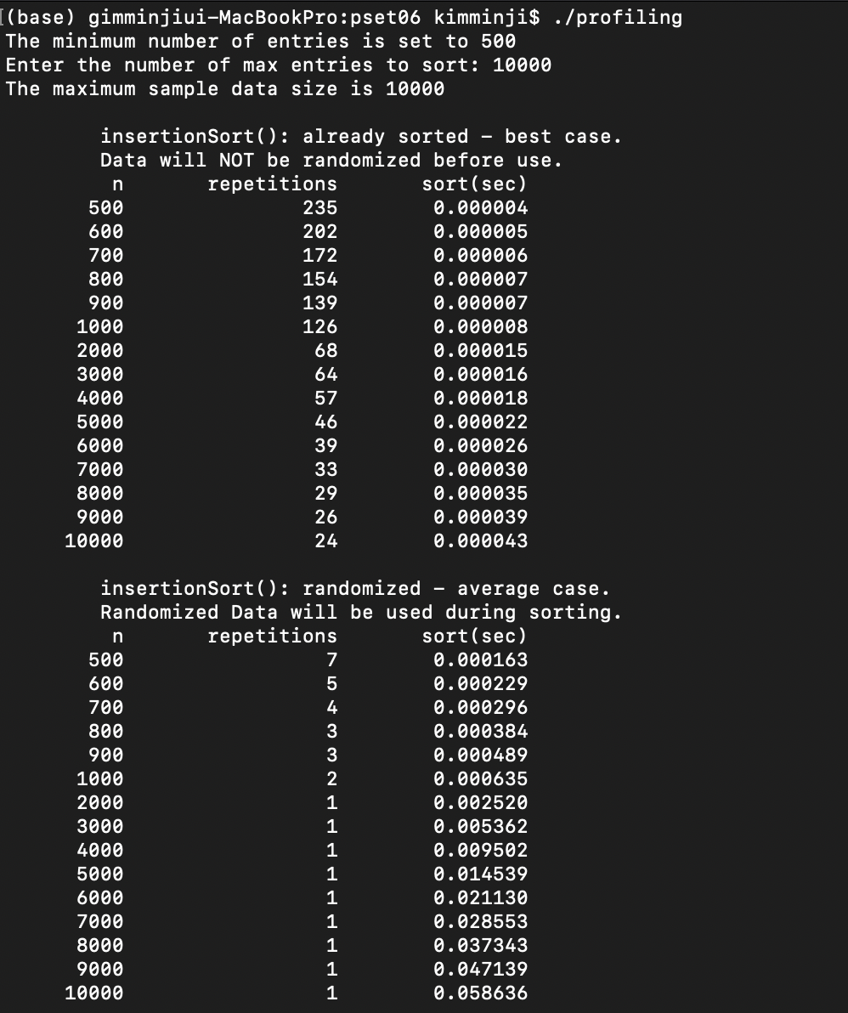

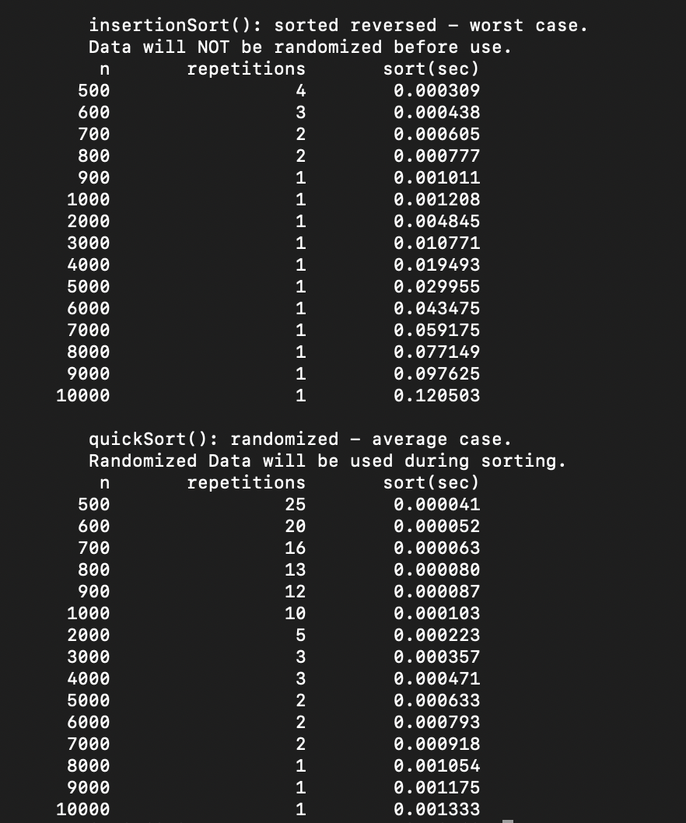

* + Complete the performance analysis tables

|  |  |  |  |  |  |  |
| --- | --- | --- | --- | --- | --- | --- |
|  | $T\left(N\right)≈a N^{b}$,  **a = 0.000021/4000**0.8556=**1.7388431906465608e-08 **b= log2(0.000038/0.000021)=0.8556**  insertionSort – Best | | $T\left(N\right)≈a N^{b}$,  **a =0.009896/4000**1.8966=**1.4577582841351116e-09 **b=log2(0.034687/0.009896)=1.8966**  insertionSort – Average | | $T\left(N\right)≈a N^{b}$,  **a =0.019784/4000**1.993=**  1.306232069994533e-09 **b=log2(0.078774/0.019784)=1.993**  insertionSort – Worst | |
| N | 4,000 | Time for Million | 4,000 | Time for Million | 4,000 | Time for Million |
| Time | 0.000021 | Estimated:  a*((10**6)**b)= 0.002365489164110785  Measured:  0.004037 | 0.009896 | Estimated:  349.5135878252974  =5min8sec  Measured:  582.675011=  9min7sec | 0.019784 | Estimated:  1192.1548861863982=19min8sec  Measured:  1229.723003  =20min4sec |
| N | 8,000 | 8,000 | 8,000 |
| Time | 0.000038 | 0.036847 | 0.078774 |

|  |  |  |
| --- | --- | --- |
|  | ,  **a =0.00051/4000**1.1089=**5.165615104748165e-08 **b=log2(0.0011/0.00051)=1.1089** Average qsort O**(N log N)** | |
| N | 4,000 | Time for Million |
| Time | 0.00051 | Estimated:  a*((10**6)**b)= 0.23266350838861397  Measured:  0.204549 |
| N | 8,000 |
| Time | 0.0011 |

|  |  |  |  |  |  |  |
| --- | --- | --- | --- | --- | --- | --- |
|  | ,  **a =0.014530/4000**b=**  9.381928034247938e-10 **b=log2(0.14530/0.057962)=1.996**  selectionSort – Case 1 | | $T\left(N\right)≈a N^{b}$,  **a =0.014423/4000**b=**  7.317989513870598e-10 **b=log2(0.058706/0.014423)=2.025**  selectionSort – Case 2 | | $T\left(N\right)≈a N^{b}$,  **a =0.014759/4000**b=**  8.364095606310649e-10 **b=log2(0.059521/0.014759)=2.01**  selectionSort – Case 3 | |
| N | 4,000 | Time for Million | 4,000 | Time for Million | 4,000 | Time for Million |
| Time | 0.014530 | Estimated:  a*(10**6)**b=888.64sec  =14min8sec  Measured:  913.400695  =15min21sec | 0.014423 | Estimated:  1035.6473000274373  =17min25sec  Measured:  928.759302  =15mim 48sec | 0.014759 | Estimated:  984.5589664888805=16min4sec  Measured:  900.309423  =15min |
| N | 8,000 | 8,000 | 8,000 |
| Time | 0.057962 | 0.058706 | 0.059521 |

**Task 3.** Compare the results with insertionSort() and write about your findings. : Selectionsort가 Insertionsort Average와 Insertion Best에 비해 느린 것으로 측정이 되었고 Insertion Worst 보다는 Selectionsort가 빠른 것으로 측정이 되었습니다.

**Task 4.**  In the previous steps, we have run quickSort() with only randomized data set (so-called average case). This time, run quickSort() with different kind of data sets such as sorted and reversed. Observe the results and write what you found in the report. : reversed 된 채로 quicksorting 하는 것이 reversed 되지 않은 채로 quicksorting 하는 것 보다 빠르다는 것을 발견할 수 있었습니다.

* + The excel chart and graph for comparing best/average/worst cases

|  |  |  |  |  |
| --- | --- | --- | --- | --- |
| n | Insertion Best | Insertion Average | Insertion Worst | qsort Average |
| 500 | 0.000004 | 0.000193 | 0.000313 | 0.000049 |
| 600 | 0.000004 | 0.000309 | 0.000452 | 0.000055 |
| 700 | 0.000006 | 0.000394 | 0.000614 | 0.000064 |
| 800 | 0.000005 | 0.000505 | 0.000803 | 0.000076 |
| 900 | 0.000006 | 0.000644 | 0.001038 | 0.000113 |
| 1000 | 0.000007 | 0.000696 | 0.001266 | 0.000119 |
| 2000 | 0.00001 | 0.002539 | 0.005424 | 0.000239 |
| 3000 | 0.000018 | 0.005857 | 0.01136 | 0.000358 |
| 4000 | 0.000021 | 0.009896 | 0.019784 | 0.00051 |
| 5000 | 0.000026 | 0.015872 | 0.031807 | 0.000646 |
| 6000 | 0.00003 | 0.021155 | 0.04466 | 0.000798 |
| 7000 | 0.000035 | 0.028577 | 0.060769 | 0.000983 |
| 8000 | 0.000038 | 0.036847 | 0.078774 | 0.0011 |
| 9000 | 0.000044 | 0.046623 | 0.09728 | 0.001441 |
| 10000 | 0.000046 | 0.064521 | 0.127007 | 0.001347 |

* + Comparison and analysis of algorithms: For example, Insertion vs quick sort, Timing, Stack problem, best/average/worst cases analysis

: quicksort가 insertion Worst, Average보다 훨씬 빠르고, insertion best 보다는 조금 느리다는 것을 발견할 수 있었습니다.

* + Draw a graph for the worst case of quickSort(). You first need to increase the stack size and test it.

|  |  |
| --- | --- |
| n | quicksort |
| 500 | 0.001061 |
| 600 | 0.00155 |
| 700 | 0.002684 |
| 800 | 0.00259 |
| 900 | 0.004894 |
| 1000 | 0.006146 |
| 2000 | 0.018696 |
| 3000 | 0.032749 |
| 4000 | 0.057396 |
| 5000 | 0.090001 |
| 6000 | 0.129394 |
| 7000 | 0.183417 |
| 8000 | 0.263506 |
| 9000 | 0.301777 |
| 10000 | 0.36927 |