Trait-Based Interaction Model across Niche Space

Introduction

Methods
Food web and trait data

Figure 1: Map of the food webs + workflow ?

Predictive models

Validation

Measuring predictive performance

Species functional roles

Results

Figure 2: Comparison of model coefficients.
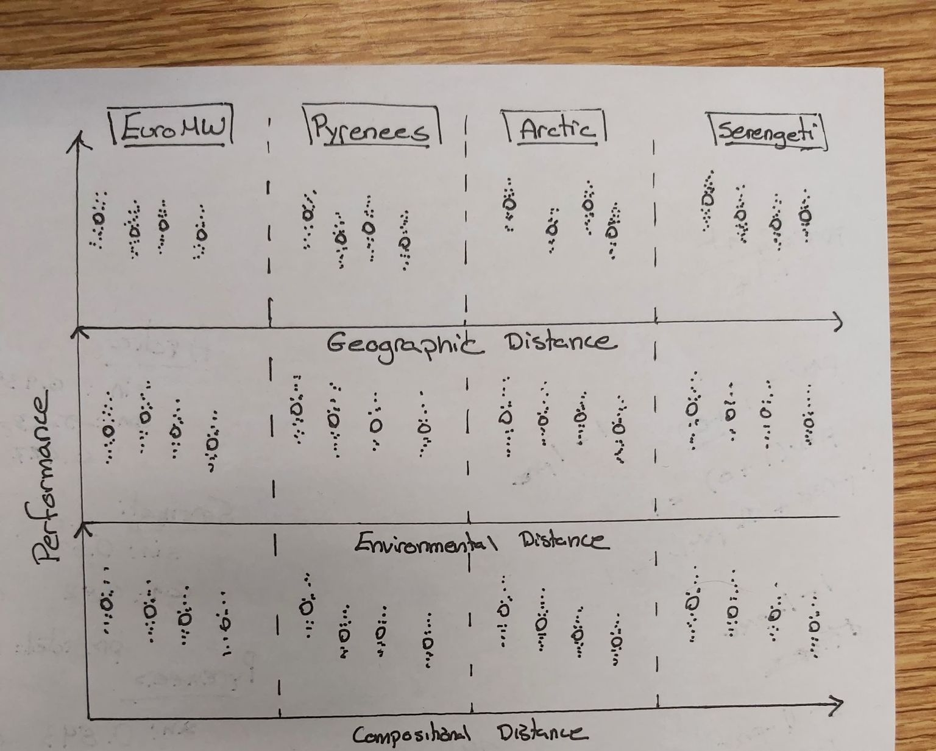Figure 3: Transferability of predictive models. Performance of models calibrated on each food web (colour coded) to predict the interactions in the different food webs. X axes are three measures of distance between the food web used for calibration and the food web used for validation. White point are the overall performance of the models, and grey points are the performance of the models for each species within the food webs.

Note:
- Performance (y axis) could be roc-auc, pr-auc, or overestimation of interactions
- Geographic distance could be measured as distance centroid-centroid
- Environmental distance could be measured as dissimilarity between environmental centroid (BIOCLIM) of x random points drawn in polygon of FW i and polygon of FW j
- Compositional distance is Jaccard dissimilarity index between composition of FW i and j
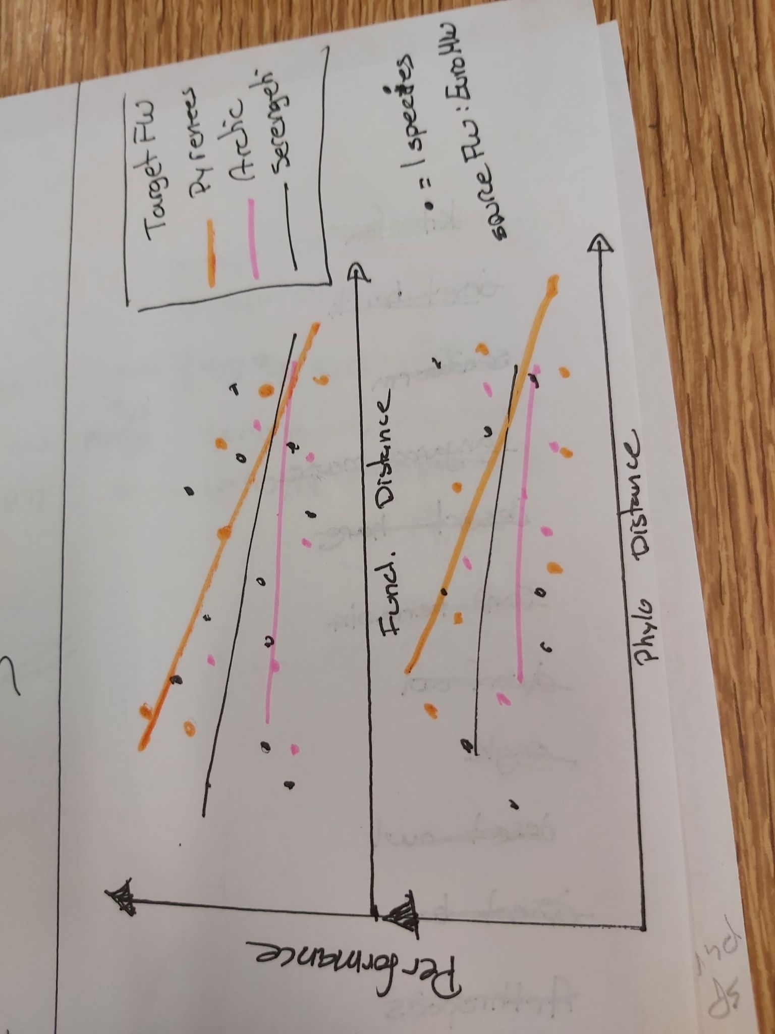
Figure 4: Predicting species functional role. Ability of the model calibrated on the European metaweb to predict the functional role of species in the other food webs. Performance is the distance between the predicted functional roles and the true functional role. We related model performance to the functional and phylogenetic distance between the species pool in the European metaweb of each species in the predicted food web.

Discussion

