Trait-Based Interaction Model across Niche Space

Introduction
authors:
D.Caron
U.Brose
M. Lurgi
D.Gravel? and G.Blanchet?
L.Pollock

Introduction
Many ecosystem functions (e.g., energy flows, material cycling, and stability) depend on the trophic relationships that link species of a community (Harvey et al., 2017; Thompson et al., 2012). These trophic relationships form the food web. Despite recognizing the central role of food webs in ecosystems for over 80 years (Lindeman, 1942), we still lack food web data for most places and taxa (Cameron et al., 2019; Hortal et al., 2015; Poisot et al., 2021). The reason for this knowledge gap is two-fold. First, the number of possible interactions increase quadratically with the number of species. Second, observing (and even more quantifying) interactions between two individuals is inherently difficult as we need to detect simultaneously two species and the interactions (Jordano, 2016). Having more widespread food web data and at larger scales would open research opportunities by integrating the Grinnellian and Eltonian niche into biogeography (Braga et al., 2019; Gravel et al., 2019), incorporating trophic interactions into meta-community ecology (Guzman et al., 2019), and describing the functional role of species in biodiversity-ecosystem functioning (Dehling & Stouffer, 2018; Gonzalez et al., 2020).

A promising first step towards filling this knowledge gap about food webs is by predicting potential trophic interactions. This should be possible since predator and prey tend to respond to a predictable set of geographic, phylogenetic and functional relationships (Morales-Castilla et al., 2015). The neutral model predicts that the probability and strength of interactions respond only to the co-occurrrences and abundances of species (Canard et al., 2012). Although co-occurrence patterns and species interactions influence each other, they are not evidence for one another (Blanchet et al., 2020). Niche theory predicts that the match between the functional traits of predators and their prey should improve these predictions by identifying which interactions are feasible (Williams & Martinez, 2000). These trait-based models have been used to predict food webs in freshwater streams (Pomeranz et al., 2019), of marine fishes (Albouy et al., 2014), terrestrial invertebrates (Laigle et al., 2018), and vertebrates (Caron et al., 2022), among others. Phylogenetic relationships are also informative since interactions and species positions tend to be evolutionary conserved (Gómez et al., 2010; Stouffer et al., 2012). For example, Strydom et al. (2021) recently used phylogeny to map latent traits extracted from the European mammal food web to predict the Canadian mammal food web.

However, some questions about the potential of trophic interaction models to predict food webs. A first question is how well can predictive models transfer knowledge across different regions? Strydom et al. (2021) successfully recovered over 90% of known interactions among Canadian mammals without any information about the food web, but they had very little information on non-interactions. It is difficult to evaluate just how well their predictions are able to recover the entire food web (interactions and non-interactions) since they could only evaluate performance on known interactions. Also, despite very little overlap in species, they transferred knowledge between two systems with large shared evolutionary history (only one order unique each in Canada and Europe). Given that their method uses phylogeny as medium to transfer knowledge, it is unclear how well their methods would do for more contrasting systems. A second question is how well can model of trophic interactions can predict the structure of the food web? By structure, we mean the properties of food webs (e.g., connectance, number of trophic levels) and the position of species (e.g., number of prey, centrality) in food webs. Most studies aimed to predict either the properties of food webs (e.g., Allesina et al., 2008; Allesina & Pascual, 2009; Cattin et al., 2004; Williams & Martinez, 2000) or interactions (e.g., Gravel et al., 2013; Laigle et al., 2018; Pomeranz et al., 2019), but rarely assessed if predicting interactions also recover the structure of the food web. Caron et al. (2022) found that connectance of terrestrial food webs tended to be systematically overpredicted across Europe by 2-4 times, but did not explore other food web properties or species positions. This is an important knowledge gap as many ecosystem functions and the functional role of species are controlled by the global shape of the food web and the position of species within the food web (Cirtwill et al., 2018; Dunne et al., 2002; Smith-Ramesh et al., 2016; Thompson et al., 2012).

Here, we trained a set of trait-based predictive models on four highly contrasting food webs of terrestrial vertebrates: the trophic food web of European tetrapods, the High Arctic tundra food web, the Pyrenees vertebrate food web, and the Serengeti food web. The models are Bayesian generalized hierarchical models that we calibrated on each food web and validated on the other food webs. We used these models to determine how well trait-based model of trophic interactions can transfer across systems. More specifically, we ask: (1) What are the factors (i.e., geographic, environmental, functional, or phylogenetic distances) influencing the transferability of models? (2) How well the trophic role of species are predicted? and (3) How well food web properties are predicted?

Methods
Food web data
We extracted trophic interactions between terrestrial vertebrates (terrestrial mammals, birds, amphibians and reptiles) from four well-resolved food webs (Table 1):

- Europe food web: The trophic food web of European tetrapods was assembled by Maiorano et al. (2020). The Europe food web contains the potential trophic interactions and non-interactions between all terrestrial vertebrates in Europe based on data from guide books, published papers, and expert opinions. The authors originally reported interactions between predators and prey at different life-stage (eggs, larvae/young, or adult). Here, we only extracted interactions between predators and adult prey.

- Pyrenees food web: The Pyrenees vertebrate food web was assembled idenpendently from the Europe food web by Lurgi et al. (2012). The authors compiled all known all known interactions between vertebrate species in the southeastern Pyrenees mountain range. To keep the same taxonomic coverage between food webs, we excluded fish species.

- Arctic food web: The High Arctic tundra food web was compiled by Legagneux et al. (2012). The Arctic food web contains the diet of each functional group for lemming peak (i.e. when lemmings are abundant) and crash (i.e. when lemmings are less abundant) years on Bylot Island (Nunavut, Canada). The diet was inferred with local data (e.g., pellet samples) and a literature review. We excluded all non-vertebrate species. To get a species-level food web, we assumed that the species diet is the same as the diet of its functional group, and that a predator species eats every species in the prey functional group. To get a single potential food web, we treated all non-zero diet proportions in either peak and crash years as potential interactions between the predator and the prey.

- Serengeti food web: The serengeti food web compiles all interactions between the different trophic groups in the Serengeti National Park (Tanzania) and was assembled from a literature review (Baskerville et al., 2011; de Visser et al., 2011). Like for the Arctic food web, we assumed that species within a trophic group share the same predator and prey. We excluded all non-terrestrial vertebrate species.

Table 1: Summary of the food webs after excluding species for which no match were found in the GBIF Backbone Taxonomy or not documented in the trait database.

Trait data
We used the database of ecological traits for terrestrial vertebrates compiled by Etard et al. (2020). Etard et al. (2020) combined the information on species-level body size, longevity, clutch size, trophic level, activity time and habitat use from large freely available secondary trait databases. The database includes traits for 6 990 amphibians, 11 634 birds, 5 380 mammals, and 10 612 reptiles.

To match species in the trait databases to the species in the food webs, we standardized their names following the taxonomic backbone of GBIF. To do so, we used the function name_backbone from the package rgbif (Chamberlain et al., 2022; Chamberlain & Boettiger, 2017) in R. In each food web, we excluded all species for which no match were found in the taxonomic backbone of GBIF or in the trait database. We imputed missing traits using the missForest algorithm (Stekhoven & Buehlmann, 2012) for amphibians, birds, mammals and reptiles separately.

Predictive models
We calibrated a Bayesian hierarchical linear model (GLMM) on each of the four food webs. The response data are trophic interactions that we modelled as Bernouilli distributed. For each model, we used 70% of all interactions, and an equal number of non-interactions for calibration. We used the remaining of the data for validation. Because we previously found that trait-interaction relationships vary between predator groups (Caron et al., 2022), we used the order of the predator as random effect on the intercept and slopes in each model.

The models used 13 trait-based predictors: the trophic level, body mass, habitat breadth, longevity, and clutch size of the predator and the prey, and the match between their activity time, habitat use and body mass. Activity time match is a binary variable where one means the predator and the prey are active at the same time of the day. Habitat match is the Jaccard similarity index between the habitat used by the prey and the predator across the 13 habitat categories in the trait database. Body mass match is the squared difference between the log-transformed body mass of the prey and the predator. We log-transformed body mass, longevity and clutch size. We also scaled each continuous predictor by subtracting it by the mean and dividing by two times the standard deviation, so that the coefficients of the scaled continuous predictors are directly comparable to coefficients of unscaled binary predictors (Gelman, 2008).

We used weakly informative priors for the intercept and the slopes of each models. The random effects (intercepts and slopes) were drawn from normal distributions. We used a normal distribution with a mean of 0 and a standard deviation of 1 as prior for the mean and a half Cauchy distribution with a scale parameter of 5 as prior for standard deviation of the random effects. We describe the models in more details in appendix XX.

We ran four chains, each with 1000 warm-up iterations, followed by 1000 iterations for inference. We diagnosed convergence and adequacy with trace plots, posterior predictive checks, and calculated the potential scale reduction factor for all runs (Gelman & Rubin, 1992; Appendix XX). We conducted the Bayesian analyses using Stan through the package brms in R (Bürkner, 2017; Carpenter et al., 2017).

Predicting species interactions
To measure how well models transfer, we used each model to predict the other three food webs (Figure 1). For each possible predator-prey pair, we extracted the mean of 100 posterior draws to get the probability of interaction. We compared these probabilities of interactions to the empirical food web interactions to measure how well species interactions are predicted. We measured performance with the area under the receiver operating characteristic curve (AUC). AUC varies from 0.5 to 1 where 0.5 indicates that the model failed to rank interactions higher than non-interactions (i.e., random prediction), and 1 indicates that the model systematically ranked interactions higher than non- interactions (i.e., perfect prediction). We also measured the area under the precision-recall curve, and directly used the posterior draws to get distributions for the true positive rate, true negative rate, positive predictive value and negative predictive value (Appendix XX).

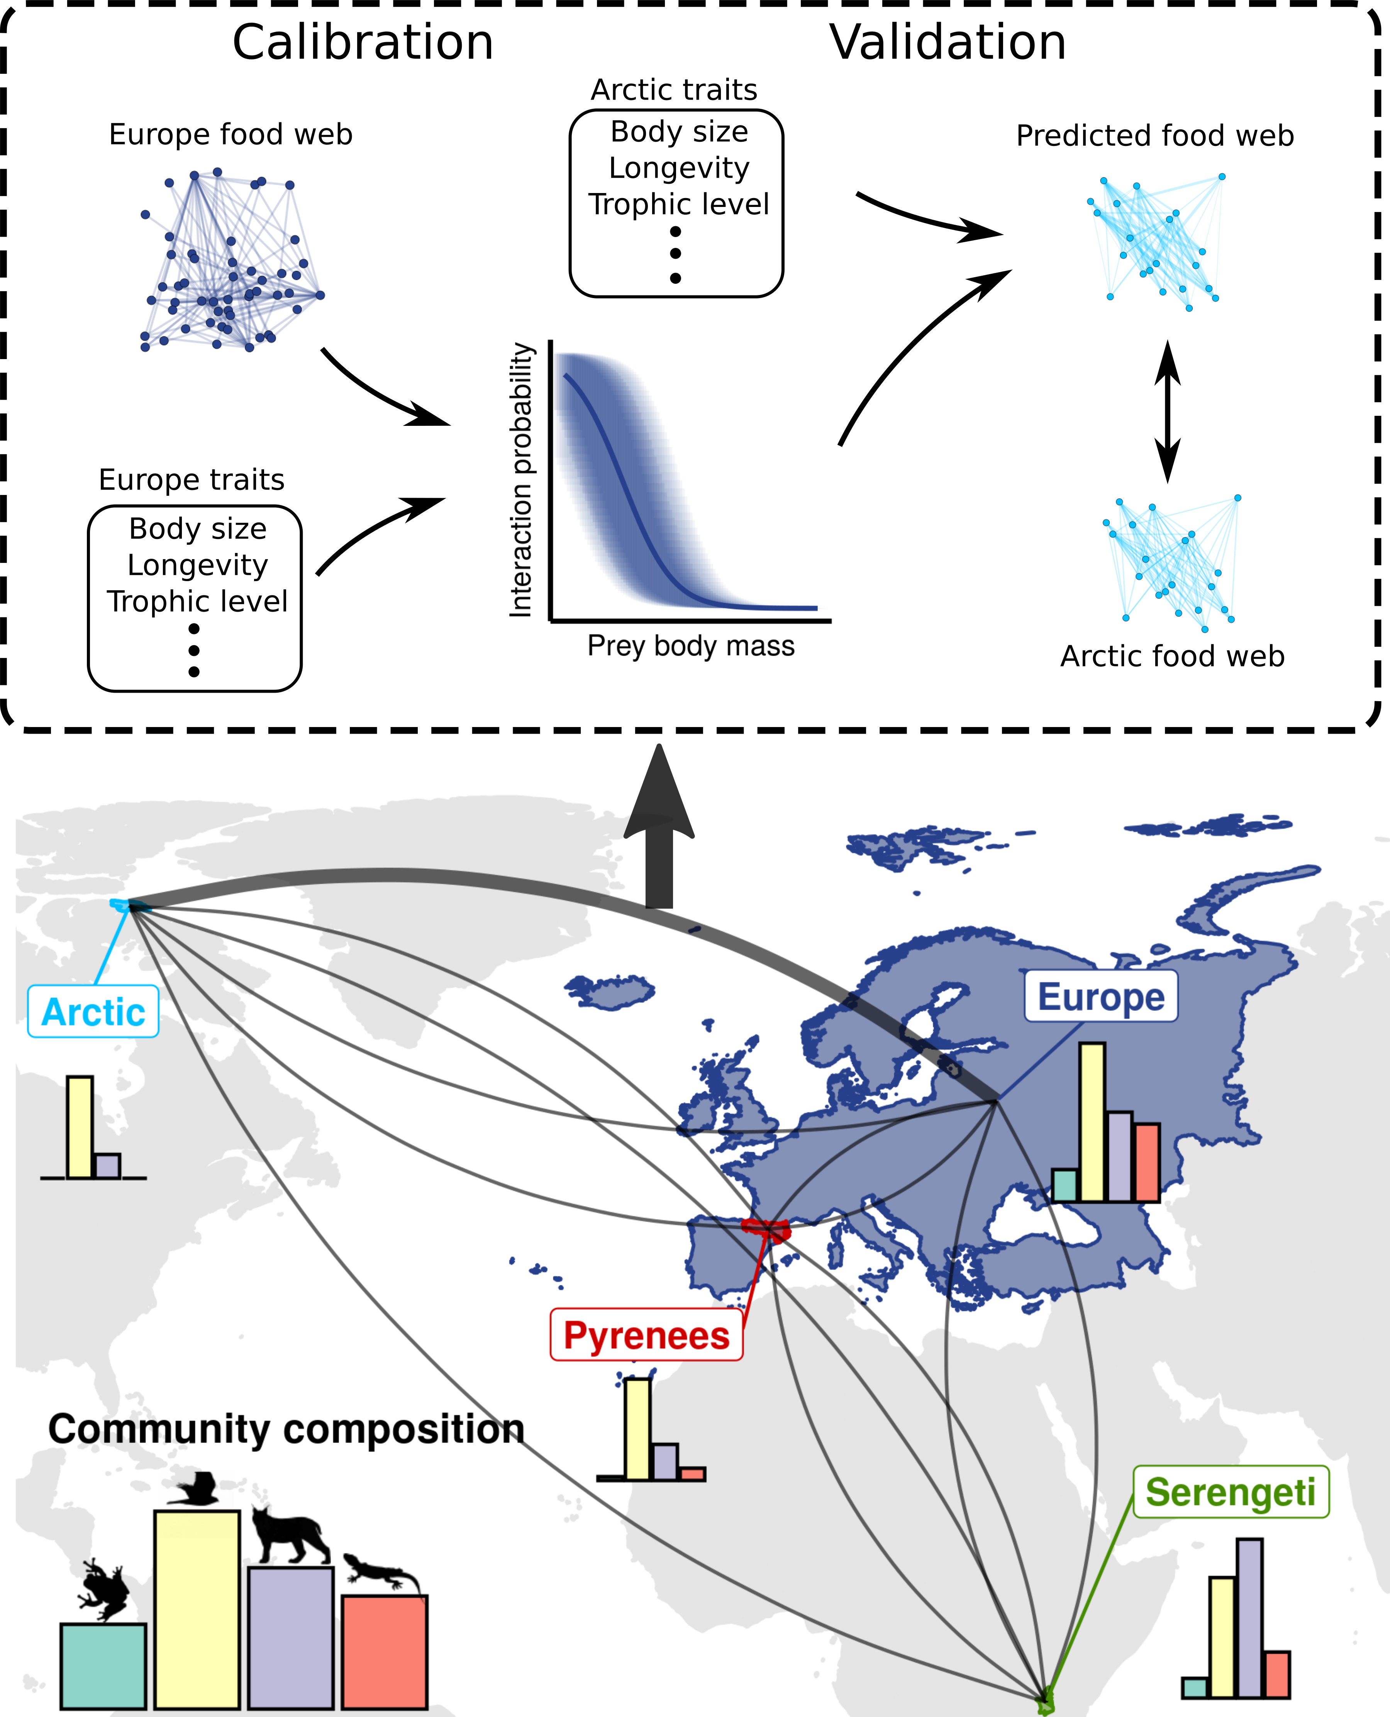

To explore which factors influence model transferability we first modelled the performance of models to predict each food webs with three distance measures: geographic distance, environmental dissimilarity, and phylogenetic relatedness. We measured geographic distance with the euclidean distance between the centroid of the polygon delimiting each food web. We measured environmental dissimilarity using all bioclimatic variables (Hijmans, 2021). We randomly drew 500 points within each polygons and extracted bioclimatic data for these points. We then ran a principal component analysis on the extracted bioclimatic variables and calculated the euclidean distance between the centroid of the principal components (Appendix XX). We measured phylogenetic relatedness with the mean phylogenetic distance to the nearest taxon of every species in the predicted food web. In other words, we averaged over all species in the predicted food web the phylogenetic distance to the closest related species in the food web used for calibration. This measures the amount of evolutionary history in the predicted food web undocumented by the food web the model was calibrated on. We used the published phylogeny for birds (Jetz et al., 2012), amphibians (Jetz & Pyron, 2018), squamates (Tonini et al., 2016), turtles (Thomson et al., 2021), and mammals (Upham et al., 2019).

We further explored the factors influencing model transfer by analyzing species-specific performance. For each combination of predicted food web-model (i.e., arrows in figure 1), we measured how well the prey and predators of each species were predicted using the AUC. We modelled the species-specific performance to how distinct the focal species is to the species pool used to calibrate the predictive model. We used the functional mean pairwise distance (Mouchet et al., 2010) and distance to nearest taxon (Tucker et al., 2017). Functional mean pairwise distance is the average Gower distance (Gower, 1971) between the focal species and all species in the food web used for calibration. To calculate Gower distances, we used all traits available in Etard (2020) through the function funct.dist from the package mFD in R (Magneville et al., 2022). Distance to nearest taxon distance is the phylogenetic distance between the focal species and the closest relative in the species in the food web used for model calibration.

Predicting species functional roles
Next, we were interested in how well species trophic role were predicted. Trophic role of a species is determined by its position in the food web (Cirtwill et al., 2018). Here, we used 5 metrics related to how connected the species (number of prey, number of predators, betweeness, closeness, eigen centrality), 2 metrics related to trophic level (trophic levels and omnivory), 2 module-based metrics (within-module degree and participation coefficient; Guimerà & Amaral, 2005), and the motif profile of species (Stouffer et al., 2012). We detail each metrics, their relation to functional role, and how they were calculated in Appendix XX.

We measured how well each trophic position metrics were predicted by calculating the Pearson correlation between the metrics calculated on the predicted food webs and the calculated on the empirical food web. For predicted food webs, we measured each metrics on 100 posterior predictions of the entire food web and took the mean to get the best point estimate for the metric. To detect biases in the predictions, we fitted a linear regression between the predicted position and the empirical position for each combination of predicted food web, model, and trophic position metric.

Predicting food web properties
Finally, we investigated how well the global properties of food webs were predicted. Again, many metrics can be used to describe the structure of food webs. We chose food web properties that influence food web functioning and stability: connectance, mean trophic level, maximum trophic level, motif distribution, food web diameter, number of clusters, and modularity. Like for species position, we evaluated these properties on the empirical food webs and compared them to the properties predicted using 100 posterior predictions. We detail each metrics, their relation to food web function, and how they were calculated in Appendix X.

Results
Predictive models

Figure 1: Model comparison. Coefficient of models calibrated with each food web. Solid points are the mean fixed effect of each predictor with their 95% credible interval.

Predicting trophic interactions
For all food webs, trophic interactions were better predicted by the model calibrated on the same food web (“within food web” predictions) than by model trained on other food webs (“between food web” predictions; Table 2). Similarly, all models performed better in predicting the food web they were trained on, than other food webs. For within food web predictions, we found a AUC varying between 0.92 and 0.98. Most model transferred relatively well with AUC over 0.8 for most between food web predictions. Notably, the model trained in the Arctic did not predicted the Serengeti food web well (AUC of 0.64) compared to other model-food web combinations. The area under the precision-recall curve, true positive rate, true negative rate, positive predictive value, and negative predictive value were all positively correlated with AUC and showed the same overall pattern (Appendix X).
Table 2: Area under the receiver operating curve (AUC)

To explore the factors influencing the transferability of interaction models, we modelled their performance to the geographic, environmental, and phylogenetic distances between the food web the model was calibrated on and the food web predicted. Overall, performance tend to decrease with environmental (fixed effect estimate: -0.65, 95%CrI = [-1.35, 0.25]) and phylogenetic distances (fixed effect estimate: -0.30, 95%CrI = [-0.87, 0.34]), and increase with geographic distance (fixed effect estimate: 0.60, 95%CrI = [-0.29, 1.27].

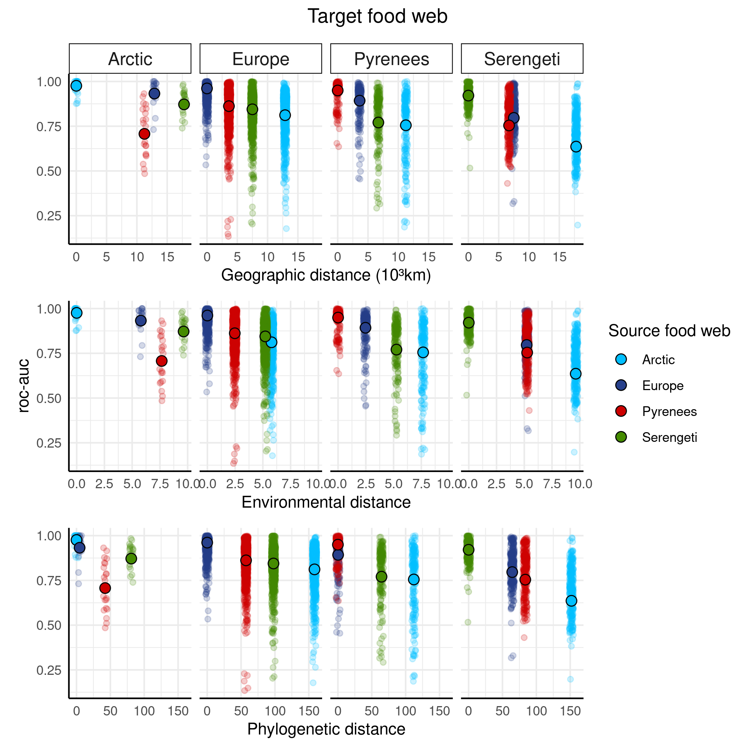Figure 2 : Transferability of predictive models. Performance of models calibrated on each food web (colour coded) to predict interactions in the different food webs. The horizontal axes are three measures of distance between the food web used for calibration and the food web used for validation. Opaque points are the overall performance of the models, and transparent points are the performance of the models for each species within the food webs.

transferability vs distances (brms):
- model 1: logitauc ~ geo.dist + env.dist + phylo.dist + (1 | Source) + (1 | Target)
fixed effects (exp()):
Intercept: Estimate = 3.65, 95% CrI = [1.37, 6.95]
geo.dist: Estimate = 1.82, 95% CrI = [0.75, 3.57]
env.dist: Estimate = 0.52, 95% CrI = [0.26, 1.28]
phylo.dist: Estimate = 0.74, 95% CrI = [0.42, 1.41]
random effect:
sd(1|Target): Estimate = 0.48, 95% CrI = [0.02, 1.97]
sd(1|Source): Estimate = 0.45, 95% CrI = [0.01, 1.71]

- model 2: log(aucpr/prevalence) ~ geo.dist + env.dist + phylo.dist + (1|Source) + (1|Target)
fixed effects:
Intercept: Estimate = 1.08, 95% CrI = [0.45, 1.44]
geo.dist: Estimate = 0.16, 95% CrI = [-0.26, 0.52]
env.dist: Estimate = -0.32, 95% CrI = [-0.73, 0.13]
phylo.dist: Estimate = -0.06, 95% CrI = [-0.42, 0.24]
random effect:
sd(1|Target): Estimate = 0.18, 95% CrI = [0.00, 0.8]
sd(1|Source) : Estimate = 0.26, 95% CrI = [0.01, 1.26]

Figure 3: Predicting species interactions. Performance of the model calibrated on each food web (colour coded) to predict the interactions of each species in the other food webs. We related model performance to the scaled functional and phylogenetic distance between the target species and the species in the food web used for calibration.

performance vs distances (brms):
mntd = mean nearest taxon distance (i.e., phylo distance between target species its nearest neighbour from the source food web)
fmpd = functional mean pairwise distance (i.e., functional distance (gower) between the target species and all species in the source food web)
- model 1: logitauc ~ mntd + fmpd + prevalence + (1|Source) + (1|Target)
fixed effects (exp()):
Intercept: Estimate = 1.46, 95% CrI = [0.22, 2.32]
mntd: Estimate = -0.19, 95% CrI = [-0.22, -0.17]
fmpd: Estimate = 0.17, 95% CrI = [0.15, 0.19]
prevalence: Estimate = -0.25, 95% CrI = [-0.27, -0.22]
random effect:
sd(1|Source): Estimate = 0.66, 95% CrI = [0.20, 2.23]
sd(1|Target): Estimate = 0.82, 95% CrI = [0.28, 2.24]

- model 2: log(aucpr/prevalence) ~ geo.dist + env.dist + phylo.dist + (1|Source) + (1|Target)
fixed effects:
Intercept: Estimate = 2.03, 95% CrI = [1.02, 2.69]
mntd: Estimate = -0.09, 95% CrI = [-0.11, -0.07]
fmpd: Estimate = 0.09, 95% CrI = [0.07, 0.10]
prevalence: Estimate = -1.10, 95% CrI = [-1.12, -1.09]
random effect:
sd(1|Source): Estimate = 0.33, 95% CrI = [0.22, 1.21]
sd(1|Target) : Estimate = 0.64 95% CrI = [0.22, 1.65]

Predicting species functional role
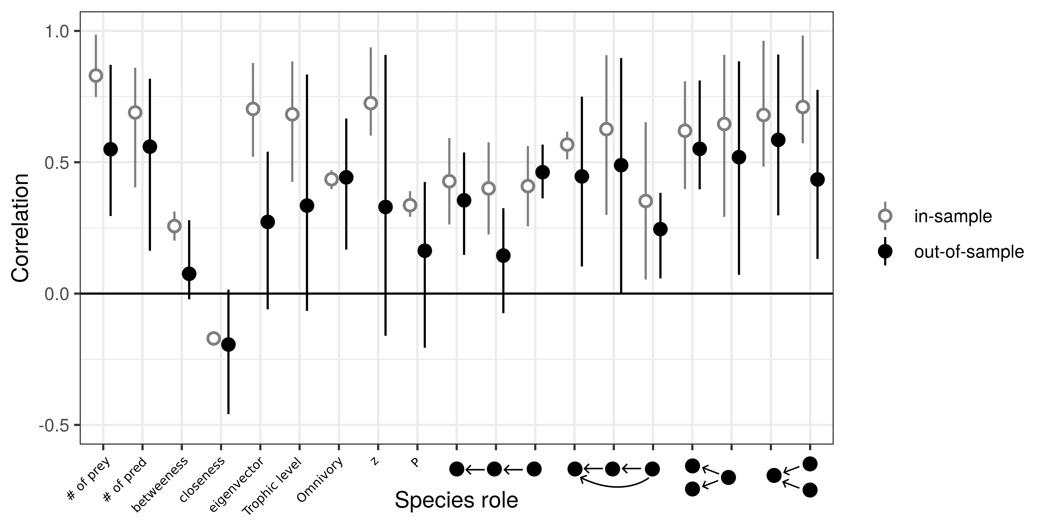
Predicting food web properties
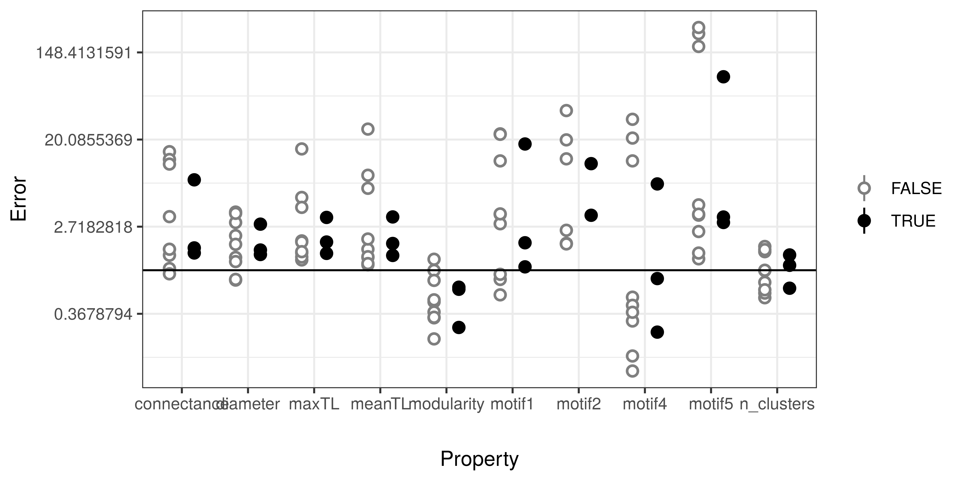

Discussion

References
Albouy, C., Velez, L., Coll, M., Colloca, F., Loc’h, F. L., Mouillot, D., & Gravel, D. (2014). From projected species distribution to food-web structure under climate change. Global Change Biology, 20(3), 730–741. https://doi.org/10.1111/gcb.12467
Allesina, S., Alonso, D., & Pascual, M. (2008). A General Model for Food Web Structure. Science, 320(5876), 658–661. https://doi.org/10.1126/science.1156269
Allesina, S., & Pascual, M. (2009). Food web models: A plea for groups. Ecology Letters, 12(7), 652–662. https://doi.org/10.1111/j.1461-0248.2009.01321.x
Baskerville, E. B., Dobson, A. P., Bedford, T., Allesina, S., Anderson, T. M., & Pascual, M. (2011). Spatial Guilds in the Serengeti Food Web Revealed by a Bayesian Group Model. PLoS Computational Biology, 7(12). https://doi.org/10.1371/journal.pcbi.1002321
Blanchet, F. G., Cazelles, K., & Gravel, D. (2020). Co-occurrence is not evidence of ecological interactions. Ecology Letters, 23(7), 1050–1063. https://doi.org/10.1111/ele.13525
Braga, J., Pollock, L. J., Barros, C., Galiana, N., Montoya, J. M., Gravel, D., Maiorano, L., Montemaggiori, A., Ficetola, G. F., Dray, S., & Thuiller, W. (2019). Spatial analyses of multi-trophic terrestrial vertebrate assemblages in Europe. Global Ecology and Biogeography, 28(11), 1636–1648. https://doi.org/10.1111/geb.12981
Bürkner, P.-C. (2017). brms: An R Package for Bayesian Multilevel Models Using Stan. Journal of Statistical Software, 80(1). https://doi.org/10.18637/jss.v080.i01
Cameron, E. K., Sundqvist, M. K., Keith, S. A., CaraDonna, P. J., Mousing, E. A., Nilsson, K. A., Metcalfe, D. B., & Classen, A. T. (2019). Uneven global distribution of food web studies under climate change. Ecosphere, 10(3), e02645. https://doi.org/10.1002/ecs2.2645
Canard, E., Mouquet, N., Marescot, L., Gaston, K. J., Gravel, D., & Mouillot, D. (2012). Emergence of Structural Patterns in Neutral Trophic Networks. PLOS ONE, 7(8), e38295. https://doi.org/10.1371/journal.pone.0038295
Caron, D., Maiorano, L., Thuiller, W., & Pollock, L. J. (2022). Addressing the Eltonian shortfall with trait‐based interaction models. Ecology Letters, ele.13966. https://doi.org/10.1111/ele.13966
Carpenter, B., Gelman, A., Hoffman, M. D., Lee, D., Goodrich, B., Betancourt, M., Brubaker, M., Guo, J., Li, P., & Riddell, A. (2017). Stan: A Probabilistic Programming Language. Journal of Statistical Software, 76(1). https://doi.org/10.18637/jss.v076.i01
Cattin, M.-F., Bersier, L.-F., Banašek-Richter, C., Baltensperger, R., & Gabriel, J.-P. (2004). Phylogenetic constraints and adaptation explain food-web structure. Nature, 427(6977), 835–839. https://doi.org/10.1038/nature02327
Chamberlain, S., Barve, V., Mcglinn, D., Oldoni, D., Desmet, P., Geffert, L., & Ram, K. (2022). rgbif: Interface to the global biodiversity information facility API [Manual]. https://CRAN.R-project.org/package=rgbif
Chamberlain, S., & Boettiger, C. (2017). R Python, and Ruby clients for GBIF species occurrence data. PeerJ PrePrints. https://doi.org/10.7287/peerj.preprints.3304v1
Cirtwill, A. R., Dalla Riva, G. V., Gaiarsa, M. P., Bimler, M. D., Cagua, E. F., Coux, C., & Dehling, D. M. (2018). A review of species role concepts in food webs. Food Webs, 16, e00093. https://doi.org/10.1016/j.fooweb.2018.e00093
de Visser, S. N., Freymann, B. P., & Olff, H. (2011). The Serengeti food web: Empirical quantification and analysis of topological changes under increasing human impact. Journal of Animal Ecology, 80(2), 484–494. https://doi.org/10.1111/j.1365-2656.2010.01787.x
Dehling, D. M., & Stouffer, D. B. (2018). Bringing the Eltonian niche into functional diversity. Oikos, 127(12), 1711–1723. https://doi.org/10.1111/oik.05415
Dunne, J. A., Williams, R. J., & Martinez, N. D. (2002). Food-web structure and network theory: The role of connectance and size. Proceedings of the National Academy of Sciences, 99(20), 12917–12922. https://doi.org/10.1073/pnas.192407699
Etard, A., Morrill, S., & Newbold, T. (2020). Global gaps in trait data for terrestrial vertebrates. Global Ecology and Biogeography, 29(12), 2143–2158. https://doi.org/10.1111/geb.13184
Gelman, A. (2008). Scaling regression inputs by dividing by two standard deviations. Statistics in Medicine, 27(15), 2865–2873. https://doi.org/10.1002/sim.3107
Gelman, A., & Rubin, D. B. (1992). Inference from Iterative Simulation Using Multiple Sequences. Statistical Science, 7(4), 457–472. https://doi.org/10.1214/ss/1177011136
Gómez, J. M., Verdú, M., & Perfectti, F. (2010). Ecological interactions are evolutionarily conserved across the entire tree of life. Nature, 465(7300), 918–921. https://doi.org/10.1038/nature09113
Gonzalez, A., Germain, R. M., Srivastava, D. S., Filotas, E., Dee, L. E., Gravel, D., Thompson, P. L., Isbell, F., Wang, S., Kéfi, S., Montoya, J., Zelnik, Y. R., & Loreau, M. (2020). Scaling-up biodiversity-ecosystem functioning research. Ecology Letters, 23(4), 757–776. https://doi.org/10.1111/ele.13456
Gower, J. C. (1971). A General Coefficient of Similarity and Some of Its Properties. Biometrics, 27(4), 857–871. https://doi.org/10.2307/2528823
Gravel, D., Baiser, B., Dunne, J. A., Kopelke, J.-P., Martinez, N. D., Nyman, T., Poisot, T., Stouffer, D. B., Tylianakis, J. M., Wood, S. A., & Roslin, T. (2019). Bringing Elton and Grinnell together: A quantitative framework to represent the biogeography of ecological interaction networks. Ecography, 42(3), 401–415. https://doi.org/10.1111/ecog.04006
Gravel, D., Poisot, T., Albouy, C., Velez, L., & Mouillot, D. (2013). Inferring food web structure from predator-prey body size relationships. Methods in Ecology and Evolution, 4(11), 1083–1090. https://doi.org/10.1111/2041-210X.12103
Guimerà, R., & Amaral, L. A. N. (2005). Cartography of complex networks: Modules and universal roles. Journal of Statistical Mechanics: Theory and Experiment, 2005(02), P02001. https://doi.org/10.1088/1742-5468/2005/02/P02001
Guzman, L. M., Germain, R. M., Forbes, C., Straus, S., O’Connor, M. I., Gravel, D., Srivastava, D. S., & Thompson, P. L. (2019). Towards a multi-trophic extension of metacommunity ecology. Ecology Letters, 22(1), 19–33. https://doi.org/10.1111/ele.13162
Harvey, E., Gounand, I., Ward, C. L., & Altermatt, F. (2017). Bridging ecology and conservation: From ecological networks to ecosystem function. Journal of Applied Ecology, 54(2), 371–379. https://doi.org/10.1111/1365-2664.12769
Hijmans, R. J. (2021). raster: Geographic data analysis and modeling [Manual]. https://CRAN.R-project.org/package=raster
Hortal, J., de Bello, F., Diniz-Filho, J. A. F., Lewinsohn, T. M., Lobo, J. M., & Ladle, R. J. (2015). Seven Shortfalls that Beset Large-Scale Knowledge of Biodiversity. Annual Review of Ecology, Evolution, and Systematics, 46(1), 523–549. https://doi.org/10.1146/annurev-ecolsys-112414-054400
Jetz, W., & Pyron, R. A. (2018). The interplay of past diversification and evolutionary isolation with present imperilment across the amphibian tree of life. Nature Ecology & Evolution, 2(5), 850–858. https://doi.org/10.1038/s41559-018-0515-5
Jetz, W., Thomas, G. H., Joy, J. B., Hartmann, K., & Mooers, A. O. (2012). The global diversity of birds in space and time. Nature, 491(7424), 444–448. https://doi.org/10.1038/nature11631
Jordano, P. (2016). Sampling networks of ecological interactions. Functional Ecology, 30(12), 1883–1893. https://doi.org/10.1111/1365-2435.12763
Laigle, I., Aubin, I., Digel, C., Brose, U., Boulangeat, I., & Gravel, D. (2018). Species traits as drivers of food web structure. Oikos, 127(2), 316–326. https://doi.org/10.1111/oik.04712
Legagneux, P., Gauthier, G., Berteaux, D., Bêty, J., Cadieux, M.-C., Bilodeau, F., Bolduc, E., McKinnon, L., Tarroux, A., Therrien, J.-F., Morissette, L., & Krebs, C. J. (2012). Disentangling trophic relationships in a High Arctic tundra ecosystem through food web modeling. Ecology, 93(7), 1707–1716. https://doi.org/10.1890/11-1973.1
Lindeman, R. L. (1942). The Trophic-Dynamic Aspect of Ecology. Ecology, 23(4), 399–417. https://doi.org/10.2307/1930126
Lurgi, M., López, B. C., & Montoya, J. M. (2012). Climate change impacts on body size and food web structure on mountain ecosystems. Philosophical Transactions of the Royal Society B: Biological Sciences, 367(1605), 3050–3057. https://doi.org/10.1098/rstb.2012.0239
Magneville, C., Loiseau, N., Albouy, C., Casajus, N., Claverie, T., Escalas, A., Leprieur, F., Maire, E., Mouillot, D., & Villéger, S. (2022). mFD: An R package to compute and illustrate the multiple facets of functional diversity. Ecography, 2022(1). https://doi.org/10.1111/ecog.05904
Maiorano, L., Montemaggiori, A., Ficetola, G. F., O’Connor, L., & Thuiller, W. (2020). TETRA‐EU 1.0: A species‐level trophic metaweb of European tetrapods. Global Ecology and Biogeography, geb.13138. https://doi.org/10.1111/geb.13138
Morales-Castilla, I., Matias, M. G., Gravel, D., & Araújo, M. B. (2015). Inferring biotic interactions from proxies. Trends in Ecology & Evolution, 30(6), 347–356. https://doi.org/10.1016/j.tree.2015.03.014
Mouchet, M. A., Villéger, S., Mason, N. W. H., & Mouillot, D. (2010). Functional diversity measures: An overview of their redundancy and their ability to discriminate community assembly rules. Functional Ecology, 24(4), 867–876. https://doi.org/10.1111/j.1365-2435.2010.01695.x
Poisot, T., Bergeron, G., Cazelles, K., Dallas, T., Gravel, D., MacDonald, A., Mercier, B., Violet, C., Vissault, S., & Chapman, D. (2021). Global knowledge gaps in species interaction networks data. Journal of Biogeography, jbi.14127. https://doi.org/10.1111/jbi.14127
Pomeranz, J. P. F., Thompson, R. M., Poisot, T., & Harding, J. S. (2019). Inferring predator–prey interactions in food webs. Methods in Ecology and Evolution, 10(3), 356–367. https://doi.org/10.1111/2041-210X.13125
Smith-Ramesh, L. M., Moore, A. C., & Schmitz, O. J. (2016). Global synthesis suggests that food web connectance correlates to invasion resistance. Global Change Biology, n/a-n/a. https://doi.org/10.1111/gcb.13460
Stekhoven, D. J., & Buehlmann, P. (2012). MissForest—Non-parametric missing value imputation for mixed-type data. Bioinformatics (Oxford, England), 28(1), 112–118.
Stouffer, D. B., Sales-Pardo, M., Sirer, M. I., & Bascompte, J. (2012). Evolutionary Conservation of Species’ Roles in Food Webs. Science, 335(6075), 1489–1492. https://doi.org/10.1126/science.1216556
Strydom, T., Bouskila, S., Banville, F., Barros, C., Caron, D., Farrell, M. J., Fortin, M.-J., Hemming, V., Mercier, B., Pollock, L., Runghen, R., Riva, G. V. D., & Poisot, T. (2021). Food web reconstruction through phylogenetic transfer of low-rank network representation. EcoEvoRxiv. https://doi.org/10.32942/osf.io/y7sdz
Thompson, R. M., Brose, U., Dunne, J. A., Hall, R. O., Hladyz, S., Kitching, R. L., Martinez, N. D., Rantala, H., Romanuk, T. N., Stouffer, D. B., & Tylianakis, J. M. (2012). Food webs: Reconciling the structure and function of biodiversity. Trends in Ecology & Evolution, 27(12), 689–697. https://doi.org/10.1016/j.tree.2012.08.005
Thomson, R. C., Spinks, P. Q., & Shaffer, H. B. (2021). A global phylogeny of turtles reveals a burst of climate-associated diversification on continental margins. Proceedings of the National Academy of Sciences, 118(7), e2012215118. https://doi.org/10.1073/pnas.2012215118
Tonini, J. F. R., Beard, K. H., Ferreira, R. B., Jetz, W., & Pyron, R. A. (2016). Fully-sampled phylogenies of squamates reveal evolutionary patterns in threat status. Biological Conservation, 204, 23–31. https://doi.org/10.1016/j.biocon.2016.03.039
Tucker, C. M., Cadotte, M. W., Carvalho, S. B., Davies, T. J., Ferrier, S., Fritz, S. A., Grenyer, R., Helmus, M. R., Jin, L. S., Mooers, A. O., Pavoine, S., Purschke, O., Redding, D. W., Rosauer, D. F., Winter, M., & Mazel, F. (2017). A guide to phylogenetic metrics for conservation, community ecology and macroecology. Biological Reviews, 92(2), 698–715. https://doi.org/10.1111/brv.12252
Upham, N. S., Esselstyn, J. A., & Jetz, W. (2019). Inferring the mammal tree: Species-level sets of phylogenies for questions in ecology, evolution, and conservation. PLOS Biology, 17(12), e3000494. https://doi.org/10.1371/journal.pbio.3000494
Williams, R. J., & Martinez, N. D. (2000). Simple rules yield complex food webs. Nature, 404(6774), 180–183. https://doi.org/10.1038/35004572

