Trophic interaction models predict interactions across space, not food webs.
Dominique Caron, Ulrich Brose, Miguel Lurgi, F. Guillaume Blanchet, Dominique Gravel, Laura J. Pollock

Table of Content:
Appendix S1 – Description of the food webs: Brief description of how the four food web were collated in the original paper, and how we extracted predator-prey interactions
Appendix S2 – Description of the structure of the predictive model: We detail the structure of the predictive model (response variable, predictors, transformations, priors).
Appendix S3 - Description of species functional roles and food web-level properties: We describe each functional role and food web-level metrics, how we calculated them, and their relation to functioning.
Appendix S4 - Sensitivity analyses: We test the effect of the random training-testing split for the evaluation and predictions of the models and the effect of the random sampling for the environmental distance estimate.
Appendix S5 - Convergence of the predictive models: Distribution of rank-normalized potential scale reduction factor on split chains (Rhat) and rank plots of the population-level effects.
Appendix S6 - Predicting species interactions extended results: Results of the predicting species interactions with other evaluation metrics, and results of the linear models between model performance and distances estimates.
Appendix S7 - Predicting functional roles extended results: Additional results for the prediction of species functional role (linear model R² and coefficients).
Appendix S8 - Predicting food web properties extended results: Additional results for the prediction of food web results.
Appendix 1: Description of the food webs

Europe food web: The food web comprising European tetrapods was assembled by Maiorano et al. (2020). It contains the potential trophic interactions between all terrestrial vertebrates in Europe based on data from atlases, field guides, published papers, and expert knowledge. Maiorano et al. (2020) originally reported interactions between predators and their prey at different life-stage (eggs, larvae/young, or adult). In this study, we focused on interactions between predators and adult prey only.

Pyrenees food web: The Pyrenees vertebrate food web was assembled independently from the European food web by Lurgi et al. (2012) who compiled all known interactions between vertebrate species in the alpine ecosystem of the southeastern Pyrenees mountain range. Data was collated from atlases, existing databases, published scientific articles and reports, and expert knowledge. This network is described at the species level and for this study, we excluded fish species.

Northern Québec and Labrador food web: The trophic tundra food web of Labrador and northern Quebec (Canada) was compiled by Berteaux et al. (2018). The Northern Québec and Labrador food web documents the presence (absence) of trophic relationships between all birds, mammals, and groups of plants (e.g., moss, ferns, grass) and arthropods (e.g., Lepidoptera, Diptera, Arachnida) whose distribution overlap Labrador and Quebec north of 50°N (Nunavik region). Trophic interactions were collated from a literature review, data from existing databases, and expert knowledge. For our study, we focused on the bird and mammal species (i.e., the vertebrates) of this network.

Serengeti food web: The Serengeti food web compiles all interactions between resource categories (e.g., seeds, shrubs, fruits and nectar), invertebrate groups (e.g., thrips, bees, moths, crickets), and vertebrate species in the Serengeti National Park (Tanzania) and was assembled from a literature review (de Visser et al. 2011). The nodes of the original food webs are resource categories, or trophic groups including one or more invertebrate groups and vertebrate species. In this study, we focused on vertebrate species, and assumed that species within a trophic group share the same predator and prey species.

Appendix 2: Description of the structure of the predictive model

The predictive models Bayesian hierarchical generalized linear model with 13 trait-based predictor variables with varying intercepts and slopes for the order of the predator. All traits were extracted from Etard et al. (2020). Gaps in the database were imputed using MissForest (Stekhoven & Buehlmann 2012; Stekhoven 2013). All traits are described in the original paper, but here is a brief description of the variables used in the predictive models:

- Population-level effects:
  - Trophic level of the predator: Categorical with 3 levels - Herbivore, Omnivore, and Carnivore. Coded as 2 binary variables (Omnivore and Carnivore).
  - Habitat Breadth of the predator: Quantitative - Number of habitats the predator is known to use based on the second level of the IUCN habitat data.
  - Body mass of the predator: Quantitative - Log-transformed body mass of the predator
  - Longevity of the predator: Quantitative - Life span of an individual of the predator species.
  - Clutch Size of the predator: Quantitative - Number of offspring or eggs per clutch/litter by the predator.
  - Trophic level of the prey: Categorical with 3 levels - Herbivore, Omnivore, and Carnivore. Coded as 2 binary variables (Omnivore and Carnivore)
  - Habitat Breadth of the prey: Quantitative - Number of habitats the prey is known to use based on the second level of the IUCN habitat data.
  - Body mass of the prey: Quantitative - Log-transformed body mass of the prey
  - Longevity of the prey: Quantitative - Life span of an individual of the prey species.
  - Clutch Size of the prey: Quantitative - Number of offspring or eggs per clutch/litter by the prey.
  - Activity Time match: Categorical binary – The predator and the prey are active during the same time of the day (1) or not (0). The original activity time data for the prey and the predator is a binary variable with possible values nocturnal and non-nocturnal (diurnal, crepuscular, or cathemeral)
  - Habitat match: Quantitative – Jaccard similarity between the habitat use of the predator and the prey. The original habitat data are 12 binary variables: Forest, Savanna, Shrubland, Grassland, Wetland, Rocky areas, Cave and subterranean, Desert, Marine, Marine/Intertidal or coastal/supratidal, Artificial, Introduced vegetation
  - Body mass match: The squared difference between the log-transformed body mass of the predator and the log-transformed body mass of the prey.

For each food web, we centered and scaled the quantitative predictors by subtracting each value by the mean and dividing by twice the standard deviation. The predictors that we scaled are: the log-transformed habitat breadth of the predator and the prey, the log-transformed body mass of the predator and the prey, the log-transformed longevity of the predator and the prey, the log-transformed clutch/litter size of the predator and the prey, the habitat match, and the body mass match.

- Group-level effects:
  - Order of the predator
    - Northern Québec and Labrador food web: 21 levels
    - Europe: 36 levels
    - Pyrenees: 23 levels
    - Serengeti: 41 levels

- Model:

,
,

  - Lij is the interaction between predator j and prey i.
  - Pij is the probability of interaction between predator j and prey i
  - α and β are the fixed intercept and slopes
  - α_{predator[j]} and β_{predator[j]} are the order-specific intercept and slopes for the order of predator j
  - T_{k} are the trait-based predictors.

- Priors:

- Iterations:
  - Warmup: 2000 iterations
  - Inference: 2000 iterations

- Calibration data:
  - 70% of all interactions in each food web and a equal number of non-interactions: Northern Québec and Labrador food web (769 interactions and non-interactions), Europe (40 422 interactions and non-interactions), Pyrenees (582 interactions and non-interactions), Serengeti (7727 interactions and non-interactions).

- Validation:
  - For within food web predictions (i.e., trophic interaction predictions in the food web used for calibration): We used the remaining 30% of the interactions of each food webs and a number of non-interactions that makes the prevalence of interactions in the validation dataset equal to the prevalence of interactions in the entire food web.
  - For across food web predictions (i.e., trophic interaction predictions in food webs other than the one used for calibration): We used the entire food web (all interactions and non-interactions).

- Model formula:
brms_form <- bf(interaction ~ 1 + (Omnivore.predator + Carnivore.predator + Habitat_breadth.predator + BM.predator + Longevity.predator + ClutchSize.predator + Omnivore.prey + Carnivore.prey + Habitat_breadth.prey + BM.prey + Longevity.prey + ClutchSize.prey + ActivityTime.match + Habitat.match + BM.match) + (1 + (Omnivore.predator + Carnivore.predator + Habitat_breadth.predator + BM.predator + Longevity.predator + ClutchSize.predator + Omnivore.prey + Carnivore.prey + Habitat_breadth.prey + BM.prey + Longevity.prey + ClutchSize.prey + ActivityTime.match + Habitat.match + BM.match) || Order.predator), family = bernoulli())

Appendix 3: Description of species functional roles and food web-level properties

Species functional roles:
To understand what each species role metrics represent and aim to describe, we recommend the reviews made by (Cirtwill et al. 2018) and (Delmas et al. 2019). Here, we very briefly describe what these metrics are, how they are related to the functioning and the stability of food webs:

- Number of prey: We calculated the number of prey of a species as the number of interactions for which the species is the predator (in-degree). It measures how generalized the species is. The loss of species with many prey are more likely to trigger top-down cascades (Curtsdotter et al. 2011). In contrast, specialist predators are more vulnerable to co-extinction. In-degree and out-degree quantify the direct influence of species on other species.

- Number of predators: We calculated the number of predators of a species as the number of interactions for which the species is the prey (out-degree). It measures the vulnerability of the prey. The loss of species with many predators are more likely to trigger bottom-up cascades (Curtsdotter et al. 2011). In-degree and out-degree quantify the direct influence of species on other species.

- Betweenness: The betweeness centrality of a species is the number of times the shortest path linking any two species in the network goes through the focal species (Freeman 1977). Betweenness quantify the number of food chains a species takes part in, and thus how it affects energy flows (Cirtwill et al. 2018). It is one important measures of species topological importance (Jordán 2009). We calculated betweenness using the function centr_betw in the R package igraph (Csardi & Nepusz 2006).

- Closeness: Closeness centrality measures how far a species is to any other species. It is therefore more “global” measure of centrality than betweenness and quantify how “efficiently” the change in this species will spread through the food web. We used the function centr_clo in the R package igraph (Csardi & Nepusz 2006).

- Eigenvector centrality: Eigenvector centrality uses the eigenvector of the largest eigenvalue of the adjacency matrix describing the food web. It is another “global” measure of centrality that aims to describe species importance in the food web. Eigenvector centrality is related to network stability (Allesina & Pascual 2009). We used the function centr_eigen of the R package igraph (Csardi & Nepusz 2006).

- Trophic level: Trophic level describe the “vertical” position (primary consumer, secondary consumer, etc.) of a species in a food web. We calculated trophic level using the function TrophInd of the package NetIndices package (Kones et al. 2009). The function calculate trophic level as 1 + the weighted average of the trophic levels of its food items. Top predators and basal species are expected to have larger effect on the community through top-down and bottom-up cascades (Dyer & Letourneau 2003).

- Omnivory: Omnivory is defined as the variety of trophic levels a species feed on. Omnivory has the potential to stabilize food webs by mitigating trophic cascades, although this effect is debated (Bascompte et al. 2005). We calculated omnivory using the function TrophInd of the package NetIndices package (Kones et al. 2009).

- Within-module degree: Within-module degree quantify how a species is connected within its module (Guimerà & Amaral 2005). Modules (groups of species interacting more together than with other species) are first defined using a spin-glass model and simulated annealing using the function cluster_spinglass from the package igraph (Csardi & Nepusz 2006). We used the function calc_topological_roles of the R package multiweb (Saravia 2022) to calculate within-module degree. Species with high within-module degree are important in the stability and functioning of their module.

- Participation coefficient: Participation coefficient quantify how much a species interact with species in other module (Guimerà & Amaral 2005). A pariticipation coefficient equal to 0 defines a species solely interacting within its module, where as 1 defines a species interacting with species with all other modules equally. Species with high participation coefficient connects module together, and therefore, are important it the cohesion of the entire food web. We used the function calc_topological_roles of the R package multiweb (Saravia 2022) to calculate participation coefficient.

- Motif profile: The motif profile of a species is the frequency of which a species occupies a position within each motif (Milo et al. 2002). We used 3-species motifs, which are the 13 different arrangements 3 species can take. For 3-species motifs, there are 30 different position a species can take. The motif profile has been proposed to be a more complete description of the Eltonian niche of a species (Stouffer et al. 2012; Cirtwill et al. 2018). Some motifs such as “linear chain”, “intraguild predation”, “direct competition”, and “apparent competition” influence the stability of food web (Stouffer & Bascompte 2010; Borrelli 2015).

Food web properties:
- Connectance: Connectance is defined as the proportion of interactions relative to the total number of possible interactions. Here, since we have a directed network with self-loop allowed, it is calculated as the number of interactions (L) divided by the squared the number of species (S²). Connectance relates to community sensitivity to perturbations and influence its dynamics (Dunne et al. 2002; Vieira & Almeida-Neto 2015).

- Mean and maximum trophic level: The mean and maximum trophic level are calculated as the average and highest trophic levels among species within a food web. These measures “vertical” diversity, describing on how many trophic levels energy flows through in the food web. Vertical diversity interacts with horizontal diversity (within trophic level diversity) to influence community stability (Duffy et al. 2007; Zhao et al. 2019).

- Motifs distribution: The motif distribution is the frequency of motifs (Milo et al. 2002). Here, we focused on the 13 possible 3-species motifs. As mentioned in species role section, some motifs such as “linear chain”, “intraguild predation”, “direct competition”, and “apparent competition” influence the stability of food web (Stouffer & Bascompte 2010; Borrelli 2015). We used the function motif of the package igraph (Csardi & Nepusz 2006) to get the motif distribution of food webs.

- Food web diameter: The diameter is the longest of all shortest paths between any two species in the food web. The diameter influence how “efficiently” a perturbation spread thought the entire food web. We calculated food web diameter using the function diameter of the package igraph (Csardi & Nepusz 2006).

- Number of clusters: The number of clusters (i.e., modules) are the number of non-overlapping highly connected species. We determined the number of clusters using the function cluster_spinglass from the package igraph (Csardi & Nepusz 2006). Perturbations spread more efficiently within a cluster than across clusters. So, an higher number of clusters should increase resistance to perturbations.

- Modularity: Modularity quantify how food webs are divided into modules (groups of species interacting more together than with other species). Modularity increases food web persistence (Stouffer & Bascompte 2011). We determined modules/clusters using the function cluster_spinglass from the package igraph (Csardi & Nepusz 2006).

Appendix 4: Sensitivity analyses
Appendix 5: Convergence of the predictive models

Northern Québec and Labrador model:
- Rank plots of the population-level effects:
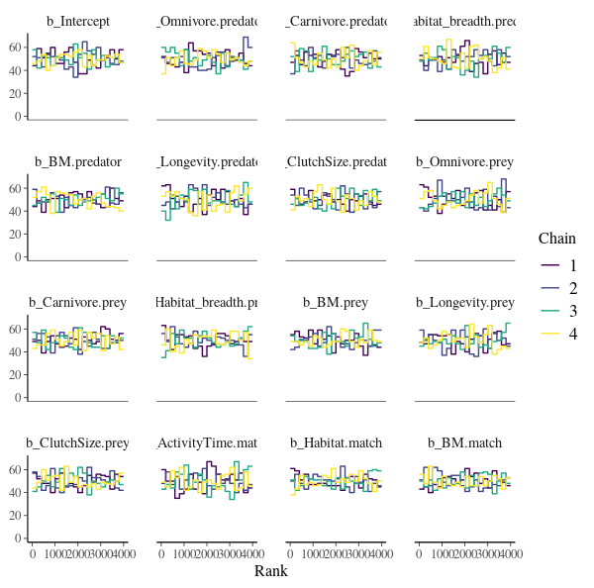

- Posterior predictive checks:
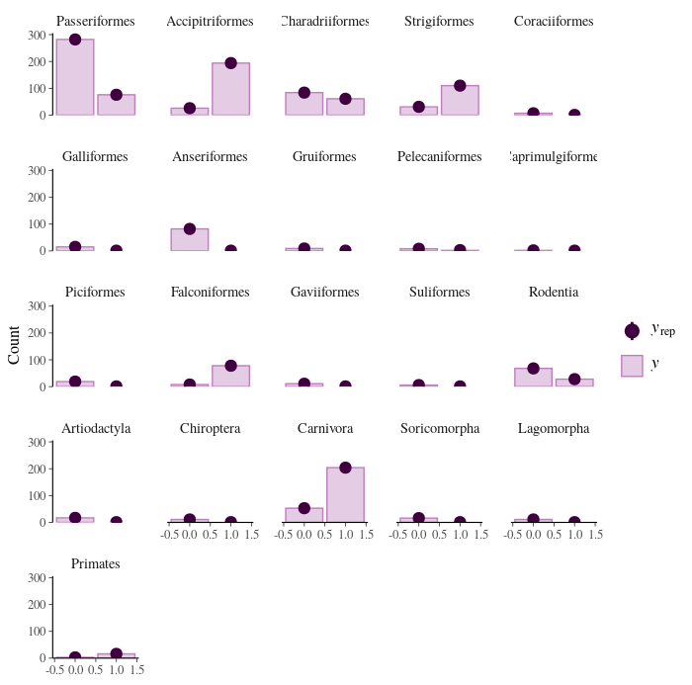

- Rank-normalized potential scale reduction factors on split chains:
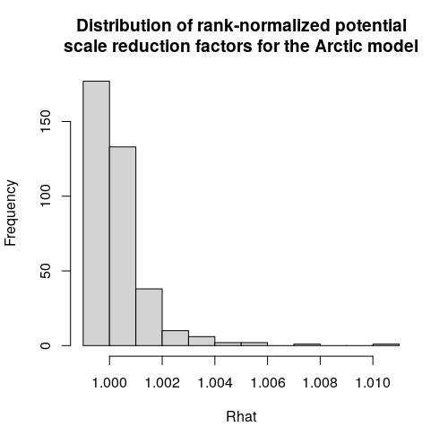
Europe model:
- Rank plots of the population-level effects:
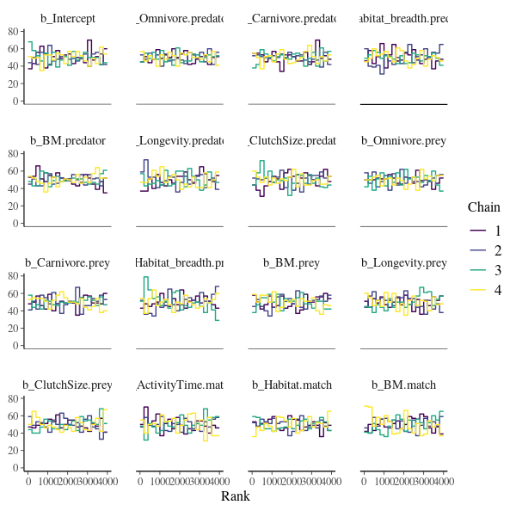

- Posterior predictive checks:
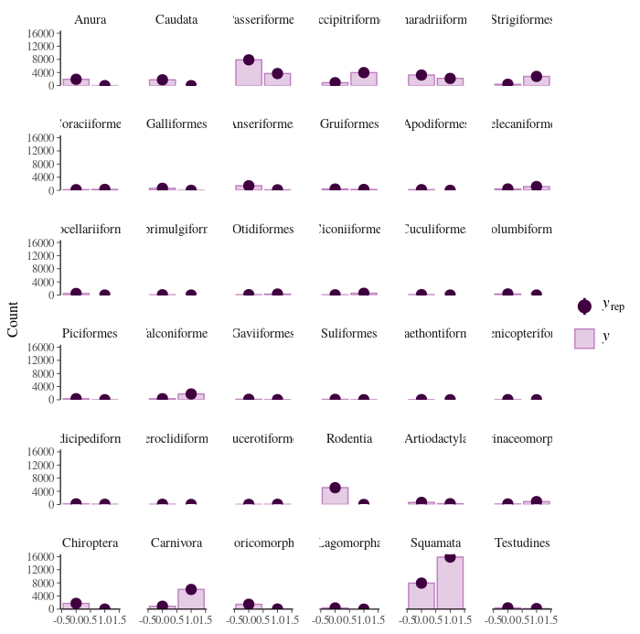

- Potential scale reduction factors:
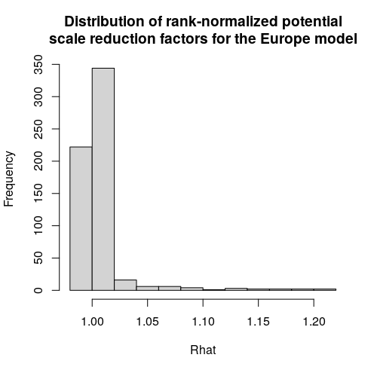

Pyrenees model:
- Rank plots of the population-level effects:

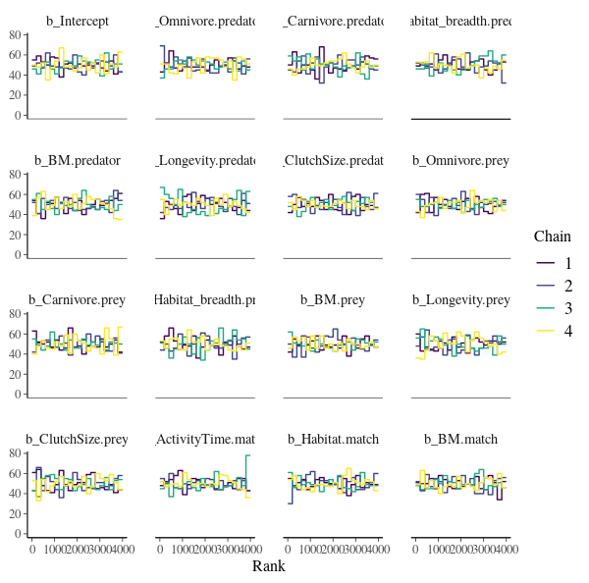

- Posterior predictive checks:
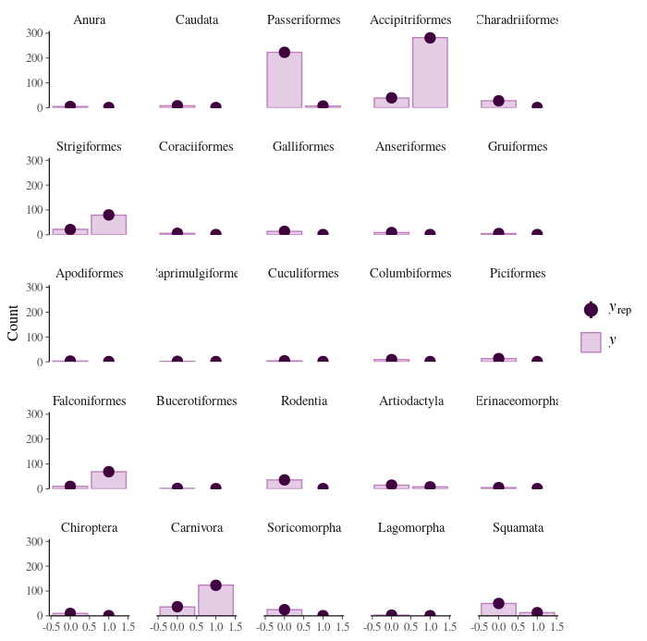

- Potential scale reduction factors:
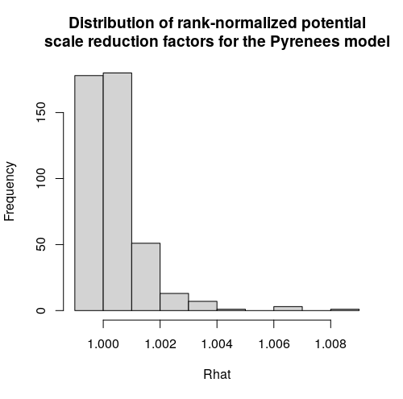
Serengeti model:
- Rank plots of the population-level effects:
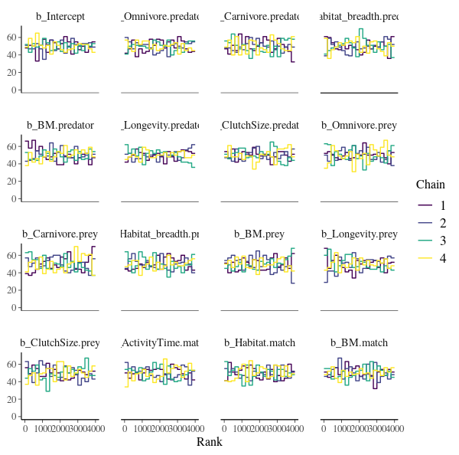

- Posterior predictive checks:
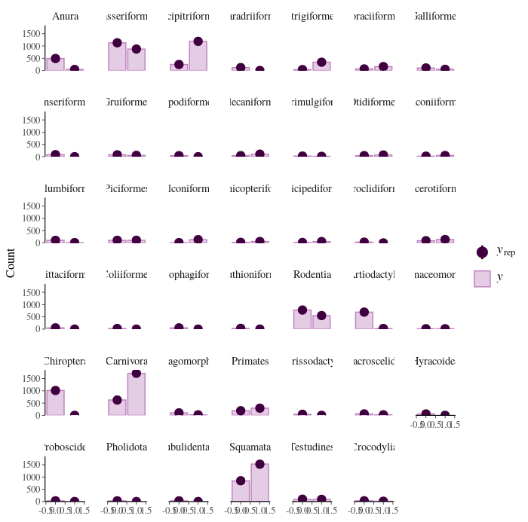
- Potential scale reduction factors:
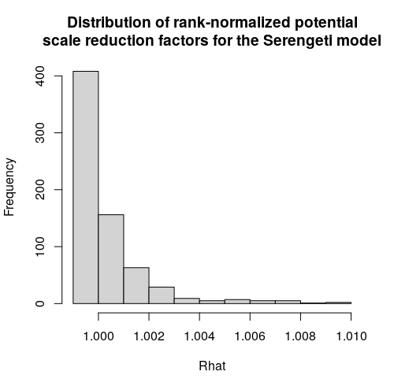
Appendix 6: Predicting species interactions extended results

AUCPR

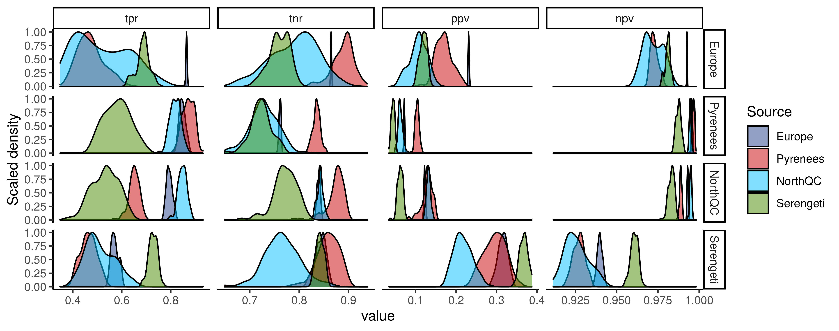
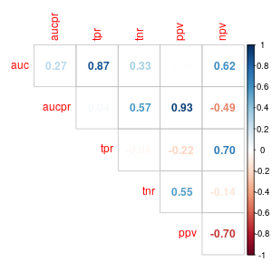

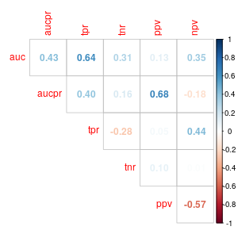
Model performance in relationship with distance:
- Model 1: Total effect of geographic distance on AUC
logitauc ~ geo.dist_sc + (1|Model) + (1|Food web)
fixed effects:
Intercept: Estimate = 1.73, 95% CrI = [0.71, 2.30]
geo.dist_sc: Estimate = -0.54, 95% CrI = [-0.79, -0.30]
random effect:
sd(1|Model): Estimate = 0.38, 95% CrI = [0.01, 1.67]
sd(1|Food web): Estimate = 0.41, 95% CrI = [0.01, 1.160]

- Model 2: Partial effect of geographic distance on AUC
logitauc ~ geo.dist_sc + phylo.dist_sc + env.dist_sc + (1|Model) + (1|Food web)
fixed effects:
Intercept: Estimate = 1.84, 95% CrI = [1.17, 2.26]
geo.dist_sc: Estimate = -0.07, 95% CrI = [-0.48, 0.34]
phylo.dist_sc: Estimate = -0.20, 95% CrI = [-0.63, 0.20]
env.dist_sc: Estimate = -0.36, 95% CrI = [-0.84, 0.17]
random effect:
sd(1|Model): Estimate = 0.25, 95% CrI = [0.01, 0.99]
sd(1|Food web) : Estimate = 0.25, 95% CrI = [0.01, 1.10]

- Model 3: Effect of phylogenetic distance on AUC after controlling for geographic distance
logitauc ~ phylo.dist_sc + geo.dist_sc + (1|Source) + (1|Target)
fixed effects:
Intercept: Estimate = 1.75, 95% CrI = [0.88, 2.29]
geo.dist_sc: Estimate = -0.26, 95% CrI = [-0.59, 0.08]
phylo.dist_sc: Estimate = -0.39, 95% CrI = [-0.78, -0.03]
random effect:
sd(1|Model): Estimate = 0.40, 95% CrI = [0.02, 1.44]
sd(1|Food web) : Estimate = 0.31, 95% CrI = [0.01, 1.24]

- Model 4: Effect of environmental distance on AUC after controlling for geographic distance
logitauc ~ env.dist_sc + geo.dist_sc + (1|Source) + (1|Target)
fixed effects:
Intercept: Estimate = 1.69, 95% CrI = [0.40, 2.23]
geo.dist_sc: Estimate = -0.08, 95% CrI = [-0.49, 0.29]
env.dist_sc: Estimate = -0.52, 95% CrI = [-0.89, -0.11]
random effect:
sd(1|Model): Estimate = 0.23, 95% CrI = [0.01, 1.13]
sd(1|Food web) : Estimate = 0.35, 95% CrI = [0.01, 1.51]

Appendix 7: Predicting species role extended results

Appendix 8: Predicting food web properties extended results

