Edit

* Add pseduocode to flow diagrams
* Justify what ur doing
* Fix the website (footer) and energy page
* Add more tables to the strategy table like maybe a justification or what happens if it does not work
* Change the value of the boxes for the forms
* Maybe do different pages for installations and scehduling
* Research carbon footprint API for code
* Explain the foreign key and stuff because drawsql does not let you change it so yeah make sure you explain that

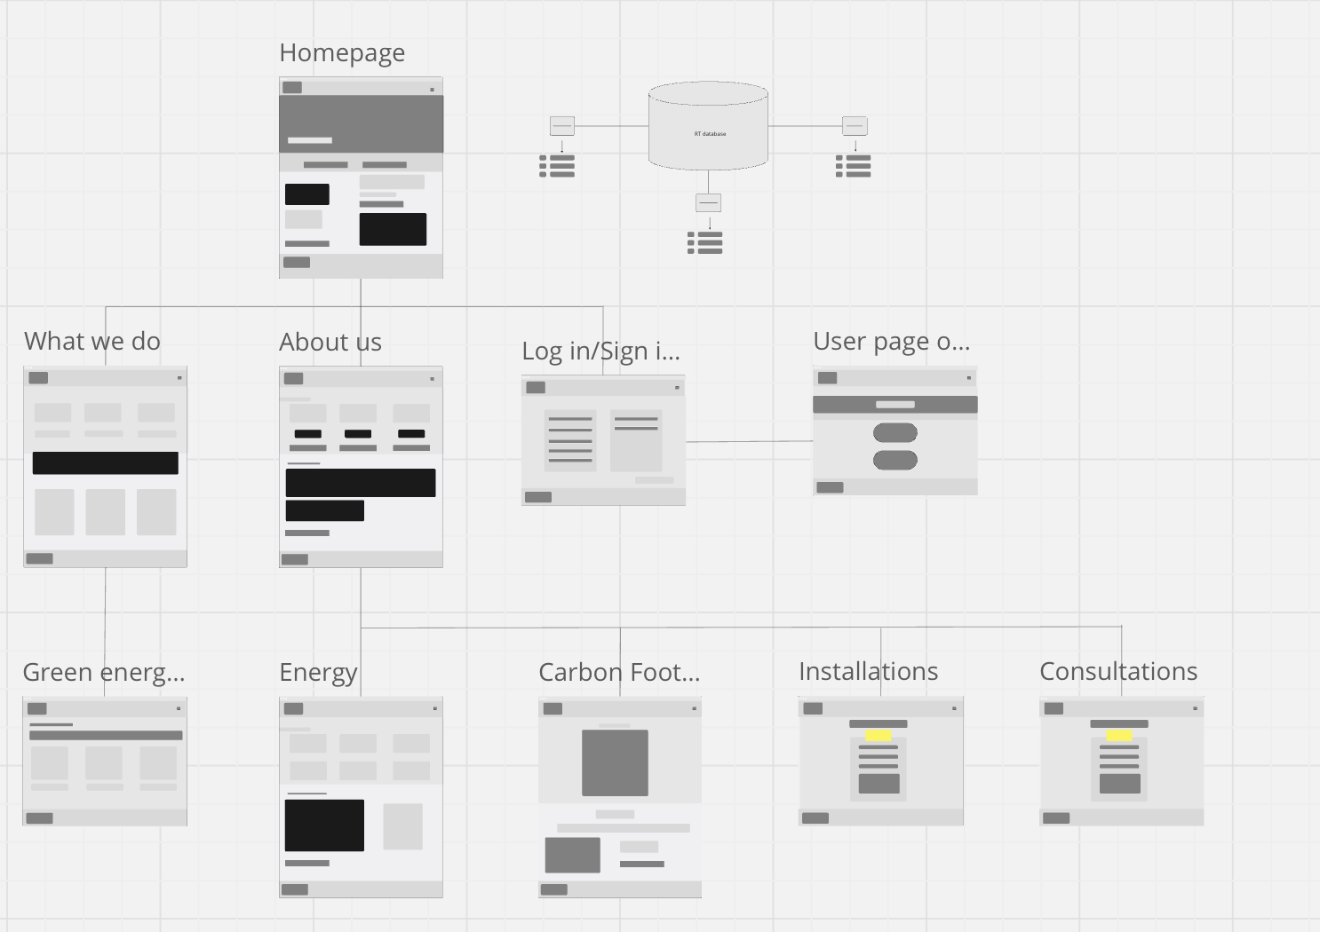

Pseudocode for the booking system either installations or consultations

FUNCTION main() DISPLAY "Energy Consultation and Installation System"

// Get customer input  
customerInput = GET_USER_INPUT("Please choose an option: \n1. Consultation \n2.

Installation")  
  
IF customerInput == 1 THEN  
 getConsultation()  
ELSE IF customerInput == 2 THEN  
 getInstallation()  
ELSE  
 DISPLAY "Invalid choice. Please try again."  
 main() // Restart the process  
END IF

END FUNCTION

FUNCTION getConsultation() DISPLAY "Choose a consultation type: \n1. Information about green energy products \n2. How to reduce your carbon footprint" ctType = GET_USER_INPUT("Enter your choice:")

IF ctType == 1 THEN  
 informationAboutProducts()  
ELSE IF ctType == 2 THEN  
 howToReduceCarbonFootprint()  
ELSE  
 DISPLAY "Invalid choice. Please try again."  
 getConsultation() // Restart the consultation process  
END IF

END FUNCTION

FUNCTION informationAboutProducts() // Provide information about green energy products DISPLAY "Here are some green energy products available in the market..." // (Display product information)

// Store consultation details in the database  
STORE_IN_DATABASE(RT, "Consultation", "Information about green energy products")

END FUNCTION

FUNCTION howToReduceCarbonFootprint() // Provide tips on reducing carbon footprint DISPLAY "Here are some tips to reduce your carbon footprint..." // (Display tips)

// Store consultation details in the database  
STORE_IN_DATABASE(RT, "Consultation", "How to reduce carbon footprint")

END FUNCTION

FUNCTION getInstallation() DISPLAY "Choose an installation type: \n1. Solar Panels \n2. Electric Vehicle Charging Stations \n3. Smart Home Energy Management Systems" installationType = GET_USER_INPUT("Enter your choice:")

IF installationType == 1 THEN  
 installSolarPanels()  
ELSE IF installationType == 2 THEN  
 installEVChargingStations()  
ELSE IF installationType == 3 THEN  
 installSmartHomeSystems()  
ELSE  
 DISPLAY "Invalid choice. Please try again."  
 getInstallation() // Restart the installation process  
END IF

END FUNCTION

FUNCTION installSolarPanels() // Provide installation details for solar panels DISPLAY "Installing solar panels..." // (Provide installation steps)

// Store installation details in the database  
STORE_IN_DATABASE(RT, "Installation", "Solar Panels")

END FUNCTION

FUNCTION installEVChargingStations() // Provide installation details for electric vehicle charging stations DISPLAY "Installing electric vehicle charging stations..." // (Provide installation steps)

// Store installation details in the database  
STORE_IN_DATABASE(RT, "Installation", "Electric Vehicle Charging Stations")

END FUNCTION

FUNCTION installSmartHomeSystems() // Provide installation details for smart home energy management systems DISPLAY "Installing smart home energy management systems..." // (Provide installation steps)

// Store installation details in the database  
STORE_IN_DATABASE(RT, "Installation", "Smart Home Energy Management Systems")

END FUNCTION

FUNCTION STORE_IN_DATABASE(database, type, details) // Code to insert the type and details into the specified database INSERT INTO database (type, details) VALUES (type, details) DISPLAY "Your choice has been recorded in the database." END FUNCTION

// Start the program main()

Justification for the table and if it goes wrong

