**Project Report**

**Smart Shopping List**

**CSTP 2301 - Emerging Technologies**

**Team Members:** Michael Kashkov, Ian McConaghy

**Why did we choose a Smart Shopping list?**

We chose this project for 2301 because it is a good example of how we can train and use the model in real applications with user interface vs command line. Another reason why we feel this application is useful is because shopping more specifically grocery shopping is something we all do on a weekly basis.

**Features and Specifications:**

* Users can type a shopping item into the text field
* Users can then draw a number in the box and using MNIST dataset it will use that number to select the quantity for the item they wrote above
  + This will be then added to the shopping list in a numbered list

**Project Design:**

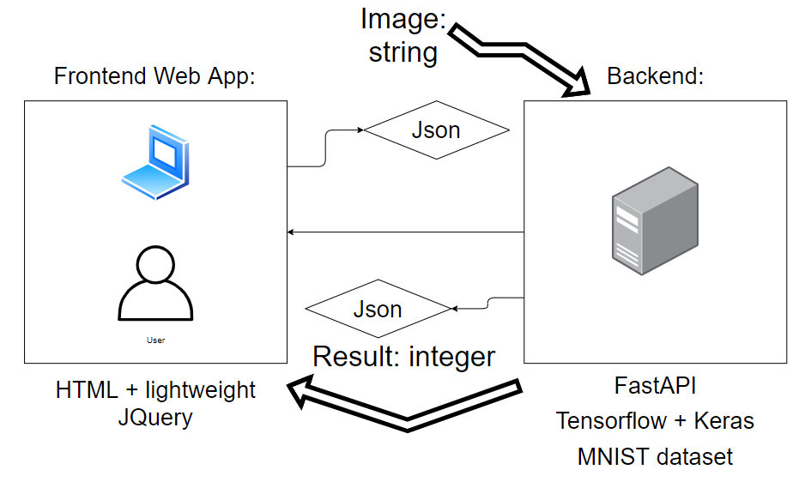

FastAPI is very useful as it supports asynchronous endpoints by default, which can simplify and make your code more efficient. This makes FastAPI a great choice over flask for example. Flask is older and can sometimes be more reliable as it has been tested a lot more; however, with newer more modern frameworks, FastAPI is known for speed with a lot of built-in support.

We used the MNIST dataset for the handwriting portion of our project. This was very useful for our shopping list because it provides the users with a small square for them to input a number between 0 and 9. 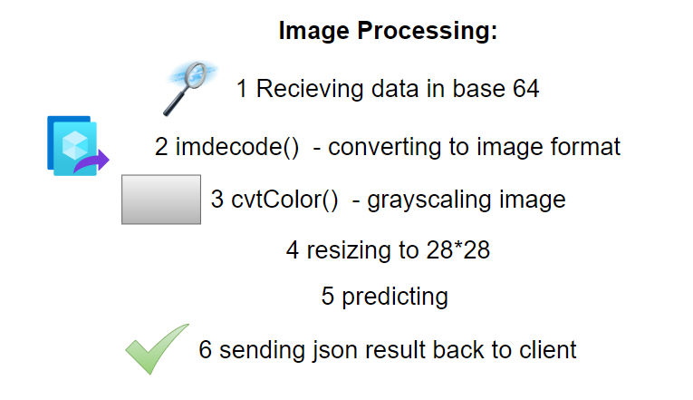

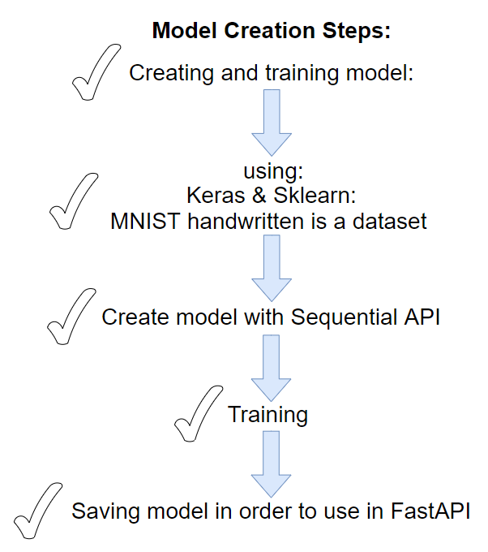

**Screenshots and Test Results:**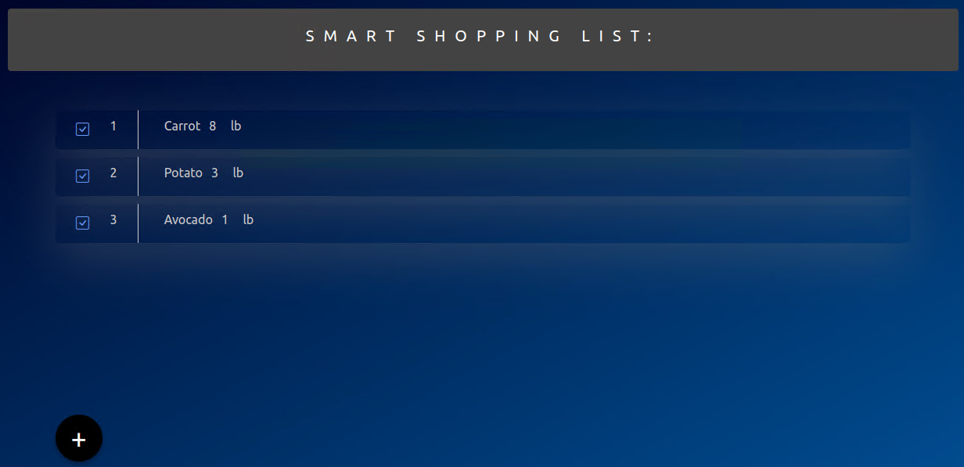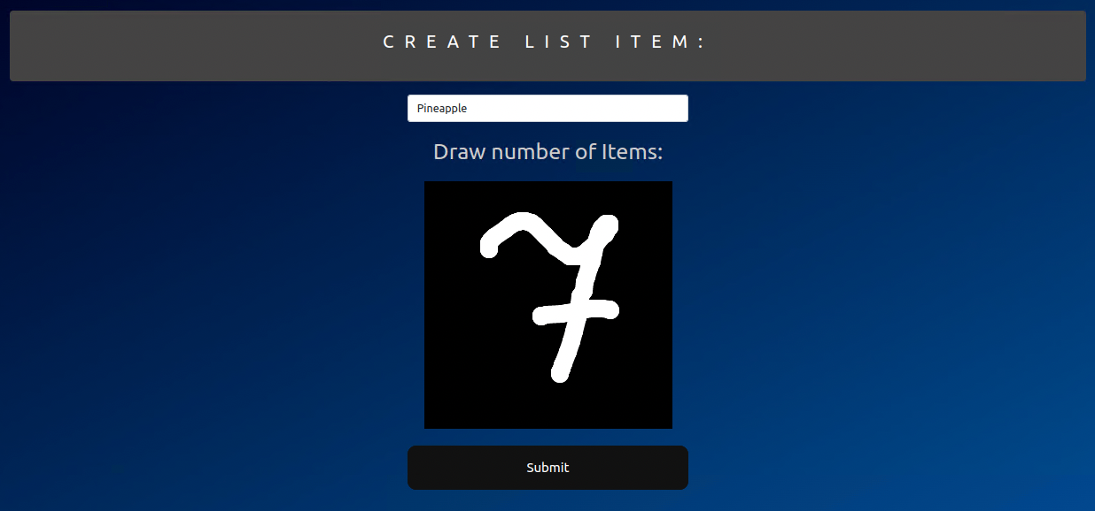

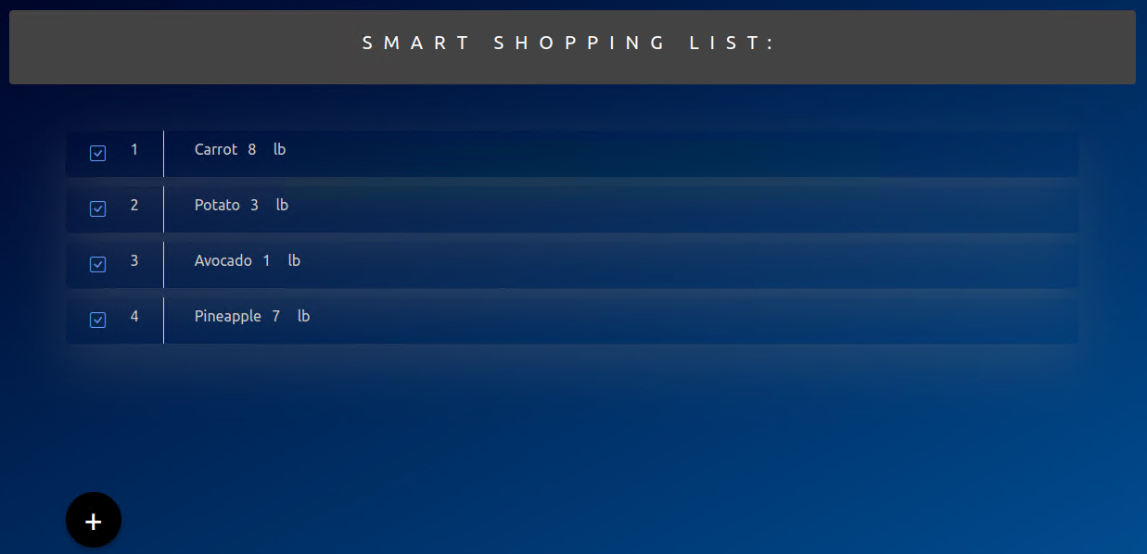

**New Concepts or Insights Learned:**

1. How to create a model
2. How to train model
3. What libraries and packages we needed for our project
4. Where to search for information that was vital for our project
5. Most importantly how to use AI in a real App

**Challenges we faced:**

1. We needed canvas which did not work well in the modern framework in our project case. So we used JQuery instead.
2. Development tool challenges: we were only able to successfully install our setup: Python + FastAPI on the lab Linux VM.
3. Development: The backend project after installation of all libraries is too big for Heroku

**What we are grateful for:**

We are very grateful for the classes and resources that our Instructor Xing Liu provided for us as it immensely helped with the creation of our project as well as the troubleshooting portion of our challenges. This class has been very helpful to use throughout the term as we were given hands-on practical examples and assignments. We were also glad that we got to choose the technologies and the project.

**References:**

Tutorials:

* <https://machinelearningmastery.com/how-to-develop-a-convolutional-neural-network-from-scratch-for-mnist-handwritten-digit-classification/>
* <https://www.analyticsvidhya.com/blog/2021/11/newbies-deep-learning-project-to-recognize-handwritten-digit/>
* <https://docs-snaplogic.atlassian.net/wiki/spaces/SD/pages/479264770/Handwritten+Digit+Recognition+using+Convolutional+Neural+Networks>

Keras:

* <https://keras.io/api/datasets/mnist/>
* Lecture 11 - Keras and CNN - Xing Liu

Sequential Model:

* <https://keras.io/guides/sequential_model/>