TECHNICAL DATA SHEET
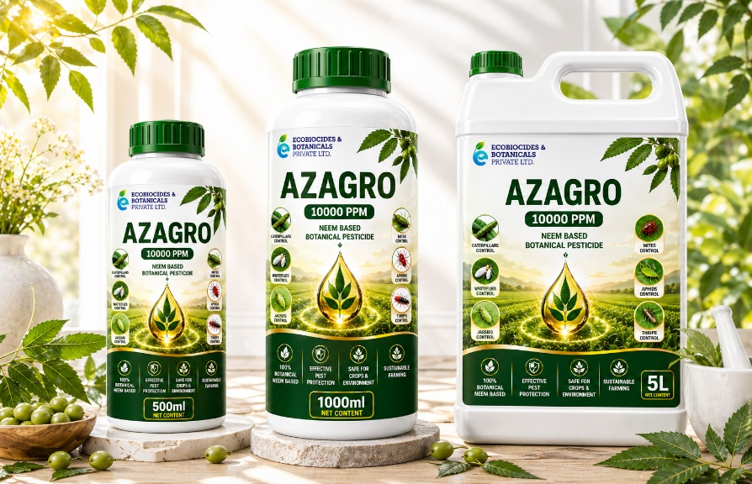

AZAGRO 10000 PPM – Neem Based Botanical Pesticide

Product Overview
AZAGRO 10000 PPM is a premium neem oil based emulsifiable concentrate (EC) containing Azadirachtin 1%. Azadirachtin the active ingredient along with other neem limonoids is effective against both sucking and chewing pest. Derived from cold-pressed neem seed kernels, it provides eco-friendly and effective pest management through anti-feedant, repellent, and insect growth regulating properties.

Key Features & Benefits
- Botanical and eco-friendly formulation
- Anti-feedant and repellent action
- Disrupts pest growth and reproduction
- Safe for crops and beneficial insects
- Suitable for integrated pest management (IPM)
- Reduces chemical pesticide dependency

Composition
Azadirachtin: 1%
Other Ingredients: 99%

Mode of Action
Azadirachtin affects the hormonal system of insects, preventing feeding, moulting and reproduction. It acts as a strong anti-feedant, repellent, and growth inhibitor, thereby reducing pest population effectively.

Target Pests
Aphids, Whiteflies, Thrips, Mites, Mealybugs, Caterpillars and other sucking pests.

Dosage & Application
Foliar Spray:
Apply 0.25 – 0.75 Liters per Acre diluted in 200 – 250 Liters of water.
Soil Drench / Root Application:
Maintain Azadirachtin concentration at 20–30 ppm.
Dilute 25 ml per 1 Liter of water.
Tree injection:
Once in 3 month the 100ml injection can be done 50ml each to be injected at the xylem level from opposite side.
Note: Dosage may vary based on crop stage and pest infestation level.

Physical & Chemical Properties
Appearance: Brownish liquid
Odor: Characteristic neem odor
Formulation: Emulsifiable Concentrate (EC)
Solubility: Emulsifies in water
Stability: Stable under normal storage conditions

Packing & Availability
Available in 100 ml, 250 ml, 500 ml, 1 Liter, 5 Liter and 200 Liter HDPE Drum.

Storage & Shelf Life
Store in a cool, dry and well-ventilated place away from direct sunlight.
Shelf Life: 2 years under recommended storage conditions.

Safety Precautions
Avoid contact with skin and eyes.
Wear protective clothing during handling and application.
Do not ingest. Keep out of reach of children and animals.

Regulatory Information
Registered with Central Insecticides Board (CIB).
BIS Certified Product.
Regn.No.CIR-46,595/2003-AZADIRACHTIN (EC) (238)-646

