 | 

Department of

ARTIFICIAL INTELLIGENCE AND MACHINE LEARNING

Real-Time Marine Vessel Tracking and Route Analytics
By
Project Report

Submitted by

L MORYAKANTHA 1RV24AI406
VINEET RAJ 1RV23AI132
SRIHARI S 1RV23AI106

in partial fulfilment for the requirement of 7th Semester
Stream Processing and Analytics (AI372IA)

Under the Guidance of
Dr.S.Anupama Kumar  Associate Professor  Department of AIML  RV College of Engineering  Bengaluru-59 | Dr.Vijayalakshmi.M.N  Associate Professor  Department of AIML  RV College of Engineering  Bengaluru-59

Academic Year
2026 - 2027

RV College of Engineering®
(Autonomous Institution Affiliated to Visvesvaraya Technological University, Belagavi)

Department of

ARTIFICIAL INTELLIGENCE AND MACHINE LEARNING
Bengaluru– 560059



CERTIFICATE
This is to certify that the work entitled “Real-Time Marine Vessel Tracking and Route Analytics” submitted in partial fulfillment of Stream Processing and Analytics (AI372IA) of VII Semester BE is a result of the bonafide work carried out by L Moryakantha (1RV24AI406), Vineet Raj (1RV23AI132) and Srihari S (1RV23AI106) during the Academic year 2026-27

Faculty In charge Head of the Department
External Examination
Name of Examiners Signature with date
1.
2.

ABSTRACT
Maritime transport carries over 80% of global trade by volume, and the vessels involved continuously broadcast their position, speed and course through the Automatic Identification System (AIS), generating millions of messages per day. Raw AIS data is, however, noisy, irregular and incomplete, which makes it difficult for operators to convert the stream into timely insight about collision risk, port congestion, illegal fishing, AIS spoofing and route inefficiency. Existing commercial tracking platforms mostly provide live positions with rule-based alerts and offer little learned anomaly detection or natural-language access to their results.
This project presents the design of a real-time marine vessel tracking and route analytics system built on open data and open-source stream-processing technology. AIS messages from the AISStream.io live WebSocket feed and from historical NOAA/MarineCadastre and Danish Maritime Authority archives are published to Apache Kafka topics partitioned by vessel identifier (MMSI) and consumed in parallel by a Spark Structured Streaming job, which cleans the data and computes five-minute sliding-window aggregates. Vessel tracks are then reconstructed and enriched with kinematic features that feed LSTM and Transformer models for 30–60 minute trajectory and ETA prediction, rule-based and Isolation Forest anomaly detection, and DBSCAN clustering for route pattern discovery. Results are stored in PostgreSQL/PostGIS, shown on a live dashboard and made queryable in natural language through a Retrieval-Augmented Generation (RAG) assistant backed by a large language model.
Exploratory analysis of the working AIS sample (114,562 records from 450 vessels over 74.7 hours) exposed duplicate messages, invalid coordinates, unphysical speeds, GPS jumps and unreliable navigational-status fields, and showed that vessel behaviour differs strongly by vessel type. These findings drive the cleaning rules, the use of kinematic rather than self-reported features, and the need for vessel-type-specific anomaly thresholds. [Add one or two sentences on the final results (trajectory error, anomaly-detection performance, query latency) once the evaluation is complete, and re-check the figures above against the real NOAA data.]
Keywords: AIS, vessel tracking, Apache Kafka, Spark Structured Streaming, trajectory prediction, anomaly detection, DBSCAN, Retrieval-Augmented Generation

Table of Contents
Contents | Page No
Abstract | i
Table of Contents | ii
List of Tables | iii
List of Figures | iv
1. Introduction | 1
1.1 Project Description | 1
1.2 Report Organization | 2
2. Problem Definition | 3
2.1 Problem Statement | 3
2.2 Background Information (Literature Review) | 3
3. Objectives | 7
3.1 Primary Objectives | 7
4. Tools and Techniques Used | 8
4.1 Tools | 8
4.2 Techniques | 9
4.3 Dataset Description | 10
4.4 System Architecture | 11
5. Implementation | 13
5.1 Code Snippets | 13
6. Results and Discussion | 14
6.1 Final Results | 14
6.2 Discussion | 20
7. Conclusion | 21
8. Future Enhancements | 22
Appendix | 23
Bibliography | 24

List of Tables
Table | Page No
Table 1: Comparison of existing tracking tools with the proposed system | 4
Table 2: Research gaps identified from the literature and the response of this project | 6
Table 3: Tools used in the project and their purpose | 8
Table 4: Primary sources of open AIS data | 10
Table 5: Key attributes of the AIS data | 10
Table 6: Kafka topics used in the pipeline | 12
Table 7: Data-quality issues found in the exploratory analysis and their handling | 16
Table 8: Abbreviations used in this report | 23

List of Figures
Figure | Page No
Figure 1: End-to-end system architecture and data flow | 11
Figure 2: Dataset overview: volume, coverage and vessel population | 14
Figure 3: Vessel type distribution by unique vessels and by AIS messages | 15
Figure 4: Outlier and noise profiling: unphysical speeds, GPS jumps and SOG by vessel type | 16
Figure 5: Reported navigational status versus actual movement, and status inconsistency | 17
Figure 6: Spatial density of traffic: shipping corridors and stationary hotspots | 17
Figure 7: Speed over ground by vessel type (violin plots and overlaid histograms) | 18
Figure 8: Manoeuvring behaviour by vessel type: mean course change and its distribution | 19
Figure 9: Course over ground distribution by vessel type (moving vessels only) | 19

CHAPTER 1

INTRODUCTION
Maritime transport is the backbone of international commerce, and the ability to observe and understand vessel movement in real time has become a basic requirement for safe, efficient and secure operations at sea. This chapter introduces the context of the project, describes the problem that motivates it and outlines the proposed solution. It closes with an overview of how the remainder of the report is organised.

1.1 Project Description
Over 80% of global trade by volume moves by sea [26], and tens of thousands of vessels are at sea at any moment. Most of these vessels carry an Automatic Identification System (AIS) transponder that periodically broadcasts the vessel's identity (the Maritime Mobile Service Identity, or MMSI), its position, speed over ground (SOG), course over ground (COG), heading and navigational status. Collected by coastal receivers and satellites, these broadcasts produce millions of messages per day and form one of the richest real-time sources of information about global shipping.
AIS data is nevertheless difficult to use directly. Raw AIS arrives as a high-velocity stream, reporting intervals are irregular, and the content is noisy and incomplete: messages are duplicated, positions occasionally jump or carry invalid sentinel values, and self-reported fields such as navigational status are often inconsistent with the actual movement of the vessel. Operators who must turn this stream into real-time insight therefore struggle, and the problems this causes include the following:
- Collision and grounding risk, because unusual manoeuvres are noticed late.
- Port congestion and inaccurate arrival times, because estimates are not updated from live movement.
- Illegal fishing, AIS “going dark” (switching the transponder off) and spoofing (broadcasting false positions).
- Route inefficiency and fuel waste, because normal routes between ports are not learned and compared.
This project proposes a real-time system that ingests live AIS data, tracks vessels, predicts their trajectories 30–60 minutes ahead, detects anomalies and analyses routes. The system is built around open and widely used stream-processing components. Apache Kafka provides event-driven ingestion, Spark Structured Streaming performs cleaning and windowed analytics, machine-learning models handle prediction, anomaly detection and clustering, PostgreSQL/PostGIS stores the results, and a live dashboard presents them. A Retrieval-Augmented Generation (RAG) assistant lets users ask questions in natural language, for example, “Which tankers deviated from their usual route near Singapore today?”.
The work is carried out as the project component of the course Stream Processing and Analytics (AI372IA). The first phase, which is the basis of this report, covers problem identification, a literature survey, selection and exploratory analysis of AIS data, and the design of the end-to-end architecture. [Update this paragraph to describe the final status of the implementation and evaluation.]

1.2 Report Organization
The remainder of this report is organised as follows:
- Chapter 2 (Problem Definition) states the problem, explains its relevance, and reviews existing systems and the research literature to identify the gaps this project addresses.
- Chapter 3 (Objectives) lists the primary objectives and the expected outcomes of the project.
- Chapter 4 (Tools and Techniques Used) describes the software tools, the machine-learning and stream-processing techniques, the datasets, and the overall system architecture.
- Chapter 5 (Implementation) presents the implementation of each pipeline module with code snippets.
- Chapter 6 (Results and Discussion) presents the exploratory data analysis and the evaluation results, and discusses whether the objectives were met.
- Chapter 7 (Conclusion) summarises the work and its contribution.
- Chapter 8 (Future Enhancements) outlines directions for extending the system.
- The Appendix lists the abbreviations used, and the Bibliography lists the references cited.
CHAPTER 2

PROBLEM DEFINITION
A useful tracking system must do more than draw ship positions on a map. It has to clean a noisy stream, keep a consistent track for every vessel, anticipate where each vessel is going, recognise behaviour that departs from the norm and allow people to ask questions about what is happening. This chapter states the problem the project addresses and then reviews existing systems and the research literature that form its background.

2.1 Problem Statement
Real-time maritime situational awareness depends on turning a noisy, high-velocity AIS stream into reliable tracks, predictions and alerts. Analysis of existing practice and of the AIS data itself identified the following specific difficulties:
- AIS messages are irregular and contain gaps, duplicates and GPS jumps.
- Short-term trajectory prediction is hard, because ships turn, slow down and change routes.
- Rule-based anomaly detection gives many false alarms.
- Route patterns, such as shipping lanes and port-to-port passages, are not learned automatically.
- No single open pipeline combines real-time streaming, prediction, anomaly detection and analytics.
- Operators cannot ask questions such as “Which tankers deviated from their usual route near Singapore today?”.
The problem addressed by this project is therefore stated as follows: design and build a real-time system that ingests streaming AIS data and tracks vessels; predicts their future trajectories and arrival times; detects abnormal behaviour; discovers route patterns; presents the results on a live dashboard; and lets users query them in natural language.
The problem is important in a real-world context because the consequences of poor maritime awareness are serious and costly. Late detection of unusual manoeuvres increases collision and grounding risk, inaccurate arrival estimates worsen congestion at ports and anchorages, undetected AIS gaps and spoofing hide illegal fishing and other illicit activity, and unoptimised routes waste fuel and increase emissions. An open, integrated and explainable pipeline lowers the barrier to such analysis, since advanced analytics are currently available mainly through paid, closed platforms.

2.2 Background Information (Literature Review)
This section reviews the tools in use today and the research literature on route discovery, trajectory prediction, anomaly detection, visual tracking, graph models and retrieval-augmented generation. In total, twenty-five works were studied; they are cited by number and listed in the Bibliography.

2.2.1 Existing systems
Commercial services such as MarineTraffic, VesselFinder and FleetMon display vessel positions on a map, and coast-guard and port vessel traffic services (VTS) combine radar with AIS. Their strengths are live positions, vessel details and basic history. Their alerts, however, are limited to rules such as geofence crossings and speed thresholds, they handle noisy, missing or spoofed AIS poorly, they do not offer natural-language querying, and their advanced analytics sit behind paid, closed platforms. Table 1 compares these systems with the proposed one.
Table 1: Comparison of existing tracking tools with the proposed system
Aspect | Existing tools | Proposed system
Live vessel positions | Yes | Yes, on a live dashboard
Alerts | Rule-based (geofence, speed threshold) | Rules plus Isolation Forest, with per-vessel-type behaviour
Unusual behaviour | Little automatic detection | Automatic detection of route deviation, sudden stops and AIS gaps
Noisy or spoofed AIS | Poorly handled | Cleaning, GPS-jump and impossible-speed checks in the stream
Prediction | Limited | 30–60 minute trajectory and ETA prediction (LSTM, Transformer)
Route patterns | Not learned automatically | Learned by DBSCAN clustering
Querying | Map and filter interfaces | Natural-language queries through RAG and an LLM
Access | Paid, closed platforms | Open data and open-source components

2.2.2 Route pattern discovery
Pallotta et al. [1] proposed an unsupervised method (TREAD) that extracts traffic routes from historical AIS data and uses them for anomaly detection and route prediction. It relies on statistical and clustering rules and therefore cannot capture complex temporal patterns. Sheng and Yin [7] applied trajectory clustering to discover shipping route patterns, but their method is an offline batch process that is sensitive to its parameters. Kontopoulos et al. [8] presented a distributed framework that scales traffic-pattern extraction to large datasets, although it concentrates on patterns rather than on prediction or live use. Murray and Perera [6] first cluster trajectories and then apply a regional BiLSTM to predict behaviour, but the approach is region-specific and its clustering step is fixed. The density-based algorithm DBSCAN [11] underlies much of this work because it finds arbitrarily shaped clusters and treats sparse points as noise; its limitations are fixed parameters and the absence of a time dimension.

2.2.3 Trajectory prediction
Classical tracking uses the Kalman filter [14], which gives optimal recursive state estimation but assumes linear motion and Gaussian noise, assumptions that vessel turns and speed changes violate. Recurrent neural networks overcome this by learning from data. Forti et al. [4] used an encoder–decoder (sequence-to-sequence) recurrent network for vessel trajectory prediction, though for short horizons and without interaction between vessels. Capobianco et al. [5] compared recurrent models and produced uncertainty estimates, but did not use environmental or port context. These models build on the Long Short-Term Memory (LSTM) unit [12], which learns long-range dependencies but trains slowly and sequentially and is weaker than Transformers on long sequences.
Transformers [13] replaced recurrence with self-attention, at a cost that grows quadratically with sequence length and with the need to adapt them to geospatial data. TrAISformer [3] adapts the Transformer to AIS by discretising positions into a “four-hot” encoding and beats LSTM baselines, but it needs heavy computation, has no live streaming component and was evaluated on limited regions. Gradient-boosted trees such as XGBoost [15] are strong on tabular data but do not model sequences directly and need engineered features.

2.2.4 Anomaly detection
Riveiro et al. [9] survey maritime anomaly detection (statistical, clustering and rule-based methods) and Wolsing et al. [10] review recent machine-learning approaches. Both note the absence of a common benchmark and the scarcity of labelled ground-truth anomalies, which makes supervised learning impractical. GeoTrackNet [2] uses a probabilistic neural network (a variational recurrent network) with a-contrario detection to find anomalies in AIS tracks, but it performs detection only, works offline and is tuned for one region. Unsupervised methods such as Isolation Forest therefore suit this problem, because they do not require labelled anomalies.

2.2.5 Visual detection and multi-object tracking
A separate line of work tracks ships in camera imagery. YOLO [16] is a real-time single-stage detector that struggles with small objects such as distant ships; SeaShips [17] is a benchmark of annotated ship images from coastal surveillance cameras, mostly nearshore with limited weather and night variety. For tracking, SORT [18] combines a Kalman filter with Hungarian assignment but suffers identity switches under occlusion, DeepSORT [19] adds appearance embeddings to reduce these switches at the cost of extra computation, and ByteTrack [20] also associates low-confidence detections to reach state-of-the-art accuracy, though it was built for video. The transformer detectors DETR [21] and Swin Transformer [22] are further strong backbones that need long training or large amounts of data. These methods are complementary to the AIS-based approach followed here and are noted as a possible extension.

2.2.6 Graph models and retrieval-augmented generation
Graph convolutional networks [23] learn on graph-structured data but are designed for static graphs rather than streams. Graph WaveNet [24] models spatio-temporal traffic on road networks, and its use for ports and sea lanes is still open. Retrieval-Augmented Generation [25] combines a retrieval component with a generator so that answers are grounded in data; it has been proven in knowledge-intensive language tasks but has not yet been applied to live maritime data and analytics queries.

2.2.7 Summary of research gaps
The literature shows that clustering (DBSCAN, TREAD) is used for route discovery, recurrent and Transformer models for trajectory prediction, variational and statistical methods for anomaly detection, and detection–tracking pipelines for visual tracking. The gaps that remain, and the way this project responds to each, are summarised in Table 2.
Table 2: Research gaps identified from the literature and the response of this project
Research gap | Response in this project
Most work is offline and batch; real-time streaming is rare | Kafka and Spark Structured Streaming pipeline with five-minute sliding windows
Prediction, anomaly detection and route analytics are studied separately | One pipeline that produces all three from the same reconstructed tracks
Models are trained on one region and do not generalise | Second region (Danish Maritime Authority data) used for generalisation testing
Labelled anomaly data is scarce | Unsupervised Isolation Forest combined with explainable rules
Transformers are promising but few live systems are deployed | LSTM and Transformer compared inside a streaming system
No natural-language interface for maritime analytics | RAG-based assistant over database and stream state

CHAPTER 3

OBJECTIVES
The problem defined in Chapter 2 is broad, so it is broken down into a small number of measurable objectives that together cover the whole path from raw AIS messages to an answer given to an operator. This chapter lists these objectives and the outcomes expected from meeting them.

3.1 Primary Objectives
The primary objectives of the project are:
- Real-time pipeline. To build a real-time pipeline that ingests live AIS data, cleans it and reconstructs vessel tracks.
- Trajectory prediction. To predict short-term vessel trajectories (30–60 minutes ahead) with LSTM and Transformer models and to compare the two.
- Anomaly detection and route discovery. To detect anomalies (route deviation, sudden stops and AIS gaps) and to discover route patterns by clustering.
- Dashboard and natural-language access. To provide a live dashboard with a natural-language query assistant (RAG and LLM) and to evaluate its accuracy and latency.
Meeting these objectives is expected to give the following outcomes: a clean and continuously updated picture of vessel movement; trajectory and ETA forecasts whose error is measured and compared across two model families; alerts that distinguish genuinely unusual behaviour from normal behaviour of the vessel type concerned; a set of learned shipping-lane clusters; and a user interface through which non-specialists can query all of this in plain language. [Add measurable targets here, for example the target trajectory error, alert precision and end-to-end latency.]
CHAPTER 4

TOOLS AND TECHNIQUES USED
This chapter describes the building blocks of the system. It lists the software tools and explains the purpose of each, describes the techniques applied at every stage and the reasons for choosing them, presents the datasets and finally brings everything together in the overall system architecture.

4.1 Tools
The system is built entirely from open components, summarised in Table 3. Hardware and runtime details are given in the last row for completeness.
Table 3: Tools used in the project and their purpose
Tool | Purpose in this project
AISStream.io (WebSocket) | Source of the live AIS feed used for real-time demonstration
Python | Implementation language for the Kafka producer, feature engineering, models and analysis scripts
Apache Kafka | Distributed event broker; receives AIS events on topic ais_raw and publishes alerts on topic ais_alerts; provides partitioning, replication and offset storage
Spark Structured Streaming | Real-time cleaning, validation, sliding-window aggregation and feature computation over the Kafka stream
LSTM and Transformer models | Prediction of vessel trajectory and ETA 30–60 minutes ahead
Isolation Forest and rule engine | Machine-learning and rule-based anomaly detection with alerts
DBSCAN | Density-based clustering of historical trajectories into shipping-route clusters
PostgreSQL / PostGIS | Storage of current vessel state, predicted trajectories, anomalies and aggregated statistics, with spatial queries
Historical database | Cleaned AIS data, route clusters and model-training datasets
Live dashboard | Map-based visualisation of vessels, anomalies, predicted routes and shipping lanes
LLM with RAG | Natural-language query interface that generates queries over the database and stream state and phrases the answer
[Deep-learning framework] | [Fill in: framework and version used for the LSTM and Transformer models]
[Dashboard framework] | [Fill in: web framework and map library used for the dashboard]
[LLM and vector store] | [Fill in: model, embedding method and vector store used for RAG]
[Hardware / environment] | [Fill in: machine specification, operating system and deployment setup]

4.2 Techniques
The techniques applied at each stage of the pipeline, and the reasons for choosing them, are described below.

4.2.1 Event-driven ingestion and partitioning
AIS events are published to Kafka partitioned by MMSI. Because all messages of a vessel land in the same partition, their order is preserved, which is essential for track reconstruction, while different vessels are processed in parallel. A consumer group (ais-processing-group) spreads the partitions across consumers, rebalances automatically when a consumer fails and resumes from offsets stored in Kafka, giving an at-least-once processing guarantee and fault tolerance without custom code.

4.2.2 Stream cleaning and windowed aggregation
Spark Structured Streaming applies the cleaning steps that the exploratory analysis showed to be necessary: removing duplicates, handling missing values, validating latitude and longitude ranges, checking for impossible speeds, detecting GPS jumps, normalising timestamps, identifying AIS gaps and sorting by timestamp. Aggregates are then computed over a five-minute sliding window that advances every minute, so that dashboard figures such as the number of active vessels, average speed, vessel counts by type, vessel density per region or grid cell, anomaly counts and top ports are refreshed continuously without waiting for a batch to complete.

4.2.3 Track reconstruction and feature engineering
A recent history is kept for every MMSI and used to derive kinematic features: distance travelled, average speed, acceleration or deceleration, change in course, turning rate, time since the last message, deviation from the learned route and AIS gap duration. Kinematic features are used in preference to self-reported fields because the analysis in Chapter 6 shows the navigational status field to be unreliable.

4.2.4 Trajectory prediction with LSTM and Transformer models
The input to the prediction models is the last 20–30 AIS points of a vessel (latitude, longitude, SOG, COG, heading, time and related features), and the output is the predicted future positions 30–60 minutes ahead. An LSTM [12] is used as the recurrent baseline because it learns long-range dependencies, and a Transformer [13], following the direction of TrAISformer [3], is used to test whether self-attention improves accuracy. Comparing the two within the same pipeline addresses a gap in the literature, where Transformers have rarely been evaluated in live systems. [Fill in the model hyper-parameters, loss function and training/validation split.]

4.2.5 ETA prediction
The estimated time of arrival is obtained by combining the predicted trajectory and the current vessel speed with the destination reported in AIS, computing the remaining distance and time, and comparing the result with the ETA broadcast in AIS when it is available.

4.2.6 Anomaly detection
Two complementary detectors are used. The rule-based detector runs in real time and flags speeds above a threshold, sudden stops, large course changes, route deviation, AIS gaps (going dark) and entry into restricted areas. The Isolation Forest detector is an unsupervised model that scores each vessel state using speed, acceleration, course change, route deviation, AIS gap duration and context features, and produces an anomaly score and alert. Isolation Forest was chosen because labelled anomalies are scarce [10], and because it isolates unusual points quickly without assumptions about their distribution. Alerts are published to the ais_alerts topic with a type and severity.

4.2.7 Route pattern discovery with DBSCAN
Historical AIS trajectories are clustered with DBSCAN [11] to obtain shipping-route clusters, that is, the common routes and lanes between ports. DBSCAN does not need the number of clusters in advance, can find arbitrarily shaped lanes and labels isolated points as noise. The traffic-density map in Chapter 6 shows clear lanes between ports and tight hotspots at ports and anchorages, which supports this choice. [Fill in the DBSCAN parameters (eps, min_samples) and the distance measure used.]

4.2.8 Natural-language querying with RAG
A user question is passed to a large language model that is grounded through Retrieval-Augmented Generation [25]. The model generates a query (filters and analytics) over the PostgreSQL/PostGIS database and the stream state, and the retrieved results are turned into a natural-language answer, for example, “3 tankers deviated from their usual route near Singapore today” followed by their details.

4.3 Dataset Description
The project uses open AIS data from three sources, listed in Table 4. The NOAA/MarineCadastre archive is used for offline training and exploratory analysis, the Danish Maritime Authority data provides a second region for testing generalisation, and the AISStream.io feed is used for the real-time demonstration.
Table 4: Primary sources of open AIS data
Source | Use
NOAA / MarineCadastre AIS (US coastal waters, daily CSV) | Offline training and EDA
Danish Maritime Authority AIS (open) | Second region, for generalisation testing
AISStream.io live WebSocket feed | Real-time demonstration

The key attributes of an AIS record used in the project are given in Table 5.
Table 5: Key attributes of the AIS data
Attribute | Description
MMSI | Maritime Mobile Service Identity; the vessel identifier used as the Kafka partition key
Timestamp | Time at which the message was received or recorded
Latitude, Longitude | Vessel position in decimal degrees
SOG | Speed over ground, in knots
COG | Course over ground, in degrees
Heading | Direction in which the bow is pointing
Vessel type | Class of vessel (cargo, tanker, passenger, tug/tow, fishing, pleasure, other)
Length, width, draught | Physical dimensions of the vessel
Navigational status | Self-reported status such as under way, at anchor or moored
Destination, ETA | Declared destination and estimated time of arrival
IMO number | International Maritime Organization ship identification number

4.4 System Architecture
Figure 1 shows the end-to-end architecture, which has thirteen stages. Data acquisition (stage 1) supplies AIS events from the live WebSocket and the historical CSV files. A Python producer publishes them to Kafka (stage 2), where the topic ais_raw carries raw AIS events and the topic ais_alerts carries detected anomalies, both partitioned by MMSI. A consumer group processes the partitions in parallel with load balancing and fault tolerance (stage 3). Spark Structured Streaming cleans the data and applies five-minute sliding windows (stage 4), and real-time aggregation produces summaries such as active vessels, average speed, counts by vessel type, vessel density, anomaly counts and top ports (stage 5).
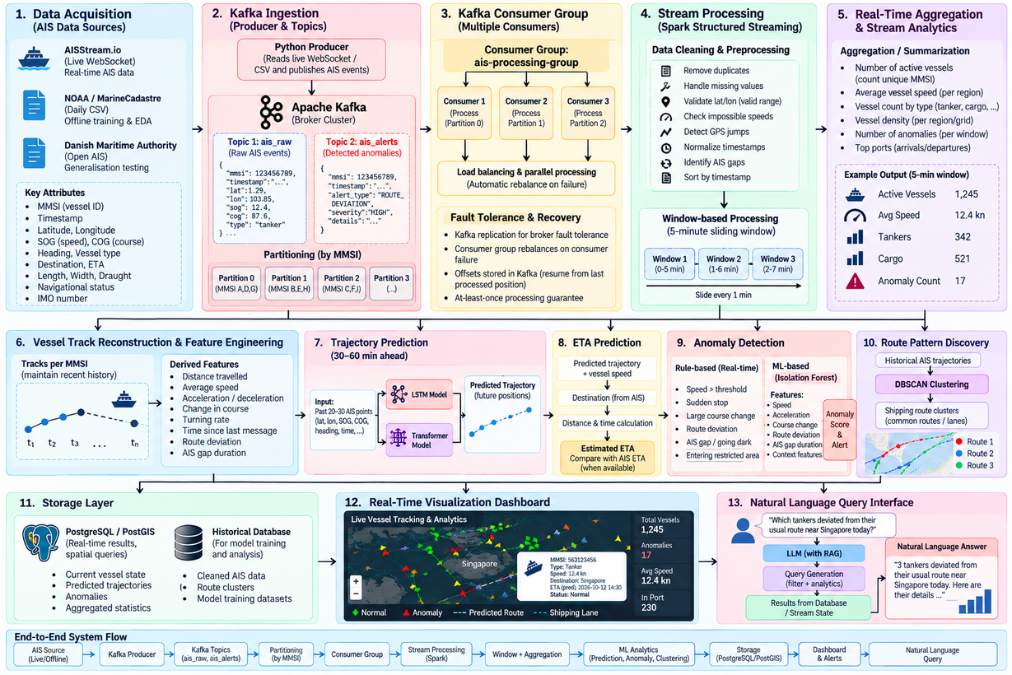
Figure 1: End-to-end system architecture and data flow
Tracks are reconstructed per MMSI and features are engineered (stage 6) before the analytics modules run: trajectory prediction 30–60 minutes ahead (stage 7), ETA prediction (stage 8), rule-based and Isolation Forest anomaly detection (stage 9) and DBSCAN route pattern discovery (stage 10). Results are stored in PostgreSQL/PostGIS for real-time spatial queries and in a historical database for model training and analysis (stage 11), shown on the real-time dashboard (stage 12) and exposed through the natural-language query interface (stage 13). The two Kafka topics are summarised in Table 6.
Table 6: Kafka topics used in the pipeline
Topic | Content | Partitioning
ais_raw | Raw AIS events: MMSI, timestamp, latitude, longitude, SOG, COG, vessel type | By MMSI (partitions 0–3)
ais_alerts | Detected anomalies: MMSI, timestamp, alert type (for example ROUTE_DEVIATION), severity and details | By MMSI

CHAPTER 5

IMPLEMENTATION
This chapter describes how the architecture of Chapter 4 is implemented. The implementation follows the data flow of the pipeline, from ingestion through stream processing and analytics to storage, visualisation and querying. Phase 1 completed the literature survey, the acquisition and exploratory analysis of the AIS data and the architecture design. [Update this paragraph to state what has been implemented and tested.]

5.1 Code Snippets

5.1.1 AIS ingestion and Kafka producer
Reads messages from the AISStream.io WebSocket (or from historical CSV files), serialises them as JSON and publishes them to the ais_raw topic keyed by MMSI.
[Insert code snippet here (use a monospaced block or screenshot) and explain the key lines.]

5.1.2 Stream cleaning and windowed aggregation
Spark Structured Streaming job that removes duplicates, validates coordinates and speeds, detects GPS jumps and AIS gaps, and computes five-minute sliding-window aggregates.
[Insert code snippet here (use a monospaced block or screenshot) and explain the key lines.]

5.1.3 Track reconstruction and feature engineering
Maintains a recent history per MMSI and derives the kinematic features used by the models.
[Insert code snippet here (use a monospaced block or screenshot) and explain the key lines.]

5.1.4 Trajectory and ETA prediction
LSTM and Transformer models trained on windows of 20–30 AIS points to predict positions 30–60 minutes ahead, and the ETA calculation.
[Insert code snippet here (use a monospaced block or screenshot) and explain the key lines.]

5.1.5 Anomaly detection
Rule-based checks and the Isolation Forest model, with alerts published to the ais_alerts topic.
[Insert code snippet here (use a monospaced block or screenshot) and explain the key lines.]

5.1.6 Route pattern discovery
DBSCAN clustering of historical trajectories into shipping-route clusters.
[Insert code snippet here (use a monospaced block or screenshot) and explain the key lines.]

5.1.7 Storage and dashboard
Writing results to PostgreSQL/PostGIS and serving them to the live dashboard.
[Insert code snippet here (use a monospaced block or screenshot) and explain the key lines.]

5.1.8 Natural-language query interface
RAG pipeline and LLM that convert a question into a database query and phrase the answer.
[Insert code snippet here (use a monospaced block or screenshot) and explain the key lines.]
CHAPTER 6

RESULTS AND DISCUSSION
This chapter presents the results obtained so far and discusses their meaning. The exploratory data analysis (EDA) of the AIS sample is reported first, because it characterises the data, quantifies its quality problems and justifies several design decisions. Placeholders are provided for the evaluation results of the prediction, anomaly-detection, clustering and query modules.

6.1 Final Results
[NOTE BEFORE SUBMISSION: the EDA plots reused from the Phase 1 presentation are labelled “illustrative simulated AIS data (NOAA-style schema)” in their footer. Regenerate them from the real NOAA/MarineCadastre CSV and update the numbers quoted in this section, in the Abstract and in Table 7.]

6.1.1 Dataset overview
Figure 2 summarises the volume, coverage and vessel population of the working sample. It contains 114,562 records from 450 unique vessels (MMSI) spanning 74.7 hours, from 2024-01-15 00:02:10 to 2024-01-18 02:44:44. Positions lie between latitudes 26.90 and 30.53 and longitudes −97.46 and −82.54, which covers the northern Gulf of Mexico. A vessel sends a median of 225 messages and the median reporting gap is 94 seconds. Duplicate messages make up 1.19% of the records, 36 records have invalid coordinates, and seven vessel classes are present.
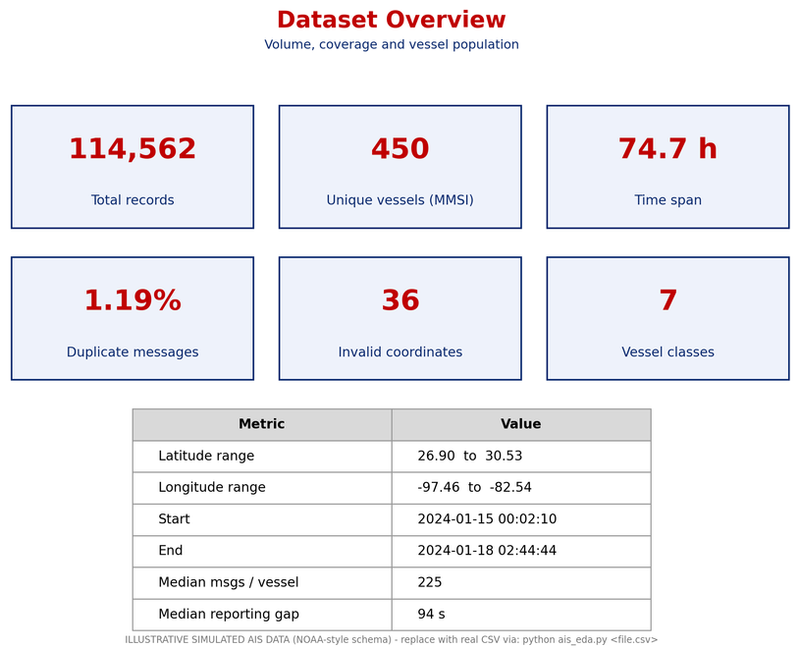
Figure 2: Dataset overview: volume, coverage and vessel population

6.1.2 Vessel type distribution
Figure 3 shows the share of unique vessels and of AIS messages by vessel type. Cargo vessels are the largest group (30.2% of vessels and 30.8% of messages), followed by tankers (19.1% and 18.2%). Together, cargo vessels and tankers account for about 49% of both vessels and messages. The small-craft classes (tug/tow, fishing and pleasure craft) account for 39.1% of vessels and 37.9% of messages, passenger vessels for 4.7% and 4.4%, and other vessels for 6.9% and 8.7%. The close agreement between vessel and message shares shows that no single type dominates the message volume.
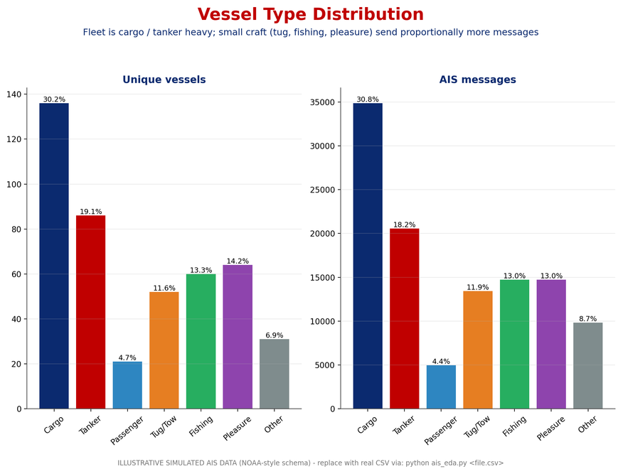
Figure 3: Vessel type distribution by unique vessels and by AIS messages

6.1.3 Outliers and noise
Figure 4 profiles the noise in the data. The reported SOG shows an unphysical tail: 182 messages (0.16%) report more than 50 knots, and the box plots show such outliers in every vessel type. Computing the speed implied by consecutive positions reveals 2,447 messages (2.16%) that imply a jump of more than 60 knots, the signature of GPS jumps. In addition, 36 rows carry sentinel values (latitude 91 and longitude 181) that mark an invalid position. These findings define the validation rules applied in the Spark cleaning stage; Table 7 lists them together with the other data-quality issues found.
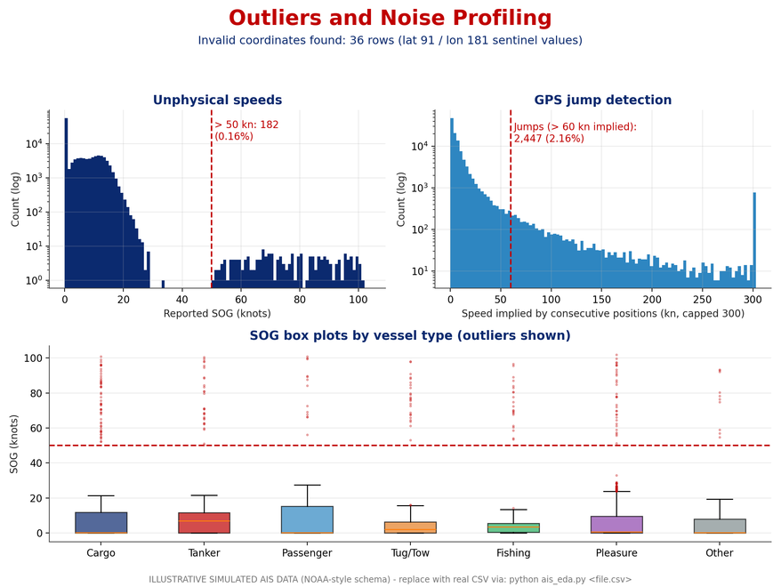
Figure 4: Outlier and noise profiling: unphysical speeds, GPS jumps and SOG by vessel type
Table 7: Data-quality issues found in the exploratory analysis and their handling
Issue | Observed | Handling in the pipeline
Duplicate messages | 1.19% of records | Remove duplicates in Spark
Invalid coordinates (lat 91 / lon 181) | 36 records | Validate latitude and longitude ranges
Unphysical SOG (> 50 kn) | 182 messages (0.16%) | Impossible-speed check
GPS jumps (implied speed > 60 kn) | 2,447 messages (2.16%) | GPS-jump detection from consecutive positions
‘Under way’ status but stationary | 15.9% of such messages | Use kinematic features, not the status field
‘Anchored/moored’ status but moving > 2 kn | 1.5% of such messages | Use kinematic features, not the status field
‘Undefined’ navigational status | 9.1% of messages | Use kinematic features, not the status field
Irregular reporting | Median gap 94 s | Timestamp normalisation, AIS-gap identification

6.1.4 Navigational status versus actual movement
Figure 5 compares the self-reported navigational status with the actual movement of the vessel. Messages reporting “moored” or “at anchor” are almost all stationary, as expected, but the status field is inconsistent in other cases: 15.9% of “under way” messages come from stationary vessels, 1.5% of “anchored/moored” messages come from vessels moving faster than 2 knots, and 9.1% of messages carry an “undefined” status. The self-reported status is therefore unreliable, and the anomaly features are built from kinematics, not from this field.
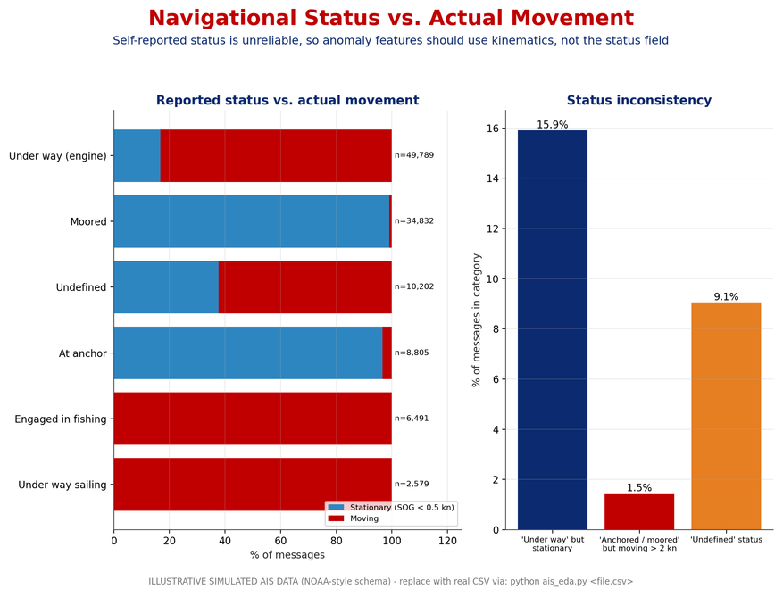
Figure 5: Reported navigational status versus actual movement, and status inconsistency

6.1.5 Spatial density of traffic
Figure 6 maps the density of all messages and of stationary messages (SOG below 0.5 knots). The first panel shows clear shipping corridors between the ports of Corpus Christi, Galveston, Mobile, the Mississippi Delta and Tampa. The second panel shows that stationary messages concentrate in tight hotspots at ports and anchorages. The combination of narrow lanes and dense hotspots is the pattern that DBSCAN is designed to separate, and it justifies density-based clustering for route discovery.
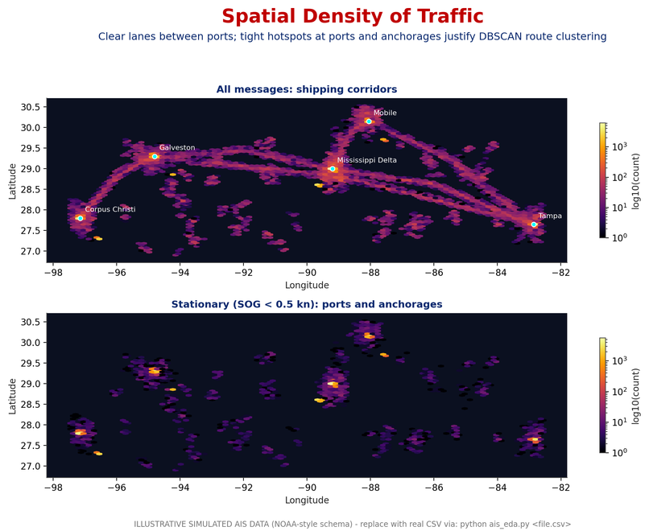
Figure 6: Spatial density of traffic: shipping corridors and stationary hotspots

6.1.6 Speed over ground by vessel type
Figure 7 shows the speed distribution of moving vessels (SOG of at least 0.5 knots). Cargo vessels and tankers cruise steadily with median speeds of roughly 11–13 knots, passenger vessels are the fastest at around 16 knots, and tugs and fishing boats are slow and variable, with medians of roughly 6 and 4–5 knots. The distributions of the vessel types overlap little at their centres, so vessel type is a strong feature for the prediction and anomaly models, and a single speed threshold would not suit all types.
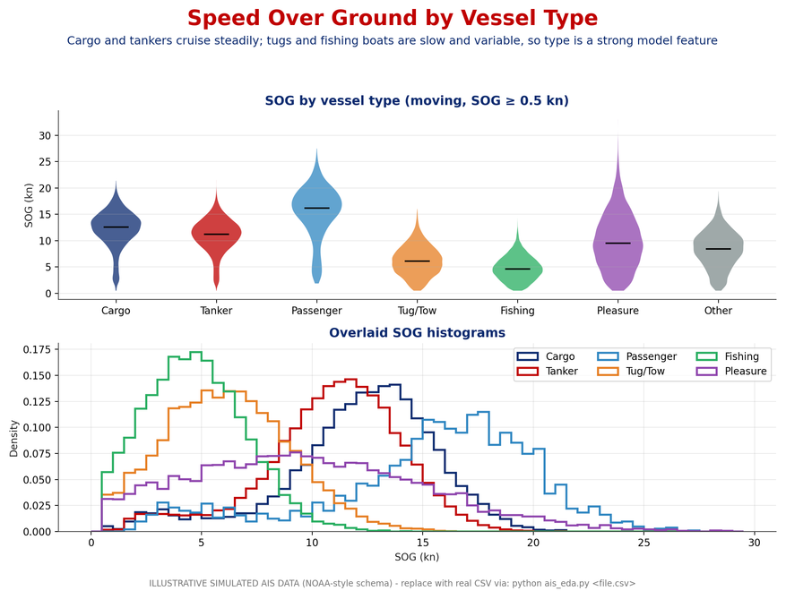
Figure 7: Speed over ground by vessel type (violin plots and overlaid histograms)

6.1.7 Manoeuvring behaviour
Figure 8 presents the course change between consecutive messages. The mean absolute course change per message is only 3.0–3.4° for cargo vessels, tankers, passenger vessels and other vessels, but 32.9° for tugs and tows, 20.6° for fishing boats and 18.4° for pleasure craft. The distribution has a long tail for tugs and fishing boats. Large turn rates are therefore normal for these vessels, and a single global turning rule would generate false alarms, which supports the use of per-type behaviour in the anomaly detector.
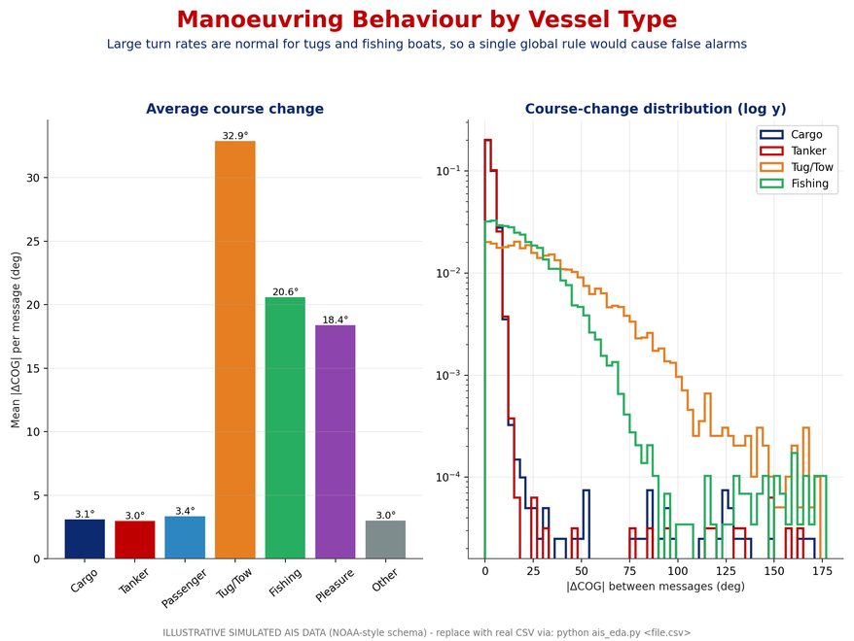
Figure 8: Manoeuvring behaviour by vessel type: mean course change and its distribution

6.1.8 Course over ground
Figure 9 shows the distribution of course over ground for moving vessels. Cargo vessels, tankers and passenger vessels follow lanes and so show sharp directional peaks, whereas tugs, fishing boats and pleasure craft spread over all headings. This confirms that lane traffic is highly regular, which is what makes route-deviation detection possible, and that regular behaviour must be learned separately for each vessel type.
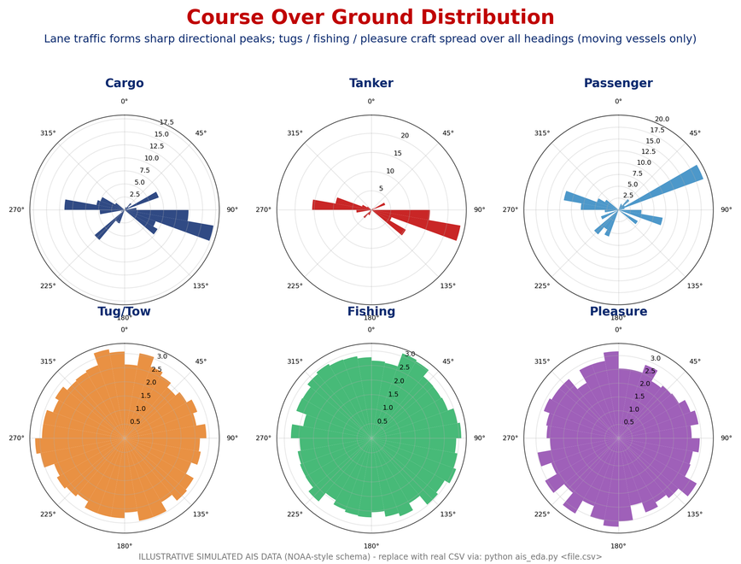
Figure 9: Course over ground distribution by vessel type (moving vessels only)

6.1.9 Model and system evaluation
[Insert the results of the trajectory prediction experiments here, for example a table comparing the LSTM and the Transformer on mean and final displacement error for 30-minute and 60-minute horizons, with a caption and a reference to it in the text.]
[Insert the results of anomaly detection (precision, recall or alert counts per type), route clustering (clusters found, silhouette or visual comparison with known lanes), ETA error, and the accuracy and latency of the natural-language query assistant.]

6.2 Discussion
The exploratory analysis leads to four conclusions that shape the design. First, the data are noisy in several independent ways (duplicates, invalid coordinates, unphysical speeds, GPS jumps and irregular reporting), so cleaning has to be part of the stream, and it must be cheap enough to run on every message. Second, the self-reported navigational status disagrees with movement in a significant share of messages, so it cannot be used as an anomaly feature. Third, vessel types differ greatly in speed and manoeuvring, so thresholds must be type-specific to avoid the false alarms that affect rule-based systems. Fourth, traffic is concentrated in lanes and port hotspots, which makes density-based route clustering appropriate.
Against the objectives of Chapter 3, the work completed so far establishes the data foundation and the design for the real-time pipeline, and the analysis provides the cleaning rules, features and thresholds that the later modules need. The objectives on prediction, anomaly detection, route discovery and the natural-language interface can only be judged from the evaluation results. [Discuss here whether each objective was met, how the LSTM and the Transformer compare, the significance of the findings, any unexpected outcomes and the limitations of the study.]
CHAPTER 7

CONCLUSION
This report presented a real-time marine vessel tracking and route analytics system that addresses critical challenges of modern maritime monitoring. The proposed design establishes a unified, open, end-to-end processing pipeline that can handle noisy, high-velocity AIS data in real time. By combining Apache Kafka for event-driven ingestion with Spark Structured Streaming for real-time cleaning and windowed feature engineering, the architecture turns raw positional broadcasts into reliable vessel tracks.
On top of these tracks, machine-learning modules overcome the limitations of traditional rule-based tracking: LSTM and Transformer models for 30–60 minute trajectory and ETA prediction, Isolation Forest for machine-learning-driven anomaly detection, and DBSCAN for automatic discovery of route patterns. The exploratory analysis of the AIS data confirmed the need for these choices by showing the presence of noise, the unreliability of self-reported status and the strong dependence of behaviour on vessel type.
Ultimately, the system transforms raw geospatial data into actionable maritime situational awareness and can improve collision prevention, port congestion management and the monitoring of anomalies such as AIS spoofing and route deviations. By serving these analytics through a live interactive dashboard coupled with a Retrieval-Augmented Generation (RAG) assistant, it lets operators query complex streaming data in natural language, and it gives maritime authorities an accessible and scalable tool to improve fleet efficiency and strengthen maritime security. [Add the final quantitative outcomes of the project to this chapter.]
CHAPTER 8

FUTURE ENHANCEMENTS
The literature review and the analysis in this report point to several directions in which the system can be extended. This chapter lists the most promising ones.
- Vessel interaction and context. Existing recurrent models ignore interaction between vessels and the environment or port context [4], [5]. Adding neighbouring-vessel features, weather, tides and port information should improve prediction at longer horizons.
- Graph-based models. Spatio-temporal graph networks such as Graph WaveNet [24] could model traffic over ports and sea lanes, which is still an open application.
- Generalisation across regions. Models trained on one region generalise poorly. The Danish Maritime Authority data can be used to study transfer learning and region-independent features.
- Spoofing and dark-vessel detection. Dedicated detectors for AIS spoofing and going dark can be added, for example by cross-checking AIS with radar or satellite imagery.
- Fusion with visual tracking. Camera-based detection and tracking (YOLO, DeepSORT, ByteTrack [16], [19], [20]) can be fused with AIS tracks near ports and coastlines.
- Labelled benchmark. Because labelled anomalies are scarce [10], a small benchmark of annotated anomalous tracks would allow supervised and semi-supervised evaluation.
- Scalability and hardening. Scaling the Kafka and Spark clusters, adding exactly-once processing, monitoring and access control, and compressing the models for lower latency.

APPENDIX
This appendix lists the abbreviations used in the report (Table 8). [Add any additional material here: extra screenshots, full code listings, configuration files or sample queries and answers.]
Table 8: Abbreviations used in this report
Abbreviation | Expansion
AIS | Automatic Identification System
COG | Course over ground
DBSCAN | Density-Based Spatial Clustering of Applications with Noise
EDA | Exploratory data analysis
ETA | Estimated time of arrival
LLM | Large language model
LSTM | Long Short-Term Memory
MMSI | Maritime Mobile Service Identity
RAG | Retrieval-Augmented Generation
SOG | Speed over ground
VTS | Vessel traffic service

BIBLIOGRAPHY
[1] G. Pallotta, M. Vespe, and K. Bryan, “Vessel pattern knowledge discovery from AIS data: A framework for anomaly detection and route prediction,” Entropy, 2013.
[2] D. Nguyen, R. Vadaine, G. Hajduch, R. Garello, and R. Fablet, “GeoTrackNet—A maritime anomaly detector using probabilistic neural network representation of AIS tracks and a contrario detection,” IEEE Trans. Intell. Transp. Syst., 2022.
[3] D. Nguyen and R. Fablet, “TrAISformer: A generative transformer for AIS trajectory prediction,” arXiv preprint, 2021.
[4] N. Forti, L. M. Millefiori, P. Braca, and P. Willett, “Prediction of vessel trajectories from AIS data via sequence-to-sequence recurrent neural networks,” in Proc. IEEE ICASSP, 2020.
[5] S. Capobianco, L. M. Millefiori, N. Forti, P. Braca, and P. Willett, “Deep learning methods for vessel trajectory prediction based on recurrent neural networks,” IEEE Trans. Aerosp. Electron. Syst., 2021.
[6] B. Murray and L. P. Perera, “An AIS-based deep learning framework for regional ship behavior prediction,” Reliab. Eng. Syst. Saf., 2021.
[7] P. Sheng and J. Yin, “Extracting shipping route patterns by trajectory clustering model based on AIS data,” ISPRS Int. J. Geo-Inf., 2018.
[8] I. Kontopoulos, I. Varlamis, and K. Tserpes, “A distributed framework for extracting maritime traffic patterns,” Int. J. Geogr. Inf. Sci., 2021.
[9] M. Riveiro, G. Pallotta, and M. Vespe, “Maritime anomaly detection: A review,” WIREs Data Min. Knowl. Discov., 2018.
[10] K. Wolsing et al., “Anomaly detection in maritime AIS tracks: A review of recent approaches,” J. Mar. Sci. Eng., 2022.
[11] M. Ester, H.-P. Kriegel, J. Sander, and X. Xu, “A density-based algorithm for discovering clusters in large spatial databases with noise,” in Proc. KDD, 1996.
[12] S. Hochreiter and J. Schmidhuber, “Long short-term memory,” Neural Comput., 1997.
[13] A. Vaswani et al., “Attention is all you need,” in Proc. NeurIPS, 2017.
[14] R. E. Kalman, “A new approach to linear filtering and prediction problems,” J. Basic Eng., 1960.
[15] T. Chen and C. Guestrin, “XGBoost: A scalable tree boosting system,” in Proc. KDD, 2016.
[16] J. Redmon, S. Divvala, R. Girshick, and A. Farhadi, “You only look once: Unified, real-time object detection,” in Proc. CVPR, 2016.
[17] Z. Shao, W. Wu, Z. Wang, W. Du, and C. Li, “SeaShips: A large-scale precisely annotated dataset for ship detection,” IEEE Trans. Multimedia, 2018.
[18] A. Bewley, Z. Ge, L. Ott, F. Ramos, and B. Upcroft, “Simple online and realtime tracking,” in Proc. IEEE ICIP, 2016.
[19] N. Wojke, A. Bewley, and D. Paulus, “Simple online and realtime tracking with a deep association metric,” in Proc. IEEE ICIP, 2017.
[20] Y. Zhang et al., “ByteTrack: Multi-object tracking by associating every detection box,” in Proc. ECCV, 2022.
[21] N. Carion et al., “End-to-end object detection with transformers,” in Proc. ECCV, 2020.
[22] Z. Liu et al., “Swin Transformer: Hierarchical vision transformer using shifted windows,” in Proc. ICCV, 2021.
[23] T. N. Kipf and M. Welling, “Semi-supervised classification with graph convolutional networks,” in Proc. ICLR, 2017.
[24] Z. Wu, S. Pan, G. Long, J. Jiang, and C. Zhang, “Graph WaveNet for deep spatial-temporal graph modeling,” in Proc. IJCAI, 2019.
[25] P. Lewis et al., “Retrieval-augmented generation for knowledge-intensive NLP tasks,” in Proc. NeurIPS, 2020.
[26] UNCTAD, “Review of Maritime Transport,” United Nations Conference on Trade and Development, Geneva, [year].
[27] NOAA Office for Coastal Management and BOEM, “MarineCadastre.gov AIS data.” [Online]. Available: https://marinecadastre.gov/ais/ [accessed date]
[28] AISStream.io, “Real-time AIS data streaming API.” [Online]. Available: https://aisstream.io [accessed date]
[29] Danish Maritime Authority, “Open AIS data.” [Online]. Available: https://dma.dk [accessed date; add the exact download URL]

