MODULE-5&6 Assignment
Q1
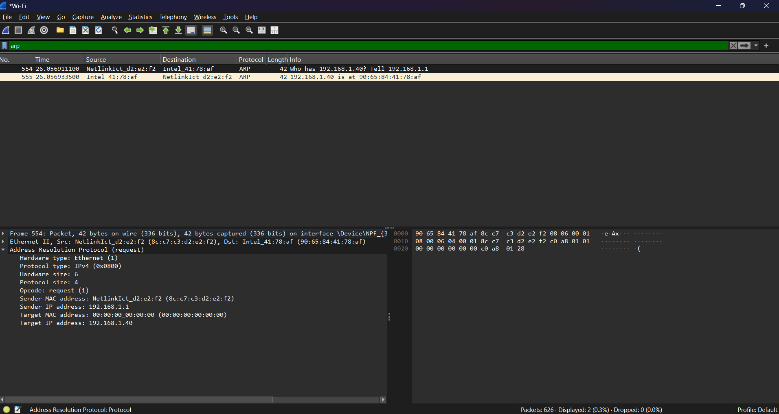
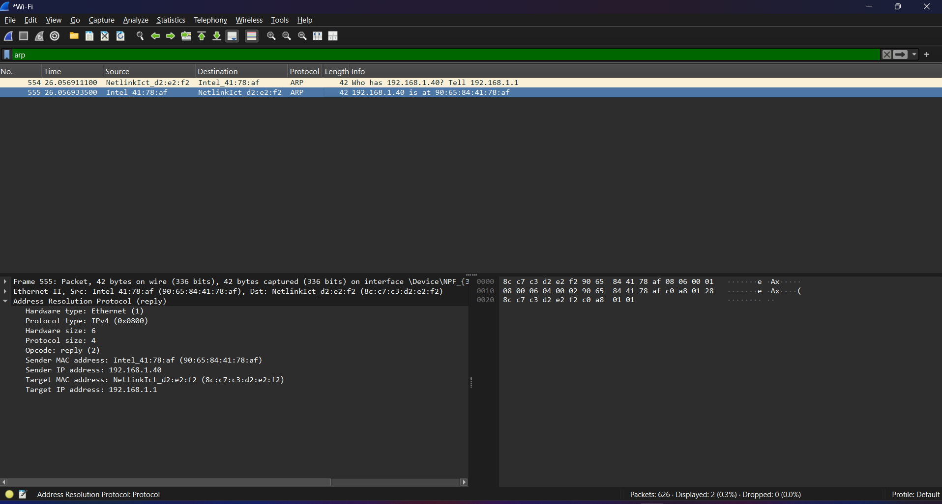

Using Wireshark, ARP packets were captured and analyzed. The ARP request was broadcast to the network asking for the MAC address corresponding to a specific IP address. The device owning that IP responded with an ARP reply containing its MAC address. The sender IP identifies the requesting device, while the sender MAC address represents the physical hardware address used for communication in the local network.

Q2
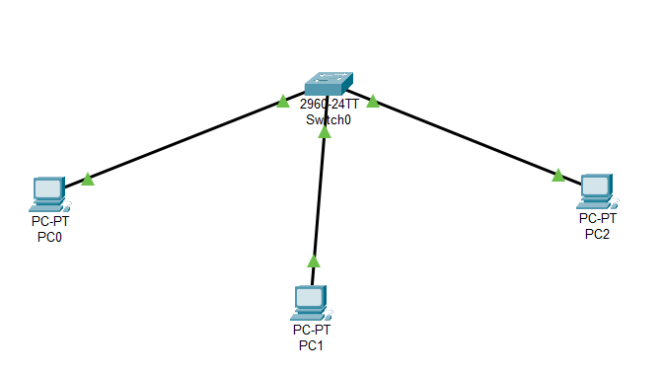
Pc0:
IP Address: 192.168.1.2
Subnet Mask: 255.255.255.0
Gateway: 192.168.1.1
Pc1:
IP Address: 192.168.1.1
Subnet Mask: 255.255.255.0
Gateway: 192.168.1.1
Pc2:
IP Address: 192.168.1.100
Subnet Mask: 255.255.255.0
Gateway: 192.168.1.1
In our network setup consisting of a victim PC, a gateway PC, an attacker PC, and a switch, ARP spoofing refers to a situation where the attacker attempts to deceive the victim by sending forged ARP messages that associate the attacker’s MAC address with the IP address of the gateway. Normally, the victim sends an ARP request to learn the MAC address corresponding to the gateway’s IP address, and the gateway replies with its legitimate MAC address. In an ARP spoofing scenario, the attacker sends a fake ARP reply claiming that the gateway’s IP address belongs to the attacker’s MAC address. As a result, the victim updates its ARP table with this incorrect mapping, causing network traffic intended for the gateway to be redirected to the attacker. This allows the attacker to potentially intercept, monitor, or manipulate the communication between the victim and the gateway within the local network.

Q3
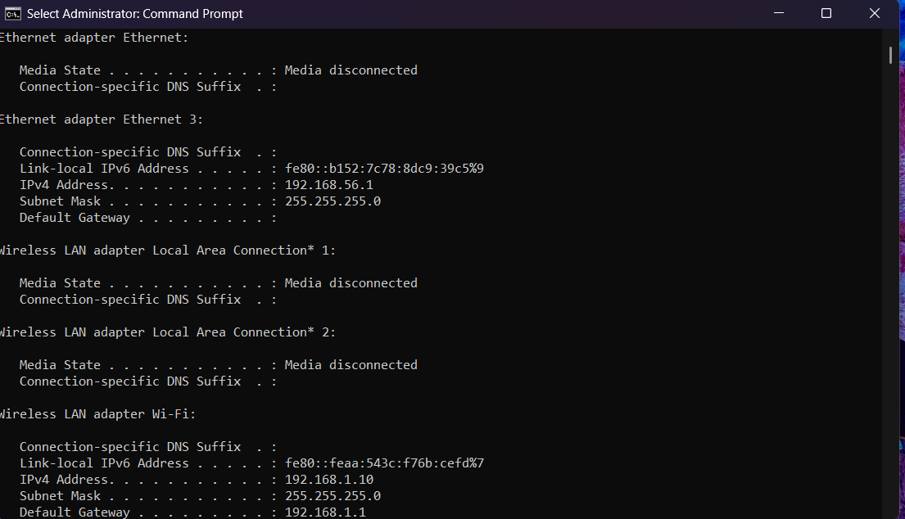
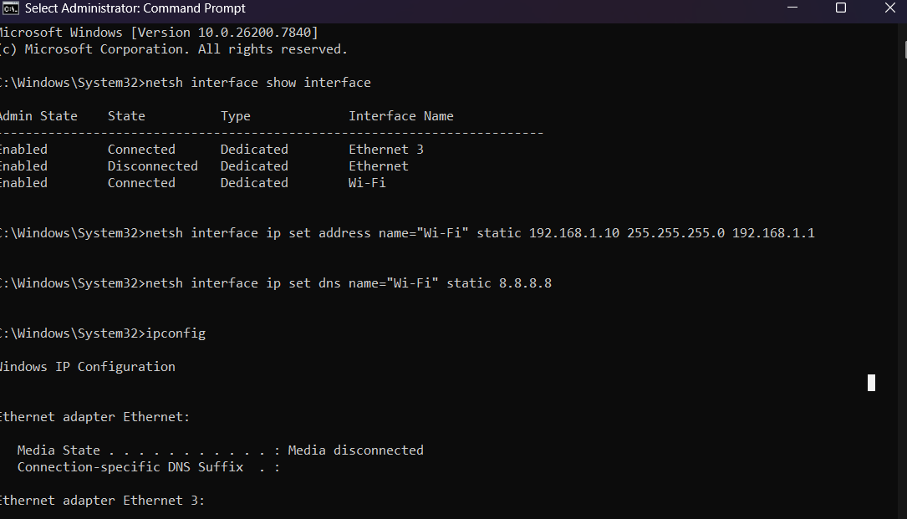
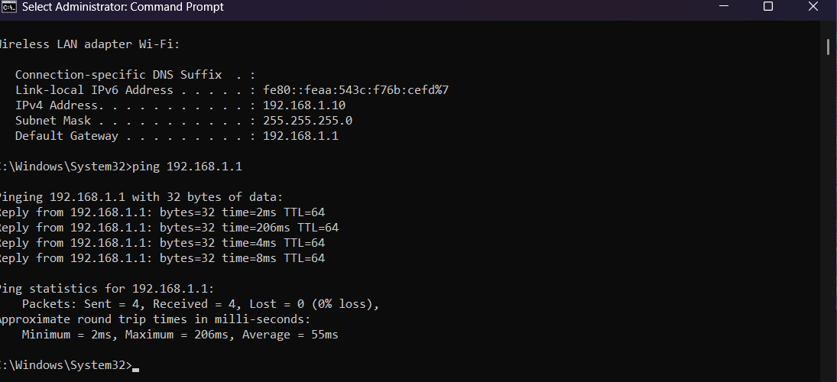

Q4
First start capture in wireshark then in order to initiate the process type ipconfig /release followed by ipconfig /renew in cmd prompt. The DHCP process was captured using Wireshark and analyzed. The communication follows the DORA process consisting of Discover, Offer, Request, and Acknowledge messages. The client first broadcasts a DHCP Discover message to locate a DHCP server. The server replies with a DHCP Offer containing an available IP address. The client then sends a DHCP Request to accept the offered address, and finally the server sends a DHCP Acknowledge confirming the IP assignment.
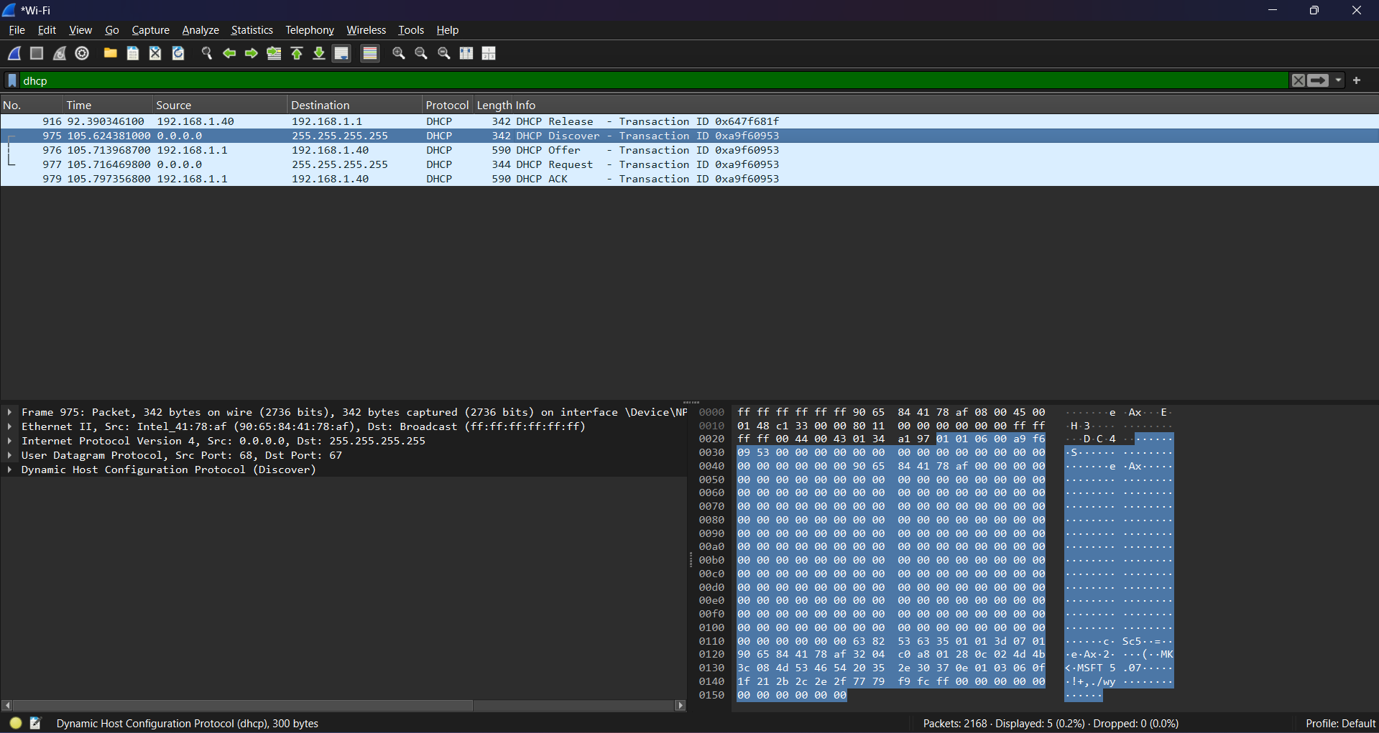

Q5
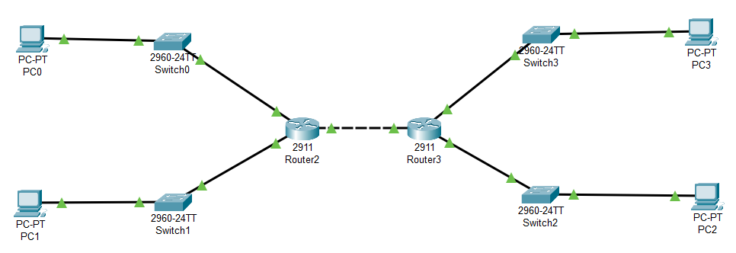
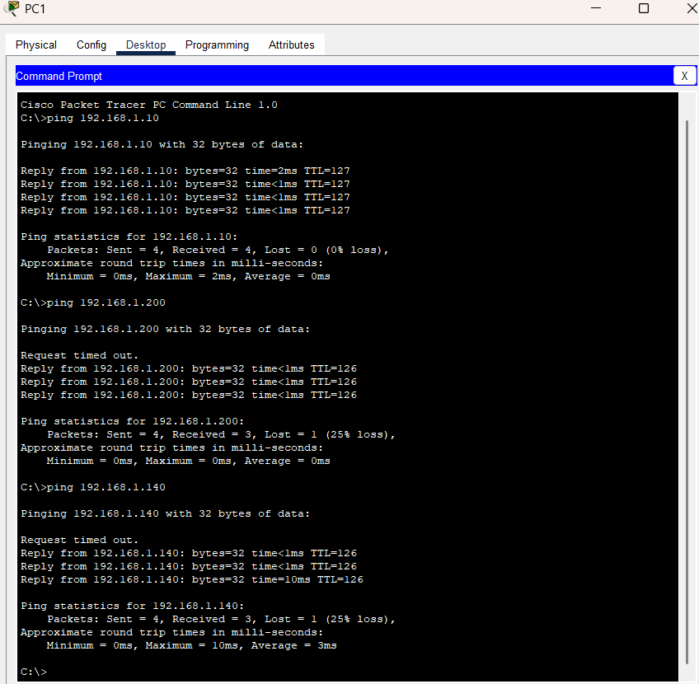

Given Network
Network Address: 192.168.1.0/24
Subnet Mask: 255.255.255.0
Total IP Addresses: 256
Usable Hosts: 254

Step 1: Determine Number of Required Subnets
We need to divide the network into 4 subnets. The formula used is:
2^n ≥ Number of required subnets
2^2 = 4, therefore we must borrow 2 bits from the host portion.

Step 2: Calculate New Prefix
Original prefix = /24
Borrowed bits = 2
New prefix = 24 + 2 = /26

Step 3: New Subnet Mask
Binary representation:
11111111.11111111.11111111.11000000
Decimal representation:
255.255.255.192

Step 4: Block Size Calculation
Block size = 256 − 192 = 64
Each subnet therefore increases by 64.

Subnet Table
Subnet | Network Address | First Host | Last Host | Broadcast Address
Subnet 1 | 192.168.1.0 | 192.168.1.1 | 192.168.1.62 | 192.168.1.63
Subnet 2 | 192.168.1.64 | 192.168.1.65 | 192.168.1.126 | 192.168.1.127
Subnet 3 | 192.168.1.128 | 192.168.1.129 | 192.168.1.190 | 192.168.1.191
Subnet 4 | 192.168.1.192 | 192.168.1.193 | 192.168.1.254 | 192.168.1.255

Explanation
By borrowing two bits from the host portion of the /24 network, four separate subnets are created. Each subnet contains 64 IP addresses, of which 62 are usable host addresses (since one address is reserved for the network ID and one for the broadcast address). The block size of 64 determines the starting point of each subnet.

Q6

Given IP Addresses
1. 10.1.1.1
2. 172.16.5.10
3. 192.168.1.5

IP Address Classes Overview
Class | First Octet Range | Default Subnet Mask
Class A | 1 – 126 | 255.0.0.0
Class B | 128 – 191 | 255.255.0.0
Class C | 192 – 223 | 255.255.255.0

Analysis of Given IP Addresses
IP Address | Class | Default Subnet Mask | Class Range
10.1.1.1 | Class A | 255.0.0.0 | 1.0.0.0 – 126.255.255.255
172.16.5.10 | Class B | 255.255.0.0 | 128.0.0.0 – 191.255.255.255
192.168.1.5 | Class C | 255.255.255.0 | 192.0.0.0 – 223.255.255.255

Explanation
IP address classes are determined by examining the first octet of the address. Class A addresses range from 1 to 126 and use the default subnet mask 255.0.0.0. Class B addresses range from 128 to 191 and use the default subnet mask 255.255.0.0. Class C addresses range from 192 to 223 and use the default subnet mask 255.255.255.0.

Q7
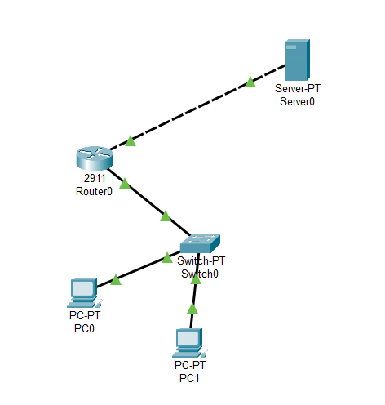

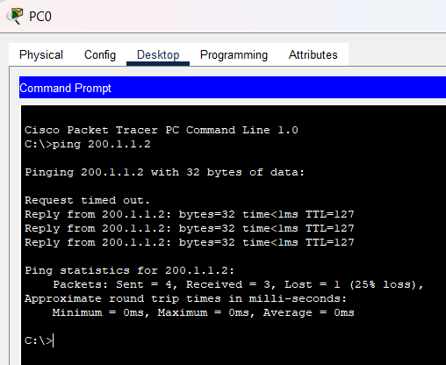

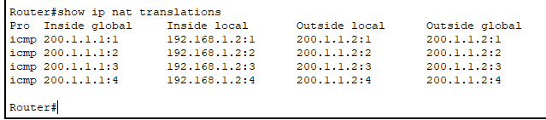

The server was configured with a public IP address and connected to the router's external interface. The router translated private IP addresses from the internal network into its public IP address using NAT. This allowed the internal PCs to communicate with the external server successfully.

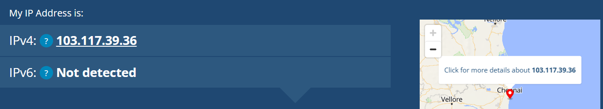

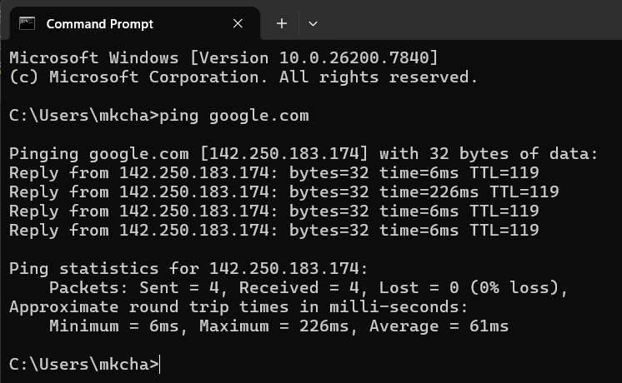
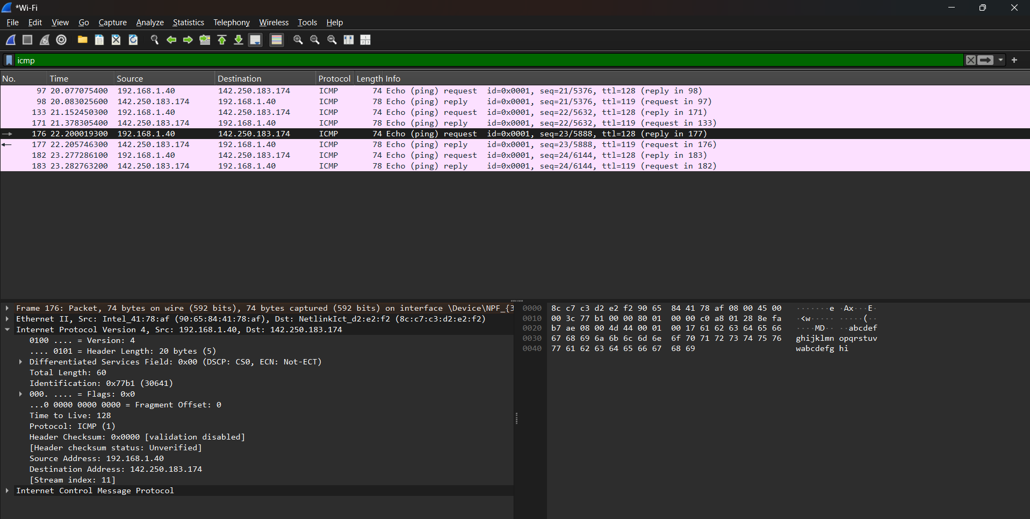
Wireshark was used to capture ICMP packets generated by a ping request to an external server. The captured packets showed the private IP address of the local machine as the source address. However, when the packet leaves the local network, the home router performs Network Address Translation (NAT) and replaces the private IP with its public IP address before forwarding it to the internet.

