Module 7 & 8 Assignment

Q1

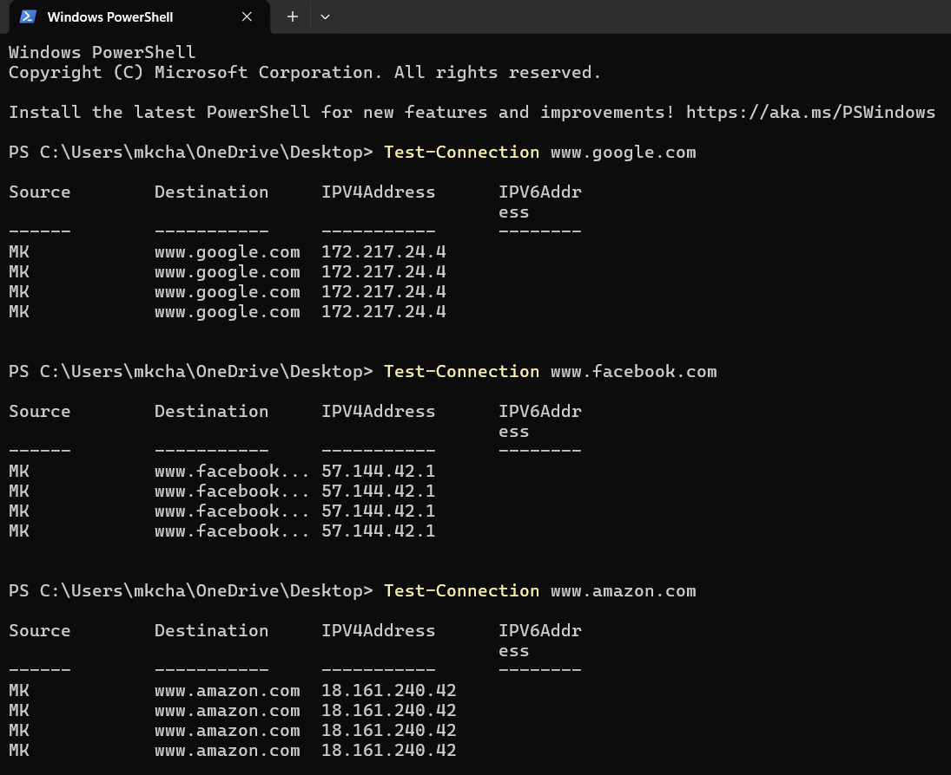
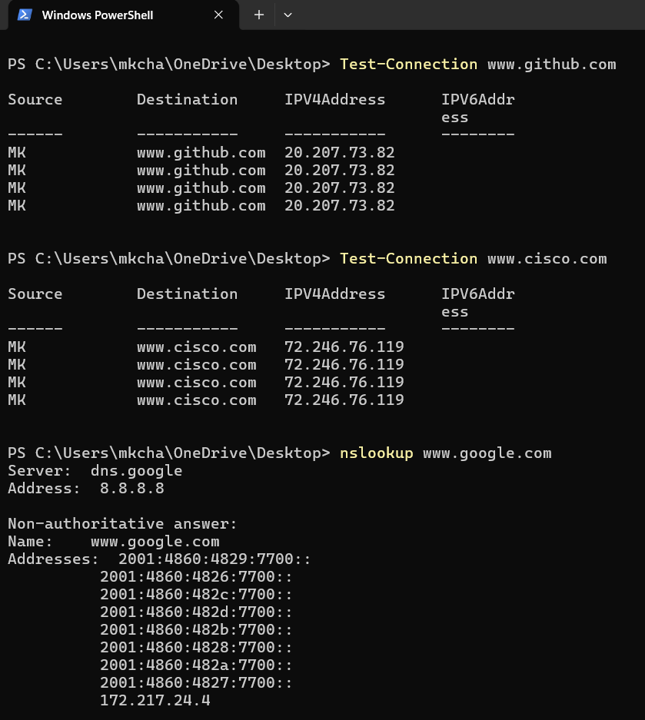

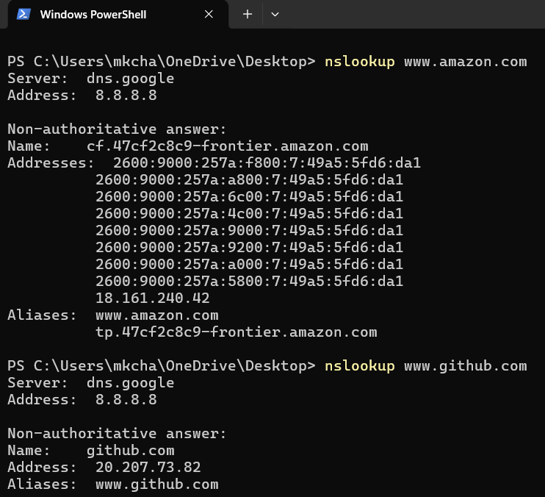
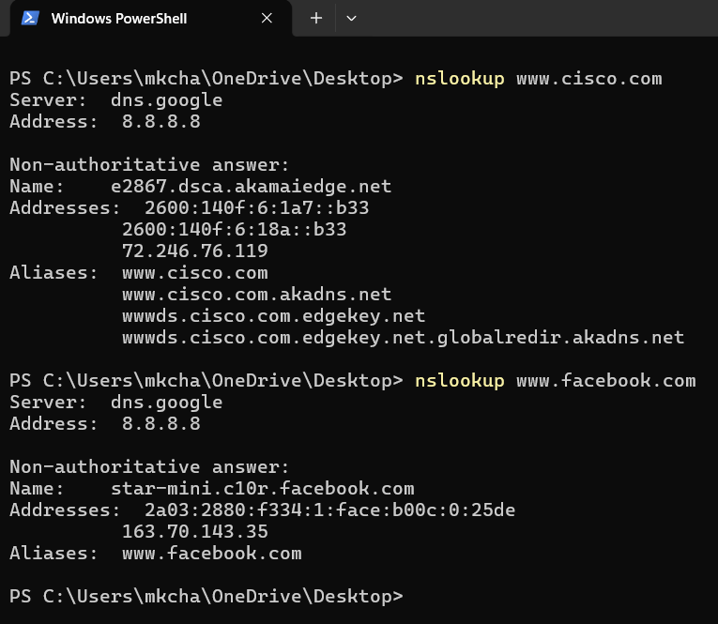

Q2

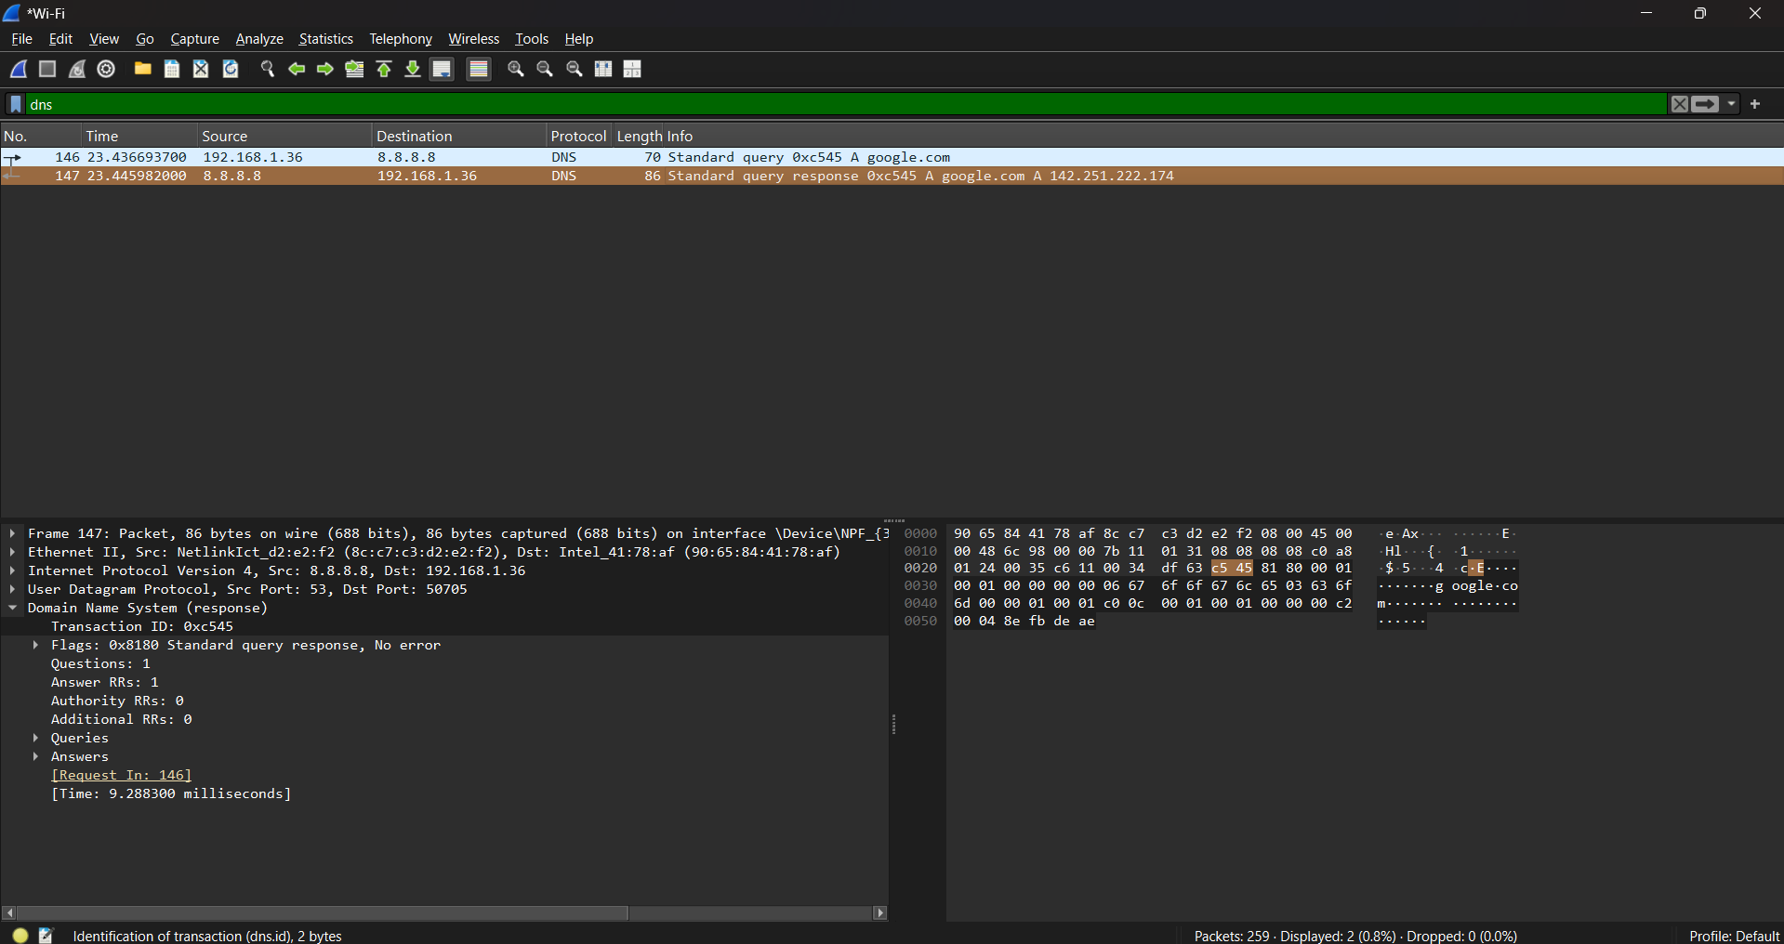

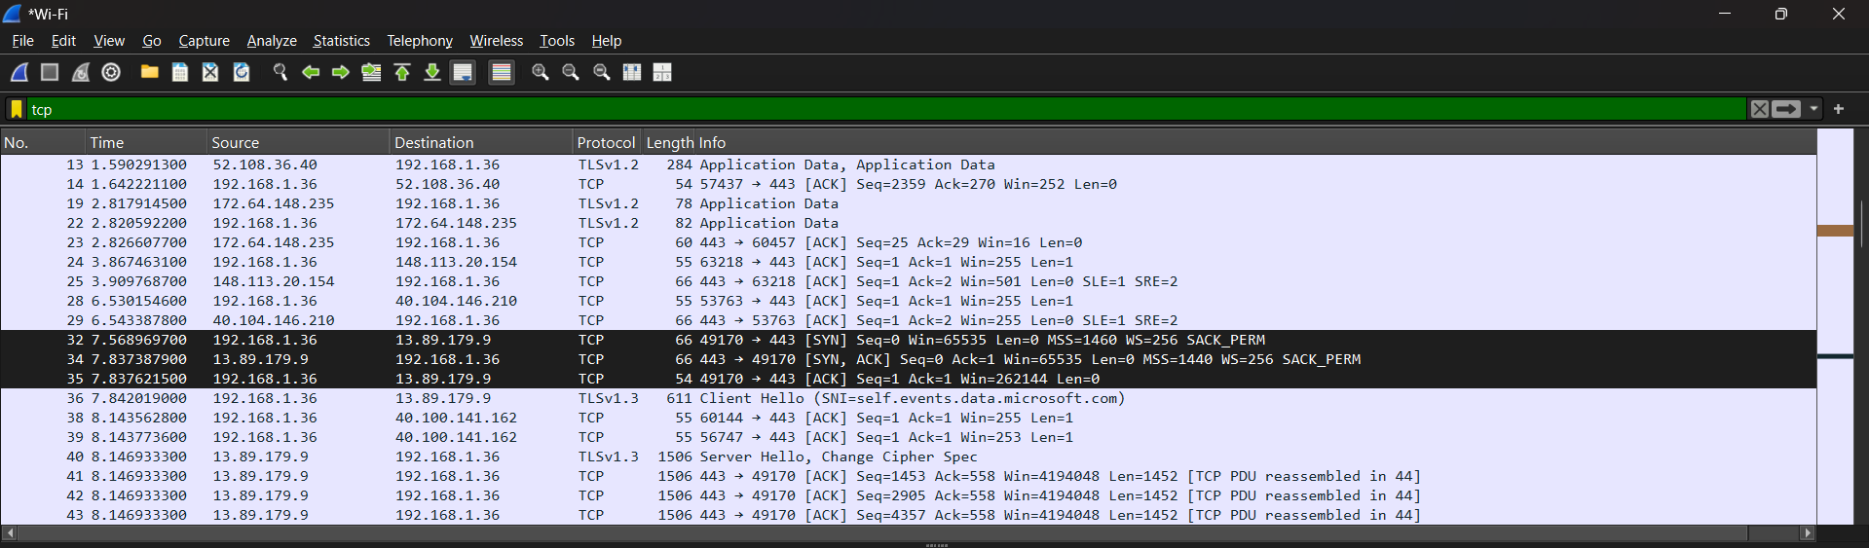

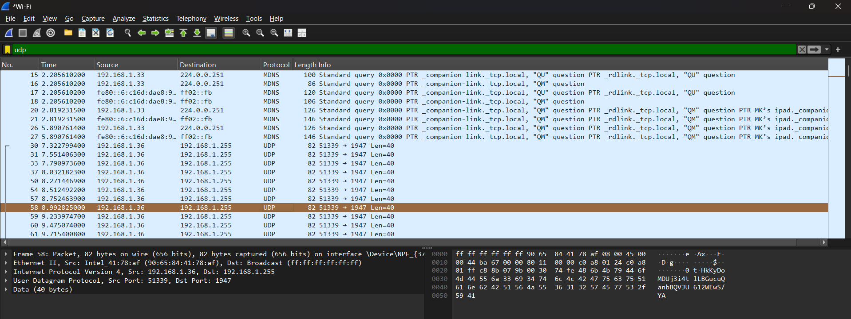

Q3

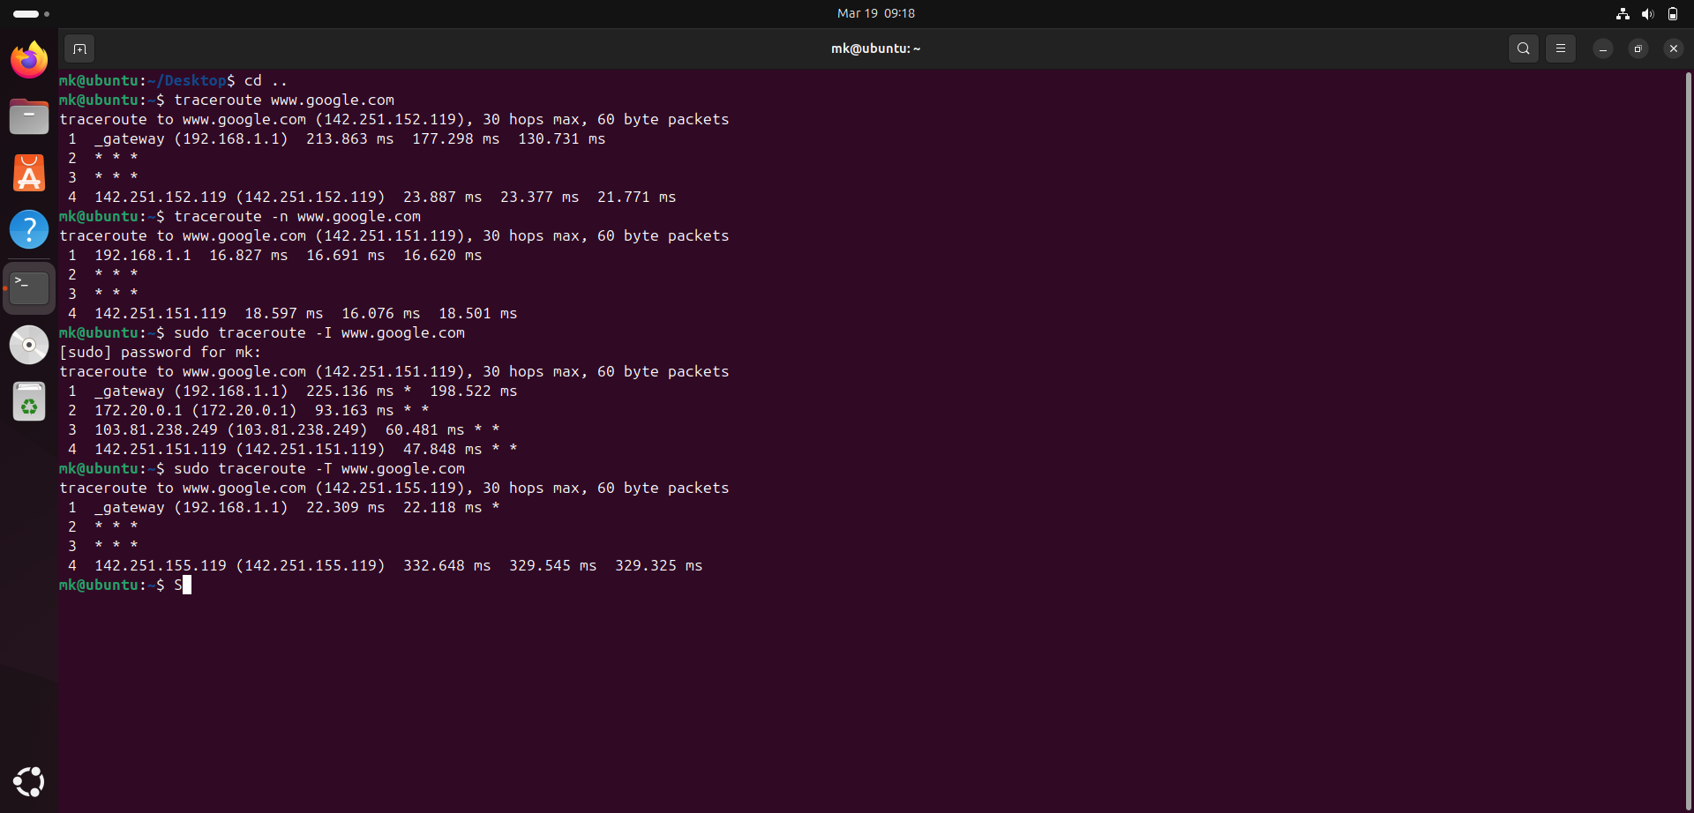

Q5

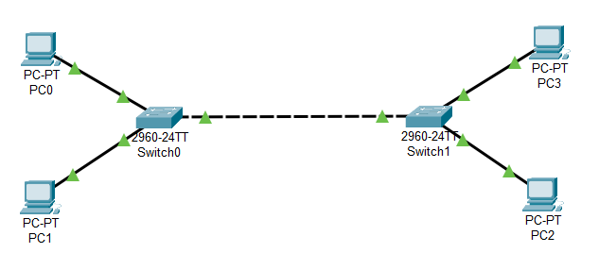

Pc0 and pc2 VLAN 10

Pc1 and pc3 VLAN 20

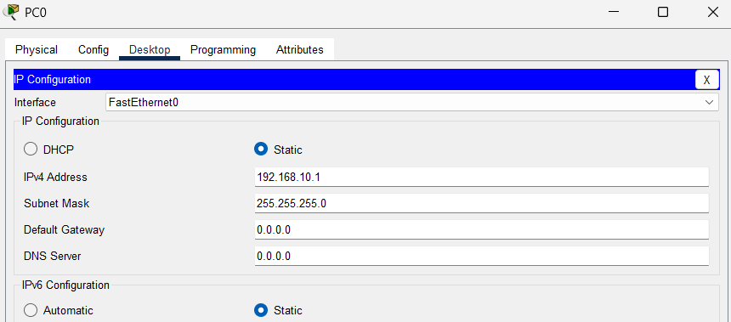
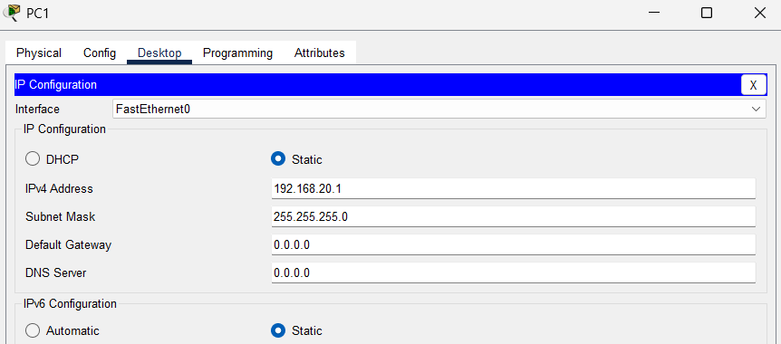
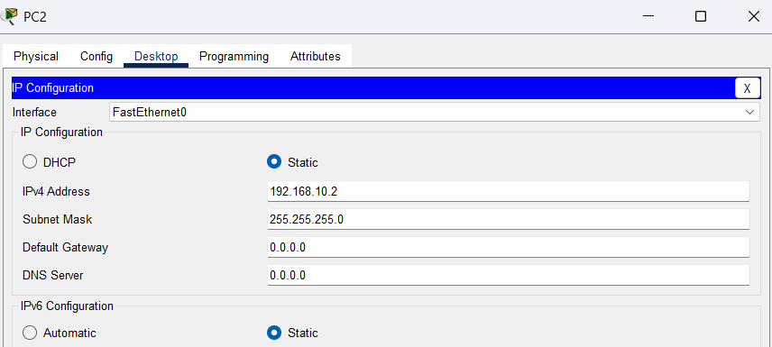
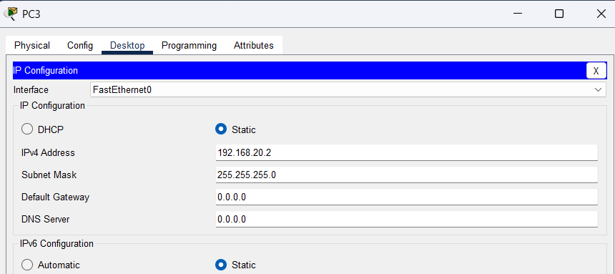
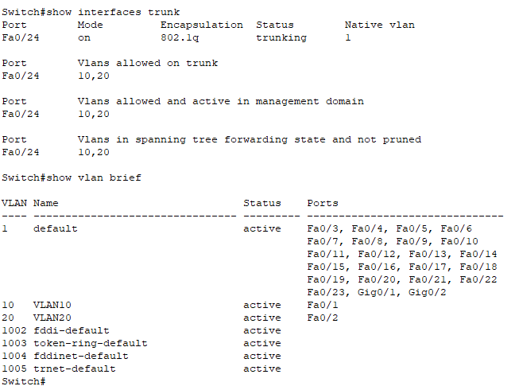
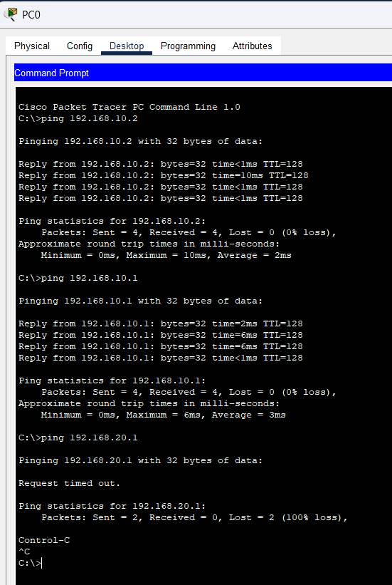
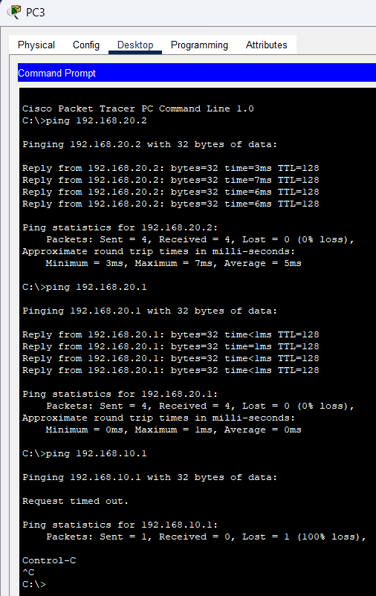

Q6

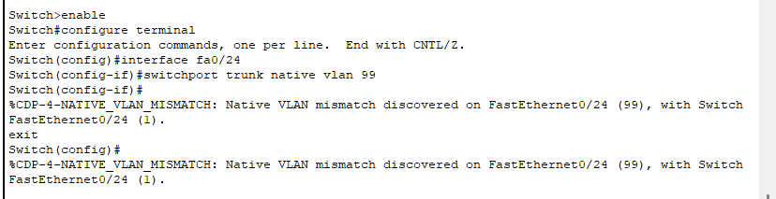
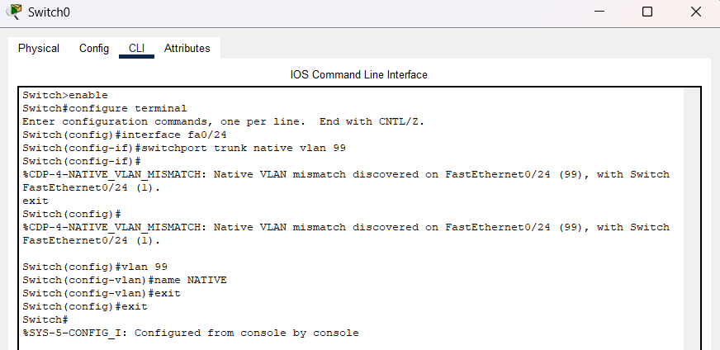
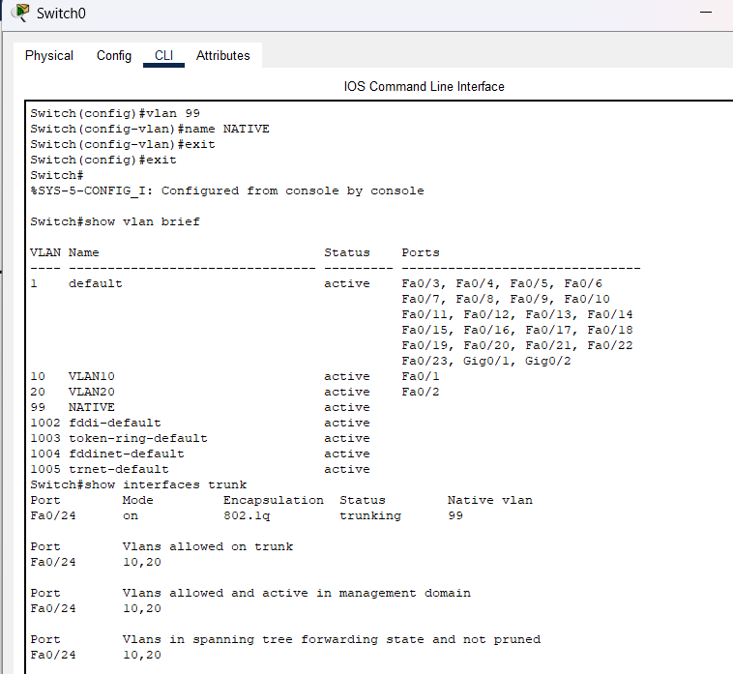

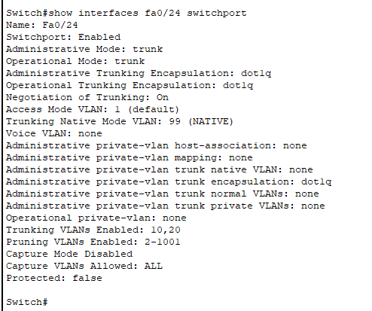

Q7

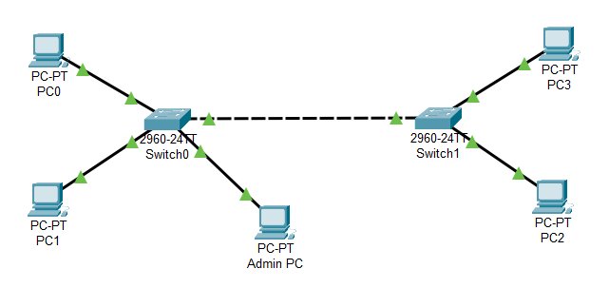

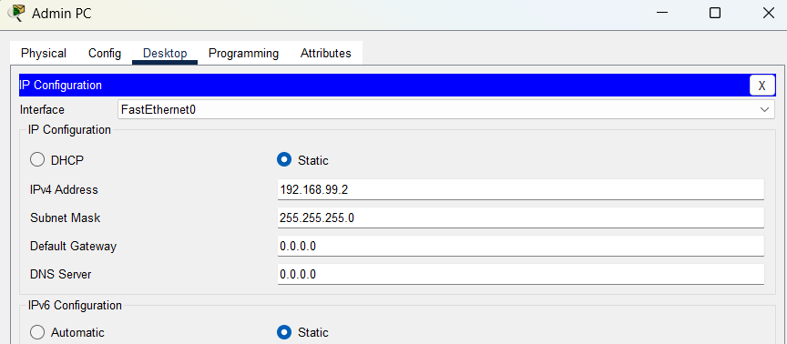

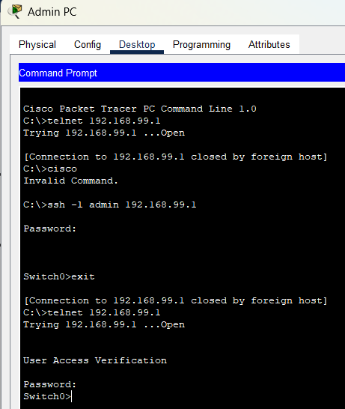
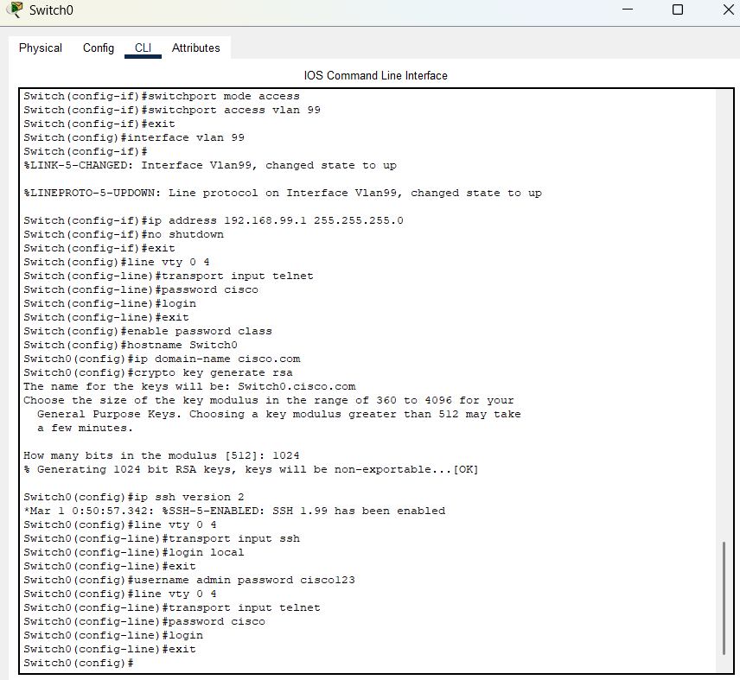

Q8

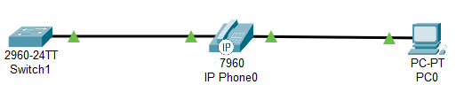

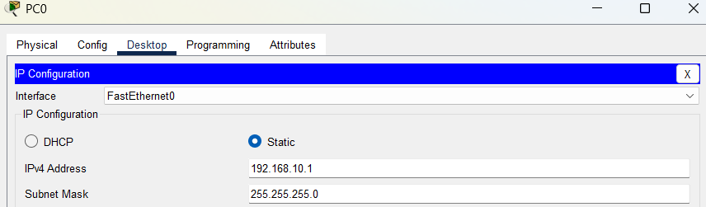

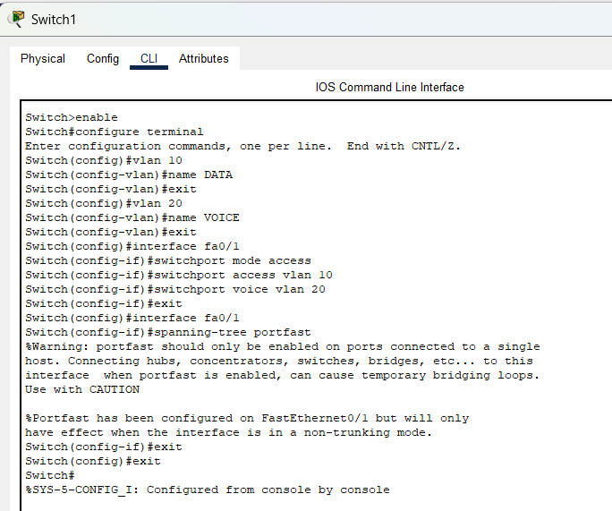

A Cisco switch port was configured to support both voice and data traffic simultaneously. Two VLANs were created — VLAN 10 for data (PC) and VLAN 20 for voice (VoIP phone). A Cisco IP Phone was connected to switch port Fa0/1, and a PC was connected through the IP phone's passthrough port.
Switch port Fa0/1 was configured as an access port for VLAN 10 (data) using switchport access vlan 10, and VLAN 20 was assigned as the voice VLAN using switchport voice vlan 20. This allows the switch port to carry untagged data traffic on VLAN 10 for the PC, and tagged voice traffic on VLAN 20 for the IP phone — both on the same physical port. The configuration was verified using show interfaces fa0/1 switchport, which confirmed the correct access and voice VLAN assignments.

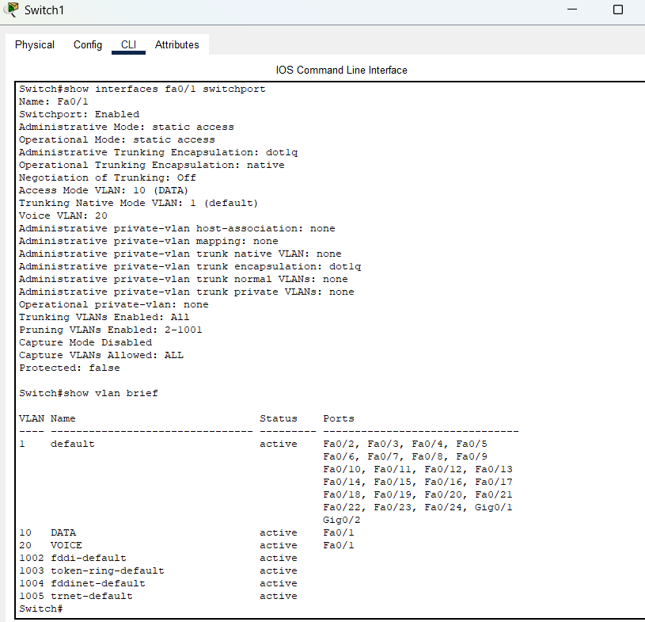

Q9

A switch was configured with VLAN 10 and VLAN 20, but devices could not communicate. The troubleshooting process involved checking VLAN assignments using show vlan brief, verifying port configurations using show interfaces switchport, and checking trunk links using show interfaces trunk. Common issues found were incorrect VLAN assignments on ports, VLANs not being created in the database, trunk ports not allowing the correct VLANs, and IP address mismatches between devices. Each issue was fixed accordingly — ports were reassigned to correct VLANs, missing VLANs were created, trunk configurations were updated, and IP addresses were corrected to match their respective VLAN subnets. It was also noted that devices in different VLANs cannot communicate by design, and inter-VLAN routing via a router is required for cross-VLAN communication, which is addressed in the next task.

Q10
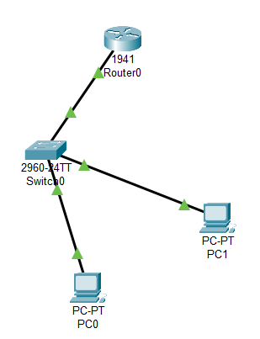

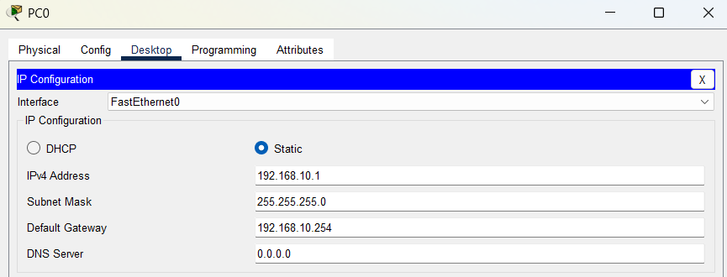

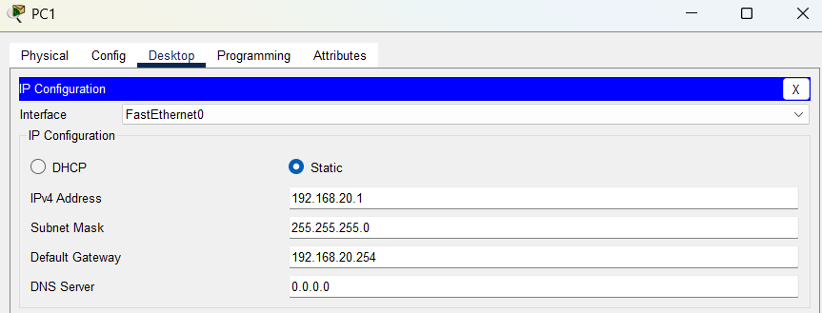
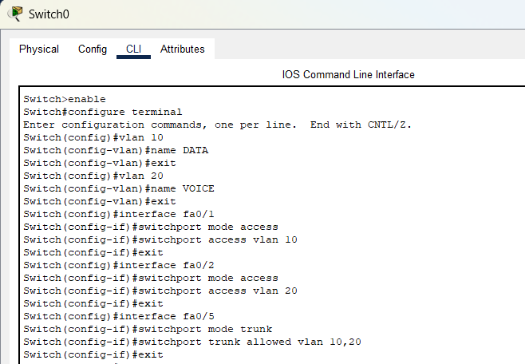

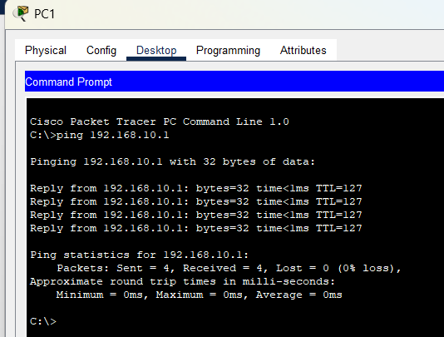
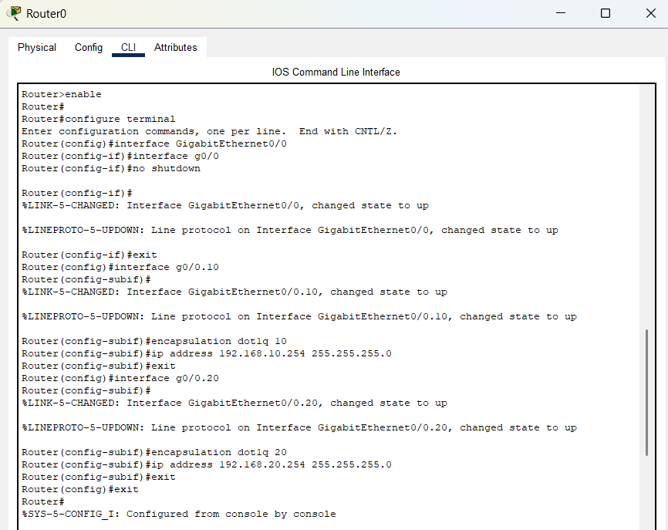
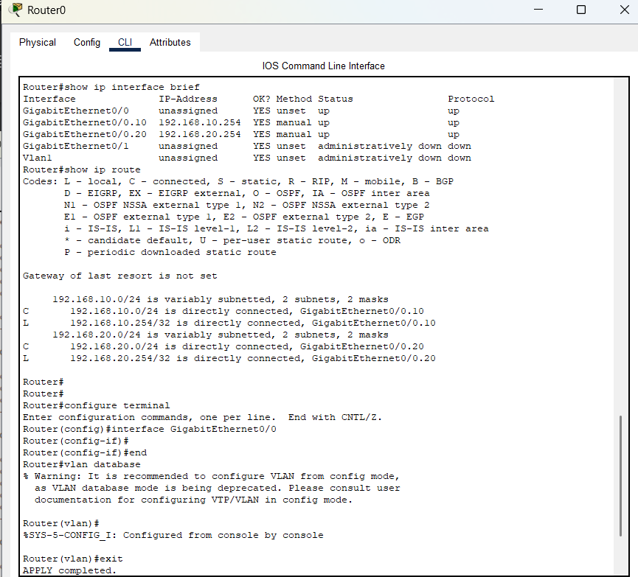
Q11

Same configuration with server added

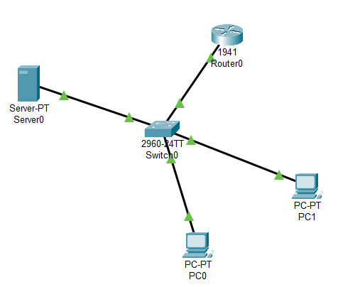

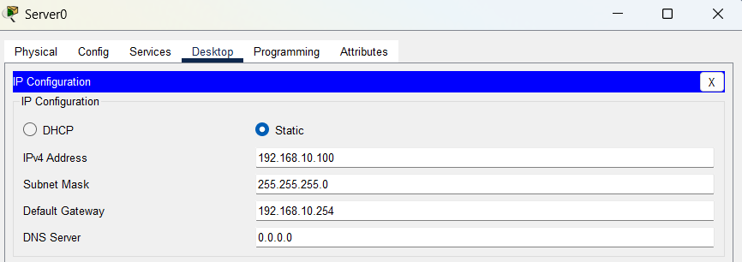

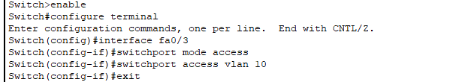

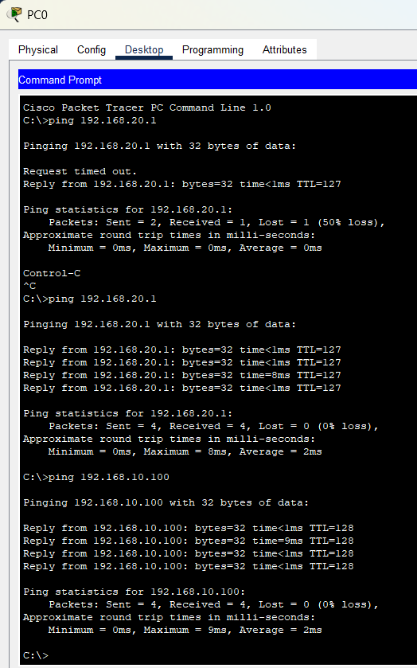
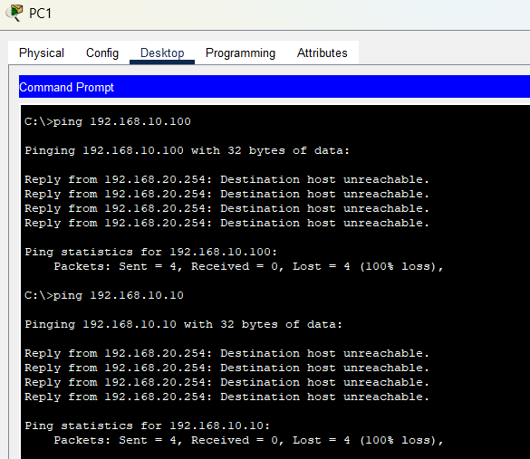

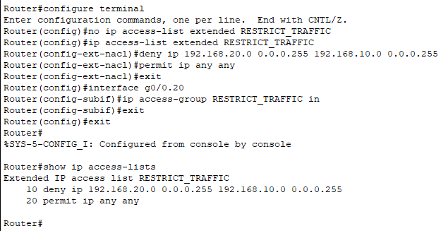

Q12
Same configuration as before
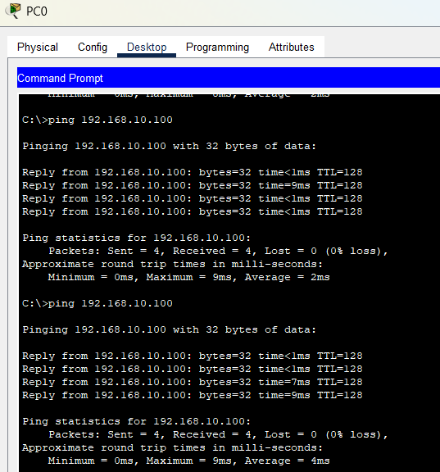

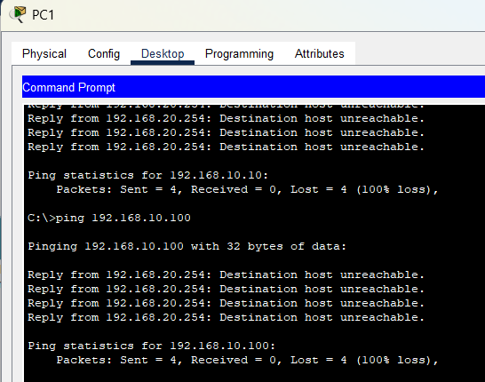
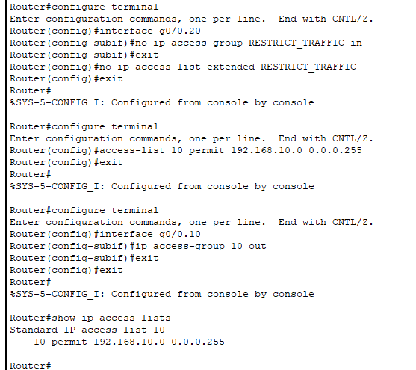

Q13
Same configuration as previous question

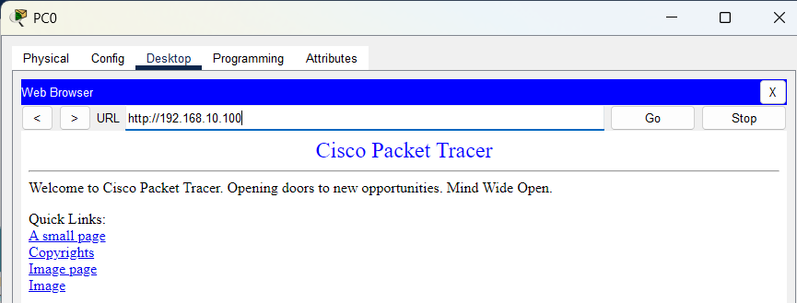
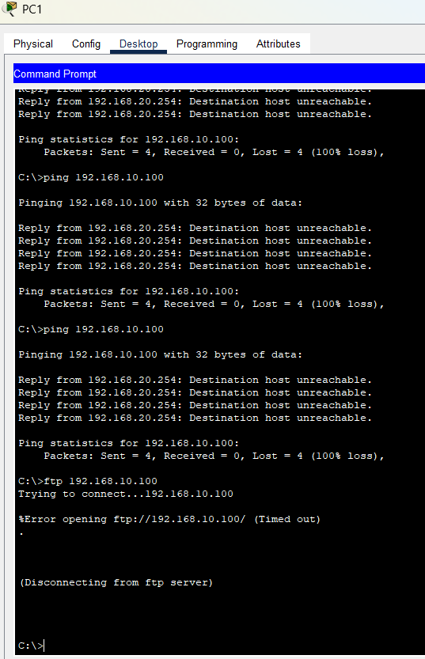
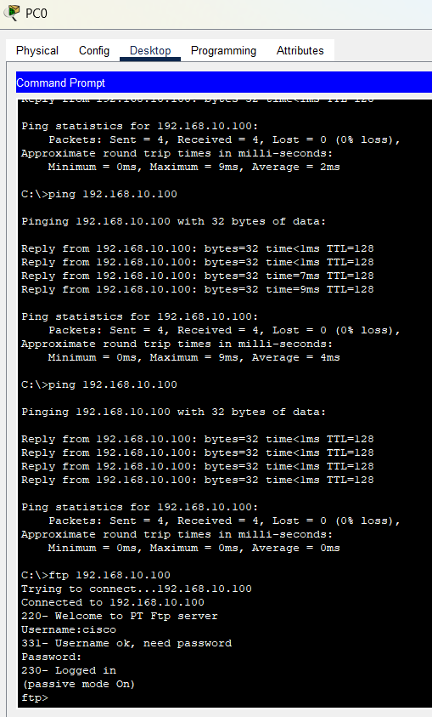
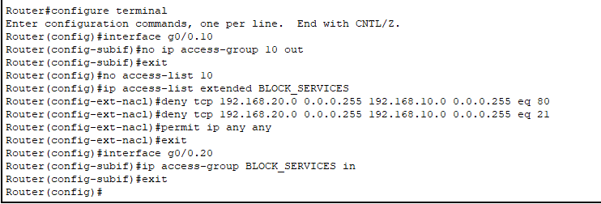
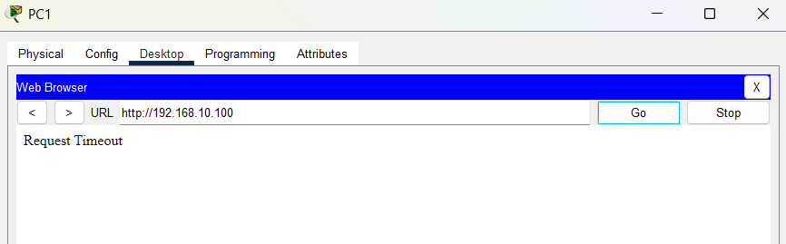

Q14

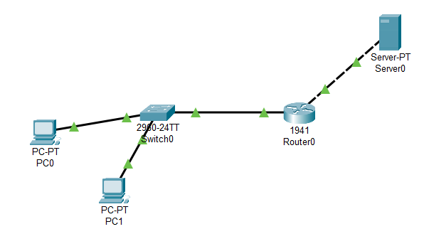

NAT

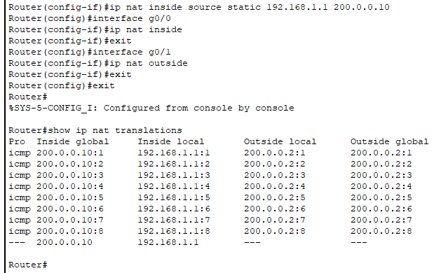
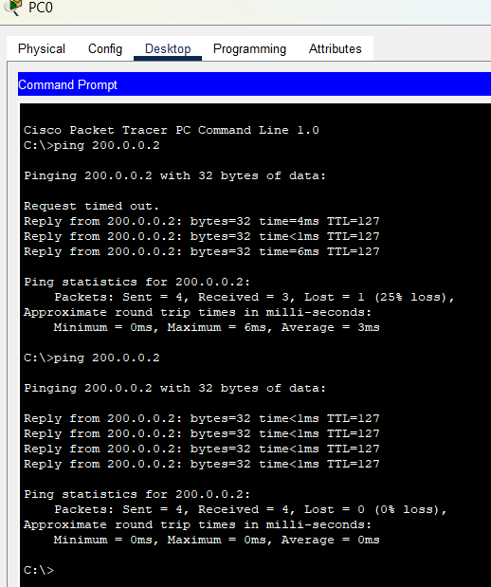
Dynamic NAT

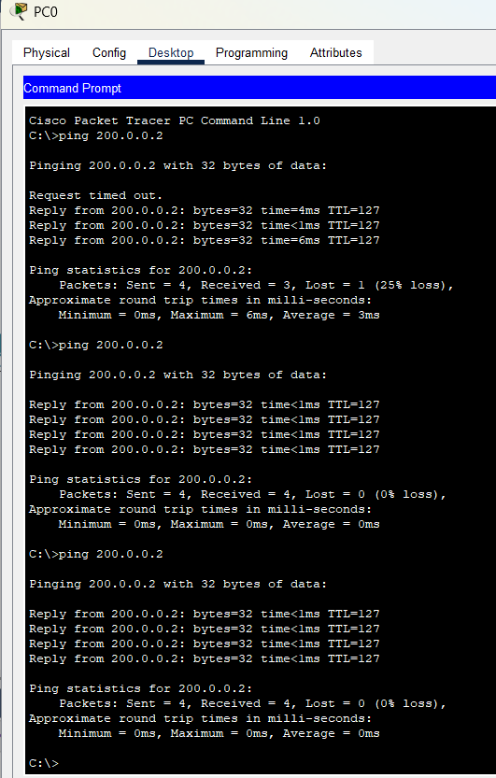

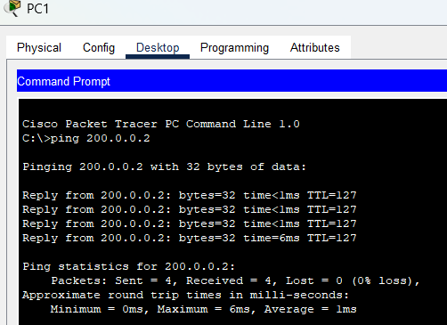

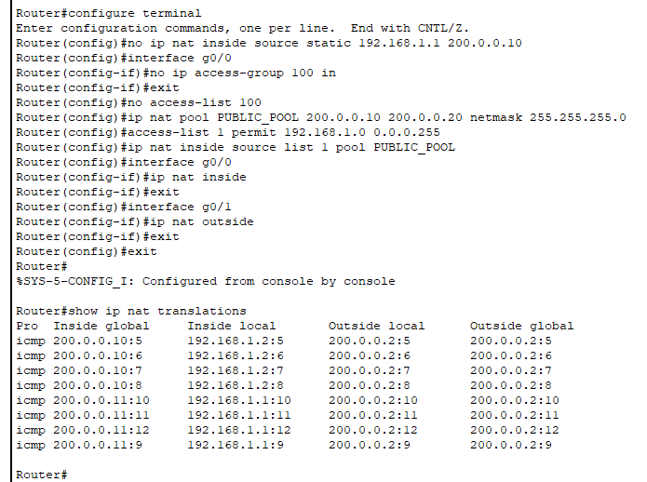

PAT

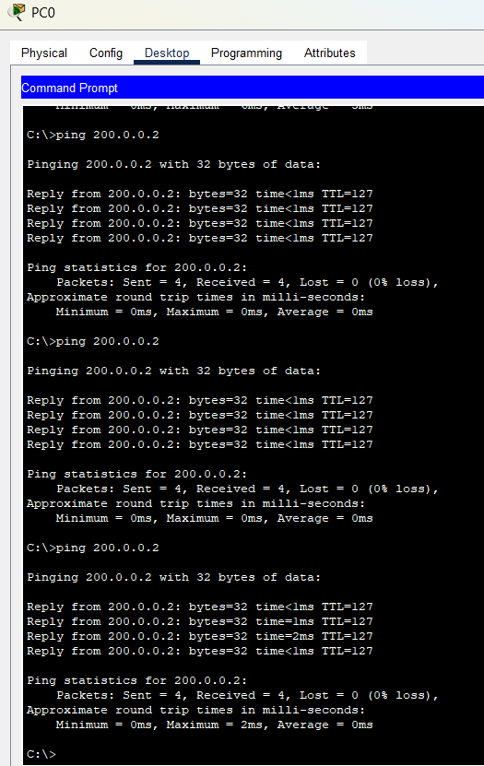

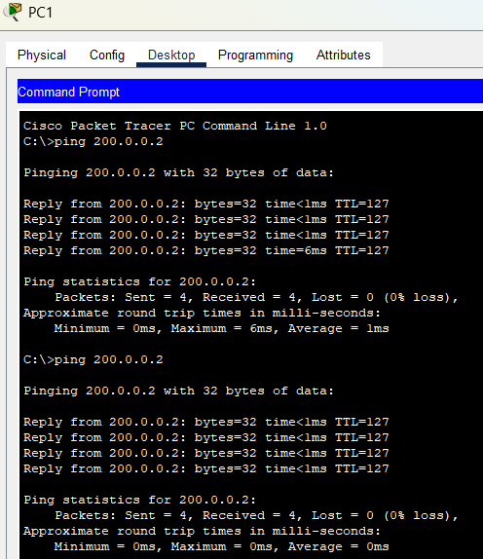

Network Address Translation (NAT) is a technique used by routers to translate private IP addresses to public IP addresses, allowing internal devices to communicate with external networks.
Static NAT creates a permanent one-to-one mapping between a private IP address and a public IP address. In this task, PC1 (192.168.1.1) was permanently mapped to public IP 200.0.0.10, meaning only PC1 could reach the outside network through that mapping.
Dynamic NAT uses a pool of public IP addresses and dynamically assigns them to internal devices as needed. A pool of public IPs (200.0.0.10 to 200.0.0.20) was configured and both PC1 and PC2 were automatically assigned different public IPs from the pool when they initiated connections to the outside network.
PAT (Port Address Translation), also known as NAT Overload, allows multiple internal devices to share a single public IP address by differentiating connections using unique port numbers. Both PC1 and PC2 were able to reach the outside network simultaneously using the single public IP address of the router's outside interface (200.0.0.1), with different port numbers assigned to each session.

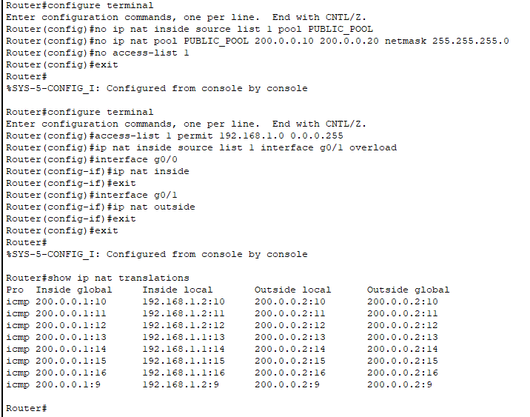

Q15

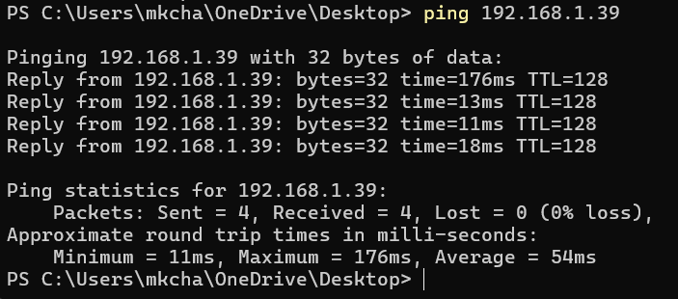

TCP
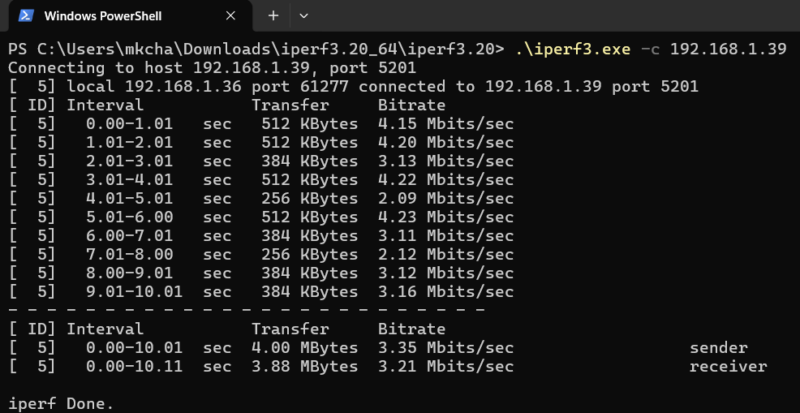

UDP
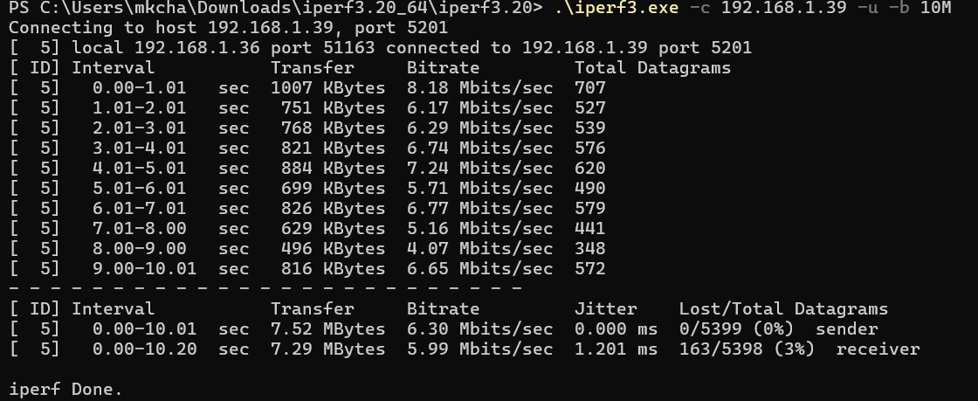

BIDIRECTIONAL
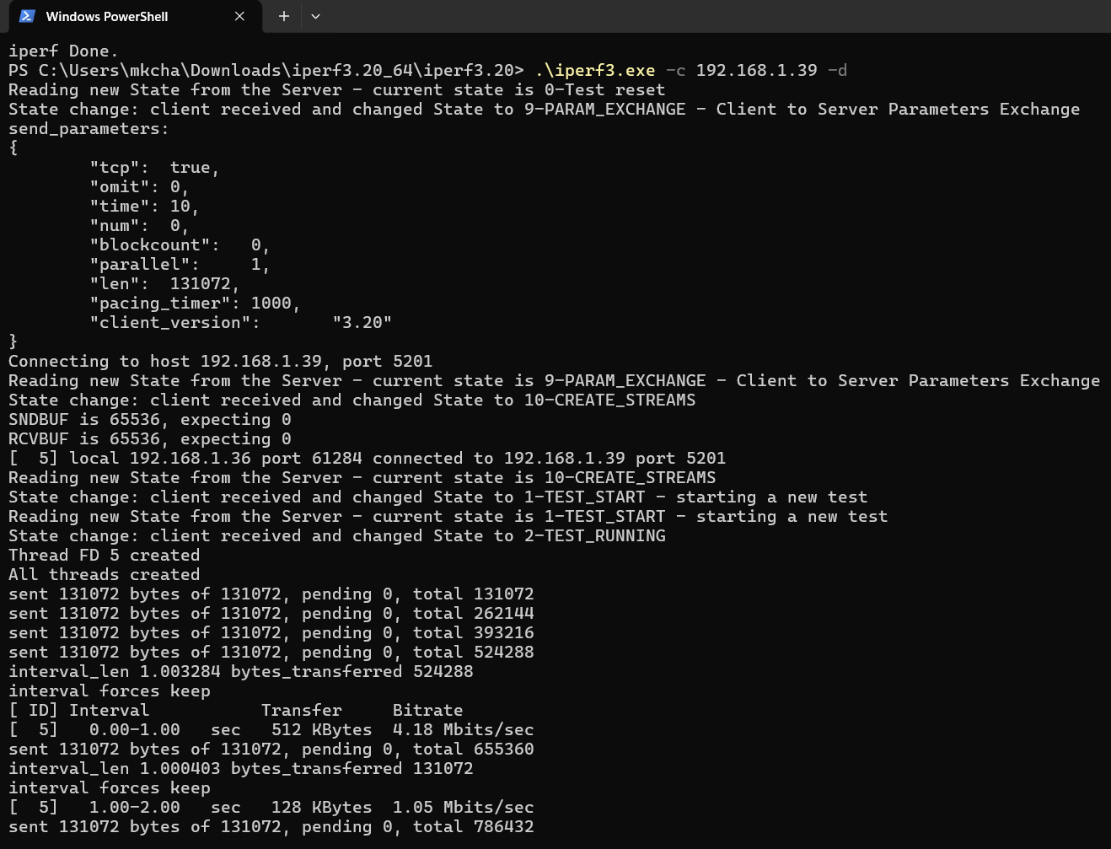
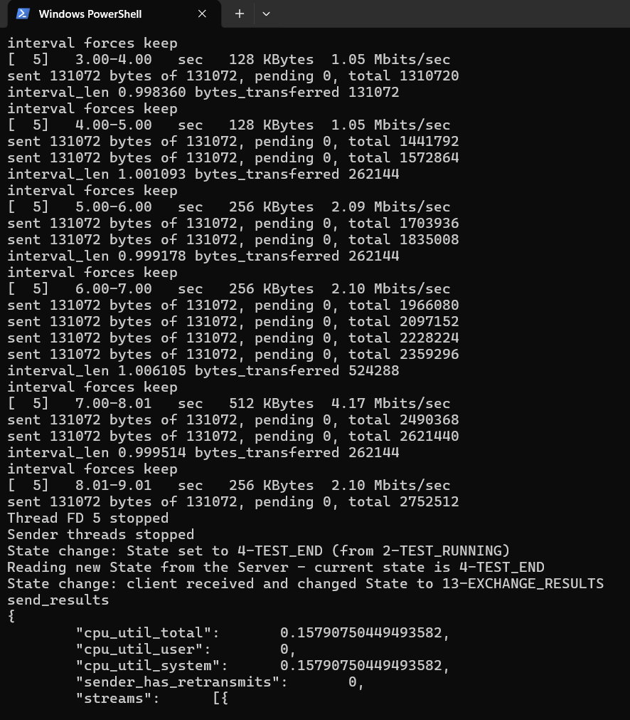
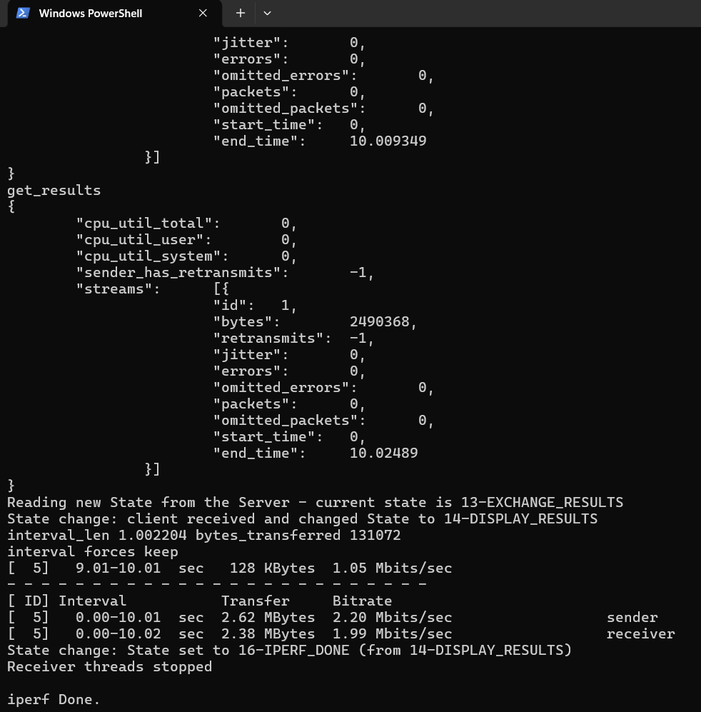

LONG DURATION TEST
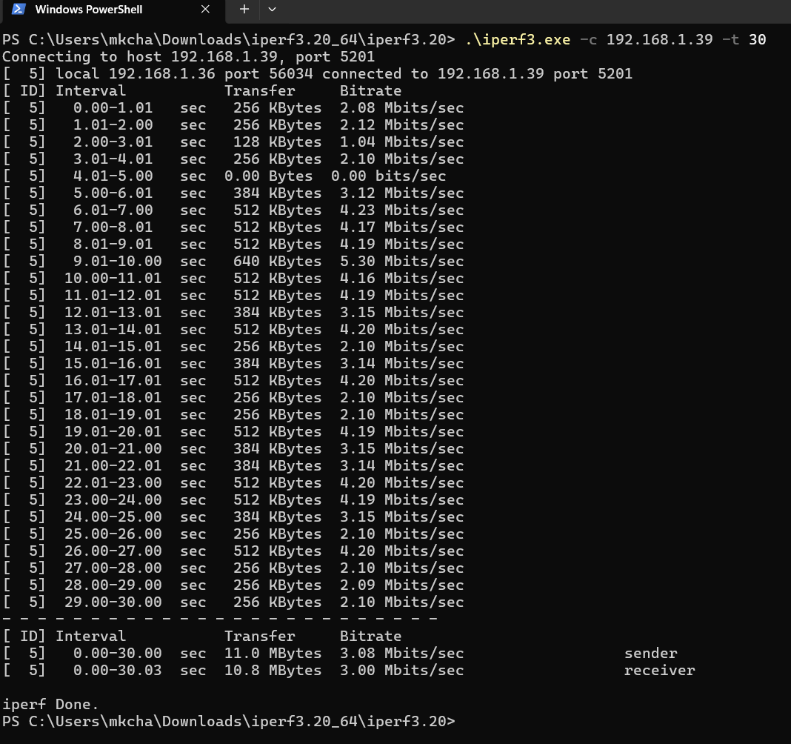

PARALLEL TEST
