In this investigation by using splunk, the client i was working for had their website defaced by an attacker, i used the lockheed martin kill chain in order to be able to reconstruct the attack

first I identified the source types that are scanning the website startrek.com (not the real name for legal purposes) in order to be able to start the investigation

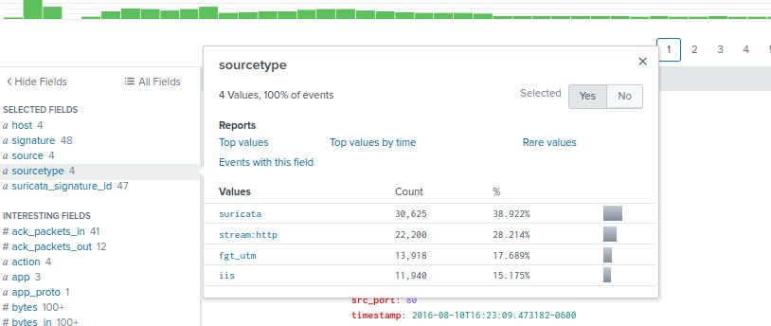
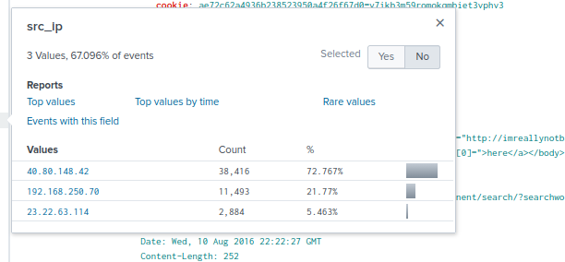



in which I was able to identify the source type and the source addresses

2. Validating the ip that is scanning my web app

index=botsv5 startrek.com src=40.80.148.42 sourcetype=suricata

after changing the sourcetype to suricata (an ids tool) we can be able to see some attempts that have been made to the webserver.

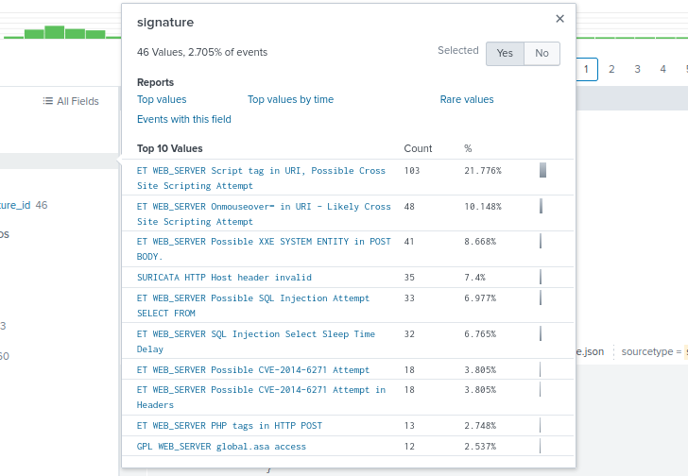

the web vulnerability scans originated from the particular source IP 40.80.148.42, we can search for traffic from 40.80.148.42 and examine the src_headers for clues related to the tool being used for the scan.

index=botsv1 src=40.80.148.42 sourcetype=stream:http (by using this command am able to see the headers on our source ip)
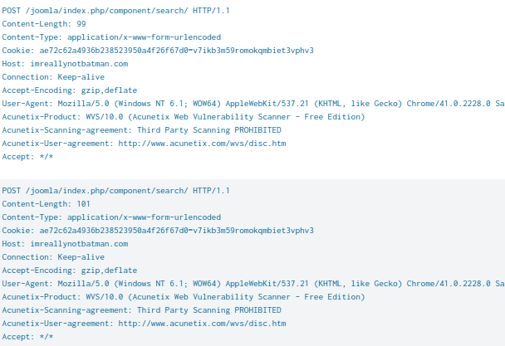

after searching the headers we can see a product called acunetix and after an osint search am able to find out that its an open source web app scanning tool

3. Discovering which web server was the target, this is done by checking the interesting fields of our last command

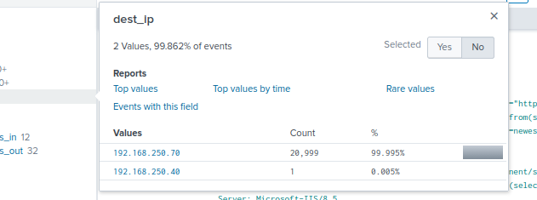

Now that I know the sourcetype AND I know the IP of the web server, we can start looking at URLs or URIs to get an idea of the kind of files and directory structures being requested.

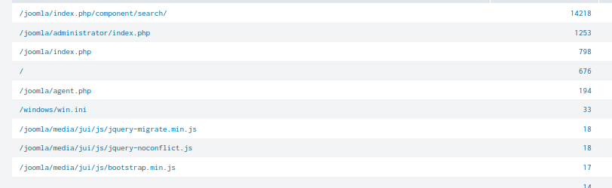

I searched the IIS logs and examined the URI strings being accessed to find indicators and verify that the http response code equals 200.

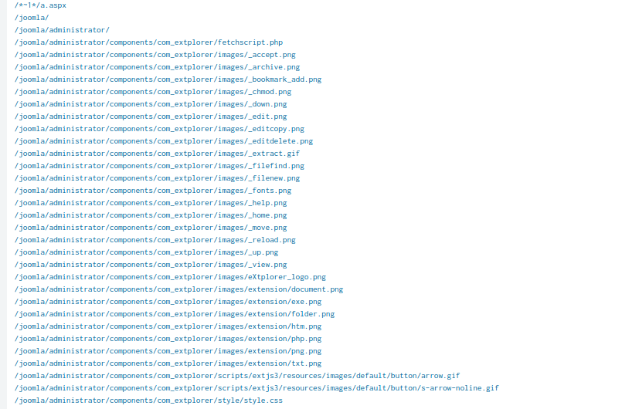
Because I have determined that a brute force password attack to a web server would most likely be a POST when added to the search Now we see only two source IP addresses with the vast majority coming from the 40.80.148.42.

4. Now I find passwords in the http wire data and which specific password was used by using the command (index=botsv1 sourcetype=stream:http dest="192.168.250.70" http_method=POST form_data=*username*passwd*)

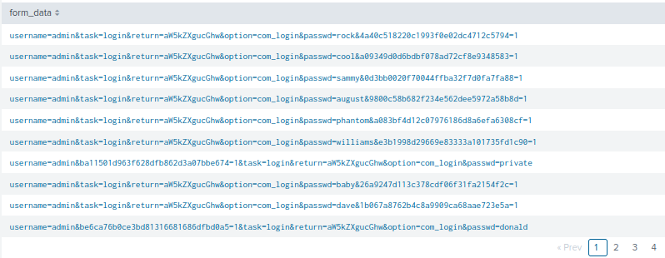
through the use of rex command in order to identify the specific password we can see that the password batman was used twice once at the 200 request and later when the attacker logged in
( index=botsv1 sourcetype=stream:http form_data=*username*passwd* dest_ip=192.168.250.70 | rex field=form_data "passwd=(?<userpassword>\w+)" )

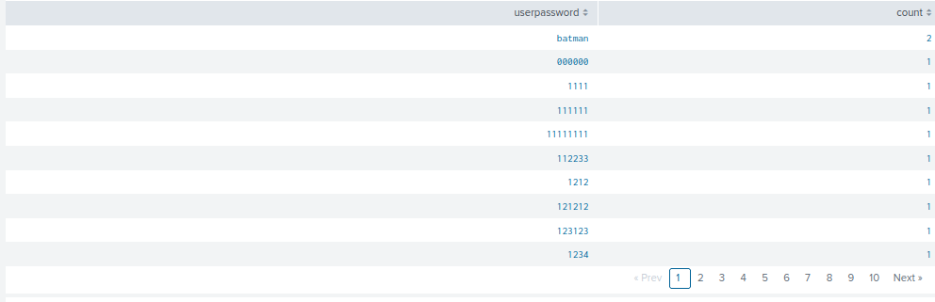
5. Identifying the executable upload that was used by the attacker by using the command ( index=botsv1 sourcetype=stream:http dest="192.168.250.70" *.exe )

