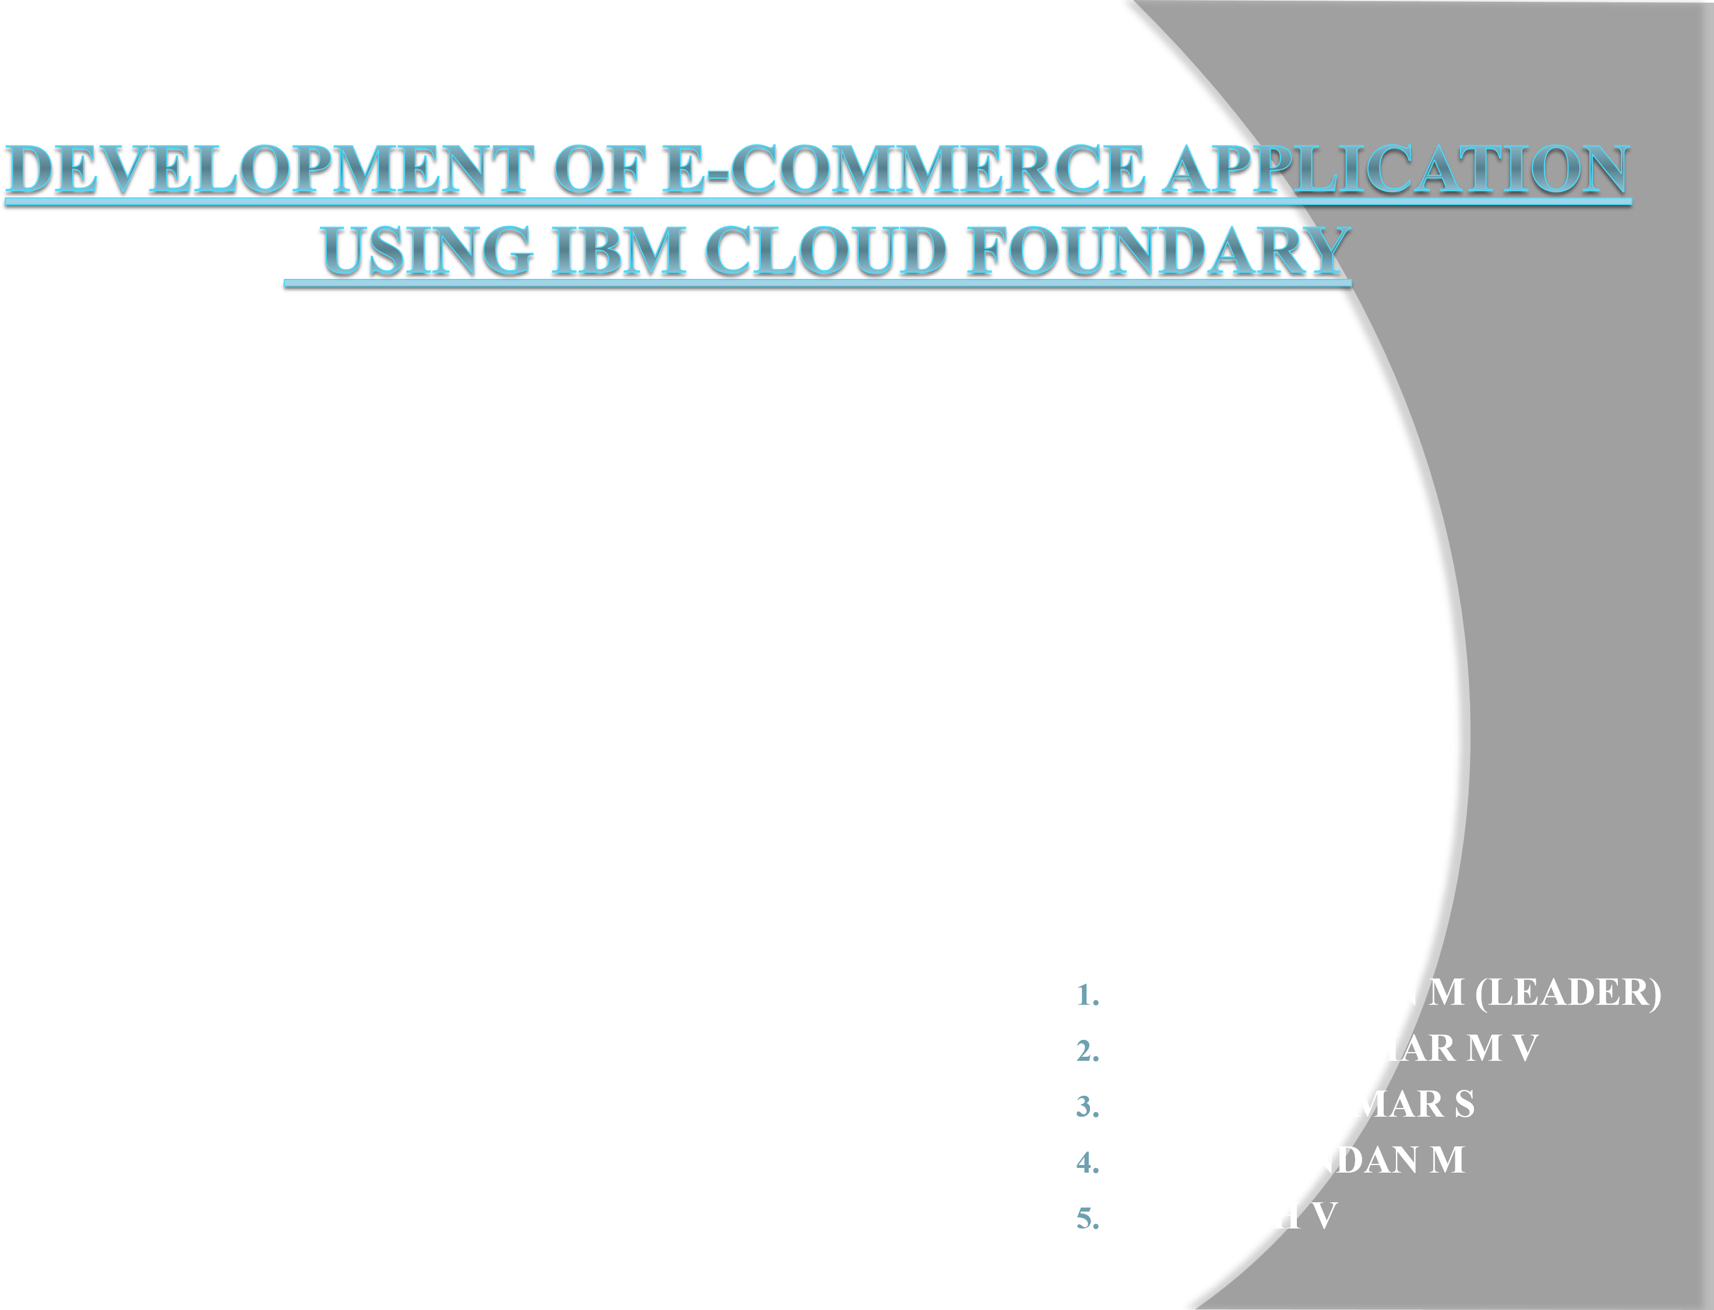

1. Real-Time Location-Based Mobile Selling
- Real-time location-based selling technology allows retailers to target customers based on their precise location and deliver personalized messages and offers in real time.
- By leveraging geolocation data from customers’ smartphones or other connected devices, retailers can provide a more personalized shopping experience and offer targeted promotions to customers near their physical stores.
- Real-time location-based selling is particularly useful for brick-and-mortar retailers as it allows them to drive foot traffic to their stores and increase sales.
- The market for location-based advertising was estimated at USD 62.35 billion in 2019; from 2020 to 2027, it is anticipated to increase at a compound annual growth rate (CAGR) of 17.4%.

2. Super Fast Delivery and Instant Pickup Counters
- Super fast delivery and instant pickup counters are innovative e-commerce solutions that offer a range of benefits for both retailers and customers.
- Convenience: Super fast delivery and instant pickup counters allow customers to receive their orders quickly and conveniently.
- Speed: With super fast delivery, customers can receive their orders in as little as a few hours, while instant pickup counters allow customers to collect their orders in minutes.
- This is particularly useful for customers needing time-sensitive items.
Competitive advantage:
Offering perks like super-fast delivery and instant pickup can
differentiate retailers from their competitors and increase customer loyalty, giving your brand a competitive advantage.

3. Voice-Powered Shopping
- Voice-powered shopping is an emerging trend in e-commerce.
- According to a study, 51% of mobile buyers look up things using their voice assistants.
- Here’s how it can be advantageous – Voice-powered shopping allows hands-free purchases using voice commands.
- Voice assistants aid customers in learning about new products and evaluating options from several brands, increasing satisfaction when they make a purchase.
- Provides personalized recommendations Offers a convenient and accessible shopping experience

4. Shopping using AR Technology
- Recent estimates from industry experts like Global Newswire indicate that the augmented reality business is booming and expanding faster than nearly any other technology.
- Here’s how shopping using AR technology is beneficial – Enables customers to visualize products using their smartphones or tablets in a real-world environment.
- Retailers can use AR technology to showcase their products more engagingly and interactively and differentiate themselves from competitors.
- AR technology can also help reduce return rates, as customers can see how products look and fit before purchasing.
- Shopping using AR technology is an emerging trend in e-commerce that has the potential to revolutionize the way customers shop and interact with retailers.

5. Single-click Checkout
- Due to the laborious and drawn-out checkout process, transactions usually get lost.
- About 17% of customers are said to abandon their carts due to a lengthy or difficult checkout procedure.
- The best way to get over that is to apply single-click checkout.
- It is a single-page payment process that is used to process orders.
- Consumers enter the necessary data, and the payment processor saves their information for future purchases.

6. Chatbots to Handle Customer Queries
- Unquestionably, an e-commerce chatbot is a novel development in the retail sector.
- Everyone should think about including e-commerce chatbots in their online business if they want to stay competitive.
- It is available 24/7.
- The ROI on e-commerce chatbots is very promising.
- It automates tasks which saves time and money.
- Users can avoid hassles, locate a better appropriate product, and get all the information immediately thanks to e-commerce chatbots.
- The multilingual support in e-commerce chatbots makes it useful for global brands to communicate with and grow.

7. Social Commerce
- Social commerce is a growing trend in e-commerce that involves selling products directly on social media platforms such as Facebook,
Instagram, and Pinterest.

It can provide customers with a seamless shopping experience, allowing them to explore and buy products without leaving the social media platform.
- By 2025, the global use of social commerce will reach $2 trillion.
- It symbolizes a fundamental shift in how customers engage with companies, including their shopping habits and times of the day.
- This opens up possibilities for consumer brands to embark on a journey that is far more engaging, entertaining, and immersive.

8. Remarketing
- Remarketing is a powerful tool for e-commerce innovation that allows you to target customers who have previously shown interest in your products or services.
- With the help of remarketing, businesses can-Increase conversions and improve your return on investment (ROI) by displaying targeted ads to these customers.
- Enables your brand to stay relevant among potential customers, reminding them of your brand and encouraging them to purchase.
- Provides valuable insights into customer behavior, allowing you to tailor your marketing messages and improve your overall e-commerce strategy.
9. E-wallet technology is a must.
- Ewallet technology offers numerous benefits for e-commerce innovation, providing customers with a convenient and secure way to purchase online.
- With e-wallets, customers can store their payment information in one place, making the checkout process faster and more streamlined.
- With the global e-wallet market expected to reach $3 trillion by 2024, incorporating this innovative payment solution into your e-commerce strategy will let you extend better customer services.

10. Voice search is growing in popularity
- Voice search is rapidly growing in popularity as more and more consumers turn to virtual assistants like Siri, Alexa, and Google Assistant to find the information they need quickly and easily.
- According to Google, 27% of people worldwide use voice search on mobile devices.
- According to Voicebot’s voice search data, 58.6% of US customers have used voice search.

