Project 4

SeaPort Project

Name: Minseok Kwak

Class: CMSC335

Professor: Nicholas Duchon

Date: December 17th, 2017

**Contents**

1. Design
   1. UML class Diagram
   2. Updates
2. User’s Guide
   1. JTree & JProgressBar with Resource pool
3. Test Plan
   1. Test case and Expected result BEFORE coding
   2. Comparison
4. Lessons Learned
5. Design
   1. UML Diagram

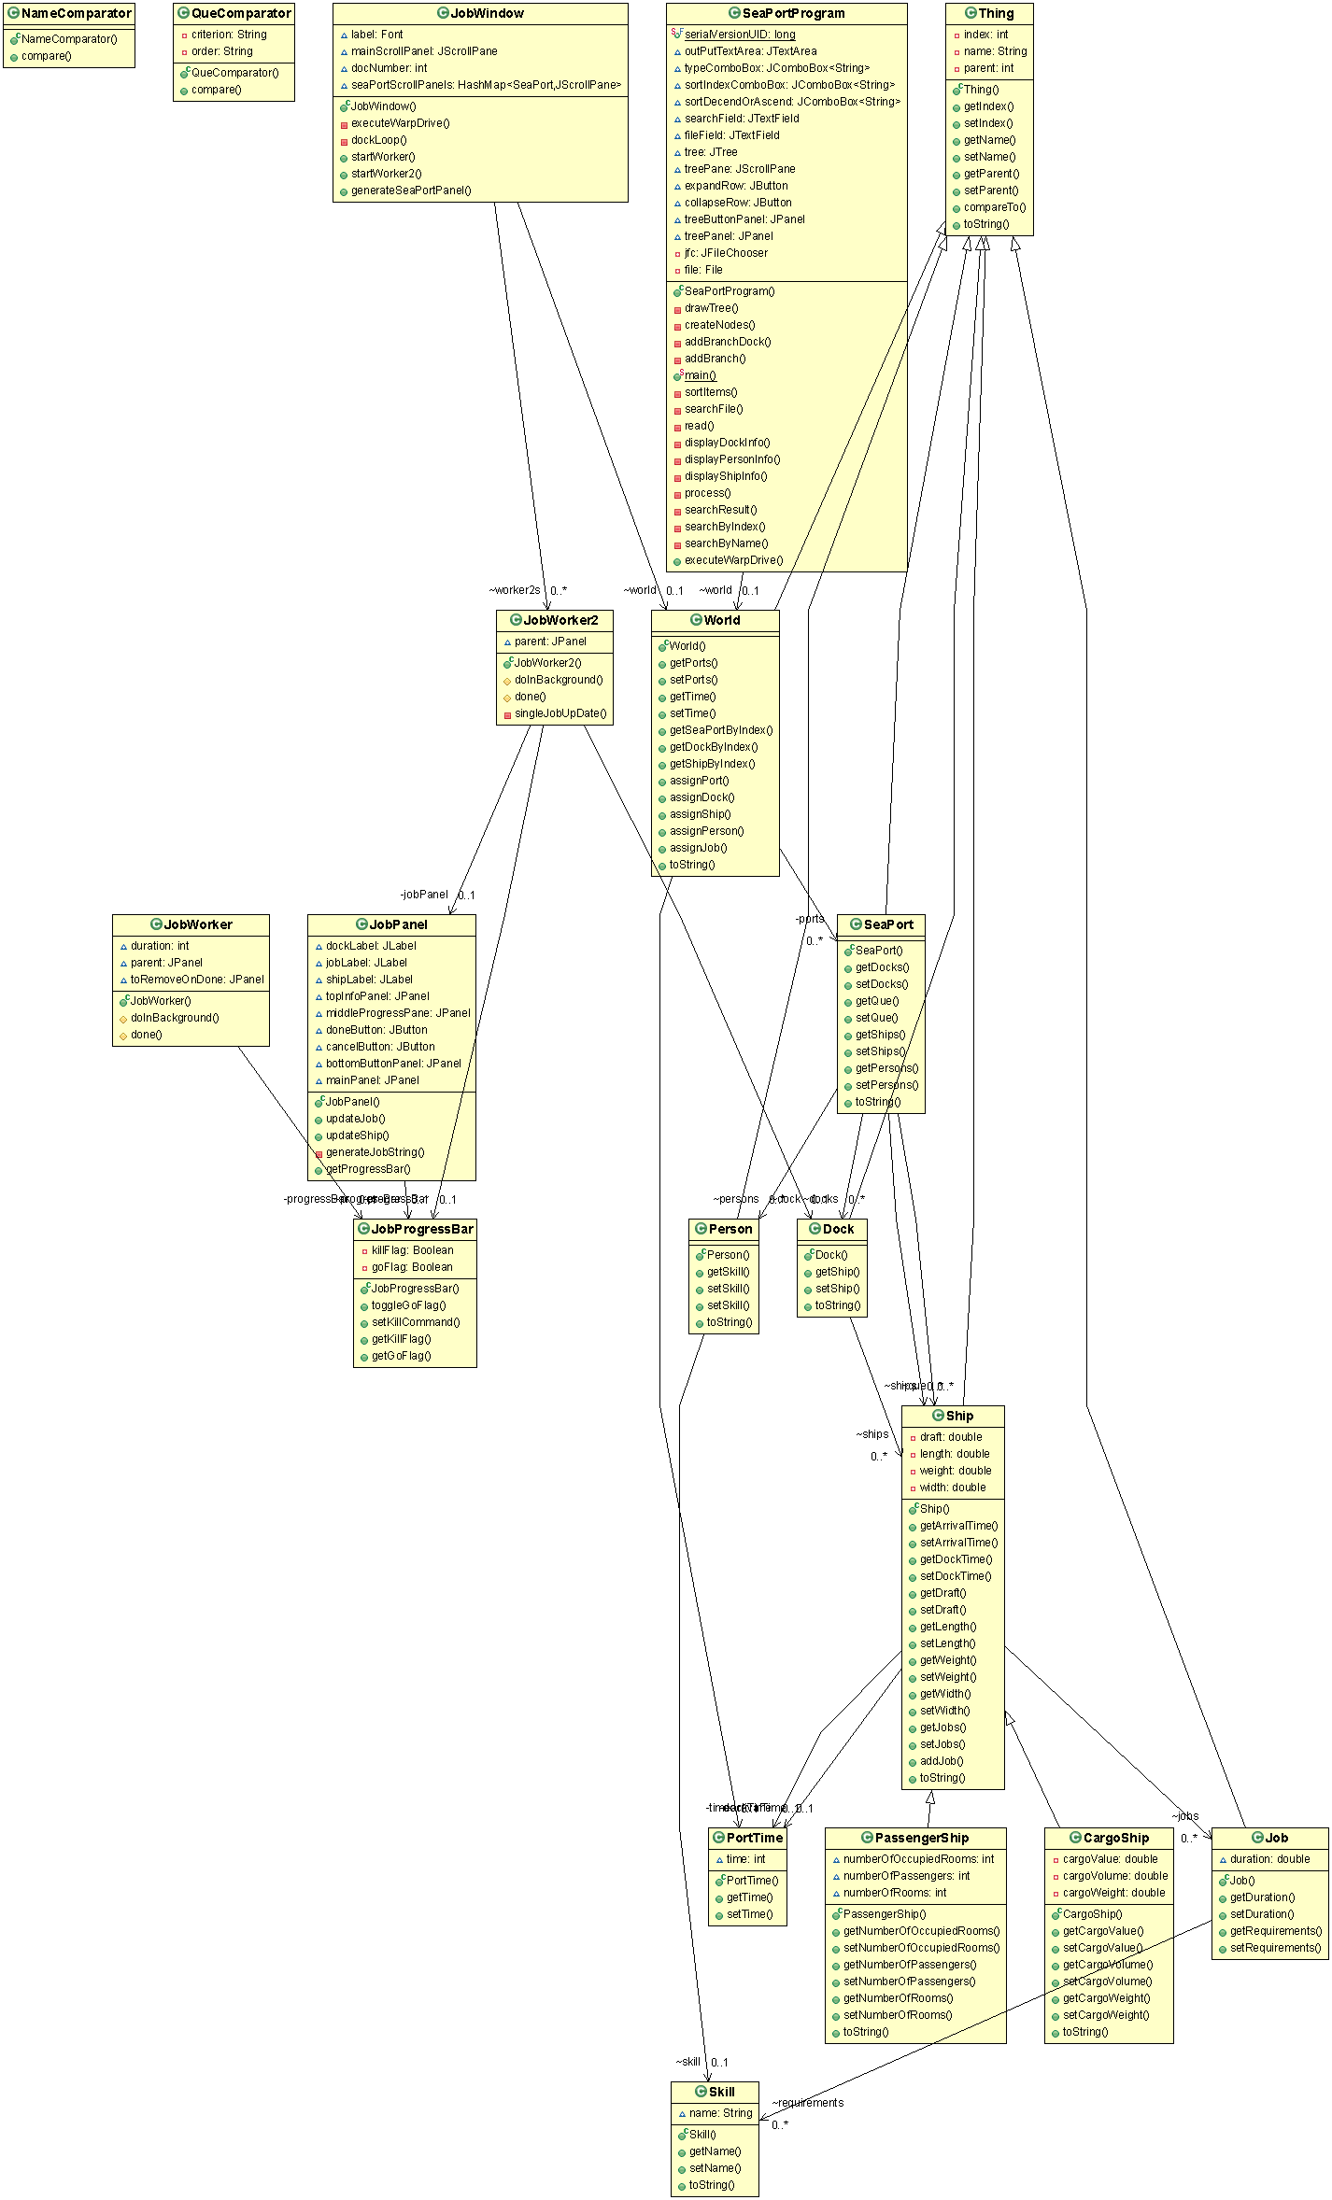

* 1. Update
     1. ResourcePoolPanel
        + JPanel with the resource pool in it and update the resource panel every time a job required skill
        + Represented the resource pool as a concurrentHashMap of <Skill, Integer> where a particular skill is mapped the number of available people in the Sea port.
     2. GUI
        + Change layouts
          1. Clean and neat
          2. User Friendly
          3. Display Skills with the JProgressBar

1. User’s Guide

* Read file and Sort objects by certain criterion and order

1. Click “Browse” button

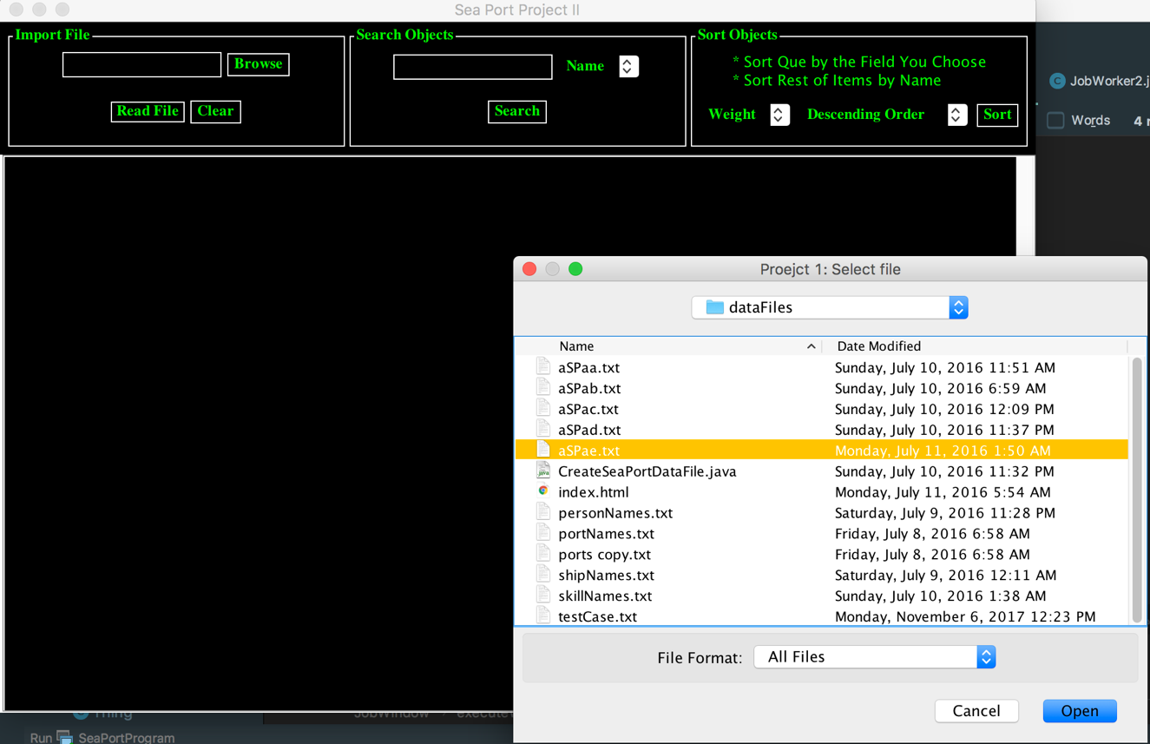

1. Select specific file and click “Read File” Then, it will show JTree  
   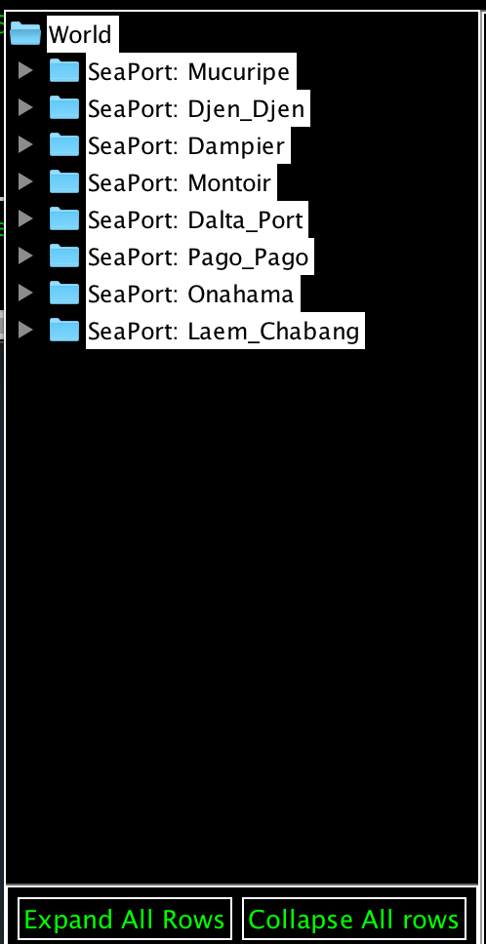
2. If the wants to see all rows, click “Expand All Rows” button  
   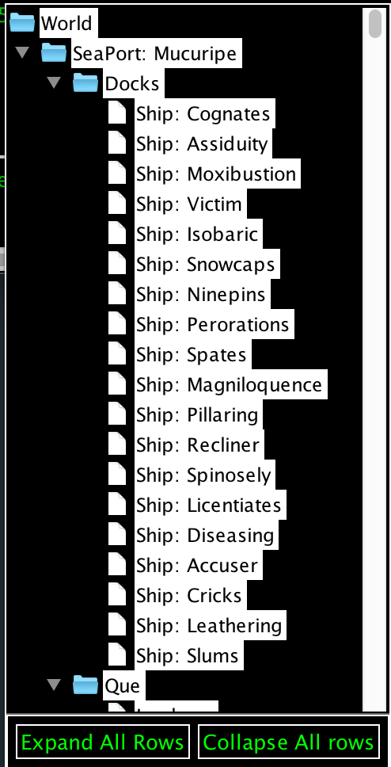
3. If wants to collapse all rows, click “Collapse All Rows” button  
   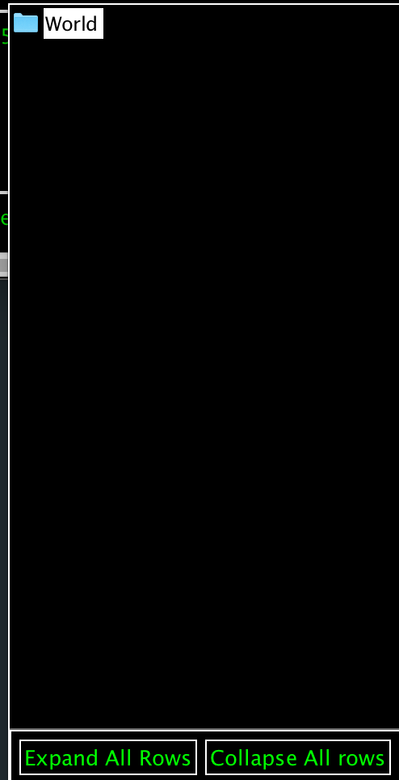
4. It also show current working jobs & Resource pool  
   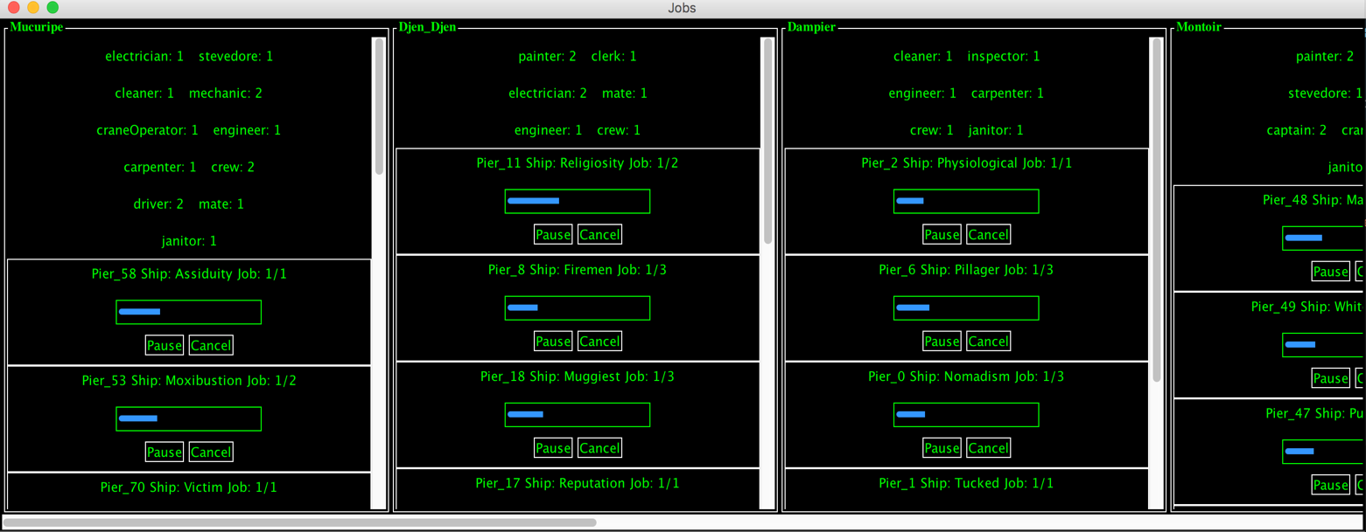
5. Test Plan

Test Case

* aSPae.txt

Test Result

* It displays progressBar and when it reaches 100 percent, then the job is done. User can also click button to cancel the working job before it is done.

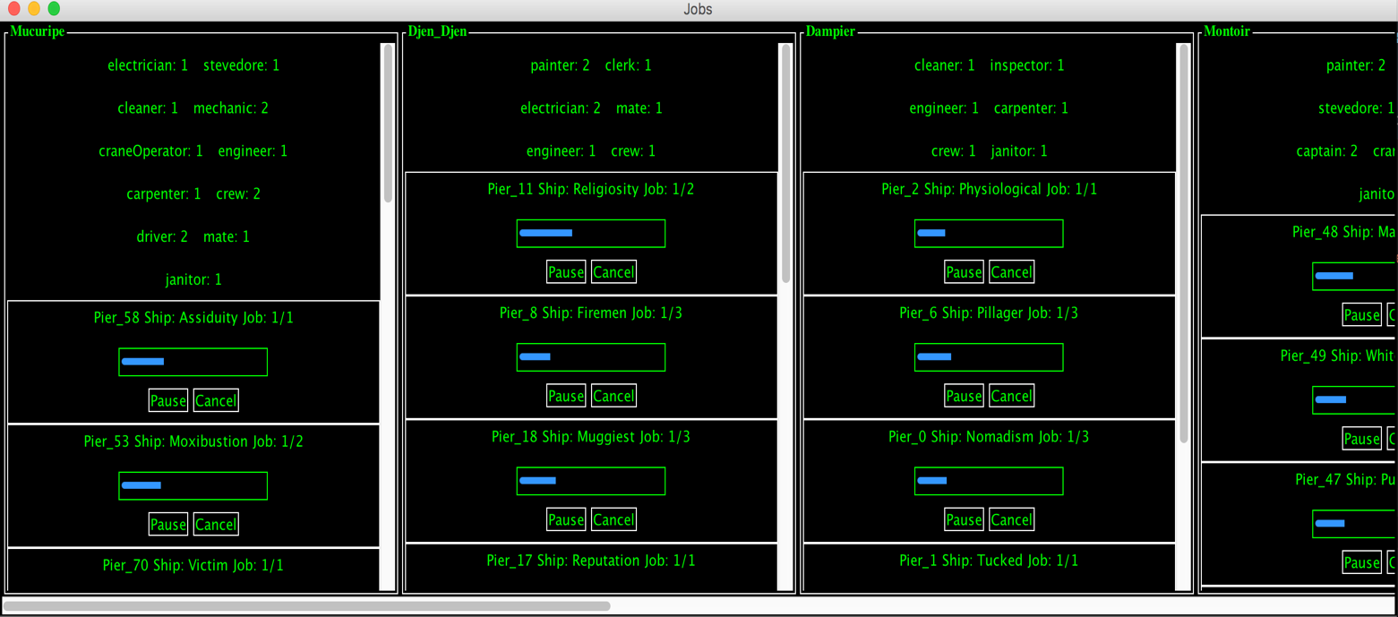

1. Lesson Learned

The first thing I’ve learned from the project is usage of ConcurrentHashMap class, which is a hash table supporting full concurrency of retrievals and high expected concurrency for updates. For update of GUI with each Skill, I used Iterator so I can go through each Skill in order to set the skills as JLabel.