FLOOD MONITORING AND EARLY WARNING

**INTRODUCTION**

Flood monitoring is a crucial component of disaster management and environmental protection. It involves the continuous surveillance, assessment, and prediction of water levels and weather conditions to anticipate and respond to potential flood events. This proactive approach helps in early warning systems, safeguarding communities, and minimizing the devastating impact of floods on lives and property. Flood monitoring utilizes various technologies, such as weather radar, river gauges, satellite imagery, and computer modeling, to gather data and provide real-time information to decision-makers and the public, enabling timely response and mitigation efforts. Flood management refers to a set of strategies and practices aimed at mitigating the adverse effects of floods on human lives, property, and the environment. This comprehensive approach encompasses flood prevention, preparedness, response, and recovery. It involves the coordination of government agencies, community initiatives, engineering solutions, and environmental considerations to reduce the impact of floods and enhance resilience in flood-prone areas. Effective flood management strategies typically include floodplain zoning, early warning systems, flood control infrastructure, and community education to minimize the devastating consequences of flooding events.

**ABSTRACT**

Develop an efficient and reliable flood monitoring system that utilizes advanced technology and data analytics to detect, track, and predict floods in real-time. The system should be capable of gathering and analyzing data from various sources, such as weather sensors, river gauges, satellite imagery, and social media, to provide timely and accurate flood warnings and enable effective disaster response and mitigation strategies. Additionally, the system should be scalable, adaptable to different geographical regions, and user-friendly for both authorities and the general public, with the ultimate goal of reducing flood-related risks and minimizing the impact on human lives and infrastructure. Flood management is a critical issue that requires effective strategies and solutions to mitigate the devastating impacts of floods. The problem at hand is to develop comprehensive flood management plans and systems that can minimize the loss of life, property damage, and disruption to communities caused by flood.

**DESIGN**

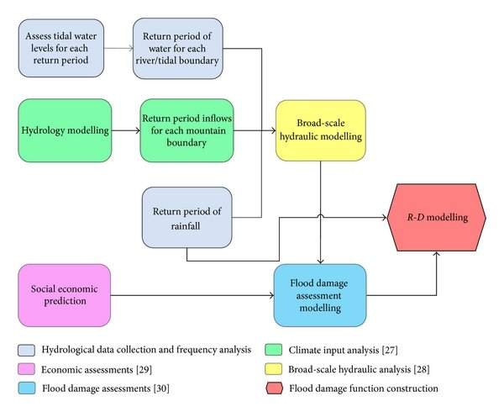

**METHODOLOGY**

Establish robust meteorological and hydrological monitoring systems. Develop predictive models for flood forecasting. Implement efficient early warning systems to alert residents and authorities .Assess and upgrade critical infrastructure, such as dams, levees, and flood barriers. Implement zoning and land use regulations that restrict construction in high-risk flood zones. Encourage sustainable land use practices and floodplain management.

**FLOOD MANAGEMENT**

Sensors placed in rivers and streams to monitor water levels .Transmit data on river stage and flow rates to assess flood risk. Instruments for measuring temperature, humidity, rainfall, wind speed, and direction. Collect real-time weather data to predict rainfall and weather patterns that can lead to floods.

**EARLY WARNING**

Utilize advanced technology like GIS (Geographic Information Systems) for data integration. Improve modeling techniques with real-time data inputs. Develop and enforce flood management policies and regulations. Collaborate with neighboring regions and agencies for coordinated flood management.

**RELATED IMAGE**

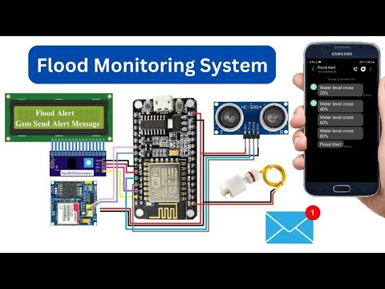

**CONCLUSION**

In conclusion, flood monitoring and early warning systems play a pivotal role in mitigating the devastating impact of floods on both human lives and infrastructure. These systems employ advanced technology and data analysis to provide timely alerts, giving communities crucial time to prepare and evacuate if necessary. As climate change continues to increase the frequency and severity of floods, the importance of investing in and improving these monitoring and warning systems cannot be overstated. By embracing innovation and collaboration, we can work towards a future where flood-related disasters are minimized, and lives are saved.

**THANK YOU**