Introduction to Power BI

Examples and Exercises

# Loading Data

1. Load all csvs
2. Check datatype

Remember to Close & Apply

# Warming up

Let’s build some simple visualizations together

The goal is to get here:

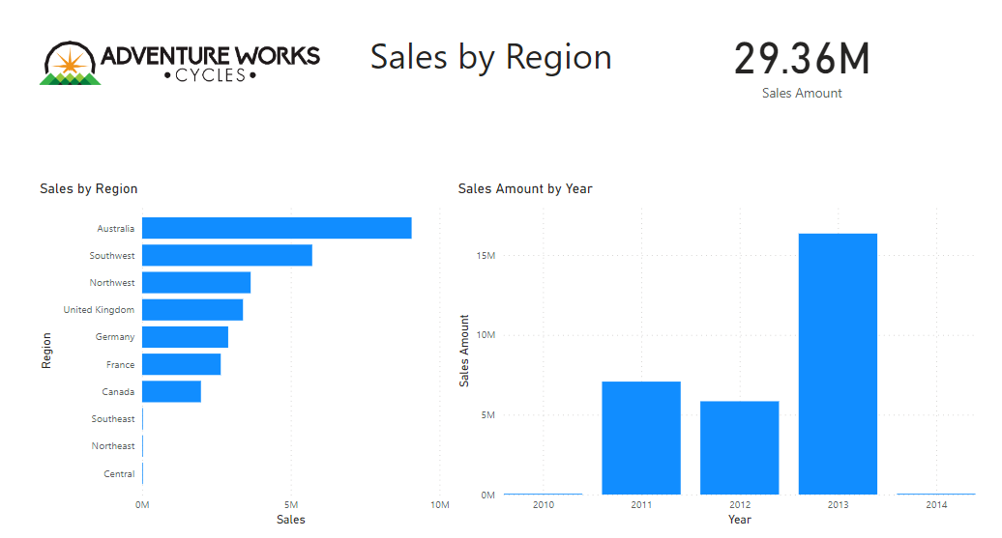

1. Rename tab to Sales
2. Create a Clustered Bar Chart using FactInternetSales[SalesAmount] and DimSalesTerritory[SalesTerritoryRegion]
3. Create a Clustered Column Chart FactInternetSales[SalesAmount] and DimDate[FullDateAlternateKey]
4. Change Axis names (I’ll give a tip on this)
5. Create also a Card showing the SaleAmount value
6. Add text and image to make this page of the report more interesting

# Transforming Data

1. Who are our top 10 customers considering SalesAmount?

Tip: First we will need Power Query to generate customers full name (FullName) since there are mamy customers with same LastName. You will need to use ‘replace values’ and ‘merge columns’

1. In the visualization you created with top 10 clients replace FullName with CustomerAlternateKey. Because of GDPR personal information should not be shared. Usually within organization only personal that really need to know who the client is have this information (e.g., customer service). So, when making your visualizations take into account GDPR and privacy issues.
2. Create a table with some information about clients so the person exploring this data can have some more details about those clients’ profile.

# Visualization

1. Complete previous page (Customer Revenue) with 2 visuals that shows:
   1. percentage of Sales of clients by gender (Top 10)
   2. percentage of Sales of clients by marital status (Top 10)
2. Answer the following questions:
   1. Who does expend more by gender? (Female or Male)
   2. Who does expend more by marital status? (Single or Married)
3. Insert also a card showing the SalesAmount for the top 10.

Tip: What if we don’t want this card to interact with the other visuals? (Edit interactions)

Let’s analyze sales

1. Create a new tab called **Sales Around the World**
   1. Use map to show how much each country sells
   2. Which product category generates the highest sales amount in general?
   3. Which product category generates the highest sales amount in 2011?
2. Waterfall chart: How Sales changed over the years per Country. Use a waterfall chart to see how the Number of Sales changed for each country (tab **Changes in Sales per Country**). What happened with the US Sales between 2011 and 2012?

# DAX

1. Generated column: Which year generated the highest profit and how much was the profit?
2. Generated measure: In which month year there was the largest number of orders?

Tip 1: Create a table **_calculations** where you will keep all your measures

Tip 2: create a measure **OrdersCount** and create a line chart.

1. Generate measures: **Total Sales**, **Total Cost**, **Total Profit**, **Profit Margin Ratio (%Margin)**

Tip: To calculate Total Cost use FactInternetSales[TotalProductCost] and (FactInternetSales[TaxAmt]

1. In which year there was the highest Profit Margin Ratio (%Margin)?

Tip: Use DAX function DIVIDE

1. Create a new tab **Profit Margin Analysis** and add visuals to show the generated measures (item 3) and a visual that helps you answer: Which year had the highest profit?
2. Considering 2012 which quarter had the highest profit? And which month?
3. Add slicers visuals so you can choose the country and/or product category to visualize the profit margin ratio.
4. Previously we have found which product category generated the highest revenue (SalesAmount). How much this product generated in 2012? (Tip: time to use CALCULATE)

SalesBikes2012 = CALCULATE([TotalSales],

FILTER(DimProductCategory, DimProductCategory[EnglishProductCategoryName]="Bikes"),

FILTER(DimDate, DimDate[FullDateAlternateKey].[Year]=2012))

1. How much this product generated in 2012 in UK (United Kingdom)?
2. Quick measure: Create a new tab called YoY. Create a new quick measure in _calculations that calculates year-over-year change for TotalSales over one period. What was the TotalSales YoY% for 2013? 179,87%

## DAX's date and time intelligence function

1. Generate column: Generate a column **Age** that shows the customer age and add this information to our **tab Customer Revenue**?
2. From Age create another column **AgeGroup** that uses the following categories?
3. Add a multi-row card showing the minimal and maximal age of customers and the total number of customers. Add this visual to **tab Customer Revenue**.
4. Use what you create in items 1 and 2 to create a visual that shows the percentage of customers within a certain Age Group. Add this visual to tab Customer Revenue.
5. Add also a visual that show the percentages of customers occupations. Which occupation has the higher percentage?



If you didn’t apply any filter to these last 2 visuals, they are considering all customers.

1. Create a tab called Products Analysis and replicate the following

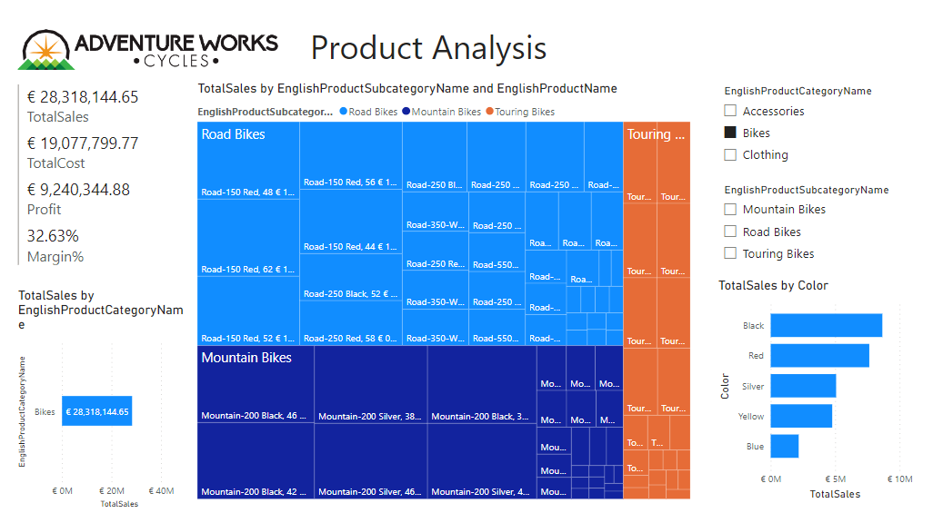

1. Make an analysis of the Sales trend. You can use something like this…

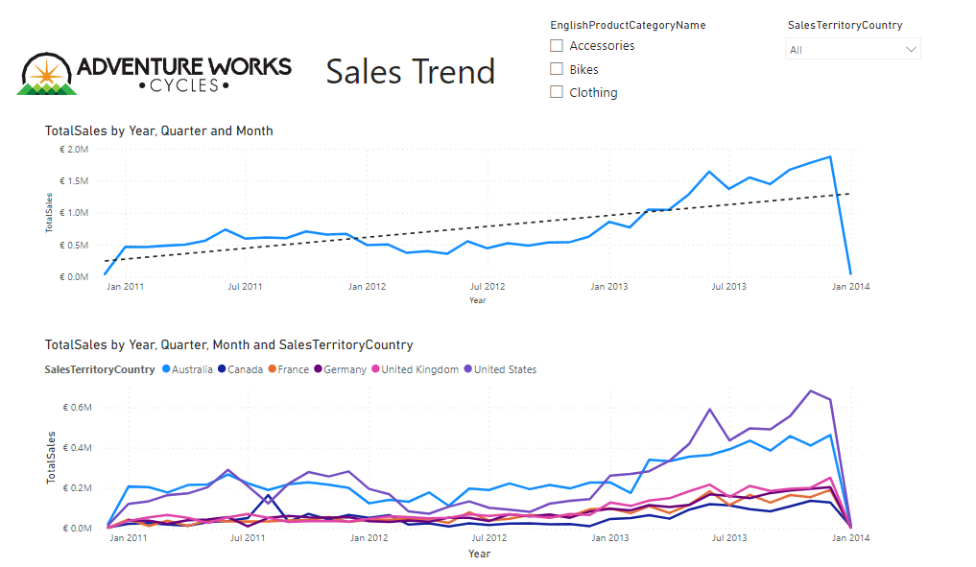

What conclusions can you obtain about the trend in Sales?

### DateTable (In a new report called DateTable)

1. Create a date table called Date table with columns: Day, Month, Year, DayName, MonthName.
2. Create a hierarchy from Year and rename it to DateHierarchy
3. Create a Stacked Column Chart Sales Amount vs Year-MonthName
4. Drill down to month. What happened with the MonthName order?
5. Sort MonthName by Month (It is important so in your visualizations you will have the name of the months in correct order)

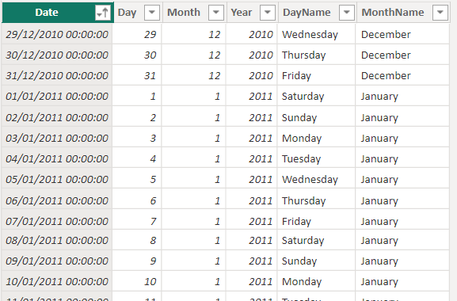

1. Refresh and see what happens

We will be using DimDate for our visualizations but it is important to know how to build and populate a standalone date table when needed (check power bi presentation to know why)

# Analysis of Client Churn

Let’s prepare a table that can be used for churn analysis while reviewing transformation using Power BI query and DAX.

1 . **Group By**: Create **CustomersActivity** table in Power Query that looks like this..

**Step1** : Duplicate **FactInternetSales** and rename **CustomersActivity**

**Step2**: Create a column called **Cost** using **TotalProductCost** and **TaxAmt**

**Step 3**: Select the columns you need (**CustomerKey**, **SalesAmount**, **OrderDate**, **Cost**)

**Step 4**: Rename SalesAmount as **Revenue**

**Step 5**: Create column **Profit**

**Step 6**: **Group By** to obtain the following table (Remember to have the right data types)

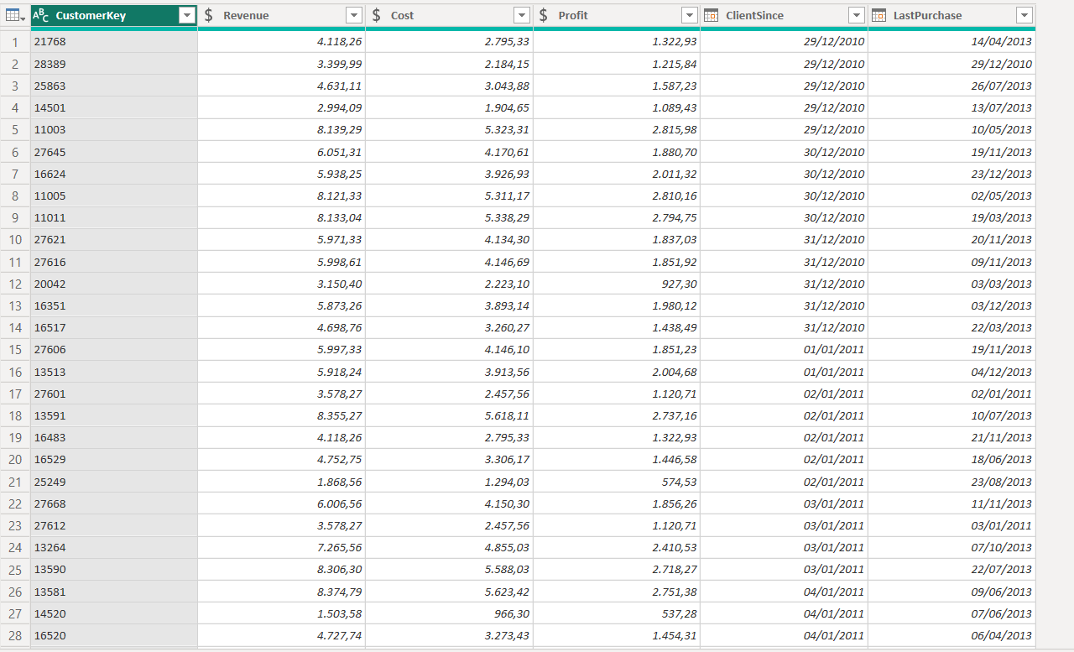

Remember to Close & Apply when leaving Power Query.

1. Add 2 columns in Data View using DAX. The final table will look like this…

Tip 1 : DaysInactive: Use DATEDIFF, MAX of OrderDate

Tip 2 : Churn: Use IF and consider churn after 180 days

What is the Churn Rate?

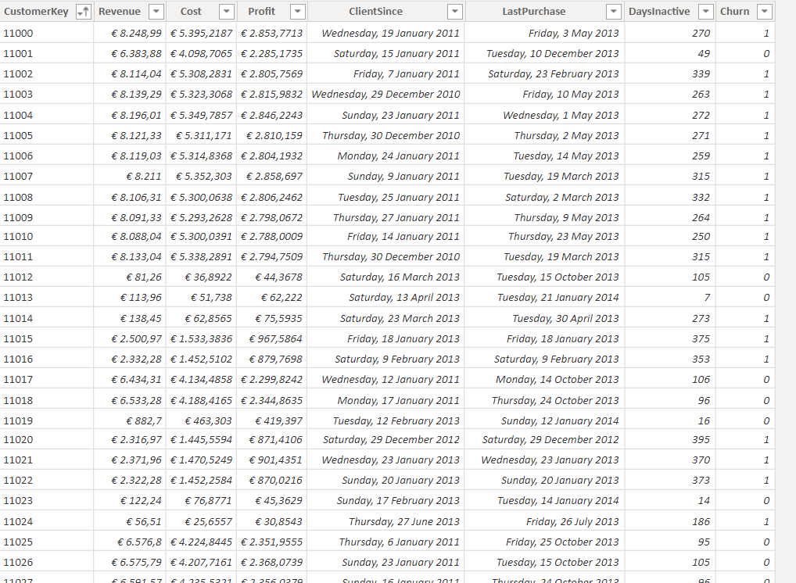

# Suggestion for exercising making a Churn Analysis

<https://www.kaggle.com/datasets/blastchar/telco-customer-churn?resource=download>