Changes made today
Thanks for downloading this sample business plan from Bplans.com!

Your business is unique. Your business plan should be too.
A sample plan is a great way to get inspired. But, your business is unique and your business plan should reflect that. If you need your own business plan, you’re still going to have to put in all your own information and do all your own financial forecasts.
LivePlan can help. You can easily create a custom business plan that will wow lenders and investors. It’s like having a business consultant, designer, and accountant by your side while you write your plan.

- A step-by-step process to follow
LivePlan asks you questions about your business, you plug in the answers. It’s as easy as that. You’ll get straightforward instructions, with examples, for every essential piece of your business plan.
- Financials that are calculated for you
LivePlan tells you exactly what kind of financial information you need to enter and then does all the calculations automatically using built-in formulas. So you end up with razor-accurate financial statements that include all the tables that a lender or investor expects to see.
- Impress lenders and investors
“I needed to write a business plan for my investors. [LivePlan] helped me create a precise plan to confidently share with investors, and I've raised $3 million so far!" - Rachid T., Olive Oil USA, LLC
Click here to save 50% off the first month of LivePlan!

get a professionally designed custom logo.
This sample business plan has been made available to users of Bplans.com, published by Palo Alto Software. Our sample plans were developed by existing companies and new business start-ups as research instruments to determine market viability, or funding availability. Names, locations and numbers may have been changed, and substantial portions of text may have been omitted to preserve
confidentiality and proprietary information.
You are welcome to use this plan as a starting point to create your own, but you do not have permission to reproduce, resell, publish, distribute
or even copy this plan as it exists here.
Requests for reprints, academic use, and other dissemination of this sample plan should be emailed to the marketing department of Palo Alto Software at marketing@paloalto.com.
Copyright  Palo Alto Software, Inc., 2018 All rights reserved.

Requests for reprints, academic use, and other dissemination of this sample plan should be emailed to the marketing department of Palo Alto Software at marketing@paloalto.com.
Copyright  Palo Alto Software, Inc., 2007-2009 All rights reserved.
]

Table of Contents
Executive Summary 1
Chart: Highlights 1
Objectives 1
Keys to Success 2
Mission 2
Company Summary 2
Company Ownership 2
Start-up Summary 3
Table: Start-up 3
Table: Start-up Funding 4
Chart: Start-up 7
Products 7
Market Analysis Summary 8
Market Segmentation 8
Chart: Market Analysis (Pie) 9
Table: Market Analysis 9
Industry Analysis 9
Competition and Buying Patterns 10
Strategy and Implementation Summary 11
Competitive Edge 11
Marketing Strategy 11
Sales Strategy 12
Sales Forecast 12
Chart: Sales Monthly 12
Table: Sales Forecast 13
Milestones 13
Table: Milestones 13
Web Plan Summary 13
Website Marketing Strategy 14
Development Requirements 14
Management Summary 14
Personnel Plan 15
Table: Personnel 15
Financial Plan 15
Important Assumptions 15
Table: General Assumptions 15
Projected Cash Flow 16
Chart: Cash 16
Table: Cash Flow 17
Break-even Analysis 18
Chart: Break-even Analysis 18
Table: Break-even Analysis 18
Projected Profit and Loss 18
Table: Profit and Loss 19
Chart: Profit Monthly 20
Projected Balance Sheet 21
Table: Balance Sheet 21
Business Ratios 22
Table: Ratios 22
Appendix i
Table: Sales Forecast i
Table: Personnel ii
Table: General Assumptions iii
Table: Profit and Loss iv
Table: Cash Flow v
Table: Balance Sheet vi

Executive Summary
Nature's Candy is an e-commerce company designed to become the market leader in Web based sales of naturopathic and homeopathic nutritional supplements. The company is located in Portland, OR. Although many Internet companies have recently failed, the Internet is still poised to support e-commerce retailers. Most of the dot-coms failed because of too easy access to capital and unproven business models with no true revenue streams. Nature's Candy will overcome these problems with an easy-to-use website and an efficient distribution system.
In the next three years Nature's Candy intends to create an icon e-commerce brand through laser-focused marketing and will grow to $319,000 in revenue.

Chart: Highlights

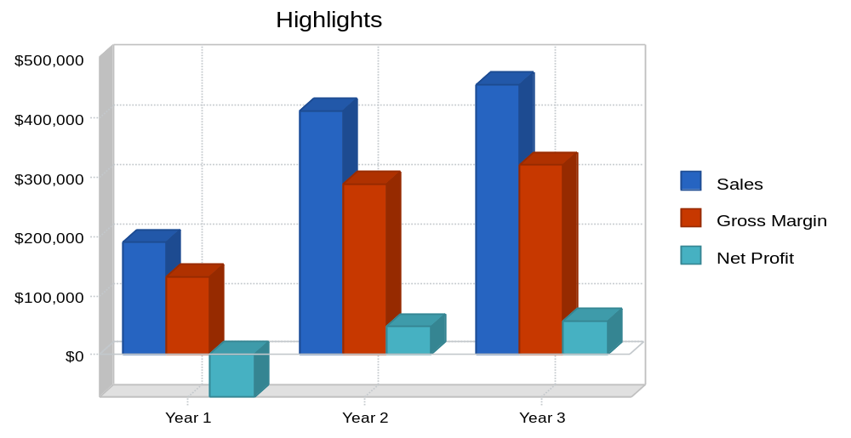

Do you need better-looking financial charts? Tools like LivePlan will do this for you automatically, with a professional modern design.

Objectives
Nature's Candy's objectives for the first three years are:
- To make Nature's Candy an icon brand.
- To develop an effective, well placed e-commerce site for sales of homeopathic and naturopathic products.
- To launch a laser-focused marketing campaign in a controllable and measurable market that will drive customer's toward the company's website.
- To create an infrastructure for the fulfillment of Web-based sales.

Keys to Success
Nature's Candy's keys to success are:
- Marketing.
- Web design.
- Product quality.
- Service.

Mission

Nature's Candy's mission is to provide the finest in natural supplements using the Internet to lower the consumer's cost. We exist to attract and maintain customers. When we adhere to this maxim, everything else will fall into place. Our services will exceed the expectations of our customers.

Company Summary
Nature's Candy's goal is to become the e-commerce market leader in sales and marketing of naturopathic and homeopathic dietary supplements.

Company Ownership
Nature's Candy is a privately held Oregon corporation. Quack Vendor will be the majority owner. The company intends to recruit a sophisticated team of owner board members. The board members will be granted shares of stock to provide an incentive for their performance on the board

Start-up Summary
Nature's Candy will incur the following start-up costs:
- Legal fees for the business formation.
- Office supplies.
- Web development.
- Telephone line installation.
- Desk, chair, filing cabinets.
- Shelving units for inventory storage.
- Computer system with Microsoft Office, QuickBooks Pro, CD-RW, printer, and a broadband Internet connection.

Table: Start-up

Start-up
Requirements
Start-up Expenses
Legal | $1,000
Stationery etc. | $200
Web Development | $10,000
Total Start-up Expenses | $11,200
Start-up Assets
Cash Required | $65,600
Other Current Assets | $0
Long-term Assets | $3,200
Total Assets | $68,800
Total Requirements | $80,000

Need to create your own financial tables? Tools like LivePlan will do this for you automatically.

Table: Start-up Funding

Start-up Funding
Start-up Expenses to Fund | $11,200
Start-up Assets to Fund | $68,800
Total Funding Required | $80,000
Assets
Non-cash Assets from Start-up | $3,200
Cash Requirements from Start-up | $65,600
Additional Cash Raised | $0
Cash Balance on Starting Date | $65,600
Total Assets | $68,800
Liabilities and Capital
Liabilities
Current Borrowing | $0
Long-term Liabilities | $0
Accounts Payable (Outstanding Bills) | $0
Other Current Liabilities (interest-free) | $0
Total Liabilities | $0
Capital
Planned Investment
Quack | $45,000
Stewart | $35,000
Other | $0
Additional Investment Requirement | $0
Total Planned Investment | $80,000
Loss at Start-up (Start-up Expenses) | ($11,200)
Total Capital | $68,800
Total Capital and Liabilities | $68,800
Total Funding | $80,000

Need Funding? Visit the Bplans Funding Portal! It’s Straightforward and Free
The Bplans Funding Portal matches entrepreneurs and small business owners with lenders that will suit their needs. Submit one free, online application and receive a host of great funding options to choose from.

You can discover a wide range of financing options, from traditional term loans and SBA loans to merchant cash advances.
- Transparency and Empowerment
You won’t find lenders trying to hide anything in the fine print. Our partners are committed to transparency for borrowers, so you know exactly what you’re getting and how to choose the best funding for your business.
- Explore 25+ Lenders and Get Impartial Advice
Our partners get their fees from lenders, not borrowers, and the fee is standardized so no lender gets an unfair advantage. This allows them to focus only on finding you the funding your business needs.
- You Choose From Competitive Offers
After filling out just one application, you receive competitive loan offers from multiple quality lenders. You get to shop prices and compare loan products, so you can make the best choice.
Click here to get started for free »

Chart: Start-up

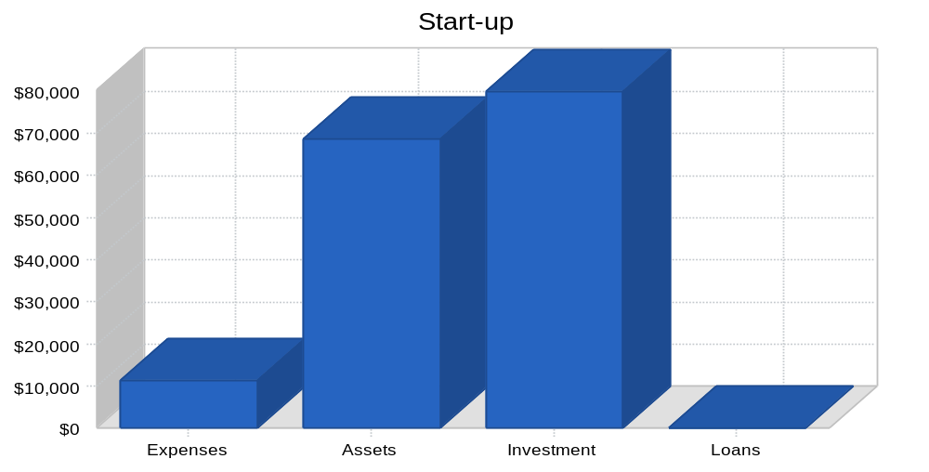

Do you need better-looking financial charts? Tools like LivePlan will do this for you automatically, with a professional modern design.

Products
Nature's Candy will market and sell private label (manufactured by a company that places the retailer's name on the packaging) naturopathic homeopathic dietary supplements to individual consumers via the Internet. These products will include ginseng, ginkoba, and various antioxidants. After year one additional products will be offered.

Market Analysis Summary
The market for vitamins and nutritional supplements has grown to over $6.5 billion annually. Herbal sales alone are growing by 20% per year. This market is lead by the aging Baby Boomer who is concerned with his/her mortality. Also, there has been a paradigm shift of perception of nutritional supplements. Homeopathic and naturopathic products are seen as normal. In addition, positive medical results from major studies have further legitimized these products.

Market Segmentation
A significant trend in America, and abroad, is that people are taking a more proactive interest in their health. This is exemplified by the increase of health clubs and health club memberships. People are looking to avoid invasive surgery and powerful pharmaceuticals. People are taking an active role in the maintenance of their health and practicing preventive medicine. Naturopathic medicine promotes the diagnosis, treatment, and prevention of human disorders through the use of non-invasive, non-pharmaceutical products and practices. In 1993, the United Stated government recognized this trend when it established the Office of Alternative Medicine.
Besides the general development of naturopathic medicine, the aging of the American population is a significant trend driving the use of naturopathic and homeopathic health supplements. The Baby Boomers are now reaching middle age and mortality is becoming a focus. This demographic segment, which is comprised of 80 million people, represents over 50% of our county's discretionary income. It is reasonable to believe that this wealthy market segment will continue to grow the sales of naturopathic products.
Another global trend is the emergence and popularity of e-commerce. Brand-focused Web retailers that can provide quality products, customer service, information, and the intangible, emotional buy-in by the customer are becoming hugely successful. E-commerce retailers have an advantage in that "Unlike traditional retailers, Web-based sellers are not slowed by the friction of store growth and local marketing" (J.W. Gurley, Fortune, 1/11/98). In addition, e-commerce companies do not have the excessive overhead of a traditional brick and mortar retailer. As seen by the recent success of Amazon.com and Gap.com, consumers are comfortable buying online and will pay for convenience. Experts predict Web sales to grow to $12 billion by 2003.
This enthusiasm about the Internet is not irrational but grounded in reality in light of the recent market crash of Internet retailers. The recent Internet crash was based on too-easy access to capital invested into retailers and other dot-coms without reasonable business plans or revenue models. Regardless of the recent fallout, the Internet is a very efficient marketing and distribution model that if done right, significantly decreases costs of serving the consumer. Nature's Candy will harness these efficiencies and will grow intelligently unlike other .dot-coms that became dot-bombs.

Chart: Market Analysis (Pie)

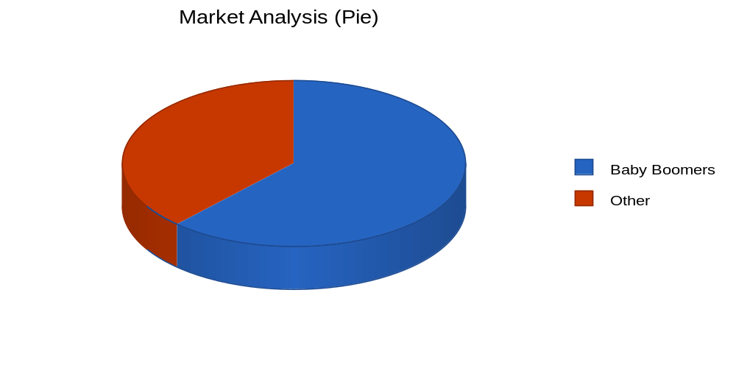

Table: Market Analysis

Market Analysis
 |  | Year 1 | Year 2 | Year 3 | Year 4 | Year 5
Potential Customers | Growth |  |  |  |  |  | CAGR
Baby Boomers | 9% | 64,785 | 70,616 | 76,971 | 83,898 | 91,449 | 9.00%
Other | 8% | 40,000 | 43,200 | 46,656 | 50,388 | 54,419 | 8.00%
Total | 8.62% | 104,785 | 113,816 | 123,627 | 134,286 | 145,868 | 8.62%

Need to create your own financial tables? Tools like LivePlan will do this for you automatically.

Industry Analysis
The nutritional supplement market is a semi-mature market characterized by high-growth rates, medium barriers to entry, and a few large competitors. Despite the competition in the market, many companies have reported annual growth levels of 30%. The market leaders are as follows:
- GNC (General Nutritional Companies, Inc.): This company is a nationwide specialty retailer of vitamins, minerals, and sports nutrition supplements. With over 3,000 stores, GNC generated $1.19 billion in 2000.
- Nature's Sunshine Products, Inc.: Nature's manufactures and markets a variety of health supplements. This multi-level marketing company had 2000 revenues of approximately $370 million.
- Rexall Sundown, Inc.: Rexall develops, manufactures, markets and sells vitamins, nutritional supplements, and consumer health products through retailers, independent distributors, and mail order. Rexall had 2000 revenues of approximately $370 million.
- International Vitamin Company, Inc.: IVC manufactures, packages, sells, and distributes private label vitamins and nutritional supplements to drug stores, supermarkets and health food stores. IVC had revenues of $107 million in 2000.
The primary channels of distribution in this market are:
- Mass market retailers (Fred Meyer, Rite Aide).
- Direct Sales organizations.
- Health Food Stores (GNC).
- Mail order catalogs and the Internet.

Competition and Buying Patterns
Within the mass market retailer channel, the three main primary vitamin and supplement product categories are national brands, broad-line brands, and private label brands. The national and broad line brands consist of 60% of the domestic market, which the private label brands account for the remaining 40% of the market.
National Brands
Examples: Centrum, One-A-Day.
Generally do not provide a full line of vitamins or other supplements.
The product formulas are conservative and generic in nature.
Broad-line Brands
Examples: Rexall Sundown, GNC's Nature's Fingerprint, Country Life.
Full lines of produce under one brand.
Manufactured by company.
This is the market segment where most of the product development and innovation occurs.
Stronger potencies and cutting edge ingredients.
Highest price.
Private Label Products
Examples: NatureMed.
Under retailer's name.
Smaller line of products than broad-line brands.
Manufactured by a third party.
More conservative potencies than broad line.
Tend to be the cheapest.

Strategy and Implementation Summary
Nature's Candy's strategy is based on capturing a small percentage of the growing homeopathic and naturopathic supplement market share through Web sales.
Also, Nature's Candy intends to create a premier brand, so that they can eventually capture market share across broad geographic lines.

Competitive Edge
Nature's Candy's competitive edge will be their easy-to-use website and superior customer service. The website design will be a competitive advantage because research indicates that an easy-to-use website significantly increases sales. The design of Nature's site will encourage purchases because it is so easy and quick to make the purchase. Too often sales are lost because of complex websites that are far from intuitive.
Nature's Candy's other competitive edge is superior customer service. The mantra of the customer service department is to serve the customer in any way required. Customers that call in with problem/issues will be amazed at the amount of personal attention they receive and how quickly issues are not only resolved, but significantly improved. This will be a powerful asset.

Marketing Strategy
Nature's Candy is focused on the merging/redefined Internet marketplace. The users will be Baby Boomers, which represent approximately 50% of the discretionary income currently in the United States. They are looking for proactive, non-invasive, and non-pharmaceutical ways to stay healthy as they age. Nature's Candy can bring these people cutting-edge products coupled with convenience and service.
The long range goal of Nature's Candy is not only to dominate the naturopathic and homeopathic supplement market, but to create an icon brand. Initially the company will:
- Engage in Web-based marketing for the next year to generate awareness of the company and product information. Because Internet based advertising has declined in recent quarters, the prices for advertising have consequently significantly dropped making the expenditure more cost effective.
- Engage in outdoor advertising providing general awareness to the public at large and direct individuals to the company's website.

Sales Strategy
Nature's Candy will process 90% of it's sales online through a secure socket layer (SSL), an secure Internet connection. All orders will be charged to Visa, Mastercard, or American Express.
By ensuring that the website is easy to navigate as well as simple to order from, Nature's Candy will be ensuring that people who make it to the website will end up purchasing something. This last point is key. Research indicates that too many sites that are not easy or intuitive lose customers who migrate through the site, often putting products in their basket, yet leave without purchasing anything.

Sales Forecast
The first month and a half will be used to develop and ready the site. There will be no sales. From month two on, Nature's Candy expects a gradual rise in sales.

Chart: Sales Monthly

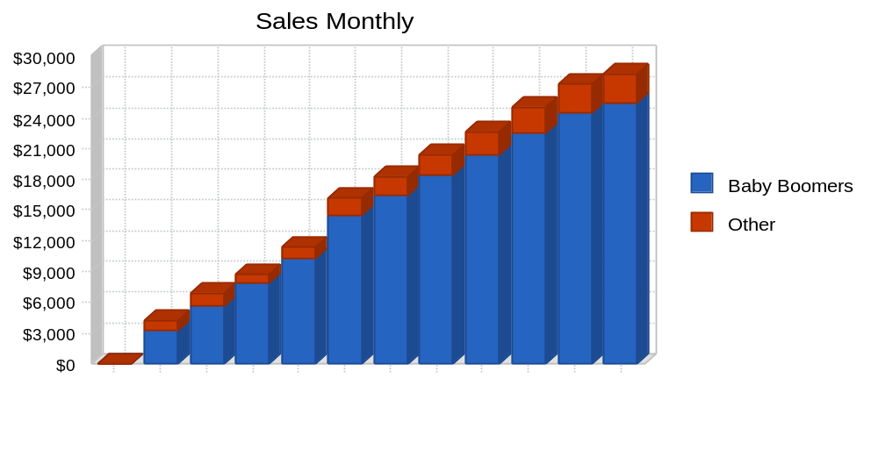

Do you need better-looking financial charts and tables? Tools like LivePlan will do this for you automatically, with a professional modern design.

Table: Sales Forecast

Sales Forecast
 | Year 1 | Year 2 | Year 3
Sales
Baby Boomers | $169,466 | $371,454 | $411,014
Other | $19,931 | $40,860 | $45,212
Total Sales | $189,397 | $412,314 | $456,226
Direct Cost of Sales | Year 1 | Year 2 | Year 3
Baby Boomers | $50,840 | $111,436 | $123,304
Other | $5,979 | $12,258 | $13,563
Subtotal Direct Cost of Sales | $56,819 | $123,694 | $136,868

Milestones
Nature's Candy will have several milestones early on:
- Business plan completion. This will be done as a roadmap for the organization. This will be an indispensable tool for the ongoing performance and improvement of the company.
- Office set up.
- Website completed.
- Complete hiring of the initial company personnel.

Table: Milestones

Milestones
Milestone | Start Date | End Date | Budget | Manager | Department
Business plan completion | 1/1/2001 | 2/1/2001 | $0 | ABC | Marketing
Office set up | 1/1/2001 | 2/1/2001 | $0 | ABC | Department
Web site completed | 1/1/2001 | 2/1/2001 | $0 | ABC | Department
Complete hiring of the intial company personnel | 1/1/2001 | 2/1/2001 | $0 | ABC | Department
Totals |  |  | $0

Web Plan Summary
Nature's Candy will use their website as their catalog and ordering device. The website will be a complete product offering as well as to provide company information.
The website will be designed with simplicity in mind. It is imperative that customers are able to navigate throughout the site intuitively with no problems. Nature's Candy will be benchmarking websites such as Amazon's to develop a best practices for the different elements of the site.
A phone number will be offered on the website to remedy and problems that customers encounter.

Website Marketing Strategy
The website will be marketed through search engines such as Yahoo and Google. In addition to advertisements on search engines, Nature's Candy will advertise with websites that have similar customer demographics like REI.com, an outdoor retailer. The cost of Internet advertising has dropped significantly with the collapse of so many dot-coms that it has become quite cost effective.

Development Requirements
Stew Wachit will be responsible for site development. Stew will be hiring a programmer to assist him starting month one.

Management Summary
Quack Vendor, president and founder. Quack worked for Arthur Andersen until qualifying for his CPA credential. He left Arthur Andersen to become operations manager at Nautilus Footwear, a niche footwear start-up. His duties included general office management, finance manager, and jack-of-all-trades. Quack has gained useful insight into the supplemental industry through in-depth conversations with his father, a naturopathic physician. He received his BS from the University of Oregon.
Stewart Wachit, technology officer. Stew worked at Imagina for two years where he specialized in C++ and HTML/XML programming. Stewart left Imagina to become a Web database developer at Systems Management Incorporated, specializing in ColdFusion and JSP. He received his BS from the University of Pittsburgh.
There are important gaps as follows:
- Customer service representative/manager.
- Distribution/warehouse manager.
- Advisory board.

Personnel Plan
Quack and Stewart will be on the payroll starting month one and a customer service agent and distribution agent will be hired for month two.
One programmer in addition to Stew will be hired in month one.

Table: Personnel

Personnel Plan
 | Year 1 | Year 2 | Year 3
Quack | $36,000 | $42,000 | $50,000
Stewart | $36,000 | $42,000 | $50,000
Programmer | $30,000 | $30,000 | $30,000
Customer service | $27,500 | $30,000 | $30,000
Distribution | $27,500 | $30,000 | $30,000
Total People | 5 | 5 | 5
Total Payroll | $157,000 | $174,000 | $190,000

Need to create your own financial tables? Tools like LivePlan will do this for you automatically.

Financial Plan
The following sections will outline important financial information.

Important Assumptions
The following table details important financial assumptions.

Table: General Assumptions

General Assumptions
 | Year 1 | Year 2 | Year 3
Plan Month | 1 | 2 | 3
Current Interest Rate | 10.00% | 10.00% | 10.00%
Long-term Interest Rate | 10.00% | 10.00% | 10.00%
Tax Rate | 30.00% | 30.00% | 30.00%
Other | 0 | 0 | 0

Projected Cash Flow
The following chart and table will indicate projected cash flow.

Chart: Cash
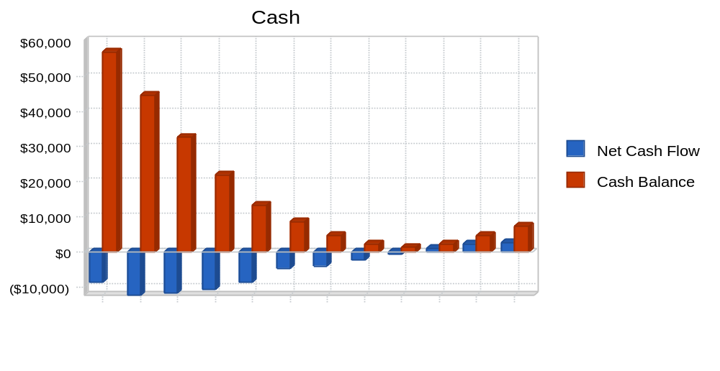

Do you need better-looking financial charts and tables? Tools like LivePlan will do this for you automatically, with a professional modern design.

Table: Cash Flow

Pro Forma Cash Flow
 | Year 1 | Year 2 | Year 3
Cash Received
Cash from Operations
Cash Sales | $189,397 | $412,314 | $456,226
Subtotal Cash from Operations | $189,397 | $412,314 | $456,226
Additional Cash Received
Sales Tax, VAT, HST/GST Received | $0 | $0 | $0
New Current Borrowing | $0 | $0 | $0
New Other Liabilities (interest-free) | $0 | $0 | $0
New Long-term Liabilities | $0 | $0 | $0
Sales of Other Current Assets | $0 | $0 | $0
Sales of Long-term Assets | $0 | $0 | $0
New Investment Received | $0 | $0 | $0
Subtotal Cash Received | $189,397 | $412,314 | $456,226
Expenditures | Year 1 | Year 2 | Year 3
Expenditures from Operations
Cash Spending | $157,000 | $174,000 | $190,000
Bill Payments | $90,905 | $187,072 | $207,195
Subtotal Spent on Operations | $247,905 | $361,072 | $397,195
Additional Cash Spent
Sales Tax, VAT, HST/GST Paid Out | $0 | $0 | $0
Principal Repayment of Current Borrowing | $0 | $0 | $0
Other Liabilities Principal Repayment | $0 | $0 | $0
Long-term Liabilities Principal Repayment | $0 | $0 | $0
Purchase Other Current Assets | $0 | $0 | $0
Purchase Long-term Assets | $0 | $0 | $0
Dividends | $0 | $0 | $0
Subtotal Cash Spent | $247,905 | $361,072 | $397,195
Net Cash Flow | ($58,508) | $51,242 | $59,030
Cash Balance | $7,092 | $58,334 | $117,364

Break-even Analysis
The Break-even Analysis indicates that $24,248 will be needed in monthly revenue to reach the break-even point.

Chart: Break-even Analysis
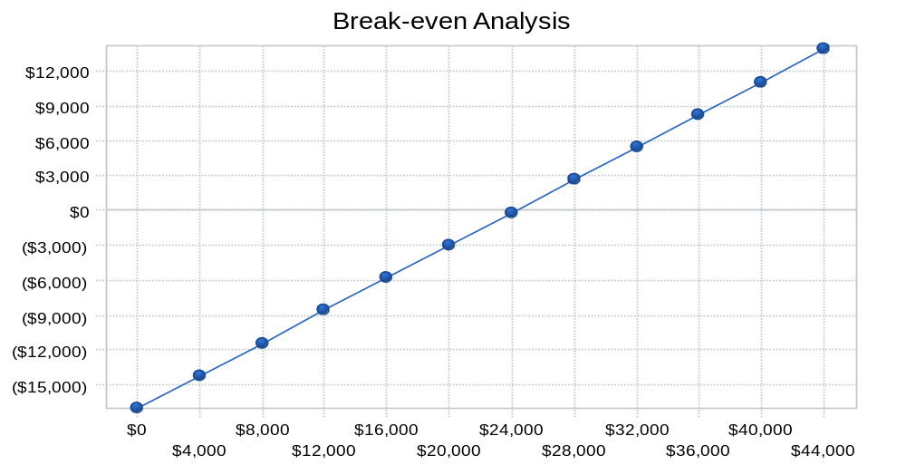

Table: Break-even Analysis

Break-even Analysis
Monthly Revenue Break-even | $24,248
Assumptions:
Average Percent Variable Cost | 30%
Estimated Monthly Fixed Cost | $16,974

Do you need better-looking financial charts and tables? Tools like LivePlan will do this for you automatically, with a professional modern design.

Projected Profit and Loss
The following table will indicate projected profit and loss.

Table: Profit and Loss

Pro Forma Profit and Loss
 | Year 1 | Year 2 | Year 3
Sales | $189,397 | $412,314 | $456,226
Direct Cost of Sales | $56,819 | $123,694 | $136,868
Other Production Expenses | $0 | $0 | $0
Total Cost of Sales | $56,819 | $123,694 | $136,868
Gross Margin | $132,578 | $288,620 | $319,358
Gross Margin % | 70.00% | 70.00% | 70.00%
Expenses
Payroll | $157,000 | $174,000 | $190,000
Sales and Marketing and Other Expenses | $10,800 | $9,200 | $7,200
Depreciation | $636 | $636 | $636
Leased Equipment | $0 | $0 | $0
Utilities | $1,800 | $1,800 | $1,800
Insurance | $1,500 | $1,500 | $1,500
Rent | $8,400 | $8,400 | $8,400
Payroll Taxes | $23,550 | $26,100 | $28,500
Other | $0 | $0 | $0
Total Operating Expenses | $203,686 | $221,636 | $238,036
Profit Before Interest and Taxes | ($71,108) | $66,984 | $81,322
EBITDA | ($70,472) | $67,620 | $81,958
Interest Expense | $0 | $0 | $0
Taxes Incurred | $0 | $20,095 | $24,397
Net Profit | ($71,108) | $46,889 | $56,925
Net Profit/Sales | -37.54% | 11.37% | 12.48%

Need to create your own financial tables? Tools like LivePlan will do this for you automatically.

Chart: Profit Monthly
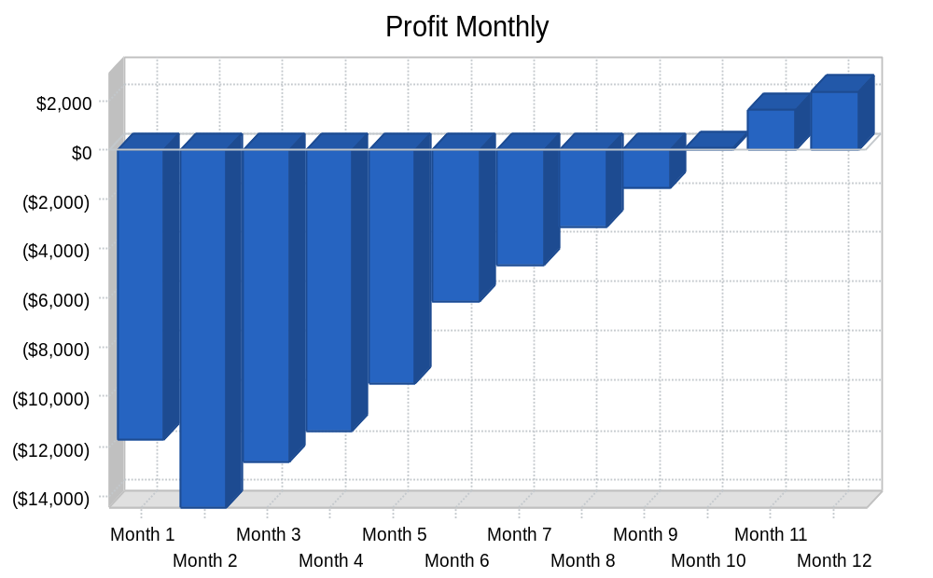

Projected Balance Sheet
The following table will indicate the projected balance sheet.

Table: Balance Sheet

Pro Forma Balance Sheet
 | Year 1 | Year 2 | Year 3
Assets
Current Assets
Cash | $7,092 | $58,334 | $117,364
Other Current Assets | $0 | $0 | $0
Total Current Assets | $7,092 | $58,334 | $117,364
Long-term Assets
Long-term Assets | $3,200 | $3,200 | $3,200
Accumulated Depreciation | $636 | $1,272 | $1,908
Total Long-term Assets | $2,564 | $1,928 | $1,292
Total Assets | $9,656 | $60,262 | $118,656
Liabilities and Capital | Year 1 | Year 2 | Year 3
Current Liabilities
Accounts Payable | $11,964 | $15,681 | $17,150
Current Borrowing | $0 | $0 | $0
Other Current Liabilities | $0 | $0 | $0
Subtotal Current Liabilities | $11,964 | $15,681 | $17,150
Long-term Liabilities | $0 | $0 | $0
Total Liabilities | $11,964 | $15,681 | $17,150
Paid-in Capital | $80,000 | $80,000 | $80,000
Retained Earnings | ($11,200) | ($82,308) | ($35,419)
Earnings | ($71,108) | $46,889 | $56,925
Total Capital | ($2,308) | $44,581 | $101,506
Total Liabilities and Capital | $9,656 | $60,262 | $118,656
Net Worth | ($2,308) | $44,581 | $101,506

Need to create your own financial tables? Tools like LivePlan will do this for you automatically.

Business Ratios
The following table compares key ratios for our industry category, SIC 5961, Electronic Shopping.

Table: Ratios

Ratio Analysis
 | Year 1 | Year 2 | Year 3 | Industry Profile
Sales Growth | n.a. | 117.70% | 10.65% | 7.56%
Percent of Total Assets
Other Current Assets | 0.00% | 0.00% | 0.00% | 27.99%
Total Current Assets | 73.45% | 96.80% | 98.91% | 77.31%
Long-term Assets | 26.55% | 3.20% | 1.09% | 22.69%
Total Assets | 100.00% | 100.00% | 100.00% | 100.00%
Current Liabilities | 123.90% | 26.02% | 14.45% | 38.85%
Long-term Liabilities | 0.00% | 0.00% | 0.00% | 18.29%
Total Liabilities | 123.90% | 26.02% | 14.45% | 57.14%
Net Worth | -23.90% | 73.98% | 85.55% | 42.86%
Percent of Sales
Sales | 100.00% | 100.00% | 100.00% | 100.00%
Gross Margin | 70.00% | 70.00% | 70.00% | 26.42%
Selling, General & Administrative Expenses | 107.54% | 58.63% | 57.52% | 12.12%
Advertising Expenses | 5.07% | 1.94% | 1.32% | 2.29%
Profit Before Interest and Taxes | -37.54% | 16.25% | 17.82% | 0.78%
Main Ratios
Current | 0.59 | 3.72 | 6.84 | 1.78
Quick | 0.59 | 3.72 | 6.84 | 0.63
Total Debt to Total Assets | 123.90% | 26.02% | 14.45% | 62.52%
Pre-tax Return on Net Worth | 3080.94% | 150.25% | 80.12% | 2.07%
Pre-tax Return on Assets | -736.41% | 111.15% | 68.54% | 5.53%
Additional Ratios | Year 1 | Year 2 | Year 3
Net Profit Margin | -37.54% | 11.37% | 12.48% | n.a
Return on Equity | 0.00% | 105.18% | 56.08% | n.a
Activity Ratios
Accounts Payable Turnover | 8.60 | 12.17 | 12.17 | n.a
Payment Days | 27 | 26 | 29 | n.a
Total Asset Turnover | 19.61 | 6.84 | 3.84 | n.a
Debt Ratios
Debt to Net Worth | 0.00 | 0.35 | 0.17 | n.a
Current Liab. to Liab. | 1.00 | 1.00 | 1.00 | n.a
Liquidity Ratios
Net Working Capital | ($4,872) | $42,653 | $100,214 | n.a
Interest Coverage | 0.00 | 0.00 | 0.00 | n.a
Additional Ratios
Assets to Sales | 0.05 | 0.15 | 0.26 | n.a
Current Debt/Total Assets | 124% | 26% | 14% | n.a
Acid Test | 0.59 | 3.72 | 6.84 | n.a
Sales/Net Worth | 0.00 | 9.25 | 4.49 | n.a
Dividend Payout | 0.00 | 0.00 | 0.00 | n.a

Need to create your own financial tables? Tools like LivePlan will do this for you automatically.

Appendix

Table: Sales Forecast

Sales Forecast
 |  | Month 1 | Month 2 | Month 3 | Month 4 | Month 5 | Month 6 | Month 7 | Month 8 | Month 9 | Month 10 | Month 11 | Month 12
Sales
Baby Boomers | 0% | $0 | $3,254 | $5,647 | $7,845 | $10,254 | $14,545 | $16,455 | $18,455 | $20,454 | $22,547 | $24,555 | $25,455
Other | 0% | $0 | $1,024 | $1,245 | $863 | $1,128 | $1,600 | $1,810 | $2,030 | $2,250 | $2,480 | $2,701 | $2,800
Total Sales |  | $0 | $4,278 | $6,892 | $8,708 | $11,382 | $16,145 | $18,265 | $20,485 | $22,704 | $25,027 | $27,256 | $28,255
Direct Cost of Sales |  | Month 1 | Month 2 | Month 3 | Month 4 | Month 5 | Month 6 | Month 7 | Month 8 | Month 9 | Month 10 | Month 11 | Month 12
Baby Boomers |  | $0 | $976 | $1,694 | $2,354 | $3,076 | $4,364 | $4,937 | $5,537 | $6,136 | $6,764 | $7,367 | $7,637
Other |  | $0 | $307 | $374 | $259 | $338 | $480 | $543 | $609 | $675 | $744 | $810 | $840
Subtotal Direct Cost of Sales |  | $0 | $1,283 | $2,068 | $2,612 | $3,415 | $4,843 | $5,480 | $6,146 | $6,811 | $7,508 | $8,177 | $8,477

Table: Personnel

Personnel Plan
 |  | Month 1 | Month 2 | Month 3 | Month 4 | Month 5 | Month 6 | Month 7 | Month 8 | Month 9 | Month 10 | Month 11 | Month 12
Quack | 0% | $3,000 | $3,000 | $3,000 | $3,000 | $3,000 | $3,000 | $3,000 | $3,000 | $3,000 | $3,000 | $3,000 | $3,000
Stewart | 0% | $3,000 | $3,000 | $3,000 | $3,000 | $3,000 | $3,000 | $3,000 | $3,000 | $3,000 | $3,000 | $3,000 | $3,000
Programmer | 0% | $2,500 | $2,500 | $2,500 | $2,500 | $2,500 | $2,500 | $2,500 | $2,500 | $2,500 | $2,500 | $2,500 | $2,500
Customer service | 0% | $0 | $2,500 | $2,500 | $2,500 | $2,500 | $2,500 | $2,500 | $2,500 | $2,500 | $2,500 | $2,500 | $2,500
Distribution | 0% | $0 | $2,500 | $2,500 | $2,500 | $2,500 | $2,500 | $2,500 | $2,500 | $2,500 | $2,500 | $2,500 | $2,500
Total People |  | 3 | 5 | 5 | 5 | 5 | 5 | 5 | 5 | 5 | 5 | 5 | 5
Total Payroll |  | $8,500 | $13,500 | $13,500 | $13,500 | $13,500 | $13,500 | $13,500 | $13,500 | $13,500 | $13,500 | $13,500 | $13,500
Need to create your own financial tables? Tools like LivePlan will do this for you automatically.

Table: General Assumptions

General Assumptions
 |  | Month 1 | Month 2 | Month 3 | Month 4 | Month 5 | Month 6 | Month 7 | Month 8 | Month 9 | Month 10 | Month 11 | Month 12
Plan Month |  | 1 | 2 | 3 | 4 | 5 | 6 | 7 | 8 | 9 | 10 | 11 | 12
Current Interest Rate |  | 10.00% | 10.00% | 10.00% | 10.00% | 10.00% | 10.00% | 10.00% | 10.00% | 10.00% | 10.00% | 10.00% | 10.00%
Long-term Interest Rate |  | 10.00% | 10.00% | 10.00% | 10.00% | 10.00% | 10.00% | 10.00% | 10.00% | 10.00% | 10.00% | 10.00% | 10.00%
Tax Rate |  | 30.00% | 30.00% | 30.00% | 30.00% | 30.00% | 30.00% | 30.00% | 30.00% | 30.00% | 30.00% | 30.00% | 30.00%
Other |  | 0 | 0 | 0 | 0 | 0 | 0 | 0 | 0 | 0 | 0 | 0 | 0

Need to create your own financial tables? Tools like LivePlan will do this for you automatically.

Table: Profit and Loss

Pro Forma Profit and Loss
 |  | Month 1 | Month 2 | Month 3 | Month 4 | Month 5 | Month 6 | Month 7 | Month 8 | Month 9 | Month 10 | Month 11 | Month 12
Sales |  | $0 | $4,278 | $6,892 | $8,708 | $11,382 | $16,145 | $18,265 | $20,485 | $22,704 | $25,027 | $27,256 | $28,255
Direct Cost of Sales |  | $0 | $1,283 | $2,068 | $2,612 | $3,415 | $4,843 | $5,480 | $6,146 | $6,811 | $7,508 | $8,177 | $8,477
Other Production Expenses |  | $0 | $0 | $0 | $0 | $0 | $0 | $0 | $0 | $0 | $0 | $0 | $0
Total Cost of Sales |  | $0 | $1,283 | $2,068 | $2,612 | $3,415 | $4,843 | $5,480 | $6,146 | $6,811 | $7,508 | $8,177 | $8,477
Gross Margin |  | $0 | $2,995 | $4,824 | $6,096 | $7,967 | $11,301 | $12,786 | $14,340 | $15,893 | $17,519 | $19,079 | $19,779
Gross Margin % |  | 0.00% | 70.00% | 70.00% | 70.00% | 70.00% | 70.00% | 70.00% | 70.00% | 70.00% | 70.00% | 70.00% | 70.00%
Expenses
Payroll |  | $8,500 | $13,500 | $13,500 | $13,500 | $13,500 | $13,500 | $13,500 | $13,500 | $13,500 | $13,500 | $13,500 | $13,500
Sales and Marketing and Other Expenses |  | $900 | $900 | $900 | $900 | $900 | $900 | $900 | $900 | $900 | $900 | $900 | $900
Depreciation |  | $53 | $53 | $53 | $53 | $53 | $53 | $53 | $53 | $53 | $53 | $53 | $53
Leased Equipment |  | $0 | $0 | $0 | $0 | $0 | $0 | $0 | $0 | $0 | $0 | $0 | $0
Utilities |  | $150 | $150 | $150 | $150 | $150 | $150 | $150 | $150 | $150 | $150 | $150 | $150
Insurance |  | $125 | $125 | $125 | $125 | $125 | $125 | $125 | $125 | $125 | $125 | $125 | $125
Rent |  | $700 | $700 | $700 | $700 | $700 | $700 | $700 | $700 | $700 | $700 | $700 | $700
Payroll Taxes | 15% | $1,275 | $2,025 | $2,025 | $2,025 | $2,025 | $2,025 | $2,025 | $2,025 | $2,025 | $2,025 | $2,025 | $2,025
Other |  | $0 | $0 | $0 | $0 | $0 | $0 | $0 | $0 | $0 | $0 | $0 | $0
Total Operating Expenses |  | $11,703 | $17,453 | $17,453 | $17,453 | $17,453 | $17,453 | $17,453 | $17,453 | $17,453 | $17,453 | $17,453 | $17,453
Profit Before Interest and Taxes |  | ($11,703) | ($14,458) | ($12,629) | ($11,357) | ($9,486) | ($6,152) | ($4,667) | ($3,113) | ($1,560) | $66 | $1,626 | $2,326
EBITDA |  | ($11,650) | ($14,405) | ($12,576) | ($11,304) | ($9,433) | ($6,099) | ($4,614) | ($3,060) | ($1,507) | $119 | $1,679 | $2,379
Interest Expense |  | $0 | $0 | $0 | $0 | $0 | $0 | $0 | $0 | $0 | $0 | $0 | $0
Taxes Incurred |  | $0 | $0 | $0 | $0 | $0 | $0 | $0 | $0 | $0 | $0 | $0 | $0
Net Profit |  | ($11,703) | ($14,458) | ($12,629) | ($11,357) | ($9,486) | ($6,152) | ($4,667) | ($3,113) | ($1,560) | $66 | $1,626 | $2,326
Net Profit/Sales |  | 0.00% | -337.97% | -183.24% | -130.43% | -83.34% | -38.10% | -25.55% | -15.20% | -6.87% | 0.26% | 5.97% | 8.23%

Table: Cash Flow
Pro Forma Cash Flow
 |  | Month 1 | Month 2 | Month 3 | Month 4 | Month 5 | Month 6 | Month 7 | Month 8 | Month 9 | Month 10 | Month 11 | Month 12
Cash Received
Cash from Operations
Cash Sales |  | $0 | $4,278 | $6,892 | $8,708 | $11,382 | $16,145 | $18,265 | $20,485 | $22,704 | $25,027 | $27,256 | $28,255
Subtotal Cash from Operations |  | $0 | $4,278 | $6,892 | $8,708 | $11,382 | $16,145 | $18,265 | $20,485 | $22,704 | $25,027 | $27,256 | $28,255
Additional Cash Received
Sales Tax, VAT, HST/GST Received | 0.00% | $0 | $0 | $0 | $0 | $0 | $0 | $0 | $0 | $0 | $0 | $0 | $0
New Current Borrowing |  | $0 | $0 | $0 | $0 | $0 | $0 | $0 | $0 | $0 | $0 | $0 | $0
New Other Liabilities (interest-free) |  | $0 | $0 | $0 | $0 | $0 | $0 | $0 | $0 | $0 | $0 | $0 | $0
New Long-term Liabilities |  | $0 | $0 | $0 | $0 | $0 | $0 | $0 | $0 | $0 | $0 | $0 | $0
Sales of Other Current Assets |  | $0 | $0 | $0 | $0 | $0 | $0 | $0 | $0 | $0 | $0 | $0 | $0
Sales of Long-term Assets |  | $0 | $0 | $0 | $0 | $0 | $0 | $0 | $0 | $0 | $0 | $0 | $0
New Investment Received |  | $0 | $0 | $0 | $0 | $0 | $0 | $0 | $0 | $0 | $0 | $0 | $0
Subtotal Cash Received |  | $0 | $4,278 | $6,892 | $8,708 | $11,382 | $16,145 | $18,265 | $20,485 | $22,704 | $25,027 | $27,256 | $28,255
Expenditures |  | Month 1 | Month 2 | Month 3 | Month 4 | Month 5 | Month 6 | Month 7 | Month 8 | Month 9 | Month 10 | Month 11 | Month 12
Expenditures from Operations
Cash Spending |  | $8,500 | $13,500 | $13,500 | $13,500 | $13,500 | $13,500 | $13,500 | $13,500 | $13,500 | $13,500 | $13,500 | $13,500
Bill Payments |  | $105 | $3,218 | $5,210 | $5,986 | $6,539 | $7,362 | $8,765 | $9,402 | $10,068 | $10,734 | $11,430 | $12,087
Subtotal Spent on Operations |  | $8,605 | $16,718 | $18,710 | $19,486 | $20,039 | $20,862 | $22,265 | $22,902 | $23,568 | $24,234 | $24,930 | $25,587
Additional Cash Spent
Sales Tax, VAT, HST/GST Paid Out |  | $0 | $0 | $0 | $0 | $0 | $0 | $0 | $0 | $0 | $0 | $0 | $0
Principal Repayment of Current Borrowing |  | $0 | $0 | $0 | $0 | $0 | $0 | $0 | $0 | $0 | $0 | $0 | $0
Other Liabilities Principal Repayment |  | $0 | $0 | $0 | $0 | $0 | $0 | $0 | $0 | $0 | $0 | $0 | $0
Long-term Liabilities Principal Repayment |  | $0 | $0 | $0 | $0 | $0 | $0 | $0 | $0 | $0 | $0 | $0 | $0
Purchase Other Current Assets |  | $0 | $0 | $0 | $0 | $0 | $0 | $0 | $0 | $0 | $0 | $0 | $0
Purchase Long-term Assets |  | $0 | $0 | $0 | $0 | $0 | $0 | $0 | $0 | $0 | $0 | $0 | $0
Dividends |  | $0 | $0 | $0 | $0 | $0 | $0 | $0 | $0 | $0 | $0 | $0 | $0
Subtotal Cash Spent |  | $8,605 | $16,718 | $18,710 | $19,486 | $20,039 | $20,862 | $22,265 | $22,902 | $23,568 | $24,234 | $24,930 | $25,587
Net Cash Flow |  | ($8,605) | ($12,440) | ($11,818) | ($10,778) | ($8,657) | ($4,717) | ($4,000) | ($2,417) | ($864) | $793 | $2,326 | $2,668
Cash Balance |  | $56,995 | $44,555 | $32,738 | $21,960 | $13,303 | $8,585 | $4,586 | $2,169 | $1,305 | $2,098 | $4,424 | $7,092

Table: Balance Sheet

Pro Forma Balance Sheet
 |  | Month 1 | Month 2 | Month 3 | Month 4 | Month 5 | Month 6 | Month 7 | Month 8 | Month 9 | Month 10 | Month 11 | Month 12
Assets | Starting Balances
Current Assets
Cash | $65,600 | $56,995 | $44,555 | $32,738 | $21,960 | $13,303 | $8,585 | $4,586 | $2,169 | $1,305 | $2,098 | $4,424 | $7,092
Other Current Assets | $0 | $0 | $0 | $0 | $0 | $0 | $0 | $0 | $0 | $0 | $0 | $0 | $0
Total Current Assets | $65,600 | $56,995 | $44,555 | $32,738 | $21,960 | $13,303 | $8,585 | $4,586 | $2,169 | $1,305 | $2,098 | $4,424 | $7,092
Long-term Assets
Long-term Assets | $3,200 | $3,200 | $3,200 | $3,200 | $3,200 | $3,200 | $3,200 | $3,200 | $3,200 | $3,200 | $3,200 | $3,200 | $3,200
Accumulated Depreciation | $0 | $53 | $106 | $159 | $212 | $265 | $318 | $371 | $424 | $477 | $530 | $583 | $636
Total Long-term Assets | $3,200 | $3,147 | $3,094 | $3,041 | $2,988 | $2,935 | $2,882 | $2,829 | $2,776 | $2,723 | $2,670 | $2,617 | $2,564
Total Assets | $68,800 | $60,142 | $47,649 | $35,779 | $24,948 | $16,238 | $11,467 | $7,415 | $4,945 | $4,028 | $4,768 | $7,041 | $9,656
Liabilities and Capital |  | Month 1 | Month 2 | Month 3 | Month 4 | Month 5 | Month 6 | Month 7 | Month 8 | Month 9 | Month 10 | Month 11 | Month 12
Current Liabilities
Accounts Payable | $0 | $3,045 | $5,011 | $5,769 | $6,295 | $7,071 | $8,452 | $9,067 | $9,711 | $10,354 | $11,028 | $11,674 | $11,964
Current Borrowing | $0 | $0 | $0 | $0 | $0 | $0 | $0 | $0 | $0 | $0 | $0 | $0 | $0
Other Current Liabilities | $0 | $0 | $0 | $0 | $0 | $0 | $0 | $0 | $0 | $0 | $0 | $0 | $0
Subtotal Current Liabilities | $0 | $3,045 | $5,011 | $5,769 | $6,295 | $7,071 | $8,452 | $9,067 | $9,711 | $10,354 | $11,028 | $11,674 | $11,964
Long-term Liabilities | $0 | $0 | $0 | $0 | $0 | $0 | $0 | $0 | $0 | $0 | $0 | $0 | $0
Total Liabilities | $0 | $3,045 | $5,011 | $5,769 | $6,295 | $7,071 | $8,452 | $9,067 | $9,711 | $10,354 | $11,028 | $11,674 | $11,964
Paid-in Capital | $80,000 | $80,000 | $80,000 | $80,000 | $80,000 | $80,000 | $80,000 | $80,000 | $80,000 | $80,000 | $80,000 | $80,000 | $80,000
Retained Earnings | ($11,200) | ($11,200) | ($11,200) | ($11,200) | ($11,200) | ($11,200) | ($11,200) | ($11,200) | ($11,200) | ($11,200) | ($11,200) | ($11,200) | ($11,200)
Earnings | $0 | ($11,703) | ($26,161) | ($38,790) | ($50,147) | ($59,633) | ($65,785) | ($70,452) | ($73,566) | ($75,126) | ($75,060) | ($73,434) | ($71,108)
Total Capital | $68,800 | $57,097 | $42,639 | $30,010 | $18,653 | $9,167 | $3,015 | ($1,652) | ($4,766) | ($6,326) | ($6,260) | ($4,634) | ($2,308)
Total Liabilities and Capital | $68,800 | $60,142 | $47,649 | $35,779 | $24,948 | $16,238 | $11,467 | $7,415 | $4,945 | $4,028 | $4,768 | $7,041 | $9,656
Net Worth | $68,800 | $57,097 | $42,639 | $30,010 | $18,653 | $9,167 | $3,015 | ($1,652) | ($4,766) | ($6,326) | ($6,260) | ($4,634) | ($2,308)
Need to create your own financial tables? Tools like LivePlan will do this for you automatically.

Get An Investor-Ready Business Plan Written By An MBA In As Little As 7 Business Days
Our writers specialize in business plans that help entrepreneurs secure loans & investment. An ideal solution for U.S. startups looking for $100,000 or more in capital.

Discover our proven, 5-step business plan writing process:
- Discover
You're assigned an MBA business plan writer who'll work with you closely to understand the needs of your company, map out your business plan and prepare key items, such as your target market, milestones and financial objectives.
- Research & Financials
Using advanced market research techniques, we'll gather the most up-to-date information and key statistics for your company. Your business plan will include 5 years of pro forma financials, custom created for your business model.
- Review
Once the plan is completely written and modeled, you’ll have ample time for a thorough review and to give us feedback.
- Design
Our graphic designers will give your plan a polished, professional look that complements your company's branding.
- Print (optional)
Once you’re 100% happy with your plan, you can have it professionally printed. You'll receive two professional-grade, full-color plan copies and a CD shipped to your door.
Click here to get a no-hassle quote free of charge »
* * U.S. submissions only * *

