CONFIDENTIAL
LOGO HERE
LVCE Address, Ph no.

Table of Contents
Executive Summary 1
Chart: Highlights 1
Objectives 1
Keys to Success 2
Mission 2
Company Summary 2
Company Ownership 2
Start-up Summary 3
Table: Start-up 3
Table: Start-up Funding 4
Chart: Start-up 7
Products 7
Market Analysis Summary 8
Market Segmentation 8
Chart: Market Analysis (Pie) 9
Table: Market Analysis 9
Industry Analysis 9
Competition and Buying Patterns 10
Strategy and Implementation Summary 11
Competitive Edge 11
Marketing Strategy 11
Sales Strategy 12
Sales Forecast 12
Chart: Sales Monthly 12
Table: Sales Forecast 13
Milestones 13
Table: Milestones 13
Web Plan Summary 13
Website Marketing Strategy 14
Development Requirements 14
Management Summary 14
Personnel Plan 15
Table: Personnel 15
Financial Plan 15
Important Assumptions 15
Table: General Assumptions 15
Projected Cash Flow 16
Chart: Cash 16
Table: Cash Flow 17
Break-even Analysis 18
Chart: Break-even Analysis 18
Table: Break-even Analysis 18
Projected Profit and Loss 18
Table: Profit and Loss 19
Chart: Profit Monthly 20
Projected Balance Sheet 21
Table: Balance Sheet 21
Business Ratios 22
Table: Ratios 22
Appendix i
Table: Sales Forecast i
Table: Personnel ii
Table: General Assumptions iii
Table: Profit and Loss iv
Table: Cash Flow v
Table: Balance Sheet vi

Executive Summary
(Draft Template here) – I will expand each section soon with your support
LV Cultural Experience LLC. (LVCE), is an e-commerce company designed to become ………
The company is located in Las Vegas, NV.
We see a huge gap and a dire need for access to certain products for certain sectors and hence this is formed to cater to this area.
We will come up ith an easy-to-use website and an efficient distribution system.
In the next three years LVCE intends to create …. And will grow to $500,000 in revenue.

Chart: Highlights

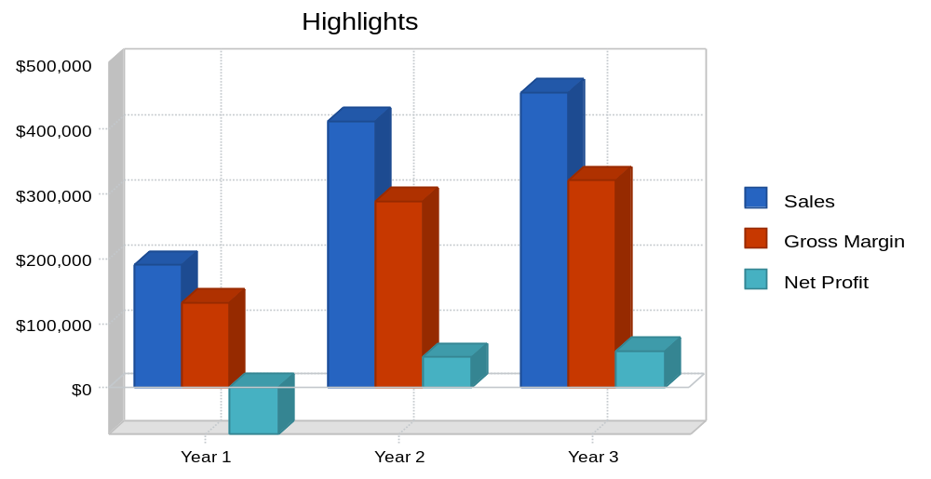

Sample data (need to refine)

Objectives
LVCE’s objectives for the first three years are:
- To make LVCE …an icon brand.
- To develop an effective, well placed e-commerce site for sales of …. These …..products.
- To launch a good marketing campaign that will drive customer's toward the company's website.
- Have a decent online purchase and fulfillment website for product sales.

Keys to Success
keys to success are:
- Marketing.
- Web design.
- Product quality.
- Service.

Mission

Our mission is to provide ….

Company Summary
LVCE’s goal is to become the e-commerce market leader in sales and marketing of ….these products.

Company Ownership
LVCE is a privately held NVcorporation. David Fleming will be the Owner. The company intends to recruit a sophisticated 2 additional team of advisory board members.

Start-up Summary
LVCE will incur the following start-up costs:
- Legal fees for the business formation.
- Office supplies.
- Web development.
- Telephone line installation.
- Desk, chair, filing cabinets.
- Shelving units for inventory storage.
- Computer system with Microsoft Office, QuickBooks Pro, CD-RW, printer, and a broadband Internet connection.
Example….. Need changes here….

Table: Start-up

Table: Start-up Funding
(Excel charts to be created with all categories)
Chart: Start-up

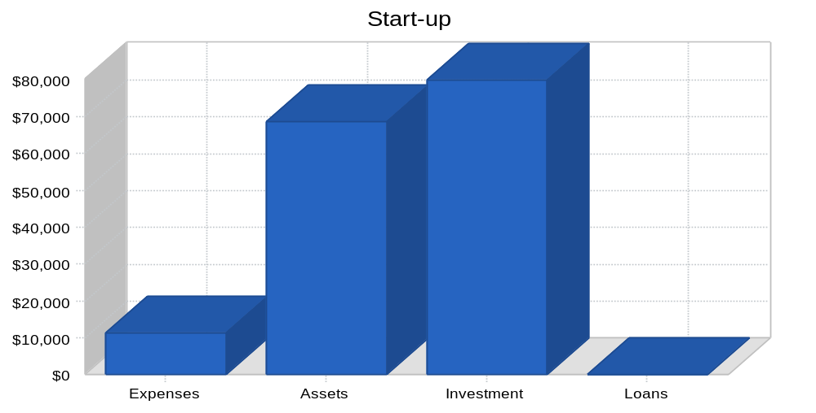

Products
List all our product offerings now, and future also…. Plans…

Market Analysis Summary

Market Segmentation
This needs some exploration, analysis and compilation

Chart: Market Analysis (Pie)

Example…… Replace this by specific to LVCE

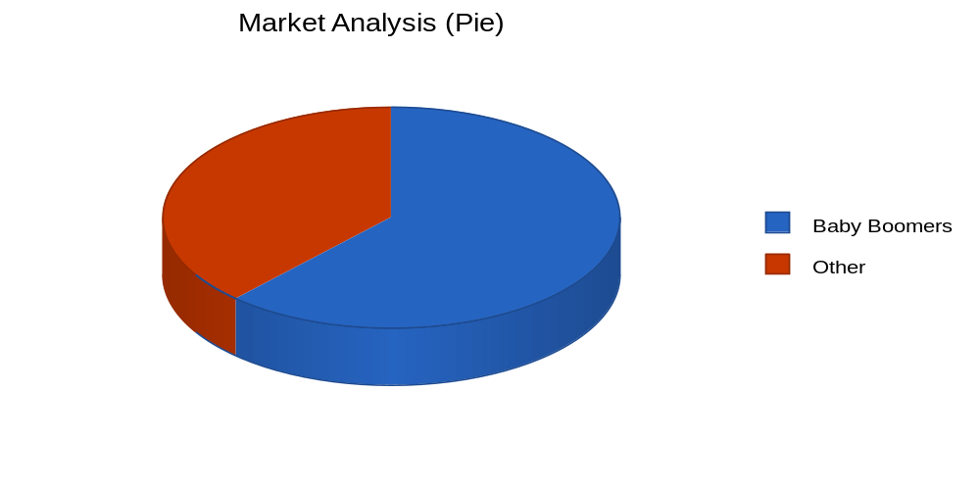

Table: Market Analysis

Market Analysis
 |  | Year 1 | Year 2 | Year 3 | Year 4 | Year 5
Potential Customers | Growth |  |  |  |  |  | CAGR
Baby Boomers | 9% | 64,785 | 70,616 | 76,971 | 83,898 | 91,449 | 9.00%
Other | 8% | 40,000 | 43,200 | 46,656 | 50,388 | 54,419 | 8.00%
Total | 8.62% | 104,785 | 113,816 | 123,627 | 134,286 | 145,868 | 8.62%

Industry Analysis
- Not all sections need elaborate (delete inappropriate areas and focus on key things)

Competition and Buying Patterns

Strategy and Implementation Summary
List bullets here

Competitive Edge

??

Marketing Strategy
LVCE is focused on the merging/redefined Internet marketplace. The users will be >>>> define Target Market and users here (ex: Baby Boomers or Millenials) , which represent approximately 50% of the discretionary income currently in the United States. They are looking for ….. products to stay healthy as they age. LVGE can bring these people cutting-edge products coupled with convenience and service.
The long range goal of LVGE is not only to dominate the …… (naturopathic and healthcare products / supplement market… example) , but to create an icon brand. Initially the company will:
- Engage in Store front and Online store ….(Web-based marketing for the next year to generate awareness of the company and product information.
- Other strategies..

Sales Strategy
LVCE will process 90% of it's sales online through a secure socket layer (SSL), an secure Internet connection. All orders will be charged to Visa, Mastercard, or American Express/ Paypal also/ ACH ?/ Checks?
By ensuring that the website is easy to navigate as well as simple to order from,

Sales Forecast
The first month and a half will be used to develop and ready the site. There will be no sales. From month two on, LVCE expects a gradual rise in sales in 1 quarter.

Chart: Sales Monthly

Table: Sales Forecast

Sales Forecast
 | Year 1 | Year 2 | Year 3
Sales
1 | $169,466 | $371,454 | $411,014
Other | $19,931 | $40,860 | $45,212
Total Sales | $189,397 | $412,314 | $456,226
Direct Cost of Sales | Year 1 | Year 2 | Year 3
1 | $50,840 | $111,436 | $123,304
Other | $5,979 | $12,258 | $13,563
Subtotal Direct Cost of Sales | $56,819 | $123,694 | $136,868

Milestones
Nature's Candy will have several milestones early on:
- Business plan completion. This will be done as a roadmap for the organization. This will be an indispensable tool for the ongoing performance and improvement of the company.
- Office set up.
- Website completed.
- Complete hiring of the initial company personnel.

Table: Milestones

Milestones
Milestone | Start Date | End Date | Budget | Manager | Department
Business plan completion
Office set up
Web site completed
Complete hiring of the intial company personnel
Totals |  |  | $0

Web Plan Summary
LVCE will use their website as their catalog and ordering device. The website will be a complete product offering as well as to provide company information.
The website will be designed with simplicity in mind. It is imperative that customers are able to navigate throughout the site intuitively with no problems. LVCE will be benchmarking websites such as Amazon's to develop a best practices for the different elements of the site.
A phone number will be offered on the website to remedy and problems that customers encounter.

Website Marketing Strategy
Search engines
SEO
SEM
DM
SM areas… listed and expanded..

Development Requirements

Management Summary
Who is the key team (reasonable elaborate detail needed)
Need a small org chart or hierarchy of team
Draft:
There are important gaps as follows:
- Customer service representative/manager.
- Distribution/warehouse manager.
- Advisory board.

Personnel Plan
We will have the below payroll starting month one and a customer service agent and distribution agent will be hired for month two.
Projections by mo, year….

Table: Personnel

Financial Plan
The following sections will outline important financial information.

Important Assumptions
The following table details important financial assumptions.

Table: General Assumptions

General Assumptions
 | Year 1 | Year 2 | Year 3
Plan Month | 1 | 2 | 3
Current Interest Rate | 10.00% | 10.00% | 10.00%
Long-term Interest Rate | 10.00% | 10.00% | 10.00%
Tax Rate | 30.00% | 30.00% | 30.00%
Other | 0 | 0 | 0

Projected Cash Flow (Samples as below – need to tweak and make it suitable for LVCE in 1 week)
The following chart and table will indicate projected cash flow.

Chart: Cash
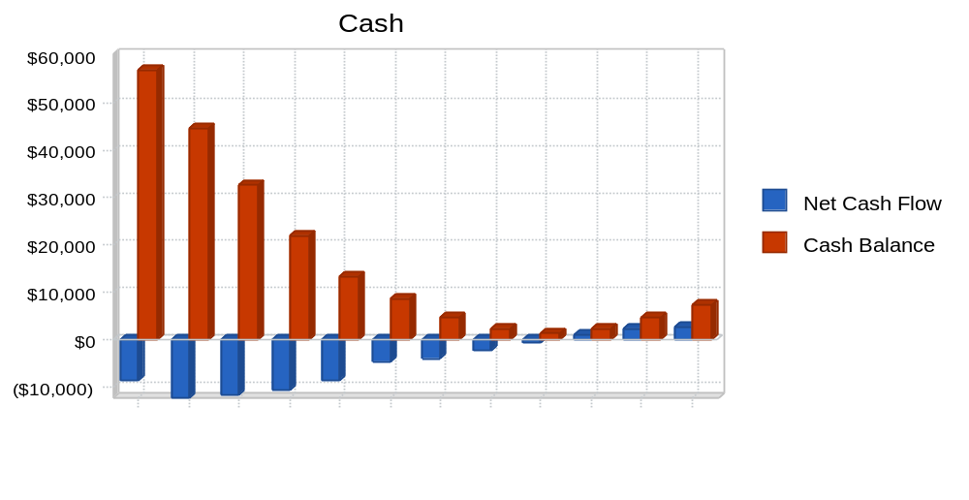

Table: Cash Flow

Break-even Analysis
The Break-even Analysis indicates that $24,248 will be needed in monthly revenue to reach the break-even point.

Chart: Break-even Analysis

Table: Break-even Analysis

Break-even Analysis
Monthly Revenue Break-even | $24,248
Assumptions:
Average Percent Variable Cost | 30%
Estimated Monthly Fixed Cost | $16,974

Projected Profit and Loss
The following table will indicate projected profit and loss.

Table: Profit and Loss

Chart: Profit Monthly
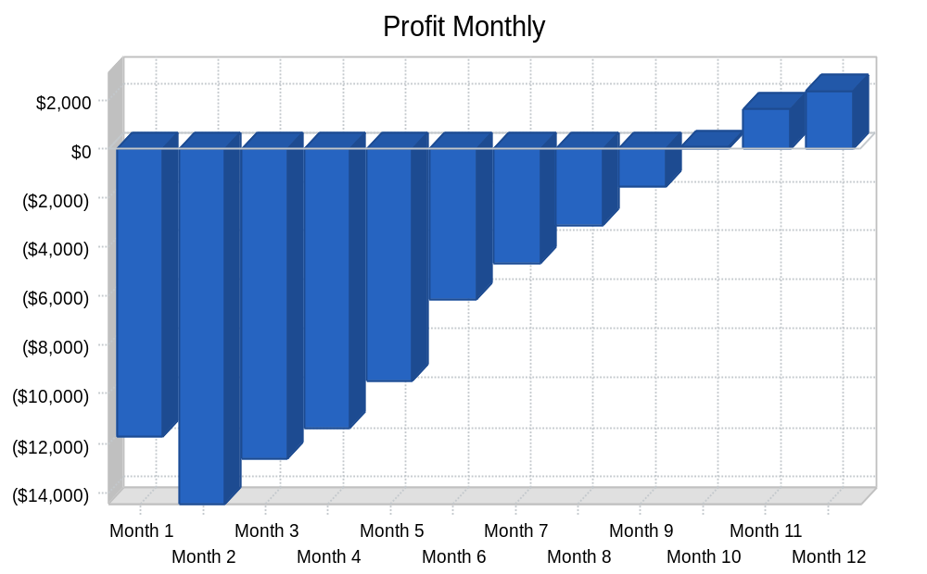

Projected Balance Sheet
The following table will indicate the projected balance sheet.

Business Ratios (Sample to be replaced)
The following table compares key ratios for our industry category, SIC….
Table: Ratios

Appendix

Table: Sales Forecast (Sample) – to be customized and created …..

Sales Forecast
 |  | Month 1 | Month 2 | Month 3 | Month 4 | Month 5 | Month 6 | Month 7 | Month 8 | Month 9 | Month 10 | Month 11 | Month 12
Sales
1 | 0% | $0 | $3,254 | $5,647 | $7,845 | $10,254 | $14,545 | $16,455 | $18,455 | $20,454 | $22,547 | $24,555 | $25,455
2 | 0% | $0 | $1,024 | $1,245 | $863 | $1,128 | $1,600 | $1,810 | $2,030 | $2,250 | $2,480 | $2,701 | $2,800
Total Sales |  | $0 | $4,278 | $6,892 | $8,708 | $11,382 | $16,145 | $18,265 | $20,485 | $22,704 | $25,027 | $27,256 | $28,255
Direct Cost of Sales |  | Month 1 | Month 2 | Month 3 | Month 4 | Month 5 | Month 6 | Month 7 | Month 8 | Month 9 | Month 10 | Month 11 | Month 12
1 |  | $0 | $976 | $1,694 | $2,354 | $3,076 | $4,364 | $4,937 | $5,537 | $6,136 | $6,764 | $7,367 | $7,637
Other |  | $0 | $307 | $374 | $259 | $338 | $480 | $543 | $609 | $675 | $744 | $810 | $840
Subtotal Direct Cost of Sales |  | $0 | $1,283 | $2,068 | $2,612 | $3,415 | $4,843 | $5,480 | $6,146 | $6,811 | $7,508 | $8,177 | $8,477

Table: Personnel

Personnel Plan
 |  | Month 1 | Month 2 | Month 3 | Month 4 | Month 5 | Month 6 | Month 7 | Month 8 | Month 9 | Month 10 | Month 11 | Month 12
1 | 0% | $3,000 | $3,000 | $3,000 | $3,000 | $3,000 | $3,000 | $3,000 | $3,000 | $3,000 | $3,000 | $3,000 | $3,000
2 | 0% | $3,000 | $3,000 | $3,000 | $3,000 | $3,000 | $3,000 | $3,000 | $3,000 | $3,000 | $3,000 | $3,000 | $3,000
3 | 0% | $2,500 | $2,500 | $2,500 | $2,500 | $2,500 | $2,500 | $2,500 | $2,500 | $2,500 | $2,500 | $2,500 | $2,500
4 | 0% | $0 | $2,500 | $2,500 | $2,500 | $2,500 | $2,500 | $2,500 | $2,500 | $2,500 | $2,500 | $2,500 | $2,500
5 | 0% | $0 | $2,500 | $2,500 | $2,500 | $2,500 | $2,500 | $2,500 | $2,500 | $2,500 | $2,500 | $2,500 | $2,500
Total People |  | 3 | 5 | 5 | 5 | 5 | 5 | 5 | 5 | 5 | 5 | 5 | 5
Total Payroll |  | $8,500 | $13,500 | $13,500 | $13,500 | $13,500 | $13,500 | $13,500 | $13,500 | $13,500 | $13,500 | $13,500 | $13,500

Table: Cash Flow (Sample)
Pro Forma Cash Flow
 |  | Month 1 | Month 2 | Month 3 | Month 4 | Month 5 | Month 6 | Month 7 | Month 8 | Month 9 | Month 10 | Month 11 | Month 12
Cash Received
Cash from Operations
Cash Sales |  | $0 | $4,278 | $6,892 | $8,708 | $11,382 | $16,145 | $18,265 | $20,485 | $22,704 | $25,027 | $27,256 | $28,255
Subtotal Cash from Operations |  | $0 | $4,278 | $6,892 | $8,708 | $11,382 | $16,145 | $18,265 | $20,485 | $22,704 | $25,027 | $27,256 | $28,255
Additional Cash Received
Sales Tax, VAT, HST/GST Received | 0.00% | $0 | $0 | $0 | $0 | $0 | $0 | $0 | $0 | $0 | $0 | $0 | $0
New Current Borrowing |  | $0 | $0 | $0 | $0 | $0 | $0 | $0 | $0 | $0 | $0 | $0 | $0
New Other Liabilities (interest-free) |  | $0 | $0 | $0 | $0 | $0 | $0 | $0 | $0 | $0 | $0 | $0 | $0
New Long-term Liabilities |  | $0 | $0 | $0 | $0 | $0 | $0 | $0 | $0 | $0 | $0 | $0 | $0
Sales of Other Current Assets |  | $0 | $0 | $0 | $0 | $0 | $0 | $0 | $0 | $0 | $0 | $0 | $0
Sales of Long-term Assets |  | $0 | $0 | $0 | $0 | $0 | $0 | $0 | $0 | $0 | $0 | $0 | $0
New Investment Received |  | $0 | $0 | $0 | $0 | $0 | $0 | $0 | $0 | $0 | $0 | $0 | $0
Subtotal Cash Received |  | $0 | $4,278 | $6,892 | $8,708 | $11,382 | $16,145 | $18,265 | $20,485 | $22,704 | $25,027 | $27,256 | $28,255
Expenditures |  | Month 1 | Month 2 | Month 3 | Month 4 | Month 5 | Month 6 | Month 7 | Month 8 | Month 9 | Month 10 | Month 11 | Month 12
Subtotal Cash Spent |  | $8,605 | $16,718 | $18,710 | $19,486 | $20,039 | $20,862 | $22,265 | $22,902 | $23,568 | $24,234 | $24,930 | $25,587
Net Cash Flow |  | ($8,605) | ($12,440) | ($11,818) | ($10,778) | ($8,657) | ($4,717) | ($4,000) | ($2,417) | ($864) | $793 | $2,326 | $2,668
Cash Balance |  | $56,995 | $44,555 | $32,738 | $21,960 | $13,303 | $8,585 | $4,586 | $2,169 | $1,305 | $2,098 | $4,424 | $7,092

Table: Balance Sheet
Sample page
Need some more specific addon pages to create a final version of this Business Plan for LVCE

