COMP 3839: Term project
By: Marcus Chan
Student Number: A01403269
Iteration Number: 5

Contents
COMP 3839: Term project By: Marcus Chan Student Number: A01403269 Iteration Number: 5 1
Overview of Project 3
Initial Assessment 4
Licences : Duplicates 4
UnitType: Freeform Data Entry Variations 5
UnitType: Nulls Values 6
Status: Issued without Business Trade Name or Business Name 7
FeePaid: Nulls 10
SME Review of Initial Assessment 12
LicenceRSN : Duplicates - Low 12
UnitType: Freeform Data Entry Variations - Medium 12
UnitType: Nulls Values – Medium High 12
Status: Issued without Business Trade Name or Business Name - Low 12
Status Issued: License Fee Null Value - High 12
Further Research for the SME 12
SME Review of Further Research 14
SME Suggests Some DQ Rules 14

Overview of Project
This project is dedicated to the data quality of Vancouver business licenses in 2019 the dataset can be found from this website: https://opendata.vancouver.ca/explore/dataset/business-licences-2013-to-2024/information/?disjunctive.status&refine.issueddate=2019 . The data set acquired for the project includes information on the business’s location, accommodations, license RSN and fees. Our SME Sam Smith is a software engineer with deep knowledge about the systems. Who is involved in this project because she handles data pipelines for the business licenses database and has knowledge of the day-to-day habits of the employees who enter the data to the database. The columns that we will be looking at during this project is LicenseRSN, UnitType and the Status of the Vancouver business licenses for 2019. There are a range of data quality issues regarding these columns such as columns missing a lot of data and columns that have questionable values given corresponding information in other columns. Most of the data quality issues are a low priority however our SME highlighting the issue regarding the missing values in the LicenseFee column that effects the bureau’s operations the most so it is the column we focus on. More information found about the LicenseFees are that there it is fairly stable throughout the year with spikes in November, January, and May, but none are outrageously outside normal parameters. New rules that have will be implemented concluding this report include changes to the Business Licenses interface to enforce input in several fields, along with new maintenance procedures which will resolve further issues.
Column Name | Description
LicenseRSN | Unique value for each business license, have found some duplicates in this column
BusinessName/  BusinessTradeName | Name which the business brands itself as.
Status | Status of business license, there have been some issues regarding surrounding details of the license
IssueDate | Date license was issued to the business
ExpiredDate | Date license expires
BusinessType/  BusinessSubType | The specification of business activities and subcategorized further in the subtype
Unit/UnitType | The kind of dwelling business activity will be conducted in, there have been some inconsistent values and a large number of nulls.
House/Street/City/  Province/Country/PostalCode | Address of the business
LocalArea | Description of local area
NumberofEmployees | Number of employees that the business has
FeePaid | Fee that is required to be paid to receive the business license
ExtractDate | Date when the records were accessed
Geom/geo_point_2d | Longitude and latitude data of the business location

Initial Assessment

Licences : Duplicates
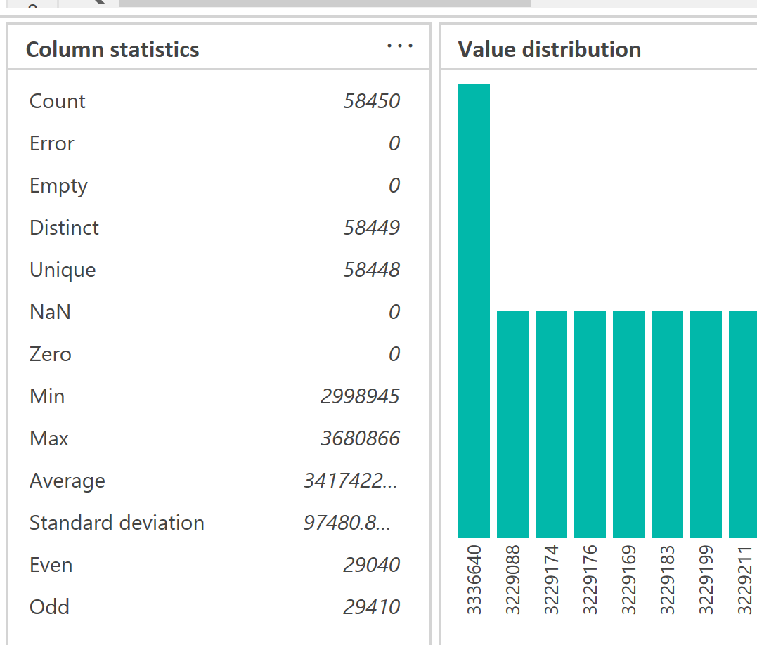
LicenceRSN are supposed to be unique identifiers to a licence, however based on figure 1 provided from Microsoft Excel we can observe that there is a duplicated value. This duplicate may indicate an error in our identification systems or may cause an error further on in our data analysis processes. It could also mean that there is a situation we did not consider that is affecting the assignment of License RSNs

Figure 1: LicenseRSN counts
We can see that the number of distinct and unique values are off by 1 values which means that there is a unique value in the LicenseRSN column of the dataset. By filtering the data by unique LicenseRSN values and displaying them in Figure 2, we can see further details about entries.
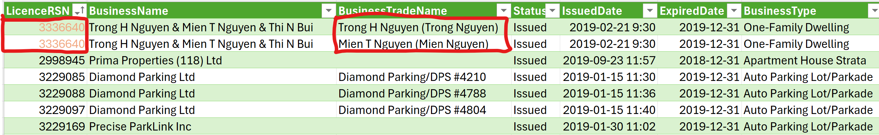
Figure 2: Duplicate Details
Based on the information from Figure 2 the duplicated business license RSN shares the same business name however differ for the Busincess Trade Name. Both licenses appear to be assigned to different people however with all other values remaining the same.

UnitType: Freeform Data Entry Variations
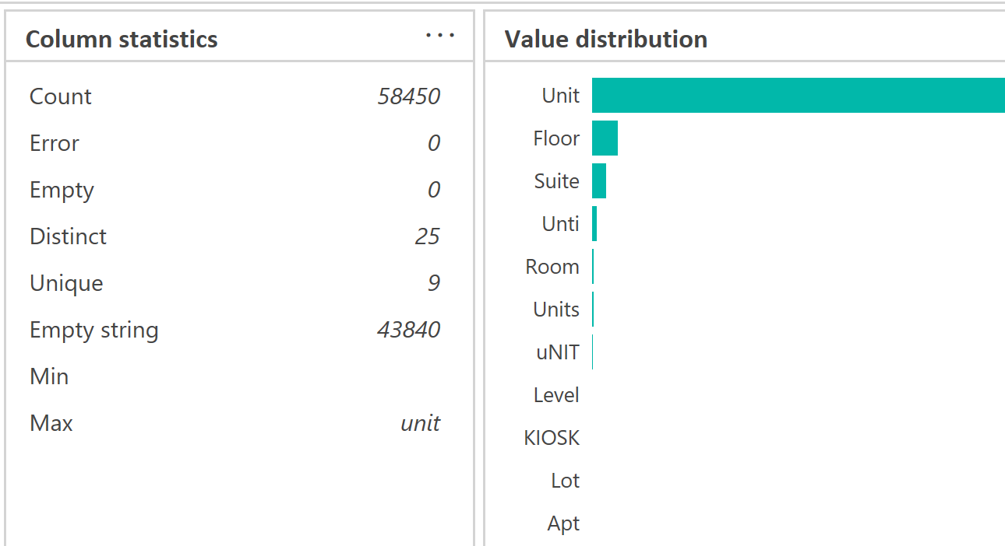
Unit type is a column to describes the size of the business’s physical location and the scale of their day-to-day operations. Based on the results found in figure 1 we can see that, there are several misspellings and inconsistent values of the Unit value. This indicates that at some point in entering values for this column, it is being done manually. This allows multiple kinds of errors into this column of the dataset.
Figure 3: UnitType Context Diagram Highlighting Obvious Freeform Values
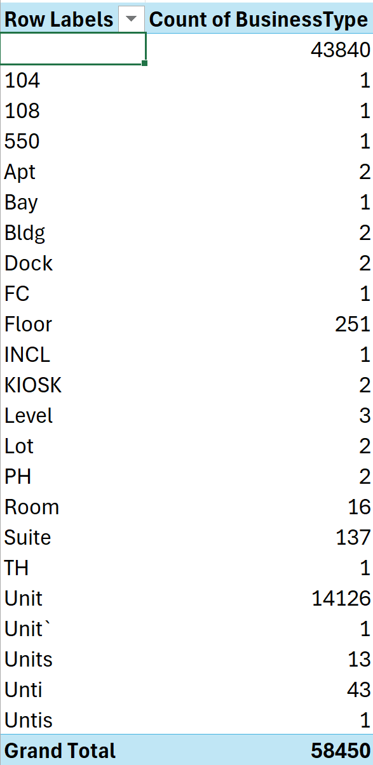
Based on the information is figure 3 we can observe that there are several issues such as Unti and uNIT as shown in the context diagram above. Those refer to the Unit value, and seem to be limited to only unit but we will be looking at the whole picture in Figure 4.
Figure 4: UnitType Pivot Table with Grouping Irregularities by color
Now the we have expanded the view of the UnitType values we have a mix of shorthand values, acronyms, full length values and what appears to be unit numbers. We can only tell by context that the values highlighted in black are unit numbers due to their similarities and that the unit number value is right next to the unit type column.

UnitType: Nulls Values
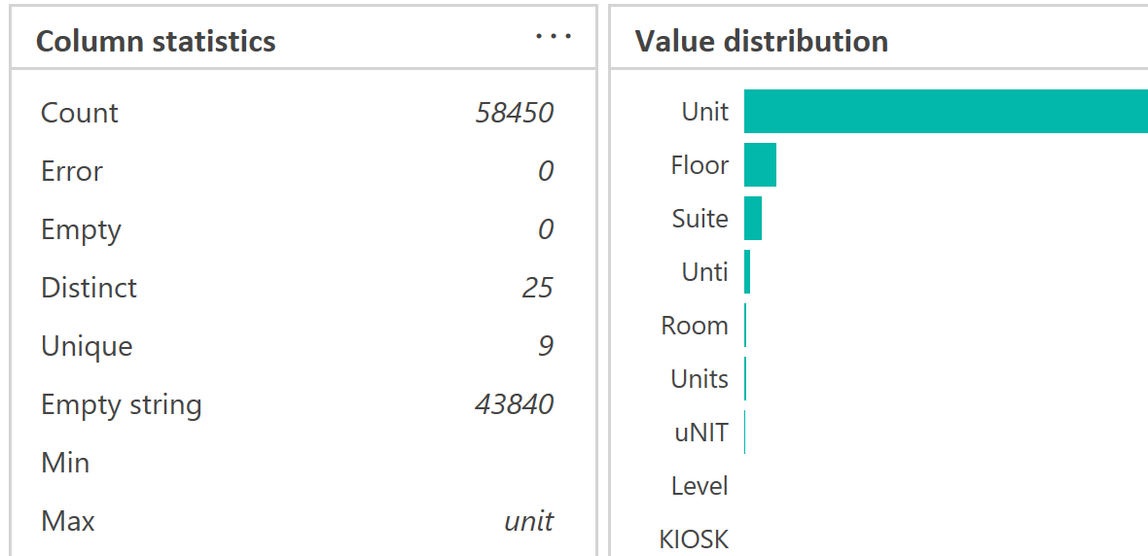
The unit type is used to determine an estimated size of the business especially when it is used in conjunction with the number of employees that that are being hired. This make it a useful parameter, however a large proportion of the UnitType values are null, when there are available UnitType values that allow for them to be categorized.
Figure 5: Context Diagram Emphasis on Empty Strings
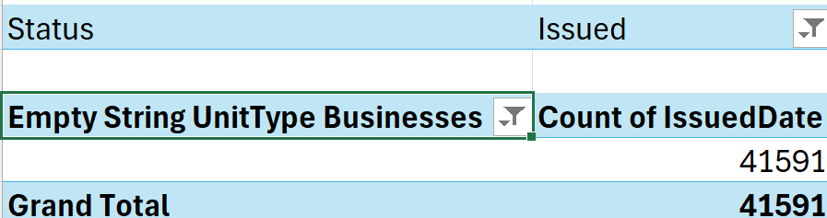
Figure 5 shows that the there are a majority of empty strings in the UnitType column. This view is a bit too broad to define as in issue such as if all the empty strings were for licenses that were not issued. To look at this we look at Figure 6.
Figure 6: Total of Issued Business Licenses with a Empty String UnitType
As shown in Figure 6 there are a significant number of licenses where this information in missing. There are classifications within the system that can replace the empty stings. An example of one of those replacements is shown in Figure 7.
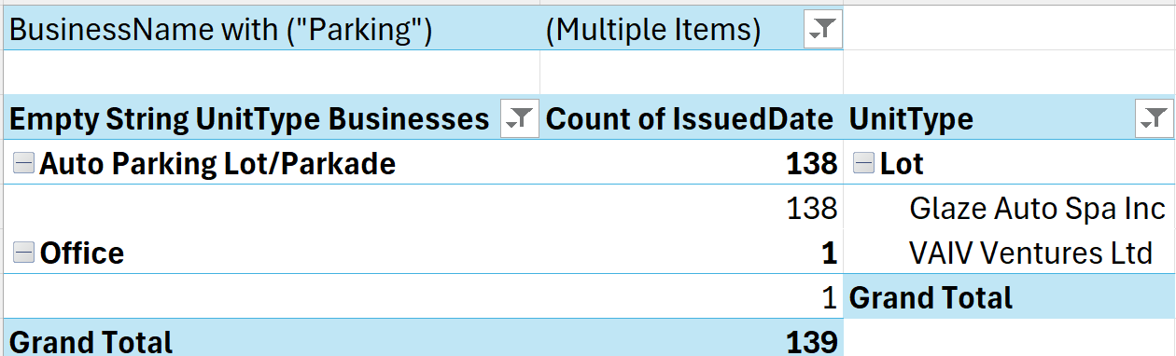
Figure 7: Two Pivot Tables Left, Empty String Parking lot businesses; Right, an available option
As we can see in Figure 7 although a lot of the UnitType is an empty string there are options that allow it to be categorized. Parking lot business can be located at a Lot, like it has been for 2 businesses that operate car washing services. There is overlap available in the system that can account for the empty strings on a case-by-case basis.

Status: Issued without Business Trade Name or Business Name
With every business license it is important that a business has a name that it operates under. This is crucial for businesses to operate under as it another identifier for the business to be known under. If the business didn’t have a business name or trade name, then it is much harder to identify a business at first glance causing an easy mix-up.
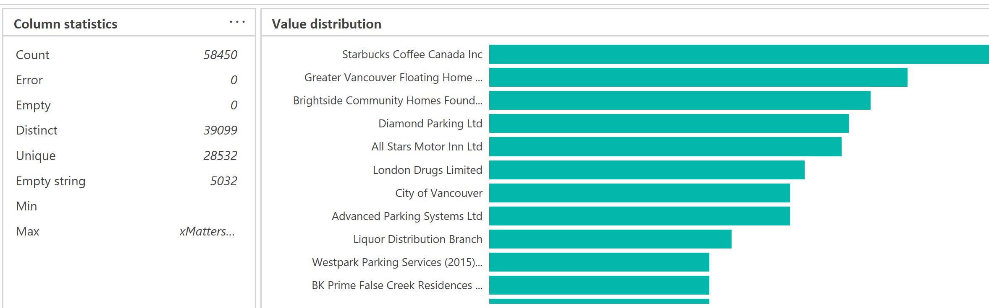
Figure 8: Business Name with Empty Strings
If Figure 8 we can observe that there are a section of business names that are an empty string. With this number of empty strings opens up the possibility of data qualty issues. In the graph below we will be looking closer at the table to observe the potential issue for the many issued lisenced businesses.

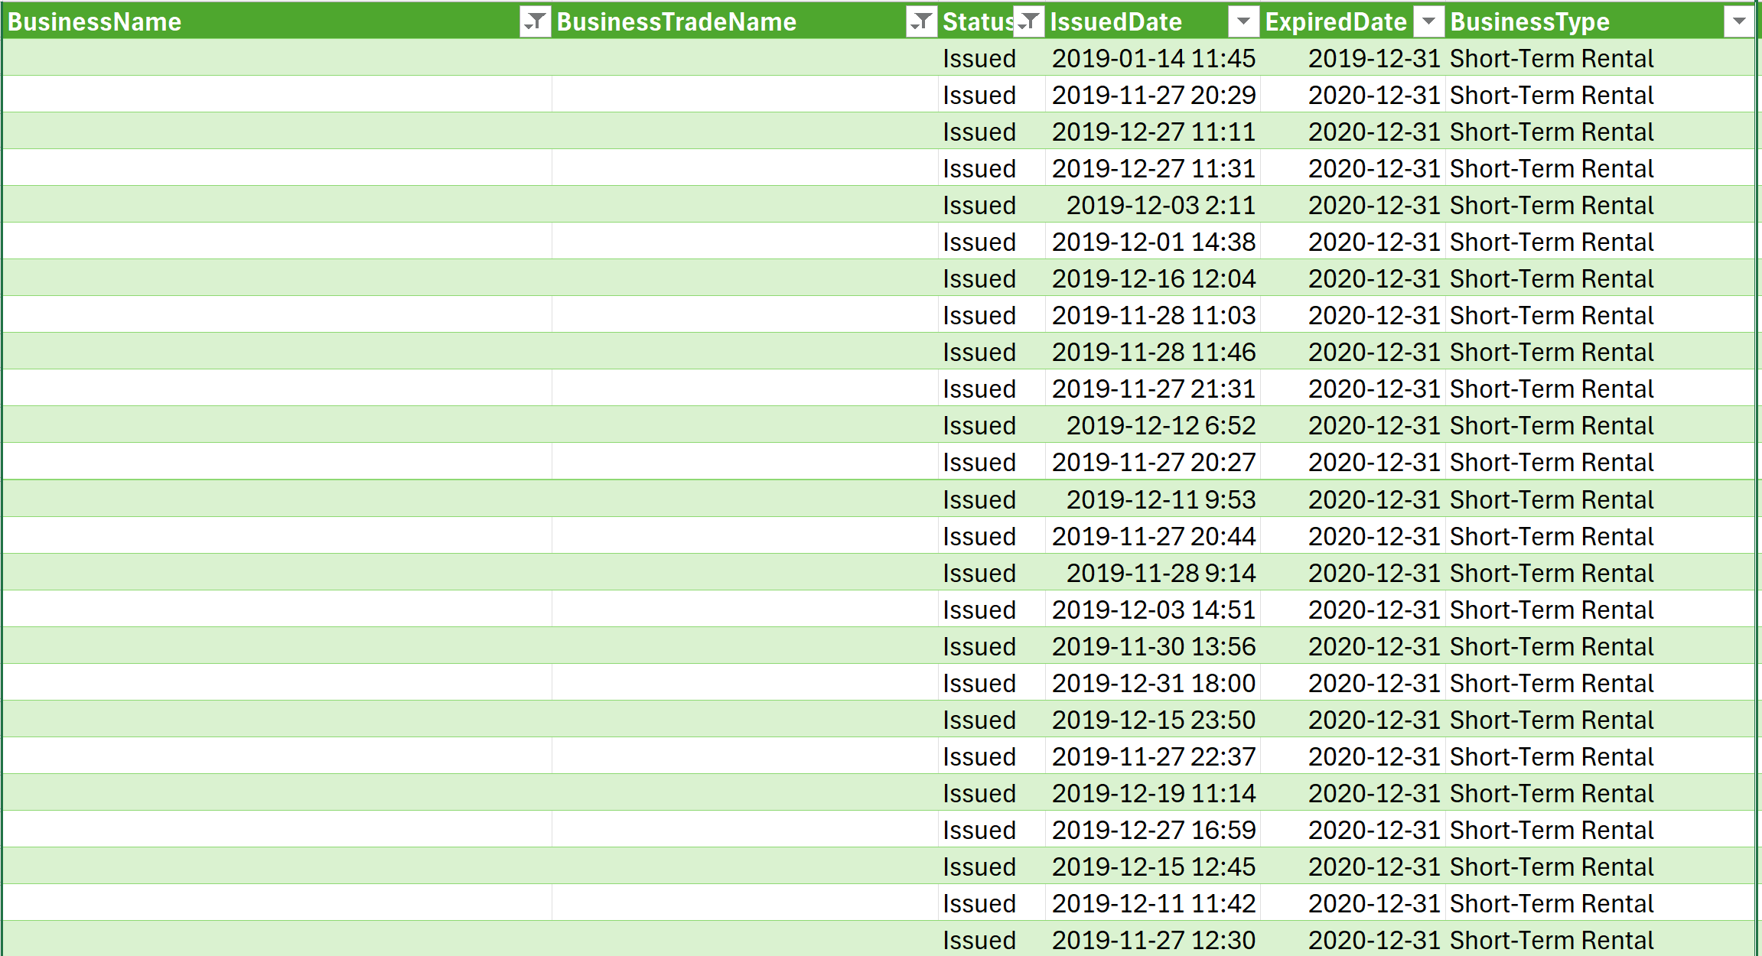
Figure 9: Issued Business Licenses with no BusinessName and BusinessTradeName
Based on the information gathered from Figure 9 we see there are numerious business licenses that do not have either a BusinessName or BusinessTradeName. Even with these lack of features, the business license is issued. We are going to look at a total of the business license without a business name or trade name.
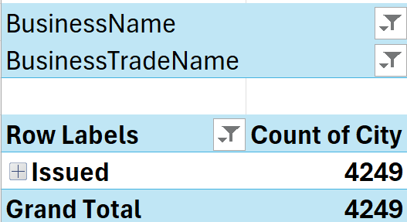
Figure 10: Total Number of business licenses without a business name or trade name
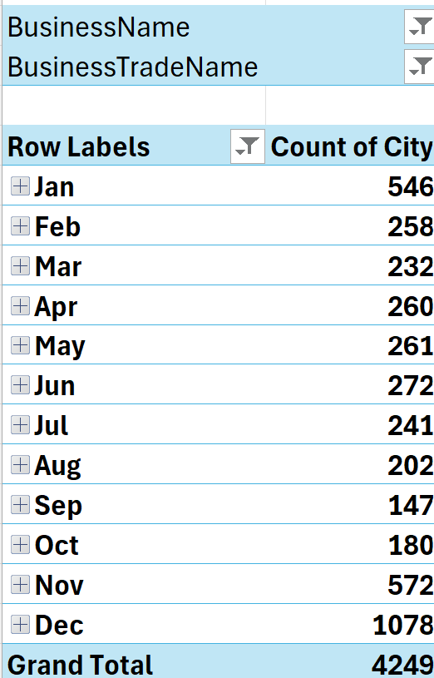
In Figure 10 it is shown that there are a substantial number of licenses that no not have either of those columns filled. The problem shown in Figure 8 continues for other licenses. We will look at the conminality, the 2 things observable in Figure 8 are the issue date and the business type. Looking at the issue date first.
Figure 11: Issued Business Licenses without Trade Name or Business Name
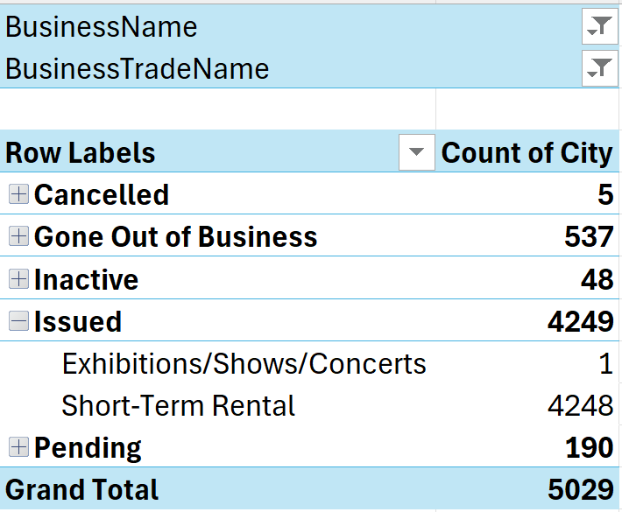
The other thing we noticed in Figure 8 is that there are quite a number of them that are Short Term Rentals. We will be looking further at the this in the next pivot table in Figure 12.
Figure 12: Business License Issued with No BusinessTradeName and BusinessName
The details for the business licenses that do not have business names or business trade names only constitute a small portion of the overall business licenses. Most of the businesses that do not have business names or trade names are short term rentals, alongwith 1 Exhibition/Concert/Show.

FeePaid: Nulls
License Fees are paid during the process a business either renews or applies for their business license that should be apply for the year. License fees not being paid is not a large issue assuming the business license hasn’t been issued yet since the application could be pending. However for the licenses that have been issued without a FeePaid then, there is no information about this transaction. This error may mean there could be exemptions made for the business or they found a way around paying the fee.
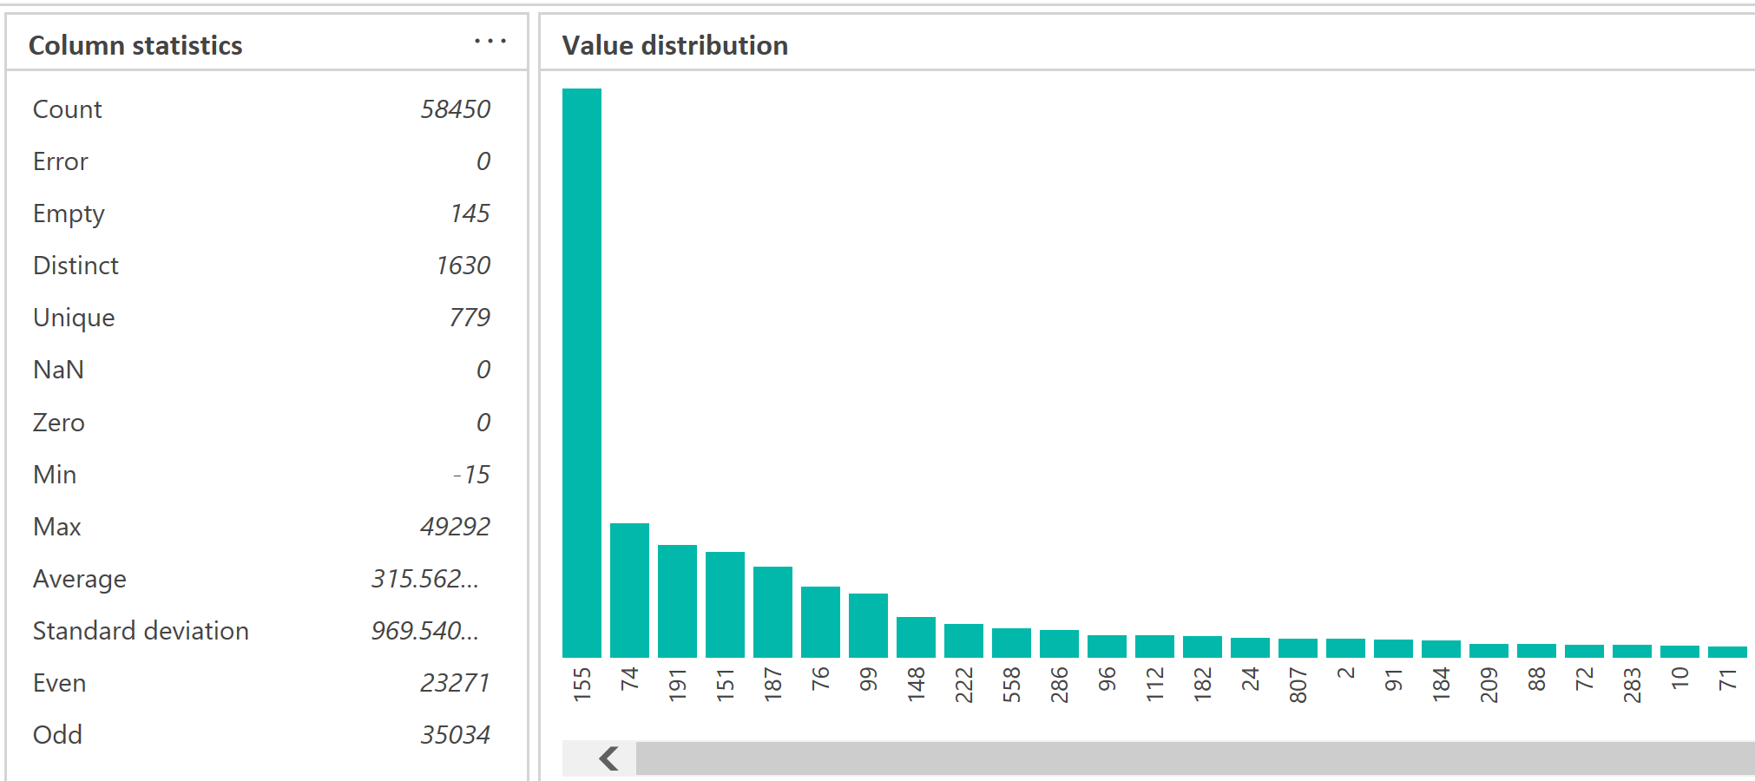
Figure 13: Distribution of FeePaid
We shall return to the Status column regarding their issued business licenses, this time with a focus on the the clarity of the fees paid. We look at the sample of the data entries in Figure 14 below.
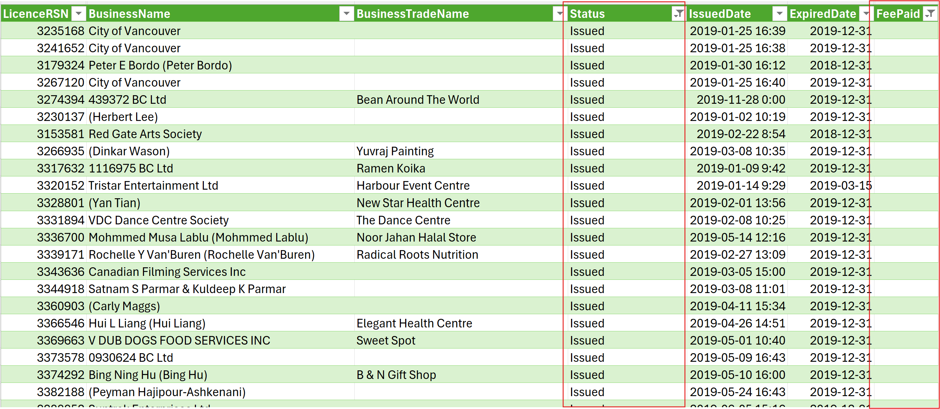
Figure 14: Table of Business Licenses with FeePaid Missing
As observed in Figure 14 there are a significant number of business licenses that have their FeePaid missing which means that we have no indication that they paid at all. Even if there are not any fees laid due to their circumstances a 0 in the FeePaid column or a N/A would be more concrete for data analysis purposes. Looking into the details of Figure 12 further for details we can look at the scope of the issue in Figure 15.
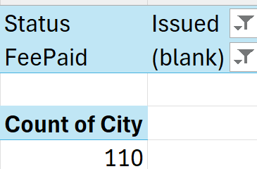
Figure 15: Total of Licenses Issued with No Fee
We observe that the issue isn’t very far spread since there aren’t thousands of cases in this situation however the issue is substantial enough to be a concern. Otherwise than the date there does not seem be any trends that emege from the review of figure 15. Going over the business types that fit into this category in figure 16.
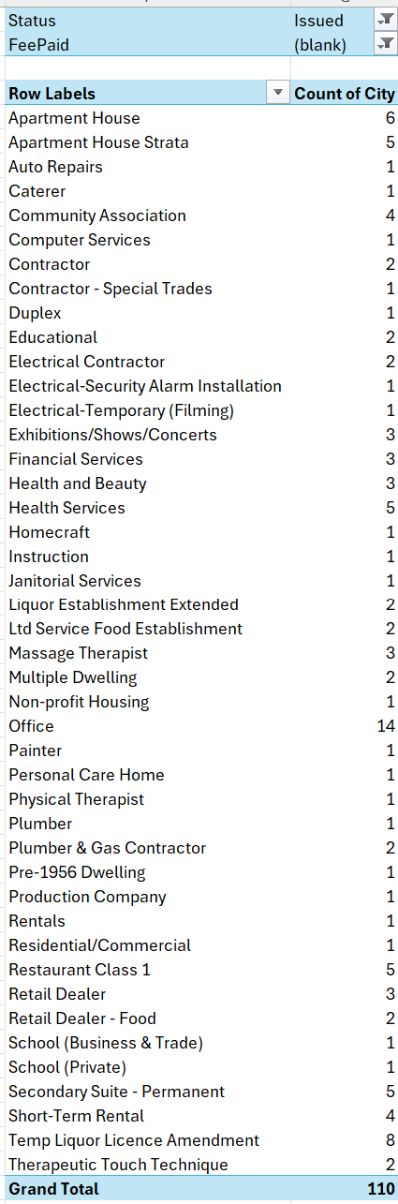
Figure 16: Distribution of FeePaid = Null, Status: Issued across Business Types
This issue follows the basic distirbution of the number of total business licenses. There does not appear to be a concentration of the errors beyond the regular distribution of licenses, and apart of a regular error that is made when a business is applying for a business license.

SME Review of Initial Assessment

LicenceRSN : Duplicates - Low
The duplicated LicenseRSN issue is prioritized as low. The issue of the LicenseRSN is not a large issue given that the business with the duplicated LicenseRSN share the business name and appear to be own by the 2 owners of the business.

UnitType: Freeform Data Entry Variations - Medium
The unit type with unclear values is prioritized as moderate. There are a lot of issues that could be resolved in this column however this will not have a significant impact outside of streamlining reports. The payoff from the corrections will not exceed some of the other issues listed here.

UnitType: Nulls Values – Medium High
Filling in the UnitType column is prioritized as high moderate. With more stratified options and replacing prior null values in the column, this will help us with analyzing the business. However There have not been significant issues caused by the excessive number of null values in the column, which is why the priority isn’t classified as high.

Status: Issued without Business Trade Name or Business Name - Low
The Business Licences being issued without business trade names or business names is a low priority. There is an already established rule stating the short-term rentals are exempt from the requirement. That covers the majority of the entries that have this issue the last event was an event of some sort and is a minor issue.

Status Issued: License Fee Null Value - High
The issue with licence fee irregularities and the fact their status is issue is prioritized as high. We need to know about the information that they have paid the bureau and they have gone through the proper channels to gain that license. This will also help with the analytics and track how business license revenue can be expected in the following years.

Further Research for the SME
Regarding the data quality concern for the issued business licenses that have a null value in the FeePaid column. One of the few things that we could make connections to during the first look at this issue is perhaps the issue date. In Figure 14 we look at the overall distribution of this issue over the year and when the licenses were issued.
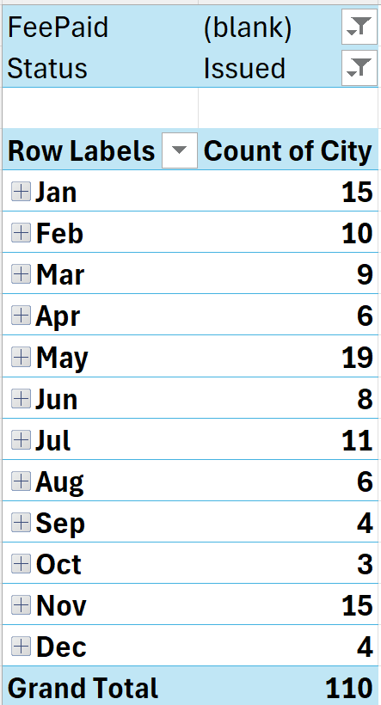
Figure 16: Distribution of the Business Licenses with no FeePaid over 2019
In the pivot table in Figure 16 it shows that the FeePaid is blank, and the Status is Issued. There are several licenses that have this issue and there isn’t a specific time frame where they are concentrated. To go further with our analysis this issue we are using a SPC form to go over the distribution and highlight the areas of interest.
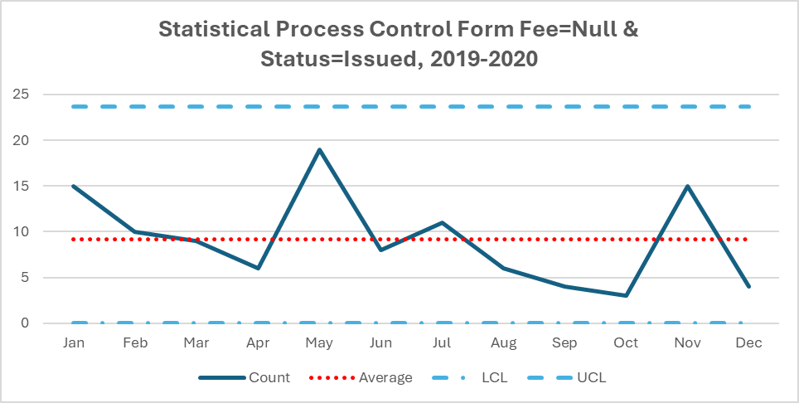
Figure12: SPC Form for Status=Issued and FeePaid=Null

We can see that there is a moderate jump in both conditions that happened in the month of May however nothing seems to be out of control and completely within the expectations of 3 standard deviations.

SME Review of Further Research
The peak in May is something that we might need to look into further, since there should not be any particular reason why there is a sudden spike in Null Fees and issued business licenses. There should be a peak in January and November since those are the months with the most number of applications and with more applications there would be more cases with Business Licenses Issued without License Fees.

SME Suggests Some DQ Rules

LicenceRSN : Duplicates
Business Rule: License RSN is a primary key, generate alert if there are duplicate License RSN values.
Suggested Process and Procedure:
A simple method to prevent this issue is to create a rule on the business license database that prevents rows that share LicenseRSN numbers in the database. If that causes a significant delay to submit data, then create a script that clears the duplicated data either by concatenating details that don’t match, deleting the row or assigning a new RSN to 1 row. Then schedule this script to run once a month.

UnitType: Freeform Data Entry Variations
Business Rule: UnitType is set to a complete set of values, if a value doesn’t match any value in the set raise an alert.
Suggested Process and Procedure:
For the variances from standard errors in UnitType column we can add a drop-down menu with a complete list of all applicable spaces where people can operate a business. Or if a drop down is already implemented include the Unit value in the drop down. Then the use may only alter the field through the drop down to standardize the values.

UnitType: Nulls Values
Business Rule: UnitType requires a value if UnitType == Null or UnitType == “” raise an alert
Suggested Process and Procedure:
As for addressing the null values in the UnitType, we could make the field a requirement to filled in before the application is submitted.

Status: Issued without Business Trade Name or Business Name
Business Rule: If BusinessName == Null and BusinessTradeName == Null and not BusinessType = “Short-Term Rental” then raise an alert
Suggested Process and Procedure:
The issue with no Business Trade Names with an issued License is not an issue, and already a rule within the bureau. We can attempt to reduce the confusion by listing their business name as a placeholder such as Short-Term Rental for the Business Trade Name.

Status Issued: License Fee Null Value
Business Rule: If (FeePaid == Null or FeePaid < 0) and status == “Issued” then raise an alert.
Suggested Process and Procedure:
Finally, with the FeePaid issue, we could make it mandatory, that a number greater than or equal to 0 must be placed in the column on submission of the form. That way we can have a clearer look at the people who are allowed to set up a business license without a fee or have more data about businesses in the Vancouver area.

