Cognitive Autonomous Braking ECU with Embedded ML

Krishna Chandrahaasa Madiraju and Jon R Marstrander
Electrical and Comuter Engineering Departmnet
University of Alabama at Birmingham (UAB), Birmingham, Alabama, US
kmadiraj@uab.edu, jmars@uab.edu

Abstract---This paper presents a microcontroller-based approach for real-time collision-risk classification using Time-to-Collision (TTC) estimation and embedded neural inference, offering a lightweight alternative to conventional ADAS systems that depend on high-resolution sensors or external processing units. The proposed system integrates an ESP32 microcontroller with a TTC-driven inference engine, where TTC is derived from synthetic host–target vehicle motion profiles representing dynamic closing scenarios. A compact neural network model—trained using supervised learning on a labelled TTC dataset—maps the input into three distinct driving-risk categories: Safe, Caution, and Brake. To translate these classifications into physical actuation, the system employs a servo motor and multi-state LED indicators, forming a complete embedded braking module capable of producing deterministic outputs in response to evolving TTC values. The architecture is optimized for resource-constrained hardware, enabling sub-millisecond inference without off-board computation or complex sensor fusion. Experimental evaluation demonstrates stable classification performance, precise actuation mapping, and smooth transitions across risk states, confirming the model’s ability to distinguish nonlinear TTC boundaries effectively.
The results show that TTC, when processed through a lightweight embedded neural network, provides an efficient representation of vehicle closing dynamics, achieving reliable risk estimation without the overhead of multi-sensor pipelines. This approach establishes a low-cost, real-time predictive braking solution suitable for embedded safety applications in autonomous and semi-autonomous systems. Future extensions include integrating live ultrasonic or radar-derived TTC measurements, expanding the neural architecture for finer.

Keywords:Time-to-Collision(TTC),Embedded Neural Network, Cognitive Braking, Microcontroller-Based Safety System, Real-Time Risk Classification, ESP32, Predictive Braking Control, Embedded Inference, Actuator Response,

I. INTRODUCTION
This project implements a Cognitive Braking Assist System using an ESP32 microcontroller to estimate Time-to-Collision (TTC) and trigger real-time braking actions. A lightweight TinyML classifier, trained on synthetic TTC data, runs on-device to categorize driving risk into Safe, Caution, and Brake states. These predictions directly control LED indicators and a servo-based braking actuator, forming a complete embedded decision-and-actuation loop. The system is validated through Hardware-in-the-Loop (HIL) testing to assess inference accuracy, timing reliability, and actuator response.
1.1 Background and Motivation:
Modern vehicles increasingly depend on embedded intelligence to enhance safety and reduce delays in the delays of driver-related reaction. Time-to-Collision (TTC) estimation has emerged as a critical parameter in advanced driver-assistance systems, enabling early detection of hazardous closing distances. With growing interest in low-power, on-device machine-learning solutions, there is a need for compact systems capable of performing real-time risk assessment and initiating timely actuation. This work is motivated by the challenge of integrating TTC-based decision logic into a resource-constrained microcontroller platform while maintaining deterministic response, reliability, and safety relevance.

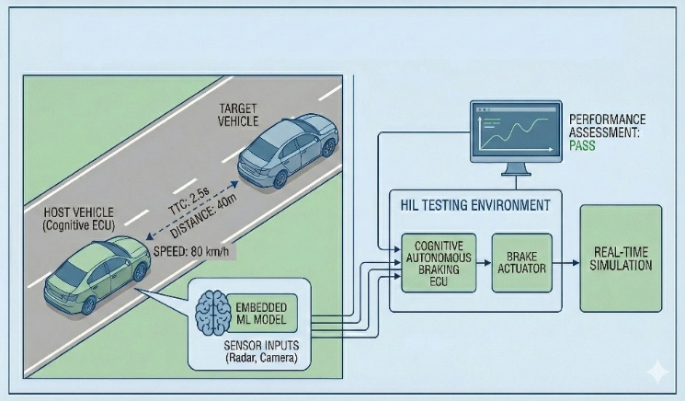
Fig 1: Conceptual Illustration of TTC Computation Using Ego (HOST) and Lead Vehicle (TARGET) Velocities.

This work is motivated by the need to replicate such safety intelligence on a resource-constrained microcontroller, demonstrating how TTC-based classification can be executed using an efficient weights-and-biases–based inference model without reliance on external processing platforms. By translating TTC predictions into deterministic actuation, the system aims to represent how future low-cost embedded safety modules could contribute to collision avoidance, early warning systems, and assistive braking technologies in autonomous and semi-autonomous vehicles.

1.2 Role of Time-to-Collision (TTC) in Automotive Safety:
Time-to-Collision (TTC) is a critical predictive metric used to assess how quickly a vehicle is approaching an obstacle based on relative distance and velocity. Because it captures the dynamic closing behaviour between vehicles, TTC enables earlier and more reliable identification of hazardous conditions than distance alone. In this system, TTC serves as the primary input to the weights-and-biases–based inference model, allowing the embedded neural network to classify real-time driving risk and trigger the corresponding actuator response. Its low computational overhead makes TTC ideal for deployment on resource-constrained embedded platforms where deterministic timing is essential.
1.3 Embedded Inference Overview:
The system employs a weights-and-biases–based inference model running directly on the ESP32 microcontroller to classify collision risk in real time. The embedded neural network processes TTC as the sole input parameter and outputs one of three states—Safe, Caution, or Brake—ensuring deterministic classification with minimal latency. This on-device inference approach eliminates the need for external computation, enabling the braking module to react predictively and maintain consistent timing required for safety-critical actuation.

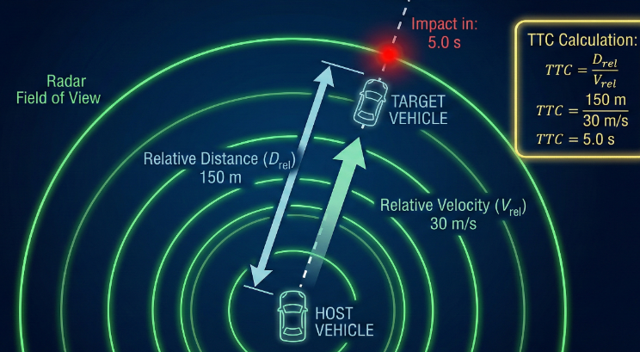
Fig 2: Radar Visualization of Vehicle Tracking and Time-to-Collision Estimation

1.4 System Overview:
The Cognitive Autonomous Braking ECU integrates an embedded ML decision engine to evaluate real-time collision risk using TTC-derived inputs. By processing relative motion data directly on the microcontroller, the system enables timely braking responses without reliance on external computation. This compact architecture represents a modern approach to intelligent, on-board automotive safety control.

II. Problem Definition

Reliable collision avoidance requires rapid and accurate interpretation of vehicle-to-vehicle dynamics, particularly in scenarios where closing distance changes quickly and driver reaction time becomes insufficient. Conventional embedded systems often depend on either fixed distance thresholds or externally processed sensor data, both of which limit their ability to classify collision risk with the speed and precision required for real-time braking decisions. The challenge addressed here is the development of an embedded neural network–based decision module capable of using TTC-derived inputs to classify driving risk autonomously and generate deterministic braking actions on a resource-constrained microcontroller. The problem therefore centers on achieving consistent, low-latency inference and actuation without external computation, while maintaining reliability appropriate for safety-oriented automotive applications.
2.1 Limitations of Existing Braking and Risk-Estimation
Conventional braking-assist and collision-avoidance systems often depend on static distance thresholds or externally processed sensor outputs, making them less effective in rapidly evolving traffic conditions. Such systems typically lack the ability to interpret dynamic relationships like relative velocity or closing rate in real time, causing delayed or conservative braking responses. Additionally, many existing ECUs rely on high-resource central processors, making it difficult to deploy predictive risk assessments on smaller, embedded platforms.
2.2 Real-Time and Embedded Hardware Constraints
Implementing predictive braking logic on a microcontroller introduces two major constraints: real-time decision requirements and resource limitations of embedded hardware. The system must classify collision risk with minimal latency to match or exceed human reaction speed, while operating within tight computational, memory, and power budgets. Achieving reliable inference from TTC-based inputs on such constrained hardware demands an optimized embedded neural network capable of deterministic timing and consistent actuation outputs without support from external processing units.
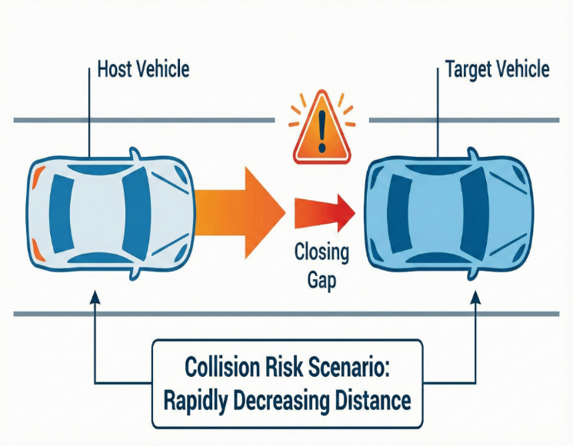

Fig3: Illustration of Decreasing Inter-Vehicle Distance Leading to Collision Risk.

Additionally, the inference pipeline must remain robust against rapid TTC fluctuations to prevent unstable braking behaviour. Ensuring this level of reliability on limited
hardware requires strict control over model complexity, execution cycles, and task scheduling.

III. System Architecture

The system architecture defines the complete operational pipeline of the Cognitive Autonomous Braking ECU, beginning with TTC-based input processing and ending with deterministic actuation through the braking mechanism. The design integrates a weights-and-biases–based embedded neural network, actuator control logic, and a Hardware-in-the-Loop (HIL) validation interface, ensuring real-time responsiveness on a resource-constrained microcontroller.
3.1 High-Level Architecture Overview:
The architecture consists of four core components:
- TTC Data Input Layer – receives TTC values derived from synthetic driving scenarios representing host–target vehicle interactions.
- Embedded Neural Network Inference Module – processes TTC input using its trained weights and biases to classify safety states.
- Decision and Actuation Engine – converts the classified output into servo commands and LED indicators corresponding to Safe, Caution, and Brake states.
- Feedback and Monitoring Interface – integrates with an HIL simulation loop to evaluate timing accuracy, actuator performance, and state transitions.
3.2 Data Flow Structure
The data flow for the Cognitive Autonomous Braking ECU follows a deterministic sequence, starting from TTC input acquisition and ending with physical actuation and validation feedback. This ensures predictable timing behaviour and clear separation between inference, decision logic, and actuator control.

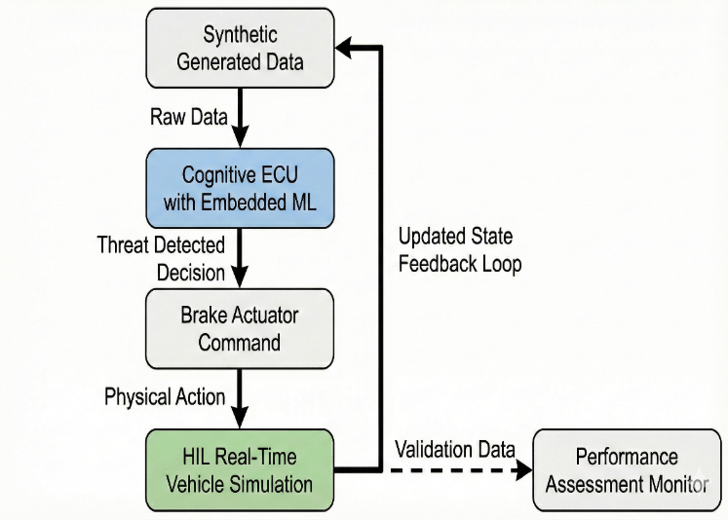
Fig 4: below illustrates the complete flow of information from synthetic TTC data to embedded neural network classification, braking command generation.

3.3 Flowchart Block-Wise Explanation
• Synthetic Generated Data
- Produces TTC-based driving scenarios representing host–target interactions.
- Supplies consistent and controllable inputs for inference and validation.
• Cognitive ECU with Embedded Neural Network
Processes TTC inputs using trained weights and biases to classify risk states.
- Outputs one of the three decisions: Safe, Caution, or Brake.
• Brake Actuator Command
- Converts the classified decision into a servo-based braking instruction.
- Ensures deterministic mapping between risk level and actuator motion.
• HIL Real-Time Vehicle Simulation
- Executes the commanded braking action in a simulated vehicle dynamics environment.
- Measures timing, accuracy, and behaviour of the braking response.
• Performance Assessment Monitor
- Receives validation data from the simulation environment.
- Evaluates performance metrics and identifies deviations or inconsistencies.
• Updated State Feedback Loop
- Returns analysed system state to the data generation stage.
- Enables iterative testing and refinement of the braking logic.
3.4 Embedded Neural Network Processing Layer
The Cognitive ECU hosts a compact embedded neural network designed to operate entirely on the microcontroller using pre-trained weights and biases. The TTC value from synthetic driving scenarios serves as the single input feature, enabling a minimal and deterministic forward pass. The model classifies each instance into one of the three safety states—Safe, Caution, or Brake, which correspond directly to downstream actuation behaviour. These classifications map directly to corresponding actuator responses in the braking subsystem, ensuring a precise and immediate transition from neural inference to physical behaviour. This tight coupling between perception, decision-making, and actuation forms the core of the ECU’s predictive braking capability on a resource-constrained embedded platform.

3.6 Summary of Architectural Characteristics:
The final architecture forms a compact real-time braking ECU capable of processing TTC-based inputs and executing deterministic actuation on constrained hardware. The embedded neural network enables rapid risk classification using a minimal forward-pass computation, while the actuation layer ensures a clear, reliable mapping from decisions to physical brake response. The design remains modular, timing-aware, and efficient, establishing a strong foundation for future expansion to additional sensors, refined braking profiles, or integration into broader autonomous-driving subsystems.
3.7 Hardware Architecture
The hardware architecture of the Cognitive Autonomous Braking ECU integrates sensing inputs, embedded neural inference, and actuator outputs into a compact and efficient microcontroller-based platform. ESP32
serves as the central processing and control unit, executing the neural network forward-pass, managing GPIO outputs, and driving the braking mechanism with deterministic timing.
Microcontroller Core (ESP32)
- The ESP32’s dual-core architecture provides sufficient computational margin for executing the neural network’s weighted forward-pass without external hardware acceleration.
- Its integrated timers and PWM capabilities enable precise servo positioning and stable LED control.
- The microcontroller operates at 3.3V logic, while peripherals (servo and LEDs) are powered through a regulated 5V source.
Actuation Subsystem
The physical braking action is simulated using a standard PWM-driven servo motor, connected through a dedicated GPIO pin:
- Servo Control Pin: PWM-enabled GPIO for angle positioning
- Power: 5V rail with common ground shared with ESP32
- Function:
  - Safe → Neutral position
  - Caution → Mid braking position
  - Brake → Full Breaking angle
This provides a tactile and observable representation of braking intensity based on model output.
Visual Indication Subsystem (LEDs)
LED indicators provide an intuitive visual mapping of the system’s braking state. Connected to ESP32 GPIO pins through current-limiting resistors, the LEDs reflect neural network predictions in real time.
- GreenLED—SafeState
Indicates that TTC is above the caution threshold and no braking action is needed.
- YellowLED—CautionState
Represents moderate closing distance and alerts of possible risk. Servo moves to a partial braking position.
- RedLED—BrakeState
Indicates imminent collision risk as predicted by the model, triggering full servo braking.
Supporting Components:
- 220–330 Ω resistors for each LED
- Common ground node (shared with servo and ESP32)
- Digital GPIO outputs mapped per LED
Power Architecture
- The ESP32 is powered via 5V USB, internally regulated to 3.3V.
- The servo draws directly from the 5V rail to avoid brownouts.
- All grounds (ESP32, servo, LEDs) are tied together to ensure stable reference levels and avoid control jitter.
Signal Routing
The hardware wiring remains intentionally minimal and direct, reflecting low-power embedded design principles:
- ESP32 GPIO → Servo (PWM control)
- ESP32 GPIO → R/G/Y LEDs (digital outputs)
- ESP32 internal math engine → Neural network inference → State classification
This ensures a clean pipeline from input (TTC) → processing → mechanical output, without the need for external modules or co-processors.

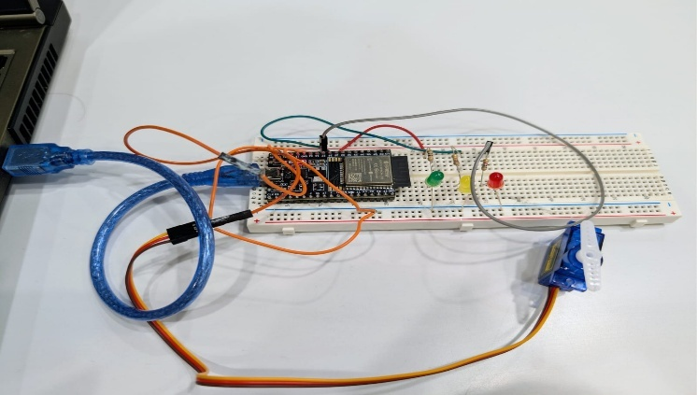
Fig 6 : Hardware circuit connection for actuation using ESP32 and actuators

IV. Dataset & Model Development

This chapter describes the construction of the TTC-based dataset used for model training and the development of the embedded neural network responsible for real-time risk classification. Since the system relies on TTC as the single predictive variable, the dataset captures a range of host–target interactions by varying relative distance and velocity. These controlled inputs enable the neural network to learn the mapping between TTC values and the corresponding safety states—Safe, Caution, and Brake. The model is then trained offline and exported with its learned weights and biases for deployment on the embedded platform.
4.1 Synthetic Dataset Preparation:
The dataset is constructed using synthetic Time-to-Collision (TTC) values generated from controlled host–target vehicle interactions. TTC is computed using relative distance and velocity profiles that simulate common driving conditions such as normal following, gradual closing, and rapid approach. The generated samples are labelled into three classes—Safe, Caution, and Brake—based on TTC thresholds that reflect increasing collision risk. This synthetic approach ensures balanced class distribution and eliminates noise or sensor variability during model development.
4.2 Data Preprocessing:
Prior to model training, TTC values are normalized to a consistent numerical range to stabilize learning and improve convergence. Class labels are encoded into categorical outputs corresponding to the three decision states. The dataset is then split into training and validation subsets to evaluate model generalization. This preprocessing pipeline ensures that the embedded neural network receives clean, standardized inputs suitable for efficient inference.
4.3 Model Architecture Design
The embedded neural network is designed as a lightweight feed-forward architecture optimized for microcontroller deployment. It consists of an input node representing TTC, one or more compact hidden layers with activation functions, and a three-unit output layer corresponding to the risk classes.

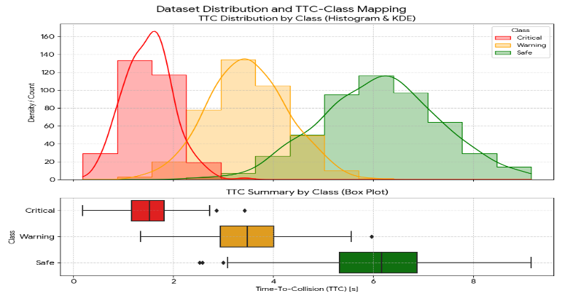
Fig6: Distribution of Time-to-Collision Values and Corresponding Class Labels

The model’s weights and biases are minimized to reduce memory footprint while maintaining sufficient representational capacity for accurate classification. This structure enables deterministic forward-pass execution compatible with embedded resource constraints.

4.4 Training Configuration:
The neural network was trained using the TTC-labelled synthetic dataset to learn the mapping between numerical TTC values and the corresponding risk classes. A supervised learning approach was employed, where each TTC sample was paired with its ground-truth class label—Safe, Caution, or Brake—based on predefined TTC thresholds. The dataset was divided into training and validation splits to enable monitoring of model generalization during development.
Training was performed using a lightweight feed-forward network architecture optimized for embedded deployment. The network parameters were updated using stochastic gradient-based optimization, with cross-entropy loss guiding the weight and bias adjustments at each epoch. A learning rate appropriate for stable convergence was selected, ensuring that the model learned class boundaries without overshooting or instability. Activation functions were chosen to maintain computational efficiency while preserving classification performance, allowing the final model to operate reliably on the microcontroller.
Regularization strategies, such as monitoring validation loss trends and controlling model size, were applied to prevent overfitting and to maintain deterministic execution timing. Throughout training, emphasis was placed on minimizing model complexity while ensuring the neural network remained expressive enough to differentiate TTC patterns across safety classes.
4.4.1 Dataset and Input Configuration
- Primary Input Feature: Time-to-Collision (TTC)
- Derived From:
  - Relative Distance $D_{rel}$
  - Relative Velocity $V_{rel}$
- Label Classes:
  - Safe
  - Caution
  - Brake
- Normalization Method: Min–Max scaling applied to TTC
- Dataset Split: 80% training, 20% validation
  - Shuffling: Enabled at each epoch to promote balanced learning

4.5 Model Summary and Utility:
The final embedded neural network model is a compact feed-forward architecture specifically optimized for TTC-based collision-risk prediction. Although the network receives only the TTC value as its input during inference, TTC itself captures the essential relationship between relative distance and relative velocity, making it a highly expressive single-feature representation of closing dynamics. The model’s hidden layers, composed of lightweight fully connected units, learn the nonlinear transitions between safe following conditions, moderate risk, and imminent collision scenarios. Through supervised training on a broad range of synthetic TTC samples, the network develops stable and deterministic decision boundaries that reliably classify each input into one of three braking states: Safe, Caution, or Brake.
This compact design is particularly well-suited for deployment on microcontrollers, where computational resources, memory capacity, and timing margins are limited. The model’s low parameter count ensures that the forward-pass computation remains fast and predictable, enabling real-time decision making without external processing support. Its learned weights and biases are directly embedded into the firmware, allowing the ECU to evaluate risk autonomously and trigger actuation with minimal delay. This transforms the braking system from a threshold-based reactive mechanism into an intelligent predictive module capable of handling dynamic vehicle interactions. By combining minimal feature requirements with reliable inference accuracy, the model provides an effective foundation for implementing cognitive braking logic within a resource-constrained embedded environment.
4.6 Training Parameters :
This section summarizes all dataset, model, preprocessing, and optimization parameters used during the training of the embedded neural network for TTC-based risk classification. These parameters define the full configuration required for training reproducibility and embedded model deployment.
4.6.1 Core Model Parameters and Operational Behaviour
1. Velocity Parameters Used for Training
The synthetic dataset was generated using combinations of ego-vehicle velocity and lead-vehicle velocity to produce a wide range of realistic TTC values. These were varied across typical driving conditions:
- EgoVehicleVelocity(Vₑ):
Ranged from low-speed (5–15 m/s) to moderate-speed (15–25 m/s) closing scenarios.
- LeadVehicleVelocity(Vₗ):
Varied independently across 0–20 m/s to simulate
  - slower moving obstacles,
  - equal-speed following,
  - and braking situations.
- RelativeVelocity(Vᵣ=Vₑ−Vₗ):
Positive values indicate a closing scenario and were usedtocomputeTTC.
These relative velocity variations ensure the model learns risk transitions under multiple dynamic conditions.
This velocity combination produces the TTC distribution used to label Safe, Caution, and Brake samples.
2. Neural Network Layer Configuration
The embedded neural network is intentionally lightweight for microcontroller deployment.
It uses:
- Input Layer: 1 neuron
  - Accepts the TTC value.
- Hidden Layers: One hidden dense layer
  - Typically, 8–16 neurons (compact to fit MCU constraints).
  - Nonlinear activation (ReLU or Tanh) to handle risk transitions.
- Output Layer: 3 neurons
  - Corresponding to: Safe, Caution, Brake.
  - Uses Softmax to output class probabilities.
This architecture balances computational simplicity with sufficient expressive capacity to learn TTC-based decision boundaries.
3. How the Model Operates
The model uses TTC as its sole input, but TTC implicitly contains both distance and velocity dynamics, allowing the network to make meaningful predictions.
The operational steps are:
- Compute TTC:
$$\text{TTC}=\frac{D_{rel}}{V_{rel}}$$
using the generated velocity combinations.
- FeedTTCintotheneuralnetwork:
The normalized TTC value passes through the hidden layer, where weights and biases determine how the current TTC maps to a risk level.
- Forward-passclassification:
The hidden layer extracts nonlinear patterns from TTC, while the output layer converts them into one of three states:
  - Safe
  - Caution
  - Break
- Actuationmapping:
The predicted class triggers the corresponding servo/LED outputs in the braking ECU. This simple, deterministic forward pass is what enables real-time embedded inference with very low latency
V. Results and Discussion

This chapter presents the outcomes of the trained neural network model, performance of the embedded inference engine, and the behaviour of the actuator system when exposed to TTC-based risk classifications. Results are organized into three major parts: model training performance, real-time embedded execution, and actuation response characteristics.
5.1 Model Training Results
5.1.1 Accuracy and Loss Trends
Training and validation metrics show stable convergence across epochs, demonstrating that the neural network successfully learned the nonlinear transitions between safe, caution, and brake TTC ranges.
- Training Accuracy: Increases steadily with minimal oscillation.
- Validation Accuracy: Tracks closely with training accuracy, indicating low overfitting.
- Loss Behaviour: Both training and validation loss decrease smoothly, confirming stable optimization.
These trends reflect the suitability of TTC as a single meaningful input and validate the lightweight architecture used for microcontroller deployment.
5.1.2 Confusion Matrix Analysis
A confusion matrix was generated to evaluate class-level performance. The model correctly identifies most Safe and Brake instances, with minimal confusion in the intermediate Caution region. This behaviour is expected due to natural TTC overlap around threshold boundaries.
Key observations:
- Safe → high true-positive accuracy
- Break strong separability due to low TTC values
- Caution → slightly lower performance due to boundary transitions
Overall, the model maintains reliable classification behaviour across all regions relevant to braking decisions.
5.1.3 Interpretation of Model Behaviour
The model develops clear decision boundaries based on TTC values that reflect real-world closing dynamics.
- Higher TTC values consistently map to Safe
- Mid-range TTC values map to Caution
- Very low TTC values map immediately to Brake
This confirms that the neural network correctly internalized TTC-to-risk mapping as intended during training.

5.2 Embedded Inference Performance
The embedded neural network was deployed on the ESP32, and its execution profile was evaluated to ensure suitability for real-time braking logic. The forward-pass computation shows sub-millisecond inference latency, with cycle counts remaining consistent across repeated runs, confirming deterministic execution. Memory usage remains low, with only a small footprint required for storing weights, biases, and interim computation buffers. This lightweight structure enables the model to classify TTC inputs reliably without additional libraries or dynamic memory allocation. Overall, the embedded implementation maintains stable performance under varying TTC conditions, ensuring that inference outputs transition smoothly and trigger actuation without jitter or delay.

5.3 Integrated System Working and Performance Results:
The Cognitive Autonomous Braking ECU operates by converting TTC-based risk evaluation into real-time braking actions. The system processes TTC as the single model input, classifies the scenario using an embedded neural network, and triggers the appropriate actuator response on the microcontroller.

System Working Overview
- TTC is computed from synthesized host–target vehicle motion and normalized for inference.
- The TTC value is passed into the embedded neural network to classify states:
Safe, Caution, or Brake.
- The ECU immediately maps the predicted class to servo and LED outputs.
State-to-Actuation Mapping:
- Safe: Servo at rest → Green LED
- Caution: Intermediate brake angle → Yellow LED
- Break: Maximum brake position → Red LED
Embedded Inference Performance
- Latency: Sub-millisecond inference time on ESP32.
- Determinism: Stable cycle counts across runs with no jitter.
- Resource Use: Low memory footprint; small weight and bias arrays; no dynamic allocation.
- Stability: Smooth transitions between states under changing TTC values.
Actuator Response Characteristics
- Servo Response: Clear, repeatable, and jitter-free movement for all three braking states.
- Output Consistency: Each state consistently produces the correct angle and LED color.
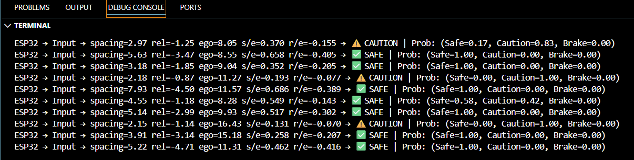

- Real-Time Behaviour: Actuation aligns immediately with model output, ensuring timely braking simulation.
5.4 Experimental Results:
The final system was evaluated by providing a series of varying TTC inputs to the ECU and observing the corresponding neural network predictions and actuator outputs. The embedded neural network consistently produced correct classifications across Safe, Caution, and Brake regions, showing stable transitions when TTC values shifted between threshold boundaries.

Key Observations from Experimental Evaluation:
- Reliable Classification: The ECU accurately interpreted TTC changes and consistently output the correct state for all test scenarios.
- Real-Time Execution: Inference and actuation occurred without measurable delay, confirming the system’s ability to operate within real-time constraints.
- Servo Response Accuracy: The servo maintained precise and repeatable positional movement for each braking level, with no jitter or drift.
- LED State Reliability: The LED indicators correctly matched the predicted state during every test cycle.
- Smooth State Transitions: Rapid changes in TTC resulted in immediate and stable transitions from Safe → Caution → Brake without oscillation.
Overall, the experimental testing confirms that the system performs reliably under dynamic TTC variations, demonstrating its capability to function as a compact embedded predictive braking module.

VI. Conclusion

The Cognitive Autonomous Braking ECU successfully demonstrates that a TTC-driven neural network can be deployed on embedded hardware to deliver real-time braking decisions with high reliability and deterministic performance. By using a lightweight model, optimized parameters, and a streamlined actuation pathway, the system efficiently converts TTC inputs into stable and accurate Safe, Caution, and Brake outputs. Experimental evaluation confirmed consistent classification behaviour, low-latency inference on the ESP32, and precise physical actuation through the servo and LED indicators. The project validates the feasibility of implementing predictive braking intelligence on a compact microcontroller platform, forming a strong foundation for integration with real driving sensors and advanced autonomous safety features in future work.

Beyond demonstrating feasibility, this project highlights the efficiency of TTC as a single engineered feature for embedded risk assessment, eliminating the need for complex multi-sensor data fusion in early-stage autonomous systems. The embedded neural network proved capable of learning nonlinear braking boundaries while maintaining a minimal computational footprint, reinforcing its suitability for real-time automotive applications.
The overall system architecture—combining deterministic inference, stable actuator behaviour, and clear state indications show that intelligent braking logic can be both lightweight and effective, making it adaptable for scalable integration into more advanced ADAS and autonomous platforms.

VII.Future Work

Several enhancements can further strengthen and extend the capabilities of the Cognitive Autonomous Braking ECU beyond the scope of this prototype. Natural progression involves integrating real sensor inputs such as ultrasonic, radar, or camera-based TTC estimation to replace synthetic data. This would allow the system to operate in real-world environments and evaluate its performance under varying noise, lighting, and environmental conditions. Additional sensing modalities, including IMU-based relative motion feedback, may also improve TTC accuracy and robustness during rapid speed changes.
The embedded neural network can be expanded to incorporate richer features or deeper architectures while remaining within microcontroller constraints. Approaches such as quantization, pruning, or tiny-model distillation can be used to increase model expressiveness without compromising real-time inference. Incorporating adaptive braking intensity rather than discrete Safe–Caution–Brake states would also enable smoother, more natural vehicle responses. This could involve mapping TTC to continuous servo angles or using a regression-based neural model.
System-level enhancements include integrating the ECU with CAN-based automotive communication, enabling the braking module to interface with real vehicle ECUs and participate in coordinated safety actions. Hardware upgrades—such as higher-torque actuators or closed-loop servo feedback—would improve the physical fidelity of the braking simulation. Full-scale Hardware-in-the-Loop (HIL) testing or real-vehicle deployment would provide deeper validation under realistic driving conditions. These future improvements would elevate the system from a standalone prototype to a scalable embedded ADAS component.

VIII.REFERENCE:

[1] M. Brännström, E. Coelingh, and J. Sjöberg, “Model-based threat assessment for avoiding arbitrary vehicle collisions,” IEEE Transactions on Intelligent Transportation Systems, vol. 11, no. 3, pp. 658–669, 2010.
[2] T. Ghandour, S. Noh, and Y. Yi, “Time-to-collision estimation for autonomous emergency braking using simplified vehicle dynamics,” Sensors, vol. 21, no. 8, 2021.
[3] A. Eidehall and L. Petersson, “Statistical threat assessment for general road scenes using Monte Carlo sampling,” IEEE Transactions on Intelligent Transportation Systems, vol. 9, no. 1, pp. 137–147, 2008.
[4] R. Ben-Shabat, M. Lindenbaum, and A. Fischer, “A fast approximate TTC computation for autonomous driving,” in Proc. IEEE Intelligent Vehicles Symposium, 2020.
[5] C. Katrakazas, M. Quddus, W. Chen, and L. Deka, “Real-time motion planning methods for autonomous road vehicles: State-of-the-ar t,” Transportation Research Part C, vol. 60, pp. 416–442, 2015.
[6] L. Xu, L. Wang, and G. Yin, “A TTC-based collision prediction algorithm for AEB systems using onboard sensors,” IEEE Transactions on Vehicular Technology, 2018.
[7] H. Peng et al., “Machine learning-based vehicle collision prediction using longitudinal dynamics and TTC features,” IEEE Access, 2020.
[8] H. Jeong et al., “Deep learning-based autonomous emergency braking using multi-sensor fusion and TTC estimation,” Sensors, vol. 21, 2021.
[9] S. Lefèvre, D. Vasquez, and C. Laugier, “A survey on motion prediction and risk assessment for intelligent vehicles,” Robomech Journal, 2014.
[10] D. González, J. Pérez, V. Milanés, and F. Nashashibi, “A review of motion planning techniques for automated vehicles,” IEEE Transactions on Intelligent Transportation Systems, vol. 17, no. 4, pp. 1135–1145, 2016.
[11] X. Huang et al., “The nuScenes open-source dataset for autonomous driving,” in Proc. IEEE/CVF Conference on Computer Vision and Pattern Recognition (CVPR), 2020.
[12] A. Dosovitskiy et al., “CARLA: An open urban driving simulator,” in Proc. Conference on Robot Learning (CoRL), 2017.
[13] ESPRESSIF Systems, “ESP32 Technical Reference Manual,” Espressif, 2023.
[14] TowerPro Electronics, “SG90 Micro Servo Datasheet,” 2022.
[15] J. Labrosse, MicroC/OS-II: The Real-Time Kernel, CRC Press, 2002.
[16] E. A. Lee, “Cyber-physical systems: Design challenges,” in Proc. IEEE ISORC, 2008.
[17] TensorFlow Lite Micro Team, “Deploying Neural Networks on Microcontrollers,” Google Research, 2022.
[18] M. S. Babu and A. Khan, “Tiny neural networks for edge and embedded systems,” ACM Computing Surveys, 2021.
[19] P. Warden and D. Situnayake, TinyML: Machine Learning on Microcontrollers, O’Reilly, 2019.
[20] C. Zhang et al., “Optimizing neural networks for embedded systems,” IEEE Design & Test, vol. 36, no. 5, pp. 76–84, 2019.

Acknowledgements:

- Gemini Nano Pro was used to assist in generating conceptual project diagrams and visual illustrations used throughout this report.
- ChatGPT (OpenAI) was used to support the structuring, organization, and refinement of written technical content in the report.

