Space Ranger Game Design Document (GDD)

**Table Of Contents**

1. Game Description
2. Game Mechanics and Genres
3. Art Style and References
4. Controls
5. Credits
6. Game Screenshots

**Game Description**

Space Ranger is a 2D space shooter where players try to survive against asteroids and the enemy spaceship as long as possible.

Players have to try to beat their own high scores to set the new one.

The overall theme is of a classic Arcady style space shooter game, to bring back the magic of old arcade games.

**Game Mechanics**

* Players can move in both x and y directions in the whole screen to dodge the incoming asteroids and laser bullets of enemy ship.
* They also have ability to shoot down asteroids and destroy them, but they can’t destroy enemy space ship so they have to dodge its attacks.
* If their spaceships collide with asteroid, enemy space ship or its bullet then the game is over and they have to retry.
* Score is recorded on the basis of the overall time player’s spaceship survived in a playthrough.

**Game Genres**

* Scifi Shooter
* Endless
* Arcade
* Hyper casual

**Art Style & References**

* Player space ship

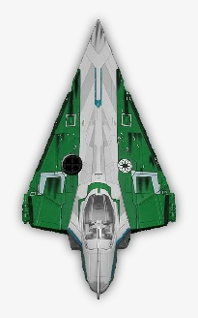(Created by me) (Reference Image)

* Bullet

(Created by me)

* Asteroid

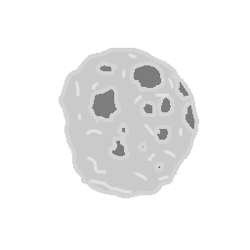

(Created by me)

* Enemy Spaceship



(Taken from - <https://frostwindz.itch.io/pixel-art-sci-fi-spaceships>)

* 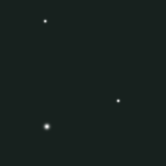Animated Background

(Taken from - <https://opengameart.org/content/animated-stars-background>)

* GUI





(Taken from - <https://free-game-assets.itch.io/free-space-shooter-game-user-interface>)

**Controls**

* W A S D – to move up, left, down, right
* Left click – shoot
* Space – To pause the game

**Credits**

* Art of player space ship, bullet and asteroid are created by me using GIMP
* Art of enemy ship, background and GUI are taken from external resources (already mentioned above)
* Background music is created by me using bosca ceoil
* Sound effects are created using jsfxr- <https://sfxr.me>
* All the coding part is done by me.

**Game Screenshots**

