BCSE302P Database Systems Lab

Project Review 2 Submission

Movie Recommendation System Using Graph-Based NoSQL Database (Neo4j)
Team members: Harshit Pandey (24BCT0173), Manik Chauhan (24BCE2063), Meet Kareliya (24BCE2053)
Review focus: Database implementation, CRUD operations, NoSQL features, and integration

1. Review 2 Checklist
| Rubric item | Evidence in this project | Status |
| --- | --- | --- |
| Database created | Neo4j schema and seed scripts in database/ | Ready to demonstrate |
| Sample data loaded | 126 base nodes plus relationships and generated reviews | Ready to demonstrate |
| CRUD operations | User create/update, rating upsert, watchlist delete, movie browsing | Ready |
| Advanced NoSQL features | Multi-hop Cypher recommendations, shortest path, PageRank-compatible projection | Ready |
| Minimum 50 records/nodes | Seed creates 126 base nodes | Satisfied |
| Source code repository | Frontend, server, Cypher, report, and manual | Ready |
Before submission: Run the commands in Section 3 in Neo4j Browser and replace every screenshot box with your own screenshot.

2. Project Overview
Framewise is a graph-based movie recommendation system. Neo4j stores users, movies, genres, actors, directors, reviews, ratings, follows, and watchlists as a connected graph. This allows recommendation queries to traverse relationships directly instead of performing multiple relational joins.

Graph labels
User, Movie, Genre, Actor, Director, Review

Relationship types
RATED, BELONGS_TO, ACTED_IN, DIRECTED_BY, FOLLOWS, WATCHLISTED, SIMILAR_TO, WROTE

Files used in the demonstration
• database/schema.cypher: constraints and indexes
• database/seed.cypher: sample graph data
• database/queries.cypher: CRUD, recommendation, search, and analytics queries
• index.html, styles.css, app.js: responsive user interface
• server.py: local demo server

3. Neo4j Demonstration and Screenshot Guide
Open Neo4j Browser and connect to the local Neo4j database or Neo4j Aura instance. Run database/schema.cypher first, followed by database/seed.cypher.

Screenshot 1: Constraints and indexes
What to show: Neo4j Browser output showing the constraints and indexes created by schema.cypher.
Run this command:
SHOW CONSTRAINTS;
SHOW INDEXES;
Expected output: Unique constraints for user, movie, genre, actor, director, and review IDs; indexes for movie title, movie year, and user email.
Paste screenshot here:
[SCREENSHOT 1: Constraints and indexes]
>
Leave approximately 10 cm of space here. Capture Neo4j Browser showing the result table.

Screenshot 2: Database population and node counts
What to show: Counts proving that the database contains more than the required 50 nodes.
Run this command:
MATCH (n)
RETURN labels(n)[0] AS label, count(n) AS total
ORDER BY label;
Expected output: At least 10 users, 20 movies, 12 genres, 40 actors, 20 directors, and 24 reviews, for 126 base nodes before any generated review nodes.
Paste screenshot here:
[SCREENSHOT 2: Node count by label]
>
Leave approximately 10 cm of space here. Capture the result table with all labels visible.

Screenshot 3: Graph visualization
What to show: A visual graph containing users, movies, genres, actors, and directors.
Run this command:
MATCH p=(u:User)-[:RATED]->(m:Movie)-[:BELONGS_TO]->(g:Genre)
RETURN p
LIMIT 40;
Expected output: Neo4j Browser graph view with connected user-rating-movie-genre paths.
Paste screenshot here:
[SCREENSHOT 3: Neo4j graph visualization]
>
Leave approximately 12 cm of space here. Switch Neo4j Browser from table view to graph view before capturing.

Screenshot 4: Create and read a user
What to show: A CRUD create operation and the created user returned by Neo4j.
Run this command:
CREATE (u:User {
id: 'demo-user',
name: 'Review 2 Demo User',
email: 'review2@framewise.demo',
joined: date().toString()
})
RETURN u;
Then verify the record:
MATCH (u:User {id: 'demo-user'})
RETURN u;
Expected output: A user node with the requested properties.
Paste screenshot here:
[SCREENSHOT 4: User create and read]
>
Leave approximately 10 cm of space here. Capture the returned node properties.

Screenshot 5: Update and delete operations
What to show: Updating a profile and deleting a watchlist relationship.
Run this command:
MATCH (u:User {id: 'demo-user'})
SET u.bio = 'Graph recommendation evaluator'
RETURN u;
For a relationship delete demonstration:
MATCH (u:User {id: 'u1'}), (m:Movie {id: 'm1'})
MERGE (u)-[:WATCHLISTED {added: '2026-09-25'}]->(m);

MATCH (u:User {id: 'u1'})-[w:WATCHLISTED]->(m:Movie {id: 'm1'})
DELETE w
RETURN u.id AS user, m.title AS movie, 'watchlist edge deleted' AS result;
Expected output: Updated user properties and a confirmation row for the deleted relationship.
Paste screenshot here:
[SCREENSHOT 5: Update and delete CRUD]
>
Leave approximately 10 cm of space here. Capture the final result row.

Screenshot 6: Rating write with relationship properties
What to show: A rating stored as a relationship with value, review text, and timestamp.
Run this command:
MATCH (u:User {id: 'u1'}), (m:Movie {id: 'm10'})
MERGE (u)-[r:RATED]->(m)
SET r.value = 5,
r.review = 'Powerful and technically precise.',
r.updated = datetime()
RETURN u.name, m.title, r.value, r.review, r.updated;
Expected output: One row showing the user, movie, rating value, review, and update timestamp.
Paste screenshot here:
[SCREENSHOT 6: Rating relationship write]
>
Leave approximately 10 cm of space here. Capture the returned relationship properties.

Screenshot 7: Collaborative recommendation
What to show: Recommendations generated by users with similar rating patterns.
Run this command:
MATCH (me:User {id:'u1'})-[my:RATED]->(seen:Movie)<-[their:RATED]-(peer:User)
WHERE their.value >= 4 AND my.value >= 4
MATCH (peer)-[recommendation:RATED]->(candidate:Movie)
WHERE recommendation.value >= 4
AND NOT (me)-[:RATED|WATCHLISTED]->(candidate)
RETURN candidate.title,
round(avg(recommendation.value), 2) AS score,
count(DISTINCT peer) AS sharedTaste
ORDER BY score DESC, sharedTaste DESC
LIMIT 5;
Expected output: A ranked list of unseen movies with a score and the number of users sharing the taste pattern.
Paste screenshot here:
[SCREENSHOT 7: Collaborative recommendation result]
>
Leave approximately 10 cm of space here. Capture the ranked result table.

Screenshot 8: Content-based recommendation
What to show: Recommendations based on shared genres, actors, or directors.
Run this command:
MATCH (u:User {id:'u1'})-[r:RATED]->(liked:Movie)
WHERE r.value >= 4
MATCH (liked)-[:BELONGS_TO|ACTED_IN|DIRECTED_BY]->(feature)
<-[:BELONGS_TO|ACTED_IN|DIRECTED_BY]-(candidate:Movie)
WHERE NOT (u)-[:RATED|WATCHLISTED]->(candidate)
RETURN candidate.title,
count(DISTINCT feature) AS matchedFeatures
ORDER BY matchedFeatures DESC
LIMIT 5;
Expected output: Movies ranked by the number of graph features shared with movies the user rated highly.
Paste screenshot here:
[SCREENSHOT 8: Content-based recommendation result]
>
Leave approximately 10 cm of space here. Capture the result table and query text.

Screenshot 9: Shortest-path analytics
What to show: The relationship path explaining how a user connects to a movie.
Run this command:
MATCH (u:User {id:'u1'}), (m:Movie {id:'m10'}),
p=shortestPath((u)-[*..6]-(m))
RETURN [n IN nodes(p) | coalesce(n.name, n.title)] AS path,
length(p) AS hops;
Expected output: A path array and hop count. This demonstrates graph traversal analytics.
Paste screenshot here:
[SCREENSHOT 9: Shortest path]
>
Leave approximately 10 cm of space here. Capture the path and hop count.

Screenshot 10: Application integration
What to show: Framewise frontend running locally with recommendations and movie posters.
Run this command in the project folder:
python3 server.py
Open http://localhost:8000 in a browser. Show the home screen, then click a movie to show the detail modal and rating buttons.
Expected output: Responsive dark streaming-style interface with search, recommendation modes, real poster artwork, rating flow, library, and graph explorer.
Paste screenshot here:
[SCREENSHOT 10: Framewise application]
>
Leave approximately 15 cm of space here. Capture the home screen or movie detail modal.
Captured screenshot:
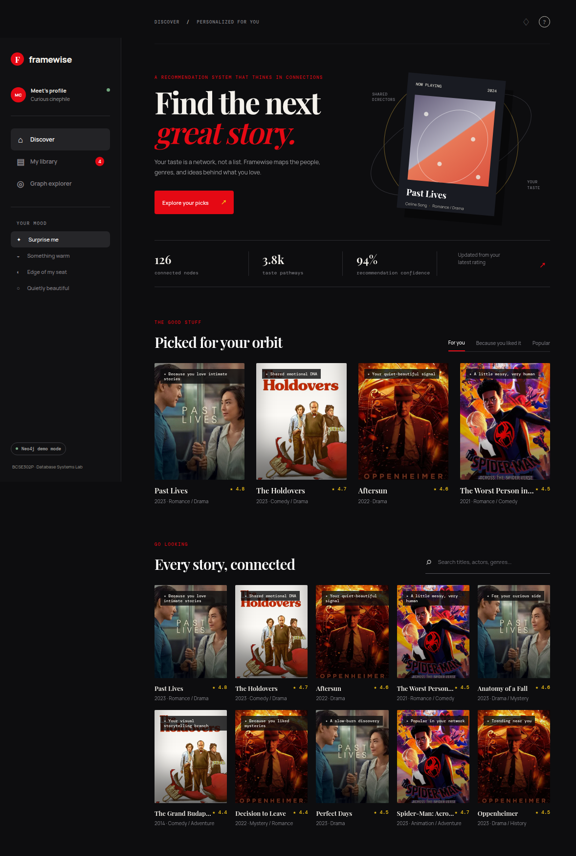

Additional screenshot: Public GitHub repository
What this proves: The source code repository is publicly available for evaluator access.
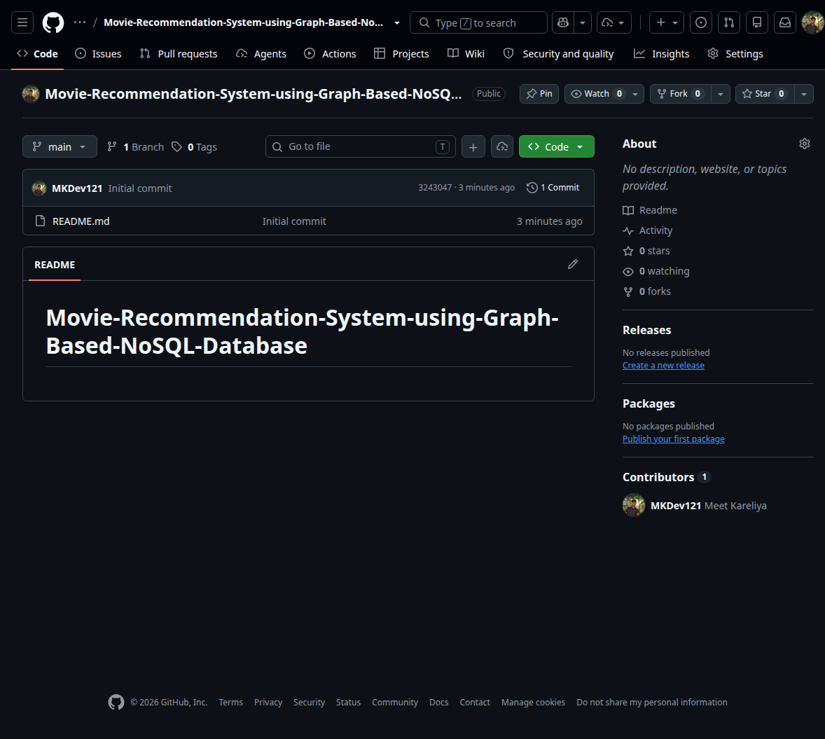

4. Advanced NoSQL Features Demonstrated
1. Native graph traversal: Recommendations use 2–3 hop traversals through users, ratings, movies, genres, actors, and directors.
2. Relationship properties: RATED stores the rating value, review, and update timestamp.
3. Constraints and indexes: Identity constraints and lookup indexes support data integrity and performance.
4. Shortest path: Explains the connection between a user and a target movie.
5. PageRank compatibility: The query file includes a Neo4j Graph Data Science projection and PageRank query.
6. Schema flexibility: New labels such as Language, Award, or Platform can be added without redesigning relational tables.

5. Review 2 Viva Preparation
Why did you choose Neo4j?
The core problem is relationship-heavy. Neo4j stores relationships as first-class graph edges and makes multi-hop recommendation queries readable and efficient.
How does collaborative filtering work?
The query finds users who rated the same movies highly as the current user, then collects other movies those similar users rated highly. Already rated or watchlisted movies are excluded.
How does content-based filtering work?
It follows relationships from highly rated movies to genres, actors, and directors, then finds candidate movies sharing those features.
What is stored on the RATED relationship?
The rating value, optional review, and update timestamp are stored as relationship properties because they describe the user-to-movie interaction.
How is the database protected from duplicate entities?
Neo4j uniqueness constraints are created for user, movie, genre, actor, director, and review identifiers.
How does the system scale?
The graph schema supports additional users, movies, and relationship types without changing a fixed set of relational tables. Indexes improve common identity and search lookups.

6. Submission Notes
• Add your screenshots in the ten marked sections.
• Keep the Neo4j query text visible where possible.
• Make sure the Neo4j Browser database name and team member details are visible in at least one screenshot if required by your instructor.
• Remove any test node named demo-user after the demonstration if your instructor expects a clean database:
MATCH (u:User {id:'demo-user'}) DETACH DELETE u;
End of Review 2 submission document

