**The Firestarters**

Fire Department Project

Contents

**1.Authors** 3

**2. Programs we used** 3

**3. Summary** 4

3.1 Goals 4

3.2 Stages of realization 4

3.3 Level of difficulty main problems during realization 4

**4. Flowchart of our site** 5

**5. Site construction** 5

# **1.Authors**

* Miriam Kostadinova Georgieva 9g
* Scrum Trainer
* [MKGeorgieva19@codingburgas.bg](mailto:MKGeorgieva19@codingburgas.bg)
* Alexander Niels Boris Klingenberg 9a
* Developer BackEnd
* [AKlingenberg19@codingburgas.bg](mailto:AKlingenberg19@codingburgas.bg)
* Teodor Toshkov Karchev 9b
* Desinger
* [TTKarchev19@codingburgas.bg](mailto:TTKarchev19@codingburgas.bg)
* Tereza Nikolaeva Opanska 9v
* Developer FrontEnd
* [TNOpanska19@codingburgas.bg](mailto:TNOpanska19@codingburgas.bg)

# **2. Programs we used**

* Visual Studio Code/Sublime text – to make our site and our README.md
* Discord – to communicate
* Git Hub – for better teamwork
* PowerPoint – to make our Presentation
* Word – to make our Documentation
* Excel – to make our QA Documentation
* Photoshop – to make our logo, backgrounds and other design elements
* Draw.io – to make the Flowchart of the site

# **3. Summary**

## 3.1 Goals

Our goals are to make our website as useful as possible, so that our clients are getting the help they need in the most efficient way and we wish to give our clients the best care.

## 3.2 Stages of realization

***First stage*** (***planning)*** - First step we took was to create a group in Discord to distribute roles to each person in our team and to decide which days at what time we can talk to discuss the the project and to see if something is wrong.

***Second stage*** ***(realization)*** - When we have discussed every problem and every role, we gave eachother tasks and started working on our website. Every two or three days we talked to eachother about what was going on and how we were doing with our tasks.

***Third stage (documentation and presentation)*** - When we had finished working on our website and it was completed, our Scrum Trainer started to write the documentation and make the presentation for our project.

## 3.3 Level of difficulty main problems during realization

We had a few problems with the functionality of the Information page but when it was done everything worked great. A few problems also appeared while making the site responsive, bit we managed at the end. We also had some organisational problem, such as when everyone was free to discuss our work. Even though we did not have many meetings we finished our work as quickly as possible.

# **4. Flowchart of our site**

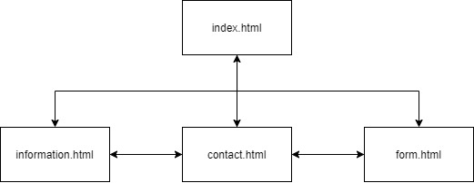

# **5. Site construction**

|  |  |
| --- | --- |
| File name | File description |
| index.html | Home page (and the starting point) for our website. |
| information.html | Page with information about the firefighters working at the fire station, the firetrucks they drive, the statistics for 2020 and the top firefighters. |
| conatct.html | Page with the contact info for the fire station (email, telephone, address, etc.). |
| form.html | Page where you can fill in a form in case of an emergency. |