**Venom**

String Project

Contents

**1.Authors** 3

**2. Programs we used** 3

**3. Summary** 4

3.1 Goals 4

3.2 Stages of realization 4

3.3 Level of difficulty main problems during realization 5

**4. Flowchart** 5

**5. Description of the functions used** 5

# **1.Authors**

* Miriam Kostadinova Georgieva 9g
* Scrum Trainer
* [MKGeorgieva19@codingburgas.bg](mailto:MKGeorgieva19@codingburgas.bg)
* Martin Valentinov Martinov 9b
* Quality engineer
* [MVMartinov19@codingburgas.bg](mailto:MVMartinov19@codingburgas.bg)
* Ivan Dyankov Staev 9v
* Developer BackEnd
* [IDStaev19@codingburgas.bg](mailto:IDStaev19@codingburgas.bg)
* Marieta Petkova Stoycheva 9g
* Code Checker
* [MPS](mailto:MPS)toycheva19@codingburgas.bg
* Teodora Nikolaeva Kompanska 9a
* Developer FrontEnd
* [TNKompanska19@codingburgas.bg](mailto:TNKompanska19@codingburgas.bg)

# **2. Programs we used**

* Visual Studio 2019 – to write our code (in C++)
* Visual Studio Code – to make our README.md
* Discord – to communicate
* Git Hub – for better teamwork

# **3. Summary**

## 3.1 Goals

Our goals are to make a game that everyone can play, regardless the ages. We did two games in one on purpose, because we want more people to play our game!

## 3.2 Stages of realization

***First stage*** (***planning)*** - First step we took was to create a group in Discord to distribute roles to each person in our team and to decide which days and which time we can talk to discuss our problems.

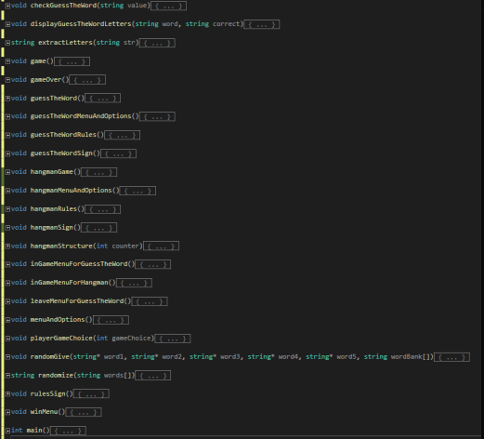***Second stage*** ***(realization)*** - When we have discussed every problem and every role, we started to work on code and every day we had to talk about what's going on and who's got how far.

***Third stage(documentation and presentation)*** - When we have finished with work on code, we should write documentation and make presentation to present our project easier.

## 3.3 Level of difficulty main problems during realization

We have a few problems with code such as bugs and with the menu functions. We had some other problems but we solve them quickly and after that we improved our work and finished our tasks at the end.

# **4. Flowchart**

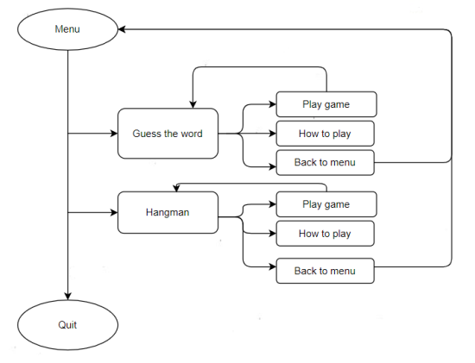

# **5. Description of the functions used**

|  |  |  |  |
| --- | --- | --- | --- |
| **Function name** | **Purpose** | **Arguments** | **Returned value** |
| **checkGuessTheWord()** | Function that checks if the player wants to play again or to return to the menu | string value | void |
| **displayGuessTheWordLetters()** | Function that displays the letters from "Guess the word" game | string word, string correct | void |
| **extractLetters()** | Function that extract letters for "Guess the word" game | string str | string |
| **game()** | The main function for the games | - | void |
| **gameOver()** | Function that displays "Game Over" if you lose the "Hangman" game and ask you what you want to do next | - | void |
| **guessTheWord()** | "Guess the word" game | - | void |
| **guessTheWordMenuAndOptions()** | Menu and options for "Guess the word" game | - | void |
| **guessTheWordRules()** | Rules for the "Guess the word" game | - | void |
| **guessTheWordSign()** | Title for "Guess the word" game | - | void |
| **hangmanGame()** | The "Hangman" game | - | void |
| **hangmanMenuAndOptions()** | Menu and options for the "Hangman" game | - | void |
| **hangmanRules()** | Rules for the "Hangman" game | - | void |
| **hangmanSign()** | Title for the "Hangman" game | - | void |
| **hangmanStructure()** | Structure of the "Hangman" game | int counter | void |
| **inGameMenuForGuessTheWord()** | "In game" sign for the "Guess the word" game | - | void |
| **inGameMenuForHangman()** | "In game" sign for the "Hangman" game | - | void |
| **leaveMenuForGuessTheWord()** | "Leave the game" instruction | - | void |
| **menuAndOptions()** | The main menu and options | - | void |
| **playerGameChoice()** | Function that allows to choose a game | int gameChoice | void |
| **randomGive()** | Function that randomizes the letters in the "Guess the word" game | string* word1, string* word2, string* word3, string* word4, string* word5, string wordBank[] | void |
| **randomize()** | Function that randomizes the words for the "Hangman" game | string words[] | string |
| **rulesSign()** | Rules title | - | void |
| **winMenu()** | Function that displays "You win" and ask us what we want to do next | - | void |