#####################################################################################

HOW TO CREATE A PROJECT FILE

#####################################################################################

1. First Open DEV c++!!

create a Project file here:

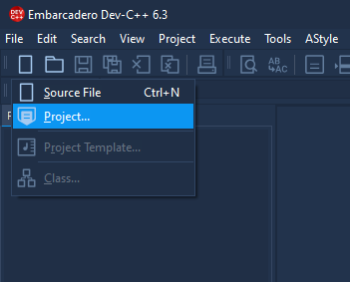

1. Before you start you need to set up the following project like this:

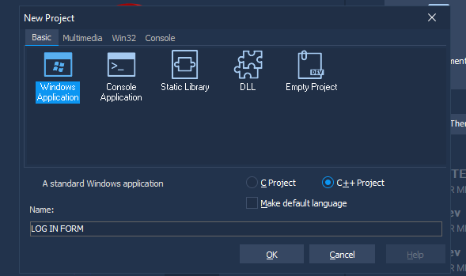

1. Put specific folder in desktop

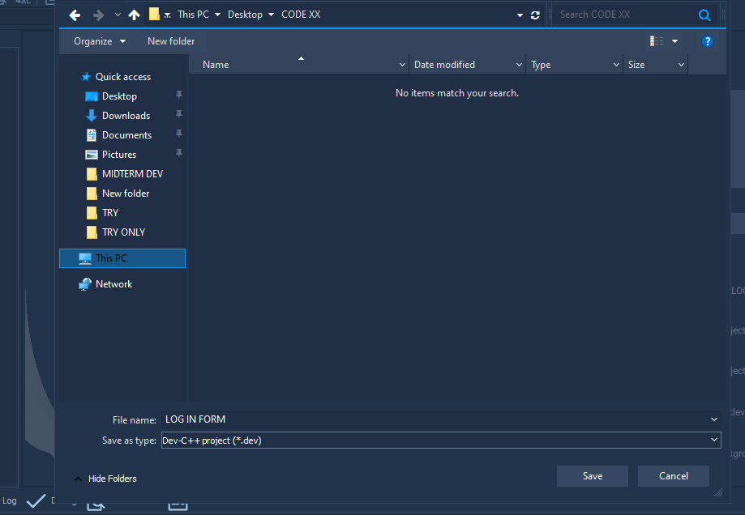

Set the file name of your project I choose LOG IN FORM by Jethro Caronan POGI

1. After the step you can now see the main.cpp

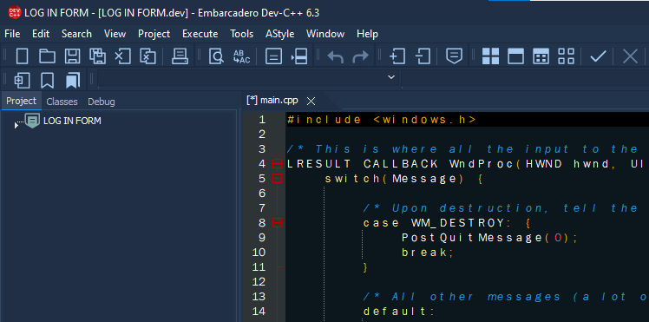

Try to crtl + S and save default name main.cpp

1. Save and default name main.cpp

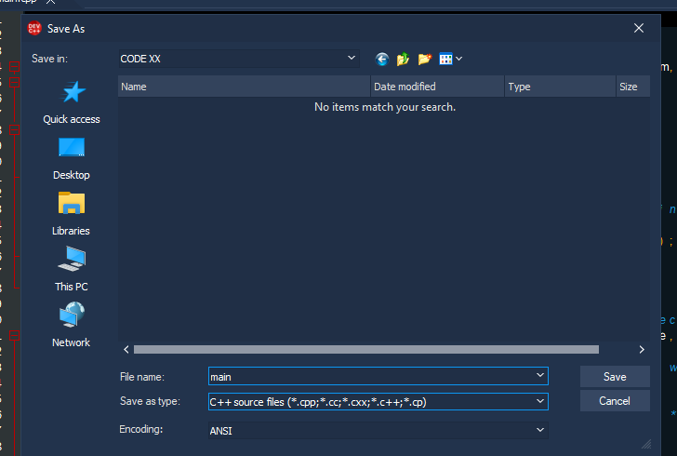

Now try your code if it works if not BOBO Ka!!!!

1. Eto saakin gumana BOY

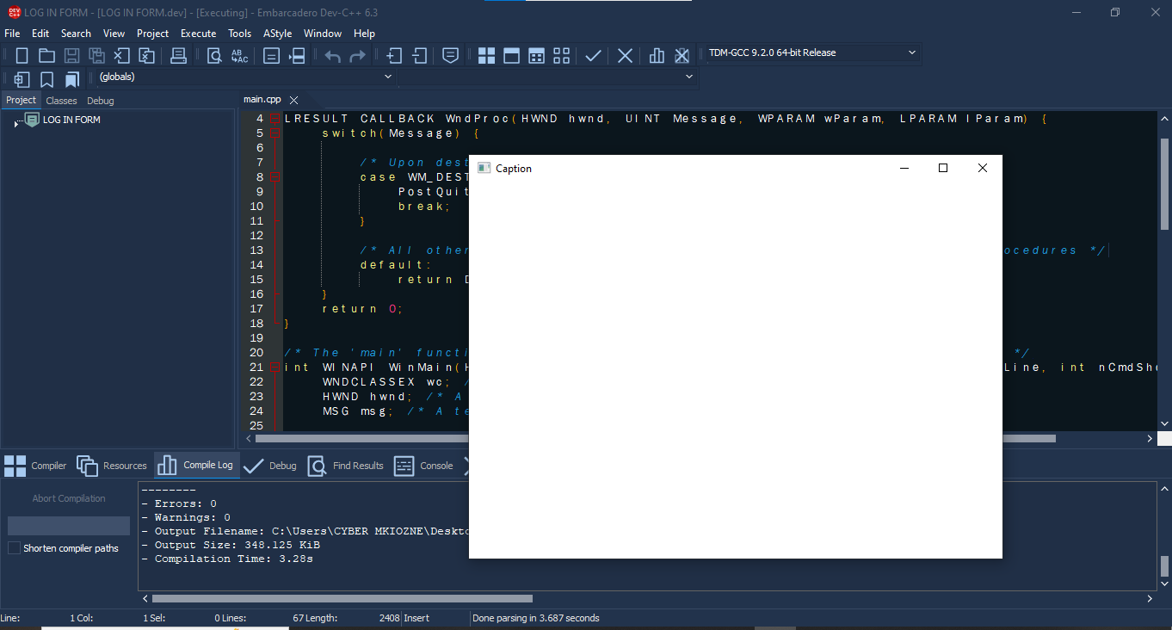

7.

I forgot you need this to run the code lets say you want color .

Add linker in   
  
project > project Options > tab parameters > Linkers and put this

-lcomctl32

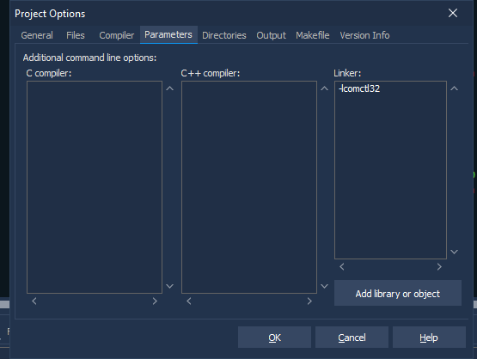

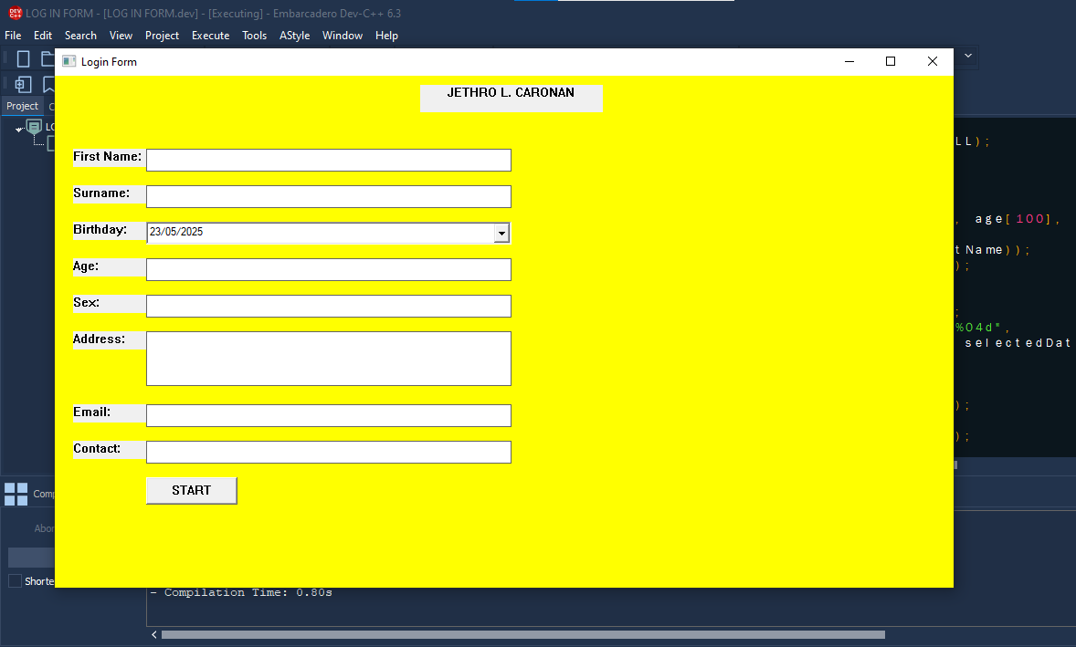DAPAT GANTO AND KINALABASAN NANG SAU AHHH

By JETHRO POGI HHAHAHAHHAH