**Appendix S1 Supporting Information**

**Figure S1**. Theoretical trait-fitness relationships in three different thermal environments (grey area). The theoretical relationship of the functional trait with fitness is the same in the three examples (Gaussian curves) but the trait value rendering highest fitness differs across thermal environments. Examples of the traits expressed by three populations (blue, red and yellow, adapted to cold, mild and hot temperatures respectively) and the fitness achieved are shown. The central, yellow population has the highest fitness because it expresses traits values closer to the optimum value. At the margins of the species’ distribution, populations express values farther apart from the optimum, and therefore, they achieve lower fitness. Phenotypic plasticity allows a population to express a wider range of trait values (dark-colored populations) and achieve higher fitness compared to less plastic populations (light -colored populations).

**Fig. S1.TIF**

**Figure S2.** Maps of current (left) and projected (right) maximum temperature of the warmest month used for the simulations.

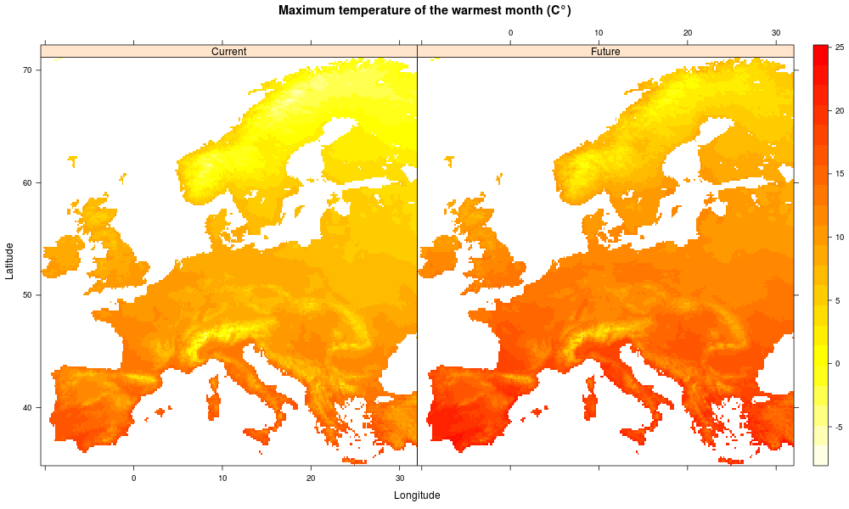

**Figure S3.** Simulations of habitat suitability for five main populations of a virtual species occurring in Europe in five intraspecific scenarios differing in population responses to temperature according to Fig. 1. **Left**: Current habitat suitability. **Right**: Predicted habitat suitability. Each group of maps corresponds to simulations for each intraspecific scenario.

C:\Users\Fernando Valladares\AppData\Local\Microsoft\Windows\Temporary Internet Files\Content.Outlook\NQJA0CGL\Fig  S2.tif

**Details on the provenance data and on the model for the real species (*Pinus sylvestris*)**

In GENFORED, *P. sylvestris* growth and survival were measured on 12 provenances grown at four sites (see Appendix S1 Table S3 and S4). In each site, seedlings were planted in an experimental randomized block design with four replicated 16 tree-plots for each provenance. In the plantation sites, species growth was measured as the differences in diameter at breast height between 2000 and 2005, and mortality as the percentage of trees that died for each provenance for the same period (see Appendix S1 Table S5). One ecological niche model based on tree growth and mortality and climate was calibrated per provenance. This niche model was explicitly designed to deal with provenance tests, and is based on the climatic differences between the provenance and the plantation site, and the combination of growth and survival as determinants of habitat suitability (Benito Garzón et al. 2013). The climatic differences were calculated for five variables that have already proven to determine Iberian tree species distributions: annual average temperature, maximum temperature of the warmest month, minimum temperature of the coldest month, annual precipitation and summer precipitation. The current climate variables cover 17 years and 2605 weather stations and were interpolated to 1 km using thin splines (Mitasova & Mitas, 1993). Prediction of the population suitability for 2050 was performed using the A1F1 HadCM3 scenario of the IPCC, as in the case of the virtual species. The ecological niche model was designed following three main steps: calibration, validation and prediction. The original growth and survival data was split into training and validation datasets to independently validate the models. The goodness of fit was measured by the generalization power of the model on the validation dataset (R2) and by the percentage of the variance explained by the algorithm. . The percentage of the variance was calculated by dividing the mean square error of model (MSE) by the variance of the response (the original observations, i.e. growth or mortality measures) and then subtracting it from 1 as follows

The model was calibrated with the training dataset using the random forest algorithm (randomForest R library), a machine learning technique that improves regression trees by the bootstrap aggregation of multiple trees and is able to learn from an initial training dataset (Breiman 2001). The random forest algorithm is able to learn from the original dataset in a first step, where *n* trees are built by bootstrapping from the original dataset (*n* was set to 200). For each bootstrap sample, a tree is fully grown randomly sampling the number of predictors *mtry* took at each node division (*mtry* was set to 5). Then, it calculates a misclassification rate (MSE) for the out-of-bag (OOB) observations and finally, each tree is fully grown and the average of the results of each fully grown tree is calculated.



The random effect of the block structure of the provenance trials leads to a a slight increase of the variance explained by the models (see Appendix S1 Table S5). Only when the predictive accuracy of a provenance model as well as the percentage of the variance explained (see Appendix S1 Table S5) was high enough (R2>0.5 and % of the variance > 40%) did we use the given provenance for prediction purposes under future climate change scenarios. Habitat suitability occurrence was calculated by maximization of the True Skill Statistics (TSS) of the combination (as algebraic difference) of the maps resulted from models calibrated with 5-years radial growth (mm) and survival maps 5-year mortality probability (in%) comparing with the EUFORGEN (http://www.euforgen.org/distribution_maps.html) observed data (Benito Garzón et al. 2013). Positive TSS indicates good agreement between the predicted and the real distribution (Appendix S1 Table S6). Habitat suitability occurrences for the A1F1 climate change scenario where projected using the same threshold as calculated for the present.

**Table S1**. Differences in optimum temperature and niche breadth among populations in the different intraspecific scenarios depicted in Fig. 1. The number of subpopulations in each population and scenario is also shown.

|  |  |  |  |
| --- | --- | --- | --- |
| **Intraspecific scenario** | **Optimum temperature** | **Niche breadth** | **Number of subpopulations in each population** |
| No differentiation | Blue = Green = Yellow = Orange = Red | Blue = Green = Yellow = Orange = Red | 9 (all equal across populations) |
| Local adaptation, equal plasticity | Blue < Green < Yellow < Orange< Red | Blue = Green = Yellow = Orange = Red | 9 (different across scenarios) |
| High margin plasticity | Blue < Green < Yellow < Orange< Red | Blue = Red > Green = Orange > Yellow | 13 blue, red; 7 green, orange; 5 yellow |
| High central plasticity | Blue < Green < Yellow < Orange< Red | Blue < Green < Yellow > Orange > Red | 4 blue, red; 9 orange, green; 19 yellow |
| Leading edge plasticity | Blue < Green < Yellow < Orange< Red | Blue > Green > Yellow > Orange > Red | 15 blue; 12 green; 10 yellow; 5 orange; 3 red |

**Table S2.** Area lost (in percentage of the total, current distribution area of the species) due to climate change according to the simulations of the virtual species in Europe in the five scenarios of plasticity and local adaptations considered in the study. Calculations are shown for the fitness threshold of 0.05 (the one used for the study, which is the least restrictive and supported by previous studies) versus 0.3. The threshold sets the minimum value of fitness needed for each population to persist. The differences among scenarios remain the same for the two fitness thresholds compared although the fraction of relative area lost increases with the threshold value.

|  |  |  |  |  |
| --- | --- | --- | --- | --- |
| **Intraspecific scenario** | **Area lost** | | | |
|  | 0.05 | | 0.3 | |
|  | Unlimited dispersal | No dispersal | Unlimited dispersal | No dispersal |
| **No differentiation** | 15.49 | 23.11 | 26.38 | 41.59 |
| **Local adaptation, equal plasticity** | 15.49 | 55.56 | 26.38 | 78.75 |
| **High margin plasticity** | 15.49 | 58.86 | 26.38 | 83.26 |
| **High central plasticity** | 15.49 | 46.88 | 26.38 | 58.47 |
| **High leading edge plasticity** | 15.49 | 49.06 | 26.38 | 74.35 |

**Table S3.** Environmental characterization of the provenance locations used for the study of *Pinus sylvestris*. T= annual average temperature, TM= average temperature of the warmest month, Tm= average temperature of the coldest month, PP= annual precipitation, PPs= summer precipitation. Provenances that were finally used for modeling purposes are indicated with an asterisk.

|  |  |  |  |  |  |  |  |  |  |
| --- | --- | --- | --- | --- | --- | --- | --- | --- | --- |
| **PROVENANCES** | **Longitude** | **Latitude** | **T (°C)** | **TM (°C)** | **Tm (°C)** | **PP**  **(mm)** | **PPs**  **(mm)** | **Altitude (m)** | **Soil** |
| **Baza** | 2º51’34’’W | 37º22’30’’N | 8.3 | 27.5 | -4.5 | 792 | 94 | 2054 | Limestone |
| **Borau** | 0º34’45’’W | 42º41’54’’N | 4.5 | 17.7 | -5.9 | 1163 | 265 | 1786 | Limestone |
| **Campinsábalos** | 3º10’46’’W | 41º13’12’’N | 8.7 | 25.7 | -3.1 | 600 | 111 | 1418 | Silica |
| **Castell de Cabrés**(*) | 0º03’19’’E | 40º38’55’’N | 10.5 | 24.5 | -0.7 | 637 | 131 | 1111 | Limestone |
| **Covaleda** | 2º48’40’’W | 41º56’39’’N | 7.1 | 23.7 | -4.4 | 766 | 155 | 1608 | Silica |
| **Galve de Sorbe** | 3º10’46’’W | 41º13’12’’N | 9.0 | 26.1 | -2.9 | 582 | 105 | 1372 | Limestone |
| **Gúdar**(*) | 0º41’05’’W | 40º24’39’’N | 7.4 | 22.4 | -4.1 | 697 | 161 | 1671 | Limestone |
| **La Cenia** | 0º11’29’’E | 40º44’49’’N | 9.9 | 23.9 | -1.3 | 685 | 142 | 1213 | Limestone |
| **Puebla de Lillo** | 5º15’11’’W | 43º03’33’’N | 7.7 | 22.3 | -2.8 | 910 | 167 | 1394 | Silica |
| **Navafría**(*) | 3º47’56’’W | 41º00’18’’N | 8.0 | 24.8 | -3.3 | 617 | 108 | 1583 | Silica |
| **San Zadornil** | 3º11’43’’W | 42º51’08’’N | 9.8 | 23.0 | 0.0 | 883 | 163 | 934 | Limestone |
| **Valsaín**(*) | 4º03’08’’W | 40º49’20’’N | 8.1 | 25.0 | -3.2 | 590 | 101 | 1578 | Silica |

**Table S4.** Environmental characterization of the plantation sites used for the study of *Pinus sylvestris*. Climate variables are averaged for the 2000-2005 period. T= annual average temperature, TM= average temperature of the warmest month, Tm= average temperature of the coldest month, PP= annual precipitation, PPs= summer precipitation.

|  |  |  |  |  |  |  |  |  |  |
| --- | --- | --- | --- | --- | --- | --- | --- | --- | --- |
| **SITES** | **Longitude** | **Latitude** | **T (°C)** | **TM (°C)** | **Tm (°C)** | **PP (mm)** | **PPs (mm)** | **Altitude (m)** | **Soil** |
| **Aragües** | 0º37’50’’W | 42º44’40’’N | 9.92 | 26.13 | -2.86 | 1365.57 | 206.87 | 1370 | limestone |
| **Baza** | 2º56’40’’W | 37º21’30’’N | 14.79 | 21.58 | 8.24 | 413.58 | 28 | 1850 | Limestone |
| **Curueño** | 5º21’20’’W | 42º46’30’’N | 10.12 | 15.99 | 4.27 | 885.98 | 76.78 | 1150 | Silica |
| **Manzanal** | 6º09’20’’W | 42º29’50’’N | 9.93 | 15.60 | 4.73 | 724.93 | 70.98 | 1350 | Silica |
| **Navafría** | 3º49’00’’W | 41º02’50’’N | 11.69 | 17.82 | 5.35 | 582.40 | 45.70 | 1600 | Silica |

**Table S5.** Average increase in diameter at breast height (**Δ**DBH) and survival for provenance between the years 2000 and 2005, goodness of fit (R2) and percentage of the variance explained (PEV) of the random forest algorithm for each of the provenance and for all the provenances together in the study of *Pinus sylvestris*. From the initial provenances, only those with R2 > 0.5 and variance explained by **Δ**DBH and survival >40% have been considering for modeling purposes (See Table S3). The last column display the importance of the drivers shaping the habitat suitability for each provenance where AT = Variation in annual temperature from the site to the given provenance, ATm = Variation in the annual coldest temperature from the site to the given provenance, ATM = Variation in the annual warmest temperature from the site to the given provenance, APPs = Variation in the summer precipitation from the site to the given provenance and APP = Variation in annual precipitation from the site to the given provenance.

|  |  |  |  |  |  |  |  |
| --- | --- | --- | --- | --- | --- | --- | --- |
| **PROVENANCES** | **ΔDBH (mm)** | **Survival (% of trees)** | Null model (without block structure) |  | Model with block structure |  | **Importance order of the drivers** |
|  |  |  | **PEV** | **R2** | **PEV** | **R2** |  |
| **All provenances** | 37.91 | 86.64 | 52.85 | 0.72 | 55.55 | 0.73 | AT>APP>ATM>APPv>ATm>block |
| **Castell de Cabrés** | 40.48 | 90.22 | 45.26 | 0.63 | 46.87 | 0.66 | APPv>ATm>AT>ATM>APP>block |
| **Gudar** | 37.77 | 87.73 | 40.08 | 0.67 | 42.72 | 0.65 | APP> ATm> APPv> ATM> AT>block |
| **Navafría** | 37.15 | 84.46 | 56.61 | 0.77 | 60.75 | 0.77 | ATM> APP> ATm> APPv> AT>block |
| **Valsain** | 43.70 | 88.60 | 65.29 | 0.83 | 65.71 | 0.83 | ATM> ATm> AT> APPv> APP>block |

**Table S6.** Sensitivity, specificity and true skill statistics (TSS) of habitat suitability models calculated from growth and mortality provenance data. Sensitivity and specificity show the occurrence and absences correctly identified by the model. TSS ranges from -1 to 1 (TSS = sensitivity + specificity – 1). Positive values always indicate good agreement between the real and projected data**.**

|  |  |  |  |
| --- | --- | --- | --- |
|  | Sensitivity | Specificity | TSS |
| **All provenances** | 0.31 | 0.96 | 0.27 |
| **Castell de Cabrés** | 0.41 | 0.93 | 0.33 |
| **Gudar** | 0.39 | 0.93 | 0.31 |
| **Navafría** | 0.22 | 0.94 | 0.16 |
| **Valsain** | 0.25 | 0.94 | 0.19 |

**Figure S4**. Thermal range for a positive-five-year radial growth for the four selected provenances.



**Figure S5**. Habitat suitability occurrence predicted for *Pinus sylvestris* by a classical niche model where different provenance characteristics are not considered. EUFORGEN (http://www.euforgen.org/distribution_maps.html) occurrence data was used to train the model with the random forest algorithm and the same climate variables used to train the growth and mortality models (annual average temperature, maximum temperature of the warmest month, minimum temperature of the coldest month, annual precipitation and summer precipitation).

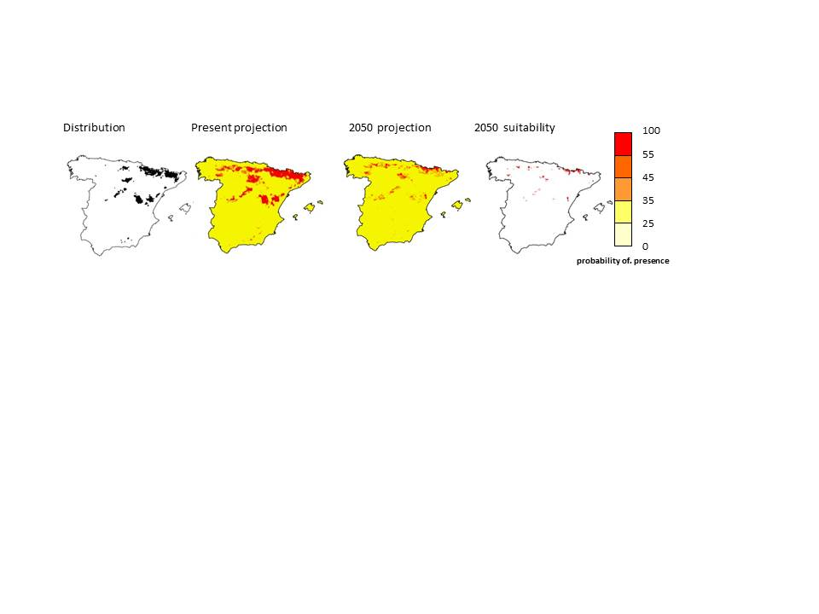

**Table S7.** Change in the predicted area occupied by the different models: niche models, all provenances models, and models per provenance for present conditions and 2050 scenario. The first and the second columns show the area occupancy as predicted by the model for the present and 2050. The last column indicates the percentage of occupancy reduction in 2050 predictions compared with the present conditions.

|  |  |  |  |
| --- | --- | --- | --- |
| **Model** | **Present (Km2)** | **2050 (Km2)** | **% reduced** |
| **All provenances** | 84407.96 | 50698.81 | 39.94 |
| **Gudar** | 18157.37 | 11249.51 | 38.04 |
| **Castel** | 16282.74 | 10028.19 | 38.41 |
| **Navafria** | 64704.99 | 49577.88 | 23.38 |
| **Valsain** | 67144.39 | 55475.68 | 17.38 |
| **Niche Model** | 30861.03 | 2894.07 | 90.62 |