Do nested, asymmetric network characteristics make mutualistic communities more evolutionarily stable?

Andria K. Salasª and Stuart R. Borrett^{b}

ªCorresponding author
601 S. College Road
Center for Marine Science and Dept. of Biology and Marine Biology
University of North Carolina Wilmington
Wilmington, NC 28403
616.334.4864
aks2515@gmail.com

^{b}601 S. College Road
Dept. of Biology and Marine Biology and Center for Marine Science
University of North Carolina Wilmington
Wilmington, NC 28403
901.962.2411
borretts@uncw.edu

Summary

Mutualistic communities, in which interactions between mutualists are reliant on complementary traits, have characteristic interaction patterns of nestedness and asymmetric dependencies. These patterns are hypothesized to affect the evolution of the species within these communities. We tested this hypothesis using a general individual-based model simulating species evolution within mutualistic communities. Experiments investigated the community-wide effects of a source of novel selection, here a species invasion, affecting a single species in a nested, asymmetric network versus a random, symmetric network. We hypothesized that the nested, asymmetric networks would show greater evolutionary stability, measured by the maintenance of trait complementarity and preservation of the initial equilibrium trait value, than the randomly connected networks with symmetric interactions, and this stability will depend on the network position of the species first targeted and the strength of the novel selection. The results show no evolutionary stability advantages of nested, asymmetric networks. The community fragments, or loses community-wide trait complementarity, when a specialist is targeted, but the remainder of the native community remains stable; the degree and duration of the fragmentation increases as selection strength increases until it is permanent at the highest level. When a generalist is targeted there is no fragmentation, although there is a quantitative shift in equilibrium mean trait values. This work suggests that evolutionary stability is conferred by all species being connected via indirect pathways, rather than the pattern of interactions.

eywords: mutualistic networks, diffuse selection, indirect effects, complex networks, , community ecology, coevolution, nestedness, plant-pollinator, asymmetries. (Do I need these? I don’t see on the okios website that I do, but that seems strange to not have keywords. Maybe you put them in during submission.)

1 Introduction

The stripes of a zebra or the hexagonal structure of a beehive are natural patterns with specific functions. A herd of zebra stripes is visually confusing to predators, and the hexagon makes for efficient use of space and resources. Other natural patterns with functions may be less obvious and require mapping species interactions (Lewinsohn and Prado 2006). Here we consider mutualistic communities, which are structured with two species guilds (e.g. plants and pollinators) with members of one guild interacting with species of the opposite guild (Bascompte et al. 2003). These communities often display a nested interaction pattern formed when specialists tend to interact with generalists (Fig. 1a; Bascompte et al. 2003; Jordano et al 2003; 2006; Joppa et al. 2010). These mutualistic networks also tend to have asymmetric dependencies between partners (hereafter asymmetry; Jordano 1987; Vazquez and Aizen 2004). Nestedness and asymmetry have been found in a diverse array of systems, from plant-pollinator to marine cleaning mutualisms (Bascompte et al. 2003; Guimarães et al. 2006; 2007; Ollerton et al. 2007), and are also suggested to aid in ecological stability as they increase species persistence and biodiversity (Jordano et al 2006; Bascompte et al 2006; Fortuna and Bascompte 2006; Burgos et al. 2007; Okuyama and Holland 2008; Bastolla et al. 2009; Thébault and Fontaine 2010; Piazzon et al. 2011). Thompson (2005) hypothesized that these interactions are mediated by a core set of complementary traits that serve as an evolutionary stable strategy. However, little is known about how nestedness and asymmetry influence the evolutionary stability of these traits against novel selection that could potentially disrupt the mutualism.
Novel selection or altered gene flow to one or more species could have evolutionary consequences for the entire network. For example, terrestrial communities such as pollination and seed dispersal networks are susceptible to habitat fragmentation (Young et al. 1996; Williams et al. 2003), and marine mutualistic communities can undergo changes in larval dispersal due to climate change or reserve design (O’Conner et al. 2007; Planes et al. 2009). These disturbances can modify or reduce gene flow, potentially causing local mismatches (Nuismer et al. 1999; Lenormand 2002) or increased genetic drift (Ellstrand and Elam 1992) for one or more species in the network. Climate change also can alter terrestrial communities by changing the phenologies of plants and pollinators; the resulting asynchrony can have severe consequences for the mutualistic interactions (Olesen et al. 2002; Memmott et al. 2007; Hegland et al. 2009), potentially changing selection on the mediating trait in the affected species.
Mutualistic networks tend to be highly susceptible to the introduction of non-native species because the core sets of traits that mediate the interaction are similar worldwide (Thompson 2005). For example, invasive species have successfully joined plant-pollinator networks (Olesen et al. 2002; Memmott and Waser 2002; Traveset and Richardson 2006; Morales and Aizen 2006; Lopezaraiza-Mikel et al. 2007; Padrón et al. 2009). Invasion is typically mediated by a native generalist species (Lopezaraiza-Mikel et al. 2007; Aizen et al. 2008; Padrón et al. 2009; Díaz-Castelzo et al. 2010), and can also be facilitated by invader traits such as conspicuous flowers (Bartomeus et al. 2008), longer flowering period (Memmott and Waser 2002), and competitive ability (Traveset and Richardson 2006; Morales and Traveset 2009). Furthermore, the influence of an invader on the community can be strong relative to native species (Aizen et al. 2008; Bartomeus et al. 2008; Morales and Traveset 2009) and can negatively influence the fitness of natives (Lopezaraiza-Mikel et al. 2007; Morales and Traveset 2009). If a source of novel selection, here termed a disturbance, such as changes in gene flow or community composition alter selection for the trait that mediates the mutualistic interaction in even a single species, partners reliant on this species could also be affected if the novel selection propagates through the network (Guimarães et al. 2007).
The likelihood that additional species will be affected depends on community context, which can influence selection on and the evolutionary trajectory of the species within the community (Thompson 1994; 2005; Siepielski and Benkman 2004; Johnson and Stinchcombe 2007). For example, diffuse selection occurs when the relative fitness associated with a species’ trait, and thus selection on that trait, is dependent on community composition (Strauss et al. 2005). Community genetics (I am not sure I agree with Alisons critique in regards to my use of this concept. Yes, my results suggest that a species may not always have that kind of influence, but this is the introduction and the concept still applies…a whole community can be affected by the influence of one, so proof that it is important to look at community context and that selection can propagate) considers the extended phenotype (Whitham et al. 2003) and interspecific indirect genetic effects (Shuster et al. 2006), both of which suggest that a species’ genes can have effects beyond its population, influencing other species and the community (). Both Whitham et al. (2003) and Shuster et al. (2006) describe situations in which selection on arthropods is dependent on the genetic composition of their host tree species, which in one study further determined selection on the parasatoids of an insect species (Whitham et al. 2003). Thus, genetically based interactions provide pathways for selection to cascade through a network of species (Guimarães et al. 2007; Murúa et al. 2010).
The pattern of connections within the network may strongly influence if, and to what degree, such cascades occur (Guimarães et al. 2007). The pattern of nestedness and asymmetry that are characteristic of mutualistic communities are hypothesized to influence the evolution of the component species (Bascompte et al. 2003; Jordano et al. 2003; Guimarães et al. 2007; Vazquez and Aizen 2003). All species are closely connected, as shown by short average path length in Olesen et al. (2006) for pollination networks and the absence of isolated subwebs in Guimarães et al. (2007) for ant-plant networks. This connectivity provides direct and indirect pathways for selection to propagate (Guimarães et al. 2007), potentially enabling concurrent evolution of the traits that mediate the mutualistic interaction. Thus, a function of the nested architecture and asymmetry in mutualistic communities may also include an evolutionary role.This may include stabilization of the mutualistic interaction by maintaining trait complementarity in the face of novel selection that may threaten trait matching.. However, this stability mechanism may depend on the relative strength of the novel selection and the network position (or say “generality” instead?) of the species initially affected.
In this work, we tested the hypothesis that nestedness and asymmetry provide mutualistic networks greater evolutionary stability than randomly connected mutualistic communities. We considered this stability with respect to maintenance of trait complementarity and the community’s initial equilibrium trait value after the introduction of a disturbance.We posited that the network connectivity provides pathways for the distribution of selection that allows species within a mutualistic community to adapt to novel selection even if the selection is initially only experienced by one species, thereby maintaining trait complementarity We hypothesize the nested asymmetric architecture makes the community more resistant and resilient to these perturbations. We also tested the auxillary hypotheses that (2) the community will be more stable when a disturbance directly impacts a specialist rather than a generalist species, and (3) the evolutionary stability of the network decreases as the strength of the novel selection increases.

2 Methods and Materials
To test these hypotheses, we constructed an individually-based evolutionary model on bi-partite networks that represents a community of two guilds whose species interact mutualistically with species of the opposite guild. After an initialization period, the community reached an equilibrium mean trait value due to selection for trait matching. For these experiments, a change in community composition was implemented by introducing a non-native species to investigate the stability of the equilibrium. Here, we introduce the general model, followed by discussion of its use in the experimental design. Appendix 1) summarizes the symbols and parameter values used in the model.
2.1 Model Description
We constructed a general individually-based model to model the evolution of species in a community composed of two mutualistically interacting guilds. This multi-species guild perspective is critical in understanding the dynamics in mutualistic networks (Stanton 2003). There were v species in each guild and z individuals in each species. Each individual has a quantitative trait value T (0 ≤ T ≤ ∞) representing the trait mediating the mutualistic associations (as in Nuismer and Doebeli 2004). It was assumed that some combination of genetic loci combine to produce this phenotypic trait (as in Whitham et al. 2003). To initiate the model these trait values were picked at random from a normal distribution with defined mean and standard deviation.
Simulation time was measured in discrete model time steps. In each time step the relative fitness of each individual was assessed and then both reproduction and death events occurred. First, relative fitness was determined for all individuals based on the degree of phenotypic (trait value) matching with their mutualistic partners. This model assumes that greater matching, or trait complementarity, confers greater fitness (e.g. Nuismer and Doebeli 2004). All individuals in species k were randomly assigned P individual partners from each partner species. The total number of mutualistic species interacting with species k is M_{k} and ranges from 1 to v connections, depending on the generality of species k. Thus, the more general the species the more individual partners with which an individual of that species interacts (Vazquez and Aizen 2003). The sum of the distance between the trait values (T) for each individual i of species k and its individual partners was determined and multiplied by the dependency (d) of species k. From this the carrying capacity of the guild to which i belongs was subtracted to account for intraguild competition. Carrying capacity was defined as the sum of individuals in each guild (g) multiplied by the scaling parameter K. The term g was equal to the number of individuals in each species multiplied by the number of species in the guild (zv) until the new species was introduced, after which it was z(v + 1) for the guild of the invader. Combining these elements, the fitness (w) for each individual i of species k was calculated as:

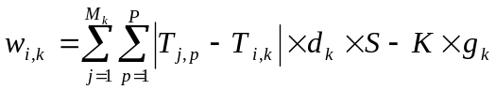. eqn 1
S scales the relative selection of a species on its partner species and was used to change the relative influence of the non-native species compared to the native species (here Alison suggests discussing the potential traits of the invader i.e. being more specific…but I can’t really do this, b/c the model is so general! If I say “bigger flowers” then it makes the model plant-pollinator, etc, and I want to keep it general). If the interaction was between natives or when the non-native had strength equivalent to the natives, S = 1. We then calculated relative fitness (r) for each individual i of species k by:
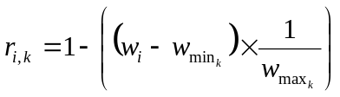 , eqn 2
where 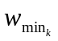is the minimum fitness value found in species k and 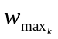 is the maximum fitness value found in species k.
For reproduction, two individuals from each species were chosen with a probability determined by their relative fitness to have a chance to sexually reproduce (as in Nuismer and Doebeli 2004). An offspring was produced that was defined by a trait value that was the mean of the parent’s trait values, with μ added or subtracted (randomly selected) to represent the per-generation rate of new genetic variation arising from mutation and recombination. We combined the sources of variation here for simplicity as the mechanism in which variation is introduced does not contribute to the investigation of the hypotheses. (This sentence seems random, but Alison thought it was weird that we lumped the two…). The second event in each time step is death; an individual from each species is randomly chosen to die. These processes of reproduction and death maintains constant population sizes for all species.
After model initialization, the system was run to Equilibrium 1, defined by a change in the mean trait value (MTV) less than the threshold of 0.001 for all species over 2500 time steps. We chose this threshold because it was a compromise between trait matching and computation time. The community mean trait value (CMTV) is the average of the MTV of all species and represents the quantitative equilibrium for that community. When Equilibrium 1 was reached, novel selection was introduced to the community in the form of an non-native species whose initial mean trait value was q greater than the CMTV at Equilibrium 1 (CMTV₁). The standard deviation of the initial non-native trait values was equal to the standard deviation of the native species trait values at Equilibrium 1. We observed that model behavior differs depending on the relative amount of “genetic diversity”, or standard deviation of the species’ trait values, of the non-native versus the native species.
In these simulations, the non-native species was always a specialist that interacted with either a native generalist or specialist species (the target) in the opposite guild. Equilibrium 2 was reached when all species met the equilibrium condition previously defined; CMTV₂ is defined at Equilibrium 2. Simulations stopped when equlibrium 2 was achieved.

2.2 Experimental Design
We used the general model discussed above to address our hypotheses as follows. For all experiments, there were sixteen species in each guild and each species had 100 individuals (v = 16 and z = 100). Further, all native species were initiated with a mean trait value of 0.5 (± 0.12 SD). Each individual interacted with P = 10 individual partners from each partner species, and genetic variability added to the offspring (μ) was ± 2x10⁻⁴. Lastly, because the model was developed to be general, it includes the terms representing carrying capacity as a density dependent mechansim to control the population growth rate. However, population size was assumed to be constant and the carrying capacity was not necessary, therefore it was effictivley removed by setting K = 1x10⁻⁶. In general, we selected parameter values that wouldreduce computation time.
To test the hypotheses, three independent factors were manipulated. Factor 1 (hypothesis 1) was network structure and the relationship in mutual dependencies. The network either had a nested structure witih asymmetric dependencies (herafter “nested”) or a random structure with symmetric dependencies (hereafter “random”; see Appendix 2 for details on network construction). To test the realism of the pattern of the dependency values we used the concept of species strength from Bascompte et al. (2006). Species strength is calculated for a species by summing the dependencies of all species that interact with the focal species. Bascompte et al. (2006) found for empirical networks that species strength increases faster than connectance. Factor 2 (hypothesis 2) was the non-native species interacting with a specialist (toS) versus a generalist (toG). Specialists were defined as having 1 partner species and generalists as having 16 partner species. Factor 3 (hypothesis 3) was strength of the non-nativewith S = 1, 2, or 10 relative to the native species. Together this generates 12 experiments, which required 1000 simulations for a represenative response (see Appendix 3). These were implimented in MATLAB© run on the NSF TeraGrid at Cornell University. The experimental results were analyzed using a randomization test with 10000 replicates.
The experimental response variables were measures of stability; we considered both resistance, staying unchanged despite a disturbance, and resilience, returning back to the original state after a disturbance (Grimm and Wissel 1997). In addition, individual fitness is gained by trait complementarity (Thompson 2005); thus the actual value of the trait is less important than it matching the complementary trait of its mutualistic partner(s). Therefore, the equilibrium may change in value, but not function. Here we made this distinction between a quantitative (value of trait) versus a qualitative (trait matching) change in equilibrium.
First, we investigated the qualitative resistance of the community’s equilibrium using the standard deviation of the species trait values. Standard deviations less than 0.001 after the invasion event indicated stability of trait matching. The change in the species’ trait values at equilibrium, or ∆CMTV = |CMTV₂–CMTV₁| was used as a quantitative measure of resistance. A meaningful shift is defined as ∆CMTV greater than 0.001, and for each experiment the mean ∆CMTV is presented with variability measured by standard deviation (σ). We also measured the resistance of each individual species to deviation from equilibrium. After the non-native is introduced, any ΔMTV greater than 0.001 relative to that species MTV at Equilibrium 1 is considered significant and that species is termed a deviant. Thus, species can be deviants even if they maintain trait matching with their partners as the term is used for any species that deviates from their initial equilibrium value; it is possible for all species to deviate in unison and thus maintain trait matching. For deviants, we determined the mode response of the number of deviants, with variability (υ) measured by the mean of the non-zero absolute deviations from the mode. Lastly, as a measure of resilience we defined Time to Equilibrium (Teq) as the time from when the non-native is introduced until Equilibrium 2 is reached. We also compared the entire community (native plusthe non-native species) to the native community without the target to investigate the impact of the selection on the species that do not directly interact with thenon-native.
3 Results
3.1 Species Strength
We first assessed the realism of the assymmetry values. As expected, species strength increases faster than species connectance in nested networks (Fig. 1c), while this relationship is linear in randomly assembled networks (r² =1; Fig. 1d). A quadratic curve fits the relationship in the nested networks (mean r²=0.90 for the 1000 nested communities). The quadratic AIC is 3.7 versus the linear AIC of 21.8. The relationship for the random networks is linear (r² =1; Fig. 1d).
3.2 Factor 1: Nested versus Random Networks
Our primary hypothesis was that the equilibrium in nested networks would be more stable, as determined by the maintenance of trait complementarity and initial equilibrium trait value, to a source of novel selection than random networks. However, the results show no difference between the nested and random experiments, as they produced the same qualitative and often the same quantitative results (Table 1) in response to the specific perturbation introduced in these experiments.
3.3 Factors 2 and 3: Attachment to a Specialist versus Generalist and non-nativeStrength
Since there is no difference between nested and random experiments, the following results are not presented specific to factor 1. If two values are given, the first is for the nested experiment and the second is for the random experiment; otherwise a single value denotes it is approximately the same for both. The significance of a randomization test comparing toS vs. toG varies depending on strength (Table 1), and results comparing invasive species strength were always highly significant (p < 0.001). As such, results are presented specific for target species type (hypothesis 2) and non-native strength (hypothesis 3).
3.3.1 Attachment to a Specialist
When the non-native attached to a specialist, the native community, not including the target, maintains phenotypic matching from its onset at Equilibrium 1 through the end of the simulation, as the mean standard deviation of the MTV for these species is less than 0.001. This is true for all relative non-native strengths. Thus, the native community, not including the target, is qualitatively resistant to the disturbance of the non-native species. The whole community, however, is not qualitatively resistant at any strength level because of the fragmentation of the target. Teq for the invader and community increases from S = 1 to S = 2, but is at its lowest at S = 10, and Teq for the non-nativeis always greater than for the community (data not shown).
When the strength of the non-nativeis equal to that of the native species (S = 1), the target species deviates from the rest of the community by an average ΔMTV = 2.5x10⁻³ (σ = 5.3x10⁻³ and 5.2x10⁻³) but rejoins the community with the approach of the non-native to the native community’s equilibrium trait value (Fig. 2a), thus showing resilience. In the majority of the runs (588 and 571 out of 1000; Fig. 3a) this is the only deviant; however, in the remainder of the runs some number of less significant deviants occurs (υ = 20.6 and 20.4; Fig. 3a). The average deviation of the native species minus the target is 8.2x10⁻⁴ (σ = 2.5x10⁻⁴ and 2.4x10⁻⁴); therefore, the remainder of the deviants experiences a shift just over the threshold of 0.001. The ΔCMTV is 0.00071 (σ = 2.7x10⁻⁴; Fig. 3b), or less than 1%, for both the community and natives minus target, which is less than the threshold of 0.001. Thus the native community is quantitatively resistant to the disturbance of the change in species composition.
When the strength of the non-native is double that of the native species (S = 2), the target species deviates from the rest of the community by an average ΔMTV = 4.6x10⁻² (σ = 7.3x10⁻⁴ and 7.4x10⁻⁴) but again shows resilience when it rejoins the native community with the approach of the non-native (Fig. 2b). In addition to this major deviant, there are also in the majority of runs (858 and 863 out of 1000) 31 additional deviants (υ = 19.2 and 18.1; Fig. 3a). The average deviation of the native species minus the target is 1.4x10⁻³ (σ = 3.4x10⁻⁴ and 3.3x10⁻⁴). The ΔCMTV is 1.3x10⁻³ (σ = 2.8x10⁻⁴ and 2.7x10⁻⁴; Fig. 3b), or less than 1%, for both the community and natives minus target, which is greater than the 0.001 threshold. Thus, we see that the native community is not quantitatively resistant to the disturbance.
For S = 10, or when the strength of the non-native is 10 times that of the evolutionary influence of a native species, the native community permanently fragments (Fig. 2c). The target species is pulled away from its native partners and reaches equilibrium with the non-native, who never matches the native community (Fig. 2c); therefore the target shows no resilience. In the majority of the runs (963 and 983 out of 1000) the target is the only deviant; however, in the remaining cases there are additional species deviations (υ = 8.7 and 7.9; Fig. 3a). These are minimal given the average deviation of the native community minus the target is 5.0x10⁻⁴ (σ = 1.8x10⁻⁴ and 1.6x10⁻⁴). The ΔCMTV is 3.3x10⁻³ (σ = 2.0x10⁻⁴; Fig. 2b); however, the ΔMTV for the native community minus target is 4.1x10⁻⁴ and 4.0x10⁻⁴ (σ = 2.2x10⁻⁴ and 2.0x10⁻⁴; Fig. 2b), or less than 1%, which is below the threshold. Therefore, we see that the native community, not including the target, shows the highest degree of quantitative resistance when the strength of the non-native is at its maximum. However, the community as a whole shows the least stability since it permanently fragments; one portion equilibrates at the initial equilibrium value and two species equilibriate at another.
3.3.2 Attachment to a Generalist
When the targeted species is a generalist, there is no longer a distinction between one major and several lesser deviants, and the non-native always converges with the native community (Fig.s 2d-2f). Further, the ΔCMTV is equivalent to the ΔMTV for the native community minus the target (Fig. 3e). For all strength values the entire native community maintains phenotypic matching from Equilibrium 1 through the end of the simulation, as the standard deviation of these species MTV is less than 0.001. Thus, the entire native community is qualitatively resistant to the disturbance regardless of the relative strength of the non-native species. Teq for the community increases with increasing S, and Teq for the invader decreases slightly with increasing S; Teq for the non-native is always greater than for the community (data not shown).
When S = 1 there are no deviants in over half of the runs (598 and 595 out of 1000; υ = 21.7 and 20.2; Fig. 3d). The degree of deviation when deviants do occur is minor given the average deviation of the natives minus target of 8.1x10⁻⁴ and 8.2x10⁻⁴ (σ = 2.5x10⁻⁴ and 2.4x10⁻⁴). The ΔCMTV = 6.9x10⁻⁴ and 7.0x10⁻⁴ (σ = 2.8x10⁻⁴ and 2.6x10⁻⁴; Fig. 3e), or less than 1%, which is below the threshold. Thus, the stable strategy of the community is quantitatively resistant to the disturbance.
When the strength of the non-native increases to S = 2, the number of deviants increases to 32 in the majority of the runs (934 and 955 out of 1000; υ = 15.6 and 11.4; Fig. 3d). The average deviation of the natives minus target is 0.0015 (σ = 2.8x10⁻⁴ and 2.5x10⁻⁴) and the ΔCMTV = 1.4x10⁻³ (σ = 2.9x10⁻⁴ and 2.6x10⁻⁴; Fig. 3e), or less than 1%.
Finally, when non-native strength is 10 times that of a native species (S = 10), there are 32 deviants in all runs (Fig. 3d). The average amount of deviation for natives minus the target is 6.6x10⁻³ (σ = 2.5x10⁻⁴ and 2.4x10⁻⁴) and ΔCMTV = 6.7x10⁻³ (σ = 2.7x10⁻⁴ and 2.6x10⁻⁴; Fig. 3e), or 1.3%. In conclusion, at the two highest strength levels, ΔCMTV is over the threshold of 0.001, indicating that the native community is not quantitatively resistant to the disturbance.

4 Discussion
We used a general individual based model to investigate the hypothesis that the common characteristics of mutualistic communities, nested and asymmetric pattern of community interactions, influence the evolution of member species (Bascompte et al. 2003; Jordano et al. 2003). Our focal hypothesis was that, compared to random networks, the evolutionary trait equilibrium in nested networks would have greater stability when a source of novel selection was introduced to a species in the network. In addition, we tested the hypotheses that the stability of the network does not depend on the generality of the species that first experiences the novel selection, and that stability will decrease as the strength of the novel selection increases. Contrary to the first hypothesis, the evidence suggests that the patterns of species interactions and dependencies together do not influence the evolution of species in a mutualistic community. However, there may be aspects of evolutionary stability conferred by the characteristics of mutualistic networks that are unexplored in this study. Furthermore, we found that the evolutionary stability of the network depends on the generality of the species the novel selection first influences, contrary to our second hypothesis. In toS experiments, the community fragments into two components, while in toG experiments the community trait equilibrium is qualitatively maintained. The duration and permanence of the fragmentation in the toS invasions, and the degree to which there is a quantitative shift in the equilibrium, is dependent on the strength of the novel selection, supporting the third hypothesis.
4.1 Characteristics of Nestedness and Asymmetry Do Not Influence Coevolution
The results suggest that the common characteristics of nestedness and asymmetric species dependencies do not differentially affect the coevolution of the species within these communities. We argue that, despite not having direct evidence, coevolution is occurring in these models because reciprocal feedbacks are necessary for a community to reach and maintain equilibrium in this model. Selection is driving the species to minimize the phenotypic distances between each individual and its partners, thus causing each species to evolve in response to each of its partner species. Hence, the reciprocity necessary for coevolution (Janzen 1980) is present. We also argue that the results do not support the hypothesis, despite the 10 (of 36) statistically significant differences (Table 1). First, we are most interested in the evolutionary interpretation of the results, and Fig. 3 clearly shows there is no difference in evolution in nested and random experiments. Second, the large sample size of 1000 runs for each experiment tends to inflate the differences that can be detected by formal statistical tests.
These finding are contrary to the predicted evolutionary influence of the nested, asymmetric characteristics of mutualistic communities, which suggests these patterns have important implications for coevolution (Bascompte et al. 2003; Jordano et al. 2006) While there could be evolutionary consequences of nestedness unexplored in this study, we did not find that evolutionary stability is unique to nested networks. In a study similar to this work, Guimarães et al. (2007) used a simulation model to investigate selection propagation in empirically-based nested ant-plant networks and their random counterparts. The authors found there is a small possibility that many species could be affected by a change to a single species in nested networks, but these networks are less likely to allow coevolutionary changes than random networks, opposite of what was found in our study. Comparisons of these studies are difficult given the many differences between them, but we argue our model is better suited to address the question given our more realistic treatment of the evolutionary process. Specifically, we model the change in trait frequency in species over time in response to selection, while the model in Guimarães et al. (2007) uses the probability of a species as a unit instantaneously adapting to the novel selection depending on its generality.
While we do not show a difference in coevolutionary dynamics between nested and random networks, both network types do exhibit characteristics that are predicted in the literature for nested communities. These are 1) the core of generalist species drives the evolutionary dynamics in the network, and 2) the coevolutionary process in mutualistic networks lies between pair-wise and diffuse evolution (Bascompte et al. 2003; Jordano et al. 2003). The results reflect the former, as the largest ΔCMTV is seen when the non-native attaches to a generalist (Fig. 3b versus Fig. 3e for S = 2 and S = 10). The results also support the second prediction. Most species have more than one mutualistic partner, and the individuals of those species reproduction is dependent on their phenotypic distances. Therefore, selection is from and adaptation is to each partner species, rather than a diffuse evolution perspective (Janzen 1980; Thompson 2005, but see Strauss et al. 2005) that would suggest adaptation is to the partners as a group and not specific species. Similarly, the presence of selection from multiple partners over both direct and indirect pathways negates pair-wise coevolution. Again, these dynamics are in both the nested and random networks, suggesting that the pattern of interactions and dependencies are less important than that the species are well connected.
4.2 Stability is Dependent on the Placement and Strength of the Novel Selection
The results show that the stability of the community is dependent on the network position of the species to which the non-nativedirectly interacts, and the selection strength of the non-native relative to the native species. In toS experiments, community fragmentation is always seen (Fig. 2a,b,c). The MTV of the specialist deviates from the community equilibrium for approximately the length of time it takes for the non-native to converge (Fig. 2a,b, Fig. 3c) when S = 1 and S = 2. Thus, the specialist is resiliant as it does eventually rejoin the community. However, this resiliance is lost when the strength is at its maximum, as we see permanent fragmentation of the specialist who reaches equilibrium with the non-native at a trait value greater than CMTV (Fig. 2c). Lewinsohn and Prado (2006) suggest that “hyperspecialized” associations can break away from the community, as we see occur here.
The remainder of the native community in toS experiments shows stability at all strength levels, as there is no further fragmentation. The equilibrium is both qualitatively and quantitatively resistant when S = 1 and S = 10 (Fig. 2b). In the majority of these runs the native community without target takes no time to reach equilibrium (median Teq = 0; data not shown), indicating that the CMTV remained unchanged. However, when S = 2, there is a quantitative change in the community’s equilibrium; therefore, the native community is qualitatively resistant as it maintains trait matching but not quantitatively resistant as it shifts to a new trait value. However, the latter is less significant as fitness is determined by trait matching. The event of a specialist non-native attaching to a native specialist may be unlikely, but invaders in pollination webs can be specialized (Olesen et al. 2002; Padrón et al. 2009; Díaz-Castelzo et al. 2010). We stress that our disturbance as a change in community composition is simply the source of selection chosen for this general model and specialists could be affected by other sources of selection (e.g. climate change) or changes in gene flow. In conclusion, when a specialist species experiences novel selection it fragments from the community, and the permanence of this fragmentation is dependent on selection strength. The remainder of the native community, however, is stable despite any quantitative shifts in its equilibrium trait value.
In toG experiments, the community is stable, or trait complentarity is maintained, as there is no fragmentation at any level of non-native strength (Fig. 2d,e,f). Thus, the equilibrium is qualitatively resistant at all levels, and quantitatively resistant at S = 1. Therefore, when a generalist experiences novel selection the entire native community is stable regardless of the strength of the selection, despite quantitative shifts in the equilibrium trait value.
4.3 Selection Propagation Provides Community Evolutionary Stability
The patterns described above are a result of selection propagation. As the strength of the non-native’s selection increases on the target, the target experiences a shift in its MTV towards the new species, and this change in turn produces selection on the partners of the target, which produces selection on the partners of these partners. Thus, evolution is dependent on community context (Whitham et al. 2003; Thompson 2005; Strauss et al. 2005). There is also a relatively instantaneous use of these indirect pathways since the entire native community (toG) and native community disregarding the target (toS) never fragment once equilibrium is established. If the use of these pathways took time to develop, we would expect to see fragmentation after the introduction of the new species, followed by a decline in the standard deviation in species MTV as selection was distributed.
The presence of these indirect pathways forms a strongly connected component (SCC) in these networks, which means that all species can be reached from each individual species over a pathway of some length. We argue this SCC provides the observed evolutionary stability. Connectivity is critical and the pattern of connectivity is less important in this instance. Further, we argue that species can be functionally removed from the SCC when the strength of the novel selection is very large relative to that from the native species. We hypothesize that this is the reason for the difference between toS and toG experiments when S = 10. The specialist is functionally removed from the community, and we see that the CMTV has the smallest shift of all experiments. However, the generalist is more embedded in the network, preventing its functional removal upon introduction of the disturbance and leading to the largest shift in CMTV. Thus, the observed stability of these mutualistic networks is a result of each species being connected to each other species via direct and indirect pathways. However, connections can be functionally removed if the selection from a disturbance is proportionately greater than the selection from the SCC.
This propagation of selection prevents the community from fragmenting and protects the community equilibrium. We would not expect the non-native to cause a large disruption to the native community given the unlikelihood of alternate “alleles” overcoming the fitness advantage of matching traits; therefore, the mutualism is relatively stable (Nuismer et al. 2000; Gomulkiewicz et al. 2003). The ability of selection propagation to maintain equilibrium of the community is dependent on species adapting on similar timescales and maintenance of community structure through time. First, in this model all species had identical rates of adaptation, however this is not always true in nature. For example, Hegland et al. (2009) discuss the temporal mismatches that occur between plants and pollinators due to differential responses to climate change.
Second, the temporal persistence of the direct and indirect pathways needs to be on a timescale equal or greater than the time for species evolution. Bascompte et al. (2006) state that the traits of mutualistic networks allow for the long-term persistence of these communities. Much of the work done looking at the persistence of community structure has been in regards to the effects of invasive species. Many of the characteristics of the networks are maintained in the presence of invasive species, such as nestedness (Díaz-Castelzo et al. 2010), connectance (Aizen et al. 2008; Padrón et al. 2009; Díaz-Castelzo et al. 2010), and linkages among natives (Padrón et al. 2009). However, Díaz-Castelazo et al. (2010) found that connectance changed through time as natives shifted from being peripheral to core species, and Aizen et al. (2008) found links shift from native-native interactions to native-invader. Regardless, we know that some aspects of community structure are maintained through time and this may be adequate for the mechanism of selection propagation to stabilize the interaction-mediating traits, particularly given the relative instantaneous use of the indirect pathways seen here.
4.4 Model Realism Reconsidered
The strength of our model lies in its generality and realistic evolutionary processes. However, we did make several simplifying assumptions that require further consideration. We assumed that all partners are equivalent, no partner choice, no cheaters, only mutualistic interactions, and the same adaptation rate for all species. In addition, we have constant population sizes; however, we made this choice under the assumption that partners are not limiting and populations are therefore controlled by some other aspect of their environment (Stanton 2003).
While our assumptions have reduced the realism of the model, we argue that we have realistically captured the nested structure (Appendix 2) and asymmetric dependencies. The latter is supported by the quadratic fit of strength versus connectance, which matches that found for empirical mutualistic networks (Bascompte et al. 2006). The connectance value is similar to values detected for similarly sized empirical networks. However, the value tends to the higher end of the range, and it would be interesting to use a lower connectance value. We argue though that connectance should not affect the qualitative results if all species are still connected in a SCC.
We argue the specific parameter values selected do not adversely affect the overall results of this study. A limited sensitivity analysis of the, dependency values, standard deviation of initial populations, number of partners, and genetic variation showed that the general model behavior does not change with ± 50% of the values used here. Additionally, the qualitative results of this study are a result of the relative fitnesses of the individuals in each species. The parameters of carrying capacity and dependency values will affect absolute but not relative fitness. The standard deviation of the initial populations only affects the time in which the first equilibrium is reached. The number of mutualistic partners will decrease absolute fitness because phenotypic distances will accumulate for more partners, but this will be the same for all individuals and therefore, again, we expect no change in relative fitness. Lastly, genetic variation influences the speed at which equilibriums are reached, but since it is the same for all species it will not affect relative fitness. Thus, we expect the qualitative results to be robust to the uncertainty in the parameter values.

5 Conclusions
Nestedness and asymmetry provide mutualistic communities a structure that is hypothesized to be a product of complementarity and convergence (Thompson 2005) and provides these networks with the function of ecological stability (see above). In this study, we find that these networks also display great evolutionary stability in that they are capable of maintaining equilibrium despite strong novel selection to the network. However, we show that this evolutionary stability is equally represented in randomly structured networks. We hypothesize that as long as all the species are connected via a network of indirect paths, phenotypic matching will be preserved by selection propagation. However, this ability will depend on these species having similar evolutionary rates and maintenance of the network structure. The persistence of diverse mutualistic communities through time despite strong perturbations such as invasive species and environmental change suggests that some mechanism providing evolutionary stability similar to that discussed here is at play.

6 Acknowledgments
AKS was supported by the James F. Merritt fellowship from the UNCW Center for Marine Science. This work was improved by constructive criticism by M. McCartney, D. McNamara, and A. Bennett.
References
Aizen, M.A.et al. 2008. Invasive mutualists erode native pollination webs. – PLoS Biology 6: 396–403.

Bartomeus, I. et al. 2008. Contrasting effects of invasive plants in plant pollinator networks. – Oecologia 155: 761–770.

Bascompte, J. et al. 2003. The nested assembly of plant-animal mutualistic networks. – Proc. Natl. Acad. Sci. USA 100: 9383–9387.

Bascompte, J. et al. 2006. Asymmetric coevolutionary networks facilitate biodiversity maintenance. – Science 312: 431– 433.

Bastolla, U. et al. 2009. The architecture of mutualistic networks minimizes competition and increases biodiversity. – Nature 458: 1018–1021.

Burgos, E. et al. 2007. Why nestedness in mutualistic networks? – J. Theor. Biol.: 249: 307–313.

Díaz-Castelzo, C. et al. 2010. Changes of a mutualistic network over time: reanalysis over a 10-year period. – Ecology 91: 793–801.

Ellstrand, N.C. and Elam, D.R. 1993. Population genetic consequences of small population size: implications for plant conservation. – Annu. Rev. Ecol. Syst. 24: 217–242.

Fortuna, M.A. and Bascompte, J. 2006. Habitat loss and the structure of plant-animal mutualistic networks. – Ecol. Lett. 9: 281–286.

Gomulkiewicz, R. et al. 2003. Coevolution in variable mutualisms. – Am. Nat. 162: S80–S93.

Grimm, V. and Wissel, C. 1997. Babel, or the ecological stability discussions: an inventory and analysis of terminology and a guide for avoiding confusion. – Oecologica 109: 323–334.

Guimarães, P.R. et al. 2006. The nested structure of marine cleaning symbiosis: is it like flowers and bees? – Biol. Lett. 22: 51–54.

Guimarães, P. R. et al. 2007. Interaction intimacy affects structure and coevolutionary dynamics in mutualistic networks. – Curr. Biol. 17: 1797–1803.

Hegland, S.J. et al. 2009. How does climate warming affect plant-pollinator interactions? – Ecol. Lett. 12: 184–195.

Janzen, D.H. 1980. When is it coevolution? – Evolution 34: 611–612.

Johnson, M.T.J. and Stinchcombe, J.R. 2007. An emerging synthesis between community ecology and evolutionary biology. – Trends Ecol. Evol. 22: 250–257.

Joppa, L.N. et al. 2010. On nestedness in ecological networks. – Evol. Ecol. Res. 12: 35–46.

Jordano, P. 1987. Patterns of mutualistic interactions in pollination and seed dispersal: connectance, dependence asymmetries, and coevolution. – Am. Nat. 129: 657–677.

Jordano, P. et al. 2003. Invariant properties in coevolutonary networks of plant-animal interactions. – Ecol. Lett. 6: 69–81.

Jordano, P. et al. 2006. The Ecological Consequences of Complex Topology and Nested Structure in Pollination Webs. – In: Waser, N.M. and Ollerton, J. (eds), Plant-Pollinator Interactions From Specialization To Generalization. University of Chicago Press, pp. 173–199.

Kiers, E.T. et al. 2010. Mutualisms in a changing world: an evolutionary perspective. – Ecol. Lett. 13: 1459–1474.

Lenormand, T. 2002. Gene flow and the limits to natural selection. – Trends Ecol. Evol. 17: 183–189.

Lewinsohn, T.M. and Prado, P.I. 2006. Structure in plant-animal interaction assemblages. – Oikos 113: 174–184.

Lopezaraiza-Mikel, M.E. et al. 2007. The impact of an alien plant on a native plant-pollinator network: an experimental approach. – Ecol. Lett. 10: 539–550.

Memmott, J. and Waser, N.M. 2002. Integration of alien plants into a native flower-pollinator visitation web. – Proc. R. Soc. Lond. B. 269: 2395–2399.

Memmott, J. et al. 2007. Global warming and the disruption of plant-pollinator interactions. – Ecol. Lett. 10: 710–717.

Morales, C.L. and Aizen, M.A. 2006. Invasive mutualism and the structure of plant-pollinator interactions in the temperate forests of north-west Patagonia, Argentina. – J. Ecol. 94: 171–180.

Morales, C.L. and Traveset, A. 2009. A meta-analysis of alien vs. native plants on pollinator visitation and reproductive success of co-flowering native plants. – Ecol. Lett. 12: 716–728.

Murúa, M. et al. 2010. Does human-induced habitat transformation modify pollinator-mediated selection? A case study in Viola portalesia (Violaceae). – Oecologia 163: 153–162.

Nuismer, S.L. and Doebeli, M. 2004. Genetic correlations and the coevolutionary dynamics of three-species systems. – Evolution 58: 1165–1177.

Nuismer, S.L. et al. 1999. Gene flow and geographically structured coevolution. – Proc. R. Soc. Lond. B 266: 605–609.

Nuismer, S.L. et al. 2000. Coevolutionary clines across selection mosaics. – Evolution 54: 1102–1115.

O’Conner, M.I. et al. 2007. Temperature control of larval dispersal and the implications for marine ecology, evolution, and conservation. – Proc. Natl. Acad. Sci. USA 104: 1266–1271.

Okuyama, T. and Holland, J.N. 2008. Network structural properties mediate the stability of mutualistic communities. – Ecol. Lett.Ecology Letters 11: 208–216.

Olesen, J.M. et al. 2006. The smallest of all worlds: Pollination networks. – J. Theor. Biol. 240: 270–276.

Olesen, J.M. et al. 2002. Invasion of pollination networks on oceanic islands: importance of invader complexes and endemic super generalists. – Div. Dist. 8: 181–192.

Ollerton, J. et al. 2007. Finding NEMO: nestedness engendered by mutualistic organization in anemonefish and their hosts. – Proc. R. Soc. Lond. B 274: 591–598.

Padrón, B. et al. 2009. Impact of alien plant invaders on pollination networks in two archipelagos. – PloS ONE 4: e6275.

Piazzon, M. et al. 2011. Are nested networks more robust to disturbance? A test using epiphyte-tree, comensalistic networks. – PloS ONE 6: e19637.

Planes, S. et al. 2009. Larval dispersal connects fish populations in a network of marine protected areas. – Proc. Natl. Acad. Sci. USA 106: 5693–5697.

Shuster, S.M. et al. 2006. Community heritability measures the evolutionary consequences of indirect genetic effects on community structure. – Evolution 60: 991–1003.

Siepielski, A.M. and Benkman, C.W. 2004. Interactions among moths, crossbills, squirrels, and lodgepole pine in a geographic selection mosaic. – Evolution 58: 95–101.

Stanton, M.L. 2003. Interacting guilds: moving beyond the pairwise perspective on mutualisms. – Am. Nat. 162: S10–S23.

Strauss, S.Y. et al. 2005. Toward a more trait-centered approach to diffuse (co)evolution. – New Phytol. 165: 81–90.

Thébault, E. and Fontaine, C. 2010. Stability of ecological communities and the architecture of mutualistic and trophic networks. – Science 329: 853–856.

Thompson, J.N. 1994. The Coevolutionary Process. – The University of Chicago Press.

Thompson, J.N. 2005. The Geographic Mosaic of Coevolution. – The University of Chicago Press.

Traveset, A., and Richardson, D.M. 2006. Biological invasions as disruptors of plant reproductive mutualisms. – Trends Ecol. Evol. 21: 208–216.

Vazquez, D.P. and Aizen, M.A. 2003. Null model analysis of specialization in plant-pollinator interactions. – Ecology 84: 2493–2501.

Vazquez, D.P. and Aizen, M.A. 2004. Asymmetric specialization: a pervasive feature of plant-pollinator interactions. – Ecology 85: 1251–1257.

Whitham, T.G. et al. 2003. Community and ecosystem genetics: a consequence of the extended phenotype. – Ecology 84: 559–573.

Williams, B.L. et al. 2003 Landscape scale genetic effects of habitat fragemetntion on a high gene flow species Speyeria idalia (Nymphalidae). – Mol. Ecol. 12: 11–20.

Young, A. et al. 1996 The population genetic consequences of habitat fragmentation for plants. – Trends Ecol. Evol. 11: 413–418.

Figure 1: Nested and random network characteristics. A) Graphical representation of a nested matrix and B) a random matrix. Each node represents a species, with black nodes representing Guild 1 and grey nodes Guild 2. Node height is proportional to the generality of the species, and a line connecting two nodes represents an interaction between species. C) Species strength versus species connectance, as in Bascompte et al. [12], for the nested, network represented in (A) and D) strength versus connectance relationship for the random network in (B). Note the quadratic fit in (C) compared to the linear fit in (D), illustrating that strength increases faster than connectance when dependencies are asymmetric.

Figure 2: Representative simulation behavior showing change in mean trait value over time. Each line is one of the 33 species, with the non-native and target species indicated. Non-native direct interaction with a specialist for A) S = 1, B) S = 2, and C) S = 10. Note that as strength increases, the degree and duration of the target’s deviation increases until permanent community fragmentation at the highest strength value. However, the remainder of the native community remains stable. Non-native direct interaction with aa generalist for D) S = 1, E) S = 2, and F) S = 10. Here no community fragmentation is seen, but at some strength values there is a quantitative shift in the community’s stable strategy. Response variables are illustrated in (B) and (F).

Figure 3: Three measures of evolutionary stability in nested (“N”) and random (“R”) network configurations. A) Number of deviants for attachment to a specialist, and D) attachment to a generalist. Bars indicate the mode for each experiment, and error bars are the mean of the non-zero absolute deviations from the mode. B) The change in mean trait value (MTV) for toS experiments, and (E) toG experiments. White bars represent the entire community (non-native included) and grey bars represent the native community without the target species. If no white bar is seen, the two are identical. Note it is not a stacked bar graph. Error bars represent one standard deviation and the horizontal line at y = 0.001 represents the threshold for a meaningful shift in MTV.

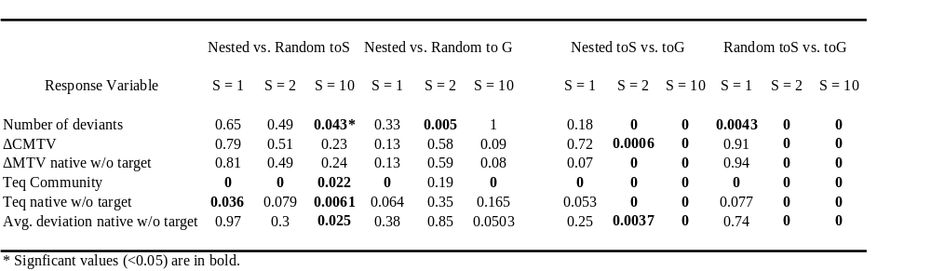
Table 1: p-values of randomization tests to investigate the significance of experimental treatments.

Figure 1

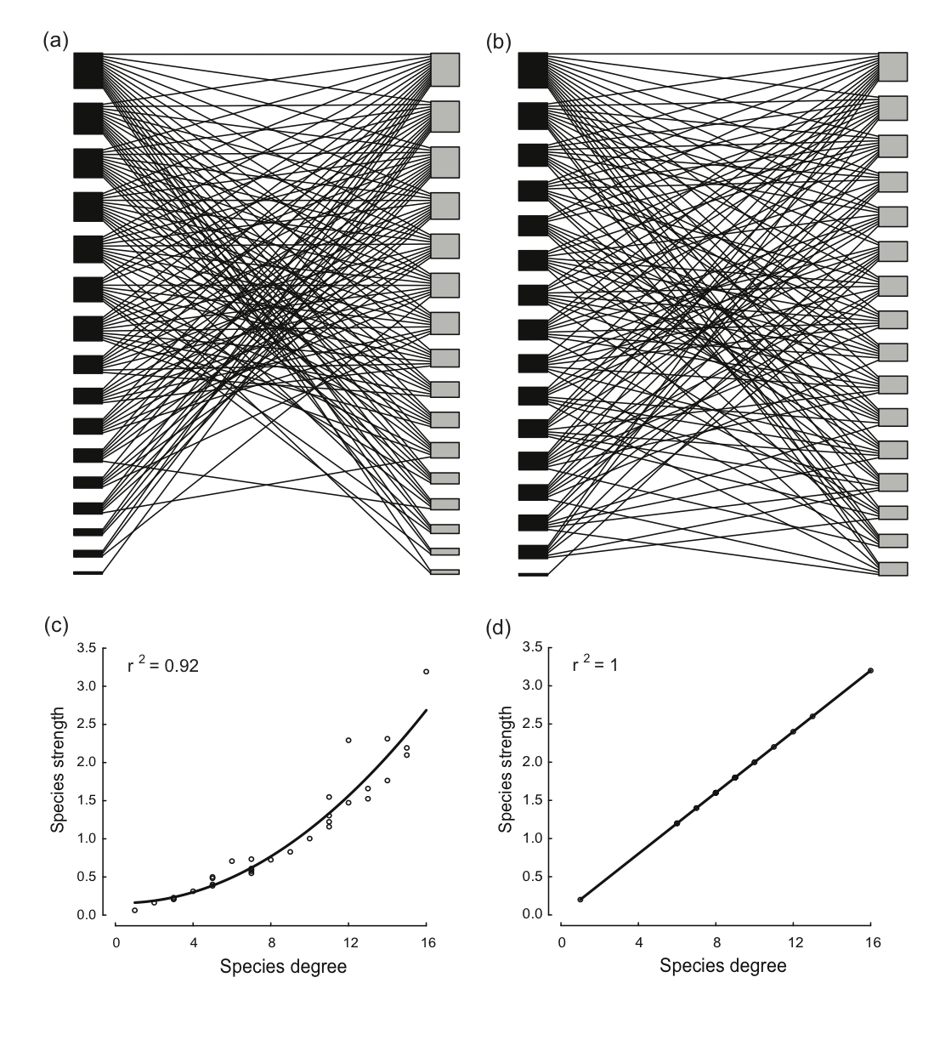

Figure 2
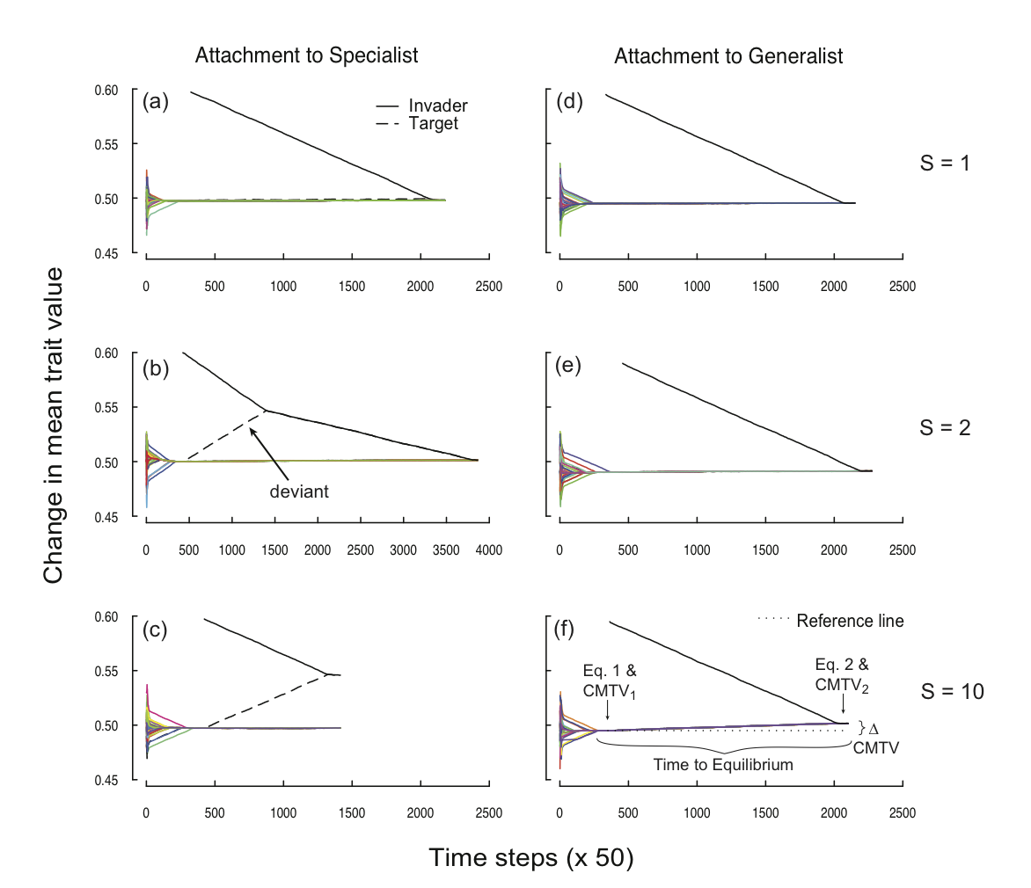

Figure 3

