**Genetic diversity creates nested, robust interaction networks**

M.K. Lau, Stuart, Shuster, Kim, Tom

Target: Ecography, PLoS Biology

* Genetic variation within foundation species is known to have profound effects at the community and ecosystem scales,
* Although the consequences of this variation are known to impact biological diversity across multiple spatial scales, the effect this variation has on the structure of ecological interaction networks has not been explored,
* In this study, first, we use a mass-action community simulation method to develop a framework for the contribution of genetic variation to interaction network structure, and, second, we test this framework using several empirical community datasets,
* We found two main results:

1. Simulations showed that co-occurrence patterns and network nestedness increased with genetically based variation in the foundation species
2. Genetic variation increases nestedness in low diversity communities (i.e. even abundances), while genetic variation decreases the effect of species dominance on nestedness in high diversity communities
3. Empirical genotype-species networks exhibited significant co-occurrence patterns and nestedness in line with simulations

* These results strongly suggest that nestedness naturally arises in communities via intraspecific genetic variation in foundation species, and because this variation is heritable provides a means for evolution to act on ecological interaction network structure via natural selection.

**Introduction**

Genetic variation within foundation species is known to have profound effects at the community and ecosystem scales,

Beyond purely ecological consequences of genetic variation, genetic correlation among individuals of different species has important implications for evolutionary dynamics. Kin selection, group selection and co-evolutionary theory all provide examples of how genetic correlations can be both manifested and selected on at levels higher than the individual and beyond the population.

Networks are important.

The field of ecological networks has demonstrated some ecological mechanisms for how indirect effects can influence community dynamics; however, none of these studies have included genetic variation, and thus, are limited in establishing how evolutionary mechanisms that are playing a role in structuring ecological networks.

Although the consequences of this variation are known to impact biological diversity across multiple spatial scales, the effect this variation has on the structure of ecological interaction networks has not been explored,

In this study, first, we use an established mass-action community simulation method to develop to simulate genotype-species interaction networks, and, second, we test this framework using several empirical community datasets. We hypothesize that the community compositional effects of foundation species genotype will contribute to interaction network structure. A genetic basis to ecological networks has important implications for understanding how evolutionary forces act to structure interactions among species in ecosystems.

**Methods**

*Simulations*

We used the community genetics simulation method previously developed in Shuster et al. 2006. Briefly, this method starts by creating a population of individuals assigned a genotypic value (i.e. genotypes). Each genotype is comprised of multiple individuals (i.e. clones), which are mapped to numerical phenotypic values. This population represents the foundation species. Next, a set of species representing the rest of the community is assigned an average genotypic value that is then also mapped to a numerical phenotypic value using an additive, bi-allelic genetic system. At each step of genotype-phenotype mapping variance is introduced through random draws from a uniform distribution, which simulates the introduction of phenotypic variance arising from non-genetically based “environmental” variation, including interactions among species in the community. It is important to note here that interactions among species beyond the foundation species’ effect on the community is not explicitly accounted for in this process but introduced as a contribution to non-genetic variation. Finally, the foundation species phenotypic values for each individual is used to determine the stable population value for each species in the community.

In an appendix, develop the use of permanova R2, inlcuding: 1) Calculation using Anderson's method, 2) Comparison to NMDS method in Shuster 2006

*Nestedness*

Measure nestedness and examine correlation between genetic variance and nestedness

*Selection Experiments*

Conduct Removal experiments (random vs targeted removal): 1) Random removal, 2) Genotype removal based on phenotpic similarity and 3) Centralized species removal

*Field Data*

Results

Discussion

Acknowledgments

References

Tables

Figures

Macintosh HD:Users:Aeolus:projects:dissertation:projects:een:results:FIG_genotype_species_network.pdf

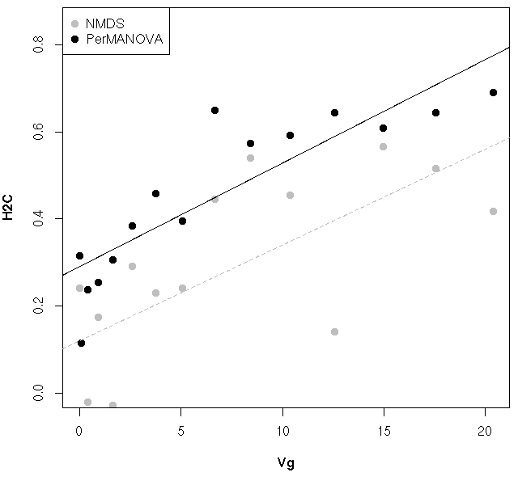

**Figure 1.** Scatterplot of the relationship between the true genotypic variance (Vg) and the two estimates of community heritability (H2C) using NMDS ordination and PerMANOVA

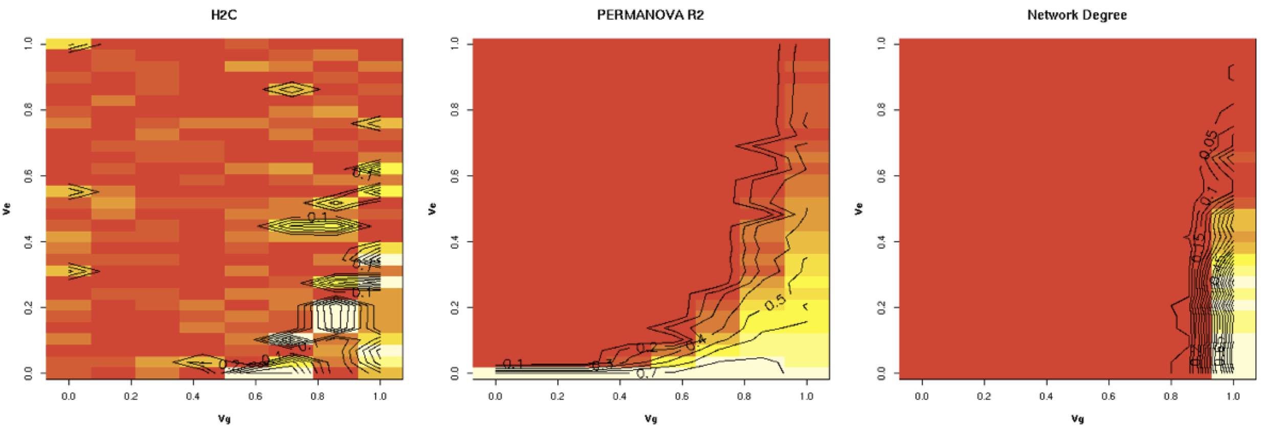

**Figure 2.** Heatmaps showing the relationships between H2C based on NMDS (left) and PerMANOVA (center) and the number of significant co-occurrence patterns (Network Degree; right) given both genetic variance of the foundation species (x-axis = Vg) and the environmental variance (y-axis = Ve).

[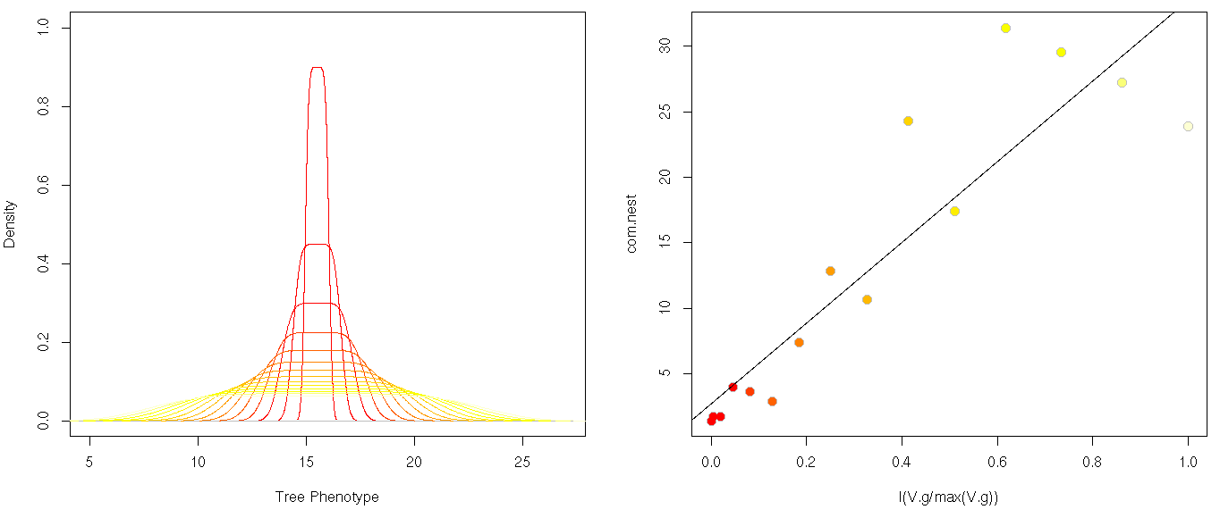](https://f.cloud.github.com/assets/5342857/1916311/c86eea6a-7d75-11e3-9af3-069c1797cb7f.png)

**B**

**A**

**Figure 3.** Plots of the (A) densities of tree phenotypic values at different levels of foundation species genetic variance (increasing from red-yellow) and (B) the relationship between the relativized foundation species genetic variance (increasing from red-yellow) and the nestedness of the interaction network (P <<< 0.001).

[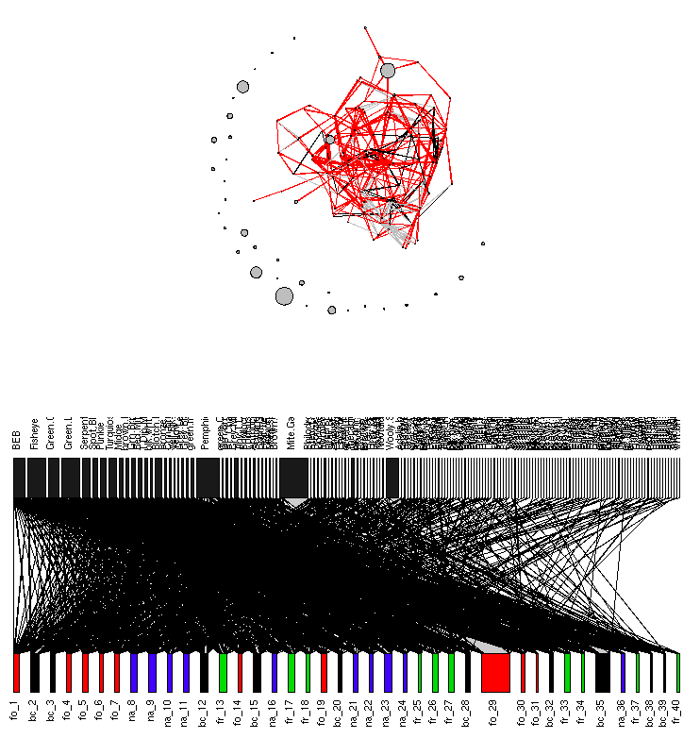](https://f.cloud.github.com/assets/5342857/1844868/e70e42f4-755a-11e3-858a-413b3fa2e4f3.png)

**Figure 4.** Networks for the Wimp et al. 2005 arthropod community dataset. The co-occurrence patterns based on the network modeling procedure of Araujo et al. 2011 (top) showing species as nodes (scaled by the log total abundance) connected by black edges (values less than 0.5), red edges (values less than 0.5) and grey edges (values equal to 0.5) and the bipartite tree-species network with nodes (upper = arthropod species, lower = tree individuals colored by cross-type) scaled by the total abundance and position (left-right) by the number of connections.