**Foundation species genotypic variation generates ecological network structure**

Biological evolution occurs in the context of complex networks of interacting species. Ecosystems are predicted to undergo both ecological and evolutionary changes in response to environmental change, such as shifting climate (Parmesan 2006). Understanding how evolutionary processes, such as natural selection, will affect the structure of ecological networks is essential for understanding ecosystem dynamics. However, no study has yet demonstrated a genetic basis to ecological network structure, which is the raw material that natural selection acts on. Here, we use both a long-term experimental common garden with genotyped individuals and a natural riparian forest of the foundation tree species, *Populus angustifolia*, to test how genetic variation contributes to the interaction network structure of a model community comprised of epiphytic lichens. We found three main results: 1) lichen communities showed significant unipartite (i.e., one mode) network structure that was similar between the common garden and natural stand, 2) genotype significantly influenced lichen species interactions within an individual tree also showing strong correlation with bark roughness, a genetically based trait known to influence bark lichen communities, and 3) bipartite (two mode) genotype-species networks, comprised of the foundation species and its associated lichen community, showed significant modular structure in both the common garden and natural stand. These results demonstrate strong support for a genetic basis to ecological network structure and the potential for selection to act in complex ecosystems. This work sets the stage for studies that address greater complexity in the evolution of biological systems and provides a framework for the discovery of evolutionarily dynamic compartments in ecosystems.

Genetic variation within species is known to be an important factor determining species interactions (e.g., Wimp et al. 2005, Crutsinger et al. 2006, Keith et al. 2010). Community genetics studies (Whitham barrage) have shown that genetic variation in foundation species (species that define a the composition of communities by creating locally stabile conditions and modulating resources; Ellison et al. 2005) contributes to variation in interactions with dependent communities in both terrestrial and aquatic ecosystems (Whitham, Barbour, Eel Grass, Bailey et al. 2009). These studies have primarily focused on direct interactions with a single species and have not explored more complex interactions beyond tri-trophic interactions (Smith et al. 2011). Network analysis of species interactions has produced significant advances in the understanding of both ecological dynamics; however, no studies have incorporated network approaches with genetic information, which is integral to the study of natural selection. As selection occurs in complex systems of many interacting species where indirect effects can play important roles (Bondavalli and Ulanowicz, Kaileen Mooney), a genetic basis of complex interaction networks would present a significant advance in our understanding of evolution in species rich ecosystems.

Here, we investigate how genetic variation in a foundation species (*Populus angustifolia*) determined the structure of interactions among species in a model community. We chose epiphytic lichen as our study system as previous research has demonstrated significant compositional responses to genotypic variation (Lamit et al. 2014), and because interactions among all species could be assessed rapidly in the field. Building on these findings, we found that genetic variation in a foundation tree species predictably influenced the structure of a complex, multi-species interaction network.

Figure 1. Significant unipartite network structure was observed for epiphytic lichens on trees of known genotype in a common garden (ONC = Ogden Nature Center, Utah, USA) (A) and individual trees in a natural stand (Uintah, Utah, USA) (B) of the foundation species, *Populus angustifolia*. Both networks are shown here with lichen species as nodes (see Methods for species names) scaled by the log of their total abundances and significant co-occurrence patterns between species shown as edges scaled by their log frequencies. The bivariate plot (C) shows the significant correlation in Eigen Centrality between the two networks. (D) The total abundance of lichen species was a significant driver of network structure for both networks.

Figure 2. Tree genotype influenced lichen co-occurrence patterns in the common garden. The barplot shows the lichen community C-Score Standardized Effect Size (SES) values for each genotype (mean ± 1SE) in order of decreasing SES. More negative SES values indicate more co-occurrences between species than expected by chance using a conservative null model that accounts for differences in both tree and lichen species totals.

Figure 4. Bipartite networks displayed significant modularity with modules comprised of both genotypes and species. The left most set of nodes shows tree genotypes (see Methods for genotype names) for the common garden (A) or individuals in the natural stand (B) connected to lichen species on the right. Both sets of nodes are scaled by their marginal totals (i.e., total observed individuals for tree nodes and total abundance for lichen species) and arranged by ascending totals from bottom to top. Node color shows the significant module membership for both trees and lichen species with module color having no direct relationship between the two networks, as modules were determined for each network independently.

We observed significant unipartite network structure (Araujo et al. 2011; Fig. 1a and b). The two networks were highly similar structurally (Mantel: r=0.51 p=0.029). Node centrality was highly correlated between networks (r = 0.7, t = 2.6135, df = 7, p = 0.035). Centrality was also highly correlated with total abundance for both networks (ONC: r = 0.77, t = 3.2427, df = 7, p = 0.014; Uintah: r = 0.86, t = 4.43, df = 7, p = 0.003). In the common garden, lichen co-occurrence patterns were greater than the null model expectation (obs = 26.33, SES = -6.31, p = 0.0002). Lichen in the natural stand were also more aggregated than the null modeled communities (obs = 1.08, SES = -3.15, p = 0.002).

Genotype contributed to network structure by influencing composition across trees and interactions within trees. Previous research has shown that tree genotype influences inter-tree compositional patterns (Lamit et al. 2011; Lamit et al. 2014). We observed that in the common garden where the effect of environmental variation was controlled, genotype was an important factor contributing to network structure (F = 3.4213, num df = 12.000, denom df = 14.668, p-value = 0.01426).

Tree genotype effects on lichen network structure was strongly linked with a genetically controlled tree trait. Tree bark roughness has previously been observed to be heritable (H2C = ; Lamit et al. 2011) and in this dataset we found similar levels of bark roughness heritability (H2C=; F = 2.953, num df = 12.000, denom df = 14.589, p-value = 0.02653) (Fig. 3a). These patterns were mirrored in the field, where tree individuals differed in their co-occurrence patterns within individual trees (Fig. 3b). Overall, regardless of the stand context (common garden or wild) interactions increased with bark roughness greater amounts of rough bark.

Genotypic variation contributed to the formation of genotype species modules. The bipartite genotype-species networks also displayed significant structure that was similar between the two stands. Both the common garden and the natural stand genotype species networks were significantly more modular than the null modeled communities (Common Garden: obs = 0.20, z = 9.64, p<0.001; Natural Stand: obs=0.3243, z = 7.422347, p<0.001).

These results support the hypothesis that genotypic variation in a foundation species can contribute to the structure of a network of interacting species. Several lines of evidence support this conclusion. First, the wild stand showed significant dependency network structure (Fig. 1a); and the genetically based tree trait, bark roughness, was a strong predictor of co-occurrence patterns (Fig. 2), while neither the effects of tree age nor geographic distance were significant. Second, the common garden network (Fig. 1b) structure showed a high degree of similarity to the wild stand network structure (Fig. 1c&d). Third, tree genotype was a significant predictor of SES values (Fig. 3a); and SES value was strongly correlated with community composition (Fig. 3b). Thus, just as numerous studies have shown that plant genotype can affect species richness, abundance, diversity, and composition, for the first time this study shown both observationally and experimentally that species interaction networks also have a genetic component.

These findings have important implications for the ecology and evolution of ecosystems. Foundation species genetics define local conditions which alters interactions. Species interaction network structure for many communities will shift with climate change, producing strong associated species shifts. The formation of modules indicates the formation of evolutionarily dynamic units. Although lichens are likely commensal in this system, other species with commensal communities might have stronger impacts indirectly (e.g., P. betae or A. parapopuli or Greg’s galling wasp). In ecological communities, plant population dynamics depend on animal-herbivore, pollinator, and seed disperser interaction networks (Jordano et al. 2006, Schupp and Fuentes 1995, Fontaine et al. 2011), which have a genetic basis. Burkle et al. (2013) found that floral visitation varied significantly among genotypes of *Solidago altissima.* In addition to arthropods, research in other systems, such as plant-plant (Lamit et al. 2011) and plant-fungal (Barbour et al. 2009, Busby et al. 2013), have also demonstrated community level impacts of genetic variation in dominant plant species. At the scale of ecosystems, trophic networks or food webs direct and control the rates of energy and nutrient flux (DeAngelis et al. 1989. One important example is Smith et al. (2011), which showed that the interactions among species across three trophic levels depended on cottonwood (*Populus* spp.) genotype. Genetic effects have been hypothesized to diffuse into ecosystems; however, this overlooks the systems perspective, where positive feedbacks can amplify effects. Altering the structure of interaction networks presents a means for genetic effects to be magnified within the sub-system module of interacting species. These results point to the importance of understanding the community and ecosystem level effects of genetic variation and corroborate previous findings of the importance of plant genetics in terrestrial and aquatic ecosystems. As heritable variation is the raw material for natural selection, a genetic basis for interaction network structure has implications for the evolution of complex interactions among species. These findings have implications for understanding how other networks that operate entirely or in part under principles similar to biological evolution, such as whole ecosystems.

**Methods Summary**

**Lichen observations in riparian forest and common garden stands.** Riparian forest Uintah, Utah, USA. Coordiates. Age of trees. Spacing of trees. Common gardens. ONC. Coordinates. Planting date. Spacing of trees. Genotype sources. Pit. Coordinates. Planting date. Spacing of trees. Genotype sources. Quadrats. Heights and testing for height effect on composition. The study was conducted along the Weber River, UT (USA). The Weber River is cottonwood (*Populus* spp.) dominated riparian ecosystem. There are two native species *Populus angustifolia* (James) and *Populus fremontii* (S. Watson), which are both widely distributed throughout western North America and known to hybridize (Eckenwalder 1996). For the purposes of this study, only pure or highly advanced backcrosses of *P.* *angustifolia* were sampled in order to avoid the effect of the hybridization between these two species. A stand of *P. angustifolia* near the city of Uintah, UT (GPS: N41.13903, W110.94400) was used for the wild stand survey. A total of 14 trees were chosen randomly over a 0.10 km2 area with a minimal distance of 5.56 m between trees. Only trees with *P. angustiolfia* morphology were sampled. All trees were geospatially referenced using an average of 10 points taken with a Garmin (Garmin, Ltd.). A common garden setting was used to isolate the effect of tree genotype from the effect of the localized micro-environment associated with each individual and spatial autocorrelation. Asexually propagated clones of genotyped *P. angustifolia* individuals (Martinsen et al. 2001) were obtained from wild collections and planted randomly in a single field (0.025 km2) at the Ogden Nature Center, Ogden, UT in 1992(?). Although some replanting of replicates occurred, the trees in the garden are either the same age or at most three years younger than the original planting (T.G. Whitham, Personal Communication). A total of thirteen genotypes replicated between 3 and 8 times each, were chosen for sampling. To establish co-occurrence patterns among the lichen species, fine scale distribution data were collected for epiphytic lichen associated with *P. angustifolia*. Observations were made in the common garden in October 2010 and May 2011 and the wild stand in May 2012. Previous work in this system has shown that the bark lichen community is comprised of fourteen species, *Xanthomendoza galericulata, X. montana, Caloplaca holocarpa, Candelariella subdeflexa, Rinodina glauca, Lecanora hagenii, Lecanora* (unknown species)*, Phyciella melanchra, Physcia adscendens, Physcia undulata, Phaeophyscia orbicularis, Phaeophyscia ciliata, Melanelia subolivacea, Meanelia elegantula*, including both crustose and foliose lichen species that exhibit low inter-annual variation (Lamit et al. 2013). All species could be identified in the field with the exception of *Physica* and *Physciella*, due to the often small thallus size (< 1mm2) and highly similar morphology, we combined them into a generic category that we refer to here as “Phys.” Lichen communities are an ideal model system. They are highly stable across years. They are not mobile. They interact at a scale that can be assessed using 1cm cell co-occurrence patterns. The lichen species displayed significant structure in both the garden and the natural stand of *P. angustifolia*. In the wild stand the most abundant lichen, *X. galericulata*, had an average occurrence of 57%, with the next most abundant species, *C. subdeflexa*, having an average occurrence of 10.5%. All other species in the wild stand occurred at frequencies of 2% or less. Species accumulation curves showed that communities in the wild and the common garden were thoroughly sampled and with very similar species richness (Supplementary Materials).

On each tree, presence or absence of each lichen species was assessed in 50 total 1 cm2 cells arrayed in a checkerboard pattern. Two adjacent 10 cm by 10 cm quadrats centered at 50 cm and 85 cm from ground level were sampled. The checkerboard sampling pattern was chosen to isolate each cell based on an average thallus size of 1 cm2. Samples were restricted to the northern aspect of the trunk to maximize the abundance of lichen and control for the effect of aspect. Thus, the thalli in each cell are expected to be spatially independent of the other cells in the quadrat, but exposed to similar micr-environmental conditions. As previous studies by Lamit et al. (2011 & 2013) have shown that bark texture or roughness was a good predictor of lichen composition and that it has an underlying genetic basis, we chose to focus on bark roughness as a predictor of co-occurrence patterns. The bark roughness of each tree was observed within the same quadrats used to sample the co-occurrence patterns on each tree in both the wild stand and the common garden. Rough bark was defined as any disruption of the outermost layer of tissue, which in early stages of growth is typically smooth and white (Lamit et al. 2011). The presence of rough bark was visually assessed within every 1 cm2 cell (100 cm2 total). Thus, the percent of rough bark was equal to the total number of cells containing rough bark. In the wild stand, two additional tree traits were observed: canopy cover and tree age. Percent canopy cover was quantified using a spherical densiometer (Forestry Suppliers, Inc.). Tree age data was obtained from Lamit et al. 2013. Briefly, tree cores were taken at a height of 1 m using an increment borer (Forestry Suppliers, Inc.). Annual growth rings were counted at 200X magnification using a dissection microscope (ZEISS).

**Network modeling and analyses.** To do this, we modeled species interaction networks using (Araujo et al. 2011) and quantified the co-occurrence patterns on individual trees of *P. angustifolia*both in a wild stand and a common garden with trees of known genetics. As interactions among lichens occur locally between individuals that are in physical contact, patterns of co-occurrence can be used to measure shifts in the frequency with which species can interact. We argue that this is a suitable model for detecting shifts in interactions. Stand-level dependence network models were generated for both the wild stand and the garden using the methods of Araujo et al. (2011). This method uses conditional probability to compare the observed to the expected frequency of co-occurrences between all pairs of species. The method produces a matrix of statistically significant dependency values for each dataset. Here it is important to note that each dependency value is the probability of co-occurrence relative to the probability of occurrence across the entire sample, and therefore, it can produce a different value for each species in a pair. The result is a matrix that defines a network of significant relationships between species based on the degree to which they occur with or without another species, relative to that species occurring at all.

**Co-occurrence and statistical analyses.** To explore the tree level patterns that contribute to the stand level network structure, we conducted null-model based co-occurrence analysis. We used Stone and Roberts (1991) C-score (*C-Score* = $\frac{\sum_{i,j}^{n}{(r_{i }-S)(r_{j }-S)}}{2n}$, where *r* is the total number of occurrences for a species and *S* is the number of co-occurrences of species *i* and *j* for all *n* species). A Standardized Effect Size (*SES* = $\frac{x_{obs }- {\overline{x}}_{sim}}{{sd}_{sim }}$) was then calculated for each tree by standardizing the observed C-score with C-scores for co-occurrence matrices generated by permuting the matrices so that species totals were preserved (Gotelli 2002). Thus, the SES is a measure of the observed co-occurrence patterns relative to co-occurrence patterns due to chance. We used a combination of univariate and multivariate statistical tests. A correlation test with Pearson’s r was used to test for the correlation between the wild and common garden networks. Linear regression and Analysis of Variance (ANOVA) were used to test for the effects of tree age, canopy cover, bark roughness and genotype on SES values. A permutation based Mantel Test was used to test for the effect of spatial distance on SES values (Mantel 1957). A vector analysis was used to assess the relationship between community composition and SES values in the common garden. All analyses were conducted using the programming language R version 3.0.2 (R Development Core Team 2014).The methods of Araujo et al. (2011) were implemented *de novo* (see Supplementary Materials) and the *sna* package was used for network analyses and plotting (Butts et al. 2010). The *vegan* package was used for all co-occurrence modeling and multivariate analyses.

**References**

Robert C. Barbour, Julianne M. O'Reilly-Wapstra, David W. De Little, Gregory J. Jordan, Dorothy A. Steane, Jonathon R. Humphreys, Joseph K. Bailey, Thomas G. Whitham, and Bradley M. Potts A geographic mosaic of genetic variation within a foundation tree species and its community-level consequences Ecology 2009 90:7, 1762-1772

D. L. DeAngelis, P. J. Mulholland, A. V. Palumbo, A. D. Steinman, M. A. Huston and J. W. Elwood *Annual Review of Ecology and Systematics* Vol. 20, (1989), pp. 71-95

Eckenwalder, J.E. (1997) Chapter 1: Systematics and evolution of *Populus*. In Biology of Populus and Its Implication for Management and Conservation. Eds. R.F. Stettler, H.D. Bradshaw, Jr., P.E. Heilman, T.M. Hinckley. NRC Research Press, Ottowa, Ontario, Canada.

Fontaine, C., Guimarães, P. R., Kéfi, S., Loeuille, N., Memmott, J., van der Putten, W. H., van Veen, F. J. F. and Thébault, E. (2011), The ecological and evolutionary implications of merging different types of networks. Ecology Letters, 14: 1170–1181. doi: 10.1111/j.1461-0248.2011.01688.x

Martinsen, G. D.; T. G. Whitham; R. J. Turek and P. Keim (2001) Hybrid populations selectively filter gene introgression between species. *Evolution* 55:1325-1335.

Jordano, P., Bascompte, J. and Olesen, J.M. 2006. The ecological consequences of complex topology and nested structure in pollination webs. In: Waser, N.M. and J. Ollerton (eds.). *Specialization and generalization in plant-pollinator interactions*. University of Chicago Press, EEUU. Pages: 173-199.

Keith, A.R., Bailey, J.K. and T.G. Whitham. **2010**. A genetic basis to community repeatability and stability. *Ecology* 91:3398-3406.

Schupp, E.W., Fuentes M. 1995. Spatial patterns of seed dispersal and the unification of plant population ecology. Ecoscience 2: 267–275.

Wimp, G. M.; G. D. Martinsen; K. D. Floate; R. K. Bangert and T. G. Whitham. **2005**. Plant genetic determinants of arthropod community structure and diversity. *Evolution* 59:61-69.

Supplementary Information line (if any)

Acknowledgements

Author Contributions

Author Information (containing data deposition statement, competing interest declaration and corresponding author line)

Matthew K. Lau1, Louis J. Lamit1, Rikke R. Naesbourg1, Stuart R. Borrett2, Stephen M. Shuster1, Miguel A. Fortuna3 and Thomas G. Whitham1

1Department of Biological Sciences and Merriam-Powell Center for Environmental Research, Northern Arizona University, Flagstaff, AZ 86011-5640, USA. 2Department of Biology and Marine Biology, University of North Carolina Wilmington, 601 South College Road, Wilmington, NC, 28403-5915, USA. 3Integrative Ecology Group, Estación Biológica de Doñana, EBD-CSIC, Sevilla, Spain.

Corresponding Author: Matthew K. Lau, Harvard Forest, 324 N Main St, Petersham, MA 01366, Email: mkl48@nau.edu, Phone: 928-523-9138

**Tables**

None.

**Figure Legends**

Figure 1. Significant unipartite network structure was observed for epiphytic lichens on trees of known genotype in a common garden (ONC = Ogden Nature Center, Utah, USA) (A) and individual trees in a natural stand (Uintah, Utah, USA) (B) of the foundation species, *Populus angustifolia*. Both networks are shown here with lichen species as nodes (see Methods for species names) scaled by the log of their total abundances and significant co-occurrence patterns between species shown as edges scaled by their log frequencies. The bivariate plot (C) shows the significant correlation in Eigen Centrality between the two networks. (D) The total abundance of lichen species was a significant driver of network structure for both networks.

Figure 2. Tree genotype influenced lichen co-occurrence patterns in the common garden. The barplot shows the lichen community C-Score Standardized Effect Size (SES) values for each genotype (mean ± 1SE) in order of decreasing SES. More negative SES values indicate more co-occurrences between species than expected by chance using a conservative null model that accounts for differences in both tree and lichen species totals.

Figure 3. The lichen co-occurrence patterns were highly correlated with the genetically based phenotypic trait, bark roughness (i.e., the percentage of textured bark), in both the common garden and natural stand. The scatterplot (A) shows the mean (± 1SE) percent rough bark and SES for each genotype for trees in the common garden with SES values becoming more negative, indicating stronger co-occurrence patterns, as bark roughness increases. The lichen communities on individual trees in the Unitah natural stand (B) displayed a similar pattern with the SES values becoming increasingly more negative on trees with more rough bark.

Figure 4. Bipartite networks displayed significant modularity with modules comprised of both genotypes and species. The left most set of nodes shows tree genotypes (see Methods for genotype names) for the common garden (A) or individuals in the natural stand (B) connected to lichen species on the right. Both sets of nodes are scaled by their marginal totals (i.e., total observed individuals for tree nodes and total abundance for lichen species) and arranged by ascending totals from bottom to top. Node color shows the significant module membership for both trees and lichen species with module color having no direct relationship between the two networks, as modules were determined for each network independently.

**Acknowledgments.** We thank funding sources (IGERT, FIBR, ARCS).

**Figure 1**.

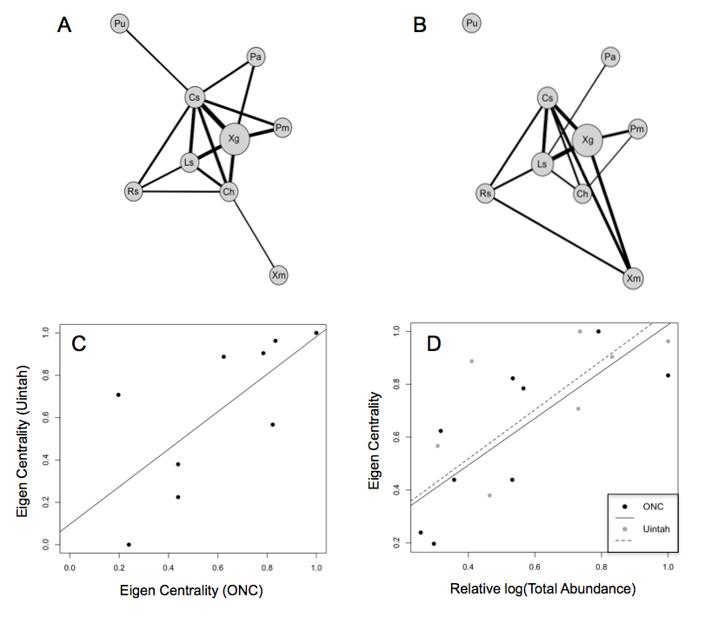

**Figure 2.**

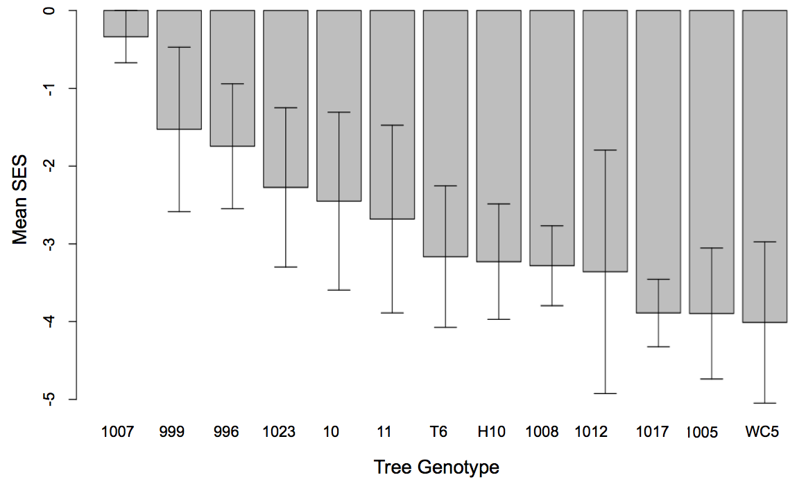

**Figure 3.**

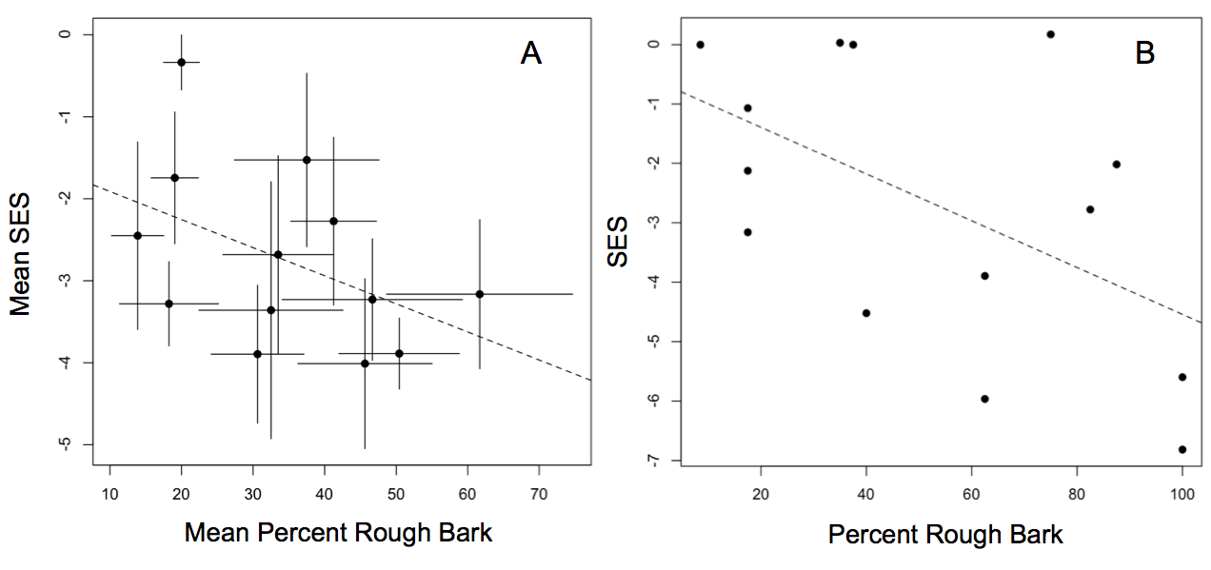

**Figure 4.**

