**Foundation species genotypic variation generates ecological network structure**

M.K. Lau, A.R. Keith, S.R. Borrett, S.M. Shuster, and T.G. Whitham

Target Journal: Ecology Letters

Corresponding Author Information:

Department of Biological Sciences and

Merriam-Powell Center for Environmental Research

Northern Arizona University

Flagstaff, AZ 86011-5640

Email: [mkl48@nau.edu](mailto:mkl48@nau.edu)

Phone: 928-523-9534

**Abstract**

* Evolutionary and ecological processes are now recognized as operating on similar time scales, and species interactions have been shown to play an important role in driving these dynamics. Although studies of the effect of a focal species’ genetics on ecological communities have shown the importance of genetic variation in many ecosystems, they have not delved into how these effects contribute to more complex patterns of species interactions, as is often analyzed using a network approach.
* In this study, we use a network perspective first to analyze an arthropod community dataset from a long-term common garden experiment with plants of known genetic makeup. We then conduct a simulation experiment investigating how genetic variation in a foundation tree species contributes to interaction network structure.
* Our study produced two main findings:
  1. The empirical genotype-species network exhibited non-random network structure and co-occurrence patterns arising in part from genotypic variation even though a conservative null model was used, and
  2. Simulated genotype-species networks displayed increasing associated species network structure and co-occurrence patterns with increasing community level genotypic effect.
* These results demonstrate that the community level impact of genetic variation in a foundation species can alter the structure of species interaction networks. We are aware of no other studies that explore the structure of genotype-species interactions networks. A genetic basis to interaction network structure has important implications for evolutionary dynamics in the context of complex communities.

**Keywords:** foundation species, ecological networks, species interactions,co-occurrence, modularity, nestedness, centrality, genetics of networks, common gardens, long-term experiment

**Introduction**

The evolution of species interactions in complex communities is a central question at the interface of ecology and evolutionary biology. Species interactions play an integral role in ecosystems (Agrawal et al. 2007; Holland and Bronstein 2008; Winfree et al. 2011). How species interactions lead to evolutionary changes in participant species has been a topic of biology at least since Darwin’s study of orchid pollinators (Darwin 1862). Studies of co-evolution between pairs and small groups of species have expanded the theory and support for evolutionarily dynamic species interactions (Ehrlich and Raven 1964; Thompson 1982; Jones et al. 2009). Studies of plant-mutualist and plant-herbivore networks have more recently provided a broader perspective, addressing more complex relationships among many species in a community (Bascompte et al. 2003; Thebault et al. 2010). Studies of phylogenetic structure of these networks have demonstrated the contribution of evolutionary processes to the structure of ecological networks (Rezende et al. 2007; Rafferty and Ives 2013). The field of community genetics, which studies the genetic basis for interactions in complex communities, primarily focusing on foundation species (i.e., species that define much of the structure of a community by creating locally stabile conditions; Dayton 1972; Ellison et al. 2005) has demonstrated how genetic variation in a single species can determine the structure of whole communities (reviewed in Whitham et al. 2012; Rowntree et al. 2011; Gugerli et al. 2013); however, the ideas and approaches from community genetics and network ecology have not previously not yet been synthesized.

Studies of co-evolution and community genetics have expanded our view of the influence of genetic variation on communities associated with a focal species. Strauss et al. (2005) theoretically demonstrated that selection occurs in a community context whenever a species response to selection on a trait is altered by the presence of another interacting species. Empirical, studies of the response of arthropod communities to foundation tree species hybridization (Wimp et al. 2005), genotypic diversity (Crutsinger et al. 2006) and genetic similarity (Bangert et al. 2008) have demonstrated significant effects of genetic variability on community composition. Others have shown that variation at the finer genetic resolution of genotypes affects the composition of other associated communities, such as soil microbes (Schweitzer et al. 2008), arthropods (Keith et al. 2010), plants (Lamit et al. 2011), and fungal endophytes (Lamit et al. 2014). In addition, several community genetics studies have examined the impact of genetic variation beyond direct interactions with the focal species. Bailey et al. (2007) showed that genetically based resistance in *Populus angustifolia* (James) to an insect herbivore influenced a tri-trophic interaction. Mooney et al. (2012) demonstrated that ant-aphid interactions depended on milkweed (*Asclepias syriaca* L.) genotype. Busby et al. (2014) found that the plant genetics mediated the indirect interactions between leaf pathogens and cottonwood (*Populus* spp.) associated insect community. Together, these and other studies (see Rowntree et al. 2011) demonstrate the importance of genetic variation for both direct and indirect interactions among species, however, we are aware of no investigations combining both empirical data and simulation experiments to investigate the genetic basis for interaction network structure.

In this study, we examine how genetic variation in a foundation species influences the structure of ecological networks in complex communities. We use a bipartite network approach, which examines networks where interactions typically occur between two main groups (e.g., plant-mutualist). Using bipartite networks provides a set of analytical tools and potential hypotheses developed by the studies of plant-mutualist (Bascompte 2010), plant-herbivore (Thébault and Fontaine 2011) and other species-species networks to networks of foundation species genotypes interacting with associated species, which we will refer to as genotype-species networks. We hypothesize that genotypic variation in foundation species produces patterns in the structure of interactions among species. More specifically, we hypothesize that genotype-species bipartite networks will exhibit structure similar to species-species networks, such as modularity and nestedness. In addition, we propose that, since species interactions tend to occur locally, this structure will determine co-occurrences among species and alter interspecific interactions by modulating the frequency that species are in close physical proximity. To test these hypotheses, we first examine the structure of an empirical network of interactions between narrowleaf cottonwood (*P. angustifolia* James) and its associated canopy arthropod community using data from a long-term, common garden experiment with trees of known genetic identity. We use a conservative, null model based approach to test for significant structural patterns in this real genotype-species network. Second, we conduct a simulation experiment using a community genetics model where we vary the intensity of the genotypic effect of a foundation species on its associated community to test for its effect on genotype-species interaction network structure and co-occurrence patterns. As a genetic basis to traits is a key requirement for evolution by natural selection, and given that multiple studies have demonstrated rapid evolution of species in response to climate change (reviewed in Parmesan 2006), a genetic basis for interaction network structure has important implications for ecological and evolutionary dynamics in many ecosystems.

**Methods**

*Empirical network analysis*

A network of interactions between canopy arthropod species and genotypes of *Populus angustifolia* James (narrowleaf cottonwood) consisted of data from Keith et al. 2014. In 1991 replicate clones of genotypes from the Weber River Watershed (Utah, U.S.A.) were randomly planted in a common environment (Ogden Utah, U.S.A., latitude = 41.248146, longitude = −111.999830, elevation = 1302 m) in order to both minimize and randomize the effect of local environmental variation with respect to genotype (Martinsen et al. 2001). Surveys of four replicate trees for each of 10 genotypes (n = 40 trees) were conducted in August of 2009 using timed sampling of similarly sized branches, and previous analyses have demonstrated community compositional effects of tree genotype (Keith et al. 2014). As plant-herbivore networks are typically highly asymmetric (Thébault and Fontaine), we interpret these connections as directed effects of the genotype on the associated community. Although these species comprise multiple trophic levels from herbivores to predators, all of these species were observed in close contact with the tree, either directly or indirectly using it as a resource. Hereafter, we use network terminology to refer to the genotypes and species in the network collectively as “nodes” and their connections as “edges” (Wasserman and Faust 1994).

We then analyzed the structure of this empirical genotype-species network. As no previous analyses have been conducted on genotype-species networks we chose three network metrics (modularity, nestedness and centrality) and a measure of species co-occurrence (C-Score; Stone and Roberts 1991). All network metrics analyze the structure of the entire network across all nodes and edges, and each measures a different aspect of the network structure. Modularity is a measurement of the degree to which the network is comprised of groups of nodes that are relatively more connected to each other, and for our analyses we used the method developed by Newman (2004). Nestedness was calculated for the observed network using the nestedness temperature metric developed by Atmar and Patterson (1993, see also Rodríguez-Gironés and Santamaria 2006), which measures the degree to which species tend to interact with subsets of the community across “parts” of the network. We used Freeman’s (1979) degree as our measure of centrality. We also measured the co-occurrence patterns among the associated community using Stone and Robert’s (199?), C-score, which is the number of “checkerboard units” averaged across all pairs of species. A checkerboard unit is measured as (*r*i-*S*ij)(*r*j-*S*ij), where *r* is the total number of occurrences for a given species and *S* is the total number of times a species pair occurs, and the C-score has been shown to have robust statistical properties (Gotelli 2001).

We tested for the significance of all network statistics and the C-score using a conservative null-model based randomization method. We chose this null model because previous work has demonstrated the importance of controlling for the total abundances of species in plant-mutualistic bipartite networks (Blüthgen 2010). More specific to our dataset, this null model constrains the matrices to maintain the genotype and restrict the species marginal totals (Wright et al. 1998). After an initial series of 100 “burn-in” permutations of the original matrix, a set of 5000 randomizations was generated and used to test the significance of the all metrics. For each metric we calculated a non-directional p-value as the proportion of null model metrics that were equal to or more extreme than the original (i.e., “observed”) metric. We also calculated a standardized score as *z* = (x - μ)/σ, where x is the observed metric and μ and σ are the mean and standard deviation for the null simulation metrics, respectively. Note that in the co-occurrence literature the standardized C-score is typically referred to as a standardized effect size (SES) value.

*Simulating genotypic effects on network structure and co-occurrence patterns*

As the structure of the empirical network could arise from factors other than phenotypic variation among foundation species genotypes, we conducted a simulation experiment testing the effect of genotype on genotype-species network structure. We used the community genetics simulation method previously developed in Shuster et al. (2006). Briefly, this method uses a combines both individual-based and mass-action modeling approaches, and starts by creating a population of individuals assigned a genotypic value (i.e., genotypes). Each genotype is comprised of multiple replicate individuals (i.e., clones), which are assigned phenotypic values as a single numeric value for each individual. This population represents the foundation species. Next, a set of species representing the associated community was assigned an average genotypic value that was then mapped to a numerical phenotypic value using an additive, bi-allelic genetic system. At each step of genotype-phenotype mapping, variance was introduced through random draws from a uniform distribution, simulating the introduction of phenotypic variance arising from non-genetically based “environmental” variation. It is important to note here that interactions among species, beyond the foundation species’ interaction with the community, is not explicitly accounted for in this process but introduced as a contribution to non-genetic, environmental variation. Last, mass-action methods were used to determine the equilibrium population value for each associated species given the phenotypic values for each foundation species individual and the carrying capacity of each associated community member (Ronce and Kirkpatrick 2001; Supplementary Materials).

We used this method to conduct simulations of communities with different levels of foundation species genotypic effect on the community. To do this, we adjusted the co-efficient determining the foundation species genotypic effect for each associated species, which modifies the fidelity of the mapping of genotype to phenotype to a species by varying the power of the co-efficient per the method of Shuster et al. (2006; Supplementary Materials). In addition, to explore the impact of variation in associated species abundances, we produced two sets of simulations, one (n = 80) with a carrying capacity (K) of 100 individuals, and a second set (n = 80) with carrying capacities for the dependent species selected from a Poisson distribution (λ = 5), ranging from K = 100 to K = 5. This distribution was chosen for its similarity to the highly skewed, “un-even” distribution of species total abundances commonly observed in ecological communities. As intended the diversities of the even communities (Shannon’s H = 3.25±0.05 SD) were greater than the un-even communities (Shannon’s H = 2.25±0.15 SD), which were very similar to the diversity of the empirical canopy arthropod community (Shannon’s H = 2.15). The simulated communities were generated using the same initial phenotypes for both the “foundation species” individuals (n = 100; 10 individuals for each of 10 genotypes) and the “associated species” (25 total). Similar to the results of Shuster et al. (2006) simulated communities differed in their individual phenotypic trait values (Fig. 1A) and produced significant variation in community composition in the simulated communities (Fig. 1B), which ranged in broadsense community heritability from 0 to an upper threshold of 0.60 (Fig. 1C) calculated using the multivariate community heritability (; Lamit et al. 2014). To test and compare the effect of genotype on the four metrics, we used correlation analysis employing Kendall’s τ as our correlation coefficient in order to capture non-linear monotonic relationships.

*Simulation and analytical software*

All simulations and analyses were conducted in R version 3.0.2 (R Development Core Team 2014). Simulations were conducted using the *ComGenR* package (Lau 2014), and simulation scripts are publically available: <https://github.com/MKLau/cg_simulations>. Non-metric multidimensional scaling (NMDS) ordination and nestedness tests were conducted with *vegan* (Okasanen et al. 2013), and networks were plotted using *bipartite* (Dormann et al. 2008).

**Results**

We observed significant network structure and co-occurrence patterns among associated species in the empirical genotype-species network. The network cottonwood foundation species genotype and canopy arthropods (Fig. 2) had levels of modularity (observed = 0.22, *z* = 13.36, *P* < 0.001), nestedness (observed = 21.48, *z* = 8.60, *P* < 0.001), centrality (observed = 0.27, *z* = 5.99, *P* < 0.001) and C-score (observed = 2.93, *z* = -12.40, *P* = 0.0006) that all differed from the null model based expectation, which maintained totals for both genotypes and species.

Simulated network structure and co-occurrence patterns increased with increasing genotypic effect but for some metrics the effect depended on the evenness of the associated community. Even community network structure and co-occurrence patterns showed increasing structure with increasing genotypic effect with modularity (Fig. 4a; τ = 0.82, *P* < 0.001), nestedness (Fig. 4b; τ = 0.83, *P* < 0.001), centrality (Fig. 4c; τ = 0.89, *P* < 0.001) and C-score (Fig. 4d; τ = 0.70, *P* < 0.001) all showing significant, positive correlations with genotypic effect. The un-even network metrics also displayed significant relationships with genotypic effect: modularity (Fig. 4a; τ =0.69, *P* < 0.001), nestedness (Fig. 4b; τ = -0.28, *P* = 0.001) and centrality (Fig. 4c; τ = -0.87, *P* < 0.001). The C-score for the un-even community simulations across all levels of genotypic effect was not significant (Fig. 4d; τ = -0.01, *P* = 0.95); however, as the relationship was clearly not monotonic, restricting the simulations to values over a threshold of genotypic effect corresponding to a broad-sense community heritability of 0.35 or greater increased the correlation between the C-score and genotypic effect (Fig. 4d) to τ = 0.23 (*P* = 0.06).

**Discussion**

Our results support the hypothesis that genotypic variation in a foundation species can contribute to ecological network structure. We observed significant network structure for all metrics, including modularity, nestedness and centrality, as well as significant co-occurrence patterns, even though these metrics were tested against a highly conservative null model that restricted tree genotype and associated species totals. In addition, our controlled simulation experiment, which manipulated both genotypic effect and community evenness, displayed significant effects of genotypic variation on all metrics, except co-occurrence patterns as measured by the C-Score in the un-even simulations. Taken together, these two lines of evidence support the conclusion that genotypic differences among individuals of a foundation species generates interaction network structure.

Significant network and co-occurrence patterns in the empirical genotype-species network indicate a genetic basis to ecological interaction network structure. In terms of the network structure metrics, modularity in plant-herbivore networks is often attributed to the specialization of a few species on a set of host species (Fontaine et al. 2011), while nestedness has been hypothesized to be a result of mutualist species minimizing within guild competition (Bascompte et al. 2006), and centrality generally can arise through the presence of a few generalists interacting with a larger number of specialist species (Sazima et al. 2010). The significant centrality of the network can easily be explained by some nodes (genotypes or species) having many more edges than others, which can be seen in the ordering of the nodes (Fig. 2). Observing both modularity and nestedness in the same network, although seemingly counterintuitive, is supported by work showing that ecological networks often possess modules displaying internal nestedness (Fortuna et al. 2011). Applying this to the empirical network, modularity is could be arising from the specialization of some arthropods on particular genotypes, and within these modules species are interacting with individuals of a given genotype in nested subsets. It is likely that the same mechanism is contributing to species co-occurrence patterns, as the C-Score was much less than the null expectation, indicating that species tended to aggregate (i.e., co-occur), as would be the expected pattern if groups of species track similar genotypes and co-occur more frequently on preferred genotypes. As stated previously, interactions among species tend to occur locally, and thus if genotype acts to increase the frequency of co-occurrences, genotypic variation is likely a force structuring the network of interactions among arthropod and other associated communities.

The results of the simulation experiment reveal the underlying force of genotypic variation in structuring interaction networks. Our study expands previous empirical and simulation based community genetics studies, which at most have examined indirect effects among species mediated by a third species (e.g., Bailey et al. 2007; Moya-Laraño 2011) or direct effects of a foundation species on a large community of species (e.g., Shuster et al. 2006; Keith et al. 2010, 2014; Lamit et al. 2011, 2013, 2014). Although the simulations we conducted are an obvious oversimplification of real ecological dynamics, our goal was to demonstrate the possibility of an underlying genetic mechanism observed in an empirical dataset. We found that when species total abundances are even, all metrics of network structure and co-occurrence patterns increase with the influence of variation among foundation species genotype. A more complicated set of patterns was observed in the un-even network simulations. Modularity increased dramatically with increasing effect of genotype, as it did in the even simulations; however, centrality decreased and both nestedness and the C-Score decreased then increased as the genotypic effect went up. The complex patterns found for nestedness and C-Score are likely the result of the counterbalancing effects of genotype versus species on nestedness and co-occurrence patterns, where initially the species abundances are determining the value of the metric. Then, as the influence of genotype increases, the metric is dominated by response of the community to the genotypic differences. Similarly, as genotypic effect increases centrality decreases as genotypic differences decrease the dominance of a few species, and thus, centrality in the even and un-even communities converge toward a similar level of centrality.

A genetic basis to network structure has implications for the consequences of selection in a community context. Using a foundation species approach, we can focus on the effect that selection will have on the structure of genotype-species interaction networks. Directional, stabilizing and divergent selection will alter the structure of these interaction networks in ways that can affect the outcome of selection, which occurs in a community context of interlinked species networks (Thompson 2013). For example, if directional selection on a foundation species selects for a “generalist” genotype (i.e., a genotype that interacts with a large number of species), we would predict a reduction in modularity and an increase in species co-occurrences, which would likely increase the frequency of species interactions. This would also increase the centrality of the network, potentially making the community less resistant to disturbance if it were to impost a different selection pressure that selects against the generalist genotype.

In conclusion, the combined analysis of an empirical genotype-species network and community genetics simulation experiment demonstrate the presence of previously over-looked community level effects of foundation species genotypic variation. As a we have demonstrate that a network perspective has the potential to elucidate patterns of interactions not found using multivariate community approaches, we advocate that extant and future community genetics datasets (e.g., Zytynska et al. 2011, Lamit et al. 2011) be analyzed using a bipartite network perspective to resolve the structure of the associated communities entangled in these datasets. Lastly, as previous work has demonstrated the importance of genetic similarity for community assembly (Bangert et al. 2008) and that phylogenetics influences species-species network structure (Rezende et al. 2007), exploring the influence of genetic similarity on genotype-species network structure will provide insight into the formation of the structural patterns.

**Acknowledgements**

Clinton Baker manager of the Northern Arizona University Computation Server. Cottonwood Ecology Group at NAU, The SEE Lab at UNCW, Miguel Fortuna, Jordi Bascompte and the Network Ecology Lab at Estacion de Doñana, Sevilla, Spain, Richard Michalet and the BioGECO Group at UB1. Ogden Nature Center.

**References**

Agrawal, A. A., D. D. Ackerly, F. Adler, A. E. Arnold, C. Caceres, D. F. Doak, E. Post,

P. J. Hudson, J. Maron, K. A. Mooney, M. Power, D. Schemske, J. Stachowicz, S. Strauss, M. G. Turner, and E. Werner. 2007. Filling key gaps in population and community ecology. Frontiers in Ecology and the Environment 5:145-152.

Atmar and Patterson 1993.

Bailey et al. 2007.

Bangert et al. 2008

Bascompte et al. 2003

Bascompte et al. 2006

Bascompte et al. 2010

Blüthgen 2010.

Busby et al. 2014.

Cristina Sazima, Paulo R. Guimarães Jr, Sérgio F. dos Reis and Ivan Sazima. 2010 What makes a species central in a cleaning mutualism network? Oikos 119: 1319-1325.

Crutsinger et al. 2006

Darwin, C. R. 1862. On the various contrivances by which British and foreign orchids are fertilised by insects, and on the good effects of intercrossing. London: John Murray.

Dayton 1972.

Dormann et al. 2008

Ehrich P.R. and Raven P.H. 1964. Butterflies and plants: a study in coevolution. Evolution 18: 586-608.

Ellison, A. M., M. S. Bank, B. D. Clinton, E. A. Colburn, K. Elliott, C. R. Ford, D. R. Foster, B. D. Kloeppel, J. D. Knoepp, G. M. Lovett, J. Mohan, D. A. Orwig, N. L. Rodenhouse, W. V. Sobczak, K. A. Stinson, J. K. Stone, C. M. Swan, J. Thompson, B. von Holle, and J. R. Webster. 2005. Loss of foundation species: consequences for the structure and dynamics of forested ecosystems. Frontiers in Ecology and the Environment 9: 479-486.

Fontaine et al. 2011

Fortuna et al. 2011

Freeman 1979

Gotelli 2001.

Gugerli et al. 2013

Holland and Bronstein 2008

Jones et al. 2009.

Keith et al. 2010

Keith et al. 2014

Lamit et al. 2011

Lamit et al. 2013

Lamit et al. 2014

Lau et al. 2014

Mooney et al. 2012

Moya-Laraño 2011.

Oksanen et al. 2013

Parmesan 2006.

Rafferty N.E. and Ives 2013. Phylogenetic trait-based analyses of ecological networks. Ecology 94: 2321-2333.

Rezende, E., Lavabre, J., Guimarães Jr., P.R., Jordano, P. and Bascompte, J. 2007. Non-random coextinctions in phylogenetically structured mutualistic networks. Nature 448: 925-928.

Rodriguez-Girones and Santamaria 2006.

Ronce and Kirkpatrick 2001.

Rowntree et al. 2011.

Sazima et al. 2010.

Schweitzer et al. 2008

Shuster et al. 2006

Strauss et al. 2005

Stone and Robert 1991.

Thébault E. and Fontaine. C. 2010. Stability of Ecological Communities and the Architecture of Mutualistic and Trophic Networks. Science 329: 853-856.

Thompson, J.N. 1982. Interaction and Coevolution, John Wiley & Sons, New York.

Wimp et al. 2005

Thompson 2013.

Whitham et al. 2012

Winfree R., Gross B.J. and Kremen C. 2011. Valuing pollination services to agriculture. Ecological Economics 71: 80-88.

**Phylogenetic trait-based analyses of ecological networks**

Wright et al. 1998

Zytynksa et al. 2011

**Figure Legends**

Figure 1. Genotypic effect in simulated communities produced differences in individual phenotypic traits that contributed to variation in the associated community. The density plot (A) shows the variation in the simulated foundation “tree” phenotypic values among individuals with each line showing the distribution for a different genotype, while the NMDS ordination (B) plots the community composition of each genotype shown as the multivariate centroid for each genotype (±1 SD). The bivariate plot (C) shows the multivariate community heritability () of simulated communities for both even (black) and un-even (red) communities ranged from 0 to 0.58 with none greater than 0.60 (dashed line) across the range of genotypic effect used in the simulation experiment.

Figure 2. Plot showing the structure of the empirical bipartite network of genotypes (left nodes) and species (right nodes) for the narrowleaf cottonwood (*Populus angustifolia*) canopy arthropod. Nodes are scaled by the marginal totals for genotypes (i.e., total arthropod abundance) and species (i.e., that species total abundance). The nodes are arranged in order of increasing interactions, which corresponds to increasing centrality bottom to top, and are colored by module membership. Lines show interactions between genotypes and species scaled by the average abundance of each arthropod species across all individuals of a given genotype. Genotype names follow the naming presented in Keith et al. (2014) and taxonomic identification of the arthropod community is provided in Supplementary Materials.

Figure 3. Bivariate plots showing how network and co-occurrence patterns of the simulated networks vary with increasing genotypic effect. When species’ total abundances were even (black), modularity (A), nestedness (B), centrality (C) and the C-Score (D) increased as the effect of foundation species genotype increased. When species total abundances were un-even (red), only modularity showed a similar pattern of increasing structure (A), while nestedness (B) showed a non-linear pattern of decreasing then increasing structure, centrality decreased linearly (D) and C-Score, like nestedness, decreased then increased with increasing genotypic effect.

Figure 1

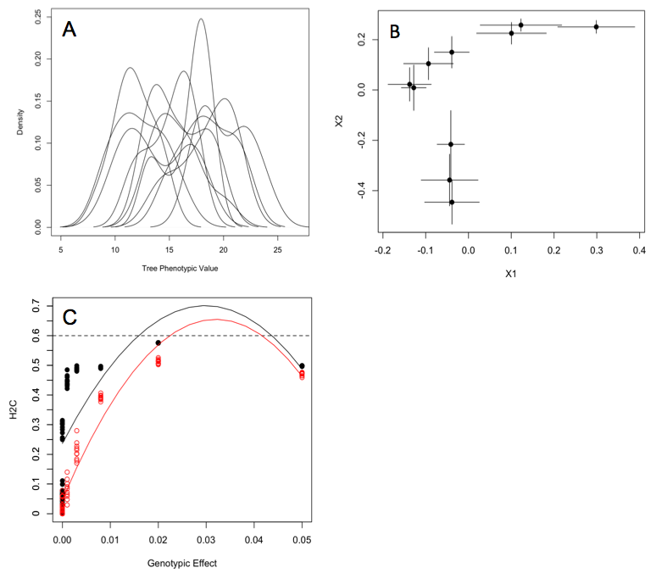

Figure 2

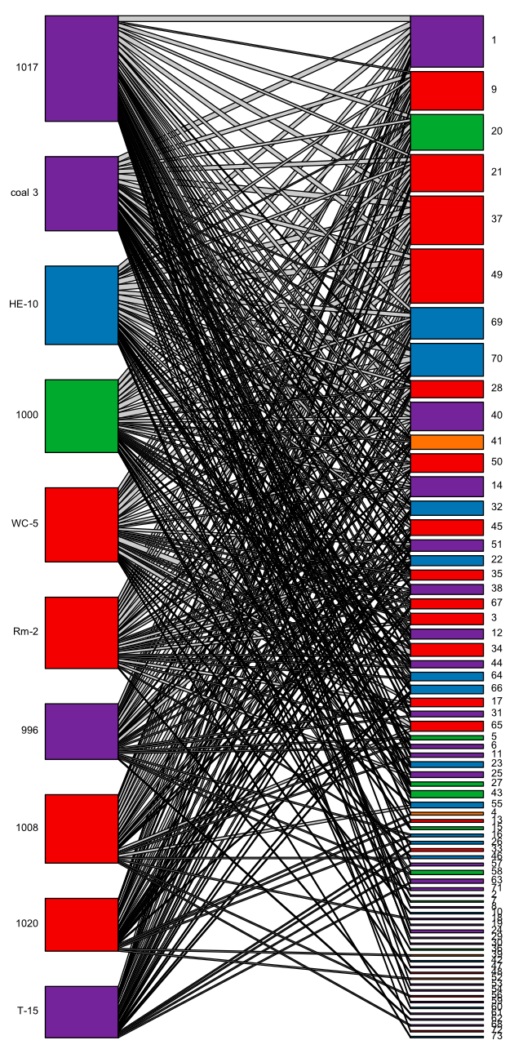

Figure 3

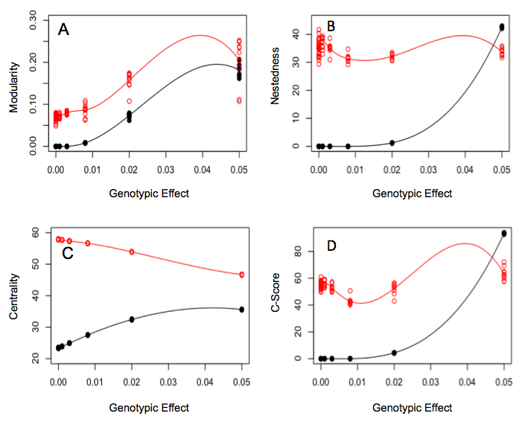

**Supplementary Materials**

Equation used for simulation experiment where equilibrium “arthropod species” abundances are determined by genetically based phenotypic variation in a “foundation species”, following the notation of Shuster et al. (2006):

*Genotypic Effect Variables*

= Selection Intensity term in Shuster et al. 2006

“Genotypic Effect” modulated in the simulation experiment

*Indices*

Foundation tree individual index

Arthropod species index

*Arthropod Variables*

Arthropod abundance at equilibrium

Arthropod carrying capacity

Arthropod trait value

Variation in the arthropod trait values

Mean arthropod trait value

*Tree Variable*

Tree phenotypic trait value,

*Environmental Variable*

Environmental variation sampled from a uniform distribution

Table of identifications for the arthropod species codes presented in the genotype-species network (Fig. 2).

|  |  |
| --- | --- |
| **Number** | **Species** |
| 1 | pb |
| 2 | Ambush.bug |
| 3 | Anthocorid |
| 4 | Araniella |
| 5 | Asilidae |
| 6 | assassin |
| 7 | Assassin..rd.blk. |
| 8 | Assilid |
| 9 | BEB |
| 10 | Beetle..unkn.blk. |
| 11 | Bp.Chalcid |
| 12 | Braconid |
| 13 | Calophorid |
| 14 | Cercopid..brn. |
| 15 | Chait..grn. |
| 16 | Clerid..rd.blk. |
| 17 | Cocc.nymph..blk.orng. |
| 18 | Coenagrionidae |
| 19 | Earwig |
| 20 | edge.mnr |
| 21 | egg.on.a.stick |
| 22 | Fly..brn.rnd. |
| 23 | Fly..gldn.Dolicho. |
| 24 | Fly..unkn.sm. |
| 25 | Formica.spp.1 |
| 26 | Formica.spp.2 |
| 27 | Formica.spp.3 |
| 28 | Globuli |
| 29 | Hymenoptera..unkn.. |
| 30 | Ichneumonid |
| 31 | Lacewing..grn. |
| 32 | Lbb..many.spt. |
| 33 | Lbb..no.spot. |
| 34 | Lf.tier |
| 35 | Lfhppr..brn. |
| 36 | Lfhppr..brnmtld. |
| 37 | Lfhppr..fisheye. |
| 38 | Lfhppr..grn. |
| 39 | Lfhppr..sknk. |
| 40 | Melyrid..gry.blk. |
| 41 | midge |
| 42 | mite.gall |
| 43 | Muscid |
| 44 | Myrm.ant |
| 45 | Paras |
| 46 | Paras..lng.thin. |
| 47 | Penta..brachy. |
| 48 | penta..rd.brn. |
| 49 | Phylla |
| 50 | punkie |
| 51 | red.mite |
| 52 | Salticid..blk.rd. |
| 53 | Salticid..zebra. |
| 54 | serp.lf.mnr |
| 55 | Snakefly |
| 56 | Spider..Araneid.blk.gry. |
| 57 | Spider..gry.crab. |
| 58 | Spider..rd.blk.Lycosid. |
| 59 | Spider..rd.wht. |
| 60 | Spider..unkn. |
| 61 | Spittle.bug |
| 62 | Spot.blotch |
| 63 | stem.borer |
| 64 | Syrphid..lttl.yllw. |
| 65 | T.dip |
| 66 | Thec..aff. |
| 67 | Thrip..blk. |
| 68 | Thrip..yllw. |
| 69 | Tip..mnr |
| 70 | Tip.roller |
| 71 | Weevil..blk. |
| 72 | Weevil..brn. |
| 73 | Weevil..gry. |