**Genotypic variation in foundation species generates interaction network structure in ecological communities**

Authors: Matthew K. Lau12, Arthur R. Keith1, Stuart R. Borrett3, Stephen M. Shuster1, and T.G. Whitham1

Contributions: MKL, SMS, SRB and TGW designed the study, MKL conducted the simulations and analyses and wrote the first draft of the manuscript, ARK collected the field data, and all authors contributed substantively to revisions

Affiliations: 1Department of Biological Sciences and Merriam-Powell Center for Environmental Research, Northern Arizona University, Flagstaff, AZ 86011-5640, 2Harvard Forest, Harvard University, Petersham, MA 01366, 3Department of Biology and Marine Biology, University of North Carolina Wilmington, Wilmington, NC 28403-5915

Emails: MKL = mkl48@nau.edu, ARK = ark36@nau.edu, SRB = borretts@uncw.edu, SMS = stephen.shuster@nau.edu, TGW = thomas.whitham@nau.edu

Short Title: Genetics of ecological networks

Keywords: foundation species, ecological networks, species interactions,genotype-species networks**,** co-occurrence, modularity, nestedness, centrality, genetics of networks, common gardens, long-term experiment

Article Type: Letter.

Word Count: Abstract = 149, Main Text = 4087 and Text Box = 0.

Figures: 3.

Tables: 0.

Text Boxes: 0.

References: 49.

Corresponding Author: Matthew K. Lau; Current Address = Harvard Forest, 324 N Main St, Petersham, MA 01366; Phone = 978-724-3302; Fax = 978-724-3595; Email = mkl48@nau.edu.

**ABSTRACT**

Although genetics in one organism is known to affect the composition and diversity of whole communities, no studies have examined how genetic variation influences complex species interaction networks. Here, we used a network perspective to analyze interactions in a community of arthropods living on replicated genotypes (clones) of a model foundation tree species in a long-term, common garden experiment. We then conducted a simulation experiment investigating how variation among individual tree genotypes contributes to network structure. Three findings emerged. 1) The empirical “genotype-species network” exhibited non-random network structure. 2) Even though a conservative null model was used, co-occurrence patterns were detected in association with individual tree genotypes. 3) Simulated “genotype-species networks” displayed increased structure with community-level genotypic effect. These results demonstrate that genetic variation in a foundation tree species can alter associated interaction networks, providing a first step in understanding the role of genetic variation in ecological network evolution.

**INTRODUCTION**

The evolution of species interactions in complex communities is a central question at the interface of ecology and evolutionary biology. Species interactions play an integral role in ecosystems (Agrawal *et al.* 2007; Winfree *et al.* 2011). How species interactions lead to evolutionary changes in participant species has been a topic of biology at least since Darwin’s writings on orchid pollinators (Darwin 1862). Studies of co-evolution between pairs and small groups of species have expanded the theory and support for evolutionarily dynamic species interactions (Ehrlich and Raven 1964; Thompson 2013; Jones *et al.* 2009). Studies of plant-mutualist and plant-herbivore networks have more recently provided a broader perspective, addressing more complex relationships among the many species in a community (Bascompte *et al.* 2010; Thébault and Fontaine 2010). Studies of phylogenetic structure of these networks have demonstrated the contribution of evolutionary processes to the structure of ecological networks (Rezende *et al.* 2007; Rafferty and Ives 2013). The field of community genetics, which studies the genetic basis for interactions in complex communities, primarily focusing on foundation species (i.e., species that define much of the structure of a community by creating locally stabile conditions; Ellison *et al.* 2005), has demonstrated how genetic variation in a single species can determine the structure of whole communities and ecosystem processes (reviewed in Whitham *et al.* 2006; Rowntree *et al.* 2011; Gugerli *et al.* 2013); however, the ideas and approaches from community genetics and network ecology have not previously been synthesized.

Studies of co-evolution and community genetics have expanded our view of the influence of genetic variation on communities associated with a focal species. Strauss *et al.* (2005) theoretically demonstrated that selection occurs in a community context whenever a species response to selection on a trait is altered by the presence of another interacting species. Empirical, studies of the response of arthropod communities to foundation tree species hybridization (Wimp *et al.* 2005), genotypic diversity (Crutsinger *et al.* 2006) and genetic similarity (Bangert *et al.* 2008) have demonstrated significant effects of genetic variability on community composition. Others have shown that variation at the finer genetic resolution of genotypes affects the composition of other associated communities, such as soil microbes (Schweitzer *et al.* 2008), arthropods (Keith *et al.* 2010), plants (Lamit *et al.* 2011), and fungal endophytes (Lamit *et al.* 2014). In addition, several community genetics studies have examined the impact of genetic variation beyond direct interactions with the focal species. Smith *et al.* (2011) showed that genetically based resistance in *Populus angustifolia* (James) to an insect herbivore influenced a tri-trophic interaction with avian predators. Mooney (2011) demonstrated that ant-aphid interactions depended on milkweed (*Asclepias syriaca* L.) genotype, and Busby *et al.* (2014) found that plant genetics mediated the interactions between leaf pathogens and cottonwoods (*Populus* spp.), which in turn defined the associated arthropod community. Together, these and other studies (see Rowntree *et al.* 2011) demonstrate the importance of genetic variation for both direct and indirect interactions among species; however, none of these studies has examined more complex species interactions that are known to occur in ecosystems.

Network ecology has provided a means to approach the complexities of multi-species interactions both from an ecological and an evolutionary perspective. Indirect effects in interaction networks have been theoretically (MacArthur 1955; May 1972; Allesina et al. 2011) and empirically (Bondavalli and Ulanowicz 1999; Bascompte et al. 2010; Bastolla *et al.* 2009) shown to influence the structure and dynamics of communities and ecosystems. For example, Bastolla *et al.* (2009) demonstrated decreased interspecific competition and increased co-existence of species in bipartite mutualistic (i.e., networks with two sets of species that primarily interact with species of the other set) that exhibited nestedness, which is a common network structural property observed in many types of networks. Phylogenetic analyses of bipartite mutualistic networks have demonstrated that evolutionary history contributes to network structure through trait complementarity (Rezende *et al.* 2007), and recently, Rafferty and Ives (2013) found similar patterns in a plant-pollinator network but determined more specifically that plant phylogenetic similarity was the primary driver of network structure. More specific to the evolutionary impacts of network structure, Guimaraes *et al.* (2011) used both simulations and a set of empirical mutualistic networks to explore the importance of network structure in determining co-evolutionary dynamics, finding increased rates of evolution, higher levels of trait complementarity and higher levels of convergence in traits in co-evolutionary networks. In addition, this study also concluded that the “super-generalist” species were of primary importance to co-evolutionary dynamics, which parallels the findings of community genetics with foundation species (e.g., Whitham *et al.* 2006). Although these studies demonstrate the importance of evolutionary processes in determining network structure and the implications of network structure for ecological dynamics, we are aware of no investigations that combine both empirical and simulation experiments to examine the genetic basis for community interaction network structure resulting from intra-specific variation in a foundation species.

In this study, we examine how genetic variation in a foundation species influences the structure of ecological networks in complex communities. We use a bipartite network approach, which examines networks where interactions typically occur between two main groups (e.g., plant-mutualist). Using bipartite networks provides a set of analytical tools and hypotheses developed by the studies of plant-mutualist (Bascompte 2010), plant-herbivore (Thébault and Fontaine 2010) and other species-species networks that we apply to a foundation tree, *Populus angustifolia*, and its arthropod community. Although previous studies have not focused on foundation species (i.e., species that are by definition ecosystem “drivers”) or incorporated the genetics of plants, here we examine the networks of foundation species genotypes interacting with associated species, which we refer to as “genotype-species networks.” This approach allows us to begin evaluating interaction networks within an evolutionary framework. We hypothesize that genotypic variation in foundation species produces patterns in the structure of interactions among species. More specifically, we hypothesize that genotype-species bipartite networks will exhibit structure similar to species-species networks, such as modularity and nestedness. In addition, we propose that, since species interactions tend to occur locally, this structure will determine co-occurrences among species and alter interspecific interactions by modulating the frequency that species are in close physical proximity. To test these hypotheses, we first examine the structure of an empirical network of interactions between narrowleaf cottonwood (*P. angustifolia* James) and its associated canopy arthropod community using data from a long-term, common garden experiment with trees of known genetic identity. We use a conservative, null model based approach to test for significant structural patterns in this “real” genotype-species network. Second, we conduct a simulation experiment using a community genetics model where we vary the intensity of the genotypic effect of a foundation species on its associated community to test for its effect on genotype-species interaction network structure and the ensuing effects on the associated species interaction structure that arise from shifting co-occurrence patterns. As a genetic basis to traits is a key requirement for evolution by natural selection, and given that multiple studies have demonstrated rapid evolution of species in response to climate change (reviewed in Parmesan 2006) as well as the importance of co-evolutionary dynamics in ecological networks (Guimaraes et al. 2011; Moya-Laraño 2011), demonstrating a genetic basis for interaction network structure has important implications for ecological and evolutionary dynamics in many ecosystems.

**MATERIALS AND METHODS**

**Empirical network analysis**

A network of interactions between canopy arthropod species and genotypes of *Populus angustifolia* James (narrowleaf cottonwood) were collected from a common garden following the methods of Keith *et al.* (2010). In 1991 replicate clones of genotypes from the Weber River Watershed (Utah, U.S.A.) were randomly planted in a common environment (Ogden Utah, U.S.A., latitude = 41.248146, longitude = −111.999830, elevation = 1302 m) in order to both minimize and randomize the effect of local environmental variation with respect to genotype (Martinsen *et al.* 2001). Surveys of four replicate trees for each of 10 genotypes (n = 40 trees) were conducted in August of 2008 using timed sampling of similarly sized branches, and previous analyses have demonstrated community compositional effects of tree genotype (Keith *et al.* 2010). As plant-herbivore networks are typically highly asymmetric (Thébault and Fontaine 2010), we interpret these connections as directed effects of the genotype on the associated community. Although these species comprise multiple trophic levels from herbivores to predators, all of these species were observed in close contact with the tree, either directly or indirectly using it as a resource. Hereafter, we use network terminology to refer to genotypes of narrowleaf cottonwood as well as species in the network as “nodes” and their connections as “edges” (Wasserman and Faust 1994).

We then analyzed the structure of this empirical genotype-species network. As no previous analyses have been conducted on genotype-species networks we chose three network metrics (modularity, nestedness and centrality) and a measure of species co-occurrence (C-Score; Stone and Roberts 1991). All network metrics analyze the structure of the entire network across all nodes and edges, and each measures a different aspect of the network structure. Modularity is a measurement of the degree to which the network is comprised of groups of nodes that are relatively more connected to each other, and for our analyses we used the method developed by Newman (2004). Nestedness was calculated for the observed network using the nestedness temperature metric developed by Atmar and Patterson (1993, see also Santamaria and Rodríguez-Gironés 2006), which measures the degree to which species tend to interact with subsets of the community across “parts” of the network. We used Freeman’s (1978) degree as our measure of centrality. We also measured the co-occurrence patterns among the associated community using Stone and Robert’s (1990), C-score, which is the number of “checkerboard units” averaged across all pairs of species. A checkerboard unit is measured as (*r*i-*S*ij)(*r*j-*S*ij), where *r* is the total number of occurrences for a given species and *S* is the total number of times a species pair occurs, and the C-score has been shown to have robust statistical properties (Gotelli 2001).

We tested for the significance of all network statistics and the C-score using a conservative null-model based randomization method. We chose this null model because previous work has demonstrated the importance of controlling for the total abundances of species in plant-mutualistic bipartite networks (Blüthgen 2010). More specific to our dataset, this null model constrains the matrices to maintain the genotype and restrict the species marginal totals (Wright *et al.* 1998). After an initial series of 100 “burn-in” permutations of the original matrix, a set of 5000 randomizations was generated and used to test the significance of the all metrics. For each metric we calculated a non-directional p-value as the proportion of null model metrics that were equal to or more extreme than the original (i.e., “observed”) metric. We also calculated a standardized score as *z* = (*x* - μ)/σ, where *x* is the observed metric and μ and σ are the mean and standard deviation for the null simulation metrics, respectively. Note that in the co-occurrence literature the standardized C-score is typically referred to as a standardized effect size (SES) value.

**Simulating genotypic effects on network structure and co-occurrence patterns**

As the structure of the empirical network could arise from factors other than phenotypic variation among foundation species genotypes, we conducted a simulation experiment testing the effect of genotype on genotype-species network structure. We used the community genetics simulation method previously developed in Shuster *et al.* (2006). Briefly, this method uses a combines both individual-based and mass-action modeling approaches, and starts by creating a population of individuals assigned a genotypic value (i.e., genotypes). Each genotype is comprised of multiple replicate individuals (i.e., clones randomly planted in a common garden), which are assigned phenotypic values as a single numeric value for each individual. This population represents the foundation species. Next, a set of species representing the associated community was assigned an average genotypic value that was then mapped to a numerical phenotypic value using an additive, bi-allelic genetic system. At each step of genotype-phenotype mapping, variance was introduced through random draws from a uniform distribution, simulating the introduction of phenotypic variance arising from non-genetically based “environmental” variation. It is important to note here that interactions among species, beyond the foundation species’ interaction with the community, is not explicitly accounted for in this process but introduced as a contribution to non-genetic, environmental variation. Last, mass-action methods were used to determine the equilibrium population value for each associated species given the phenotypic values for each foundation species individual and the carrying capacity of each associated community member (Supplementary Materials).

We used this method to conduct simulations of communities with different levels of foundation species genotypic effect on the community. To do this, we adjusted the co-efficient determining the foundation species genotypic effect for each associated species, which modifies the fidelity of the mapping of a tree genotype to phenotype to an arthropod species by varying the power of the co-efficient per the method of Shuster *et al.* (2006; Supplementary Materials). In addition, to explore the impact of variation in associated species abundances, we produced two sets of simulations, one (n = 80) with a carrying capacity (K) of 100 individuals, and a second set (n = 80) with carrying capacities for the dependent species selected from a Poisson distribution (λ = 5), ranging from K = 100 to K = 5. This distribution was chosen for its similarity to the highly skewed, “un-even” distribution of species total abundances commonly observed in ecological communities. As intended the diversities of the even communities (Shannon’s H = 3.25±0.05 SD) were greater than the un-even communities (Shannon’s H = 2.25±0.15 SD), which were very similar to the diversity of the empirical canopy arthropod community (Shannon’s H = 2.15). The simulated communities were generated using the same initial phenotypes for both the “foundation species” individuals (n = 100; 10 individuals for each of 10 genotypes) and the “associated species” (25 total). To test and compare the effect of genotype on the four metrics, we used correlation analysis employing Kendall’s τ as our correlation coefficient in order to capture non-linear monotonic relationships.

**Simulation and analytical software**

All simulations and analyses were conducted in R version 3.0.2 (R Development Core Team 2014). Simulations were conducted using the *ComGenR* package, and simulation scripts are publically available: <https://github.com/MKLau/cg_simulations>. Non-metric multidimensional scaling (NMDS) ordination and nestedness tests were conducted with *vegan*, and networks were plotted using *bipartite*.

**RESULTS**

Supporting our hypothesis that a genotype-species network would display non-random structure, we found significant structure and co-occurrence patterns among associated species in the empirical network. The cottonwood foundation species genotype and canopy arthropod network (Fig. 1) had levels of modularity (observed = 0.20, *z* =3.82, *P =* 0.038), nestedness (observed = 38.17, *z* = -3.00, *P* = 0.003), centrality (observed = 0.31, *z* = 3.90, *P* = 0.003) and C-Score (observed = 0.47, *z* = 1.95, *P* = 0.025) that all differed from the null model based expectation. Modularity, centrality and C-Score all showed greater structure than the null expectation (i.e., more modules, greater centrality and more checkerboard units); however, the observed nestedness was lower than the null model.

In line with previous simulations of community level genetic effects, our simulated communities displayed genetic impacts that were similar to the results of Shuster *et al.* (2006) for both the even and un-even simulations. The simulated trees differed in their individual phenotypic trait values (Fig. 2A). Consequently, the community level effects of this variation also led to differences in community composition among genotypes (Fig. 2B). The broad-sense community heritability ranged from 0 to an upper threshold of 0.60 (Fig. 2C) calculated using multivariate community heritability (; Lamit *et al.* 2014).

In line with our analysis of the empirical network, we observed genotypic effects in our simulations that supported the hypothesis of a genetic basis to network structure. All four metrics of simulated network structure and co-occurrence patterns increased with increasing genotypic effect, but for some metrics the effect depended on the evenness of the associated community. Even community network structure and co-occurrence patterns showed increasing structure with increasing genotypic effect with modularity (Fig. 3a; τ = 0.82, *P* < 0.001), nestedness (Fig. 3b; τ = 0.83, *P* < 0.001), centrality (Fig. 3c; τ = 0.89, *P* < 0.001) and C-score (Fig. 3d; τ = 0.70, *P* < 0.001) all showing significant, positive correlations with genotypic effect. The evenness of the associated communities affected how network structure changed with increasing genotypic effect. Three of the four metrics for the un-even network structure displayed significant correlations with genotypic effect: modularity (Fig. 3a; τ =0.69, *P* < 0.001), nestedness (Fig. 3b; τ = -0.28, *P* = 0.001) and centrality (Fig. 3c; τ = -0.87, *P* < 0.001). The C-score for the un-even community simulations across all levels of genotypic effect was not significant (Fig. 3d; τ = -0.01, *P* = 0.95); however, as the relationship was clearly not monotonic, restricting the simulations to values over a threshold of genotypic effect corresponding to a broad-sense community heritability of 0.35 or greater increased the correlation between the C-score and genotypic effect (Fig. 3d) to τ = 0.23 (*P* = 0.06).

**DISCUSSION**

Our results support the hypothesis that genotypic variation in a foundation species can contribute to ecological network structure. We observed significant empirical network structure for all metrics, including modularity, nestedness and centrality, as well as significant co-occurrence patterns. These findings emerged even though they were tested against a highly conservative null model that restricted tree genotype and associated species totals that greatly reduced the probability of detecting significant structure.

In a second line of support for our empirical findings, our controlled even simulation experiment, which manipulated both genotypic effect and community evenness, displayed significant effects of genotypic variation on all metrics. Furthermore in our un-even simulations, the same results emerged in three of four metrics, in which only the co-occurrence patterns as measured by the C-Score was not significant. Taken together, these two lines of evidence (one empirical and simulations of two flavors) support the conclusion that genotypic differences among individuals of a foundation species generate interaction network structure.

**Empirical network structured by genotypic variation**

Significant network and co-occurrence patterns in the empirical genotype-species network indicate a strong genetic basis to ecological interaction network structure. In terms of the network structure metrics, modularity in plant-herbivore networks is often attributed to the specialization of a few species on a set of host species (Fontaine *et al.* 2011), while centrality generally can arise through the presence of a few generalists interacting with a larger number of specialist species (Sazima *et al.* 2010). Applying this to the empirical network, modularity could be arising from the specialization of some arthropods on particular genotypes. It is likely that the same mechanism is contributing to species co-occurrence patterns, as the C-Score was much less than the null expectation, indicating that species tended to aggregate (i.e., co-occur), as would be the expected pattern if groups of species track similar genotypes and co-occur more frequently on preferred genotypes. As stated previously, interactions among species tend to occur locally, and thus if genotype acts to increase the frequency of co-occurrences, genotypic variation is likely an ecological and evolutionary force that will structure the network of interactions among arthropods and other associated communities (Bell *et al.* 2010). Nestedness is hypothesized to minimize interspecific competition in mutualistic networks (Bastolla *et al.* 2009); however, nestedness was lower than the null model networks, suggesting depressed levels of nestedness. This is likely a result of the effects of tree genotype modules breaking up the nested structure at the scale of the whole network.

Why should individual plant genotypes have such pervasive effects on community networks? Several empirical approaches support our findings. First, the finding of a multivariate plant resource/defense phenotype demonstrates extensive genetic variation in n-dimensional traits including chemical defenses, ontogeny, induction, phenology, sink-source relationships, productivity, leaf litter, and other genetics based traits (Holeski *et al.* Oecologia 2012 and others) that results in each tree genotype differing from other tree genotypes in important traits that affect communities of insects and other organisms ranging from microbes to vertebrates. These differences result in different plant genotypes exhibiting significantly different community and ecosystem phenotypes (review by Whitham *et al.* 2006). Thus, the greater the variation in the multivariate plant resource/defense phenotype, the greater the variation in the associated communities a species will support. Second, genotypes that are more similar in their genetics and the traits they express support more similar communities than those that differ in their genetics and the traits they express (genetic similarity rule of Bangert *et al.* 2008; Barbour *et al.* 2009). Second, genetics based interactions between strongly interacting species can create greater habitat variation, which in turn supports different communities that is genotype dependent (e.g., Bailey *et al.* 2006; Shuster *et al.* 2006; Keith *et al.* 2010; Lamit *et al.* 2011, 2014; Busby *et al.* 2014). For example, Busby *et al.* 2014 showed that the genetics-based interaction of the tree and a common pathogen played a major role in defining the arthropod community, which differed among genotypes based on the plant’s resistance to the pathogen. Thus, species trait values could be averaging over ecologically relevant variation in traits. In combination, these findings provide a mechanistic logic for why trait differences among individual tree genotypes should be manifested in different community networks.

**Network structure in community genetics simulations**

In further support of our empirical findings, the results of the simulation experiment reveal the underlying impacts of genotypic variation in structuring interaction networks. We found that when species total abundances are even, all metrics of network structure and co-occurrence patterns increase with the influence of variation among foundation species genotype. A more complicated set of patterns was observed in the un-even network simulations. Modularity increased dramatically with increasing effect of genotype, as it did in the even simulations; however, centrality decreased and both nestedness and the C-Score decreased then increased as the genotypic effect went up. The complex patterns found for nestedness and C-Score are likely the result of the counterbalancing effects of genotype versus species on nestedness and co-occurrence patterns, where initially the species abundances are determining the value of the metric. Then, as the influence of genotype increases, the metric is dominated by the response of the community to the genotypic differences. Similarly, as genotypic effect increases centrality decreases as genotypic differences decrease the dominance of a few species, and thus, centrality in the even and un-even communities converge toward a similar level of centrality. Although these simulations are an obvious oversimplification of real ecological dynamics, our results demonstrate the possibility of an underlying genetic mechanism that is supported by observations from an empirical data set in a common garden.

**Evolutionary network perspective**

A genetic basis to network structure has implications for the consequences of selection and evolution in a community context. Using a foundation species approach, we can focus on the effect that selection will have on the structure of genotype-species interaction networks. Directional, stabilizing and divergent selection will alter the structure of these interaction networks in ways that can affect the outcome of selection, which occurs in a community context of interlinked species networks (Thompson 2013). For example, similar to the predictions of selection imposed by “super-generalist” species in the context of co-evolutionary dynamics (Guimaraes *et al.* 2011), if directional selection on a foundation species selects for a “generalist” genotype, i.e., a genotype that interacts with a large number of species, we would predict a reduction in modularity and an increase in species co-occurrences, which would likely increase the frequency of species interactions. This would also increase the centrality of the network, potentially making the community less resistant to disturbance if it were to impost a different selection pressure that selects against the generalist genotype.

**Conclusion**

The combined analysis of an empirical genotype-species network, and community genetics simulation experiments demonstrate the presence of previously over-looked community level effects driven by the genetic differences among individuals of a foundation species. These findings are further empowered by the rich experimental documentation that different genotypes support different communities and ecosystem phenotypes, and that major species interactions are genotype specific (interacting foundation species hypothesis; Keith *et al.* 2010, Busby *et al.* 2014). As we have demonstrated, a network perspective has the potential to elucidate patterns of interactions that can drive the descriptive community metrics of richness, abundance, composition and others. Most importantly, since interactions among species play a major role in the evolutionary process, our expansion of interaction networks at the individual genotype level allows analyses of drivers of biodiversity, community stability and other ecosystem processes to be empowered by genetics and evolutionary approaches.

**Acknowledgements**

We would like to thank Clinton Baker manager of the Northern Arizona University Computation Server, the Cottonwood Ecology Group at NAU, The SEE Lab at UNCW, The Integrative Ecology Lab at Estacion de Doñana, Sevilla, Spain, Richard Michalet and the BioGECO Group at Université Bordeaux 1, Talence, France, The Ogden Nature Center and the Achievement Rewards for College Scholars (ARCS) Foundation. This work was supported by the NSF Integrative Graduate Education Research Traineeship (IGERT) and Frontiers in Integrative Biological Research (FIBR) grant DEB-0425908.

**References**

Agrawal, A.A., Ackerly, D.D., Adler, F., Arnold, A.E., Cáceres, C., Doak, D.F., *et al.* (2007). Filling key gaps in population and community ecology. *Front. Ecol. Environ.*, 5, 145–152.

Allesina, S. & Levine, J.M. (2011). A competitive network theory of species diversity. *Proc. Natl. Acad. Sci. U. S. A.*, 108, 5638–42.

Atmar, W. & Patterson, B.D. (1993). The measure of order and disorder in the distribution of species in fragmented habitat. *Oecologia*, 96, 373–382.

Bailey, J.K., Wooley, S.C., Lindroth, R.L. & Whitham, T.G. (2006). Importance of species interactions to community heritability: a genetic basis to trophic-level interactions. *Ecol. Lett.*, 9, 78–85.

Bangert, R.K., Lonsdorf, E. V, Wimp, G.M., Shuster, S.M., Fischer, D., Schweitzer, J.A., *et al.* (2008). Genetic structure of a foundation species: scaling community phenotypes from the individual to the region. *Heredity*, 100, 121–31.

Barbour, R.C., O’Reilly-Wapstra, J.M., Little, D.W. De, Jordan, G.J., Steane, D.A., Humphreys, J.R., *et al.* (2009). A geographic mosaic of genetic variation within a foundation tree species and its community-level consequences. *Ecology*, 90, 1762–1772.

Bascompte, J. (2010). Ecology. Structure and dynamics of ecological networks. *Science*, 329, 765–6.

Bastolla, U., Fortuna, M.A., Pascual-García, A., Ferrera, A., Luque, B. & Bascompte, J. (2009). The architecture of mutualistic networks minimizes competition and increases biodiversity. *Nature*, 458, 1018–1020.

Bell, J.R., Andrew King, R., Bohan, D.A. & Symondson, W.O.C. (2010). Spatial co-occurrence networks predict the feeding histories of polyphagous arthropod predators at field scales. *Ecography*, 33, 64–72.

Blüthgen, N. (2010). Why network analysis is often disconnected from community ecology: A critique and an ecologist’s guide. *Basic Appl. Ecol.*, 11, 185–195.

Bondavalli, C. & Ulanowicz, R.E. (1999). Unexpected Effects of Predators Upon Their Prey: The Case of the American Alligator. *Ecosystems*, 2, 49–63.

Busby, P.E., Lamit, L.J., Keith, A.R., Newcombe, G., Gehring, C.A., WhithamT.G., & Dirzo, R. (2014). Genetics-based interactions among plants, pathogens and herbivores define arthropod community structure. *Ecology*, Accepted.

Crutsinger, G.M., Collins, M.D., Fordyce, J.A., Gompert, Z., Nice, C.C. & Sanders, N.J. (2006). Plant genotypic diversity predicts community structure and governs an ecosystem process. *Science*, 313, 966–8.

Darwin, C.R. (1862). On the various contrivances by which British and foreign orchids are fertilised by insects, and on the good effects of intercrossing. London: John Murray.

Ellison, A.M., Bank, M.S., Clinton, B.D., Colburn, E.A., Elliott, K., Ford, C.R., *et al.* (2005). Loss of foundation species: consequences for the structure and dynamics of forested ecosystems. *Front. Ecol. Environ.*, 3, 479–486.

Ehrlich, P.R. & Raven, P.H. (1964). Butterflies and plants: a study in coevolution. *Evolution*, 18, 586–608.

Fontaine, C., Guimarães, P.R., Kéfi, S., Loeuille, N., Memmott, J., van der Putten, W.H., *et al.* (2011). The ecological and evolutionary implications of merging different types of networks. *Ecol. Lett.*, 14, 1170–81.

Gotelli, N.J. (2001). Research frontiers in null model analysis. *Glob. Ecol. Biogeogr.*, 10, 337–343.

Gugerli, F., Brandl, R., Castagneyrol, B., Franc, A., Jactel, H., Koelewijn, H.-P., *et al.* (2013). Community genetics in the time of next-generation molecular technologies. *Mol. Ecol.*, 22, 3198–207.

Guimarães, P.R., Jordano, P. & Thompson, J.N. (2011). Evolution and coevolution in mutualistic networks. *Ecol. Lett.*, 14, 877–85.

Holeski, L.M., Hillstrom, M.L., Whitham, T.G. & Lindroth, R.L. (2012). Relative importance of genetic, ontogenetic, induction, and seasonal variation in producing a multivariate defense phenotype in a foundation tree species. *Oecologia*, 170, 695–707.

Jones, L.E., Becks, L., Ellner, S.P., Hairston, N.G., Yoshida, T. & Fussmann, G.F. (2009). Rapid contemporary evolution and clonal food web dynamics. *Philos. Trans. R. Soc. Lond. B. Biol. Sci.*, 364, 1579–91.

Keith, A.R., Bailey, J.K. & Whitham, T.G. (2010). A genetic basis to community repeatability and stability. *Ecology*, 91, 3398–3406.

Lamit, L.J., Wojtowicz, T., Kovacs, Z., Wooley, S.C., Zinkgraf, M., Whitham, T.G., *et al.* (2011). Hybridization among foundation tree species influences the structure of associated understory plant communities. *Botany*, 89, 165–174.

Lamit, L.J., Lau, M.K., Sthultz, C.M., Wooley, S.C., Whitham, T.G. & Gehring, C.A. (2014). Tree genotype and genetically based growth traits structure twig endophyte communities. *Am. J. Bot.*, ajb.1400034.

MacArthur, R. (1955). Fluctuations of Animal Populations and a Measure of Community Stability. *Ecology*, 36, 533.

Martinsen, G. D., T. G. Whitham; R. J. Turek, P.K. (2001). Hybrid populations selectively filter gene introgression between species. *Evolution*, 55, 1325–1335.

May, R.M. (1972). Will a Large Complex System be Stable? *Nature*, 238, 413–414.

Mooney, K.A. (2011). Genetically based population variation in aphid association with ants and predators. *Arthropod. Plant. Interact.*, 5, 1–7.

Moya-Laraño, J. (2011). Genetic variation, predator-prey interactions and food web structure. *Philos. Trans. R. Soc. Lond. B. Biol. Sci.*, 366, 1425–1437.

Newman, M.E.J. (2006). Modularity and community structure in networks. *Proc. Natl. Acad. Sci. U. S. A.*, 103, 8577–82.

Parmesan, C. (2006). Ecological and Evolutionary Responses to Recent Climate Change. *Annu. Rev. Ecol. Evol. Syst.*, 37, 637–669.

Rafferty, N.E. & Ives, A.R. (2013). Phylogenetic trait-based analyses of ecological networks. *Ecology*, 94, 2321–2333.

Rezende, E.L., Lavabre, J.E., Guimarães, P.R., Jordano, P. & Bascompte, J. (2007). Non-random coextinctions in phylogenetically structured mutualistic networks. *Nature*, 448, 925–8.

Rowntree, J.K., Shuker, D.M. & Preziosi, R.F. (2011). Forward from the crossroads of ecology and evolution. *Philos. Trans. R. Soc. Lond. B. Biol. Sci.*, 366, 1322–8.

Santamaría, L. & Rodríguez-Gironés, M.A. (2007). Linkage rules for plant-pollinator networks: trait complementarity or exploitation barriers? *PLoS Biol.*, 5, e31.

Sazima, C., Guimarães, P.R., Dos Reis, S.F. & Sazima, I. (2010). What makes a species central in a cleaning mutualism network? *Oikos*, 119, 1319–1325.

Schweitzer, J.A., Bailey, J.K., Fischer, D.G., LeRoy, C.J., Lonsdorf, E. V, Whitham, T.G., *et al.* (2008). Plant-soil microorganism interactions: heritable relationship between plant genotype and associated soil microorganisms. *Ecology*, 89, 773–781.

Shuster, S.M., Lonsdorf, E. V, Wimp, G.M., Bailey, J.K. & Whitham, T.G. (2006). Community heritability measures the evolutionary consequences of indirect genetic effects on community structure. *Evolution*, 60, 991–1003.

Smith, D.S., Bailey, J.K., Shuster, S.M. & Whitham, T.G. (2011). A geographic mosaic of trophic interactions and selection: trees, aphids and birds. *J. Evol. Biol.*, 24, 422–9.

Stone, L. & Roberts, A. (1990). The checkerboard score and species distributions. *Oecologia*. 85, 74–79.

Strauss, S.Y., Sahli, H. & Conner, J.K. (2005). Toward a more trait-centered approach to diffuse (co)evolution. *New Phytol.*, 165, 81–89.

Thébault, E. & Fontaine, C. (2010). Stability of ecological communities and the architecture of mutualistic and trophic networks. *Science*, 329, 853–6.

Thompson, J.N. (2013). Relentless Evolution. University of Chicago Press. Chicago, IL, USA.

Whitham, T.G., Bailey, J.K., Schweitzer, J.A., Shuster, S.M., Bangert, R.K., LeRoy, C.J., *et al.* (2006). A framework for community and ecosystem genetics: from genes to ecosystems. *Nat. Rev. Genet.*, 7, 510–523.

Wimp, G.M., Martinsen, G.D., Floate, K.D., Bangert, R.K. & Whitham, T.G. (2005). Plant genetic determinants of arthropod community structure and diversity. *Evolution*, 59, 61–9.

Wasserman, S., Faust, K. (1994). *Advances in Social Network Analysis: Research in the Social and Behavioral Sciences*. SAGE Publications.

Wright, D.H., Patterson, B.D., Mikkelson, G.M., Cutler, A. & Atmar, W. (1997). A comparative analysis of nested subset patterns of species composition. *Oecologia*, 113, 1–20.

**Figure Legends**

**Figure 1**. Plot showing the structure of the empirical bipartite network of plant genotypes (left nodes) and arthropod species (right nodes) for the narrowleaf cottonwood (*Populus angustifolia*) canopy arthropod. Nodes are scaled by the marginal totals for genotypes (i.e., total arthropod abundance) and species (i.e., that species total abundance). The nodes are arranged in order of increasing interactions, which corresponds to increasing centrality bottom to top, and are colored by module membership. Lines show interactions between genotypes and species scaled by the average abundance of each arthropod species across all individuals of a given genotype. Plant genotype names follow the naming presented in Keith *et al.* (2010) and taxonomic identification of the arthropod community is provided in Supplementary Materials.

**Figure 2.** Genotypic effect in simulated communities produced differences in individual phenotypic traits that contributed to variation in the associated community. The density plot (A) shows the variation in the simulated foundation “tree” phenotypic values among individuals with each line showing the distribution for a different genotype, while the NMDS ordination (B) plots the community composition of each genotype shown as the multivariate centroid for each genotype (±1 SD). The bivariate plot (C) shows the multivariate community heritability () of simulated communities for both even (black) and un-even (grey) communities ranged from 0 to 0.58 with none greater than 0.60 (dashed line) across the range of genotypic effect used in the simulation experiment.

**Figure 3**. Bivariate plots showing how network and co-occurrence patterns of the simulated networks vary with increasing genotypic effect. When species’ total abundances were even (black), modularity (A), nestedness (B), centrality (C) and the C-Score (D) increased as the effect of foundation species genotype increased. When species total abundances were un-even (grey), only modularity showed a similar pattern of increasing structure (A), while nestedness (B) showed a non-linear pattern of decreasing then increasing structure, centrality decreased linearly (D) and C-Score, like nestedness, decreased then increased with increasing genotypic effect. Dashed lines show the empirical network values.

**Figure 1**

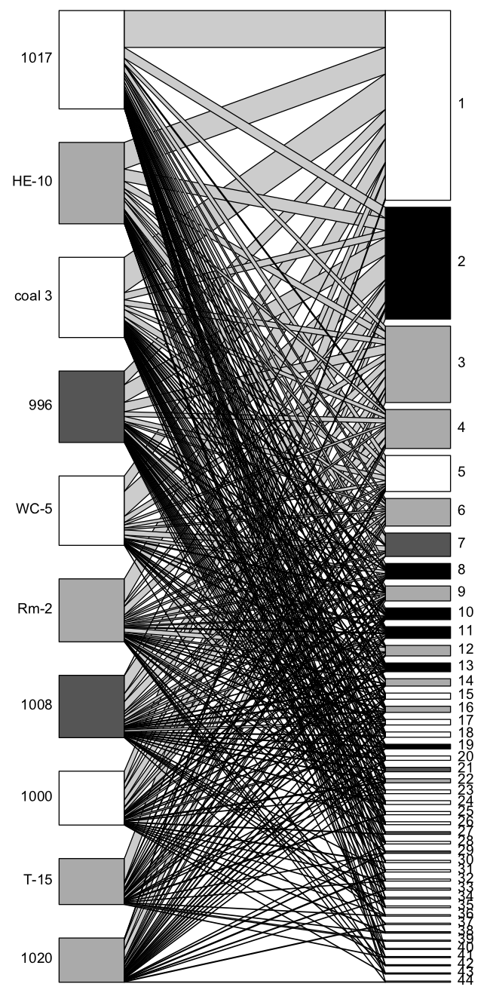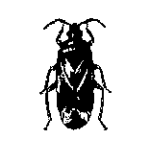

**Figure 2**

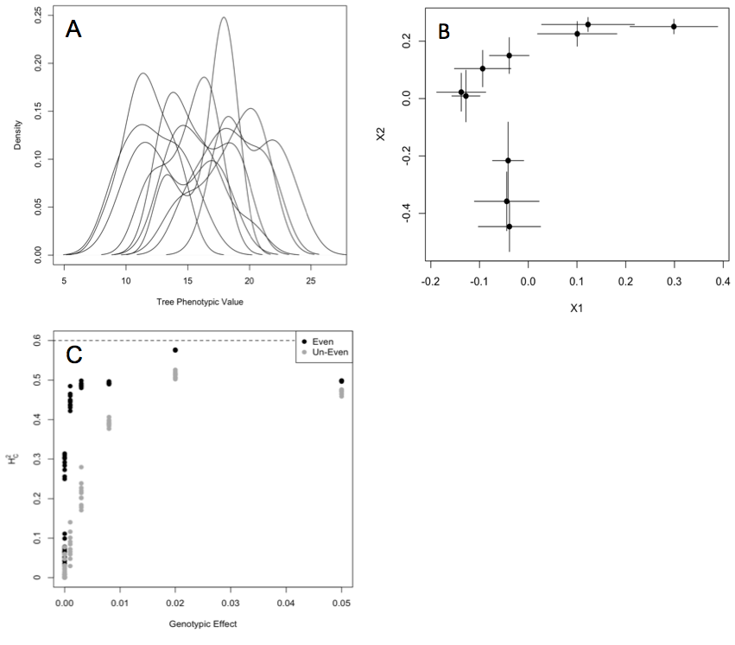

**Figure 3**

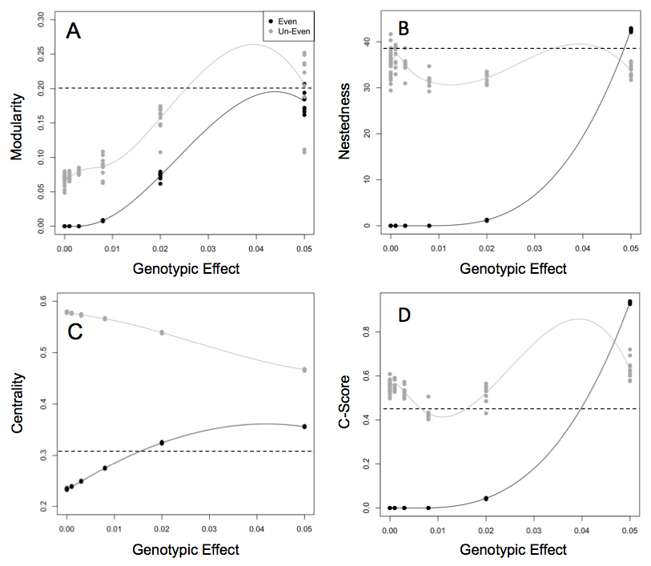

**Supplementary Materials**

Equation used for simulation experiment where equilibrium “arthropod species” abundances are determined by genetically based phenotypic variation in a “foundation species”, following the notation of Shuster *et al.* (2006):

*Genotypic Effect Variables*

= Selection Intensity term in Shuster *et al.* 2006

“Genotypic Effect” modulated in the simulation experiment

*Indices*

Foundation tree individual index

Arthropod species index

*Arthropod Variables*

Arthropod abundance at equilibrium

Arthropod carrying capacity

Arthropod trait value

Variation in the arthropod trait values

Mean arthropod trait value

*Tree Variable*

Tree phenotypic trait value,

*Environmental Variable*

Environmental variation sampled from a uniform distribution

Table of identifications for the arthropod species codes presented in the genotype-species network (Fig. 2).

|  |  |
| --- | --- |
| **Number** | **Species** |
| 1 | pb |
| 2 | Ambush.bug |
| 3 | Anthocorid |
| 4 | Araniella |
| 5 | Asilidae |
| 6 | assassin |
| 7 | Assassin..rd.blk. |
| 8 | Assilid |
| 9 | BEB |
| 10 | Beetle..unkn.blk. |
| 11 | Bp.Chalcid |
| 12 | Braconid |
| 13 | Calophorid |
| 14 | Cercopid..brn. |
| 15 | Chait..grn. |
| 16 | Clerid..rd.blk. |
| 17 | Cocc.nymph..blk.orng. |
| 18 | Coenagrionidae |
| 19 | Earwig |
| 20 | edge.mnr |
| 21 | egg.on.a.stick |
| 22 | Fly..brn.rnd. |
| 23 | Fly..gldn.Dolicho. |
| 24 | Fly..unkn.sm. |
| 25 | Formica.spp.1 |
| 26 | Formica.spp.2 |
| 27 | Formica.spp.3 |
| 28 | Globuli |
| 29 | Hymenoptera..unkn.. |
| 30 | Ichneumonid |
| 31 | Lacewing..grn. |
| 32 | Lbb..many.spt. |
| 33 | Lbb..no.spot. |
| 34 | Lf.tier |
| 35 | Lfhppr..brn. |
| 36 | Lfhppr..brnmtld. |
| 37 | Lfhppr..fisheye. |
| 38 | Lfhppr..grn. |
| 39 | Lfhppr..sknk. |
| 40 | Melyrid..gry.blk. |
| 41 | midge |
| 42 | mite.gall |
| 43 | Muscid |
| 44 | Myrm.ant |
| 45 | Paras |
| 46 | Paras..lng.thin. |
| 47 | Penta..brachy. |
| 48 | penta..rd.brn. |
| 49 | Phylla |
| 50 | punkie |
| 51 | red.mite |
| 52 | Salticid..blk.rd. |
| 53 | Salticid..zebra. |
| 54 | serp.lf.mnr |
| 55 | Snakefly |
| 56 | Spider..Araneid.blk.gry. |
| 57 | Spider..gry.crab. |
| 58 | Spider..rd.blk.Lycosid. |
| 59 | Spider..rd.wht. |
| 60 | Spider..unkn. |
| 61 | Spittle.bug |
| 62 | Spot.blotch |
| 63 | stem.borer |
| 64 | Syrphid..lttl.yllw. |
| 65 | T.dip |
| 66 | Thec..aff. |
| 67 | Thrip..blk. |
| 68 | Thrip..yllw. |
| 69 | Tip..mnr |
| 70 | Tip.roller |
| 71 | Weevil..blk. |
| 72 | Weevil..brn. |
| 73 | Weevil..gry. |