**Tree genotype directs leaf arthropod interaction network structure by modulating co-occurrence patterns**

M.K. Lau, T.G. Wojtowicz, A.R. Keith, T.G. Whitham

Target: Ecology Letters

Abstract

* Although evolutionary forces, such as selection, have been proposed as a mechanism that creates these network structures and genetic variation within foundation species has been shown to contribute to community composition and shifts in species interactions, the effect of genetic variation on the structure of ecological interaction networks has not been examined.
* Here we examine the impact that genetic variation in a tree’s response to an insect herbivore has on interaction network structure.
* We found three main results:
  + Early senescence of leaves was driven by genetically based susceptibility to *Pemphigus betae*
    - Percent leaves with *P. betae* decreased 31% from live to senesced leaves
    - *P. betae* on live leaves was heritable (=0.39, 2=6.75, *P*=0.009), but not senesced leaves (2=3.32, *P*=0.07)
    - Genotype affected composition (relativized by species max) of living leaves (*F*=1.85, *P*=0.004, *R2*=0.28)
  + Genotype does not affect SES, but genotype does affect multivariate co-occurrence patterns (MCP) for live (negative co-occurrences) and senescent (positive co-occurrences) leaves. These data are relatvized to co-occurrence maximum and use the Clarke adjustment.
    - REML for Live SES~Genotype (chi2=1.208, p=0.272) and Sen SES~Genotype (chi2=2.385, p=0.123)
    - PerMANOVA for MCP~genotype, Positive Live (R2=0.199, p=0.484), Positive Sen (R2=0.272, p=0.029) and Negative Live (R2=0.311, p=0.001) and Negative Sen (R2=0.239, p=0.135)
  + Living but not senesced genotype-herbivore bipartite network structure was significantly nested
    - Live: *z*=-2.2931, *P*=0.023
    - Senesced = *z*=-1.786, *P*=0.086
* These results demonstrate how genetic variance in a foundation species can affect the structure of an ecological interaction networks. This has important implications for both the effect of genetic diversity on communities and how natural selection may act in the context of complex ecological communities.
  + Trees influence co-occurrence patterns at the stand scale not intra-tree scale

**Introduction**

Understanding the interplay between ecological and evolutionary dynamics in the context of multi-species communities is a major research frontier. This is based on the now sizeable body of research showing that genetic variation in a single species can contribute to the structure, assembly and stability of communities (see Whitham et al. 2013 and Thompson 2013). These studies have primarily focused on the role of a single species on composition and have generally not put this in the context of shifting interactions among species (but see Bailey et al. 2007, Bolnick et al. 2011, Moya-Larano 2011 and Pires 2011). Recently, the merger of findings from the fields of ecological genetics and network ecology has lead to a new, more complete perspective of evolutionary ecology. The primary contribution of network ecology has been the development of a perspective that enables the study of structures beyond isolated species pairs (Proulx et al. 2005).

Of the many structural concepts in network theory, nestedness has played an important role in advancing the study of ecological networks and of evolution in a community context. Primarily used in the study of networks comprised of two distinct groups (i.e. bi-partite networks), nestedness is the tendency for both generalist and specialist species to interact with generalist species (Atmar and Patterson 1993). Studied predominantly in mutualistic networks, nestedness has been shown to increase diversity (Bascompte et al. 2006). One mechanism for the effect of nestedness is that it should minimize competition among species within each part of the network (Patterson and Brown 1991). It has often been concluded that nestedness arises in ecological networks through selection for species interactions that lead to nestedness.

Genetic variation in foundation species is likely to contribute to the structure of ecological interaction networks. Genetic diversity has previously been shown to have positive effects on arthropod species’ diversity in ecosystems (Wimp et al. 2004, Crutsinger et al. 2006, Agrawal???, Strauss???). Genetic variation in plant species, such as cottonwoods (Keith et al. 2010) and evening primrose (Agrawal et al. 20??), has also been shown to affect insect community composition. In addition, plant genetic similarity has also been shown to the similarity of the communities of arthropods associated with cottonwoods (Bangert et al. 2005) and eucalypts (Barbour et al. 2011). Thus, because genetic variation leads to distinct but overlapping communities of associated species, it is possible that these compositional effects will lead to nestedness of arthropods and other groups of interacting species.

Although studies of nestedness have often employed an evolutionary perspective, all such empirical studies have been at the scale of species-species interaction networks. DISCUSS Bailey et al. 2007, Bolnick et al. 2011, Moya-Larano 2011 and Pires 2011.

Here, we study the structure of interactions between leaf modifying arthropods and a foundation species, *Populus angustifolia* James (narrowleaf cottonwood), to examine how genetically based variability influences interaction network structure. We use a common garden to experimentally separate the community level effects of phenotypic variation by minimizing and randomizing local environmental variation. We set out to test the main hypothesis that genetic variation in traits determining interactions can lead to nestedness in ecological interaction networks and the ensuing hypothesis that genetically based variation in traits involved in a plant-herbivore interaction contribute to nestedness. We begin by testing whether or not plant genotype contributes to nestedness of a plant interaction network by influencing community composition. We then explore how genetically based variation in traits controlling an interaction with a keystone herbivore contributes to network structure. These findings have important implications for both ecological and evolutionary theory, as a genetic basis to nestedness would provide a means for selection to act on ecological interaction network structure and a new mechanism for how genetic variation contributes to community stability.

**Methods**

*Common Garden Design*

Location, Pit site in Uintah. Genotypes largely originated from nearby site (screen). Replicated genotypes. Randomly planted in 1991 (Martinsen et al. ????). Genotypes identified by RFLP.

*Leaf-modifying Insect Observations*

Insect observations were conducted on both living and senescing leaves. This was done in order to illucidate how tree sensescence, which is known to be driven by *P. betae*, to influence network structure.

*Network Modeling*

Bipartite network builder and Araujo method

*Statistical Analyses and Software*

REML, PERMANOVA, t-test, Nestedness, nestedness temperature, co-occurrence null modeling, SES, C-Score, vegan, bipartite, ComGenR, ecodist

**Results**

* + Living but not senesced genotype-herbivore bipartite network structure was significantly nested
    - Live: *z*=-2.2931, *P*=0.023
    - Senesced = *z*=-1.786, *P*=0.086
  + Genotype affected composition (relativized by species max) of living leaves (*F*=1.85, *P*=0.004, *R2*=0.28)
  + Both living and senesced leaves showed significant co-occurrence patterns with high amounts of community aggregation
    - SESlive = -7.865, P << 0.001
    - SESsenesced = -4.447, P << 0.001
    - Co-occurrence network structure differed between live and senescent (QAP: *z*=7.454, *P*<<0.001)
    - Genotype did not influence co-occurrence patterns within trees (2=0.00, *P*=1.00)
  + Early senescence of leaves was driven by genetically based susceptibility to *Pemphigus betae*
    - Average percent leaves with *P. betae* decreased 31% from senescing to live leaves (Paired t=-5.5791, df=34, P<<0.001)
    - The percent of leaves with *P. betae* was heritable for live (=0.39, 2=6.75, *P*=0.009), but not senescent leaves (2=3.32, *P*=0.07)
    - The frequency of leaves with gall free and single gall leaves varied among genotypes for live leaves (REML: X2=6.701,P=0.0096 and X2=6.27,P=0.012), while the frequency of leaves with 2 gall leaves varied among genotypes for senescent leaves (REML: X2=4.045,P=0.044).

Discussion

Acknowledgements

References

Tables

**Figure Legends**

Figure 1. Plots showing the genetic basis of the gall forming herbivore (*Pemphigus betae*) susceptibility and leaf modifier community composition. (A) Barplot showing the variation in *P. betae* abundance among genotypes. (B) NMDS ordination of the leaf modifier with a vector showing the correlation with *P. betae* abundance.

Figure 2. Plot of the leaf modifier uni-partite network. Species (see Supplementary Materials, Table 1) are shown as nodes (i.e. points) scaled by the log of their total abundance and the difference in significant co-occurrence patterns between the living and senescent leaves are shown as edges (i.e. lines) connecting points.

Figure 3. (A) Live and (B) senesced genotype-insect networks.

Figure 1

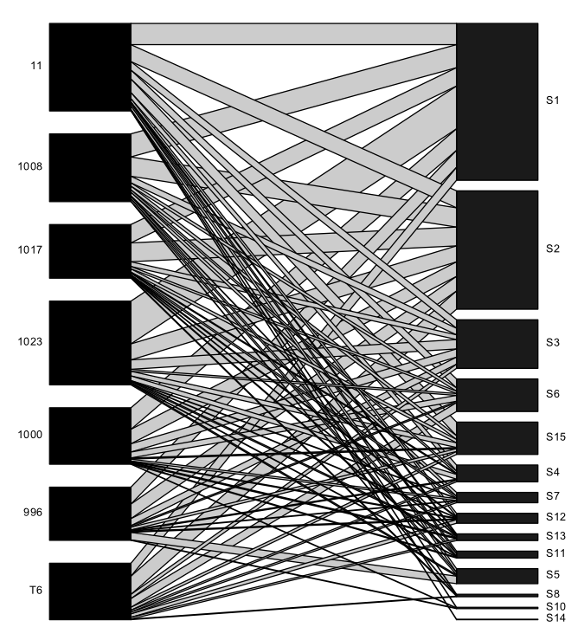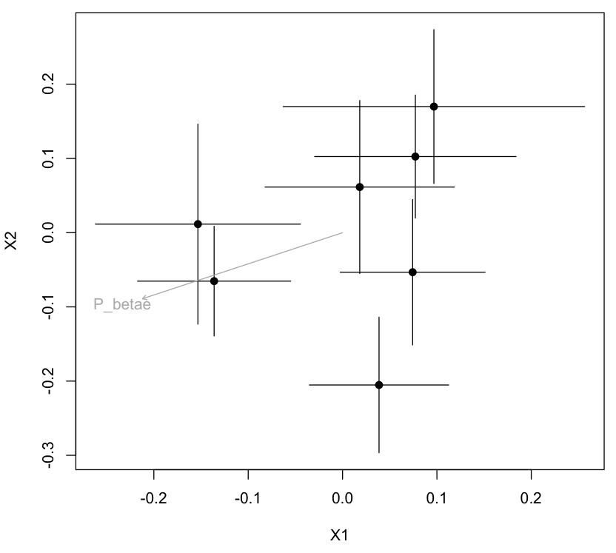

Figure 2.

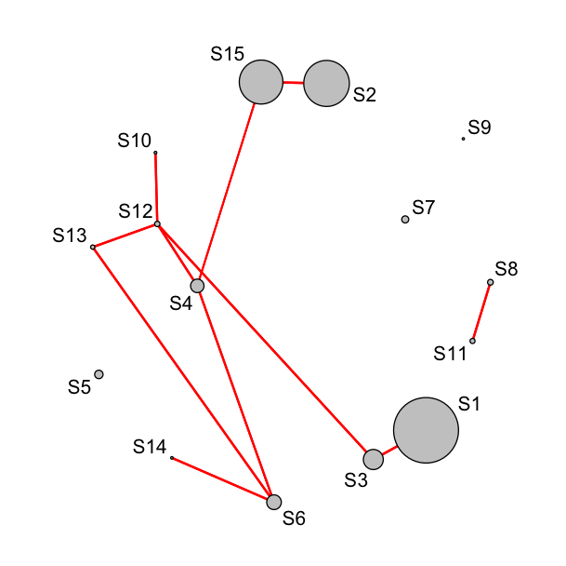

Figure 3

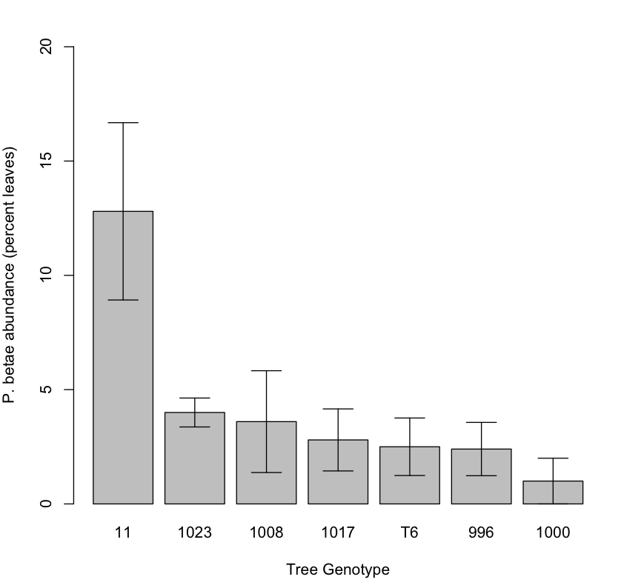

Supplementary Materials

Table 1. Leaf modifiers associated with labels used in figures.

|  |  |
| --- | --- |
| Label | Leaf Modifier |
| S1 | chew.edge = ? |
| S2 | Scrape = ? |
| S3 | Chomp = ? |
| S4 | pb.pred = ? (Phorid) |
| S5 | pb.abort = Pemphigus |
| S6 | chew.holes = |
| S7 | Thrips = Thysanura |
| S8 | Tier = geometridae |
| S9 | fish.eye = leafhopper |
| S10 | tip.miner = Geometridae 1 |
| S11 | edge.miner = Geometridae 2 |
| S12 | mid.miner = Gemoetridae 3 |
| S13 | Pinch = Phylacolpa |
| S14 | edge.fold = Phylacolpa |
| S15 | Pb = Pemphigus |