**Genetic variation in foundation species leads to species co-occurrence patterns and nested ecological networks**

M.K. Lau, Stuart, Shuster, Kim, Tom

Target: Ecography, PLoS Biology

* Genetic variation within foundation species is known to have profound effects at the community and ecosystem scales,
* Although the consequences of this variation are known to impact biological diversity across multiple spatial scales, the effect this variation has on the structure of ecological interaction networks has not been explored,
* In this study, first, we use a mass-action community simulation method to develop a framework for the contribution of genetic variation to interaction network structure, and, second, we test this framework using several empirical community datasets,
* We found two main results:

1. Simulations showed that co-occurrence patterns and network nestedness increased with genetic variation in the foundation species
2. Empirical genotype-species networks exhibited significant co-occurrence patterns and nestedness in line with simulations

* These results strongly suggest that nestedness naturally arises in communities via intraspecific genetic variation in foundation species, and because this variation is heritable provides a means for evolution to act on ecological interaction network structure via natural selection.

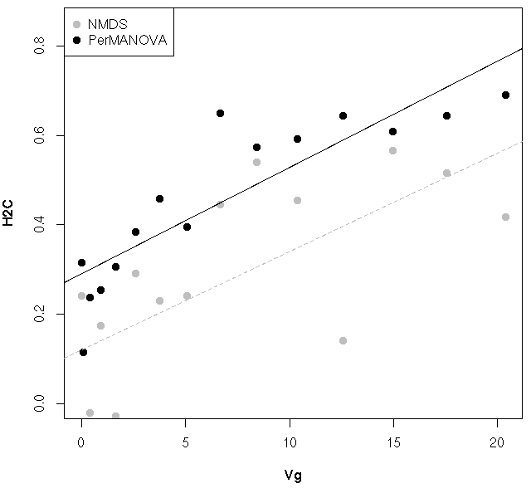

**Figure 1.** Scatterplot of the relationship between the true genotypic variance (Vg) and the two estimates of community heritability (H2C) using NMDS ordination and PerMANOVA

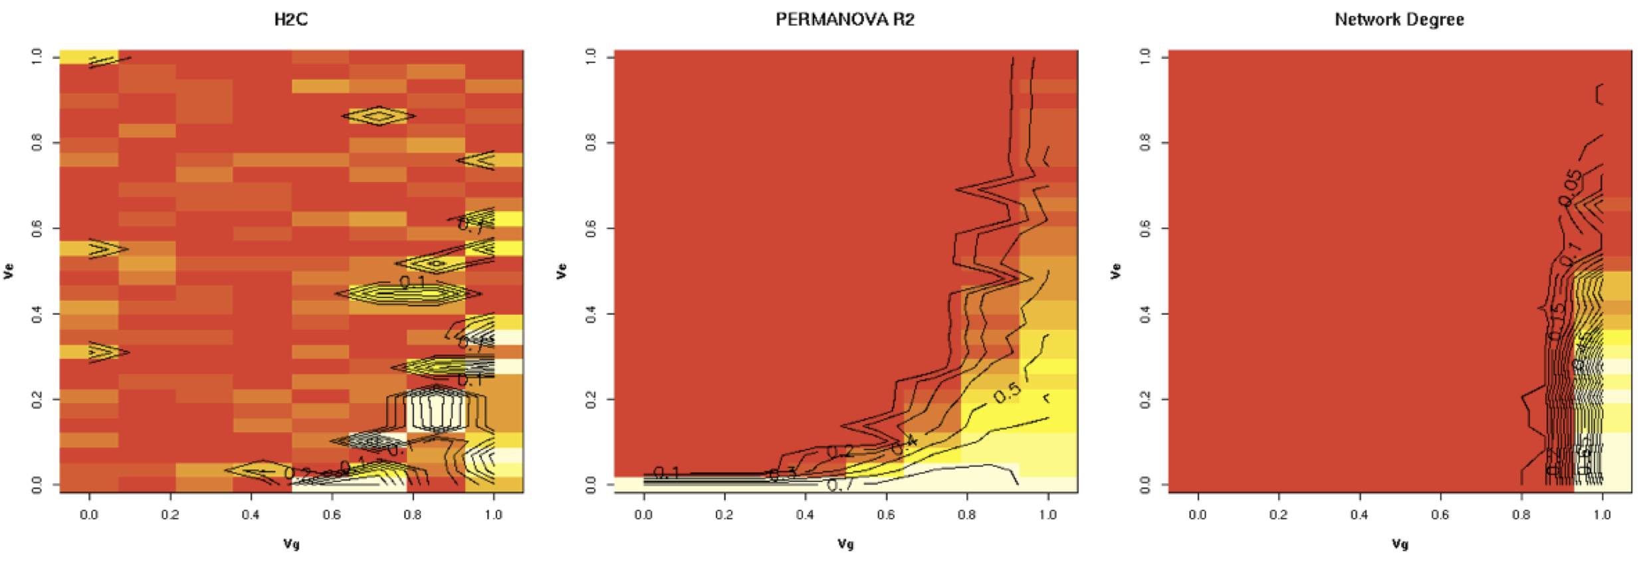

**Figure 2.** Heatmaps showing the relationships between H2C based on NMDS (left) and PerMANOVA (center) and the number of significant co-occurrence patterns (Network Degree; right) given both genetic variance of the foundation species (x-axis = Vg) and the environmental variance (y-axis = Ve).

[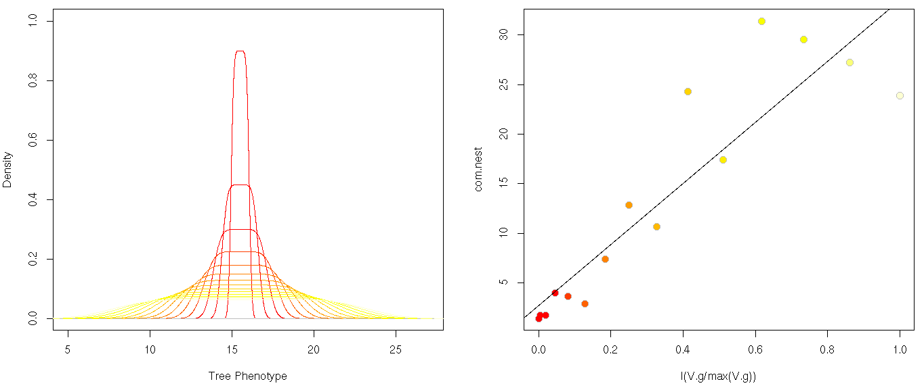](https://f.cloud.github.com/assets/5342857/1916311/c86eea6a-7d75-11e3-9af3-069c1797cb7f.png)

**B**

**A**

**Figure 3.** Plots of the (A) densities of tree phenotypic values at different levels of foundation species genetic variance (increasing from red-yellow) and (B) the relationship between the relativized foundation species genetic variance (increasing from red-yellow) and the nestedness of the interaction network (P <<< 0.001).

[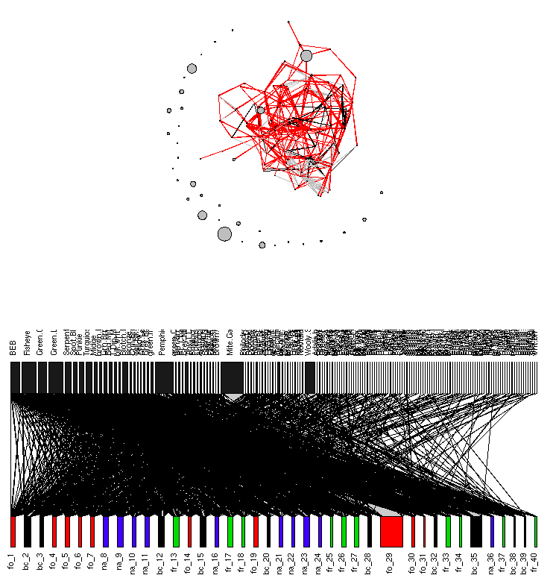](https://f.cloud.github.com/assets/5342857/1844868/e70e42f4-755a-11e3-858a-413b3fa2e4f3.png)

**Figure 4.** Networks for the Wimp et al. 2005 arthropod community dataset. The co-occurrence patterns based on the network modeling procedure of Araujo et al. 2011 (top) showing species as nodes (scaled by the log total abundance) connected by black edges (values less than 0.5), red edges (values less than 0.5) and grey edges (values equal to 0.5) and the bipartite tree-species network with nodes (upper = arthropod species, lower = tree individuals colored by cross-type) scaled by the total abundance and position (left-right) by the number of connections.