**The meat of the paper seems solid! The main improvements I think will come from making sure your concepts are clearly defined and connecting with a broad audience by bringing in a couple ecological examples to show why your findings are so cool and applicable to real world communities.**

**May be nice to mention that bipartite networks often consist of a primary producer and primary consumer, or some example, to ground it more in ecology.**

**Definitely clarify what you been by the general term 'genetic effect'. Rather your explanation made a lot of sense when you described it as increased phenotypic variation. And be sure to clarify if this is different from selection strength.**

**Keep up the good work:)**

**No genotype is an island: Genetic variation creates nested ecological networks**

The Adam Wymore, M.K. Lau, S.R. Borrett, S.M. Shuster, A.R. Keith, M.A. Fortuna T.G. Whitham

Target Journal: PLoS Biology?, Ecology Letters?, Others???

Corresponding Author Information:

Department of Biological Sciences and

Merriam-Powell Center for Environmental Research

Northern Arizona University

Flagstaff, AZ 86011-5640

Email: [mkl48@nau.edu](mailto:mkl48@nau.edu)

Phone: 928-523-9534

**Abstract**

* Studies of ecological networks have demonstrated the importance of indirect effects of interactions in communities to contribute to community dynamics; however, although the majority of these studies use an evolutionary perspective, no empirical studies have explored the genetic basis of these patterns.
* Here, using long-term common gardens of plants with known genetic makeupmakeup, we investigate how genetic variation in a foundation tree species contributes to interaction network structure and what functional consequences this might have for evolutionary dynamics.
* We first analyze an empirical genotype-species dataset for how genotypic variation contributes to interaction network structure. We then conduct a series of simulation experiments to explore how genetic variation can contribute to network structure and the consequences this structure can have on community robustness.
* We found three major results:
  1. An empirical genotype-species network exhibited significant nestedness under the most conservative null model of network structure,
  2. The nestedness of simulated genotype-species networks increased as the effect of genetic variation increased,
  3. When genotypic effects and ecological diversity were both high, selection on phenotypically similar genotypes had the highest impact on community robustness.
* These findings demonstrate that the community level impact of genetic variation in a foundation species can alter the structure of species interaction networks, leads to more stable communities. This work points to a previously overlooked consequence of genetically based, intra-specific diversity and provides a mechanism for evolution to act on ecological network structure. This study presents a major step toward incorporating a genetics based, evolutionary perspective into ecological network theory..

**Keywords:** foundation species, ecological networks, species interactions,nestedness, robustness, genetics of networks, common gardens, long-term experiment

**Introduction**

Evolutionary processes play an integral role in creating biological diversity. Species interactions have been shown repeatedly to drive the evolution of biological diversity, contributing to a continual process of evolutionary dynamics (Thompson 2013). Genetic variation itself has been shown to influence a suite of community and ecosystem level patterns (reviewed in Whitham et al. 2012, Gugerli et al. 2013). Because different plant genotypes have been shown to support different communities, one important, specific example is that greater genetic diversity within a species leads to higher diversity of communities associated: such as insects associated with *Populus* spp., *Solidago* *canadensis* and *Oenothera* *bienis* (Wimp et al. 2005, Crutsinger et al. 2006 and Johnson and Agrawal 2007, respectively). One generative mechanism for this pattern is the genetic similarity rule (Bangert et al. 2006, Barbour et al. 2009, Zytinska et al. 2011, Meneses et al. 2012, Ferrier et al. 2013), which states that the greater the genetic differences of two individuals, the greater the differences in their in their phytochemistry and other traits, creating greater differences in community composition and their interactions with associated species. These differences as scale from local to regional levels (Bangert et al. 2008, Bernhardsson et al. 2013). Evolutionary processes play an integral role in creating biological diversity and are now recognized to function on time scales equivalent with ecological dynamics (need citations. Franks et al 2007?).. Species interactions are recognized as contributing to the continual process of evolutionary dynamics in ecosystems Maybe talk about radiations due to pollination? (Thompson 2013). Studies of the evolution of species interactions have historically focused on species pairs (e.g., the actual species pair in Ehrlich and Raven 1964); however, ecosystem studies have lead to an understanding of the relevance of indirect effects for both ecological and evolutionary dynamics (Patten and Higashi 1991; Wootton 1994, Keith et al?).). Recently, eco-evolutionary studies have begun to recognize and explore the role of evolution in the context of complex communities (Whitham et al. 2006; Fussman et al. 2007).

The introduction of network approaches to ecology has provided2006, Smith et al. 2011), this genetics based perspective of community ecology has not yet considered the effect that genetic variation can have on interactions within the context of complex networks of species or individuals.

The mathematical and conceptual treatment of both direct and indirect effects of species interactions.. Put simply, the network perspective facilitates the quantification and conceptualization of relationships (Borrett et al. 2012). Although the concept of the ecological network, or “tangled bank,” dates backat least to Darwin (1859), it was almost a century later that ecologists began to rigorously explore the effects that interaction network structure cancancancancan have on ecological dynamics (MacArthur 1955).Within the context of community ecology, the application of network methods has produced insights into community stability (May 1972,, Cohen et al. 1981,, Schmitz et al. 2010), ecosystem development (Ulanowicz 1981), and indirect effects (Patten and Higashi 1991).).).

Recently, studies using a bipartite network perspective have propelled our understanding of co-evolution in complex communities of interacting species. Bipartite networks are composed of two groups of species that interact more strongly across than within “parts” of the network (Fig. 1). Investigations into the structure of these networks have shown consistent(repeatable? or common across different species studies?)patterns (Bascompte et al. 2003, Vasquez et al. 2009, Thebault and Fontaine 2011). In particular, nestedness, in which specialist species interact with subsets of the community thanthat more generalized species interact with (Fig. 1; Patterson and Atmar 1986), has been observed repeatedly in many types of networks (Bascompte 2010). Evidence from simulated species removal studies suggestssuggestssuggestssuggestssuggests that nestedness contributes to community stability and species co-existence by minimizing competition among species (Bascompte et al. 2006; Fortuna and Bascompte 2006).).

Intra-specific genetic variation is likely an important but overlooked contributor to ecological network structure. Vasquez et al. (2009) clearly reviewed how ecological and evolutionary processes and observation influence bipartite network structure. In particular, phylogeneticstudies of bipartite networks have demonstrated evidence for the evolutionary contribution to bipartite networknetworknetworknetworknetwork structure with phylogeny explaining patterns in interaction overlap among species (Rafferty and Ives 2013).These phylogenetic patterns likely arise from trait similarity between more closely related lineages, which then leads to similarity in interactions (Rezende et al. 2007). Although the phylogenetic approach demonstrates how evolutionary processes, which contribute to similarities among closely related species, can contribute to interaction network structure, all of this work has been conducted at the level of species-species interaction networks.....

Similar to the effects of phylogenetic similarity, intra-specific genetic variation has been shown to have community level effects that could contribute to interaction network structure. Genetic variation in one species has been shown to lead to higher levels of ecological diversity in the associated community (Wimp et al. 2005; Crutsinger et al. 2006). The genetic similarity rule of community assembly, where individuals that are more genetically similar tend to interact with similar species in the regional species pool, is one potential explanation for this pattern (Bangert et al. 2007). Multiple studies have now demonstrated that plant genetics can affect the composition) have been shown to operate below the species level (Wimp et al. 2005, Bangert et al. 2007, of associated communities,: such as insects associated with *Populus* spp., *Oenothera* *bienis* and *Eucalyptus* spp. (Keith et al. 2010, Johnson and Agrawal 2007 and Barbour et al. 2010, respectively). ).2007 and Smith et al. 2011), we are aware of no studies that have considered the effect that intra-specific genetic variation can have on interaction network structure.

In this study, we explore the properties of genotype-species networks and the genetic basis for interaction network structure. We focus on interactions between genotypes of a foundation species (Dayton 1972) and their associated communitties (Fig.community (Fig. 1),1), as network structure at this level has important consequences for community dynamics 1) because of the strong impact that foundation species have in ecosystems (Ellison et al. 2005, ). First, we examine the structure of an empirical, genotype-species network of the foundation species *Populus angustifolia* and its associated canopy arthropod community. We hypothesizedWeWeWe that genetically based phenotypic variation contributes to nestedness in ecological networks. Second, becauseinter-correlated processes beyond genetics produce empirical network structure, we used a communitycommunitycommunitycommunitycommunity genetics simulation method to isolate the effect of genetic variation and demonstrate how it can can influence network structure. Lastly Third, we examinedexamine the interaction between network structure and the diversity of the associated community in the context of selection on the foundation species. Demonstrating a link between genetic variation and network structure and dynamics will revealrevealrevealrevealdynamicsreveal how genetic diversity impacts ecological communities and how selection acts on species interactions in complex communities.

**Methods**

*Empirical network analysis*

A network of interactions between canopy arthropod species with genotypes of *Populus angustifolia* James (narrowleaf cottonwood) was modeled using field data from Keith et al. 2014. Observations of canopy arthropod species were conducted on individual trees of knownknown genetic identity. Replicate clones of genotypes collected from the Weber River Watershed (Utah, U.S.A.) were randomly randomly in 2009 in a common environment in order to both minimize and randomize the effects of environmental variation (Martinsen et al. 2001). Surveys of four replicate trees of 10 genotypes (n = 40 trees) were conducted in August of 2009 using timed sampling of similarly sized branches (see Keith et al. 2010). Genotype averages for the abundances of all arthropod species were then calculated to construct a genotype-species network.

We then explored the structure of the genotype-species network, focusing on nestedness. Nestedness was calculated for the observed network using the nestedness temperature metric developed by Atmar and Patterson (1993, see also Rodríguez-Gironés and Santamaria 2006). This method measures the degree to which species tend to interact with subsets of the community by comparing the observed network to a “low temperature” or non-nested re-arrangement. We tested for the significance of the nestedness statistic using a conservative null-model based randomization procedure that limits the randomizations used in the test to matrices that maintain the original genotype and species marginal totals, oftenoftenoftenoftenoften referred to as a fixed-fixed algorithm in the co-occurrence literature (Wright et al. 1998; Gotelli 2001). After an initial series of 50 “burn-in” permutations of the original matrix a total of 5000 randomizations were used to test the significance of the nestedness metric.

We also tested for the genetic contribution to nestedness. As previous studies have already demonstrated the effect of genotype on community composition and stability in this system (see Shuster et al. 2006, Keith et al. 2010), we only present analyses that test for whether or not tree genotypes differed in the strength of their interactions with the entire canopy arthropod community. In network terminology, this is termed degree. To measure the degree of each replicate tree, we first relativized all species abundances to their maximum value observed across all trees. This relativization was integral to the analysis as it places all species, which can vary greatly in total abundance, onto equal footing by rescaling all values between 0 (= absence) and 1 (= maximum abundance). Relativized abundances were then summed across all species for each tree. We then tested for the effect of genotype on degree using Restricted Maximum Likelihood (REML), which permits appropriate testing of genetic analyses by allowing for the specification of genotype as a fixed effect (Falconer and Mackay 1996,, Conner and Hartl 2004).

*Simulations of community genetic effects on nestedness and robustness*

We used the community genetics simulation method previously developed in Shuster et al. (2006). Briefly, this method starts by creating a population of individuals assigned a genotypic value (i.e.,.,., genotypes). Each genotype is comprised of multiple replicate individuals (i.e.,.,., clones), which are assigned phenotypic values as a single numeric value for each individual. This population represents the foundation species (i.e., a species that has a large effect on the community; Ellison et al. 2005). ). Next, a set of species representing the associated community was assigned an average genotypic value that was then mapped to a numerical phenotypic value using an additive, bi-allelic genetic system. At each step of genotype-phenotype mapping, variance was introduced through random draws from a uniform distribution, which simulated the introduction of phenotypic variance arising from non-genetically based “environmental” variation. It is important to note here that interactions among species, beyond the foundation species’ interaction with the community, is not explicitly accounted for in this process but introduced as a contribution to non-genetic, environmental variation. Finally, the foundation species phenotypic values for each individual were used to determine the equilibrium population value for each species given that species'species carrying capacity (Ronce and Kirkpatrick 2001; Supplementary Materials Appendix 1).

This method allows the control and manipulation of several variables that can influence network structure: 1) environmental and species interaction effects, 2) genotype and species abundances, and 3) genetic effects. For all simulations, we introduced random variation using random draws from a uniform distribution when determining the mapping of genotype to phenotype and determining the impacts of tree phenotype on the associated species. Note that interactions among community members beyond the foundation species were also modeled to produce a random effect. This is an obvious oversimplification of nature; however, we argue that this effect is not essential to the initial demonstration of the effect of genetics on interactions network structure, as it is commonly assumed that intra-partite interactions (e.g., interactions among arthropods in plant-mutualist networks) are typically relatively small by comparison or random in their effects. The abundances of individuals of each genotype and each species were held constant. The carrying capacity of all species was set at 100 individuals for all simulations with the exception of the robustness experiments. A total of 10 communities were simulated for 8 levels of genotypic effect on community composition. To do this, the co-efficient determining the effect of tree genotype (via the mapped phenotype) on each species () was adjusted by raising the power of the co-efficient per the method of Shuster et al. (2006).

To better understand/test the effect of selection strengthvarying Each of these communities was generated using the same initial phenotypes for both the “foundation species” individuals (n = 100; 10 individuals for each of 10 genotypes) and the “associated species” (25 total

To examine the stability? of these networks, we conducted a series of foundation species removal experiments. Trees were removed according to three different algorithms: 1) random removal, 2) connectedness removal and 3) phenotypic similarity. The random removal algorithm used a uniform probability distribution to select individuals. The connectedness removal algorithm assigned individuals with more interactions a higher probability for removal. The phenotypic similarity removal algorithm assigned removal probabilities by the phenotypic similarity among individuals. These algorithms were applied to the communities for species with equal carrying capacities as described above and to a second set of communities (n = 80),) in which the carrying capacities for the dependent species were selected from a Poisson distribution intended to simulate the highly skewed, “un-even” distribution of species total abundances most often observed in natural communities- I think you could cite any of Adam’s papers. That should work out great for you...... The carrying capacities of species ranged from K = 100 to K = 5.

*Simulation and analytical software*

All simulations and analyses were conducted in R version 3.0.2 (R Development Core Team 2014). REML was conducted using the *lme4* package (Bates et al. 2013). Simulations were conducted using the *ComGenR* package (Lau 2014), and simulation scripts and output are publically hosted at <https://github.com/MKLau/cg_simulations>. Non-metric multidimensional scaling (NMDS) ordination and nestedness tests were conducted with *vegan* (Okasanen et al. 2013), and networks were plotted using *bipartite* (Dormann et al. 2008).

**Results**

The cottonwood canopy arthropod genotype-species network showed significant nestedness correlated with underlying genetic variation. The nestedness was statistically different from the null expectation using the most conservative null model (Fig. 2; nested; nestedness temperature = 19.542, *P* = 0.017). Individual tree genotypesgenotypes differed significantly in theirtheir total relativized abundance values (i.e.,degree), used as a measure of the magnitude of interaction with the community (REML: 2=16.06, *P*=0.00006) – This sentence might need to be more fully explained..

Differences among genotypes altered species interaction patterns to create nestedness. Simulated tree phenotypes (Fig. 3a) produced significant variation in community composition in the simulated communities (Fig. 3b).

Nestedness of simulated communities increased with the strength of selection?. genotype. . The variation of simulated communities increased non-linearly across each of the eight levels of selectionselectionselectionselectionselection (i.e., the magnitude of the genetic effecteffecteffecteffecteffect) on nestedness (Fig. 4). The3). Note that the non-linear, exponential, trend in the effect of selection was the result of the power scaling of the co-efficient that determines selection.

Genetically based nestedness increased network robustness – You might want to give quick, parenthetical definition of network robustness..; in other words ….... Communities with carrying capacities drawn from a Poisson distribution were on average 19% less even (Pielou’s Evenness) than communities with a fixed carrying capacity for all species (*t* = 154.55, *P* <<<<<<<<<<<<<<<<<<<<<< 0.001; Fig. 44444). Networks with low evenness (i.e., high diversity) were more susceptible to removals overall, but this susceptibility was driven by the species abundances and not the effect of genotype. When species abundances were even, the effect of selection on a genetically based phenotype had a strong impact on the robustness of the community to fluctuations in the foundation species abundances? genotype composition?.

**Discussion**

The hypothesis that intraspecific variation contributes to nestedness in genotype-species networks was supported. The empirical genotype-species network of cottonwood genotypes and canopy arthropods was significantly nested, using the most conservative null model. In addition, simulations of genotype-species networks showed a strong, positive relationship between the genetic effect of the foundation species on the community and nestedness. Our hypothesis that nestedness in genotype-species networks would have functional consequences for the robustness of the community was also supported, but only when a realistically diverse distribution of species total abundances was used. These results have important implications for both the effect of genetic variation on community dynamics and the evolution of ecological networks.

*Nestedness and the effects of genetic diversity*

The finding that genotypic variation among individuals of a foundation species leads to nested genotype-species networks suggests an overlooked effect of genetic diversity. Previously, Wimp et al. (2005) showed that increased genetic diversity in stands of cottonwoods (*Populus* spp.) was correlated with increased arthropod species diversity, which was demonstrated experimentally by Crutsinger et al. (2006) with arthropod communities associated with *Solidago canadensis*. Given that the functional consequences of network nestedness that occurs for species-species mutualistic networks applies to genotype-species networks, we would expect more highly nested genotype-species networks to be more stable and diverse than less nested networks. Do you support this claim that nested networks are more stable and diverse above? I missed this, but it seems really important (seems like an Intro point). Thus, community diversity and stability arise not only through the genetic similarity rule (Bangert et al. 2006), but throughfrom the creation of nestedness as well, that likely functions in a similar way as it does in species-species networks.

Our study did not explicitly examine the effects of the associated species on the foundation species genotypes or the interactions among dependent? species. Although we did not quantify these interactions in the empirical model or manipulate them in the simulation experiments, strong asymmetry in interactions between foundation species and associated community members defines foundation species (Ellison et al. 2005), thus the potential feedbacks to the foundation species and interactions among species should be relatively small compared to the effectaffect of the foundation species on the associated community.

*Selection and evolution in nested networks*

There are three important aspects of selection to discuss here: 1) how will different modes of selection (i.e., directional, stabilizing and disruptive) on the foundation species influence network structure, 2) how does co-evolution influence the effect that this selection will have on the community and 3) how will these dynamics scale up to influence species-species networks?.

*Conclusion*

This study has only begun to explore the structure and function of the network level consequences of intraspecific genetic variation. Future work should investigate other network parametersstructures, such as centrality and modularity (Wasserman and Faust 1994; Oleson et al. 2007), and aim to expand our view of evolutionary dynamics in complex networks by investigating genotype-genotype or individual-individual networks. New methods for generating genetics and transcriptional protein data will likely provide a means toward this end with the production of high resolution data for modeling these networks (Gotelli et al. 2011; Gugerli et al. 2013; Wirta et al. 2014). In addition, methods using computational approaches to simulate *in silico* ecological networks are beginning to provide experimental means to observe eco-evolutionary dynamics in the context of alternate evolutionary systems (Fortuna et al. 2013). Future studies that investigate the network structure that arises from genetic variation will greatly advance our understanding of evolution in complex communities.

MAJOR COMMENTS: (can you see Field Ecology grading shining through?)

* I am unclear what exactly you mean by “genetic effects”, as I’ve mentioned several times in the sidebar. Is is the three removal simulations? Is this analogous to the selection event? You need to tie all these together better.
* I think you need to hammer out why looking at nestedness is super-duper important to communities.
* You mention the evolution of networks a few times. It would be nice if you gave an example of what this would look like/mean ecologically. E.g. expand on the result of one of your selection simulations and talk about the real-world consequence of it.

**Acknowledgements**

The Cottonwood Ecology lab at NAU, USA. The Bascompte Lab at Estacion de Doñana, Spain and the SEE Lab at UNCW, USA for helpful discussions on ecological networks. The Adam Wymore (TAW) would like to acknowledge TAW for being so awesome. Additionally, TAW would like to thank TAW for his clear thinking in acknowledging the awesomeness of TAW

**References**

Agrawal 2010 Current trends in the evolutionary ecology of plant defence. Functional Ecology doi: 10.1111/j.1365-2435.2010.01796.x

Thompson 2013 Relentless Evolution. Chicago University Press.

Ehrlich and Raven 1964

Patten and Higashi 1991

Wootton 1994 The Nature and Consequences of Indirect Effects in Ecological Communities. Ann. Rev. of Ecol. and Syst. 25: 443-466.

2006

Fussman GF, Loreau M, Abrams PA 2007 Eco-evolutionary dynamics of communities and ecosystems. Functional Ecology 21: 465–477.

Borrett et al. 2012

Darwin 1859

MacArthur 1955

May 1972

Cohen et al. 1981

Schmitz et al. 2010

Ulanowicz 1981

Patten and Higashi 1991

Bascompte et al. 2003 The nested assembly of plant–animal mutualistic networks. PNAS 100: 9383–9387.

Vasquez et al. 2009 Uniting pattern and process in plant–animal mutualistic networks: a review. Annals of Botany 103: 1445–1457.

Thebault and Fontaine 2011

Patterson and Atmar 1986

Bascompte 2010

Bascompte et al. 2006

Fortuna and Bascompte 2006

Fortuna et al. 2013 Evolving Digital Ecological Networks. PLoS Computational Biology 9: e1002928- e1002928.

Rafferty and Ives 2013 Phylogenetic trait-based analyses of ecological networks. Ecology 94: 2321–2333.

Rezende et al. 2007 Effects of phenotypic complementarity and phylogeny on the nested structure of mutualistic networks. Oikos 116: 1919-1929.

Rezende et al. 2007 Non-random coextinctions in phylogenetically structured mutualistic networks. Nature 448: 925-928.

Wimp, G.M., Martinsen, G.D., Floate, K.D., Bangert, R.K. and T.G. Whitham. 2005. Plant genetic determinants of arthropod community structure and diversity. EVOLUTION 59: 61-69.

Crutsinger et al. 2006

Bangert, R.K., Allan, G.J., Turek, R.J., Wimp, G.M., Meneses, N., Martinsen, G.D., Keim, P., and T.G. Whitham. 2006. From genes to geography: a genetic similarity rule for arthropod community structure at multiple geographic scales. MOLECULAR ECOLOGY 15: 4215-4228.

Keith et al. 2010

Johnson and Agrawal 2007

Barbour et al. 2010

Bailey et al. 2007

Smith et al. 2011

Dayton 1972

Ellison et al. 2005

Martinsen et al. 2001

Keith et al. 2010

Atmar and Patterson 1993 The measure of order and disorder in the distribution of species in fragmented habitat. Oecologia 96:373-382.

Rodriguez-Girons and Santamaria 2006 A new algorithm to calculate the nestedness temperature of presence–absence matrices. J. Biogeogr. 33: 924–935.

Wright et al. 1998

Gotelli 2001

Wimp et al. 2007

Keith et al. 2010

Falconer and Mackay, 1996

Conner and Hartl 2004

Ronce and Kirkpatrick 2001

Shuster, S.M., Lonsdorf, E.V., Wimp, G.M., Bailey, J.K, and T.G. Whitham. 2006. Community heritability measures the evolutionary consequences of indirect genetic effects on community structure. EVOLUTION 60: 991-1003.

R Development Core Team 2014

Bates et al. 2013

Lau 2014 R Package ComGenR. v1.0. Comprehensive R Archive Network.

Okasanen et al. 2013 Vegan.

Dormann et al. 2008 lme4.

Mougi et al. 2012 Diversity of interaction types and ecological community stability. Nature.

Oleson et al. 2007 The modularity of pollination networks. PNAS 104: 19891–19896

Smith et al. 2011 A geographic mosaic of trophic interactions and selection: trees, aphids and birds

Wirta et al. 2014 http://www.pnas.org/content/111/5/1885.full.pdf

Gugerli et al. 2013 Community genetics in the time of next- generation molecular technologies

Guimaraes and Thompson 2011 Asymmetries in specialization in ant–plant

mutualistic networks. Proc. R. Soc. B 273: 2041–2047

Guimaraes et al. 2011 Evolution and coevolution in mutualistic networks. Ecology Letters 14: 877–885.

Allesina et al. A General Model for Food Web Structure. Science 320: 658.

Wasserman, S. & Faust, K. (1994) Social network analysis: Methods and applications. Cambridge University Press, Cambridge; New York.

**Figure Legends**

Figure 1. Although interspecific variation in interaction traits is known to lead to nested ecological networks (e.g. mutualistic networks), the contribution of intra-specific variation to network structure has not been explored. This figure illustrates a hypothetical bipartite graph of a mutualistic network of plant species (left; green circles) and associated species (right; red circles) connected by light grey lines representing their interactions at the level of a species-species network. The center set of green nodes shows intraspecific variation within the top-most plant species represented by individuals of two genotypes (darker vs. lighter green) that have distinct phenotypes that affect their interactions between species (dark grey lines). Note that the species-species network assumes random variation among individuals within a species; whereas, the genotype-species networks shows the potential for non-random variation based on the genetic similarity rule.

individualFigure 2. The barplot shows the genotypic variation in the total percent species maximums summed across all species for a given tree showing that differ genotypes significantly in the degree to which they interact with the arthropod community. The network shows the empirical bipartite genotype-species

3The scatterplot on the left shows the effect of selection intensity on nestedness temperature. The effect of selection on nestedness increases non-linearly because levels of selection intensity were scaled exponentially. An example simulated bipartite genotype-species network is shown on the right with tree genotype (left) and associated species (right) where connections are scaled by the average species abundance across genotype replicates and nodes are scaled by the number of connections. This network displays a high degree of nestedness with genotypes and species of lower connectedness being subsets of the community.

Figure 44444. Scatterplots showing the relationship between selection intensity and the percent trees removed for the first extinction metric (see methods) for (A) high (=equal carrying capacities) and (B) low evenness (i.e. high diversity, Poisson distributed carrying capacities) communities for three tree individual removal scenarios: red = random, green = preference for higher connectedness and blue = preference for phenotypic similarity.

Figure 1.

Macintosh HD:Users:Aeolus:projects:dissertation:projects:een:results:FIG_genotype_species_network.pdf

Figure 2.

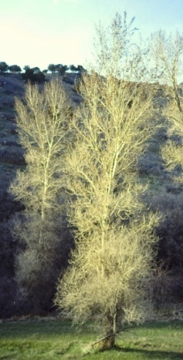

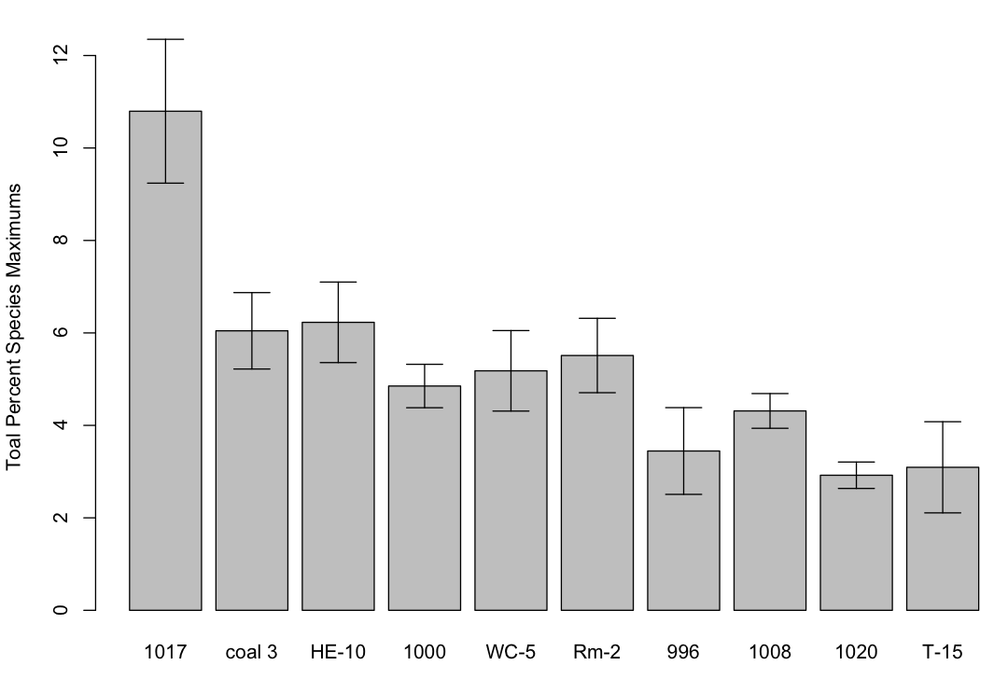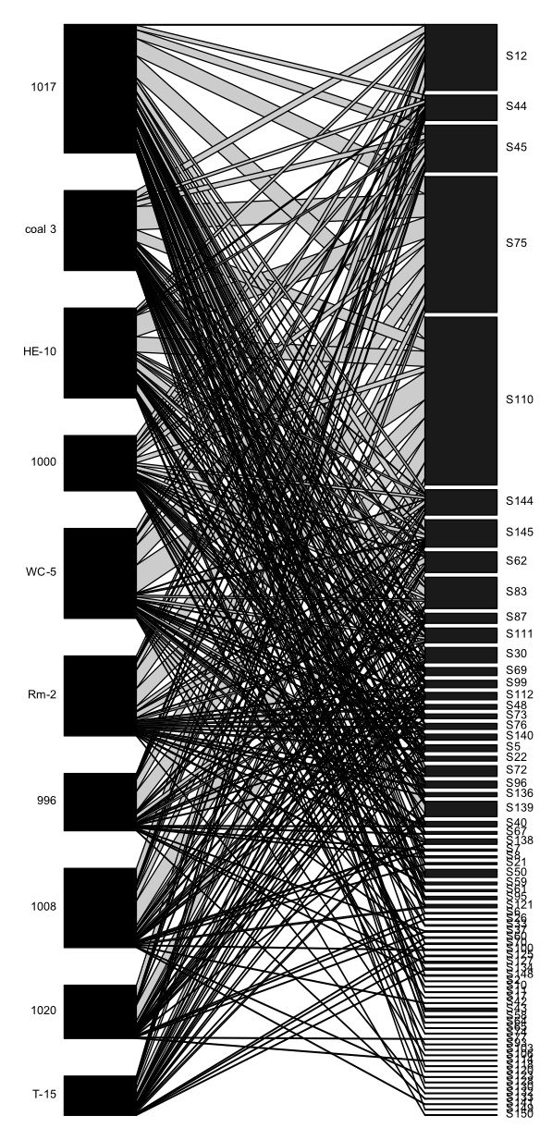

Figure 3.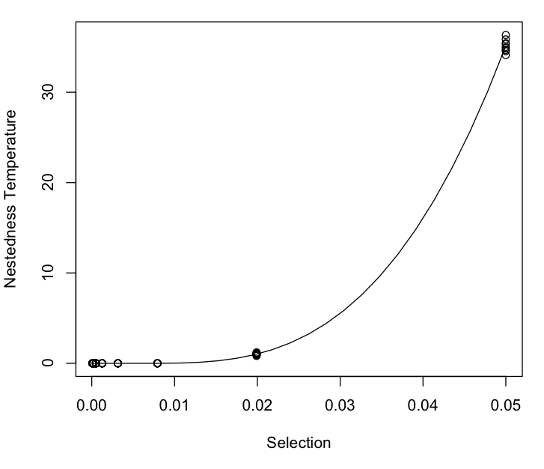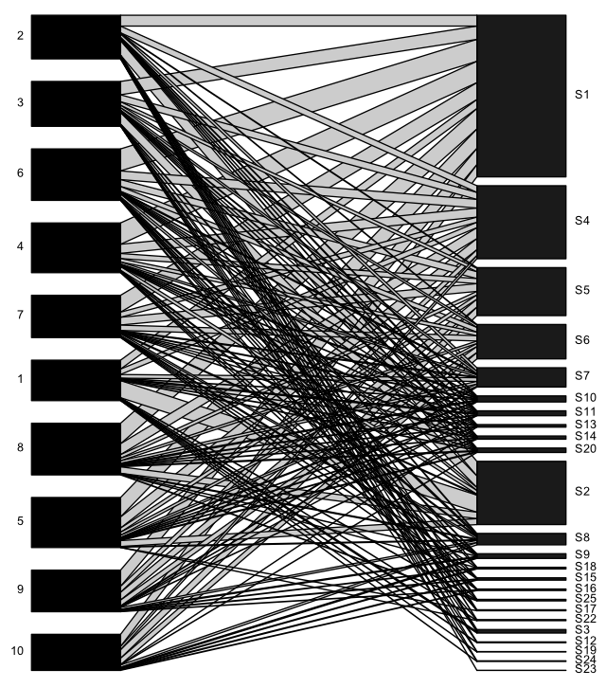

4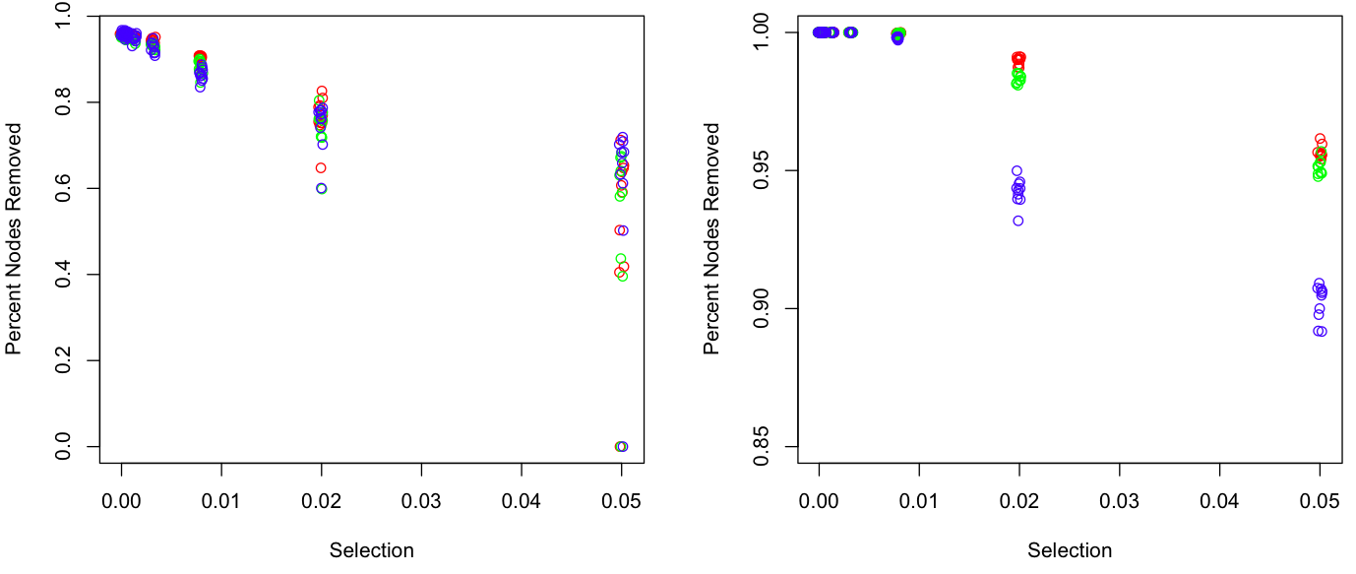

**A**

**B**

**A**

**B**

**A**

**B**

**A**

**B**

**Supplementary Materials**

**Appendix 1. Method for manipulating tree genotypic effects on the community**

**Equation 1**.

**Appendix 2. Simulated tree phenotypic distributions and community ordination**

1. Plots of the (A) densities of tree phenotypic values and (B) the NMDS ordination of the simulated communities for each tree genotype showing the centroids 1 S.E. for the community of each genotype.

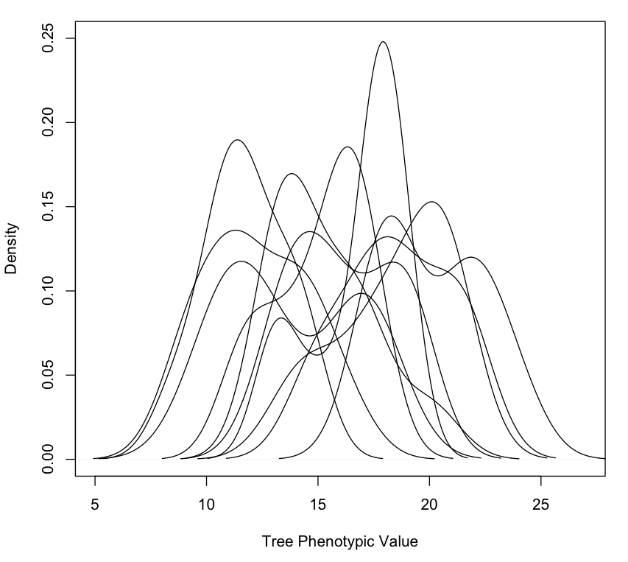

**A**



**B**

**A**



**B**

**A**



**B**

**A**



**B**

**A**

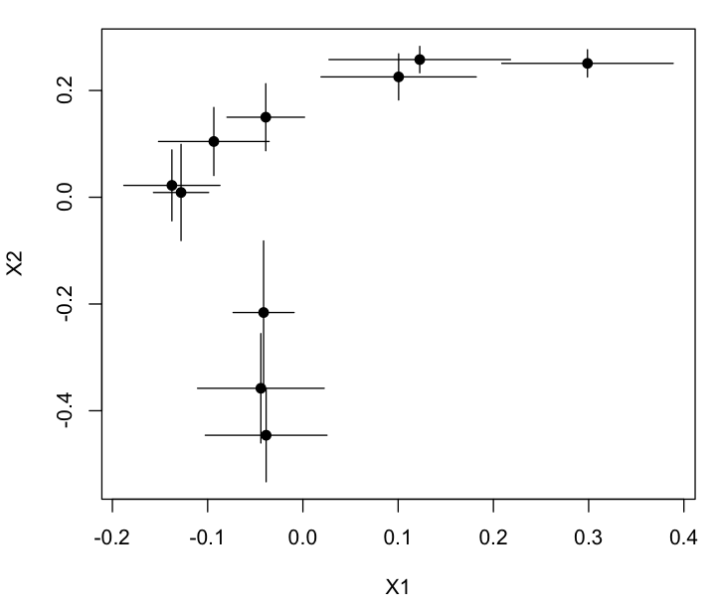

**B**