**No genotype is an island: Genetic variation creates nested, robust ecological networks**

M.K. Lau, S.R. Borrett, S.M. Shuster, A.R. Keith, M.A. Fortuna T.G. Whitham

Target Journal: PLoS Biology?, Ecology Letters?, Others???

Corresponding Author Information:

Department of Biological Sciences and

Merriam-Powell Center for Environmental Research

Northern Arizona University

Flagstaff, AZ 86011-5640

Email: [mkl48@nau.edu](mailto:mkl48@nau.edu)

Phone: 928-523-9534

**Abstract**

* Studies of ecological networks have demonstrated the importance of indirect effects of interactions in communities to contribute to community dynamics; however, although the majority of these studies use an evolutionary perspective, no empirical studies have explored the genetic basis of these patterns.
* Here, we investigate structural patterns that genetic variation in a foundation species contributes to interaction network structure and what functional consequences this might have for evolutionary dynamics.
* We first analyze an empirical genotype-species dataset for how genotypic variation contributes to interaction network structure. We then conduct a series of simulation experiments to explore how genetic variation can contribute to network structure and the consequences this structure can have on community robustness.
* We found three major results:
  1. An empirical genotype-species network exhibited significant nestedness under the most conservative null model of network structure,
  2. The nestedness of simulated genotype-species networks increased as the effect of genetic variation increased,
  3. When genotypic effects and ecological diversity were both high, selection on phenotypically similar genotypes had the highest impact on community robustness.
* These findings demonstrate that the community level impact of genetic variance can alter the structure of species interaction networks, which leading to more stable communities. This work points to a previously overlooked consequence of genetically based, intra-specific diversity and provides a mechanism for evolution to act on ecological network structure. This study presents a major step toward incorporating a genetics based, evolutionary perspective into ecological network theory.

**Keywords:** foundation species, ecological networks, species interactions,nestedness, robustness

**Introduction**

Evolutionary processes play an integral role in creating biological diversity and are now recognized to function on time scales equivalent with ecological dynamics. Species interactions are recognized as contributing to the continual process of evolutionary dynamics in ecosystems (Thompson 2013). Studies of the evolution of species interactions have historically focused on species pairs (e.g., Ehrlich and Raven 1964); however, ecosystem studies have lead to an understanding of the relevance of indirect effects for both ecological and evolutionary dynamics (Patten and Higashi 1991; Wootton 1994). Recently, eco-evolutionary studies have begun to recognize and explore the role of evolution in the context of complex communities (Whitham et al. 2006; Fussman et al. 2007).

The introduction of network approaches to ecology has provided mathematical and conceptual treatment of both direct and indirect effects of species interactions. Put simply, the network perspective facilitates the quantification and conceptualization of relationships. Although the concept of the ecological network, or “tangled bank,” dates back at least to Darwin (1859), it was almost a century later that ecologists began to rigorously explore the effects that interaction network structure can have on ecological dynamics (MacArthur 1955). Within the context of community ecology, the application of network methods has produced insights into community stability (May 1972; Cohen et al. 1981; Schmitz et al. 2010), ecosystem development (Ulanowicz 1981), and indirect effects (Patten and Higashi 1991).

Recently, studies using a bipartite network perspective have propelled our understanding of co-evolution in complex communities of interacting species. Bipartite networks are composed of two groups of species that interact more strongly across than within “parts” of the network (Fig. 1). Investigations into the structure of these networks have shown consistent patterns of interaction network structure (Bascompte et al. 2003, Vasquez et al. 2009, Thebault and Fontaine 2011). In particular nestedness, where more specialized species interact with subsets of the community that more generalized species interact with (Fig. 1; Patterson and Atmar 1986), has been observed repeatedly in many types of networks (Bascompte 2010). Evidence from simulated species removal studies suggests that nestedness contributes to community stability and species co-existence by minimizing competition among species (Fortuna and Bascompte 2006).

Intra-specific genetic variation is likely an important but overlooked contributor to ecological network structure. Vasquez et al. (2009) very clearly reviewed how ecological and evolutionary processes influence bipartite network structure. In particular, phylogenetic studies of bipartite networks have demonstrated evidence for the evolutionary contribution to bipartite network structure with phylogeny explaining patterns in interaction overlap among species (Rafferty and Ives 2013). These phylogenetic patterns likely arise from trait similarity between more closely related lineages, which then leads to similarity in interactions (Rezende et al. 2007). Although the phylogenetic approach demonstrates how evolutionary processes leading to species similarities can contribute to interaction network structure, all of this work has been conducted at the level of species-species interaction networks.

Similar to the effects of phylogenetic similarity, intra-specific genetic variation has been shown to have community level effects that could contribute to interaction network structure. Genetic variation in one species has been shown to lead to higher levels of ecological diversity ((Wimp et al. 2005; Crutsinger et al. 2006). The genetic similarity rule of community assembly, where individuals that are more genetically similar tend to interact with the similar species in the regional species pool, is one potential explanation for this pattern (Bangert et al. 2007). Multiple studies have now demonstrated that plant genetics can affect the composition of associated communities: such as insects associated with *Populus* spp., *Oenothera* *bienis* and *Eucalyptus* spp. (Keith et al. 2010, Johnson and Agrawal 2007 and Barbour et al. 2010, respectively). Although previous work has considered the effects that genetic variation can have on tri-trophic interactions (Bailey et al. 2007 and Smith et al. 2011), we are aware no studies that have considered the effect that genetic variation can have on interaction network structure.

In this study, we explore the properties of genotype-species networks and the genetic basis for interaction network structure. We focus on interactions between genotypes of a foundation species (Dayton 1972; Ellison et al. 2005) and its associated community (Fig. 1). First, we examine the structure of an empirical, genotype-species network of a foundation species (*Populus angustifolia*) and its associated canopy arthropod community. We hypothesize that genetically based phenotypic variation contributes to nestedness in ecological networks. Second, because inter-correlated processes beyond genetics produce empirical network structure, we use a community genetics simulation method to isolate the effect of genetic variation and demonstrate how it can influence network structure. Last, we test how the loss of genetic diversity (i.e., a disturbance event) in the simulated communities can impact network robustness. Demonstrating a link between genetic variation and network structure and robustness will add to our understanding of both how genetic diversity impacts ecological communities and how selection acts on species interactions in complex communities.

**Methods**

*Empirical network analysis*

An network of interactions between canopy arthropod species with genotypes of *Populus angustifolia* James (narrowleaf cottonwood) was modeled using data from Keith et al. 2014. Observations of canopy arthropod species were conducted on individual trees of know genetic identity. Replicate clones of genotypes collected from the Weber River Watershed (Utah, U.S.A.) were planted randomly in 2009 in a common environment in order to both minimize and randomize the effect of environmental variation (Martinsen et al. 2001). Surveys of 4 replicate trees of 10 genotypes (n = 40 trees) were conducted in August of 2009 using timed sampling of similarly sized branches (see Keith et al. 2010). Genotype averages for the abundances of all arthropod species were then calculated to construct a genotype-species network.

We then explored the structure of the genotype-species network, focusing on nestedness. Nestedness was calculated for the observed network using the nestedness temperature metric developed by Atmar and Patterson (1993, see also Rodríguez-Gironés and Santamaria 2006). This method measures the degree to which species tend to interact with subsets of the community by comparing the observed network to a “low temperature” or non-nested re-arrangement. We tested for the significance of the nestedness statistic using a conservative null-model based randomization procedure that limits the randomizations used in the test to matrices that maintain the original genotype and species marginal totals, sometimes referred to as a fixed-fixed algorithm (Wright et al. 1998; Gotelli 2001). After an initial series of “burn-in” permutations of the original matrix a total of 5000 randomizations were used to test the significance of the nestedness metric.

We also tested for the genetic contribution to nestedness. As previous studies have already demonstrated the effect of genotype on community composition and stability in this system (see Wimp et al. 2007 and Keith et al. 2010), we only present analyses that test for whether or not tree genotypes differed in the strength of their interactions with the entire canopy arthropod community. In network terminology, this is termed degree. To measure the degree of each replicate tree, we first relativized all species abundances to their maximum value observed across all trees. This relativization was integral to the analysis as it places all species, which can vary greatly in total abundance, onto equal footing by rescaling all values between 0 (= absence) and 1 (= maximum abundance). Relativized abundances were then summed across all species for each tree. We then tested for the effect of genotype on degree using Restricted Maximum Likelihood (REML), which permits appropriate testing of genetic analyses by allowing for the specification genotype as a fixed effect (Falconer and Mackay, 1996; Conner and Hartl 2004).

*Simulations of community genetic effects on nestedness and robustness*

We used the community genetics simulation method previously developed in Shuster et al. 2006. Briefly, this method starts by creating a population of individuals assigned a genotypic value (i.e. genotypes). Each genotype is comprised of multiple individuals (i.e. clones), which are mapped to phenotypic values as a single numeric value for each individual. This population represents the foundation species (i.e., a species that has a large effect on the community; Ellison et al. 2005). Next, a set of species representing the associated community was assigned an average genotypic value that was then mapped to a numerical phenotypic value using an additive, bi-allelic genetic system. At each step of genotype-phenotype mapping, variance is introduced through random draws from a uniform distribution, which simulates the introduction of phenotypic variance arising from non-genetically based “environmental” variation. It is important to note here that interactions among species beyond the foundation species’ interaction with the community is not explicitly accounted for in this process but introduced as a contribution to non-genetic, environmental variation. Finally, the foundation species phenotypic values for each individual are used to determine the equilibrium population value for each species (Ronce and Kirkpatrick 2001).

For this study, we generated a set of 10 replicate communities for 8 scenarios of selection intensity for a total of 80 communities. Each of these communities was generated using the same initial phenotypes for both the “foundation species” individuals (n = 100 with 10 individuals for each of 10 genotypes) and the “associated species” (n = 25) (see Online Supplementary Materials, Appendix X). For the main set of analyses, a carrying capacity (K) of 100 individuals was used for to remove the effect of differences in total abundances among species.

This method allows the control and manipulation of several variables that can influence network structure: 1) environmental and species interaction effects, 2) genotype and species abundances, and 3) genetic effects. For all simulations, we introduced random variation using random draws from a uniform distribution when determining the mapping of genotype to phenotype and determining the impacts of tree phenotype on the associated species. Note that interactions among community members beyond the foundation species were modeled to produce a random effect. This is an obvious oversimplification of nature; however, we argue that this effect is not essential to the initial demonstration of the effect of genetics on interactions network structure as it is commonly assumed that intra-partite interactions (e.g., interactions among arthropods in plant-mutualist networks) are often assumed to be relatively small by comparison or random in their effects. The abundances of individuals of each genotype and each species were held constant. The carrying capacity of all species was set at 100 individuals for all simulations with the exception of the robustness experiments. A total of 10 communities were simulated for 8 levels of genotypic effect on community composition. To do this, the co-efficient determining the effect of tree genotype (via the mapped phenotype) on each species () was adjusted by raising the power of the co-efficient per the method of Shuster et al. (2006).

To examine the robustness of these networks, we conducted a series of foundation species removal experiments. Trees were removed according to three different algorithms: 1) random removal, 2) connectedness removal and 3) phenotypic similarity. The random removal algorithm used a uniform probability distribution to select individuals. The connectedness removal algorithm assigned individuals with more interactions with species higher probability for removal. The phenotypic removal algorithm assigned removal probabilities by the phenotypic similarity among individuals. These algorithms were applied to the communities for species with equal carrying capacities as described and to a second set of communities in which the carrying capacities for the dependent species were selected from a Poisson distribution intended to simulate the highly skewed, un-even distribution of species total abundances most often observed in natural communities.

*Simulation and analytical software*

All simulations and analyses were conducted in R version 3.0.2 (R Development Core Team 2014). REML was conducted using the *lme4* package (Bates et al. 2013). Simulations were conducted using the *ComGenR* package (Lau 2014), and simulation scripts and output are publically hosted at <https://github.com/MKLau/cg_simulations>. Non-metric multidimensional scaling (NMDS) ordination and nestedness tests were conducted with *vegan* (Okasanen et al. 2013), and networks were plotted using *bipartite* (Dormann et al. 2008).

**Results**

The cottonwood canopy arthropod genotype-species network showed significant nestedness correlated with underlying genetic variation. The nestedness was statistically different from the null expectation (Fig. 2; nested temperature = 19.542, *P* = 0.017). Genotypes differed significantly in the total relativized abundance values (i.e., genotype degree), used as a measure of the magnitude of interaction with the community (REML: 2=16.06, *P*=0.00006).

Genetic variation altered species interaction patterns to create nestedness. Simulated tree phenotypes (Fig. 3a) produced significant variation in community composition in the simulated communities (Fig. 3b).

Nestedness of simulated communities increased with the effect of genotype. The variation of simulated communities increased non-linearly across each of the eight levels of selection (i.e., the magnitude of the genetic effect) on nestedness (Fig. 4). The non-linear, exponential trend in the effect of selection was the result of the power scaling of the co-efficient that determines selection.

Genetically based nestedness increased network robustness. Communities with carrying capacities drawn from a Poisson distribution were on average 19% less even (Pielou’s Evenness) than communities with a fixed carrying capacity for all species (*t* = 154.55, *P* <<< 0.001; Fig. 5). Networks with low evenness (i.e., high diversity) were more susceptible to removals overall, but this susceptibility was driven by the species abundances and not the effect of genotype. When species abundances were even, the effect of selection on a genetically based phenotype had a strong impact on the robustness of the community to fluctuations in the foundation species.

**Discussion**

From the introduction: 1) how genetic diversity impacts ecological communities and 2) how selection acts on species interactions in complex communities.

*Nestendess within nestedness: An overlooked benefit of genetic diversity*

Empirical results.

Selection as a specificity and module breaking process.

*Reality Check*

How does this apply to real systems?

This study has not treated the potential for interactions among species to shift within the context of an individual of a foundation species. Future studies should collect higher resolution data that will allows to explore how interactions among species may shift given the particular local environmental context that they occur within.

**Acknowledgements**

The Bascompte Lab at Estacion de Doñana, Spain and the SEE Lab at UNCW, USA for helpful discussions on ecological networks. The Cottonwood Ecology lab at NAU, USA. Clinton Baker ITS at NAU.

**References**

**Figure Legends**

Figure 1. Although interspecific variation in interaction traits is known to lead to nested ecological networks (e.g. mutualistic networks), the contribution of intra-specific variation to network structure has not been explored. This figure illustrates a hypothetical bipartite graph of a mutualistic network of plant species (left; green circles) and associated species (right; red circles) connected by light grey lines representing their interactions at the level of a species-species network. The center set of green nodes shows intraspecific variation within the top-most plant species represented by individuals of two genotypes (darker vs. lighter green) that have distinct phenotypes that affect their interactions between species (dark grey lines). Note that the species-species network assumes random variation among individuals within a species; whereas, the genotype-species networks shows the potential for non-random variation based on the genetic similarity rule.

Figure 2. Empirical bipartite genotype-individual network of canopy arthropod species associated with *Populus angustifolia* genotypes exhibiting significant nestedness. Nodes are ordered by their degrees (i.e. total number of connections). The barplot shows the genotypic variation in the total percent species maximums summed across all species for a given tree showing that differ genotypes significantly in the degree to which they interact with the arthropod community.

Figure 3. Plots of the (A) densities of tree phenotypic values and (B) the NMDS ordination of the simulated communities for each tree genotype.

Figure 4. The scatterplot on the left shows the effect of selection intensity on nestedness temperature. The effect of selection on nestedness increases non-linearly because levels of selection intensity were scaled exponentially. An example simulated bipartite genotype-species network is shown on the right with tree genotype (left) and associated species (right) where connections are scaled by the average species abundance across genotype replicates and nodes are scaled by the number of connections. This network displays a high degree of nestedness with genotypes and species of lower connectedness being subsets of the community.

Figure 5. Scatterplots showing the relationship between selection intensity and the percent trees removed for the first extinction metric (see methods) for (A) high (=equal carrying capacities) and (B) low evenness (i.e. high diversity, Poisson distributed carrying capacities) communities for three tree individual removal scenarios: red = random, green = preference for higher connectedness and blue = preference for phenotypic similarity.

Figure 1.

Macintosh HD:Users:Aeolus:projects:dissertation:projects:een:results:FIG_genotype_species_network.pdf

Figure 2.

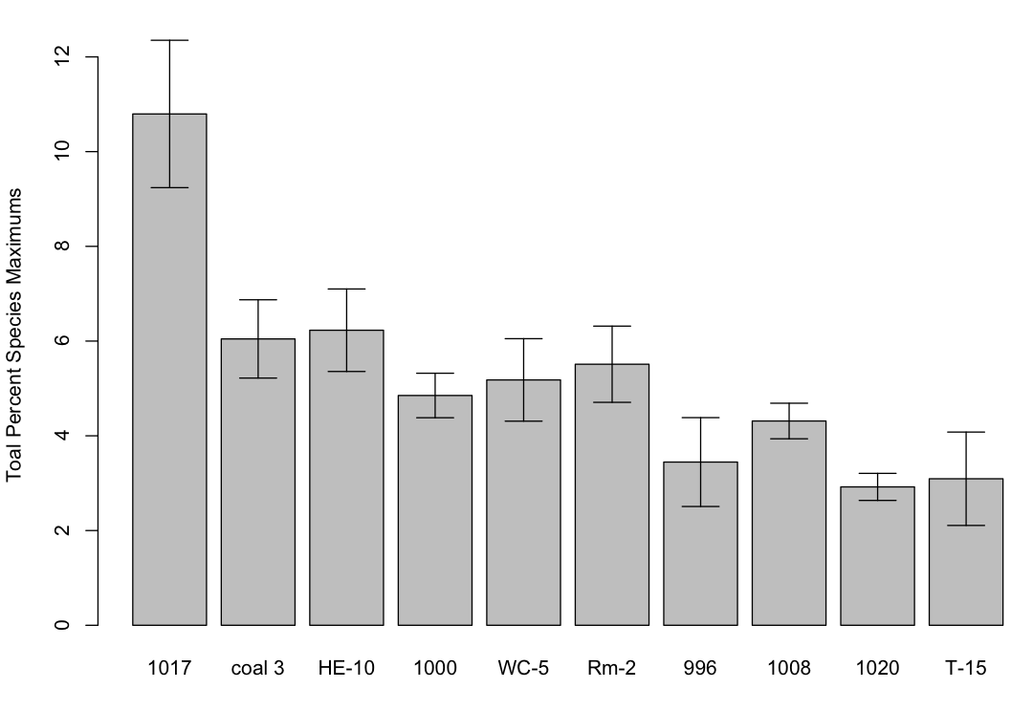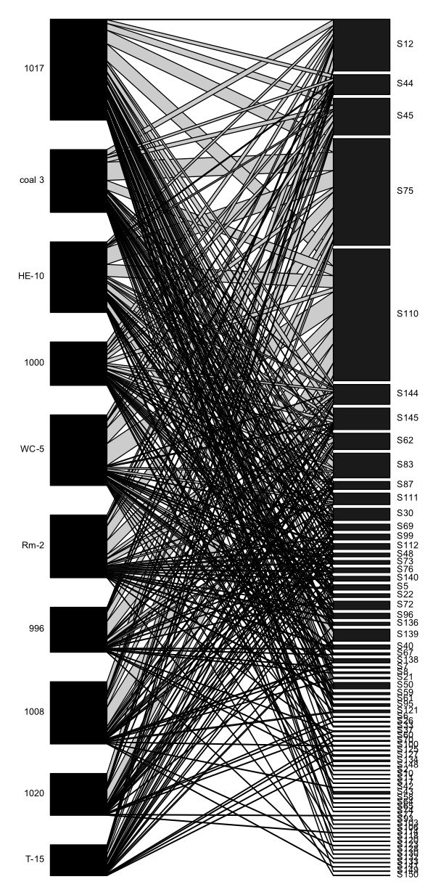

Figure 3.

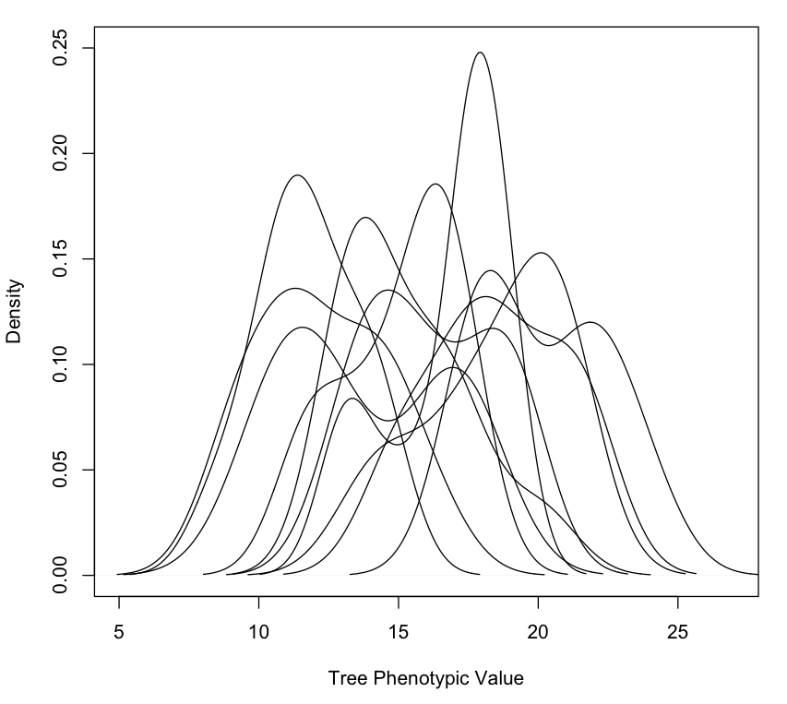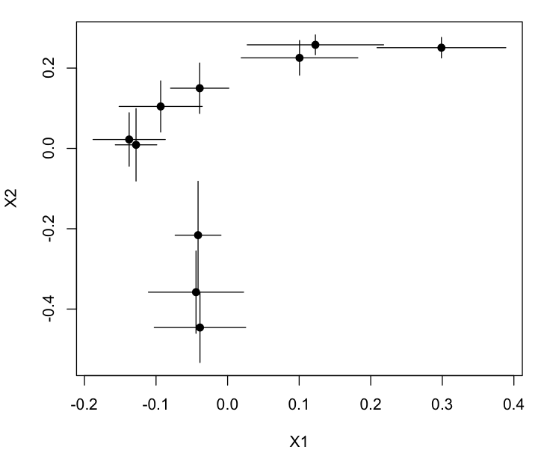

**A**

**B**

Figure 4.

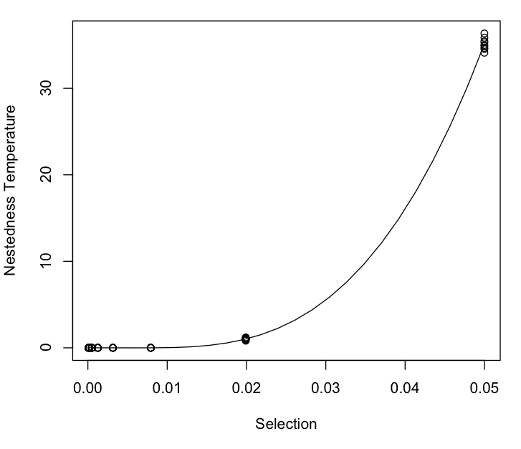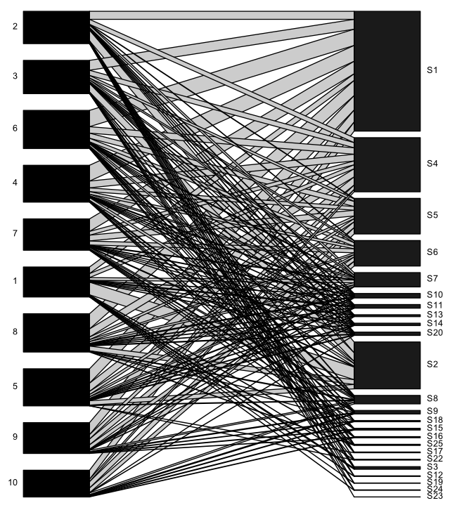

Figure 5.

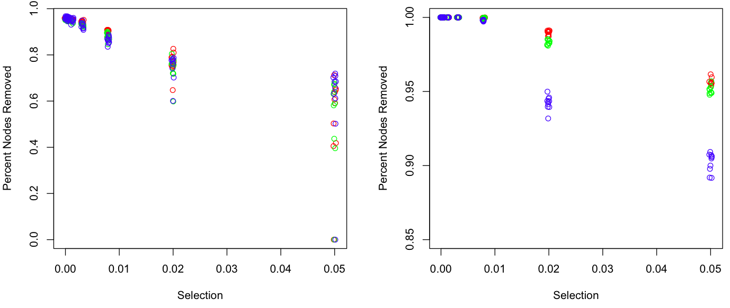

**A**

**B**

**Supplementary Materials**

**Appendix 1. Method for manipulating tree genotypic effects on the community**

**Equation 1**.