**Genotypic variation contributes to ecological network structure**

M.K. Lau, S.R. Borrett, S.M. Shuster, A.R. Keith, M.A. Fortuna T.G. Whitham

Target Journal: Evolution?, Ecology Letters?

Corresponding Author Information:

Department of Biological Sciences and

Merriam-Powell Center for Environmental Research

Northern Arizona University

Flagstaff, AZ 86011-5640

Email: [mkl48@nau.edu](mailto:mkl48@nau.edu)

Phone: 928-523-9534

**Abstract**

* Evolutionary and ecological processes are now recognized as operating on similar time scales, and species interactions have been shown to play an important role in driving these dynamics. Although studies of the effect of a focal species’ genetics on ecological communities have shown the importance of genetic variation in many ecosystems, they have not delved how these effects contribute to more complex patterns of species interactions, as is often analyzed using a network approach.
* In this study, we use a network perspective first to analyze an arthropod community dataset from a long-term common garden of plants with known genetic makeup and then to conduct a simulation experiment investigating how genetic variation in a foundation tree species contributes to interaction network structure and what consequences this might have for evolutionary dynamics.
* We found two main results:
  1. The empirical genotype-species network exhibited non-random co- network structure and co-occurrence patterns arising in part from genotypic variation even though the most conservative null model was used,
  2. Simulated genotype-species networks displayed increasing associated species co-occurrence patterns and network structure with increasing genotypic effect on the community.
* These findings demonstrate that the community level impact of genetic variation in a foundation species can alter the structure of species interaction networks, leads to more stable communities. This work points to a previously overlooked consequence of genetically based, intra-specific diversity and provides a mechanism for evolution to act on ecological network structure.

**Keywords:** foundation species, ecological networks, species interactions,co-occurrence, modularity, nestedness, centrality, genetics of networks, common gardens, long-term experiment

**Introduction**

The evolution of species interactions in complex communities is a central question at the interface of ecology and evolutionary biology. Species interactions play an integral role in ecosystems (Agrawal et al. 2007; Holland and Bronstein 2008; Winfree et al. 2011). How species interactions lead to evolutionary changes in participant species has been a topic of biology at least since Darwin’s study of orchid pollinators (Darwin 1862). Studies of co-evolution between pairs and small groups of species have expanded the theory and support for evolutionarily dynamic species interactions (Ehrlich and Raven 1964; Thompson 1982; Jones et al. 2009). Studies of plant-mutualist and plant-herbivore networks have more recently provided a broader perspective, addressing more complex relationships among many species in a community (Bascompte et al. 2003; Thebault et al. 2010). Studies of phylogenetic structure of these networks have demonstrated the contribution of evolutionary processes to the structure of ecological networks (Rezende et al. 2007; Rafferty and Ives 2013). The field of community genetics, which studies the genetic basis for interactions in complex communities, primarily focusing on foundation species (i.e., species that define much of the structure of a community by creating locally stabile conditions; Dayton 1972; Ellison et al. 2005) has demonstrated how genetic variation in a single species can determine the structure of whole communities (reviewed in Whitham et al. 2012; Rowntree et al. 2011; Gugerli et al. 2013); however, the ideas and approaches from community genetics and network ecology have not previously not yet been synthesized.

Studies of co-evolution and community genetics have expanded our view of the influence of genetic variation on communities associated with a focal species. Strauss et al. (2005) theoretically demonstrated that selection occurs in a community context whenever a species response to selection on a trait is altered by the presence of another interacting species. Empirical, studies of the response of arthropod communities to foundation tree species hybridization (Wimp et al. 2005), genotypic diversity (Crutsinger et al. 2006) and genetic similarity (Bangert et al. 2008) have demonstrated significant effects of genetic variability on community composition. Others have shown that variation at the finer genetic resolution of genotypes affects the composition of other associated communities, such as soil microbes (Schweitzer et al. 2008), arthropods (Keith et al. 2010), plants (Lamit et al. 2011), and fungal endophytes (Lamit et al. 2014). In addition, several community genetics studies have examined the impact of genetic variation beyond direct interactions with the focal species. Bailey et al. (2007) showed that genetically based resistance in *Populus angustifolia* (James) to an insect herbivore influenced a tri-trophic interaction. Mooney et al. (2012) demonstrated that ant-aphid interactions depended on milkweed (*Asclepias syriaca* L.) genotype. Busby et al. (2014) found that the plant genetics mediated the indirect interactions between leaf pathogens and cottonwood (*Populus* spp.) associated insect community. Together, these and other studies (see Rowntree et al. 2011) demonstrate the importance of genetic variation for both direct and indirect interactions among species, however, we are aware of no investigations combining both empirical data and simulation experiments to investigate the genetic basis for interaction network structure.

In this study, we examine how genetic variation in a foundation species influences the structure of ecological networks in complex communities. We primarily use a bipartite network approach, which examines networks where interactions typically occur between two main groups of species (e.g., plant-mutualists or host-parasite). Using bipartite networks permits us to apply specific hypotheses developed with ecological, species-species interaction networks (see Bascompte 2010) to networks of foundation species genotypes interacting with associated species, such as modularity (i.e., groups of interacting species) and nestedness (i.e., species in one part interact with subsets of species in the other part of the network). We hypothesize that, as with species-species bipartite networks (Fortuna et al. 2011), genotype-species networks will simultaneously exhibit both modularity and nestedness, which will increase with the intensity of the genetic effect of the foundation species. In addition, we hypothesize that genotype-species bipartite network structure will influence the structure of interaction networks among the foundation species associated community members. We argue that, since species interactions tend to occur locally, shifting co-occurrences will produce shifts in interactions by altering the frequency with which species are physically located together. To test these hypotheses we first explore the structure of an empirical network of interactions between narrowleaf cottonwood (*P. angustifolia* James) and its associated canopy arthropod community using a conservative, null model approach. We then conduct a community genetics simulation experiment where we vary the intensity of the community level effect of genotypic differences of a foundation species on its associated community and examine the structure of the resulting genotype-species interaction networks. As a genetic basis to traits is a key requirement for evolution by natural selection, demonstrating a genetic basis for interaction network structure has important implications for evolutionary dynamics in ecosystems.

* Species-species network structure, modularity and nestedness
  + Bipartite structure
  + Usually primary producer and consumer
  + Relevance to real communities
  + Community assembly is just who’s there, but a community is a group of interacting species
* Although studies often invoke an evolutionary mechanism, but do not use a genetics based perspective
* Explain genotypic variation, genetic variation and links with phenotypic variation
* Genotype-species networks, what they mean relative to species-species networks
* Motivation for investigating network structure, past studies of interacting species, composition doesn’t resolve the actually structure of the genotype effect, which could have significant consequences
* Motivation and structure of study, empirical and simulations.
* Hypotheses:
  + Empirical network would exhibit significant co-occurrence patterns and network structure being more modular and nested than expected under a null model
  + Simulated networks will exhibit increasing network structure with increasing genotypic effect
  + Varying the evenness of the associated community will alter the relationship between genotypic variation and network structure
* Why this is important to ecology and evolution?
  + Given that multiple studies have demonstrated rapid evolution of species and food webs in response to climate change (reviewed in Parmesan 2006), understanding the role of foundation species genetic variation in the context of complex ecological networks has important implications for understanding the ecological and evolutionary response to ecosystems to changing environmental conditions.

Methods

* Background on empirical dataset
  + Utah Riparian Forest
  + Garden
  + Canopy arthropod surveys
  + Genetics/genotypes
* Simulations
  + Shuster et al. 2006 model description
  + The Shannon’s Diversity Index for the asymptotic total abundance simulations was close to the empirical canopy arthropod community, while the mean of even simulations was 40% greater than the asymptotic simulations (Supplementary Materials Barplot).
* Network analyses
  + Bipartite networks?
  + Why these network statistics?
  + Modularity, Nestedness, Centrality and C-score

Results

* Empirical network
  + Modularity
  + Nestedness
  + Centrality
  + Co-occurrence negative co-occurrence,
  + obs.cs obs.mod obs.nest.binmatnest2 obs.cen
  + obs 12.76104 0.216648 21.482721 0.2659266
  + nul.z 13.39516 13.356564 8.596514 5.9877052
  + nul.p 0.00060 0.000000 0.000000 0.0000000
* Simulated networks
  + Tree phenotype and community variation among genotypes
  + Co-occurrence and network structure correlated with genetic effect
    - Correlation table
    - Network structure depends on community evenness

Discussion

Our goal here is not to predictively model empirical patterns but to demonstrate the possibility of the underlying genetic mechanism.

Although the concept of the ecological network, or “tangled bank,” dates back to Darwin (1859), it was almost a century later that ecologists began to rigorously explore the effects that interaction network structure can have on ecological dynamics (MacArthur 1955). The network approach facilitates the study of complex relationships among discrete components, and as community ecology focuses on interactions among multiple species, network thinking has contributed significantly to our understanding of complex ecological patterns and dynamics (Borrett et al. 2012), such as: community stability (May 1972, Cohen et al. 1981, Schmitz et al. 2010), ecosystem development (Ulanowicz 1981), and indirect interactions (Patten and Higashi 1991).

Phylogenetics and community similarity.

Previous simulation studies of community genetics have either examined indirect effects among species mediated by a third species (Moya-Laraño 2011) or direct effects of a foundation species on a large community of species (Shuster et al. 2006), and neither study explored the complex network structure that results for community level genetic effects.

* Hypotheses supported
* Modules are microcosms of evolution
* Nestedness influences persistence and stability
* Co-occurrence patterns altered, could lead to altered interactions through encounter frequency, i.e. interactions depend on the genetic context
* Centrality influences robustness and stability
* Evenness affects
* Scaling up to species-species networks
* Future work should introduce interactions among the associated species (Bastolla 2010, James 2012)

References

Darwin, C. R. 1862. On the various contrivances by which British and foreign orchids are fertilised by insects, and on the good effects of intercrossing. London: John Murray.

Ehrich P.R. and Raven P.H. 1964. Butterflies and plants: a study in coevolution. Evolution 18: 586-608.

Thompson, J.N. 1982. Interaction and Coevolution, John Wiley & Sons, New York.

Thébault E. and Fontaine. C. 2010. Stability of Ecological Communities and the Architecture of Mutualistic and Trophic Networks. Science 329: 853-856.

Rezende, E., Lavabre, J., Guimarães Jr., P.R., Jordano, P. and Bascompte, J. 2007. Non-random coextinctions in phylogenetically structured mutualistic networks. Nature 448: 925-928.

Rafferty N.E. and Ives 2013. Phylogenetic trait-based analyses of ecological networks. Ecology 94: 2321-2333.

Agrawal, A. A., D. D. Ackerly, F. Adler, A. E. Arnold, C. Caceres, D. F. Doak, E. Post,

P. J. Hudson, J. Maron, K. A. Mooney, M. Power, D. Schemske, J. Stachowicz, S. Strauss, M. G. Turner, and E. Werner. 2007. Filling key gaps in population and community ecology. Frontiers in Ecology and the Environment 5:145-152.

Winfree R., Gross B.J. and Kremen C. 2011. Valuing pollination services to agriculture. Ecological Economics 71: 80-88.

**Phylogenetic trait-based analyses of ecological networks**

Parmesan 2006

Ellison, A. M., M. S. Bank, B. D. Clinton, E. A. Colburn, K. Elliott, C. R. Ford, D. R. Foster, B. D. Kloeppel, J. D. Knoepp, G. M. Lovett, J. Mohan, D. A. Orwig, N. L. Rodenhouse, W. V. Sobczak, K. A. Stinson, J. K. Stone, C. M. Swan, J. Thompson, B. von Holle, and J. R. Webster. 2005. Loss of foundation species: consequences for the structure and dynamics of forested ecosystems. Frontiers in Ecology and the Environment 9: 479-486.

Figures

Macintosh HD:Users:Aeolus:projects:dissertation:projects:een:results:FIG_genotype_species_network.pdf

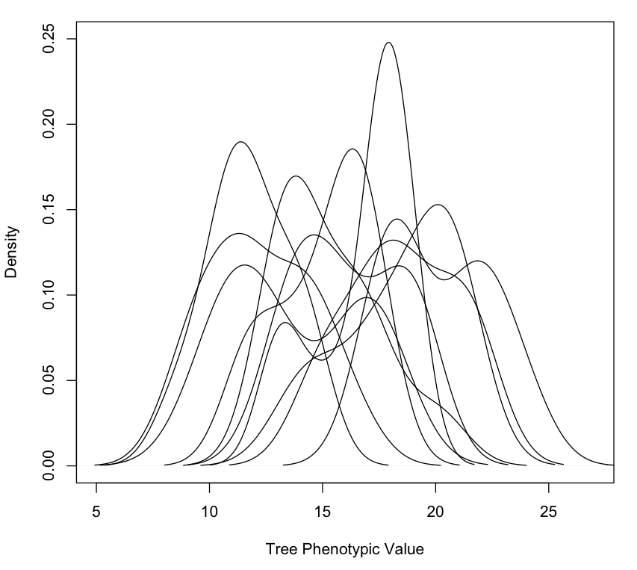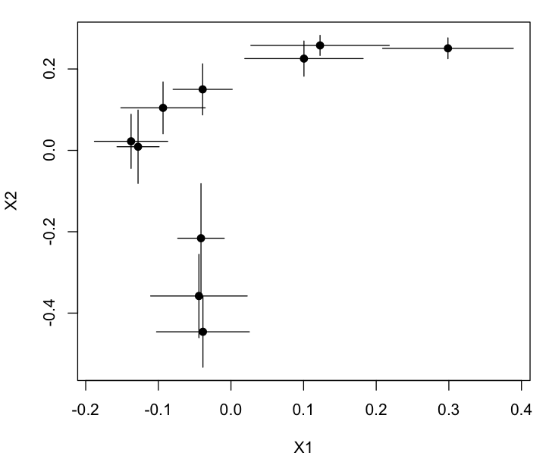

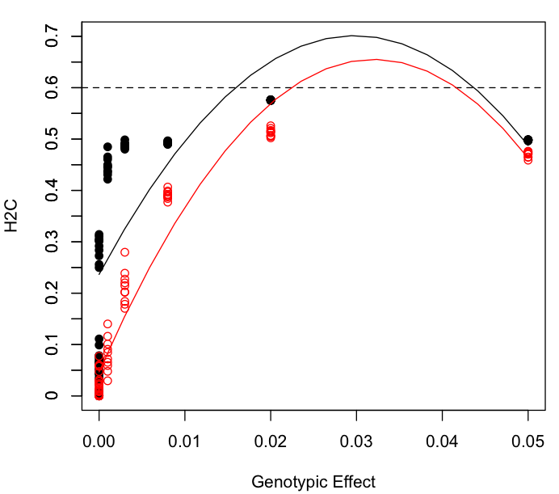

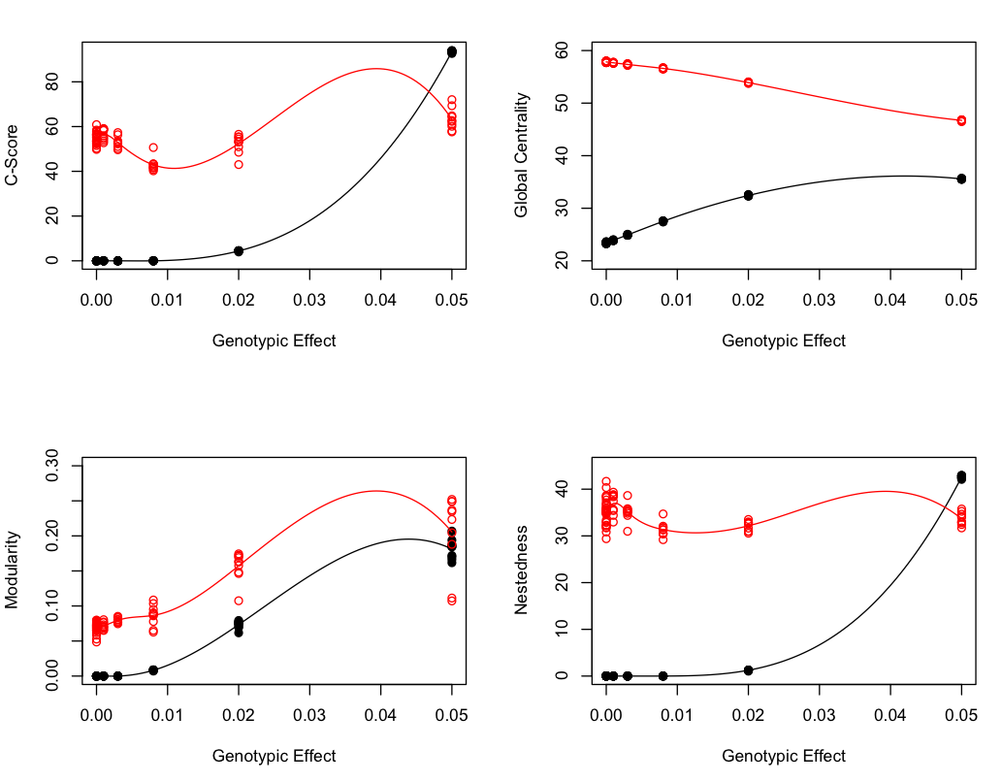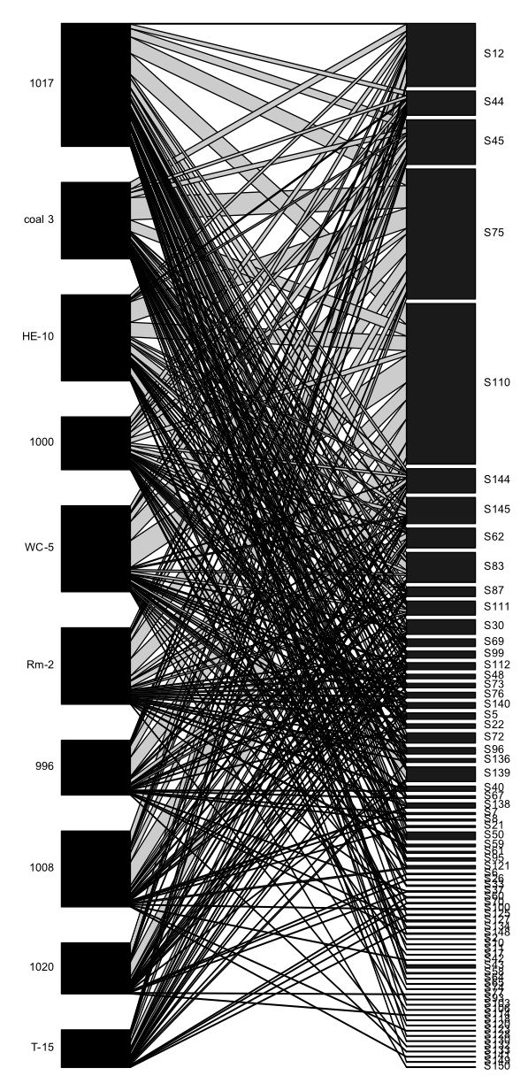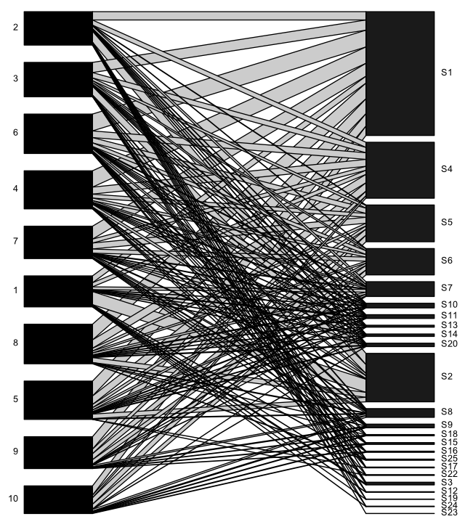

Appendix

