**No genotype is an island: Genetic variation creates nested, robust ecological networks**

M.K. Lau, S.R. Borrett, S.M. Shuster, A.R. Keith, M. Fortuna T.G. Whitham

Target Journal: PLoS Biology?, Ecology Letters?, Others???

Contact Information

**Abstract**

* Studies of ecological networks have demonstrated the importance of indirect effects of interactions in communities to contribute to community dynamics; however, although the majority of these studies use an evolutionary perspective, no empirical studies have explored the genetic basis of these patterns.
* Here, we investigate structural patterns that genetic variation in a foundation species contributes to interaction network structure and what functional consequences this might have for evolutionary dynamics.
* We first analyze an empirical genotype-species dataset for how genotypic variation contributes to interaction network structure. We then conduct a series of simulation experiments to explore the effect genetic variation can have on interaction network structure and function.
* We found three major results:
  1. An empirical genotype-species network exhibited significant nestedness under the most conservative null model of network structure,
  2. Nestedness of genotype-species networks increased as the effect of genetic variation increased,
  3. When genotypic effects and ecological diversity were both high, selection on phenotypically similar genotypes had the highest impact on community robustness.
* These findings demonstrate that the community level impact of genetic variance can alter the structure of species interaction networks, which leading to more stable communities. This work points to a previously overlooked consequence of genetically based, intra-specific diversity and provides a mechanism for evolution to act on ecological network structure. This study presents a major step toward incorporating a genetics based, evolutionary perspective into ecological network theory.

**Keywords:** foundation species, ecological networks, species interactions,nestedness, robustness

**Introduction**

Evolutionary dynamics play an integral in the creation of biological diversity. Species interactions have been shown repeatedly to drive the evolution of biological diversity, contributing to a continual process of evolutionary dynamics (see Thompson 2013). Genetic variation itself has been shown to influence a suite of community and ecosystem level patterns (reviewed in Whitham et al. 2013 and Gugerli et al. 2013). One important, specific example is that greater genetic diversity within a species leads to higher diversity of communities associated: such as insects associated with *Populus* spp., *Solidago* *canadensis* and *Oenothera* *bienis* (Wimp et al. 2005, Crutsinger et al. 2006 and Johnson and Agrawal 2007, respectively). One suggested mechanism is the genetic similarity rule (Bangert et al. 200), which states that genetically distinct individuals tend to be different phenotypically, which leads to differences in their interactions with associated species. These studies have made great strides in developing a genetics perspective in community ecology; however, none of them has explicitly viewed the community as a network of interacting species.

For over half a century, ecologists have been studying the structure of interaction networks and how this can change the dynamics of ecological communities. Although the concept of complex networks of species forming food-webs dates back to at least Charles Darwin (1959), Robert MacArthur (1955) was perhaps the first ecologist to rigorously explore the implications of species interactions from a network perspective. Further work in the field of network ecology has produced insights into community stability (May 1972), ecosystem development (Ulanowicz 1981), propagation of indirect effects (Patten and Higashi 1991), and co-evolution of species (Bascompte et al. 2003). The main contribution that network theory has made to ecology is that it provides a conceptual and analytical framework that acknowledges both direct and indirect effects of interactions among species.

Recently, studies using a bipartite network perspective have propelled our understanding of co-evolution in complex communities of interacting species. In particular, investigations into the structure of mutualistic and trophic networks (Thébault and Fontaine 2010) have shown that these networks display consistent patterns of nestedness (more specialized species interact with subsets of the community that interact with more generalized species) and modularity (species interact in isolated clusters). Evidence from simulated species removal studies suggest that nestedness contributes to community stability and species co-existence by minimizing competition among species, while theory suggests that the formation of modules keeps the effects of negative interactions from propagating through the rest of the network (Bascompte et al. 2010). Although it has been proposed that both of these structures arise via evolutionary processes, we are aware of no studies that have investigated how genetic variation within species influences the structure of interactions with a complex community of species.

Thus, focusing initially on foundation species has been an important step forward, but has obviously been ignoring the insights that could be made by incorporating evolutionary genetics and a community level interaction network perspective. In this study, we first use an established mass-action community genetics simulation to study the effect of intra-specific variation on interaction network structure. We examine these simulated communities using a genotype-species network perspective (Fig. 1). We hypothesize that genetically based variation in a clonal foundation species will contribute to the structure of interaction networks will increase as the influence of genetic variation on community composition increases. Second, we examine the robustness of these communities to the loss of genetic diversity, where we hypothesize that altering the effect of genetics will affect network robustness. Last, we examine the structure of an empirical network where plant genetics is known. Demonstrating a link between genetic variation and network structure and robustness will alter our understanding of how selection acts on species interactions in complex communities.

**Methods**

*Network Structural Analyses*

Nestedness was then calculated for each of these networks using the nestedness temperature metric (Rodríguez-Gironés and Santamaria 2006). This method uses a packing algorithm first described in Atmar and Patterson (1993) that compares a presence-absence representation of the observed matrix to a “low temperature” or non-nested re-arrangement of the matrix. The greater the difference is between the observed and the re-arranged matrix, the higher the nestedness temperature value.

*Empirical cottonwood genotype canopy arthropod network analysis*

An empirical network of canopy arthropod species on known genotypes of *Populus angustifolia* James (narrowleaf cottonwood) was taken from Keith et al. 2014. Trees planted in a common garden in 1991 (Martinsen et al. 2001) that randomized replicate genotypes (based on RFLP genotypic) with respect to local environmental variation were surveyed for arthropods in August of 2009 using timed sampling of similarly sized branches. Genotype averages for species abundances were used to construct a genotype-species network. A nestedness significance test was performed on this network using 1000 permutations of the original data and a 50 iteration burn-in. A fixed row and column permutation algorithm that maintained marginal totals was used to control for differences in total abundance of both genotypes and arthropod species.

We also tested for the genetic contribution to nestedness. To do this, we first relativized all species abundances to their maximum value observed across all trees. This relativization was integral to this analysis, as it places all species, which can vary greatly in total abundance, onto equal footing by rescaling all values between 0 (= absence) and 1 (= maximum abundance). We then summed these species maximums for each tree, and used Restricted Maximum Likelihood (REML) to test for effect of genotype.

*Simulations*

We used the community genetics simulation method previously developed in Shuster et al. 2006. Briefly, this method starts by creating a population of individuals assigned a genotypic value (i.e. genotypes). Each genotype is comprised of multiple individuals (i.e. clones), which are mapped to phenotypic values as a single numeric value for each individual. This population represents the foundation species (i.e., a species that has a large effect on the community; Ellison et al. 2005). Next, a set of species representing the associated community was assigned an average genotypic value that was then mapped to a numerical phenotypic value using an additive, bi-allelic genetic system. At each step of genotype-phenotype mapping, variance is introduced through random draws from a uniform distribution, which simulates the introduction of phenotypic variance arising from non-genetically based “environmental” variation. It is important to note here that interactions among species beyond the foundation species’ interaction with the community is not explicitly accounted for in this process but introduced as a contribution to non-genetic, environmental variation. Finally, the foundation species phenotypic values for each individual are used to determine the equilibrium population value for each species (Ronce and Kirkpatrick 2001).

For this study, we generated a set of 10 replicate communities for 8 scenarios of selection intensity for a total of 80 communities. Each of these communities was generated using the same initial phenotypes for both the “foundation species” individuals (n = 100 with 10 individuals for each of 10 genotypes) and the “associated species” (n = 25) (see Online Supplementary Materials, Appendix X). For the main set of analyses, a carrying capacity (K) of 100 individuals was used for to remove the effect of differences in total abundances among species.

This method allows the control and manipulation of several variables that can influence network structure:

1. Genotype abundances
2. Species abundances
3. Genetic variation and impact
4. Environmental variation and impact

*Genotype-species networks*

Genotypic averages of species abundances were then used to generate a bipartite network of genotype-species interactions. As the network nestedness matrix rely on presence-absence data, each network was reduced to a minimal set of connections. A cut-off of 5 observations for a given species on an individual tree was used as a threshold to “prune” the network to the minimal connections. This threshold value was chosen because it is the point at which a binomial test of significance had enough power to produce a significant test.

*Robustness Experiments*

To examine the robustness of these networks, we conducted a series of foundation species removal experiments. Trees were removed according to three different algorithms: 1) random removal, 2) connectedness removal and 3) phenotypic similarity. The random removal algorithm used a uniform probability distribution to select individuals. The connectedness removal algorithm assigned individuals with more interactions with species higher probability for removal. The phenotypic removal algorithm assigned removal probabilities by the phenotypic similarity among individuals. These algorithms were applied to the communities for species with equal carrying capacities as described and to a second set of communities in which the carrying capacities for the dependent species were selected from a Poisson distribution intended to simulate the highly skewed, un-even distribution of species total abundances most often observed in natural communities (Supplementary Materials, Appendix 1).

*Software*

All simulations and analyses were conducted in R version 3.0.2 (R Development Core Team 2014). Simulations were conducted using the *ComGenR* package (Lau 2014), and simulation scripts and output are publically hosted at <https://github.com/MKLau/cg_simulations>. Non-metric multidimensional scaling (NMDS) ordination, co-occurrence analyses and nestedness tests were conducted with *vegan* (Okasanen et al. 2013), and networks were plotted using *bipartite* (Dormann et al. 2008).

**Results**

*Genetic variation altered species co-occurrence patterns to produce nestedness*

Composition and co-occurrence patterns of the simulated communities were affected by tree genetics (Fig. 2).

The nestedness of simulated networks increased with the intensity of selection (Fig. 3).

*Genetically based nestedness increases network robustness*

Communities with carrying capacities drawn from a Poisson distribution were on average 19% less even (Pielou’s Evenness) than communities with a fixed carrying capacity for all species (*t* = 154.55, *P* <<< 0.001).

Networks with low evenness were more susceptible to removals overall, but this susceptibility was driven by the species abundances and not the effect of genotype. When species abundances were even, the effect of selection on a genetically based phenotype had a strong impact on the robustness of the community to fluctuations in the foundation species (Fig. 4).

*Empirical genotype-species network exhibits Nestedness*

The cottonwood canopy arthropod genotype-species network showed significant nestedness. The nestedness was statistically different from the null expectation (Fig. 5; nested temperature = 19.542, *P* = 0.017). Genotypes differed significantly in the sum of percent species maximum values, which is here used as a magnitude of interaction with the community (REML: 2=16.06, *P*=0.00006)

**Discussion**

*Nestendess: An overlooked benefit of genetic diversity*

Empirical results.

*Nestedness, genetic diversity and community dynamics*

Simulation results

Selection as a specificity and module breaking process.

*Reality Check*

How does this apply to real systems?

This study has not treated the potential for interactions among species to shift within the context of an individual of a foundation species. Future studies should collect higher resolution data that will allows to explore how interactions among species may shift given the particular local environmental context that they occur within.

**Acknowledgements**

The Bascompte Lab at Estacion de Doñana, Spain and the SEE Lab at UNCW, USA for helpful discussions on ecological networks. The Cottonwood Ecology lab at NAU, USA. Clinton Baker ITS at NAU.

**References**

**Figure Legends**

Figure 1. Although interspecific variation in interaction traits is known to lead to nested ecological networks (e.g. mutualistic networks), the contribution of intra-specific variation to network structure has not been explored. This figure shows a bipartite graph of a mutualistic network of plant species (left; green circles) and associated species (right; red circles) connected by light grey lines representing their interactions. The center set of green nodes shows a hypothetical scenario in which the top-most plant species is comprised of two genotypes that have distinct phenotypes that affect their interactions between species (dark grey lines).

Figure 2. Empirical bipartite genotype-individual network of canopy arthropod species associated with *Populus angustifolia* genotypes exhibiting significant nestedness. Nodes are ordered by their degrees (i.e. total number of connections). The barplot shows the genotypic variation in the total percent species maximums summed across all species for a given tree showing that differ genotypes significantly in the degree to which they interact with the arthropod community.

Figure 3. Plots of the (A) densities of tree phenotypic values and (B) the NMDS ordination of the simulated communities for each tree genotype.

Figure 4. The scatterplot on the left shows the effect of selection intensity on nestedness temperature. The effect of selection on nestedness increases non-linearly because levels of selection intensity were scaled exponentially. An example simulated bipartite genotype-species network is shown on the right with tree genotype (left) and associated species (right) where connections are scaled by the average species abundance across genotype replicates and nodes are scaled by the number of connections. This network displays a high degree of nestedness with genotypes and species of lower connectedness being subsets of the community.

Figure 5. Scatterplots showing the relationship between selection intensity and the percent trees removed for the first extinction metric (see methods) for (A) high and (B) low evenness communities for three tree individual removal scenarios: red = random, green = preference for higher connectedness and blue = preference for phenotypic similarity.

Figure 1.

Macintosh HD:Users:Aeolus:projects:dissertation:projects:een:results:FIG_genotype_species_network.pdf

Figure 2.

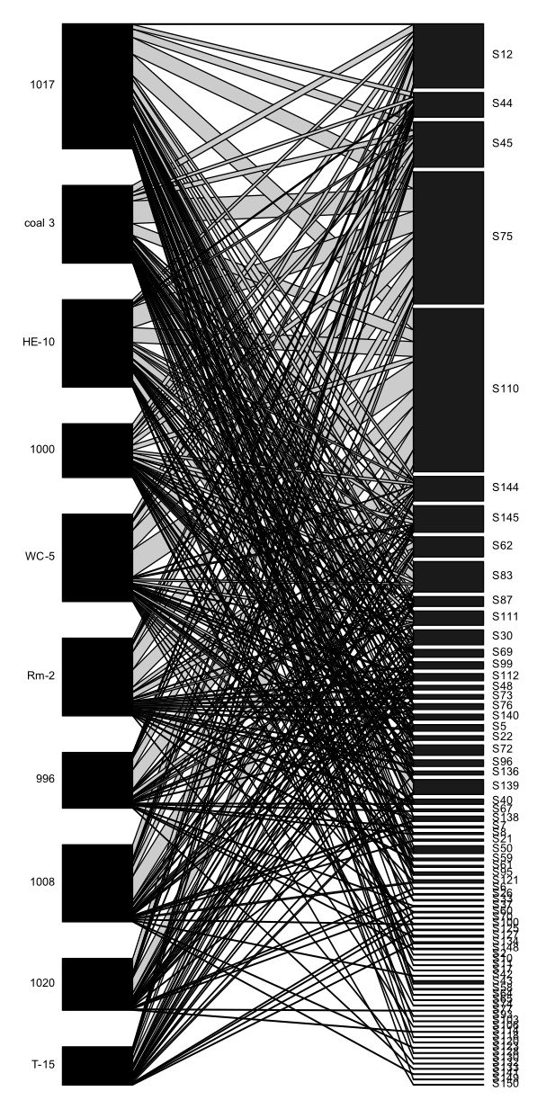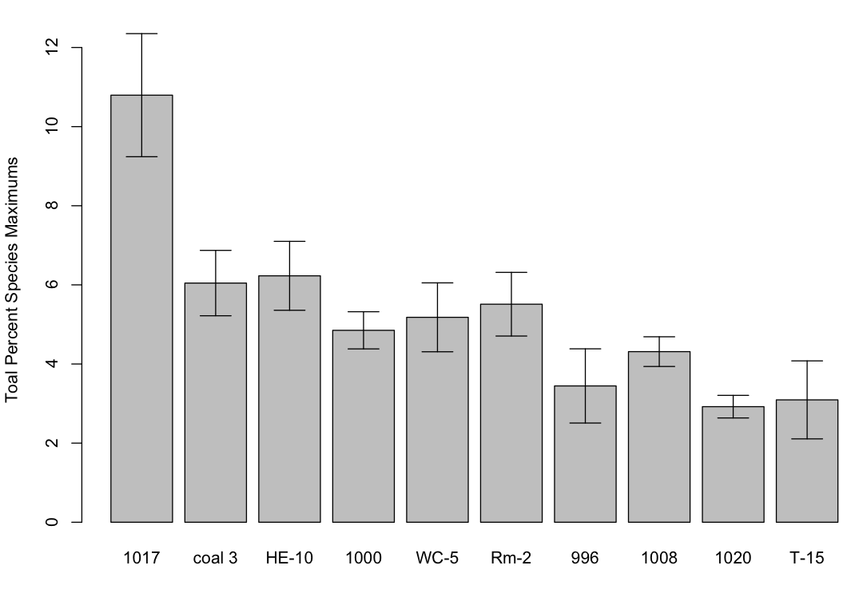

Figure 3.

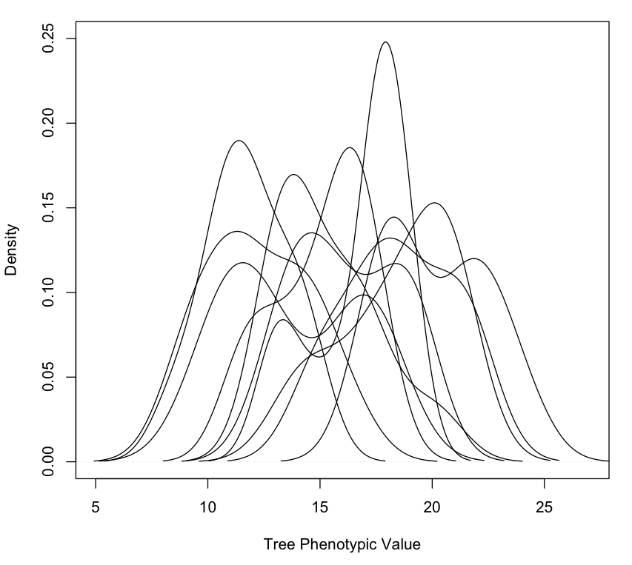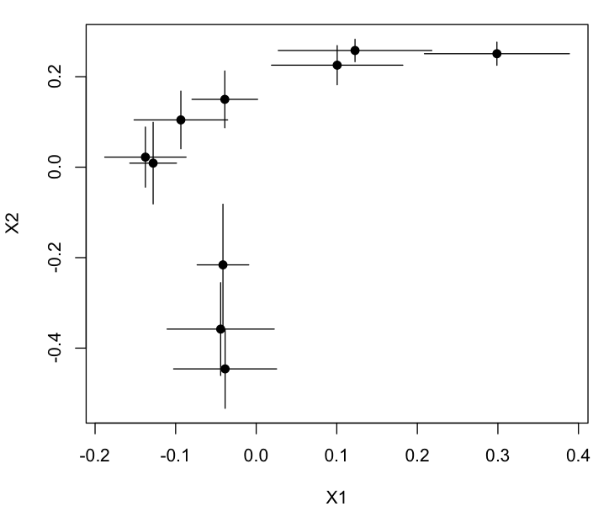

**B**

**A**

Figure 4.

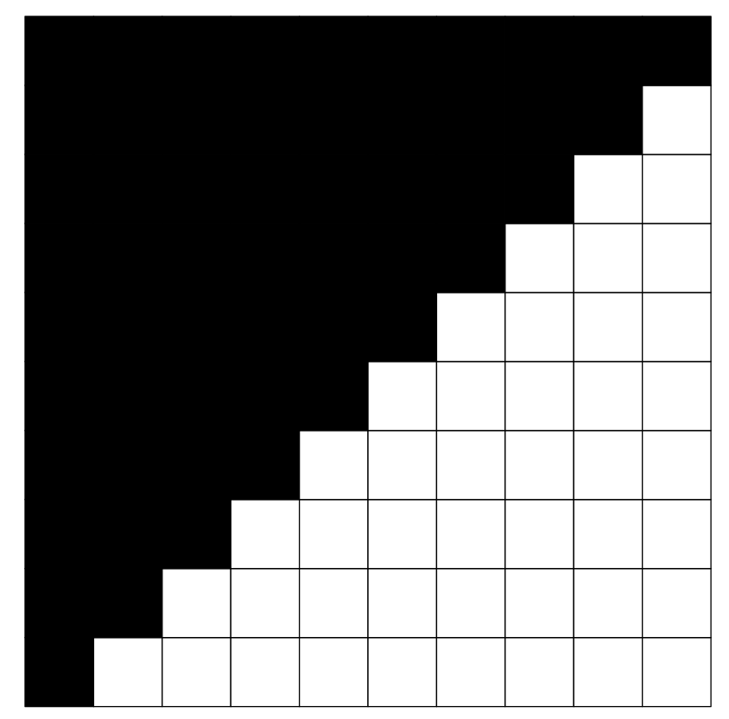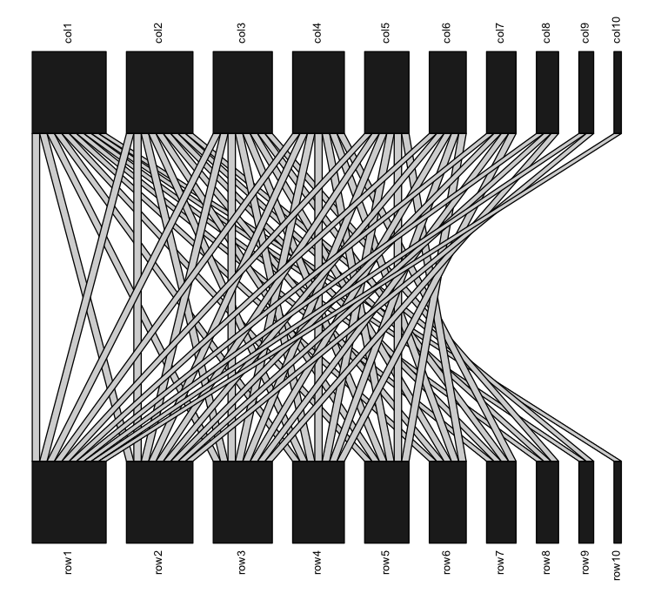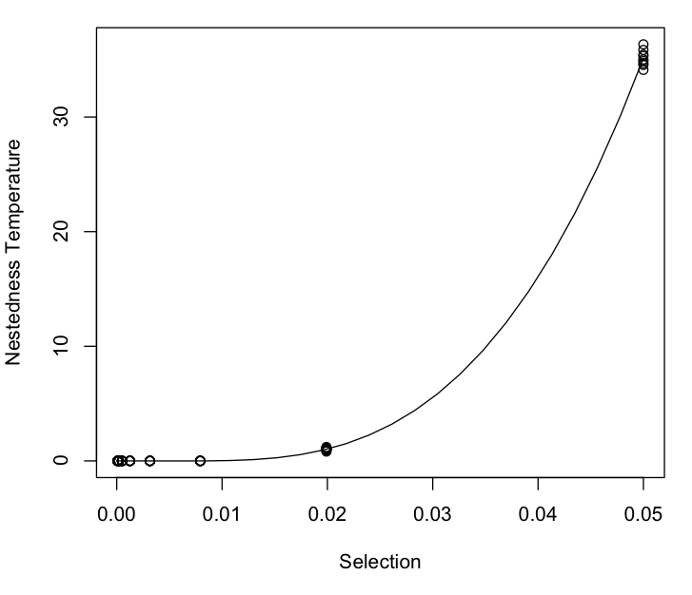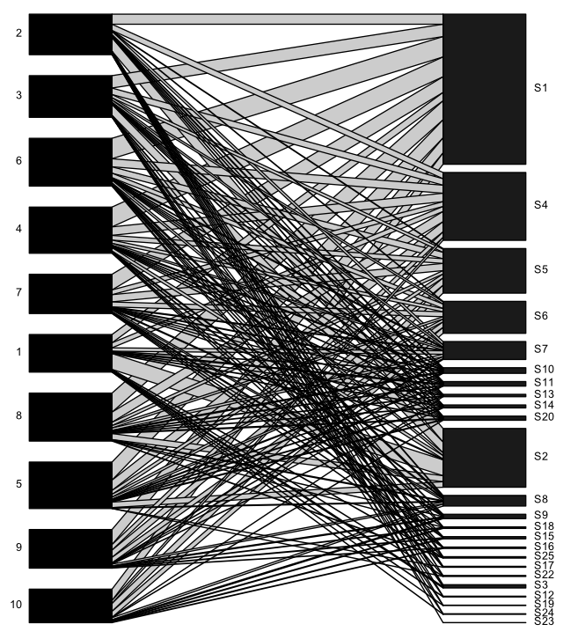

Figure 5.

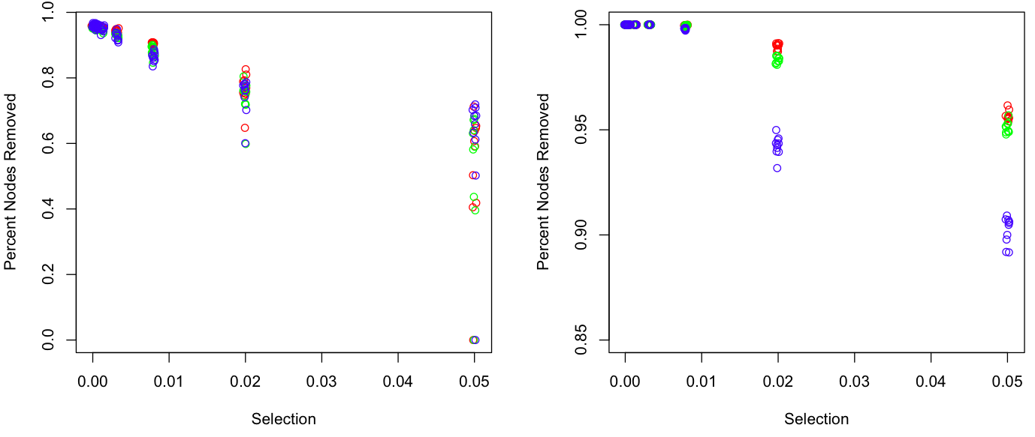

**A**

**B**

**Supplementary Materials**

**Appendix 1. Simulation of un-even communities.**

**Appendix 2. Table of species for empirical genotype-species network**