Title page

ABSTRACT

Copyright Page

ACKNOWLEDGEMENTS

TABLE OF CONTENTS

Title Page

Preface

Introduction

Acknowledgements

Index

Chapter I

Chapter II

Chapter III

Chapter IV

DEDICATION

PREFACE

INTRODUCTION

CHAPTER I. Ecological and Evolutionary Interaction Network Exploration: Addressing the Complexity of Biological Interactions in Natural Systems with Community Genetics and Statistics

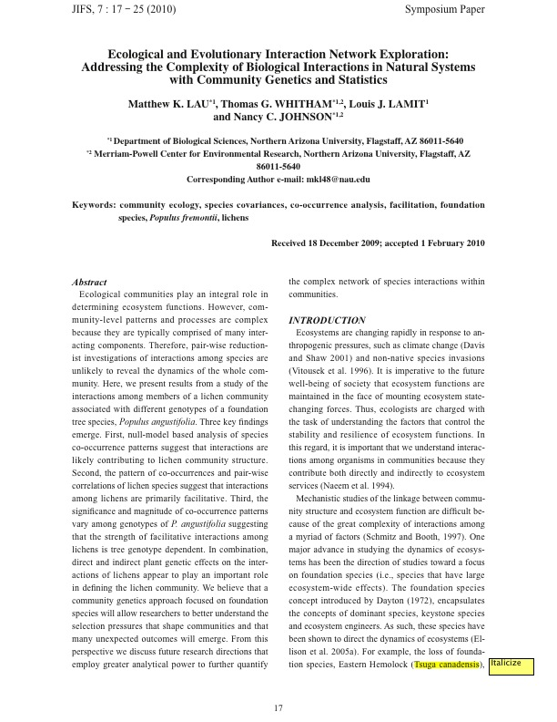

CHAPTER II. Genotypic variation in foundation species generates interaction network structure in ecological communities

CHAPTER III. Foundation species genotypic variation generates ecological network structure

CHAPTER IV. Interacting foundation species drive leaf arthropod interaction network structure