**Genetic variation in a foundation tree species creates ecological network structure**

M.K. Lau, L.J. Lamit, R.R. Naesbourg, T.G. Whitham

* Ecological network structure contributes to community dynamics, and in particular, nestedness and modularity are two network structures that have been hypothesized to contribute to the stability of communities
* Although evolutionary forces, such as selection, have been proposed as a mechanism that creates these network structures and genetic variation within foundation species has been shown to contribute to community composition and shifts in species interactions, the effect of genetic variation on the structure of ecological interaction networks has not been examined,
* In this study, we use data from both natural and experimental stands of a foundation tree species (*Populus angustifolia*, James) where tree genetic identity is known to test how genetic variation contributes to network structure for a community of epiphytic lichens,
* Our study yielded three primary results:
  1. Tree genetics contributed to significant co-occurrence patterns of epiphytic lichen,
  2. As with species-species bipartite networks, the individual-species and genotype-species networks showed significant nestedness,
  3. Variation in bark roughness, a genetically based tree trait, produced similar patterns of co-occurrence and nestedness in the natural stand,
* Based on these results, we conclude that genetic variation in foundation species contributes to the structure of ecological interaction networks for species with a high degree of dependence. This finding provides the first evidence that variation in ecological network structure can be subject to the evolutionary force of natural selection.

**Introduction**

**Methods**

**Results**

**Discussion**

**Acknowledgments**

**References**

**Tables**

**Figures**

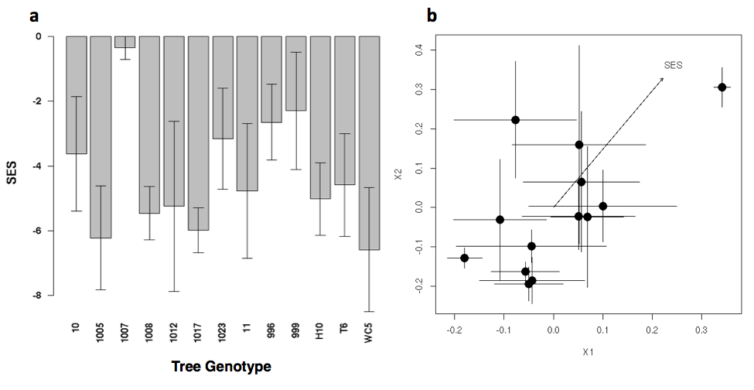

**Figure 1**. The barplot (**a**) shows the mean (±1 S.E.), tree-level standardized effect sizes (SES) on each genotype and the NMDS ordination plot (**b**) shows the ordinated lichen community composition (genotype centroids with bars showing ±1 S.E.) and the multivariate correlation between the ordinated scores and the SES values (arrow scaled by the magnitude of the correlation and oriented in the direction of the correlation).

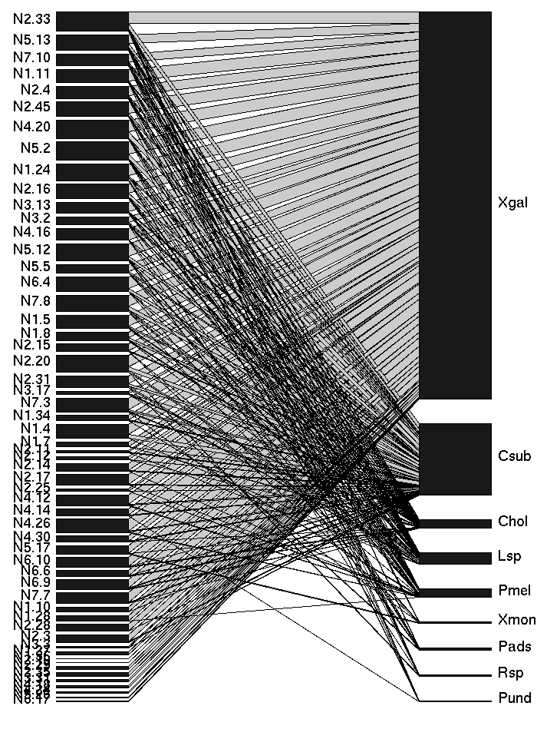 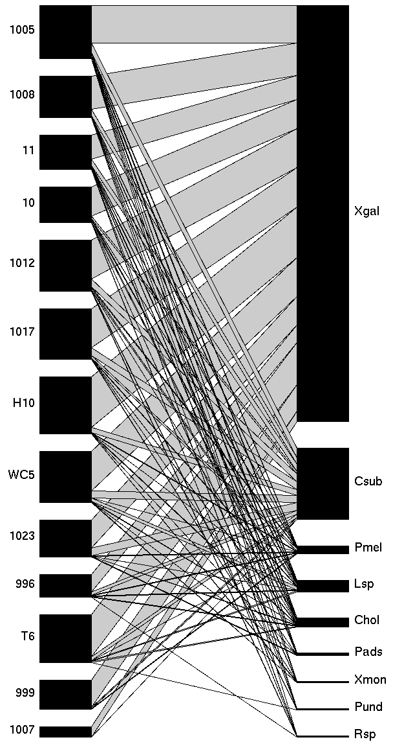

**B**

**A**

**Figure 2.** Plots showing the structure of the bipartite networks for (A) tree-species and (B) genotype-species for the *Populus angustifolia* epiphytic lichen community in the common garden, Ogden, UT, USA. Nodes in each part of the network (i.e. tree, genotype or species) are arranged in order of increasing number of connections from bottom to top.

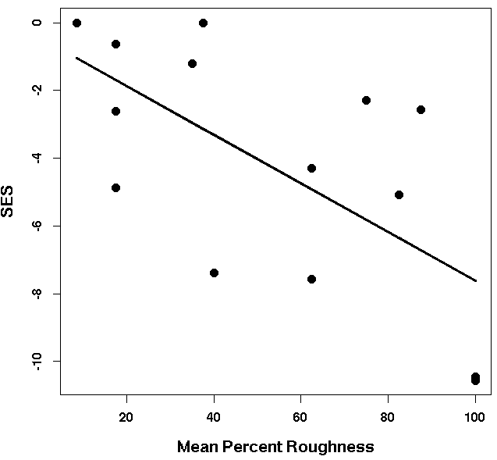 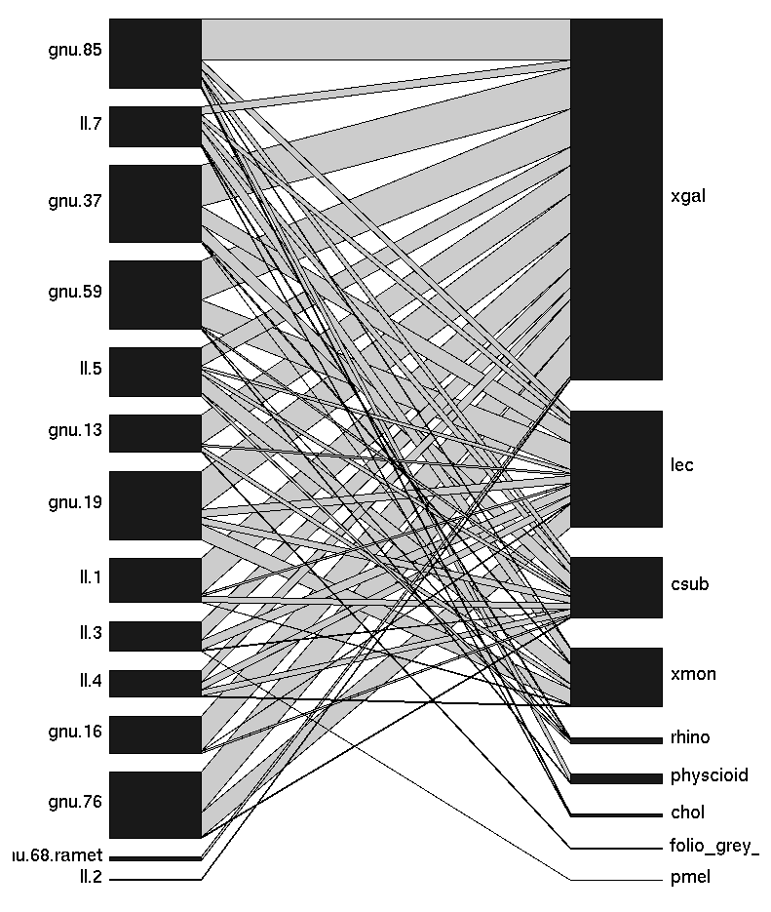

**B**

**A**

**Figure 3.** (A) Scatterplot showing the correlation between the epiphytic lichen community co-occurrence patterns (Standardized Effect Size = SES) and bark roughness. (B) The tree-species bipartite network for the natural stand showing significant nestedness.

**Appendix 1.**

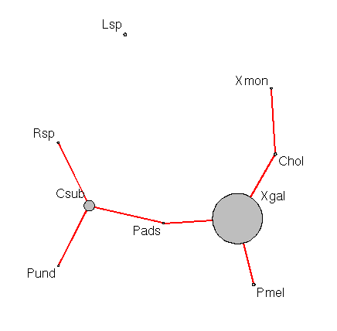

**Figure 1**. Plots showing the significant network patterns for the epiphytic lichen at the scale of the entire stand. Species are shown as nodes scaled by log of the relative abundance and significant co-occurrence patterns (i.e. Bray-Curtis similarity values) shown as lines connecting species. Species taxonomy associated with each species code are shown in Table XXX.