Supplementary Materials

Species Accumulation Curves for Common Garden and Wild Stands

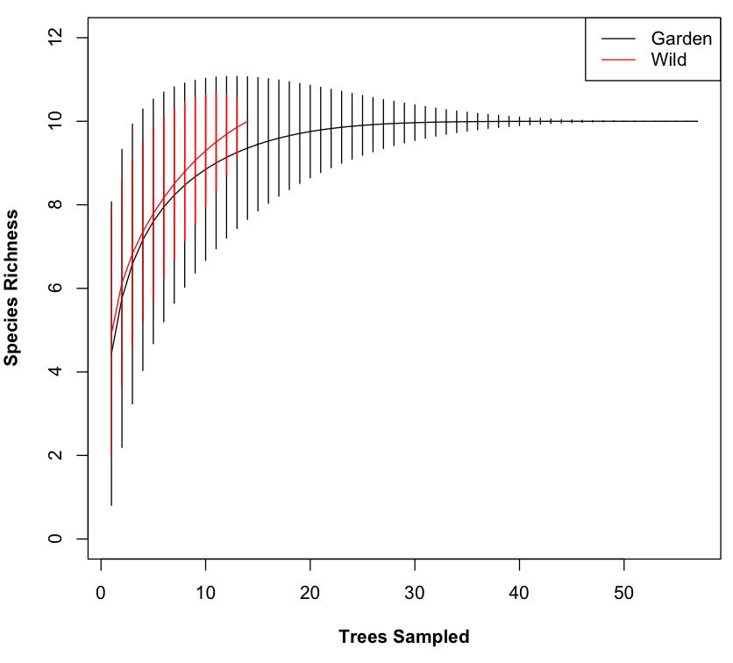

Figure 1. Species accumulation curves show slightly higher, though similar, diversity in the wild versus the common garden stands. Expected means and errors for the curves were generated using an exact method (Ugland et al. 2003).

References

Ugland, K.I., Gray, J.S. & Ellingsen, K.E. (2003). The species-accumulation curve and estimation of species richness. *Journal of Animal Ecology* 72: 888–897.