Tables

|  |  |  |  |  |  |
| --- | --- | --- | --- | --- | --- |
| Source | Df | SS | MS | F | P-value |
| Bark Roughness | 1 | 76.54 | 76.54 | 8.736 | 0.012 |
| Residuals | 12 | 105.14 | 8.76 |  |  |
| Total | 13 | 181.68 |  |  |  |

**Table 1**. F-table showing the significant effect of Bark Roughness on the epiphytic lichen co-occurrence patterns, which were measured with null-model based Standardized Effect Size (SES).

Figures

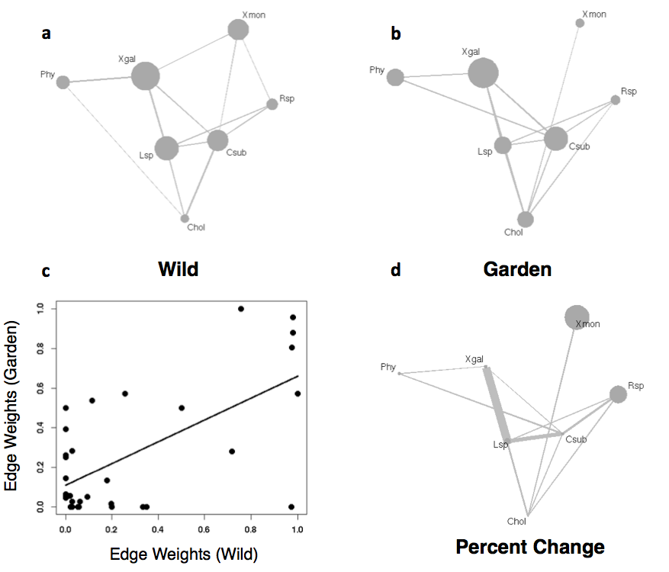

**Figure 1**. Plots showing the significant network patterns for the epiphytic lichen at the scale of the entire stand (a and b). Species and significant co-occurrence patterns are shown as nodes scaled by log of the relative, total abundance of taxon and lines connecting edges scaled by the dependency value. The correlation between the structure of the two stand level networks (c). The network diagram (d) shows the percent change of both the total relative abundances and the edge weights.

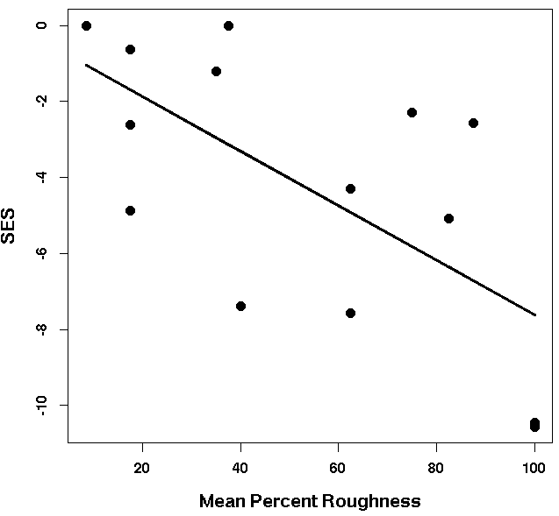

**Figure 2**. Scatterplot showing the significant effect of tree bark roughness and the Standardized Effect Sizes (SES) for individual trees.

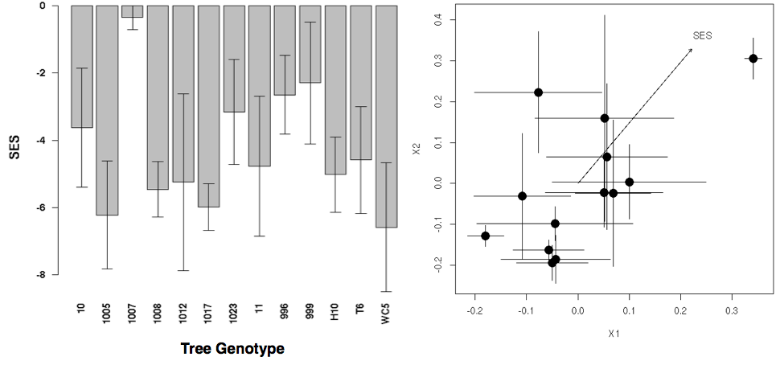

**Figure 3**. The barplot (left) shows the mean (±1 S.E.), tree-level standardized effect sizes (SES) on each genotype and the NMDS ordination plot (right) shows the ordinated lichen community composition (centroid with bars showing ±1 S.E.) and the multivariate correlation between the ordinated scores and the SES values (arrow scaled by the magnitude of the correlation and oriented in the direction of the correlation).